Dog Breed Application

Dog Breed application intended to show the all images of dogs based on breed type. Application is build using Spring MVC, REST, Maven and Java8.

Here is Directory Structure:

Database And Initial Entries:

create table DOG_BREED_DETAILS (
id tinyint(3) not null default '0',
breed_Type varchar(25) not null default '',
favorite_Count tinyint(2) not null default '0',
image_id tinyint(3) not null default '0',
image_name varchar(50) not null default '',
other_Info varchar(250) not null default '',
url varchar(200) not null default '',
PRIMARY KEY (`id`)
);

INSERT INTO DOG_BREED_DETAILS VALUES (1,'Affenpinscher',0,101,'AffenpinscherAugi.JPG','shortly comming more details', 'click the url');

INSERT INTO DOG_BREED_DETAILS VALUES (2,'Affenpinscher',0,102,'American_water_spaniel.jpg','shortly comming more details', 'click the url');
INSERT INTO DOG_BREED_DETAILS VALUES (3,'Affenpinscher',0,103,'NorfolkTerrierinde.jpg','shortly comming more details', 'click the url');
INSERT INTO DOG_BREED_DETAILS VALUES (4,'Affenpinscher',0,104,'PapillonFrisbee.jpg','shortly comming more details', 'click the url');
INSERT INTO DOG_BREED_DETAILS VALUES (5,'Affenpinscher',0,105,'PapillonFrisbee.jpg','shortly comming more details', 'click the url');

INSERT INTO DOG_BREED_DETAILS VALUES (6,'JackRussell',0,106,'Brittany_02625.jpg','shortly comming more details', 'click the url');
INSERT INTO DOG_BREED_DETAILS VALUES (7,'JackRussell',0,107,'Labrador_retriever.jpg','shortly comming more details', 'click the url');
INSERT INTO DOG_BREED_DETAILS VALUES (8,'JackRussell',0,108,'RebelTerrierPurebred.jpg','shortly comming more details', 'click the url');
INSERT INTO DOG_BREED_DETAILS VALUES (9,'JackRussell',0,109,'RebelTerrierPurebred.jpg','shortly comming more details', 'click the url');

INSERT INTO DOG_BREED_DETAILS VALUES (10,'Labrador',0,110,'Curly-coated_retriever.jpg','shortly comming more details', 'click the url');
INSERT INTO DOG_BREED_DETAILS VALUES (11,'Labrador',0,111,'Labrador_retriever.jpg','shortly comming more details', 'click the url');
INSERT INTO DOG_BREED_DETAILS VALUES (12,'Labrador',0,112,'Labrador_retriever_06455.jpg','shortly comming more details', 'click the url');
INSERT INTO DOG_BREED_DETAILS VALUES (13,'Labrador',0,113,'Rocket-sitting-primary.jpeg','shortly comming more details', 'click the url');
INSERT INTO DOG_BREED_DETAILS VALUES (14,'Labrador',0,114,'sample_dog_output.png','shortly comming more details', 'click the url');

DB Snapshot:

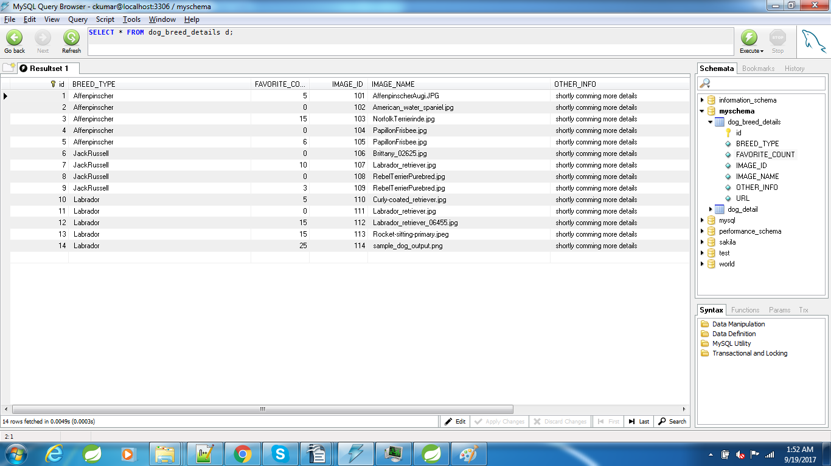

Dog and Hibernate table Mapping

package com.adp.dogbreed.model;

import javax.persistence.Column;
import javax.persistence.Entity;
import javax.persistence.GeneratedValue;
import javax.persistence.GenerationType;
import javax.persistence.Id;
import javax.persistence.Table;
import javax.validation.constraints.Digits;
import javax.validation.constraints.Size;

@Entity
@Table(name="DOG_BREED_DETAILS")
public class Dog {

@Id
@GeneratedValue(strategy = GenerationType.IDENTITY)
private int id;

@Size(min=3, max=50)
@Column(name = "IMAGE_NAME", nullable = false)
private String imageName;

@Digits(integer=3, fraction = 0)
@Column(name = "IMAGE_ID", nullable = false)
private Integer imageId;

@Size(min=3, max=200)
@Column(name = "URL", nullable = false)
private String url;

@Digits(integer=5, fraction = 0)
@Column(name = "FAVORITE_COUNT", nullable = false)
private Integer favoriteCount;

@Size(min=3, max=50)
@Column(name = "BREED_TYPE", nullable = false)
private String breedType;

@Size(min=3, max=250)
@Column(name = "OTHER_INFO", nullable = false)
private String otherInfo;

public Dog() {
super();
}

public Dog(int id, String imageName, Integer imageId, String url, Integer favoriteCount, String breedType,
String otherInfo) {
super();
this.id = id;
this.imageName = imageName;
this.imageId = imageId;
this.url = url;
this.favoriteCount = favoriteCount;
this.breedType = breedType;
this.otherInfo = otherInfo;
}

public int getId() {
return id;
}

public void setId(int id) {
this.id = id;
}

public String getImageName() {
return imageName;
}

public void setImageName(String imageName) {
this.imageName = imageName;
}

public Integer getImageId() {
return imageId;
}

public void setImageId(Integer imageId) {
this.imageId = imageId;
}

public String getUrl() {
return url;
}

public void setUrl(String url) {
this.url = url;
}

public Integer getFavoriteCount() {
return favoriteCount;
}

public void setFavoriteCount(Integer favoriteCount) {
this.favoriteCount = favoriteCount;
}

public String getBreedType() {
return breedType;
}

public void setBreedType(String breedType) {
this.breedType = breedType;
}

public String getOtherInfo() {
return otherInfo;
}

public void setOtherInfo(String otherInfo) {
this.otherInfo = otherInfo;
}

@Override
public int hashCode() {
final int prime = 31;
int result = 1;
result = prime * result + id;
result = prime * result + ((imageId == null) ? 0 : imageId.hashCode());
return result;
}

@Override
public boolean equals(Object obj) {
if (this == obj)
return true;
if (obj == null)
return false;
if (!(obj instanceof Dog))
return false;
Dog other = (Dog) obj;
if (id != other.id)
return false;
if (imageId == null) {
if (other.imageId != null)
return false;
} else if (!imageId.equals(other.imageId))
return false;
return true;
}

@Override
public String toString() {
return "Dog [id=" + id + ", imageName=" + imageName + ", imageId=" + imageId + ", url=" + url
+ ", favoriteCount=" + favoriteCount + ", breedType=" + breedType + ", otherInfo=" + otherInfo + "]";
}

}

DAO (Data Access Object) Layer

package com.adp.dogbreed.dao;

import java.util.List;

import org.hibernate.Criteria;
import org.hibernate.Query;
import org.hibernate.criterion.Restrictions;
import org.springframework.stereotype.Repository;

import com.adp.dogbreed.model.Dog;

@Repository("dogDao")
public class DogDAOImpl extends AbstractDAO<Integer, Dog> implements DogDAO {

@SuppressWarnings("unchecked")
@Override
public List<Dog> findAllDogs() {
Criteria criteria = createEntityCriteria();
return (List<Dog>) criteria.list();
}

@SuppressWarnings("unchecked")
@Override
public List<Dog> findDogsByBreedType(String breedType) {
Criteria criteria = createEntityCriteria();
criteria.add(Restrictions.eq("breedType", breedType));
return (List<Dog>) criteria.list();
}

@Override
public Dog findByDogId(int id) {
return getByKey(id);
}

@Override
public void voteForFavoriteDog(int dogId, int count) {
Query query = getSession().createSQLQuery("update Dog_detailss set favoriteCount = favoriteCount + :count where id = :dogId");
query.setInteger("dogId", dogId);
query.setInteger("count", count);
query.executeUpdate();
}

@Override
public void saveDog(Dog dog) {
persist(dog);
}

}

Service Layer

package com.adp.dogbreed.service;

import java.util.List;

import org.springframework.beans.factory.annotation.Autowired;
import org.springframework.stereotype.Service;
import org.springframework.transaction.annotation.Transactional;

import com.adp.dogbreed.dao.DogDAO;
import com.adp.dogbreed.model.Dog;

@Service("dogService")
@Transactional
public class DogServiceImpl implements DogService {

@Autowired
private DogDAO dao;

@Override
public List<Dog> findAllDogs() {
return dao.findAllDogs();
}

@Override
public List<Dog> findDogsByBreedType(String breedType) {
return dao.findDogsByBreedType(breedType);
}

@Override
public Dog findByDogId(int id) {
return dao.findByDogId(id);
}

@Override
public void saveDog(Dog dog) {
dao.saveDog(dog);
}

@Override
public void voteForFavoriteDog(int dogId, int count){
Dog entity = dao.findByDogId(dogId);
if(entity!=null){
entity.setFavoriteCount(count);
}
saveDog(entity);
}

/*
public boolean isDogIdUnique(Integer id, String id) {
Dog dog = findDogById(id);
return ( dog == null || ((id != null) && (dog.getId() == id)));
}*/

}

Deployment and Build

Running Application:

All API working based on selection. Dog details are fetched from MySQL database using Hibernate:

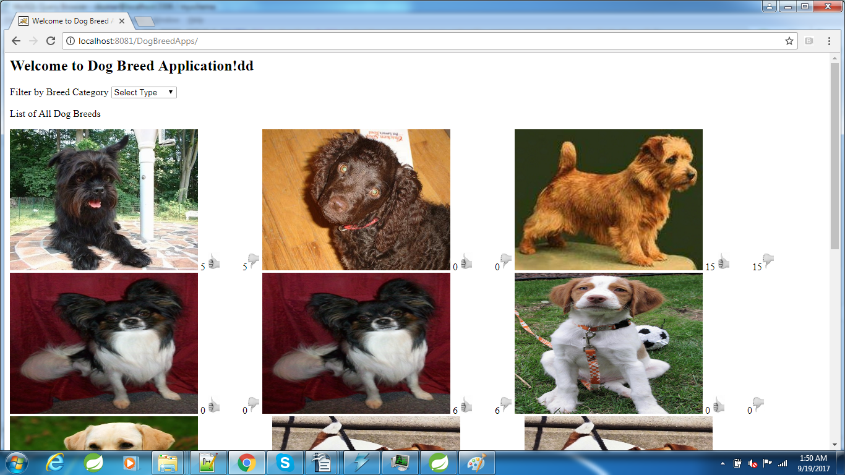

By Selecting Labrador

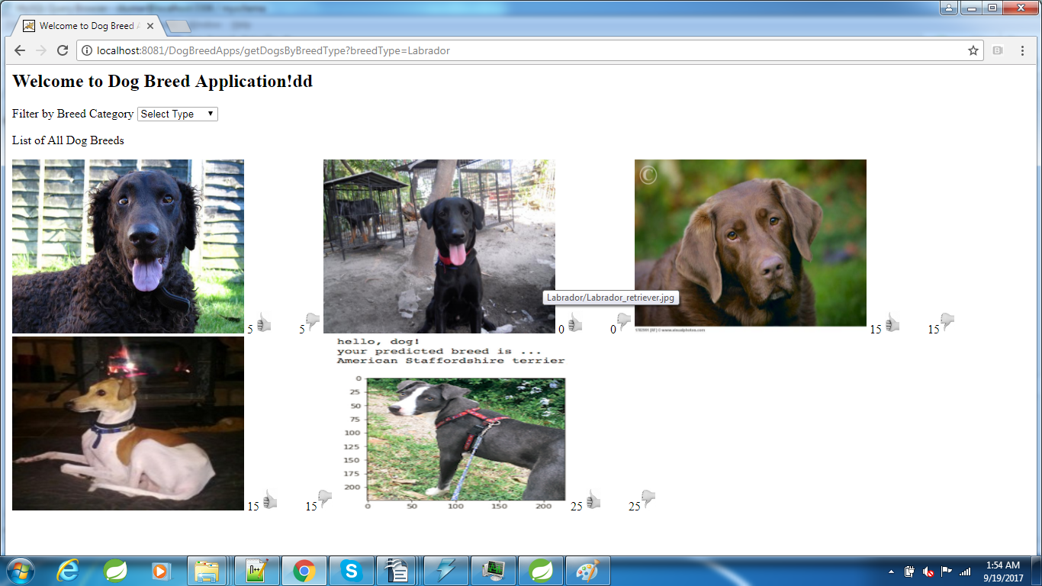

By Selecting “JackRussell”

