**8*8 LED MATRIX MAX 7219 USING ARDUINO**

**Abstract :**

This study explores the integration of an 8x8 LED matrix with MAX7219 using Arduino, facilitating IoT applications. The MAX7219 chip enables efficient control and multiplexing of LEDs, while Arduino serves as the platform for programming and interfacing. Through this project, we aim to demonstrate the versatility of IoT in driving visual displays and enhancing user interactions. The system's architecture and circuitry will be discussed, alongside the development of Arduino code for seamless LED control. Practical applications of the implemented system will be explored, emphasizing its potential in IoT-driven projects for information dissemination, data visualization, and interactive displays. The project's outcomes will contribute to understanding the integration of hardware components for IoT applications, offering insights into leveraging LED matrices for dynamic visualizations in various contexts.the project encompasses hardware assembly, software development, and testing to deliver a functional prototype capable of dynamic content display. This research contributes to the IoT field by showcasing the seamless integration of hardware components for visual communication and data presentation.

**CHAPTER-1**

**Introduction**

* 1. **About Arduino**

Arduino Uno, the flagship board of the Arduino platform, stands as an emblem of innovation and accessibility in the realm of electronics and programming. Featuring an ATmega328P microcontroller at its core, Arduino Uno provides a versatile platform for enthusiasts, hobbyists, educators, and professionals to unleash their creativity and bring ideas to life. With its user-friendly design and extensive community support, the Uno serves as an entry point into the world of embedded systems and Internet of Things (IoT) projects. Equipped with a plethora of input and output pins, including digital and analog pins, the Uno offers ample opportunities for interfacing with sensors, actuators, displays, and communication modules. Its onboard USB interface facilitates easy programming and communication with a computer, enabling seamless integration with the Arduino Integrated Development Environment (IDE).

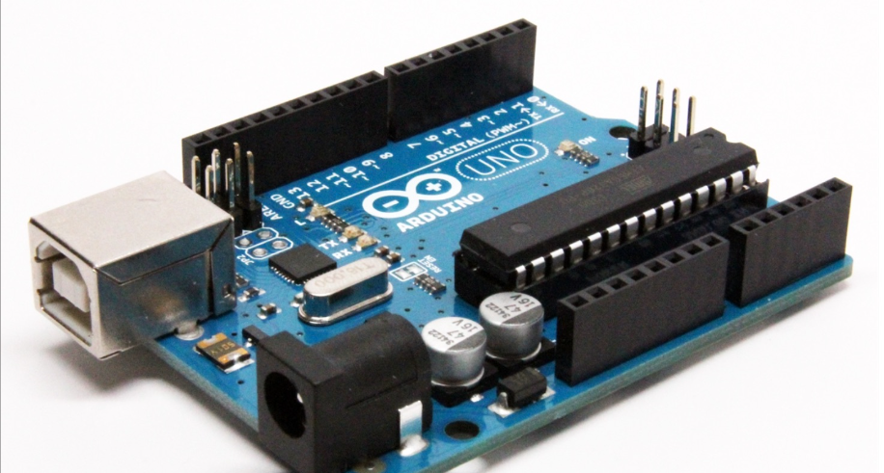

The Uno's compact form factor, affordability, and robust construction make it an ideal choice for a wide range of applications, from simple blinking LED projects to more complex robotics and automation systems. Moreover, Arduino Uno's open-source nature encourages collaboration, innovation, and knowledge sharing within the global maker community, fostering a culture of exploration and experimentation. Whether used for educational purposes, prototyping new inventions, or creating interactive art installations, Arduino Uno continues to inspire and empower individuals worldwide to transform their ideas into reality.

* 1. **components of Arduino**

**1. Microcontroller (e.g., ATmega328P):** The microcontroller is the brain of the Arduino board, responsible for executing programmed instructions and controlling connected devices. It processes inputs, performs calculations, and generates outputs based on the code uploaded to it via the Arduino IDE.

**2. Input/Output (I/O) Pins:** These pins allow communication with external sensors, actuators, and other electronic components. They can be configured as digital input/output or analog input, providing flexibility for interfacing with various peripherals.

**3. Voltage Regulator:** The voltage regulator regulates the input voltage (typically 7-12V) to a stable level (5V or 3.3V) suitable for powering the microcontroller and other components on the board. It ensures consistent and reliable operation of the Arduino in different power supply scenarios.

**4. Crystal Oscillator:** The crystal oscillator provides the clock signal needed for the microcontroller to execute instructions at precise intervals. It ensures accurate timing for the microcontroller's operations, facilitating reliable performance in time-sensitive applications.

**5. USB Interface:** The USB interface enables programming and communication between the Arduino board and a computer. It allows users to upload code to the microcontroller, monitor serial output, and establish data exchange for various applications.

**6. Power Jack/Vin Pin:** The power jack or Vin pin provides options for powering the Arduino board externally. Users can connect a regulated power supply or battery to these inputs, offering flexibility in power source selection for different projects.

**7. LEDs (e.g., Power LED, Pin 13 LED):** LEDs on the Arduino board provide visual feedback during operation. The Power LED indicates that the board is powered on, while the Pin 13 LED can be controlled by the user for debugging or signaling purposes in their sketches.

**8. Reset Button:** The reset button allows users to reset the microcontroller, useful for troubleshooting or reprogramming purposes. Pressing the reset button restarts the execution of the code uploaded to the Arduino board.

**9. Headers/Connectors:** Headers or connectors on the Arduino board enable easy attachment of shields, modules, or additional components. They provide standardized interfaces for expanding Arduino's capabilities and integrating various peripherals for diverse applications.

* 1. **Working of Arduino:**

Arduino works by executing code uploaded to its microcontroller, which processes inputs, performs computations, and controls connected devices based on programmed instructions. Upon power-up or reset, the microcontroller initializes and starts executing the setup() function, configuring pins, variables, and other necessary settings. It then enters the main loop() function, where it continuously repeats the instructions written in the loop, interacting with sensors, actuators, and other components as programmed. Input signals from sensors are read through digital or analog pins, while output signals control actuators such as motors, LEDs, or displays. The Arduino IDE provides a user-friendly interface for writing, compiling, and uploading code to the board, facilitating the development of various projects ranging from simple to complex. The USB interface enables communication with a computer for code upload, debugging, and serial communication, enhancing the versatility and accessibility of Arduino-based projects.

* 1. **Different types of Arduino**

**1. Arduino Uno:** The Arduino Uno is the most popular and widely used board in the Arduino family. It features an ATmega328P microcontroller, 14 digital I/O pins (of which 6 can be used as PWM outputs), 6 analog input pins, and a USB interface for programming and communication. Its versatility, ease of use, and extensive community support make it ideal for beginners and professionals alike.

**2. Arduino Mega:** The Arduino Mega is a larger variant of the Uno, featuring an ATmega2560 microcontroller with significantly more I/O pins and memory. With 54 digital I/O pins (of which 15 can be used as PWM outputs) and 16 analog input pins, the Mega is suitable for projects requiring a higher number of connections, such as robotics and automation.

**3. Arduino Nano:** The Arduino Nano is a compact and lightweight board with similar functionality to the Uno, but in a smaller form factor. It is equipped with an ATmega328P microcontroller, 14 digital I/O pins, 8 analog input pins, and a USB interface for programming and communication. The Nano is ideal for projects with space constraints or where portability is a priority.

**4. Arduino Due:** The Arduino Due is a powerful board based on the ARM Cortex-M3 architecture, offering significantly higher processing power and capabilities compared to traditional AVR-based Arduinos. It features 54 digital I/O pins, 12 analog input pins, and compatibility with 3.3V logic levels. The Due is suitable for projects requiring advanced computation or interfacing with high-speed peripherals.

* 1. **Uses of Arduino**

1. **Education:** Arduino serves as an excellent educational tool for teaching electronics, programming, and prototyping in schools, universities, and workshops.
2. **Robotics:** Arduino is widely used in robotics projects for controlling motors, sensors, and actuators to build autonomous or remote-controlled robots.

**3. Home Automation:** Arduino enables DIY enthusiasts to create smart home systems for controlling lights, temperature, security cameras, and other appliances.

**4. Internet of Things (IoT):** Arduino facilitates the development of IoT applications by connecting sensors and devices to the internet for data collection, monitoring, and control.

**5. Wearable Technology:** Arduino is utilized in wearable tech projects to create interactive clothing, fitness trackers, and health monitoring devices.

**6. Art Installations:** Artists use Arduino to incorporate interactivity, light, sound, and motion into their installations, enhancing audience engagement and immersion.

**7. Environmental Monitoring:** Arduino-based sensor networks are deployed for monitoring air quality, weather conditions, soil moisture, and water levels in environmental research and conservation efforts.

**8. Gaming:** Arduino is employed in DIY gaming projects for building custom controllers, interactive displays, and immersive gaming experiences.

**9. Prototyping:** Arduino is widely used for rapid prototyping of electronic devices, allowing engineers and designers to quickly iterate and test ideas before production.

**10. Accessibility Solutions:** Arduino is utilized in assistive technology projects to develop devices that improve accessibility and quality of life for individuals with disabilities, such as braille displays and voice-controlled interfaces.