**Technologies Used:**

* Spring 4.3.2
* Hibernate 4.3.6.Final
* HSQLDB (In Memory DB for storage).
* HTML5, Twitter Bootstrap, JQuery.
* Maven as Build tool
* Java 7

**Instruction to run the web application:**

1. Run the clean install command as below from project root folder ensuring maven is in your path variable (system variables)

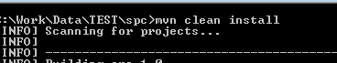

2- Run the inbuilt tomcat with the command given below

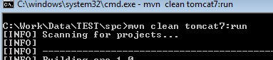

3-Access the application by url : <http://localhost:8888/spc/index> .

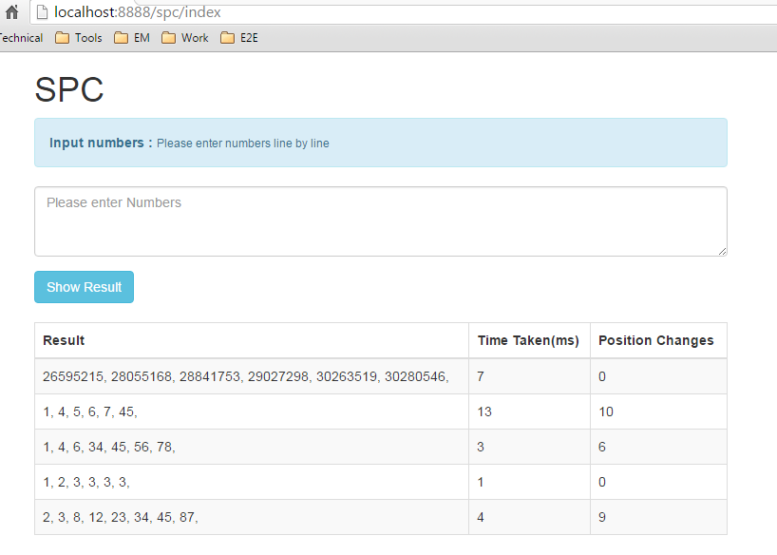

**Assumptions:**

* No field validation
* No exception handling
* Only happy path ☺

Project GITHUB Repository Location

<https://github.com/chittalion/spc>