IPSC Project
Progress Report

Title: Parallel Face Recognition Using SVD

Team Members:
Name: Chittaranjan Rath
Roll No: 2018201007

Name: Nitish Srivastava
Roll No: 2018201012

Name: Prakash Nath Jha
Roll No: 2018201013

Deliverables:
- Implementation of face recognition using open mp
- Observing the various aspects of our implementation using other approaches like
    - k-NN
    - Nearest Mean
    - K Means
- Dimensionality reduction by using PCA (using SVD)

Technologies to be used:
      - C++14
      - python 3
      - open MP
      - Intel MKL libraries ( Eigen Library )
      - C++ Boost library(to be used for primitive operations)
      - GNU Plot

Implementation Approches:
Nearest Mean ( serial implementation ):
Accuracy:
Execution Time Taken:
Observation:
Nearest Mean ( parallel implementation ):
Accuracy:
Execution Time Taken:
Observation:
K-NN ( serial implementation ):
Accuracy:
Execution Time Taken:
Observation:

Visualization
It is performed for parallel immplementation of algorithms
No of threads vs time
No of processors vs time

threads_vs_time_means (execution #1)
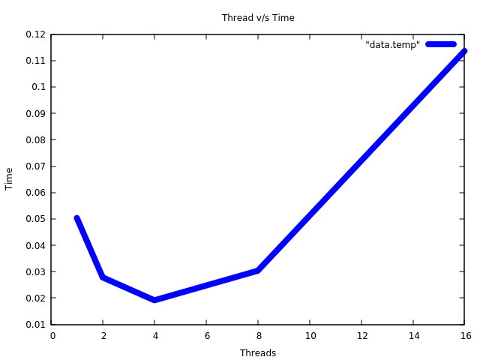

threads_vs_time_means (execution #2)
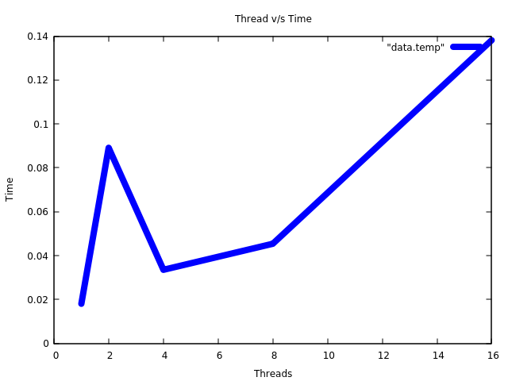

Observation:

- As the number of threads increases, time taken for execution is reduced
- The reduction in time is till we approach a threshold ( when number of threads exceeds number of available cores )
- As number of threads increases the execution time increases ( seen beyond #threads > no_of_cores (8) )

Resources :

- Face Recognition Using Singular Value Decomposition of Facial Colour Image Database
Reference: https://pdfs.semanticscholar.org/cdab/c8ec5e0629752980f8cb613a56a33efb05c7.pdf
- Face Recognition using Eigenfaces and Distance
Classifiers
Reference https://onionesquereality.wordpress.com/2009/02/11/face-recognition-using-eigenfaces-and-distance-classifiers-a-tutorial/
- Face Recognition Using Tensor SVD Chapter 14
Book : Matrix Methods in Data Mining and Pattern Recognition

Github Repository :

https://github.com/chittaranjan-rath/Parallel-Face-Recognition

Probable DataSets:

      - https://facedetection.com/datasets/
      - http://www.face-rec.org/databases/

Assumptions:

The datasets were collected with the assumptions that the algorithm implementation is performed only for face recognition. Face detection is currently beyond the scope of project.

Testing Plan:

Various analysis criteria such as
      - comparision of serial vs parallel execution
      - speed up w.r.t number of threads(equal or less than number of cores)
      - speed up w.r.t number of threads(may be more than number of cores)
      - Observe the factors of memory bound and computation bound in algorithm
      - performance (accuracy) of parallel face recognition algorithm

