IPSC Project
Progress Report

Title: Parallel Face Recognition Using SVD

Team Members:

Name: Chittaranjan Rath
Roll No: 2018201007

Name: Nitish Srivastava
Roll No: 2018201012

Name: Prakash Nath Jha
Roll No: 2018201013

Deliverables:

- Implementation of face recognition using open mp
- Observing the various aspects of our implementation using other approaches like
    - k-NN
    - Nearest Mean
    - K Means
- Applying PCA for dimensionality reduction by using SVD

Technologies to be used:
      - C++14
      - Python 3
      - Open MP
      - Intel MKL libraries ( Eigen Library )
      - C++ Boost library(to be used for primitive operations)
      - GNU Plot

Implementation Approches:

Nearest Mean ( serial implementation ):
Accuracy: 90%
Execution Time : 0.020303 sec

Nearest Mean ( parallel implementation ):

Threads: 2
Accuracy: 90%
Execution Time : 0.226169 sec

Threads: 4
Accuracy: 90%
Execution Time : 0.068082 sec

Threads: 8
Accuracy: 90%
Execution Time : 0.081548 sec

K-NN ( serial implementation ):

K = 4:
Accuracy: 91.25%
Execution Time : 0.060538 sec

K = 10:
Accuracy: 76.25%
Execution Time : 0.098322 sec

Visualization:

It is performed for parallel immplementation of algorithms
No of threads vs time
No of processors vs time

Threads vs Time Means (execution #1)
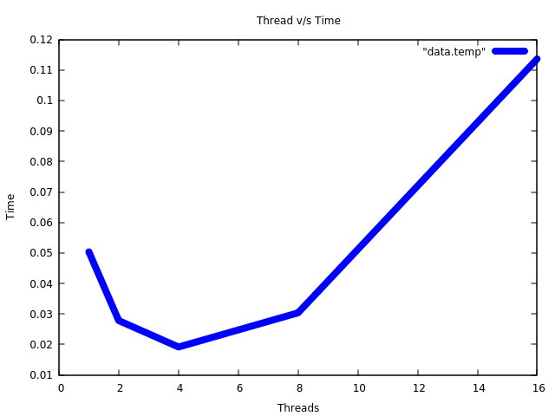
Threads vs Time Means (execution #2):
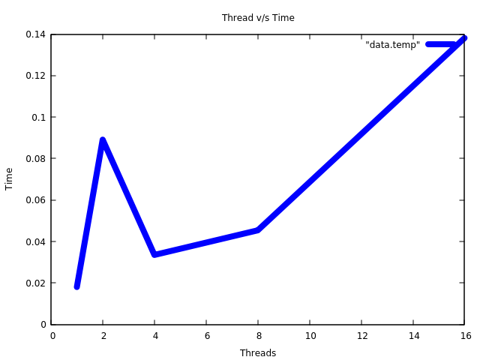

Observation:

- As the number of threads increases, time taken for execution is reduced.
- The reduction in time is till we approach a threshold ( when number of threads exceeds number of available cores )
- As number of threads increases the execution time increases ( seen beyond #threads > no_of_cores (8) )

Resources :

- Face Recognition Using Singular Value Decomposition of Facial Colour Image Database
Reference: https://pdfs.semanticscholar.org/cdab/c8ec5e0629752980f8cb613a56a33efb05c7.pdf
- Face Recognition using Eigenfaces and Distance
Classifiers
Reference https://onionesquereality.wordpress.com/2009/02/11/face-recognition-using-eigenfaces-and-distance-classifiers-a-tutorial/
- Face Recognition Using Tensor SVD Chapter 14
Book : Matrix Methods in Data Mining and Pattern Recognition

Github Repository :

https://github.com/chittaranjan-rath/Parallel-Face-Recognition

Probable DataSets:

      - https://facedetection.com/datasets/
      - http://www.face-rec.org/databases/

Assumptions:

The datasets were collected with the assumptions that the algorithm implementation is performed only for face recognition. Face detection is currently beyond the scope of project.

Testing Plan:

Various analysis criteria such as

      - Comparision of serial vs parallel execution
      - Speed up w.r.t number of threads(equal or less than number of cores)
      - Speed up w.r.t number of threads(may be more than number of cores)
      - Observe the factors of memory bound and computation bound in algorithm
      - Performance (accuracy) of parallel face recognition algorithm

