JBCS-HTTPD24-2.4

Step 1: Download the jbcs-httpd24-2.4 zip file from redhat site and unzip the file.

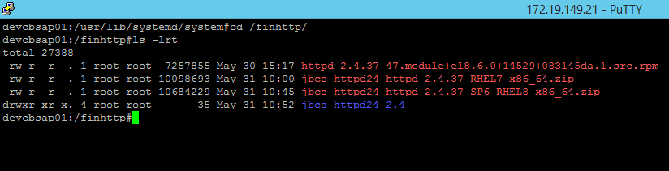

Step 2: Edit httpd.service file in the below path. We can create new httpd.service for instances using jbcs-httpd24-httpd.service, jbcs-httpd24-httpd.inst1.service and jbcs-httpd24-httpd.inst2.service

/usr/lib/systemd/system/httpd.service

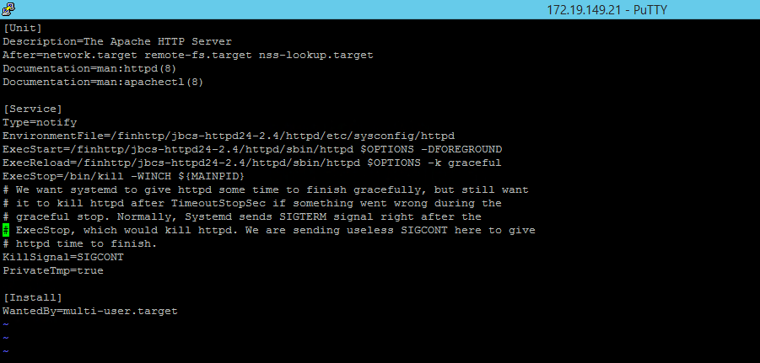

Step 3: Create shortcut link etc folder in JBCS-HTTPD24-2.4/httpd/etc by using below command

ln -s /etc

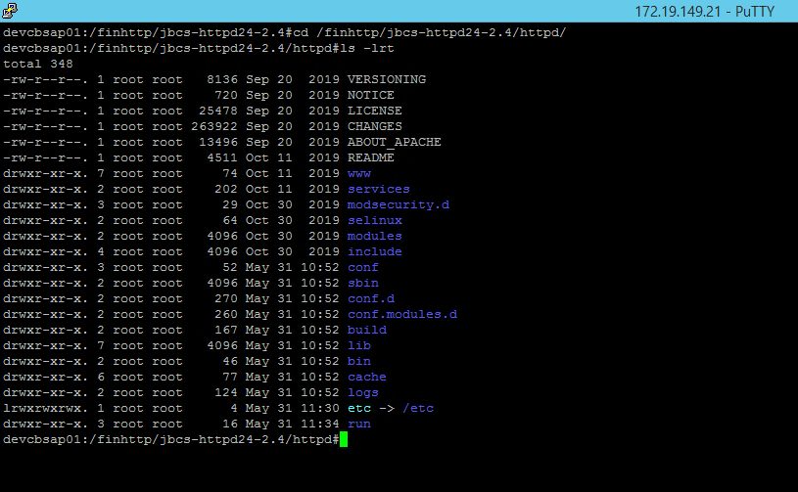

Step 4: Edit httpd file in /finhttp/jbcs-httpd24-2.4/httpd/etc/sysconfig/httpd

To auto start httpd service while OS restart add below parameter in httpd file

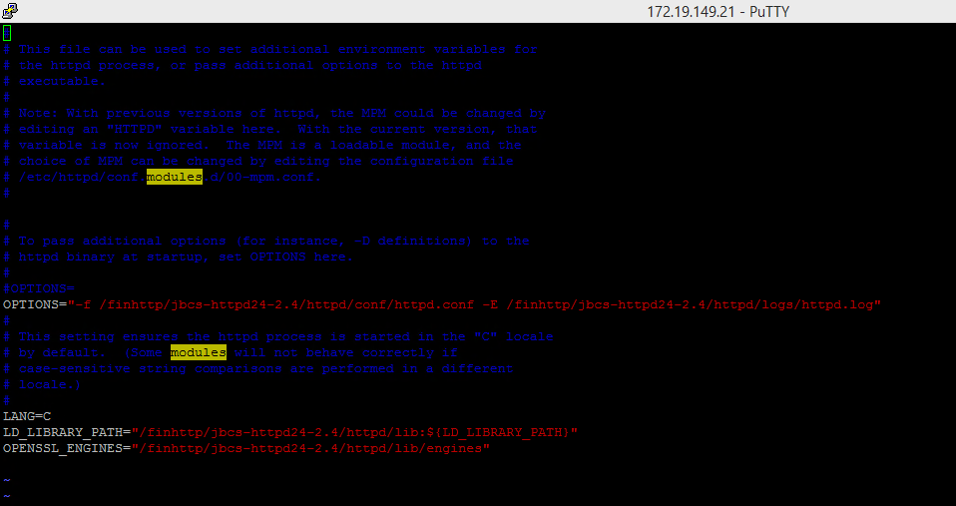

Step 5: To enable httpd.service

systemctl enable httpd.service

Step 6: Now start the httpd.service by using below command.

systemctl start httpd.service (or) systemctl start jbcs-httpd24-httpd.service

systemctl stop httpd.service (or) systemctl stop jbcs-httpd24-httpd.service

systemctl status httpd.service (or) systemctl status jbcs-httpd24-httpd.service

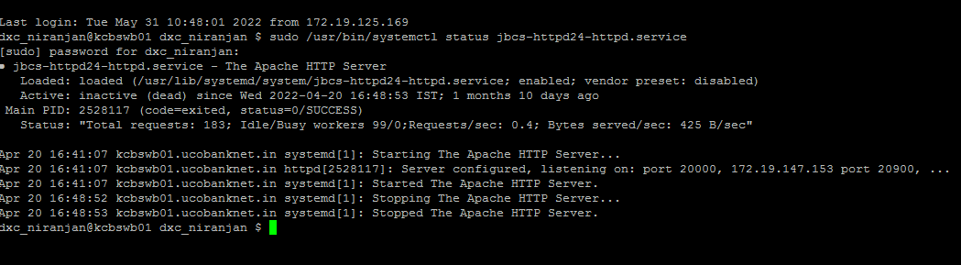

Task added new images to ucoebanking.in

/var/www/html/corp/L001/corporate/images/slider_images