Quick Commerce Market Analytics – End-to-End Business Intelligence Project

1. INTRODUCTION
The rapid growth of quick commerce has transformed the retail industry by enabling customers to receive groceries, household essentials, and other products within minutes of placing an order. Driven by advancements in digital technology, logistics, and changing consumer preferences, quick commerce platforms have become an integral part of urban lifestyles in India.
Leading companies such as Blinkit, Zepto, Swiggy Instamart, BigBasket, Dunzo, Flipkart Minutes, and Amazon Fresh compete on factors including delivery speed, product availability, pricing, discounts, and customer satisfaction. As competition intensifies, businesses increasingly rely on data analytics to understand customer behavior, optimize operations, and improve decision-making.
This project performs an Exploratory Data Analysis (EDA) using Tableau on a publicly available quick commerce dataset. The analysis aims to uncover trends, identify patterns, compare platform performance, and generate business insights that can support strategic decision-making.

2. PROJECT OBJECTIVE
The primary objective of this project is to perform an exploratory data analysis on a publicly available quick commerce dataset using Tableau. The study aims to understand customer purchasing behavior, delivery performance, sales trends, and operational efficiency across leading quick commerce platforms.
The specific objectives include:
- Analyze customer purchasing patterns across different platforms.
- Compare business performance using key metrics such as revenue, order volume, and average order value.
- Evaluate delivery performance using delivery time and distance metrics.
- Identify popular product categories and payment methods.
- Explore customer satisfaction through ratings and reviews.
- Develop interactive Tableau dashboards that effectively communicate business insights.
- Provide actionable recommendations based on the findings.

3. PROJECT SCOPE
This project focuses on analyzing transactional data from leading quick commerce platforms operating in India. The analysis includes customer behavior, product demand, delivery performance, payment preferences, and business performance indicators.
The project primarily utilizes Tableau for data visualization and dashboard development. The findings are intended to demonstrate how exploratory data analysis can support business intelligence and strategic decision-making within the quick commerce industry.

4. TOOLS AND TECHNOLOGIES
Tool | Purpose
Tableau | Data visualization and dashboard creation
Microsoft Excel / CSV | Data inspection and preparation
Microsoft Word | Documentation and report writing
Kaggle | Public dataset source
SQL | Used to query the dataset, analyze business metrics, calculate KPIs, and answer key business questions.
Python (Pandas, NumPy) | Used for data loading, data cleaning, validation, exploratory analysis, and preparing the dataset for visualization.

5. METHODOLOGY
The project follows a structured data analytics workflow:
- Select a suitable publicly available quick commerce dataset.
- Understand the dataset and identify relevant variables.
- Perform data cleaning and preprocessing.
- Conduct exploratory data analysis using Tableau.
- Develop interactive dashboards to visualize key trends.
- Interpret findings and derive business insights.
- Provide recommendations based on the analysis.
Project Workflow
- Data Collection (Kaggle Dataset)
- Data Inspection
- Data Cleaning & Validation
- Exploratory Data Analysis
- Dashboard Development in Tableau
- Business Insights
- Recommendations
- Conclusion

6. DATASET DESCRIPTION
This project utilizes a publicly available Quick Commerce dataset obtained from Kaggle. The dataset contains transactional information from leading quick commerce platforms operating in India. It includes customer demographics, order details, delivery performance, payment methods, product categories, and customer satisfaction metrics.
The dataset is designed to simulate real-world quick commerce operations, making it suitable for exploratory data analysis (EDA) and dashboard development using Tableau.

Dataset Summary
Attribute | Details
Dataset Name | Quick Commerce Dataset
Source | Kaggle (Public Dataset)
File Format | CSV
Total Records | 947,752
Total Variables | 13
Tool Used | Tableau

7. DATA DICTIONARY
Variable | Description
Order_ID | Unique identifier assigned to each customer order.
Company | Name of the quick commerce platform processing the order.
City | City where the order was placed.
Customer_Age | Age of the customer placing the order.
Order_Value | Total monetary value of the order.
Delivery_Time_Min | Time taken to deliver the order (minutes).
Distance_Km | Distance between the store and the customer (kilometers).
Items_Count | Number of items included in the order.
Product_Category | Category of products purchased.
Payment_Method | Mode of payment used by the customer.
Customer_Rating | Rating provided by the customer after delivery.
Discount_Applied | Indicates whether a discount was applied to the order (1 = Yes, 0 = No).
Delivery_Partner_Rating | Rating assigned to the delivery partner.

- INITIAL DATA UNDERSTANDING
The dataset consists of nearly one million transaction records collected across multiple quick commerce platforms. It captures several aspects of business operations, including customer demographics, order value, delivery performance, payment preferences, and customer satisfaction.
The dataset contains a combination of:
- Categorical variables
  - Company
  - City
  - Product Category
  - Payment Method
- Numerical variables
  - Customer Age
  - Order Value
  - Delivery Time
  - Distance
  - Number of Items
  - Customer Rating
  - Delivery Partner Rating
- Identifier
  - Order_ID
The dataset provides sufficient information to perform comparative analysis across companies, identify customer purchasing patterns, evaluate delivery efficiency, and derive actionable business insights through interactive Tableau dashboards.

- PLANNED EXPLORATORY DATA ANALYSIS
The exploratory analysis focuses on answering the following business questions:

Company Performance
- Which company receives the highest number of orders?
- Which company generates the highest total revenue?
- Which company has the highest average order value?
- Which company receives the highest customer ratings?
- Which company provides the fastest deliveries?

Customer Analysis
- Which age groups place the most orders?
- Which payment methods are preferred by customers?
- Which product categories receive the highest number of orders?
- How are customer ratings distributed?

Delivery Analysis
- How does delivery performance vary across cities?
- How does delivery time vary across different product categories?
- What is the distribution of delivery times?
- Which company covers the highest average delivery distance?

Regional Analysis
- Which city has the highest average delivery time?
- Which city has the lowest average delivery time?

10. DATA CLEANING AND PREPROCESSING
The dataset was imported into Tableau for analysis and underwent a preliminary data quality assessment. The following preprocessing steps were performed to ensure the data was suitable for exploratory analysis:
- Imported the CSV dataset into Tableau.
- Verified the data types of all variables.
- Checked for missing (null) values across all columns.
- Checked for duplicate records using the unique Order_ID field.
- Reviewed numerical variables for consistency.
- Confirmed that categorical variables were correctly classified.
The assessment revealed that the dataset contained 947,752 records and 13 variables. No missing values or duplicate records were identified. All variables were in the appropriate data format, making the dataset suitable for further analysis and visualization.
Data Quality Check | Result
Missing Values | None
Duplicate Records | None
Invalid Data Types | None
Null Order IDs | None
Numeric Validation | Passed
Categorical Validation | Passed

11. DATA QUALITY ASSESSMENT
The dataset demonstrated a high level of data quality. All columns were complete, with no missing values observed. Duplicate record checks confirmed that each transaction was unique, and the Order_ID field contained no duplicate entries. The data types were appropriate for their respective variables, allowing seamless analysis in Tableau.
Since no significant data quality issues were identified, the dataset required minimal preprocessing and was considered ready for exploratory data analysis and dashboard development.
KPI Summary
KPI | Description
Total Orders | Number of customer orders
Total Revenue | Revenue generated
Average Order Value | Revenue / Orders
Average Delivery Time | Mean delivery time
Average Customer Rating | Customer satisfaction
Number of Companies | Platforms analyzed
Number of Cities | Geographic coverage
Number of Product Categories | Product diversity

12. DASHBOARD 1 – EXECUTIVE OVERVIEW DASHBOARD

12.1 Dashboard Title
Quick Commerce Market Analytics – Executive Overview Dashboard

12.2 Dashboard Objective
The Executive Overview Dashboard provides a high-level summary of the operational performance of major quick commerce platforms included in the dataset. It enables stakeholders to compare companies based on key business metrics such as total orders, total revenue, average order value, customer satisfaction, and delivery efficiency. Interactive filters allow users to explore the data across different companies, cities, product categories, and payment methods, making the dashboard suitable for business monitoring and decision-making.

12.3 Dashboard Components
The dashboard contains the following visualizations:
Visualization | Purpose
Total Orders by Company | Compares the total number of orders processed by each company.
Total Revenue by Company | Displays total revenue generated by each company.
Average Order Value by Company | Shows the average value of customer orders.
Average Customer Rating by Company | Compares customer satisfaction levels across companies.
Average Delivery Time by Company | Measures delivery efficiency by comparing average delivery times.
Interactive Filters
- Company
- City
- Product Category
- Payment Method
These filters enable users to perform dynamic analysis by narrowing the data to specific business conditions

12.4 Dashboard Screenshot
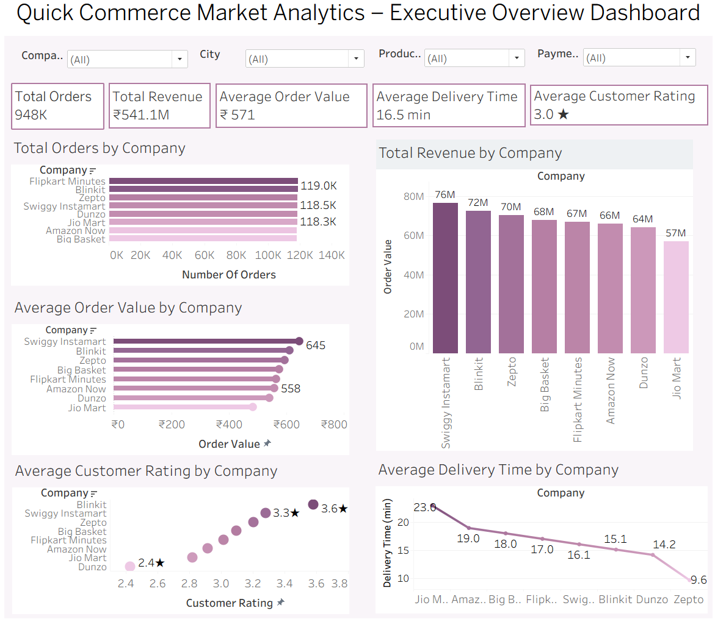

12.5 Key Observations
Based on the dashboard analysis, the following observations were identified:
- Flipkart Minutes processed the highest number of customer orders among all companies included in the dataset.
- Swiggy Instamart generated the highest overall revenue, indicating stronger sales despite processing slightly fewer orders.
- Swiggy Instamart also achieved the highest average order value, suggesting customers tend to purchase higher-value baskets on this platform.
- Blinkit received the highest average customer rating, indicating strong customer satisfaction.
- Zepto recorded the lowest average delivery time, demonstrating the fastest delivery performance among the analyzed companies.
- Jio Mart showed the highest average delivery time, indicating comparatively slower deliveries.
- The comparison shows that higher order volume does not necessarily translate into higher revenue, emphasizing the importance of average order value.

12.6 Business Insights
The Executive Overview Dashboard provides several valuable business insights:
- Revenue growth is influenced not only by the number of orders but also by the average value of each transaction.
- Customer satisfaction appears to be closely related to efficient service quality and delivery performance.
- Companies with faster delivery times are likely to improve customer experience and retention.
- Organizations with lower average order values can focus on cross-selling and upselling strategies to increase revenue.
- Decision-makers can use these metrics to benchmark company performance and identify operational improvement opportunities.

12.7 Business Recommendations
- Increase Average Order Value
  - Companies with lower average order values should introduce bundle offers and cross-selling strategies to encourage customers to purchase more items per order.
- Improve Delivery Efficiency
  - Companies with higher delivery times should optimize delivery routes and expand dark stores in high-demand areas to reduce delivery delays.
- Enhance Customer Satisfaction
  - Companies with lower customer ratings should analyze customer feedback and improve delivery reliability and customer support.
- Benchmark High Performers
  - Organizations can study the practices of top-performing platforms and adopt successful strategies to improve operational performance.
- Monitor KPIs Regularly
  - Business teams should monitor KPIs such as revenue, order volume, customer ratings, and delivery time through interactive dashboards for faster decision-making.

12.8 Dashboard Features
The Executive Overview Dashboard includes several interactive Tableau features:
- Dynamic filtering by Company, City, Product Category, and Payment Method.
- Interactive comparison across multiple business performance indicators.
- Automatic updates of all visualizations when filters are applied.
- Clear visualizations with data labels for improved readability.
- A user-friendly layout that enables quick identification of business trends and performance differences.

12.9 Summary
The Executive Overview Dashboard serves as a centralized business performance dashboard that summarizes the operational efficiency of quick commerce companies. It provides a comprehensive comparison of order volume, revenue generation, customer satisfaction, average order value, and delivery performance. The insights obtained from this dashboard help stakeholders understand competitive positioning and identify opportunities for improving operational efficiency and customer experience.

13. DASHBOARD 2 – CUSTOMER ANALYSIS DASHBOARD

13.1 Dashboard Title
Quick Commerce Market Analytics – Customer Analysis Dashboard

13.2 Dashboard Objective
The Customer Analysis Dashboard provides insights into customer purchasing behavior, demographic trends, product preferences, payment methods, and customer satisfaction. It enables stakeholders to understand customer buying patterns, identify popular product categories, evaluate preferred payment methods, and analyze customer ratings across different market segments. Interactive filters allow users to explore customer behavior based on companies, cities, product categories, and payment methods, making the dashboard valuable for customer-focused business analysis and strategic decision-making.

13.3 Dashboard Components
The dashboard contains the following visualizations:
Visualization | Purpose
Orders by Product Category | Compares the total number of orders across different product categories.
Orders by Payment Method | Displays customer preference for different payment methods.
Orders by Customer Age Group | Analyzes order distribution among different customer age groups.
Customer Rating Distribution | Shows the frequency distribution of customer ratings to understand overall customer satisfaction.

Interactive Filters
- Company
- City
- Product Category
- Payment Method
These filters allow users to perform detailed customer analysis by focusing on specific business conditions and customer segments.

13.4 Dashboard Screenshot
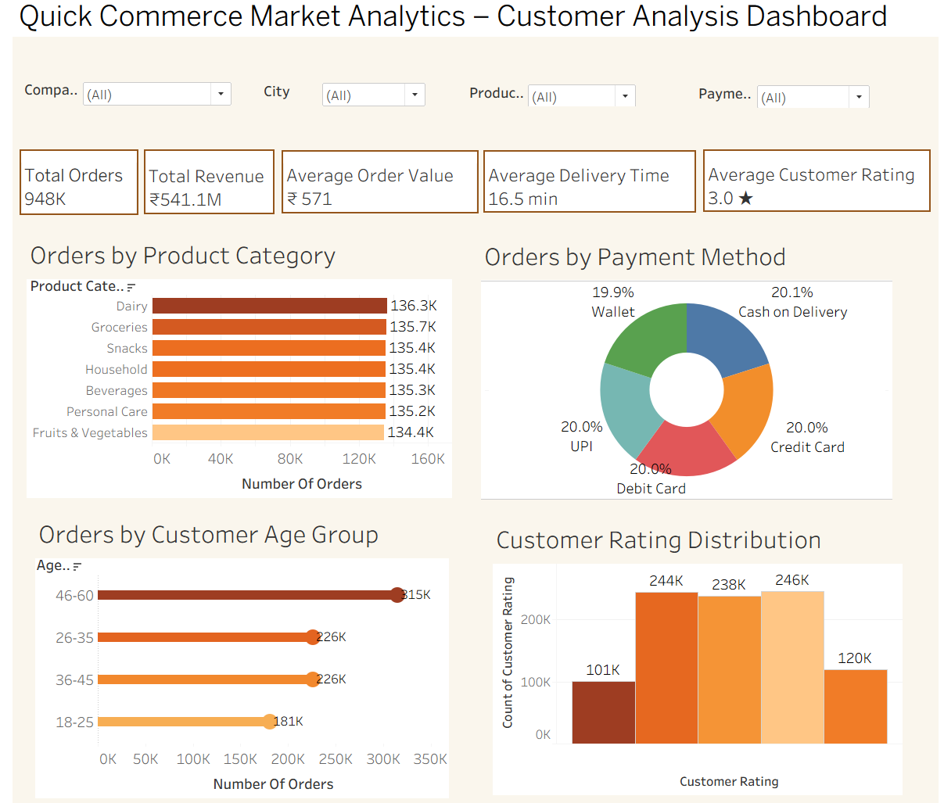

13.5 Key Observations
Based on the dashboard analysis, the following observations were identified:
- Dairy recorded the highest number of customer orders among all product categories, indicating strong demand for daily essential items.
- Grocery and Snacks also contributed significantly to the total number of orders, while Fruits & Vegetables received comparatively fewer orders.
- Customers used all available payment methods, including Cash on Delivery, Credit Card, Debit Card, UPI, and Wallet, with nearly equal frequency, indicating balanced payment preferences.
- The 46–60 years age group placed the highest number of orders, making it the most active customer segment.
- Customers aged 26–35 and 36–45 contributed similar order volumes, while the 18–25 age group placed comparatively fewer orders.
- Customer ratings were primarily concentrated between 2 and 4, indicating generally satisfactory customer experiences with relatively few extremely low or extremely high ratings.
- The distribution of customer ratings suggests opportunities for improving customer satisfaction through enhanced service quality and delivery performance.

13.6 Business Insights
The Customer Analysis Dashboard provides several valuable business insights:
- Daily essential products such as Dairy and Grocery should remain adequately stocked due to consistently high customer demand.
- Businesses should continue supporting multiple payment methods since customers actively use all available payment options.
- Marketing campaigns and loyalty programs can be targeted toward the 46–60 years customer segment, which contributes the highest number of orders.
- Customer satisfaction can be improved by addressing factors affecting mid-range ratings through better delivery services, product quality, and customer support.
- Businesses can use demographic insights to design personalized promotional campaigns for different customer age groups and improve customer engagement.

13.7 Business Recommendations
- Maintain Inventory for High-Demand Categories
  - Ensure consistent stock availability for frequently ordered product categories such as Dairy and Grocery to avoid stock-outs.
- Personalize Marketing Campaigns
  - Develop targeted promotions for different customer age groups based on their purchasing behavior.
- Strengthen Digital Payment Offers
  - Continue offering cashback and reward programs for digital payment methods to encourage customer adoption.
- Improve Customer Experience
  - Analyze the reasons behind mid-range customer ratings and implement improvements in product quality, delivery accuracy, and customer service.
- Leverage Customer Insights
  - Use demographic and purchasing behavior data to design personalized recommendations and loyalty programs.

13.8 Dashboard Features
The Customer Analysis Dashboard includes several interactive Tableau features:
- Dynamic filtering by Company, City, Product Category, and Payment Method.
- Interactive comparison of customer purchasing behavior across different business dimensions.
- Automatic updating of all visualizations whenever filters are applied.
- Clear visualizations with data labels for easy interpretation.
- A simple and user-friendly dashboard layout that enables efficient customer behavior analysis.

13.9 Summary
The Customer Analysis Dashboard provides a comprehensive overview of customer purchasing patterns, product demand, payment preferences, demographic distribution, and customer satisfaction. It enables businesses to identify high-demand product categories, understand customer demographics, evaluate payment behavior, and monitor customer ratings. The insights generated from this dashboard support data-driven decisions related to inventory planning, marketing strategies, customer engagement, and service improvement, ultimately helping businesses enhance customer satisfaction and overall operational performance.

14. DASHBOARD 3 – DELIVERY PERFORMANCE DASHBOARD

14.1 Dashboard Title
Quick Commerce Market Analytics – Delivery Performance Dashboard

14.2 Dashboard Objective
The Delivery Performance Dashboard provides insights into the operational efficiency of quick commerce companies by analyzing delivery time and delivery distance across cities, product categories, and companies. It helps stakeholders evaluate delivery performance, identify geographical variations, understand delivery time distribution, and compare logistics efficiency among companies. Interactive filters allow users to explore delivery performance based on different business conditions, supporting operational monitoring and process optimization.

14.3 Dashboard Components
The dashboard contains the following visualizations:
Visualization | Purpose
Average Delivery Time by City | Compares the average delivery time across different cities.
Average Delivery Time by Product Category | Displays average delivery time for different product categories.
Delivery Time Distribution | Shows how delivery times are distributed across different time intervals.
Average Delivery Distance by Company | Compares the average delivery distance covered by each company.

Interactive Filters
- Company
- City
- Product Category
- Payment Method
These filters enable users to analyze delivery performance under different operational conditions and business segments

14.4 Dashboard Screenshot
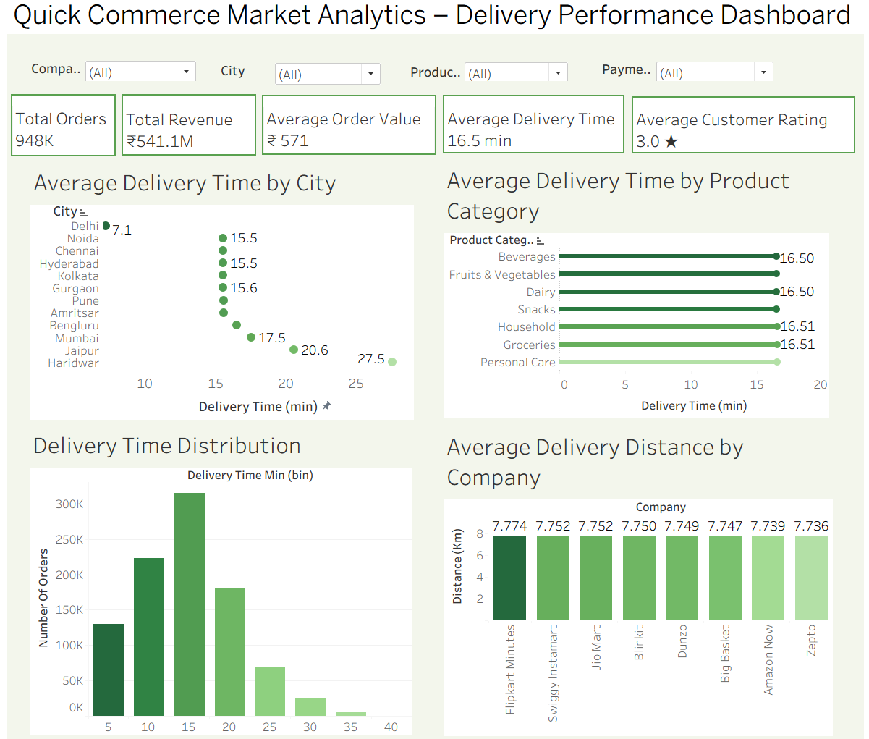

14.5 Key Observations
Based on the dashboard analysis, the following observations were identified:
- Haridwar recorded the highest average delivery time, indicating comparatively slower deliveries than other cities.
- Delhi showed the lowest average delivery time, demonstrating relatively faster order fulfillment.
- The average delivery time across different product categories was almost identical, indicating that product type has minimal impact on delivery duration.
- The Delivery Time Distribution chart shows that most deliveries are completed within the 10 to 20-minute range.
- Deliveries requiring more than 30 minutes were comparatively rare, indicating generally efficient delivery operations.
- Flipkart Minutes recorded the highest average delivery distance among all companies.
- Zepto had the lowest average delivery distance, suggesting comparatively shorter delivery routes.

14.6 Business Insights
The Delivery Performance Dashboard provides several valuable business insights:
- Cities with higher average delivery times should be prioritized for logistics improvements and operational optimization.
- Since delivery time remains fairly consistent across product categories, operational efficiency appears to depend more on logistics than product type.
- The majority of deliveries are completed within a short time frame, demonstrating an efficient quick commerce delivery network.
- Companies with longer average delivery distances may benefit from establishing additional dark stores or fulfillment centers to reduce delivery routes.
- Monitoring delivery performance helps improve customer satisfaction by ensuring faster and more reliable deliveries.

14.7 Business Recommendations
- Optimize Logistics in Slow-Performing Cities
  - Prioritize operational improvements in cities with higher average delivery times to improve service levels.
- Expand Fulfillment Infrastructure
  - Establish additional dark stores or fulfillment centers in regions with longer delivery distances to reduce delivery time.
- Improve Route Planning
  - Implement route optimization techniques to improve delivery efficiency and reduce transportation costs.
- Track Delivery Performance Continuously
  - Monitor delivery KPIs regularly to identify operational bottlenecks and maintain service quality.
- Enhance Customer Communication
  - Provide real-time order tracking and delivery notifications to improve transparency and customer satisfaction.

14.8 Dashboard Features
The Delivery Performance Dashboard includes several interactive Tableau features:
- Dynamic filtering by Company, City, Product Category, and Payment Method.
- Interactive comparison of delivery performance across multiple operational dimensions.
- Automatic updating of all visualizations when filters are applied.
- Clear visualizations with data labels for improved readability.
- A user-friendly dashboard layout that supports quick analysis of delivery efficiency and logistics performance.

14.9 Summary
The Delivery Performance Dashboard provides a comprehensive overview of delivery operations across companies, cities, and product categories. It highlights geographical differences in delivery time, illustrates the distribution of delivery durations, and compares average delivery distances among companies. The insights generated from this dashboard enable businesses to identify operational bottlenecks, improve logistics planning, optimize delivery routes, and enhance overall customer satisfaction through faster and more efficient delivery services.

15. PROJECT LIMITATIONS
- The analysis was conducted using a publicly available dataset, which may not fully represent the real-time operational data of quick commerce companies.
- The dataset contains simulated transactional information and may not capture all real-world customer purchasing behaviors and business scenarios.
- The analysis does not consider seasonal trends, festivals, or special promotional events that can significantly influence customer demand and sales performance.
- External factors such as weather conditions, traffic congestion, and public holidays were not included in the analysis, although they can impact delivery efficiency and customer satisfaction.
- The dataset does not contain customer retention or repeat purchase information, limiting the ability to analyze customer loyalty and long-term purchasing behavior.
- The findings are based only on the available variables in the dataset; therefore, additional business factors such as inventory availability, operational costs, and marketing campaigns were not evaluated.

16. FUTURE SCOPE
- Future work can incorporate sales forecasting models to predict future order volumes and revenue trends, enabling businesses to make better inventory and resource planning decisions.
- Customer segmentation techniques can be applied to group customers based on their purchasing behavior, demographics, and preferences, allowing companies to design more personalized marketing strategies.
- Machine learning models can be developed to predict customer churn, helping businesses identify customers who are likely to stop using the platform and implement effective retention strategies.
- Demand forecasting can be integrated to estimate future product demand across different locations, improving inventory management and reducing stock shortages.
- The project can be extended by developing real-time interactive dashboards that automatically update with live business data to support faster and more informed decision-making.
- Additional external data sources such as weather conditions, traffic information, public holidays, and promotional campaigns can be incorporated to improve the accuracy and depth of business analysis.
- Advanced predictive analytics and machine learning techniques can be implemented to generate intelligent business recommendations and optimize operational performance across quick commerce platforms.

17. CONCLUSION
This exploratory data analysis successfully examined the operational performance of leading quick commerce companies using Tableau. Three interactive dashboards were developed to analyze company performance, customer behavior, and delivery efficiency. The analysis highlighted differences in order volume, revenue generation, customer satisfaction, delivery performance, and purchasing patterns across companies and cities. The findings demonstrate how data visualization can support business decision-making by identifying strengths, operational gaps, and opportunities for improvement. Overall, Tableau proved to be an effective tool for transforming raw transactional data into meaningful business insights through interactive and visually intuitive dashboards.

