

CENTENNIAL COLLEGE PROGRESS CAMPUS

COURSE COMP125 Summer 2021

Assignment 5

Implement a simple Bug Smasher browser-based (HTML5 canvas) game similar to the snapshot below:
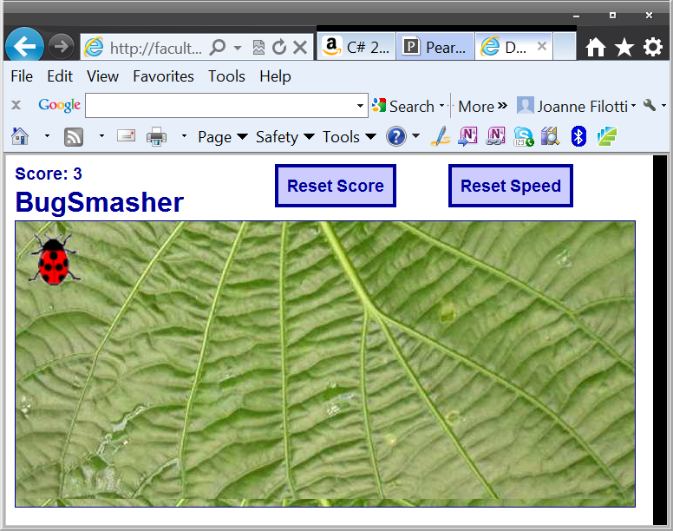

Features:
The bug hops randomly around the game area at a given interval. The player tries to catch the bug by clicking on it. If he succeeds, the score is incremented and the hopping interval is decremented by a number of milliseconds, so it gets harder to catch the bug.
If the game becomes too challenging, the payer can reset the speed to the initial hopping interval by clicking the Reset Speed button.
If the player wants, he can start again by resetting the score by clicking the Reset Score button.

Guidelines:
Your GUI does not need to be laid out exactly as the above screenshot, you can use graphics of your own and a different page layout as long as the core functionality of the game is preserved.

Use as guidelines the game described at:
http://www.lostdecadegames.com/how-to-make-a-simple-html5-canvas-game/

Important:
- This assignment is due on August 1st at 11:59 pm.
- Late submission: seven days after the due date, marked out of 80%.
- Submit your assignment to Assignment 5 drop box.
- ALSO PUBLISH IT to the student web.

