CS101 Project
Bombay Bazaar -Simulation

Submitted by:-
Sheshansh Agrawal 150050027
Chitwan Saharia 150050011

Our project has the following features:

1.The Home Screen :We can enter any of the four choices..The exit option stops the program execution and brings the control out of the main program.
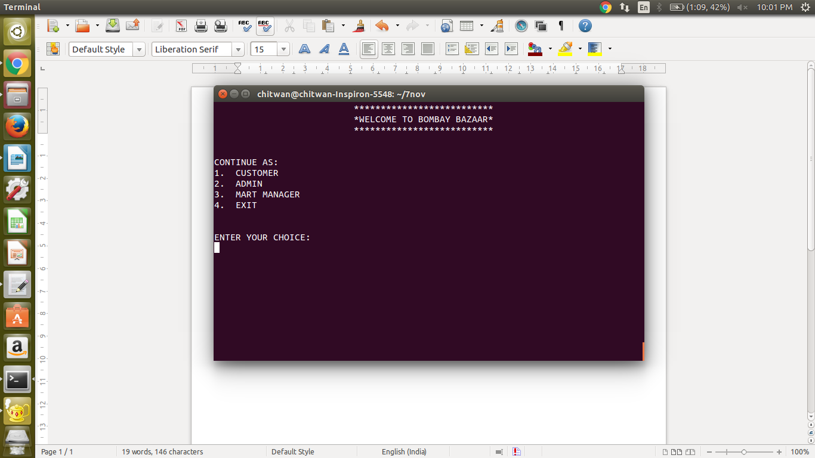

2.The Customers can log into their existing accounts or can create a new one. For this their is an id and password for each user. There is also a username which is asked for at the time of signup (Example the next photo shows the account of a user named Ram).
Once logged in he can perform the following operations.
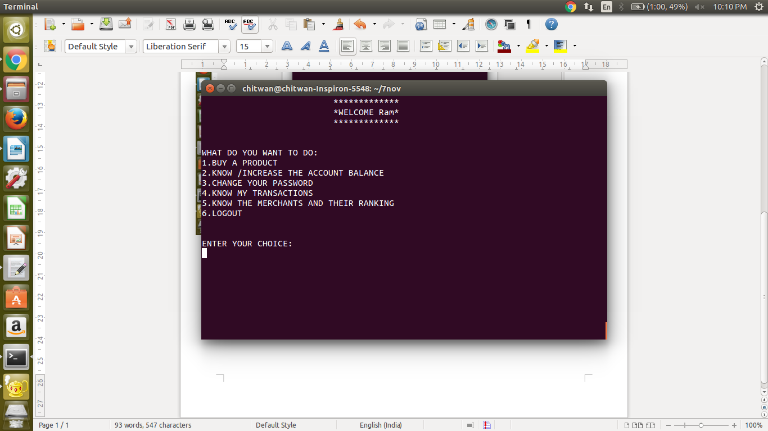
Customer can
a. Buy a product: People can buy their desired products .They are asked to choose a type of product.Then they are asked to input the price range(Lower limit and Upper limit).Then the program compares the sellprice of each product among the 3 marts and displays the one with the least price.
Then the user can choose any of the product by entering its product id.After that the the program asks the user to reenter his password and then the transaction is completed by producing a bill for the same and it also gets stored in the database for future reference.
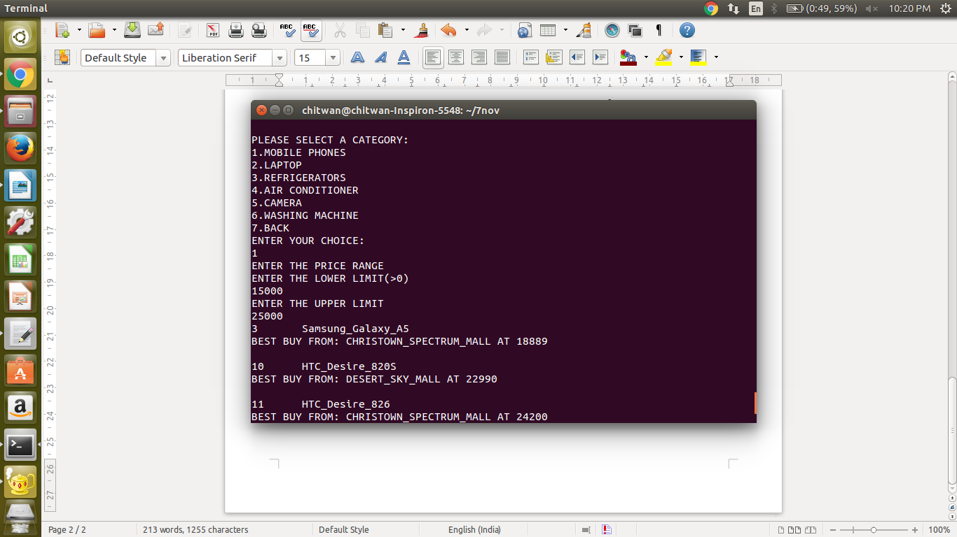
b.Know / Increase the account balance: The program asks for how much amount to credit and also for account password for authentication. It also asks for bank name, account number and password which are just dummy .

c.Change your password

d.Know my transactions: Displays all the bills of transactions done by the customer till date.

e.Know the ranking of merchants: It dispays the list of all the merchants sorted according to their incomes (profit), highest first. Two merchants with same income are given the same rank and the next rank is left vacant.

f.Logout

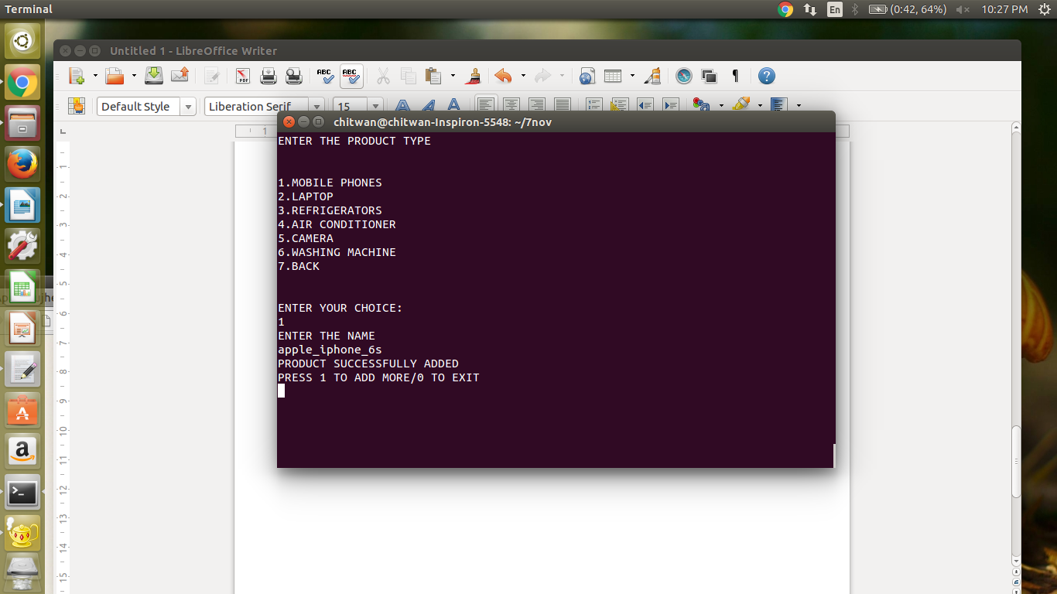
3. Administrator :The administrator with the password ”iamadmin” can login to propose a new product in the market and initialise the buyprice and sellprice for each mall to 0.Then the malls can either set their prices on the product and start dealing with it or can leave it 0 if they dont want to deal with it.
The name cannot consist of “-” .

4. Mart Manager :There are 3 mart managers in the present program.
Each mart has a name, id , password. The marts can log into their accounts .
The marts are: password

1. Desert Sky Mall desert
2.Christown Spectrum Mall christown
3.Fiesta Mall fiesta

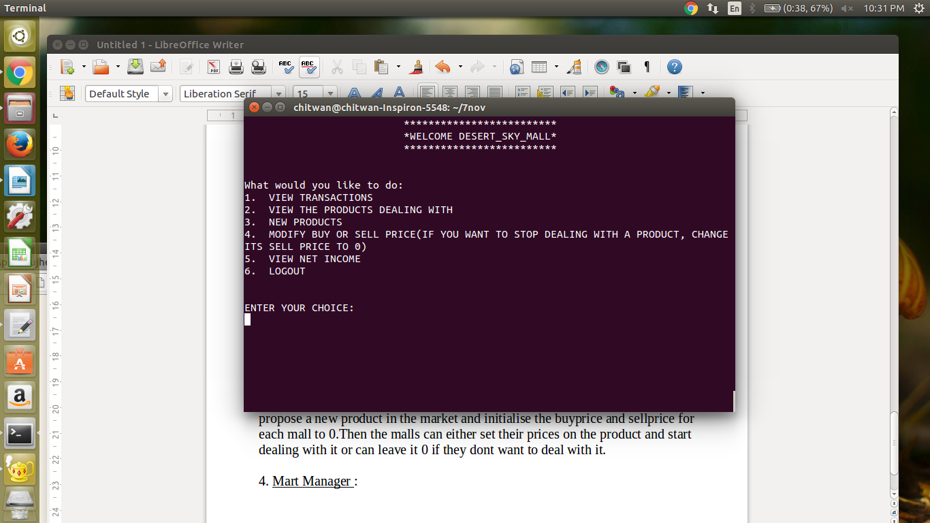
Each mart manager can:
a. View Transactions: It displays all the transactions of the mart uptil date.

b. View The Products Dealing With: Each mart can see the products the mart is
dealing with, i.e. the sell price is >0.

c. New products: Each mart can see the new products introduced by the administrator.

d.Modify the prices: Marts can use this to change their prices so that theirs is the best buy. And also it can be used to start dealing with a product by changing its price from zero to non-zero. Also if a mall wants to stop dealing with a product, it can set its price to zero.

e.View Net Income Of The Mall

