网络影响力数据：[11838 rows x 3 columns]

合表，将三个网络平台的招聘数据(RECRUIT_QCWY, RECRUIT_ZHYC, RECRUIT_ZLZP)进行加和，此时数据为三维，不经过PCA直接聚类

K-Means, n_clusters=5

轮廓系数：0.7570107737986477

Calinski-Harabaz Index:35665.28605626537

K-Means, n_clusters=4

轮廓系数：0.7511268331183819

Calinski-Harabaz Index:32237.976096423547

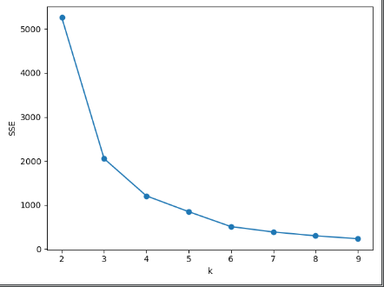

Mean-shift

Estimate_bandwidth 自动调参，取得bandwidth= 0.5237026244392864

number of estimated clusters : 5

轮廓系数：0.7472407082320528

Calinski-Harabaz Index:30261.707303313746

DBSCAN

在eps=0.5, min_samples=2000情况下，n_cluster=4

轮廓系数：0.7511268331183819

Calinski-Harabaz Index:32237.976096423547

Agglomerative Clustering

number of estimated clusters : 2

轮廓系数：0.5561826087637134

Calinski-Harabaz Index:12096.861734564669

此算法结果不理想

Birch Clustering

number of estimated clusters : 4

轮廓系数：0.6865798682745252

Calinski-Harabaz Index:21851.939723441687

OPTICS Clustering

number of estimated clusters : 3

轮廓系数：0.6246671486370686

Calinski-Harabaz Index:17135.459970693828

number of estimated clusters : 4

轮廓系数：0.6784946640799904

Calinski-Harabaz Index:17231.29490225741

对结果较好的dbscan, k-means进行绘图：

k-means:

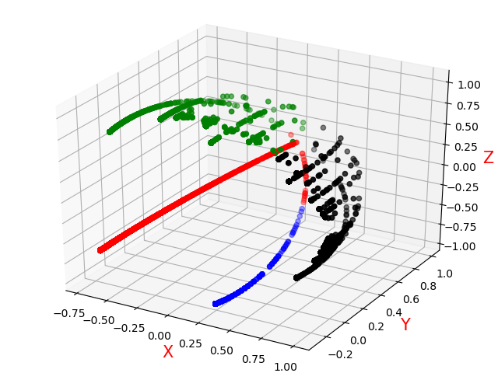

dbscan:

