hw2.R

QY

Sat Feb 28 02:14:56 2015

######z=xn+yn###########  
########################  
pmf <- c(1/12, 1/12, 1/6, 1/6, 1/6, 0, 1/12, 1/12, 1/6)  
# len is the number of probabilities (in this case, 9)  
len <- length(pmf)  
# now calculate the accumulated sum vector.   
cdf <- cumsum(pmf)  
  
# constuct a dataframe  
ds <- data.frame(expand.grid(x=-1:1,y=-1:1))  
# and attach the probabilities to the dataframe as a third colume  
ds <- cbind(ds,cdf)  
#draw a random numer from U(0,1)  
  
xmar<-NULL  
ymar<-NULL  
z<-NULL  
  
for(n in 1:10)  
{ r <- runif(1)  
 # calculate the row in the random table   
 row <- len + 1 - sum(as(r<cdf,"integer"))  
 #   
 x <- ds[row, ]$x  
 y <- ds[row, ]$y  
   
 xmar<-c(xmar,x)  
 ymar<-c(ymar,y)  
 z <-c(z,x+y)  
   
}  
###pmf of z#####  
pmf_z<-c(1/12,3/12,5/12,1/12,2/12)  
###empirical test#####  
sample1<-sample(c(-2:2),10,prob=pmf_z,replace=T)  
  
###comparison#####  
plot(-2:2,cumsum(pmf_z),type="l")  
plot(ecdf(z),lwd="2",add=TRUE)  
ks.test(z,sample1)

## Warning in ks.test(z, sample1): cannot compute exact p-value with ties

##   
## Two-sample Kolmogorov-Smirnov test  
##   
## data: z and sample1  
## D = 0.1, p-value = 1  
## alternative hypothesis: two-sided

title("z=xn+yn, n=10")

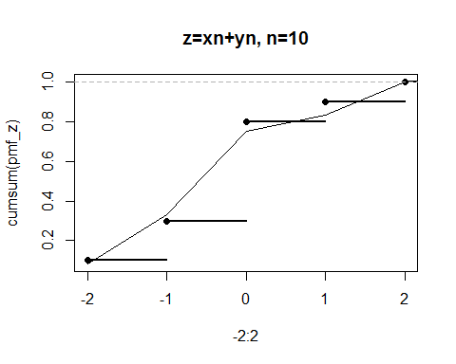

######z=xn+yn###########  
########################  
pmf <- c(1/12, 1/12, 1/6, 1/6, 1/6, 0, 1/12, 1/12, 1/6)  
# len is the number of probabilities (in this case, 9)  
len <- length(pmf)  
# now calculate the accumulated sum vector.   
cdf <- cumsum(pmf)  
  
# constuct a dataframe  
ds <- data.frame(expand.grid(x=-1:1,y=-1:1))  
# and attach the probabilities to the dataframe as a third colume  
ds <- cbind(ds,cdf)  
#draw a random numer from U(0,1)  
  
xmar<-NULL  
ymar<-NULL  
z<-NULL  
  
for(n in 1:100)  
{ r <- runif(1)  
 # calculate the row in the random table   
 row <- len + 1 - sum(as(r<cdf,"integer"))  
 #   
 x <- ds[row, ]$x  
 y <- ds[row, ]$y  
   
 xmar<-c(xmar,x)  
 ymar<-c(ymar,y)  
 z <-c(z,x+y)  
   
}  
###pmf of z#####  
pmf_z<-c(1/12,3/12,5/12,1/12,2/12)  
###empirical test#####  
sample1<-sample(c(-2:2),100,prob=pmf_z,replace=T)  
  
###comparison#####  
plot(-2:2,cumsum(pmf_z),type="l")  
plot(ecdf(z),lwd="2",add=TRUE)  
ks.test(z,sample1)

## Warning in ks.test(z, sample1): p-value will be approximate in the  
## presence of ties

##   
## Two-sample Kolmogorov-Smirnov test  
##   
## data: z and sample1  
## D = 0.12, p-value = 0.4676  
## alternative hypothesis: two-sided

title("z=xn+yn, n=100")

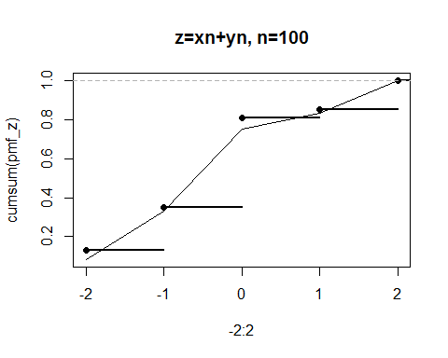

######z=xn+yn###########  
########################  
pmf <- c(1/12, 1/12, 1/6, 1/6, 1/6, 0, 1/12, 1/12, 1/6)  
# len is the number of probabilities (in this case, 9)  
len <- length(pmf)  
# now calculate the accumulated sum vector.   
cdf <- cumsum(pmf)  
  
# constuct a dataframe  
ds <- data.frame(expand.grid(x=-1:1,y=-1:1))  
# and attach the probabilities to the dataframe as a third colume  
ds <- cbind(ds,cdf)  
#draw a random numer from U(0,1)  
  
xmar<-NULL  
ymar<-NULL  
z<-NULL  
  
for(n in 1:1000)  
{ r <- runif(1)  
 # calculate the row in the random table   
 row <- len + 1 - sum(as(r<cdf,"integer"))  
 #   
 x <- ds[row, ]$x  
 y <- ds[row, ]$y  
   
 xmar<-c(xmar,x)  
 ymar<-c(ymar,y)  
 z <-c(z,x+y)  
   
}  
###pmf of z#####  
pmf_z<-c(1/12,3/12,5/12,1/12,2/12)  
###empirical test#####  
sample1<-sample(c(-2:2),1000,prob=pmf_z,replace=T)  
  
###comparison#####  
plot(-2:2,cumsum(pmf_z),type="l")  
plot(ecdf(z),lwd="2",add=TRUE)  
ks.test(z,sample1)

## Warning in ks.test(z, sample1): p-value will be approximate in the  
## presence of ties

##   
## Two-sample Kolmogorov-Smirnov test  
##   
## data: z and sample1  
## D = 0.018, p-value = 0.9969  
## alternative hypothesis: two-sided

title("z=xn+yn, n=1000")

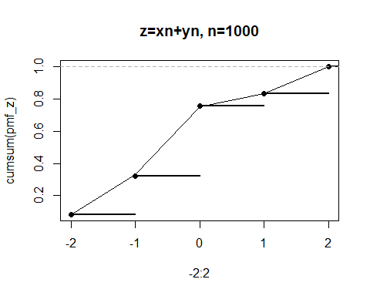

##################  
###z=x+y##########  
##################  
pmf <- c(1/9, 1/9, 1/9, 1/9, 1/9, 1/9, 1/9, 1/9, 1/9)  
len <- length(pmf)  
# now calculate the accumulated sum vector.   
cdf <- cumsum(pmf)  
  
# constuct a dataframe  
ds <- data.frame(expand.grid(x=-1:1,y=-1:1))  
# and attach the probabilities to the dataframe as a third colume  
ds <- cbind(ds,cdf)  
#draw a random numer from U(0,1)  
  
xmar<-NULL  
ymar<-NULL  
z<-NULL  
  
for(n in 1:10)  
{ r <- runif(1)  
 # calculate the row in the random table   
 row <- len + 1 - sum(as(r<cdf,"integer"))  
 #   
 x <- ds[row, ]$x  
 y <- ds[row, ]$y  
   
 xmar<-c(xmar,x)  
 ymar<-c(ymar,y)  
 z <-c(z,x+y)  
   
}  
###pmf of z#####  
pmf_z<-c(1/9,2/9,3/9,2/9,1/9)  
###empirical test#####  
sample1<-sample(c(-2:2),10,prob=pmf_z,replace=T)  
  
###comparison#####  
plot(-2:2,cumsum(pmf_z),type="l")  
plot(ecdf(z),lwd="2",add=TRUE)  
ks.test(z,sample1)

## Warning in ks.test(z, sample1): cannot compute exact p-value with ties

##   
## Two-sample Kolmogorov-Smirnov test  
##   
## data: z and sample1  
## D = 0.1, p-value = 1  
## alternative hypothesis: two-sided

title("z=x+y, n=10")

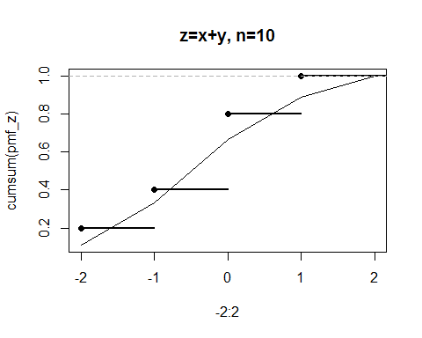

###z=x+y##########  
##################  
pmf <- c(1/9, 1/9, 1/9, 1/9, 1/9, 1/9, 1/9, 1/9, 1/9)  
len <- length(pmf)  
# now calculate the accumulated sum vector.   
cdf <- cumsum(pmf)  
  
# constuct a dataframe  
ds <- data.frame(expand.grid(x=-1:1,y=-1:1))  
# and attach the probabilities to the dataframe as a third colume  
ds <- cbind(ds,cdf)  
#draw a random numer from U(0,1)  
  
xmar<-NULL  
ymar<-NULL  
z<-NULL  
  
for(n in 1:100)  
{ r <- runif(1)  
 # calculate the row in the random table   
 row <- len + 1 - sum(as(r<cdf,"integer"))  
 #   
 x <- ds[row, ]$x  
 y <- ds[row, ]$y  
   
 xmar<-c(xmar,x)  
 ymar<-c(ymar,y)  
 z <-c(z,x+y)  
   
}  
###pmf of z#####  
pmf_z<-c(1/9,2/9,3/9,2/9,1/9)  
###empirical test#####  
sample1<-sample(c(-2:2),100,prob=pmf_z,replace=T)  
  
###comparison#####  
plot(-2:2,cumsum(pmf_z),type="l")  
plot(ecdf(z),lwd="2",add=TRUE)  
ks.test(z,sample1)

## Warning in ks.test(z, sample1): p-value will be approximate in the  
## presence of ties

##   
## Two-sample Kolmogorov-Smirnov test  
##   
## data: z and sample1  
## D = 0.05, p-value = 0.9996  
## alternative hypothesis: two-sided

title("z=x+y, n=100")

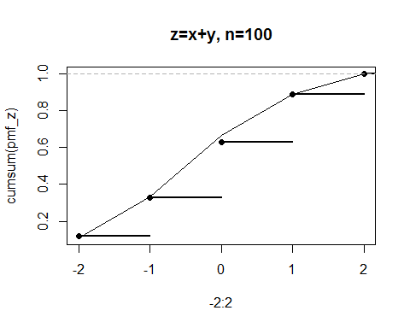

###z=x+y##########  
##################  
pmf <- c(1/9, 1/9, 1/9, 1/9, 1/9, 1/9, 1/9, 1/9, 1/9)  
len <- length(pmf)  
# now calculate the accumulated sum vector.   
cdf <- cumsum(pmf)  
  
# constuct a dataframe  
ds <- data.frame(expand.grid(x=-1:1,y=-1:1))  
# and attach the probabilities to the dataframe as a third colume  
ds <- cbind(ds,cdf)  
#draw a random numer from U(0,1)  
  
xmar<-NULL  
ymar<-NULL  
z<-NULL  
  
for(n in 1:1000)  
{ r <- runif(1)  
 # calculate the row in the random table   
 row <- len + 1 - sum(as(r<cdf,"integer"))  
 #   
 x <- ds[row, ]$x  
 y <- ds[row, ]$y  
   
 xmar<-c(xmar,x)  
 ymar<-c(ymar,y)  
 z <-c(z,x+y)  
   
}  
###pmf of z#####  
pmf_z<-c(1/9,2/9,3/9,2/9,1/9)  
###empirical test#####  
sample1<-sample(c(-2:2),1000,prob=pmf_z,replace=T)  
  
###comparison#####  
plot(-2:2,cumsum(pmf_z),type="l")  
plot(ecdf(z),lwd="2",add=TRUE)  
ks.test(z,sample1)

## Warning in ks.test(z, sample1): p-value will be approximate in the  
## presence of ties

##   
## Two-sample Kolmogorov-Smirnov test  
##   
## data: z and sample1  
## D = 0.011, p-value = 1  
## alternative hypothesis: two-sided

title("z=x+y, n=1000")

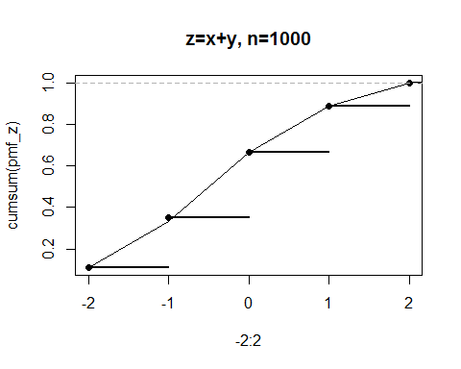

#######################  
######z=x ############  
#######################  
pmf <- c(1/3,1/3,1/3)  
len <- length(pmf)  
# now calculate the accumulated sum vector.   
cdf <- cumsum(pmf)  
  
# constuct a dataframe  
ds <- data.frame(expand.grid(x=-1:1))  
# and attach the probabilities to the dataframe as a third colume  
ds <- cbind(ds,cdf)  
#draw a random numer from U(0,1)  
  
xmar<-NULL  
  
z<-NULL  
  
for(n in 1:10)  
{ r <- runif(1)  
 # calculate the row in the random table   
 row <- len + 1 - sum(as(r<cdf,"integer"))  
 #   
 x <- ds[row, ]$x  
   
   
 xmar<-c(xmar,x)  
   
 z <-c(z,x)  
   
}  
###pmf of z#####  
  
pmf_z<-c(1/3,1/3,1/3)  
  
###empirical test#####  
sample1<-sample(c(-1:1),10,prob=pmf_z,replace=T)  
  
  
###comparison#####  
plot(-1:1,cumsum(pmf_z),type="l")  
plot(ecdf(z),lwd="2",add=TRUE)  
ks.test(z,sample1)

## Warning in ks.test(z, sample1): cannot compute exact p-value with ties

##   
## Two-sample Kolmogorov-Smirnov test  
##   
## data: z and sample1  
## D = 0.6, p-value = 0.05465  
## alternative hypothesis: two-sided

title("z=x, n=10")

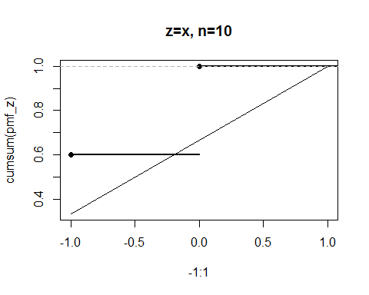

######z=x ############  
#######################  
pmf <- c(1/3,1/3,1/3)  
len <- length(pmf)  
# now calculate the accumulated sum vector.   
cdf <- cumsum(pmf)  
  
# constuct a dataframe  
ds <- data.frame(expand.grid(x=-1:1))  
# and attach the probabilities to the dataframe as a third colume  
ds <- cbind(ds,cdf)  
#draw a random numer from U(0,1)  
  
xmar<-NULL  
  
z<-NULL  
  
for(n in 1:100)  
{ r <- runif(1)  
 # calculate the row in the random table   
 row <- len + 1 - sum(as(r<cdf,"integer"))  
 #   
 x <- ds[row, ]$x  
   
 xmar<-c(xmar,x)  
   
 z <-c(z,x)  
   
}  
###pmf of z#####  
pmf_z<-c(1/3,1/3,1/3)  
###empirical test#####  
sample1<-sample(c(-1:1),100,prob=pmf_z,replace=T)  
  
###comparison#####  
plot(-1:1,cumsum(pmf_z),type="l")  
plot(ecdf(z),lwd="2",add=TRUE)  
ks.test(z,sample1)

## Warning in ks.test(z, sample1): p-value will be approximate in the  
## presence of ties

##   
## Two-sample Kolmogorov-Smirnov test  
##   
## data: z and sample1  
## D = 0.05, p-value = 0.9996  
## alternative hypothesis: two-sided

title("z=x, n=100")

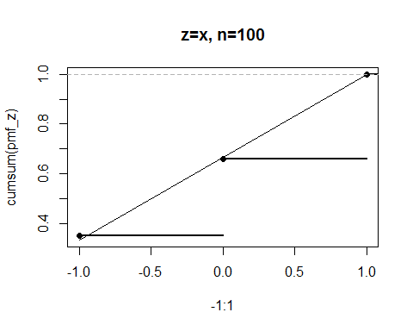

######z=x ############  
#######################  
pmf <- c(1/3,1/3,1/3)  
len <- length(pmf)  
# now calculate the accumulated sum vector.   
cdf <- cumsum(pmf)  
  
# constuct a dataframe  
ds <- data.frame(expand.grid(x=-1:1))  
# and attach the probabilities to the dataframe as a third colume  
ds <- cbind(ds,cdf)  
#draw a random numer from U(0,1)  
  
xmar<-NULL  
  
z<-NULL  
  
for(n in 1:1000)  
{ r <- runif(1)  
 # calculate the row in the random table   
 row <- len + 1 - sum(as(r<cdf,"integer"))  
 #   
 x <- ds[row, ]$x  
   
   
 xmar<-c(xmar,x)  
   
 z <-c(z,x)  
   
}  
###pmf of z#####  
pmf_z<-c(1/3,1/3,1/3)  
###empirical test#####  
sample1<-sample(c(-1:1),1000,prob=pmf_z,replace=T)  
  
###comparison#####  
plot(-1:1,cumsum(pmf_z),type="l")  
plot(ecdf(z),lwd="2",add=TRUE)  
ks.test(z,sample1)

## Warning in ks.test(z, sample1): p-value will be approximate in the  
## presence of ties

##   
## Two-sample Kolmogorov-Smirnov test  
##   
## data: z and sample1  
## D = 0.004, p-value = 1  
## alternative hypothesis: two-sided

title("z=x, n=1000")

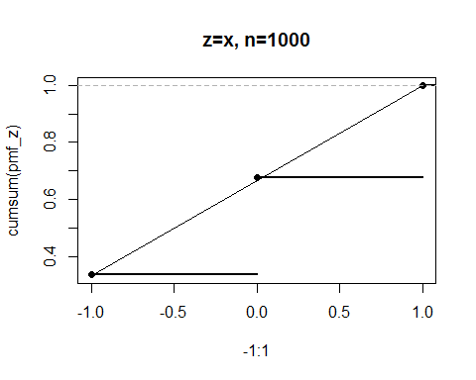

######################  
######z=y ############  
#######################  
pmf <- c(1/3,1/3,1/3)  
len <- length(pmf)  
# now calculate the accumulated sum vector.   
cdf <- cumsum(pmf)  
  
# constuct a dataframe  
ds <- data.frame(expand.grid(y=-1:1))  
# and attach the probabilities to the dataframe as a third colume  
ds <- cbind(ds,cdf)  
#draw a random numer from U(0,1)  
  
  
ymar<-NULL  
z<-NULL  
  
for(n in 1:10)  
{ r <- runif(1)  
 # calculate the row in the random table   
 row <- len + 1 - sum(as(r<cdf,"integer"))  
 #   
   
 y <- ds[row, ]$y  
   
   
 ymar<-c(ymar,y)  
 z <-c(z,y)  
   
}  
###pmf of z#####  
pmf_z<-c(1/3,1/3,1/3)  
###empirical test#####  
sample1<-sample(c(-1:1),10,prob=pmf_z,replace=T)  
  
###comparison#####  
plot(-1:1,cumsum(pmf_z),type="l")  
plot(ecdf(z),lwd="2",add=TRUE)  
ks.test(z,sample1)

## Warning in ks.test(z, sample1): cannot compute exact p-value with ties

##   
## Two-sample Kolmogorov-Smirnov test  
##   
## data: z and sample1  
## D = 0.3, p-value = 0.7591  
## alternative hypothesis: two-sided

title("z=y, n=10")

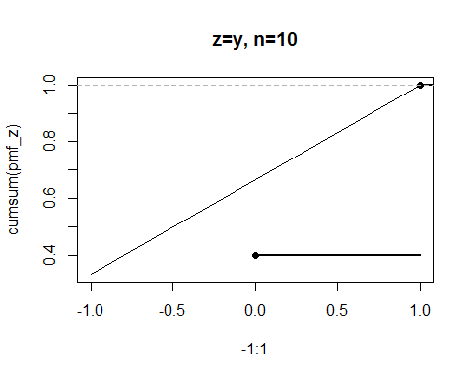

######z=y ############  
#######################  
pmf <- c(1/3,1/3,1/3)  
len <- length(pmf)  
# now calculate the accumulated sum vector.   
cdf <- cumsum(pmf)  
  
# constuct a dataframe  
ds <- data.frame(expand.grid(y=-1:1))  
# and attach the probabilities to the dataframe as a third colume  
ds <- cbind(ds,cdf)  
#draw a random numer from U(0,1)  
  
  
ymar<-NULL  
z<-NULL  
  
for(n in 1:100)  
{ r <- runif(1)  
 # calculate the row in the random table   
 row <- len + 1 - sum(as(r<cdf,"integer"))  
 #   
   
 y <- ds[row, ]$y  
   
   
 ymar<-c(ymar,y)  
 z <-c(z,y)  
   
}  
###pmf of z#####  
pmf_z<-c(1/3,1/3,1/3)  
###empirical test#####  
sample1<-sample(c(-1:1),100,prob=pmf_z,replace=T)  
  
###comparison#####  
plot(-1:1,cumsum(pmf_z),type="l")  
plot(ecdf(z),lwd="2",add=TRUE)  
ks.test(z,sample1)

## Warning in ks.test(z, sample1): p-value will be approximate in the  
## presence of ties

##   
## Two-sample Kolmogorov-Smirnov test  
##   
## data: z and sample1  
## D = 0.08, p-value = 0.9062  
## alternative hypothesis: two-sided

title("z=y, n=100")

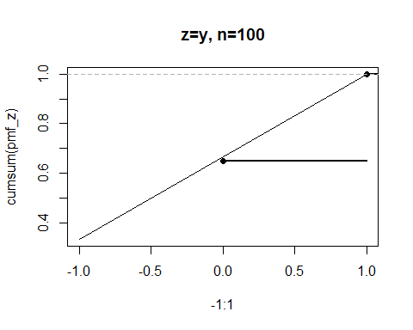

######z=y ############  
#######################  
pmf <- c(1/3,1/3,1/3)  
len <- length(pmf)  
# now calculate the accumulated sum vector.   
cdf <- cumsum(pmf)  
  
# constuct a dataframe  
ds <- data.frame(expand.grid(y=-1:1))  
# and attach the probabilities to the dataframe as a third colume  
ds <- cbind(ds,cdf)  
#draw a random numer from U(0,1)  
  
  
ymar<-NULL  
z<-NULL  
  
for(n in 1:1000)  
{ r <- runif(1)  
 # calculate the row in the random table   
 row <- len + 1 - sum(as(r<cdf,"integer"))  
 #   
   
 y <- ds[row, ]$y  
   
   
 ymar<-c(ymar,y)  
 z <-c(z,y)  
   
}  
###pmf of z#####  
pmf_z<-c(1/3,1/3,1/3)  
###empirical test#####  
sample1<-sample(c(-1:1),1000,prob=pmf_z,replace=T)  
  
###comparison#####  
plot(-1:1,cumsum(pmf_z),type="l")  
plot(ecdf(z),lwd="2",add=TRUE)  
ks.test(z,sample1)

## Warning in ks.test(z, sample1): p-value will be approximate in the  
## presence of ties

##   
## Two-sample Kolmogorov-Smirnov test  
##   
## data: z and sample1  
## D = 0.017, p-value = 0.9987  
## alternative hypothesis: two-sided

title("z=y, n=1000")

