**Question 1**

As shown in the output files, both the QQ plots and the Kolmogorov-Smirnov test agree that the empirical distributions fit the theoretical distributions, and we also observed the following situations:

1. The distribution of a larger sample size fits the theoretical distribution better. For Z=Xn+Yn, X+Y, X, Y four scenarios, we find the D value of Kolmogorov-Smirnov is decreasing from n=10 to n=1000 gradually, which means the differences between CDF is decreasing.
2. P-value

Ho: The empirical distribution is the same as the theoretical distribution.

Ha: The empirical distribution is not the same as the theoretical distribution.

For all distributions, the p-value<0.05 (alpha=0.05). We failed to reject the null hypothesis. The empirical distribution is the same as the theoretical distribution. Besides, for each situation of Z, p-value is increasing from n=10 to n=1000, which also means the distributions fit better when the sample size is larger

1. Plot

The plots also show that when n is increasing under each situation, the distributions fit better.

In calculus we say that a sequence of real numbers xn converges to a limit x if, for every a > 0, |xn – x| < a for all large n.

The Theorem  was observed in the calculation of probability. converges in probability to the expectation.

For the distribution, we saw For example, in Z=X, where Yn0, the results showed that 

**Question 2**

Screenshot of HTML, WORD, PDF output.

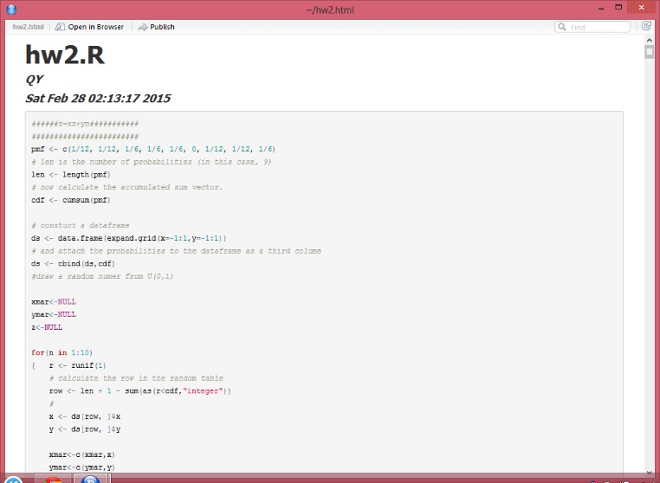

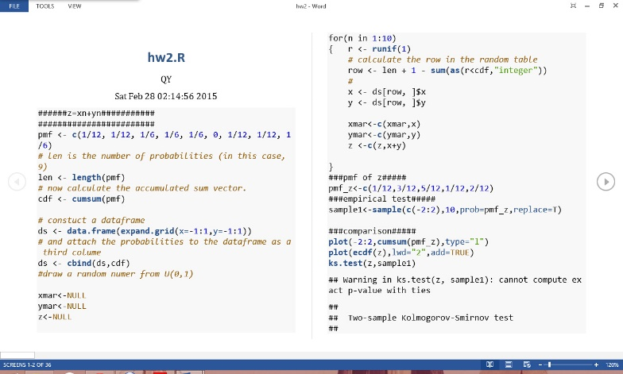

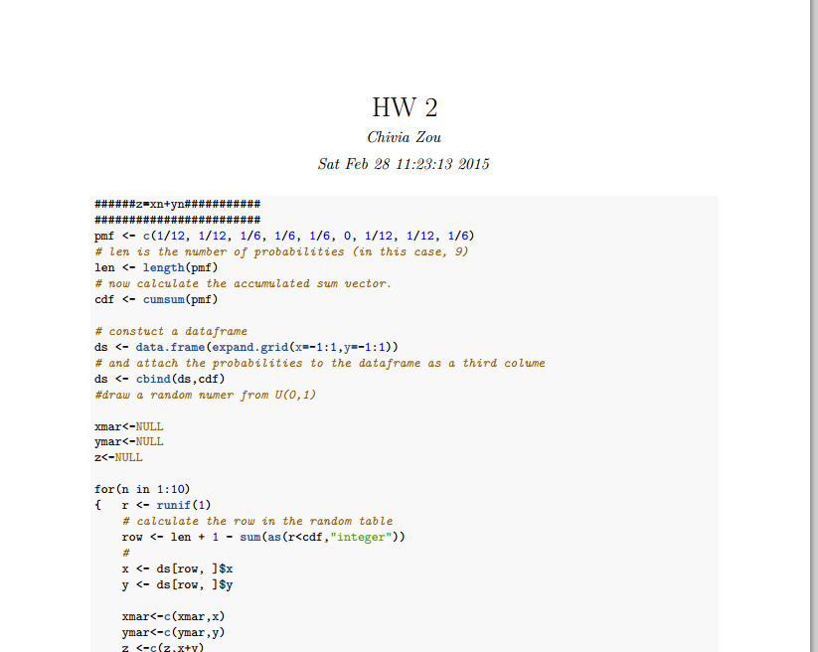

Screenshot of Demo Shiny output

