构造分段函数

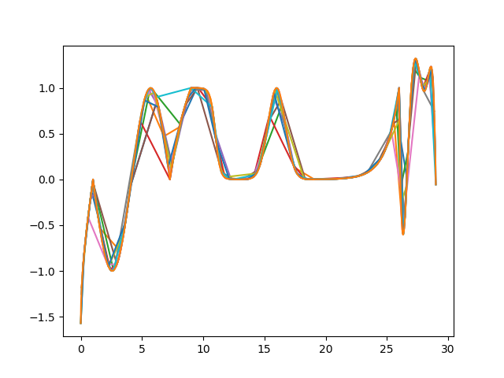
包含反三角函数，三角函数，对数函数，指数函数，sigmoid函数，gauss函数以及多项式函数。

f(x) = arc sin(x - 1) x∈[0, 1]
= sin(x – 1) x∈[1, 2Pi + 1]
= ln(x – 2Pi) x∈[2Pi +1, 2Pi + 1 + e]
= -sigmoid(5(x-2Pi-3-e)) x∈[2Pi + 1 + e, 2Pi + 5 + e]
= gauss(x – (2Pi + e + 8)) x∈[2pi+e+5, 2pi+e+11]
= exp(x – (2pi +e + 17)) x∈[2Pi + e + 11, 2pi +e +18]
= (-y * (y + 1) * (y – 1.8) * (y – 1.2) * (y – 0.9) + 1)
y = x – (2pi + e + 19)
x ∈[2pi+e+18, 2pi+e+ 21]

