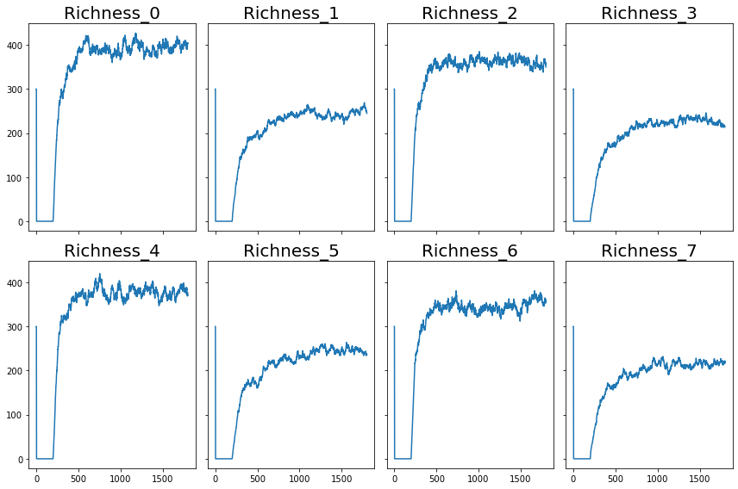
Figure S1 Richness dynamics. For varied combinations of three parameters: variance for growth rate ($σ_{r}$), the variance of interaction strength ($σ_{α}$), and the mean introduction rate ($λ$), the dynamics of species richness passes through three phases. The three phases observed are the exponential decay in a closed system for 200-time steps and a linear increase when new species are introduced.

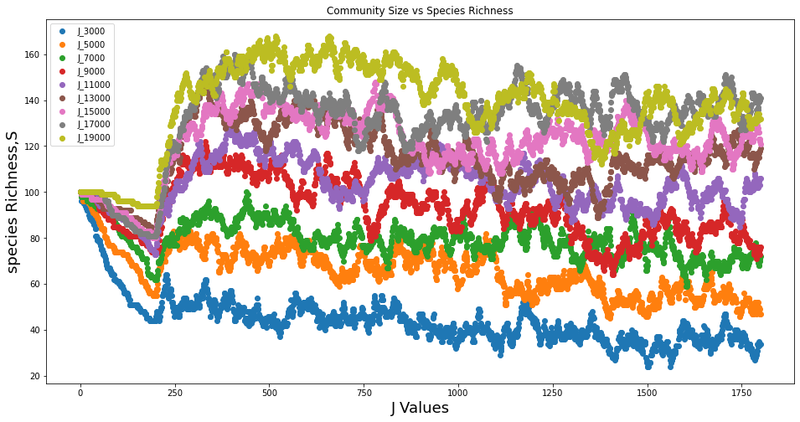
Figure S3 Community effects on species richness. The dynamic of species richness for various community size values.

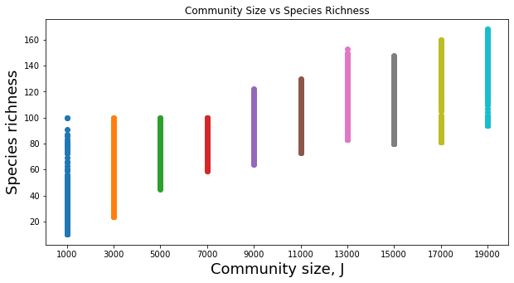
Figure S4 Community effects on species richness. The dynamic of species richness for various community size values. The $R^{2}$ value for the relationship between the change in J values and species richness is 0.96.

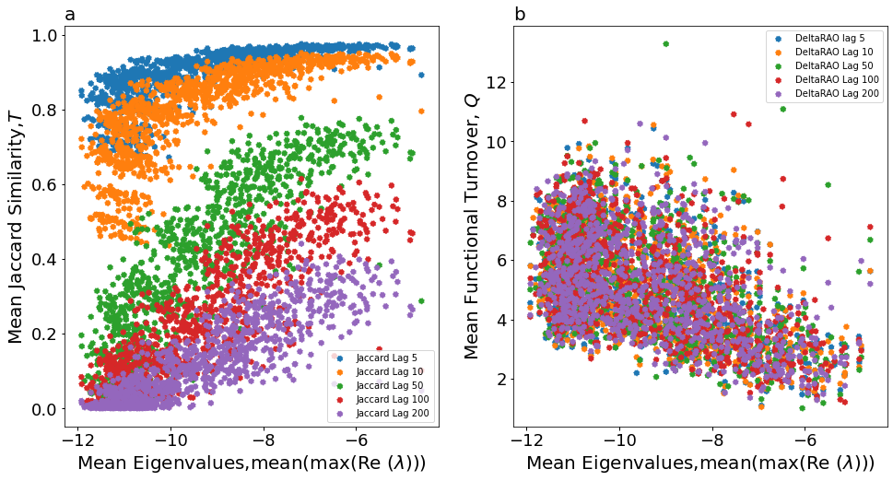
Figure S5 Jaccard Similarity Indices and Functional Turnover for different time lags.

