Course 1

Objectives:

Introduce data analytics

* Data Analysis Process: ask, prepare, process, analyze, share

Think analytically

Exploring the wonderful world of data

Setting up a data toolbox

Discovering data career opportunities

Completing the course challenge

Data Science:

1. Machine Learning and AI: when you want to automate and make many many decisions under uncertainty
   1. Performance focused
2. Analytics: Don’t know how many decisions you want to make before beginning – you want to encounter your unknown unknowns, you want to understand your world
   1. Speed driven
   2. How quickly can you go through vast amounts of data and discover the gems
   3. Ambiguous, working on a lot of different things and looking at a lot of data
   4. More on the creative side, focus on the fun rather than perfection
3. Statistics: Make a few important decisions under uncertainty
   1. Rigorous
   2. Careful about protecting decision makers from coming to the wrong conclusion

**Understanding the Data Ecosystem**

Data ecosystems are made up of various elements that interact with one another in order to produce, manage, store, organize, analyze, and share data. These include hardware and software tools, the people who use them and data storage (i.e. cloud)

Data analysis is the collection, organization, and transformation of data to draw conclusions.

Data analytics is the science of data – encompasses everything from the job of managing and using data to the tools and methods that data workers use every day.

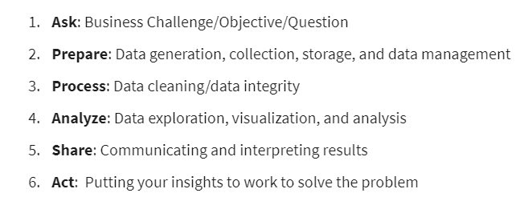

EMC’s Data Analytics Lifecycle

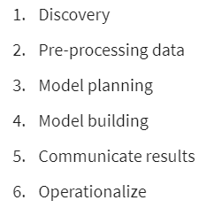

SAS’s Iterative Lifecycle

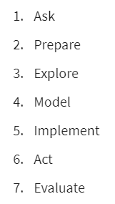

Project Based Data Analytics Lifecycle

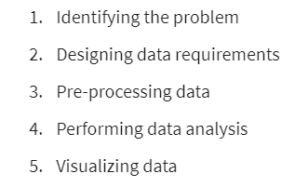

Big Data Analytics lifecycle

