Rendering: Marching Cubes

To construct surface for the fluid particles, we use Marching Cubes algorithm. The basic idea of the algorithm is to form a facet approximation to an isosurface through a scalar field sampled on a rectangular 3D grid. If one vertex is above the isosurface say and an adjacent vertex is below the isosurface then we know the isosurface cuts the edge between these two vertices. The position that it cuts the edge will be linearly interpolated, the ratio of the length between the two vertices will be the same as the ratio of the isosurface value to the values at the vertices of the grid cell.

The isosuface value we use here is the distance between each vertex on the marching cubes and particles in the grid. If the distance between the position of the corner of one cube and its closest particle in the surrounding grid is smaller than the threshold iso_value, then we can say this corner is below the surface.

The indexing convention for vertices and edges used in the algorithm are shown below:

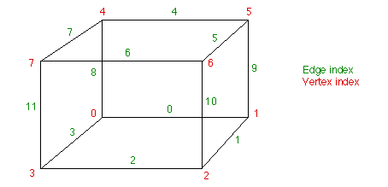

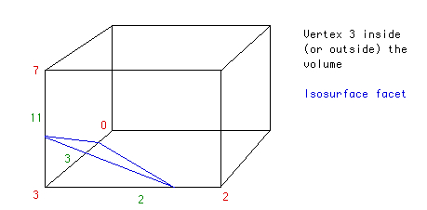

Then we use an edgeTable which maps the vertices under the isosurface to the intersecting edges to indicate each cube’s intersection information.  If P1 and P2 are the vertices of a cut edge and V1 and V2 are the scalar values at each vertex, the the intersection point P is given by P = P1 + (isovalue - V1) (P2 - P1) / (V2 - V1). By connecting each intersection points to be triangles, we can finally get a surface of current fluid particles.