Industrial Internship Report on
” Prediction of Agriculture Crop Production in India”
Prepared by
[Chiranjeev Kumar]

Executive Summary
This report provides details of the Industrial Internship provided by upskill Campus and The IoT Academy in collaboration with Industrial Partner UniConverge Technologies Pvt Ltd (UCT).
This internship was focused on a project/problem statement provided by UCT. We had to finish the project including the report in 6 weeks’ time.
My project was “Prediction of Agriculture Crop Production in India using Machine Learning”. The objective of the project was to analyze agricultural datasets and design a machine learning pipeline capable of forecasting crop production based on parameters such as state, season, crop type, and cultivated area. This involved data preprocessing, exploratory data analysis, model training using algorithms like Linear Regression, Random Forest, and XGBoost, and finally evaluating the performance using accuracy metrics.
This internship gave me a very good opportunity to get exposure to Industrial problems and design/implement solution for that. It was an overall great experience to have this internship.

TABLE OF CONTENTS
1 Preface 3
2 Introduction 4
2.1 About UniConverge Technologies Pvt Ltd 4
2.2 About upskill Campus 8
2.3 Objective 9
2.4 Reference 9
2.5 Glossary 10
3 Problem Statement 11
4 Existing and Proposed solution 12
5 Proposed Design/ Model 13
5.1 High Level Diagram (if applicable) 13
5.2 Low Level Diagram (if applicable) 13
5.3 Interfaces (if applicable) 13
6 Performance Test 14
6.1 Test Plan/ Test Cases 14
6.2 Test Procedure 14
6.3 Performance Outcome 14
7 My learnings 15
8 Future work scope 16

Preface

This report is prepared as part of my internship in the domain of Machine Learning at NIT Nagaland. The objective of the project was to apply machine learning techniques for predicting agricultural crop production in India. The report presents the motivation, design, implementation, results, and learnings gained throughout the internship.

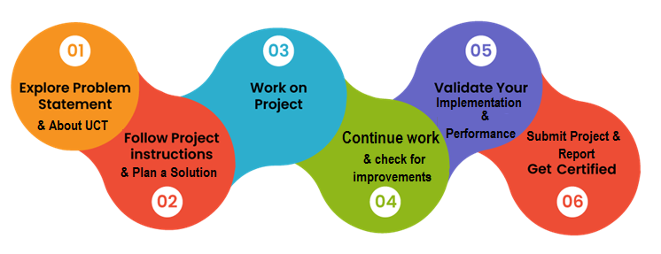
I sincerely thank my mentors, faculty members, and peers for their continuous support and guidance .

Introduction

About UniConverge Technologies Pvt Ltd
A company established in 2013 and working in Digital Transformation domain and providing Industrial solutions with prime focus on sustainability and RoI.
For developing its products and solutions it is leveraging various Cutting Edge Technologies e.g. Internet of Things (IoT), Cyber Security, Cloud computing (AWS, Azure), Machine Learning, Communication Technologies (4G/5G/LoRaWAN), Java Full Stack, Python, Front end etc.
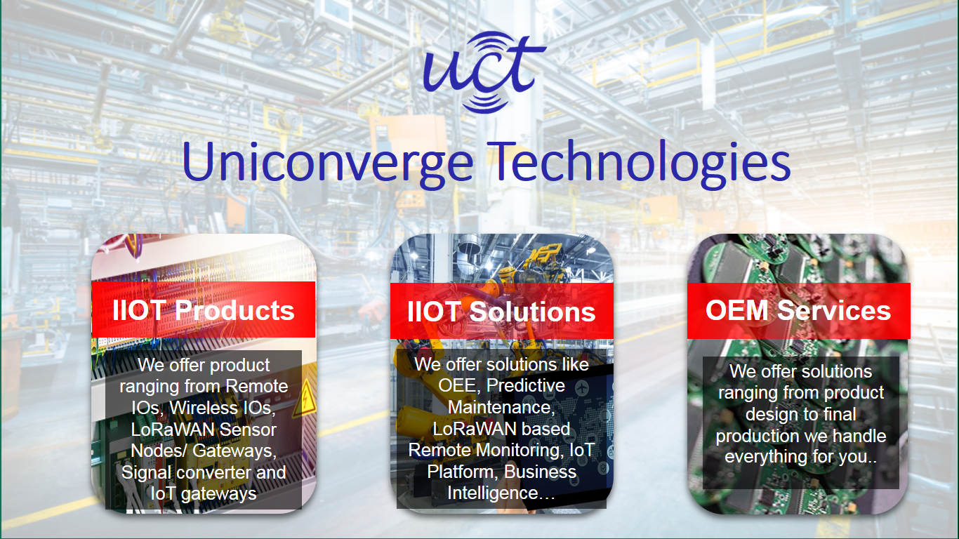
- UCT IoT Platform ()
UCT Insight is an IOT platform designed for quick deployment of IOT applications on the same time providing valuable “insight” for your process/business. It has been built in Java for backend and ReactJS for Front end. It has support for MySQL and various NoSql Databases.
- It enables device connectivity via industry standard IoT protocols - MQTT, CoAP, HTTP, Modbus TCP, OPC UA
- It supports both cloud and on-premises deployments.
It has features to
• Build Your own dashboard
• Analytics and Reporting
• Alert and Notification
• Integration with third party application(Power BI, SAP, ERP)
• Rule Engine

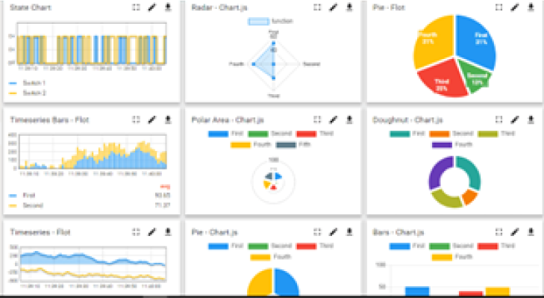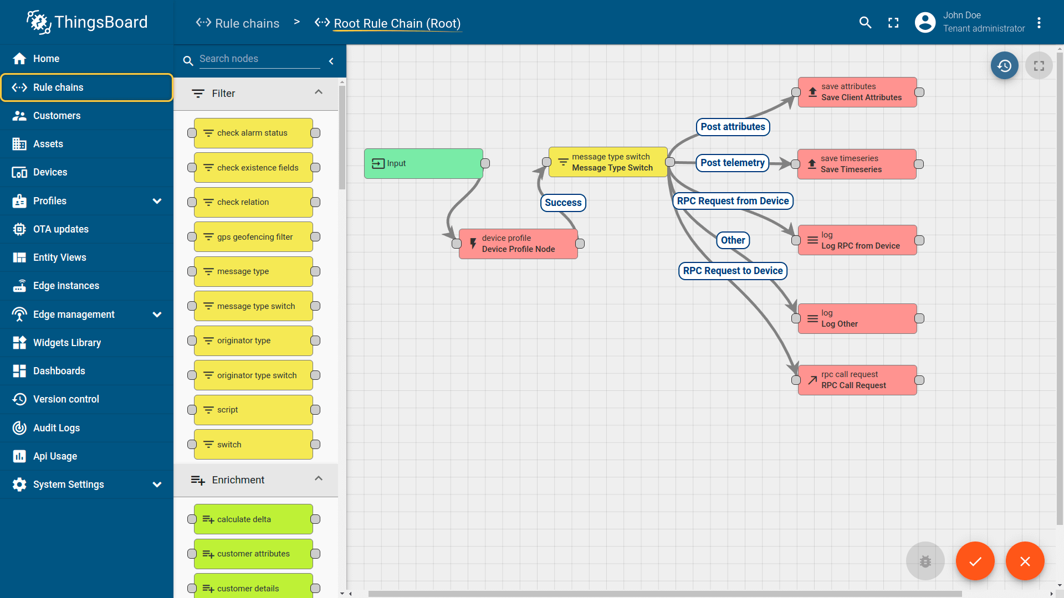

- Smart Factory Platform ()
Factory watch is a platform for smart factory needs.
It provides Users/ Factory
- with a scalable solution for their Production and asset monitoring
- OEE and predictive maintenance solution scaling up to digital twin for your assets.
- to unleased the true potential of the data that their machines are generating and helps to identify the KPIs and also improve them.
- A modular architecture that allows users to choose the service that they what to start and then can scale to more complex solutions as per their demands.
Its unique SaaS model helps users to save time, cost and money.
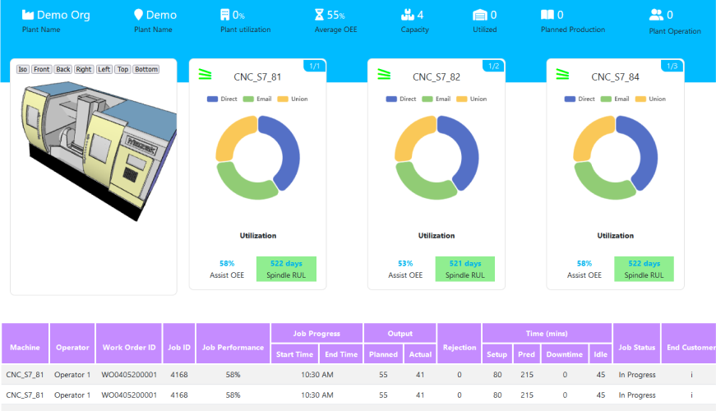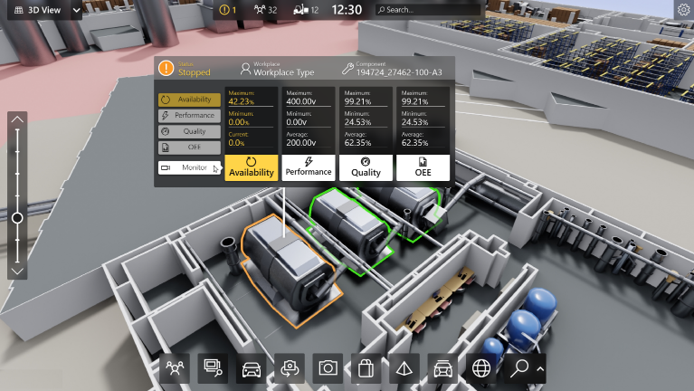

- 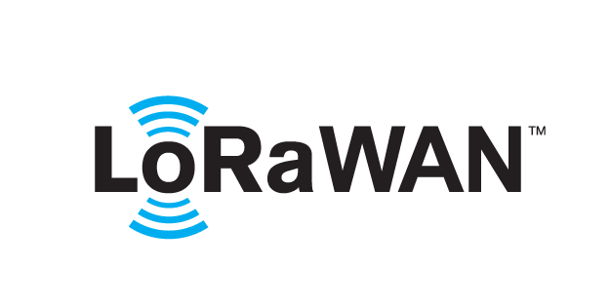 based Solution
UCT is one of the early adopters of LoRAWAN teschnology and providing solution in Agritech, Smart cities, Industrial Monitoring, Smart Street Light, Smart Water/ Gas/ Electricity metering solutions etc.
- Predictive Maintenance
UCT is providing Industrial Machine health monitoring and Predictive maintenance solution leveraging Embedded system, Industrial IoT and Machine Learning Technologies by finding Remaining useful life time of various Machines used in production process.
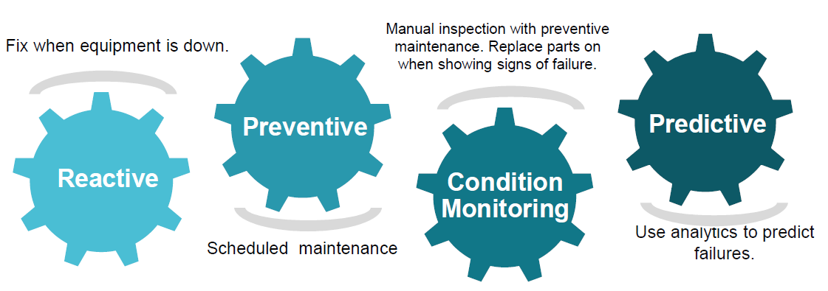

About upskill Campus (USC)
upskill Campus along with The IoT Academy and in association with Uniconverge technologies has facilitated the smooth execution of the complete internship process.
USC is a career development platform that delivers personalized executive coaching in a more affordable, scalable and measurable way.




Seeing need of upskilling in self paced manner along-with additional support services e.g. Internship, projects, interaction with Industry experts, Career growth Services
https://www.upskillcampus.com/
upSkill Campus aiming to upskill 1 million learners in next 5 year

The IoT Academy
The IoT academy is EdTech Division of UCT that is running long executive certification programs in collaboration with EICT Academy, IITK, IITR and IITG in multiple domains.

Objectives of this Internship program
The objective for this internship program was to
☛ get practical experience of working in the industry.
☛ to solve real world problems.
☛ to have improved job prospects.
☛ to have Improved understanding of our field and its applications.
☛ to have Personal growth like better communication and problem solving.

Introduction
Agriculture is the backbone of the Indian economy, employing more than half of the country’s workforce. Accurate prediction of crop production is crucial for ensuring food security, resource allocation, and effective policy-making. Machine Learning (ML) offers powerful tools to analyze large agricultural datasets, identify patterns, and generate reliable forecasts.
This project focuses on developing an ML-based system to predict agricultural crop production in India using historical crop, season, and state-level data. The report outlines the methodology followed, results obtained, and learnings achieved.

Problem Statement

Traditional methods of crop forecasting often rely on manual surveys and statistical methods, which are time-consuming and prone to errors. This creates challenges in timely planning for farmers, government, and supply chains. Hence, there is a need for a robust data-driven approach.
The key objectives of this project are:
- To preprocess and analyze agricultural crop production datasets.
- To design and implement machine learning models for crop production prediction.
- To evaluate models using performance metrics and identify the most accurate algorithm.
- To visualize results and derive insights useful for decision-making.
- To explore potential use cases for farmers, policymakers, and agribusiness.

Existing and Proposed solution

The solution involves creating a machine learning pipeline comprising data preprocessing, feature engineering, model training, evaluation, and visualization. Various regression models were tested including Linear Regression, Random Forest, and XGBoost. Hyperparameter tuning and cross-validation were applied to improve accuracy.

Implementation
The implementation was carried out in phases over four weeks:
Week 1: Data acquisition, exploratory data analysis (EDA), and familiarization with tools (Pandas, NumPy, Matplotlib).
Week 2: Designing the solution framework, creating a flow diagram, drafting pseudo-code, and identifying libraries.
Week 3: Implementation of baseline and advanced models (Linear Regression, Random Forest, XGBoost), followed by training and evaluation.
Week 4: Hyperparameter tuning, cross-validation, visualization of predictions, and performance comparison.Results and Performance Testing
The performance of the models was evaluated using R² Score, Mean Squared Error (MSE), and Root Mean Squared Error (RMSE). Among the tested models, XGBoost achieved the highest accuracy with an R² score of approximately 0.92, demonstrating its effectiveness in handling non-linear patterns in agricultural data.
Visualizations such as actual vs. predicted plots and feature importance charts provided additional insights into key factors influencing crop production. Sample use cases demonstrated the model’s applicability in predicting state-wise and crop-specific production levels.
[Insert plots, screenshots, or diagrams here]

Learnings
Through this project, I gained valuable knowledge and practical skills in:
- Data preprocessing and feature engineering.
- Implementing and tuning ML regression models.
- Using cross-validation for model reliability.
- Visualizing model results for better interpretation.
- Managing end-to-end ML project workflowFuture Work
Future improvements to this project could include:
- Deployment of the model using Flask or Streamlit for user-friendly interfaces.
- Integration of real-time data sources (e.g., weather APIs).
- Use of deep learning methods such as LSTMs for time-series forecasting.
- Extension of the system to cover multiple countries and larger datasets.

Conclusion
The internship project successfully demonstrated the application of machine learning for predicting crop production in India. By systematically implementing data-driven models, it was shown that advanced algorithms like XGBoost significantly outperform traditional methods. The work provides a foundation for future enhancements and has practical implications for agriculture planning, policy-making, and supply chain management.

References
- Government of India, Ministry of Agriculture and Farmers’ Welfare Data Portal (data.gov.in)
- Scikit-learn Documentation (https://scikit-learn.org/)
- XGBoost Documentation (https://xgboost.readthedocs.io/)
- Kaggle datasets and notebooks on agricultural prediction

Code submission (Github link)

# Project: Prediction of Agriculture Crop Production in India

import pandas as pd
import numpy as np
import matplotlib.pyplot as plt
import seaborn as sns

from sklearn.model_selection import train_test_split, GridSearchCV, cross_val_score
from sklearn.preprocessing import LabelEncoder
from sklearn.metrics import r2_score, mean_squared_error
from sklearn.linear_model import LinearRegression
from sklearn.ensemble import RandomForestRegressor
import xgboost as xgb
import joblib

# ---------------------------------------------------------
data = pd.read_csv("crop_production.csv")
print("Dataset loaded successfully!")
print(data.head())

data = data.dropna()

cat_cols = ["State_Name", "Season", "Crop"]
le = LabelEncoder()
for col in cat_cols:
data[col] = le.fit_transform(data[col])

X = data.drop("Production", axis=1)
y = data["Production"]

X_train, X_test, y_train, y_test = train_test_split(
X, y, test_size=0.2, random_state=42
)

print("Data preprocessing completed!")

lr_model = LinearRegression()
lr_model.fit(X_train, y_train)
y_pred_lr = lr_model.predict(X_test)

print("\nLinear Regression Performance:")
print("R2 Score:", r2_score(y_test, y_pred_lr))
print("RMSE:", np.sqrt(mean_squared_error(y_test, y_pred_lr)))

rf = RandomForestRegressor(random_state=42)

params = {
"n_estimators": [100, 200],
"max_depth": [5, 10, None],
"min_samples_split": [2, 5]
}

grid_rf = GridSearchCV(rf, param_grid=params, cv=3, n_jobs=-1, scoring="r2")
grid_rf.fit(X_train, y_train)

best_rf = grid_rf.best_estimator_
y_pred_rf = best_rf.predict(X_test)

print("\nRandom Forest Performance:")
print("Best Params:", grid_rf.best_params_)
print("R2 Score:", r2_score(y_test, y_pred_rf))
print("RMSE:", np.sqrt(mean_squared_error(y_test, y_pred_rf)))
xgb_model = xgb.XGBRegressor(
objective="reg:squarederror",
n_estimators=200,
learning_rate=0.1,
max_depth=6,
random_state=42
)

xgb_model.fit(X_train, y_train)
y_pred_xgb = xgb_model.predict(X_test)

print("\nXGBoost Performance:")
print("R2 Score:", r2_score(y_test, y_pred_xgb))
print("RMSE:", np.sqrt(mean_squared_error(y_test, y_pred_xgb)))

plt.figure(figsize=(8,6))
plt.scatter(y_test, y_pred_xgb, alpha=0.5, color="blue")
plt.xlabel("Actual Production")
plt.ylabel("Predicted Production")
plt.title("Actual vs Predicted Crop Production (XGBoost)")
plt.grid(True)
plt.show()

xgb.plot_importance(xgb_model)
plt.show()
joblib.dump(xgb_model, "final_crop_prediction_model.pkl")
print("\nFinal XGBoost model saved as 'final_crop_prediction_model.pkl'")

Report submission (Github link) :

