HIXON ENTERPRISES REAL ESTATE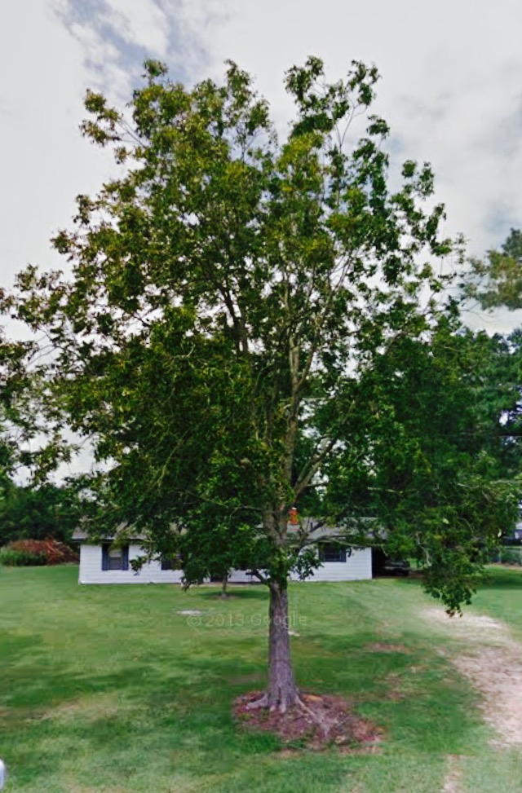

**THE 1 MAIN BUSINESS GOAL**

To profit $1million by year 2021

**3 PRIORITIES TO ACHIEVE THE GOAL**

1. Establish online presence
2. Lead generate for new business
3. Organize COI in CRM Database and systematically grow and contact it

5 STRATEGIES FOR EACH PRIORITY

1. Online Presence 2. Lead Generate 3. COI Database

|  |  |  |
| --- | --- | --- |
| Online Presence | Lead Generate | COI Database |
| 1. Setup and/or update all social media network profiles. Establish general action plan for communication on each network | 1. Lead generate every Monday-Friday for 3 hours (9am-12pm). Alternate contacts to COI, FSBOs, Expires & Just listed/solds | 1.Update contact list of family , friends, past clients |
| 2) Create personal landing page linking all social media networks | 2. Meet with accountability partner every Monday morning at 10am to hold me accountable to my goals | 2) Contact 50 people per week until everyone is contacted |
| 3) Complete 4 agent websites for 1) sellers 2) buyers 3) neighborhood farm; and 4) blog | 3. Be faithful to my calendar! Time block my lead generation time to hold me accountable to my goals | 3) Enter all accounts in Database Management System. Add 10 new contacts per week to database |
| 4) Locate & attend 3 training courses on Internet generation | 4. Role play scripts with an accountability partner regularly | 4) Attend CRM training to help me get everyone uploaded, create, & launch campaigns |
| 5) Develop blog theme, create action page & start blog post | 5. Obtain 3 new listings, 3 buyer contracts & 4 closed transactions per month | 5) Systemize campaign touches & calendar |
|  |  |  |