Test case generator – Non customizsed/non dynamic
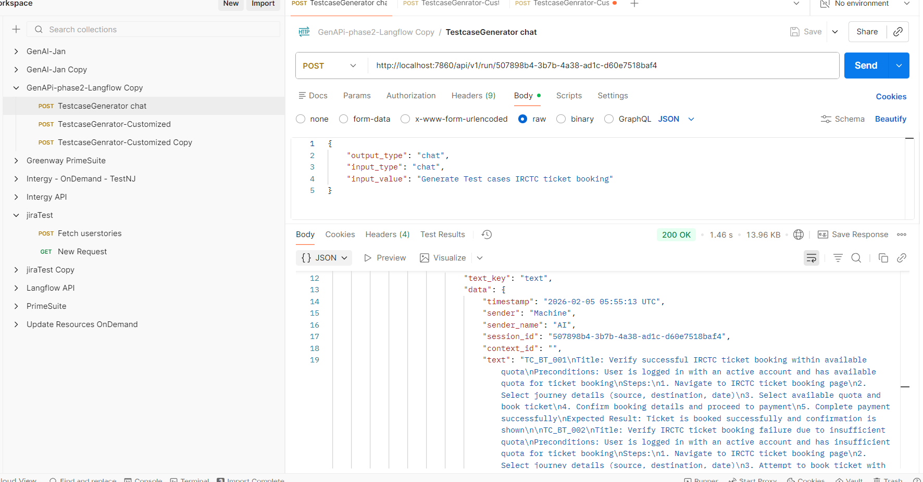

Test case generator – Customized/Dynamic -> Using groq api key and model directly
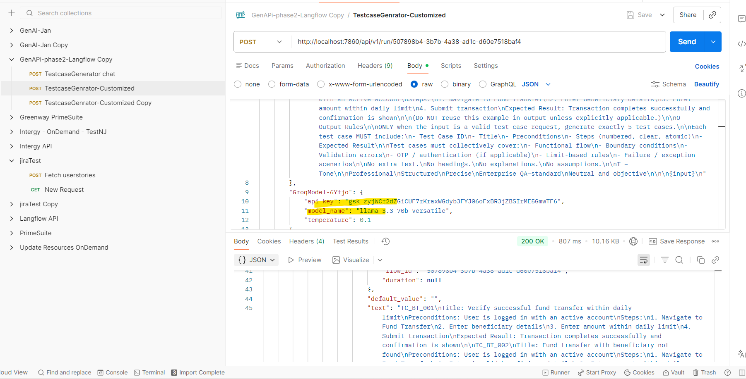

Test case generator – Customized/Dynamic -> Using groq api key variable and model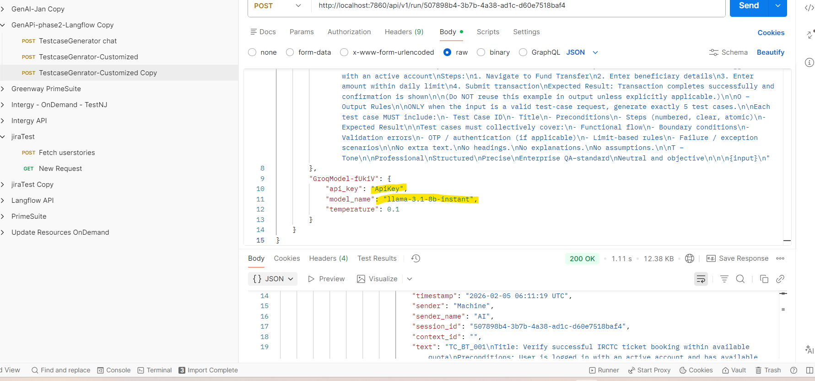

PDF reader -> customized
