Assignment 1: Embedding test case: Converting excel file to Json and then embedding
Vector search created with the meta data:
{
"fields": [
{
"type": "vector",
"path": "embedding",
"numDimensions": 1024,
"similarity": "cosine"
},
{
"type": "filter",
"path": "id"
},
{
"type": "filter",
"path": "module"
},
{
"type": "filter",
"path": "title"
},
{
"type": "filter",
"path": "description"
},
{
"type": "filter",
"path": "steps"
},
{
"type": "filter",
"path": "expectedResults"
},
{
"type": "filter",
"path": "risk"
},
{
"type": "filter",
"path": "priority"
}
]
}

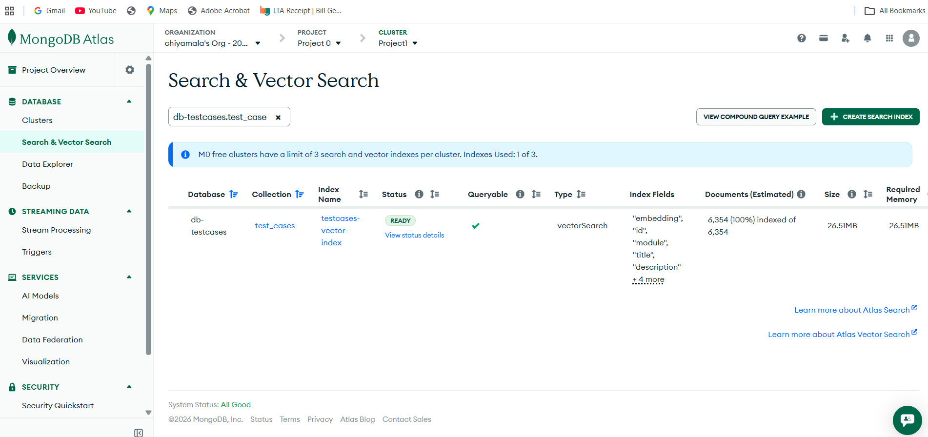

Test cases are embedded:
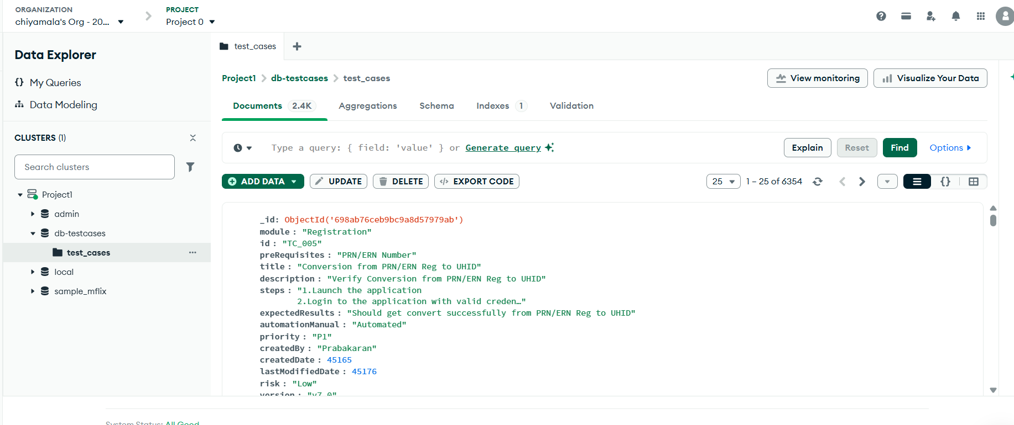
Assignment 2:
Vector search created with the meta data:
{
"fields": [
{
"type": "vector",
"path": "embedding",
"numDimensions": 1024,
"similarity": "cosine"
},
{
"type": "filter",
"path": "jiraMetadata.projectKey"
},
{
"type": "filter",
"path": "status.name"
},
{
"type": "filter",
"path": "priority.name"
},
{
"type": "filter",
"path": "assignee.displayName"
},
{
"type": "filter",
"path": "components"
},
{
"type": "filter",
"path": "labels"
},
{
"type": "filter",
"path": "fixVersions"
}
]
}
Embedding user stories -> using the given json for embedding
