# 2018.05.16python作业

## 1.python源文件改写

textFile = open('源代码.txt', 'rt')  
textFile.seek(0)  
excludes = {"if","in","not","else","while","True","break"}  
for word in textFile:  
    for p in word:  
        if p in excludes:  
            print(p, end='')  
        elif ord("a") <= ord(p) <= ord("z"):  
            print(str.upper(p))  
        else:  
            print(p, end='')  
textFile.close()

## 2.图像文件压缩

from PIL import Image  
from PIL import ImageFilter  
im = Image.open("C:\\池艳.jpeg")  
im.thumbnail((80,80))  
im.save("池艳TN","jpeg")

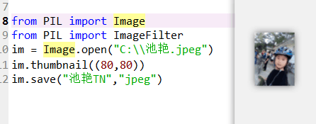

## 3.去掉红色系

from PIL import Image  
im = Image.open("C:\\天柱山.jpeg")  
r,g,b = im.split()  
newer = r.point(lambda i:i*0)  
om = Image.merge(im.mode,(newer,g,b))  
om.save("C:\\池艳Merge.jpeg")

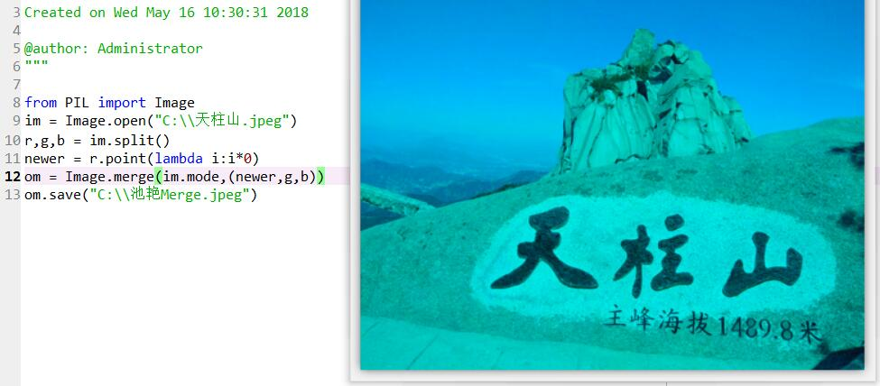

## 4.轮廓获取

from PIL import Image  
from PIL import ImageFilter  
im = Image.open("C:\\池艳.jpeg")  
om = im.filter(ImageFilter.CONTOUR)  
om.save("池艳Contour.jpeg")

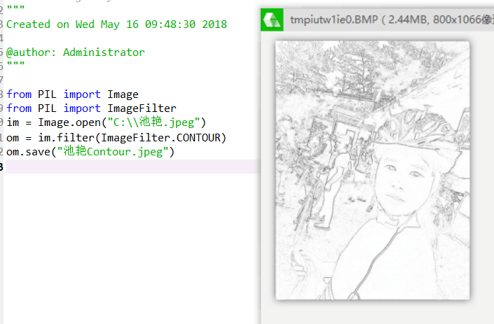

## 5.PS

from PIL import Image  
im = Image.open("C:\\池艳.jpeg")  
r,g,b = im.split()  
newr = r.point(lambda i:i*0.8)  
newg = g.point(lambda i:i<50)  
newb = b.point(lambda i:i*0.8)  
om = Image.merge(im.mode,(newr,newg,newb))  
om.save("C:\\池艳Merge.jpeg")

