Quality Assurance: Commodity Prices

Table of contents

This document contains information on the quality assurance for the commodity price index computation. To be more specific, two aspects are discussed:

* quality of compiled indices (for different groups as UNCTAD publishes) after changing the data source
* documentation of individual price series that have changed data sources.

In general, the indices computed from old and new data sources are fairly consistent, suggesting that the source change is feasible. Some discrepancies are recorded for the reader’s information.

### 0.0.1 Summary

In the table below we list a summary of commodity products whose data sources are changed. The majority of the products can use the new sources without issues. Some have inconsistent values and/or time period availability:

* Values match, while some time periods are missing: **iron ore, manganese, rubber, wool (fine)**. In the computation of index, we either use omit the missing period in the new source, or impute with historical data from another source.
* Time periods are all available, while values differ. This can be due to different units, exchange rates or unknown reasons. After adjustment, the difference do not affect the index computation much.
* Historical comparison data from old sources are unavailable.

Please go to the details for each product for more information. The data source corresponding to the 4-digit code can be found in Appendix 1.

| Product | Product ID | Data Source (2024) | Data Source (2025) | Values matched? | Availability matched? |
| --- | --- | --- | --- | --- | --- |
| fish_salmon | 030212.01 | 7801 | 2311 | Good | Good |
| banana_us | 080300.01 | 5110 | 5110 | Good | Good |
| coffee_arabica | 090100.03 | 1901 | 5110 | Good | Good |
| coffee_robusta | 090100.05 | 1901 | 5110 | Good | Good |
| wheat_us | 100100.01 | 6901 | 5110 | Good | Good |
| maize | 100500.02 | 6901 | 5110 | Good | Good |
| sugar | 170100.01 | 2401 | 5110 | Good | Good |
| cocoa | 180100.01 | 1801 | 5110 | Good | Good |
| tobacco | 240100.01 | 4901 | 5110 | Good | Good |
| iron_ore | 260100.02 | 7901 | 5110 | Good | Period difference |
| manganese_99 | 260200.02 | 6801 | 2311 | Good | Period difference |
| copper | 260300.01 | 6801 | 5110 | Good | Good |
| nickel | 260400.01 | 6801 | 5110 | Good | Good |
| aluminium | 260600.01 | 6801 | 5110 | Good | Good |
| lead | 260700.02 | 6801 | 5110 | Good | Good |
| zinc | 260800.01 | 6801 | 5110 | Good | Good |
| tin | 260900.01 | 6801 | 5110 | Good | Good |
| silver | 261600.01 | 6801 | 5110 | Good | Good |
| coal | 270100.02 | 7901 | 5110 | Good | Good |
| rubber_rss3 | 400100.02 | 5110 | 5110 | Good | Period difference |
| hides | 410100.01 | 2311 | 2311 | No comparison | No comparison |
| wool_fine | 510100.03 | 8001 | 2311 | Good | Period difference |
| jute | 530300.01 | 1603 | 1603 | No comparison | No comparison |
| gold | 710800.01 | 6801 | 5110 | Good | Good |
| platinum | 711000.01 | 6801 | 5110 | Good | Good |

# 1. Compiled indices

In the table below we list the published UNCTAD commodity data names, and the the short names for coding.

| unctad_name | group_name |
| --- | --- |
| All.groups_Index_Base_2015_Value | all |
| All.food_Index_Base_2015_Value | all_food |
| Food_Index_Base_2015_Value | food |
| Tropical.beverages_Index_Base_2015_Value | tropical_beverages |
| Vegetable.oilseeds.and.oils_Index_Base_2015_Value | vegetable_oilseeds_oil |
| Agricultural.raw.materials_Index_Base_2015_Value | agricultural_raw_material |
| Minerals..ores.and.metals_Index_Base_2015_Value | minerals_ore_metal |
| Minerals..ores.and.non.precious.metals_Index_Base_2015_Value | minerals_ore_metal_non_precious_metal |
| Precious.metals_Index_Base_2015_Value | precious_metal |
| Fuels_Index_Base_2015_Value | fuels |
| Tropical.beverages.and.food_Index_Base_2015_Value | tropical_beverages_food |
| All.groups.excl..fuels_Index_Base_2015_Value | all_excl_fuels |
| All.groups.excl..precious.metals_Index_Base_2015_Value | all_excl_precious_metal |
| All.groups.excl..precious.metals.and.fuels_Index_Base_2015_Value | all_excl_precious_metal_fuels |

In the following section, computed indices with the automatic sources are visualized together. The ordering are based on the groups:

* overall
* food and agricultural
* metal
* fuel
* other combinations

Please refer to the metadata to find out what is included in each group.

In general, the quality of using automatic commodity sources are quite good. For more details please check the graphics below.

## 1.1 Overall group

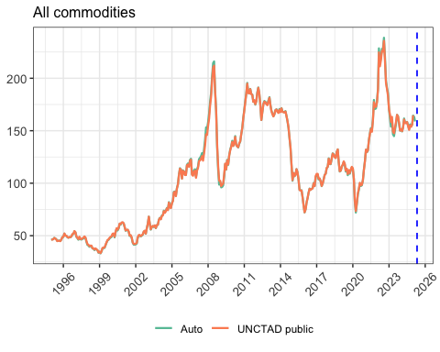

## 1.2 Subgroups: food and agricultural

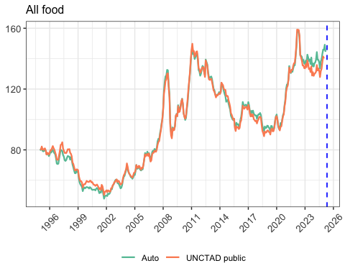

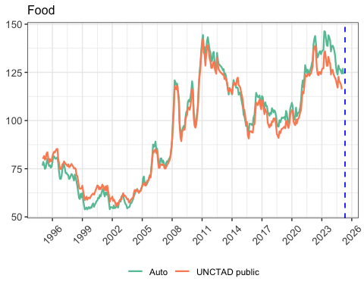

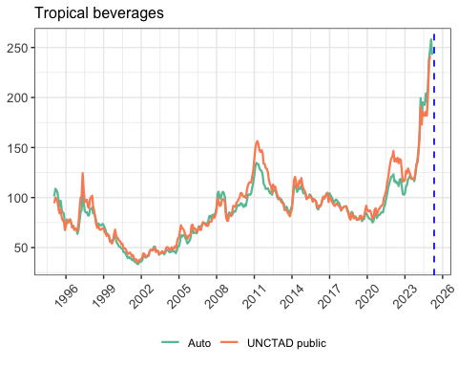

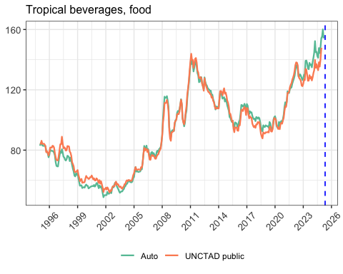

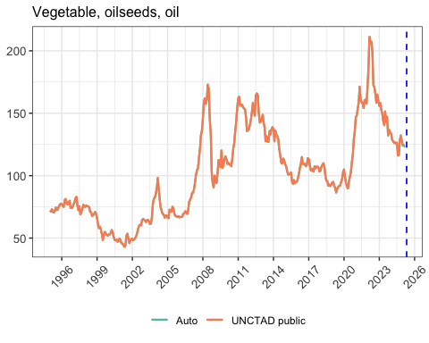

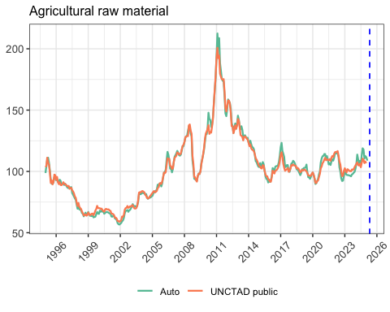

## 1.3 Subgroups: metal

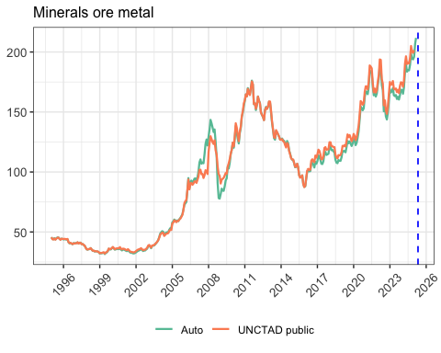

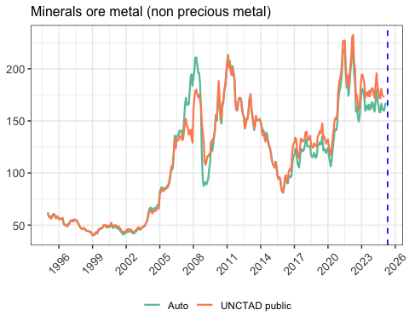

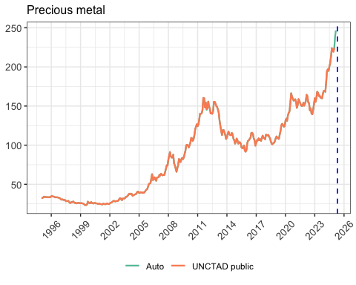

## 1.4 Subgroups: fuels

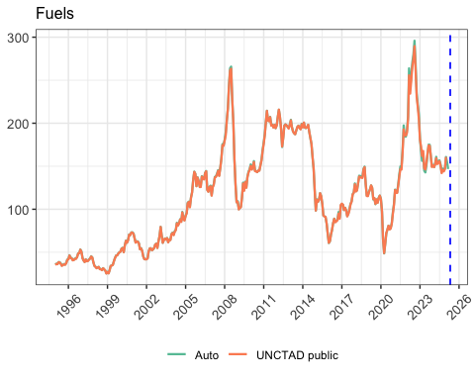

## 1.5 Subgroups: combinations

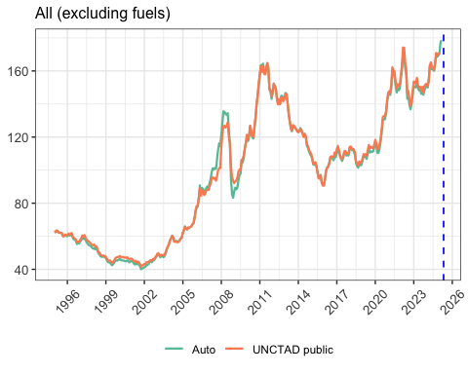

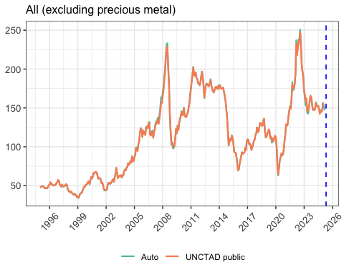

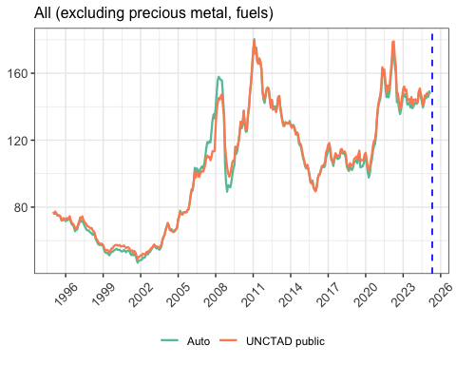

# 2. Individual commodity products

In this section we provide the details on each commodity. They are ordered based on the 8-digit product ID, as shown in the table above.

## 2.1 Fish (Salmon)

| Description | Fish (Salmon) |
| --- | --- |
| Description (code) | fish_salmon |
| Index sort | 1010 |
| Product ID | 030212.01 |
| Description (as of 2024) | Salmon, fresh, fish-farm bred, export price, Norway ($/kg) |
| Unit (as of 2024) | usd_per_kg |
| Data source (2024) | 7801 Statistics Norway |
| Data source (2025) | 2311 IMF - Primary Commodity Prices |

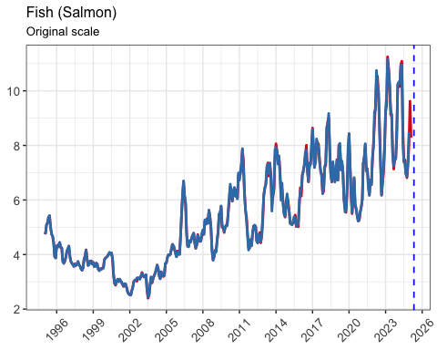

## 2.2 Banana

In the metadata, there are three codes for banana

* if we use 080300.01, the old source is also WB. Can use directly
* in the old way to compile the price index, code 080300.03 is used, which comes from TR. This series is quite different from WB data.
* another series 080300.02 also exists in WB

| Description | Banana (US) |
| --- | --- |
| Description (code) | banana_us |
| Index sort | 1006 |
| Product ID | 080300.01 |
| Description (as of 2024) | Bananas, Central and South America, FOT, US import price ($/kg) |
| Unit (as of 2024) | usd_per_kg |
| Data source (2024) | 5110 World Bank - Commodity-markets |
| Data source (2025) | 5110 World Bank - Commodity-markets |

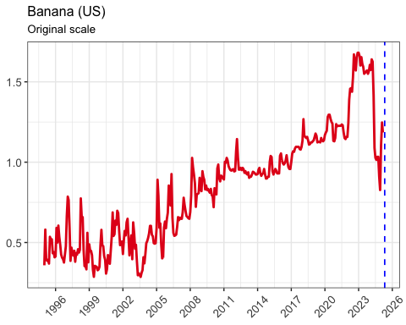

## 2.3 Coffee

| Description | Coffee (Arabica) |
| --- | --- |
| Description (code) | coffee_arabica |
| Index sort | 1101 |
| Product ID | 090100.03 |
| Description (as of 2024) | Coffee, other mild Arabicas, ex-dock US (¢/lb.) |
| Unit (as of 2024) | cent_per_lb |
| Data source (2024) | 1901 International Coffee Organization (ICO) |
| Data source (2025) | 5110 World Bank - Commodity-markets |

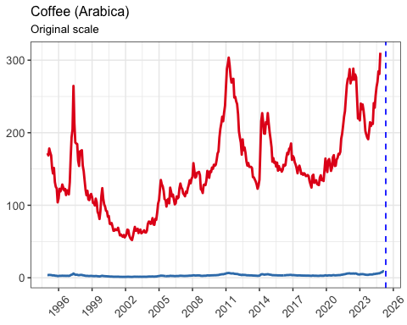

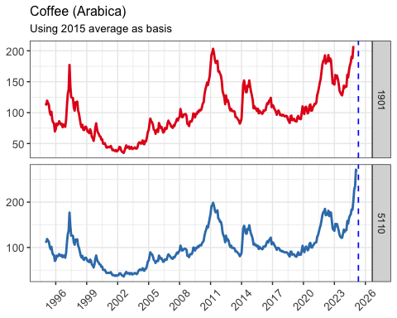

| Description | Coffee (Robusta) |
| --- | --- |
| Description (code) | coffee_robusta |
| Index sort | 1101 |
| Product ID | 090100.05 |
| Description (as of 2024) | Coffee, Robustas, ex-dock US (¢/lb.) |
| Unit (as of 2024) | cent_per_lb |
| Data source (2024) | 1901 International Coffee Organization (ICO) |
| Data source (2025) | 5110 World Bank - Commodity-markets |

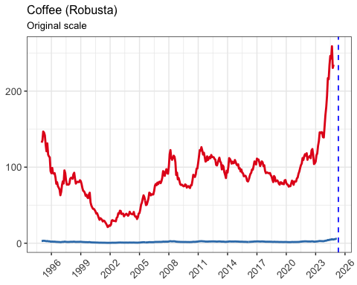

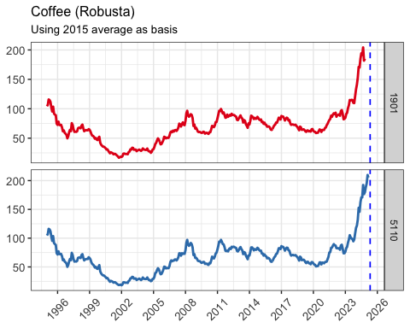

## 2.4 Wheat

| Description | Wheat (US, HRW) |
| --- | --- |
| Description (code) | wheat_us |
| Index sort | 1001 |
| Product ID | 100100.01 |
| Description (as of 2024) | Wheat, United States, n° 2 Hard Red Winter (ordinary), FOB Gulf ($/t) |
| Unit (as of 2024) | usd_per_tonne |
| Data source (2024) | 6901 International Grains Council (IGC) |
| Data source (2025) | 5110 World Bank - Commodity-markets |

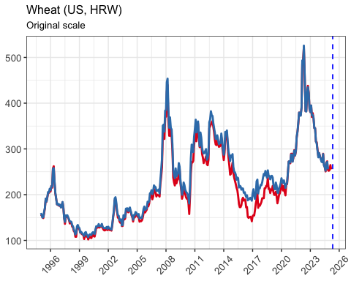

### 2.4.1 Maize

| Description | Maize |
| --- | --- |
| Description (code) | maize |
| Index sort | 1002 |
| Product ID | 100500.02 |
| Description (as of 2024) | Maize, United States, n° 3 yellow, FOB Gulf ($/t) |
| Unit (as of 2024) | usd_per_tonne |
| Data source (2024) | 6901 International Grains Council (IGC) |
| Data source (2025) | 5110 World Bank - Commodity-markets |

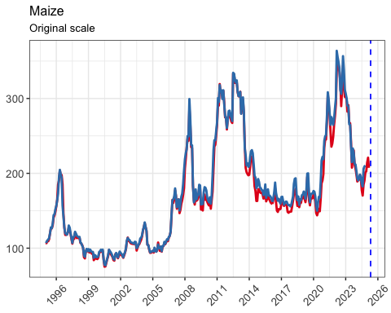

## 2.5 Sugar

| Description | Sugar (World) |
| --- | --- |
| Description (code) | sugar |
| Index sort | 1004 |
| Product ID | 170100.01 |
| Description (as of 2024) | Sugar, average of I.S.A. daily prices, FOB & Stowed, in bulk, Caribbean ports (¢/lb.) |
| Unit (as of 2024) | cent_per_lb |
| Data source (2024) | 2401 International Sugar Organization (ISO) |
| Data source (2025) | 5110 World Bank - Commodity-markets |

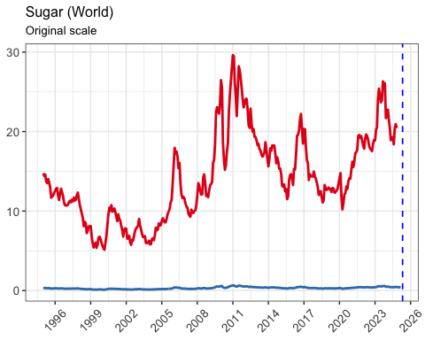

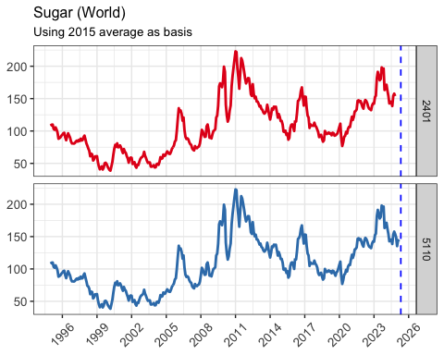

## 2.6 Cocoa

| Description | Cocoa |
| --- | --- |
| Description (code) | cocoa |
| Index sort | 1102 |
| Product ID | 180100.01 |
| Description (as of 2024) | Cocoa beans, average daily prices New York/London (¢/lb.) |
| Unit (as of 2024) | cent_per_lb |
| Data source (2024) | 1801 International Cocoa Organization (ICCO) |
| Data source (2025) | 5110 World Bank - Commodity-markets |

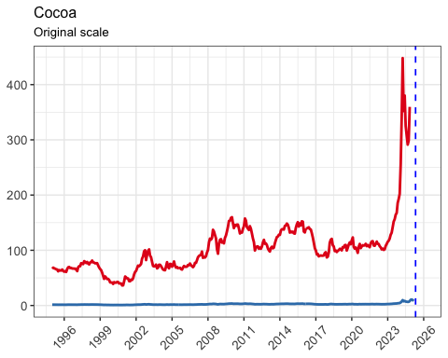

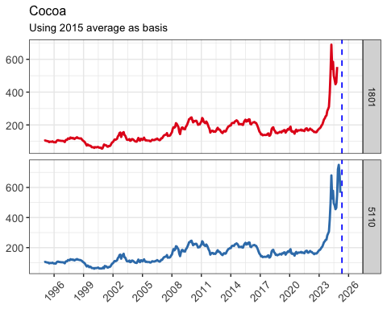

## 2.7 Tobacco

| Description | Tobacco |
| --- | --- |
| Description (code) | tobacco |
| Index sort | 2002 |
| Product ID | 240100.01 |
| Description (as of 2024) | Tobacco, unmanufactured, US import unit value ($/t) |
| Unit (as of 2024) | usd_per_tonne |
| Data source (2024) | 4901 United States Department of Agriculture (USDA) |
| Data source (2025) | 5110 World Bank - Commodity-markets |

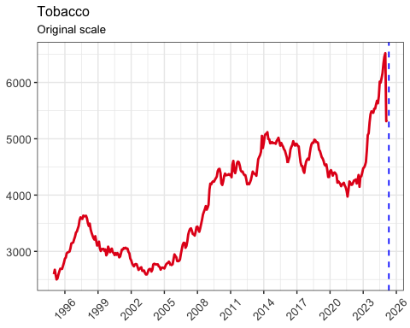

## 2.8 Iron ore

| Description | Iron ore |
| --- | --- |
| Description (code) | iron_ore |
| Index sort | 3003 |
| Product ID | 260100.02 |
| Description (as of 2024) | Iron ore, Australia to China, fines, 62% Fe, offshore export price, CIF ($/dry ton) |
| Unit (as of 2024) | usd_per_dry_tonne |
| Data source (2024) | 7901 Thomson Reuters Eikon Database |
| Data source (2025) | 5110 World Bank - Commodity-markets |

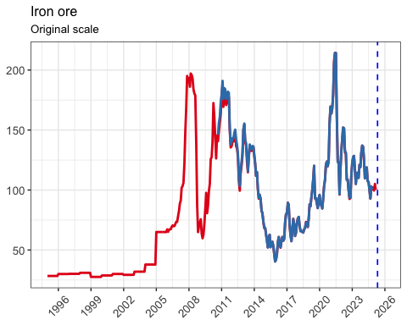

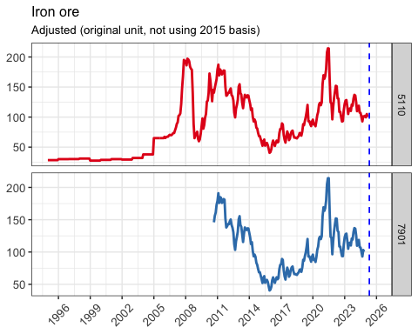

## 2.9 Manganese

Historical data is from Metal Bulletin.

New source: IMF, available from 2012.6.1. In the computation of price indices, historical data may be used to impute the missing values.

| Description | Manganese 99.7 |
| --- | --- |
| Description (code) | manganese_99 |
| Index sort | 3002 |
| Product ID | 260200.02 |
| Description (as of 2024) | Manganese 99.7% electrolytic manganese flake, free market, in warehouse ($/t) |
| Unit (as of 2024) | usd_per_tonne |
| Data source (2024) | 6801 Metal Bulletin Limited |
| Data source (2025) | 2311 IMF - Primary Commodity Prices |

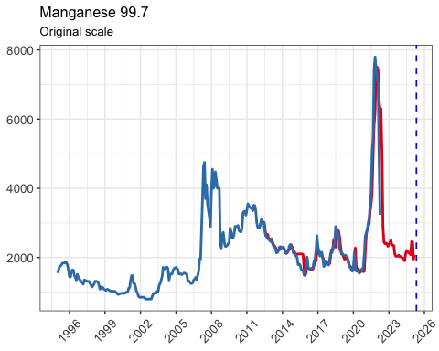

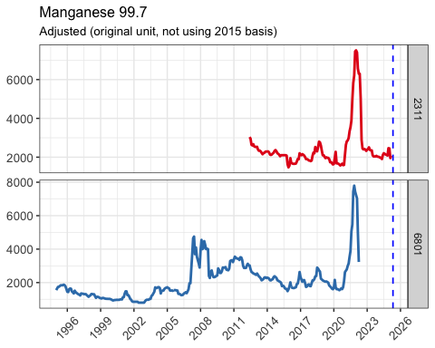

## 2.10 Copper

| Description | Copper |
| --- | --- |
| Description (code) | copper |
| Index sort | 3005 |
| Product ID | 260300.01 |
| Description (as of 2024) | Copper, grade A, electrolytic wire bars/cathodes, LME, cash (£/t) |
| Unit (as of 2024) | gbp_per_tonne |
| Data source (2024) | 6801 Metal Bulletin Limited |
| Data source (2025) | 5110 World Bank - Commodity-markets |

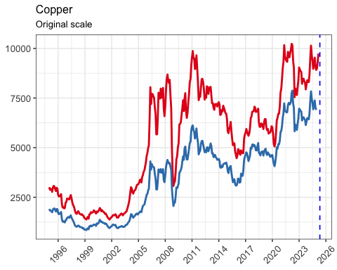

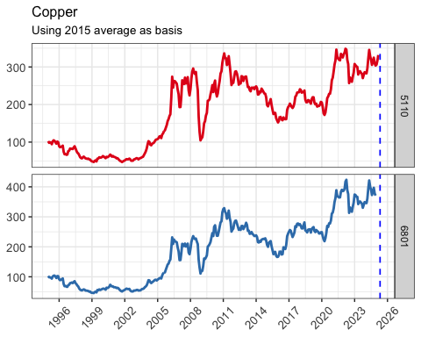

## 2.11 Nickel

| Description | Nickel |
| --- | --- |
| Description (code) | nickel |
| Index sort | 3006 |
| Product ID | 260400.01 |
| Description (as of 2024) | Nickel, LME, cash ($/t) |
| Unit (as of 2024) | usd_per_tonne |
| Data source (2024) | 6801 Metal Bulletin Limited |
| Data source (2025) | 5110 World Bank - Commodity-markets |

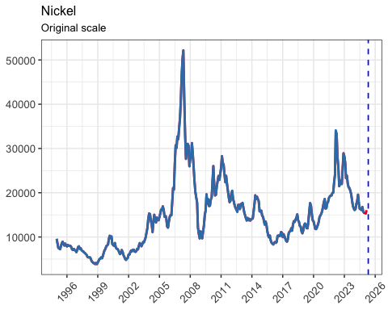

## 2.12 Aluminum

| Description | Aluminum |
| --- | --- |
| Description (code) | aluminium |
| Index sort | 3004 |
| Product ID | 260600.01 |
| Description (as of 2024) | Aluminium, primary, high grade, LME, cash ($/t) |
| Unit (as of 2024) | usd_per_tonne |
| Data source (2024) | 6801 Metal Bulletin Limited |
| Data source (2025) | 5110 World Bank - Commodity-markets |

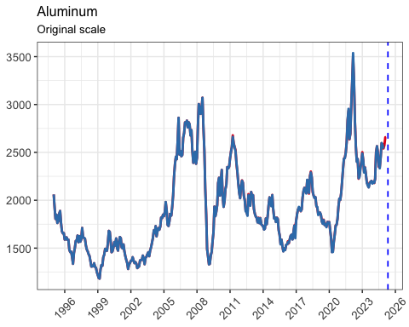

## 2.13 Lead

| Description | Lead |
| --- | --- |
| Description (code) | lead |
| Index sort | 3007 |
| Product ID | 260700.02 |
| Description (as of 2024) | Lead, LME, cash settlement ($/t) |
| Unit (as of 2024) | usd_per_tonne |
| Data source (2024) | 6801 Metal Bulletin Limited |
| Data source (2025) | 5110 World Bank - Commodity-markets |

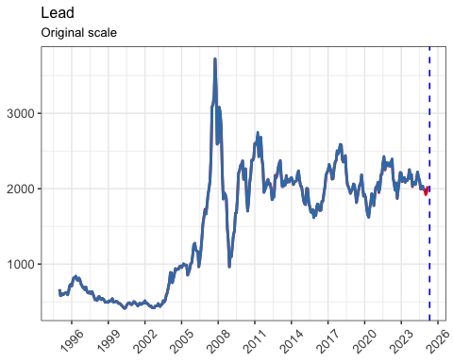

## 2.14 Zinc

| Description | Zinc |
| --- | --- |
| Description (code) | zinc |
| Index sort | 3008 |
| Product ID | 260800.01 |
| Description (as of 2024) | Zinc, special high grade, LME, cash settlement ($/t) |
| Unit (as of 2024) | usd_per_tonne |
| Data source (2024) | 6801 Metal Bulletin Limited |
| Data source (2025) | 5110 World Bank - Commodity-markets |

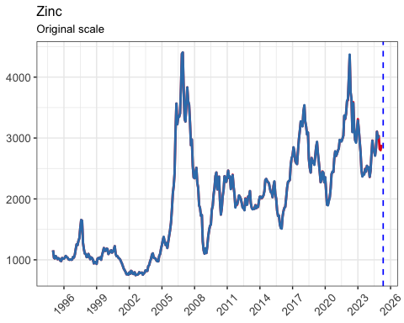

## 2.15 Tin

| Description | Tin |
| --- | --- |
| Description (code) | tin |
| Index sort | 3009 |
| Product ID | 260900.01 |
| Description (as of 2024) | Tin, LME, cash ($/t) |
| Unit (as of 2024) | usd_per_tonne |
| Data source (2024) | 6801 Metal Bulletin Limited |
| Data source (2025) | 5110 World Bank - Commodity-markets |

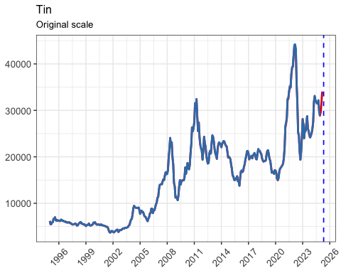

## 2.16 Silver

| Description | Silver |
| --- | --- |
| Description (code) | silver |
| Index sort | 3102 |
| Product ID | 261600.01 |
| Description (as of 2024) | Silver, 99.9%, Handy & Harman, New York (¢/troy ounce) |
| Unit (as of 2024) | usd_per_troy_ounce |
| Data source (2024) | 6801 Metal Bulletin Limited |
| Data source (2025) | 5110 World Bank - Commodity-markets |

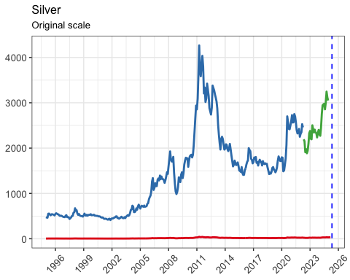

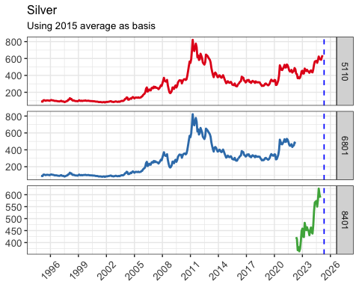

## 2.17 Coal

| Description | Coal (Australian) |
| --- | --- |
| Description (code) | coal |
| Index sort | 4101 |
| Product ID | 270100.02 |
| Description (as of 2024) | Coal, steam coal, Australia, average FOB Newcastle ($/t) |
| Unit (as of 2024) | usd_per_tonne |
| Data source (2024) | 7901 Thomson Reuters Eikon Database |
| Data source (2025) | 5110 World Bank - Commodity-markets |

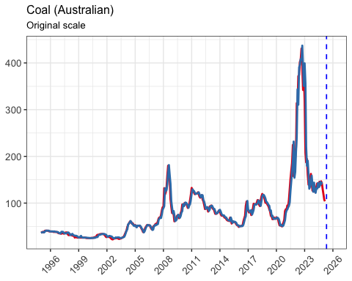

## 2.18 Rubber

Rubber has two codes in WB, RSS3 and TR

* RSS3 is available for all times
* TSR20 is available from 1999.1.1. The old source is using TSR20 in the price index computation
* We can either impute the historical TSR20, or use RSS3 instead, should not create big difference. In practice, we are using only **RSS3**.

| Description | Rubber (RS33) |
| --- | --- |
| Description (code) | rubber_rss3 |
| Index sort | 2010 |
| Product ID | 400100.02 |
| Description (as of 2024) | Rubber, RSS n°3, Singapore Commodity Exchange, 1st contract (¢/kg) |
| Unit (as of 2024) | cent_per_kg |
| Data source (2024) | 5110 World Bank - Commodity-markets |
| Data source (2025) | 5110 World Bank - Commodity-markets |

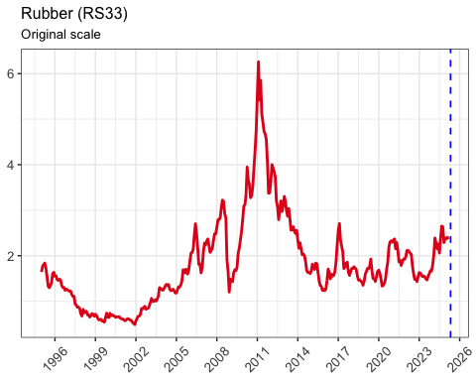

## 2.19 Hides

No comparison data, only IMF.

Available for all times.

| Description | Hides |
| --- | --- |
| Description (code) | hides |
| Index sort | 2006 |
| Product ID | 410100.01 |
| Description (as of 2024) | Cattle hides, US Chicago packer's heavy native steers, FOB shipping point (¢/lb.) |
| Unit (as of 2024) | cent_per_lb |
| Data source (2024) | 2311 IMF - Primary Commodity Prices |
| Data source (2025) | 2311 IMF - Primary Commodity Prices |

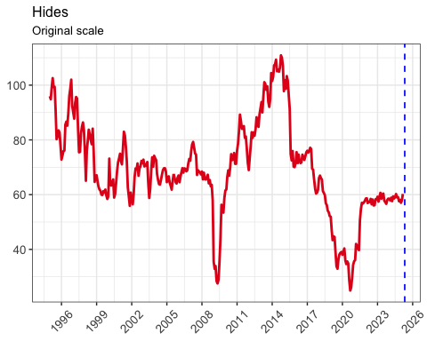

## 2.20 Wool

Historical data: 510100.02, 510100.03 available from AWI

* 510100.03 only from 2013. Fine wool
* 510100.02 only available for very short period, can drop it

New source: IMF has PWOOLF (fine) and PWOOLC (coarse) for all times. For the comparison, 510100.03 is compared with PWOOLF. For the period where they both exist, seem to overlap quite well.

For the purpose of computing the index, use PWOOLF.

| Description | Wool (fine) |
| --- | --- |
| Description (code) | wool_fine |
| Index sort | 2004 |
| Product ID | 510100.03 |
| Description (as of 2024) | Fine wool, 19 Micron, AWEX auction price, Australia ($/t) |
| Unit (as of 2024) | usd_per_tonne |
| Data source (2024) | 8001 Australian Wool Innovation (AWI) |
| Data source (2025) | 2311 IMF - Primary Commodity Prices |

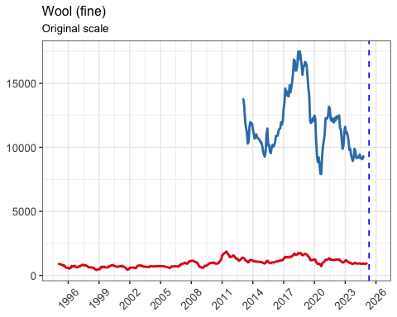

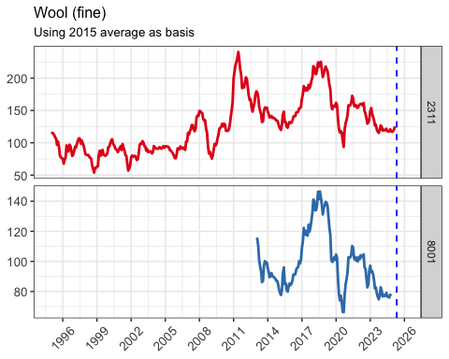

## 2.21 Jute

Jute only has one data source, which is FAO. No other historical data exists. Just use this for the computation.

Only available from 2004. In the price compilation, it may be dropped completely.

| Description | Jute |
| --- | --- |
| Description (code) | jute |
| Index sort | 2005 |
| Product ID | 530300.01 |
| Description (as of 2024) | Jute, Bangladesh, BWD, FOB Mongla ($/t) |
| Unit (as of 2024) | usd_per_tonne |
| Data source (2024) | 1603 FAO - Trade and Markets Division |
| Data source (2025) | 1603 FAO - Trade and Markets Division |

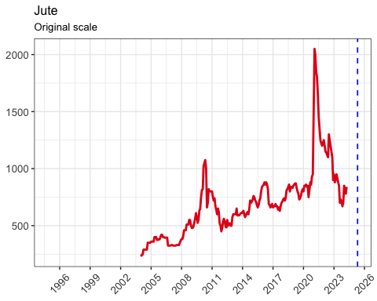

## 2.22 Gold

| Description | Gold |
| --- | --- |
| Description (code) | gold |
| Index sort | 3101 |
| Product ID | 710800.01 |
| Description (as of 2024) | Gold, 99.5% fine, afternoon fixing London ($/troy ounce) |
| Unit (as of 2024) | usd_per_troy_ounce |
| Data source (2024) | 6801 Metal Bulletin Limited |
| Data source (2025) | 5110 World Bank - Commodity-markets |

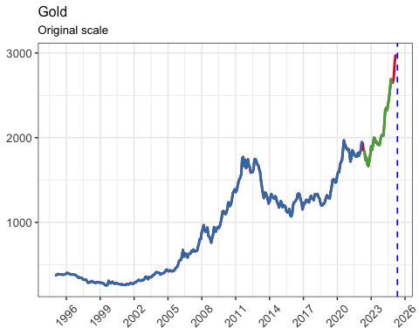

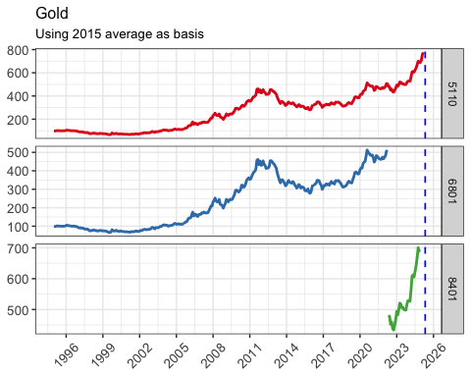

## 2.23 Platinum

| Description | Platinum |
| --- | --- |
| Description (code) | platinum |
| Index sort | 3103 |
| Product ID | 711000.01 |
| Description (as of 2024) | Platinum ($/troy ounce) |
| Unit (as of 2024) | usd_per_troy_ounce |
| Data source (2024) | 6801 Metal Bulletin Limited |
| Data source (2025) | 5110 World Bank - Commodity-markets |

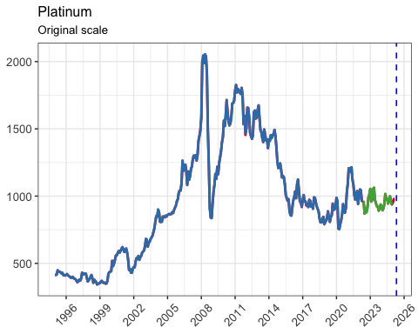

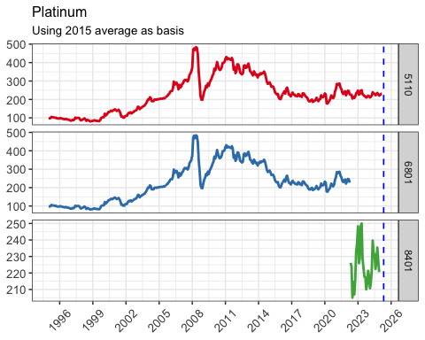

# 3. Appendix 1

| Code | Label | Label (short) |
| --- | --- | --- |
| 1603 | FAO - Trade and Markets Division | FAO |
| 1801 | International Cocoa Organization (ICCO) | ICCO |
| 1901 | International Coffee Organization (ICO) | ICO |
| 2311 | IMF - Primary Commodity Prices | IMF |
| 2401 | International Sugar Organization (ISO) | ISO |
| 4901 | United States Department of Agriculture (USDA) | USDA |
| 5001 | U.S. Geological Survey (USGS) | USGS |
| 5110 | World Bank - Commodity-markets | World Bank |
| 6701 | Oil World, ISTA Mielke GmbH | OilWorld |
| 6801 | Metal Bulletin Limited | Metal Bulletin |
| 6901 | International Grains Council (IGC) | IGC |
| 7001 | IEG Vu, Agribusiness intelligenge Informa | IEG Vu |
| 7301 | Harland M. Braun & Co. | HB |
| 7501 | International Tropical Timber Organization (ITTO) | ITTO |
| 7601 | Office for National Statistics, UK (ONS) | ONS (UK) |
| 7801 | Statistics Norway | SSB (Norway) |
| 7901 | Thomson Reuters Eikon Database | Thomson Reuters |
| 8001 | Australian Wool Innovation (AWI) | AWI |
| 8101 | Cotton Outlook | Cotton Outlook |
| 8201 | The TEX Report | TEX |
| 8301 | International Rubber Study Group (IRSG) | IRSG |