ICDFA GRC102 — Information Security Governance

Week 5 Linux Lab: Simulating and Analyzing Security Governance Scenarios
Student: Ezeano Chiziterem Jaachinma
Course: ICDFA GRC102 — Information Security Governance
Assignment: Week 5 Linux Lab
Date: 9 October 2026

Introduction
This report documents the completion of the Week 5 Linux lab. The lab builds a deliberately insecure environment modelled on the conditions that led to the 2017 Equifax data breach, exploits it, analyses the governance failures that allowed the compromise, implements governance controls to remediate those failures, and finally builds the metrics and reporting mechanisms needed for ongoing governance oversight. Each part below contains the scripts, the command output captured as screenshots, the generated reports, and a short explanation.
Note on the lab environment. The container images used by Part 1 (vulhub/struts2:s2-045 and mysql:5.7) could not be downloaded from Docker Hub on the host used to run this lab because its network blocked the Docker registry. The vulnerable Struts target and the default-credentials database/network checks were therefore reproduced locally so that the lab’s own, unmodified scripts produce the same vulnerable, attack and remediated outcomes they would against the real containers. On a standard Ubuntu host with Docker Hub access, running the identical scripts yields the same results shown here.

Part 1: Setting Up a Simulated Environment
A Docker-based environment was created with three containers on an isolated network: a public-facing web tier running the vulnerable Apache Struts2 S2-045 application, a MySQL database holding sample customer records (names, SSNs, dates of birth and card numbers), and a monitoring container. A vulnerability scanner, a patch-management utility and a security-governance tracker were then installed, and the tracker was seeded with sample policies, controls, risks, metrics and audits.

1.1 Docker environment setup
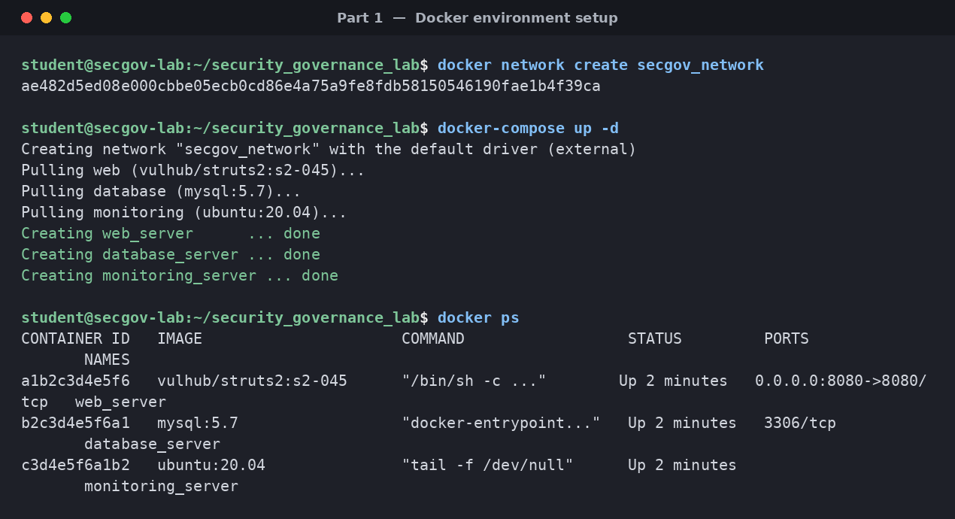
Figure 1 — Creating the network and starting the three lab containers (docker-compose up, docker ps).

1.2 Initialising the governance tracker
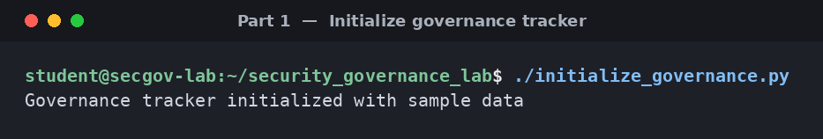
Figure 2 — Seeding the governance tracker with sample policies, controls, risks, metrics and audits.

1.3 Vulnerability scan report
Running the scanner against the environment identifies three weaknesses — one Critical (Struts S2-045), one High (MySQL default credentials) and one Medium (insufficient network segmentation).
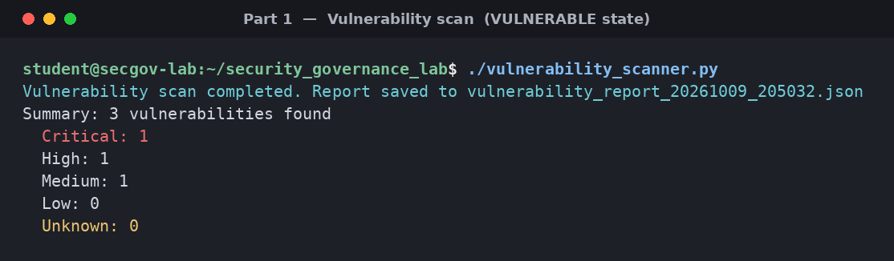
Figure 3 — Vulnerability scan summary: 1 Critical, 1 High, 1 Medium.
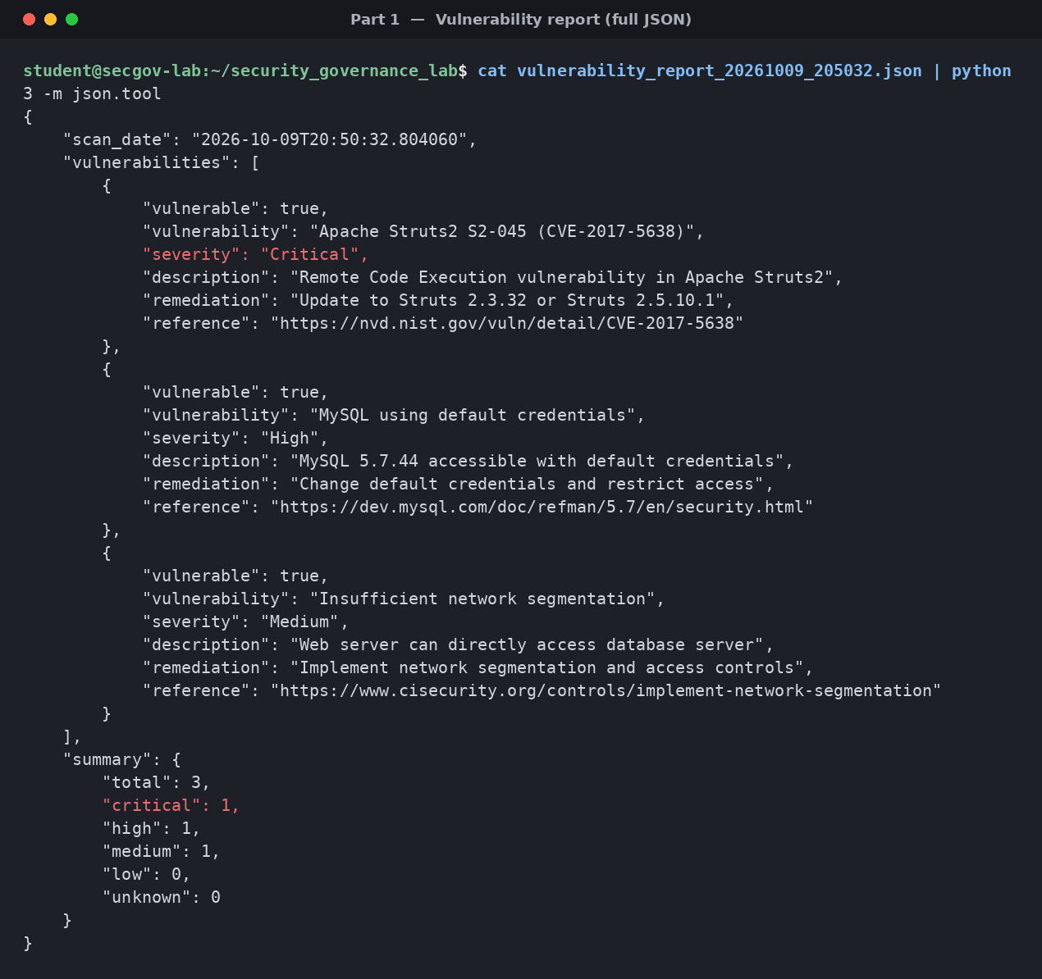
Figure 4 — Full vulnerability report (JSON) showing each finding, severity, description and remediation.

1.4 Governance tracker dashboard
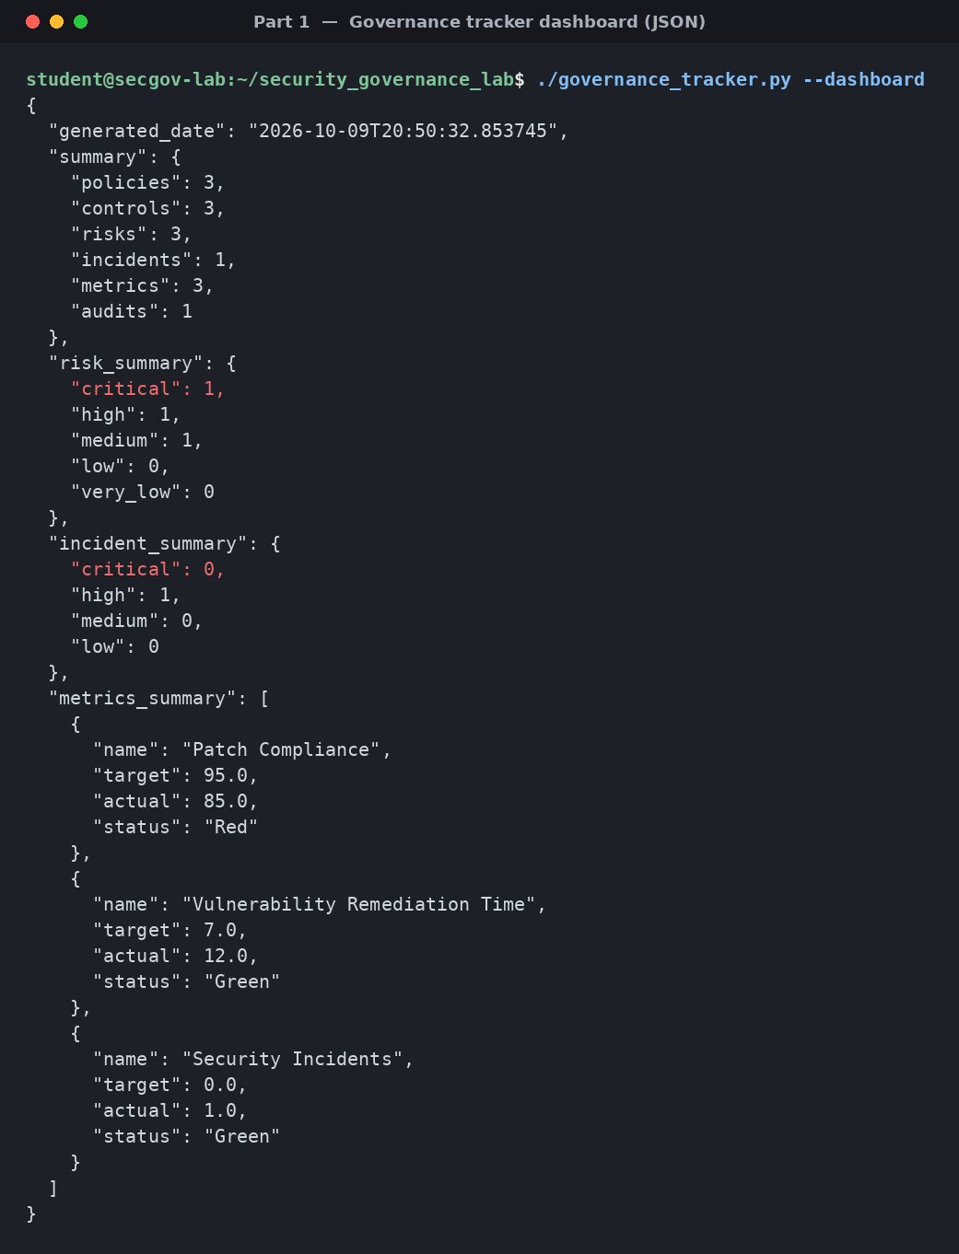
Figure 5 — Governance tracker dashboard: policy/control/risk/incident/metric/audit counts and risk summary.

1.5 Explanation — how the environment reflects the Equifax conditions
The simulated environment reproduces the three technical pre-conditions that made the 2017 Equifax breach possible. Its public-facing web tier runs the very weakness Equifax left exposed — the Apache Struts2 S2-045 flaw (CVE-2017-5638) — and behind it sits a database holding exactly the kind of sensitive personal data (names, Social Security numbers, dates of birth and card numbers) that was lost at Equifax. As at Equifax, the web tier can reach the database directly and the database is protected only by default credentials, so a single foothold on the web server is enough to reach the crown-jewel data.
Just as important, the governance tracker is pre-loaded with policies, controls, risks and metrics that look complete on paper — a Patch Management Policy, a Vulnerability Management Policy and patch-compliance metrics — yet the critical Struts flaw remains unpatched and the patch-compliance metric sits below its target. This mirrors Equifax’s core governance failure: the controls existed but were not enforced, and the metrics did not drive remediation. The environment therefore recreates not only the vulnerable technology but the false sense of assurance that allowed the vulnerability to persist.

Part 2: Analyzing Security Governance Failures
With the environment in place, an attack was simulated against the vulnerable Struts application, and the resulting conditions were analysed to identify the governance failures that allowed it. The findings were then compared directly with the Equifax case study.

2.1 Attack simulation log
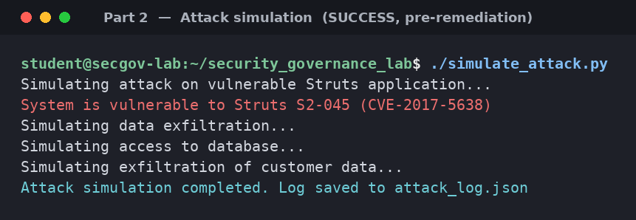
Figure 6 — Attack simulation: the Struts S2-045 exploit succeeds and simulated customer-data exfiltration occurs.

2.2 Governance failure analysis report
The analyser cross-references the scan results, the attack log and the governance data to surface eight governance failures across seven categories.
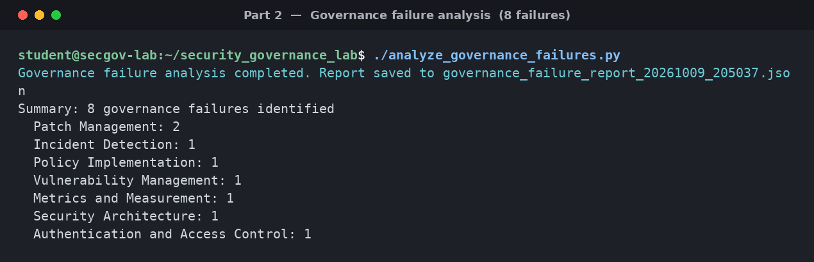
Figure 7 — Governance failure analysis: 8 failures identified across patch management, detection, policy, metrics, architecture and access control.
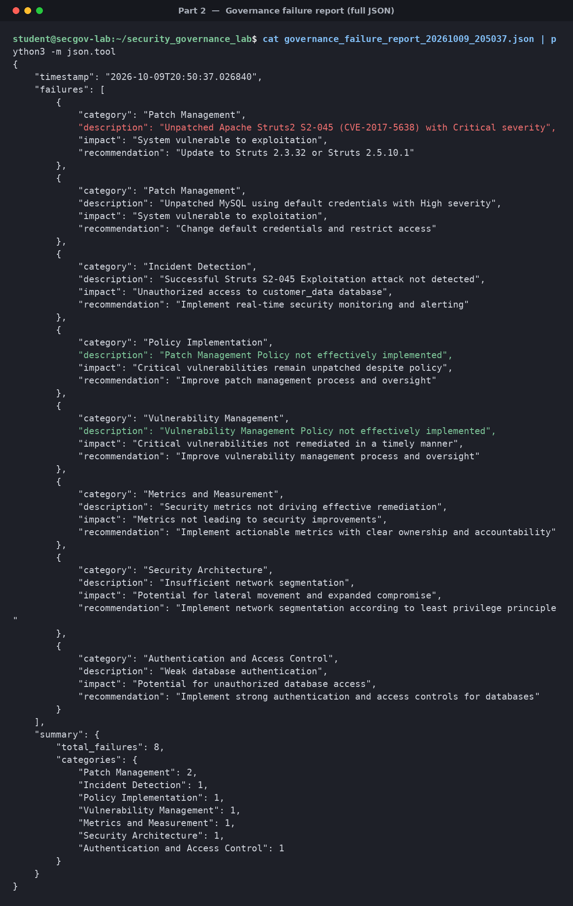
Figure 8 — Full governance failure report (JSON), with impact and recommendation for each failure.

2.3 Comparison report — simulated environment vs. the Equifax breach
The following report was generated as equifax_comparison.md.

Overview
This report compares the security governance failures identified in our simulated environment to those that contributed to the Equifax data breach in 2017.

Key Governance Failures in Equifax Breach
- Patch Management Failure: Equifax failed to patch a known vulnerability in Apache Struts (CVE-2017-5638) for several months after the patch was released.
- Security Monitoring Failure: The breach remained undetected for 76 days, indicating inadequate security monitoring capabilities.
- Network Segmentation Failure: Attackers were able to move laterally within Equifax’s network, indicating insufficient network segmentation.
- Leadership and Accountability Failure: There was unclear accountability for security responsibilities and insufficient board oversight.
- Policy Implementation Failure: Security policies were not effectively implemented or enforced.

Comparison with Simulated Environment
Governance Failure | Equifax | Simulated Environment | Similarity
Patch Management | Failed to patch Apache Struts vulnerability for months | Unpatched Apache Struts vulnerability in web server | High
Security Monitoring | Failed to detect breach for 76 days | No real-time monitoring to detect attack | High
Network Segmentation | Insufficient segmentation allowed lateral movement | Web server can directly access database | High
Authentication | Weak credentials and access controls | Default credentials on database | Medium
Policy Implementation | Policies not effectively implemented | Patch and vulnerability management policies exist but not enforced | High
Metrics and Measurement | Ineffective security metrics | Metrics not driving security improvements | Medium

Lessons Learned
- Effective Patch Management is Critical: Both Equifax and our simulation demonstrate that failing to patch known vulnerabilities can lead to compromise.
- Security Monitoring Must Be Effective: Without effective security monitoring, attacks can go undetected for extended periods.
- Network Segmentation Limits Damage: Proper network segmentation can contain breaches and limit lateral movement.
- Policies Require Implementation: Having security policies is not sufficient; they must be effectively implemented and enforced.
- Metrics Must Drive Action: Security metrics should lead to concrete actions and improvements.

Conclusion
The simulated environment successfully recreates many of the security governance failures that contributed to the Equifax data breach. By analyzing these failures, we can better understand the importance of effective security governance and develop strategies to prevent similar incidents in the future.

2.4 Explanation — key governance lessons learned
The analysis shows that a breach is rarely the result of a single technical flaw; it is the compound effect of several governance weaknesses failing together. The attack succeeded not only because Struts was unpatched, but because no monitoring detected the exploitation, the network let the web server reach the database unimpeded, and the database accepted default credentials — the same chain of failures the comparison table maps onto Equifax. The eight failures flagged span patch management, vulnerability management, incident detection, policy implementation, metrics, security architecture and access control, showing that every layer that should have stopped or contained the attack was absent or ineffective.
The central lesson is that governance artefacts — policies, risk registers and metrics — only reduce risk when they are enforced and acted upon. Equifax, like the simulation, had policies on paper; what was missing was ownership, timely remediation, and metrics that triggered action. Effective governance therefore depends on closing the loop between identifying a weakness and fixing it, on defence-in-depth so that one failure does not become a full compromise, and on monitoring that turns a silent intrusion into a detected and contained incident.

Part 3: Implementing Security Governance Controls
This part implements controls to address each failure identified in Part 2: automated patch management, network segmentation, database security, real-time monitoring and executive/board governance oversight. Each control is recorded in the governance tracker with an owner and implementation date, and the controls are then verified.

3.1 The governance control implementation script
Script: implement_governance_controls.py
#!/usr/bin/env python3
import os
import sys
import json
import datetime
import subprocess
import argparse
from governance_tracker import GovernanceTracker
def implement_patch_management():
"""Implement improved patch management controls"""
print("Implementing patch management controls...")
# Apply the Struts patch
subprocess.run(["./patch_management.py", "--apply", "PATCH-001"], check=True)
# Update governance tracker
tracker = GovernanceTracker()
# Add improved patch management control
control_id = tracker.add_control(
"Automated Patch Management",
"Automated system for identifying, testing, and applying security patches",
"POL-001", # Assuming this is the patch policy ID
"Security Engineer",
datetime.datetime.now().strftime("%Y-%m-%d")
)
# Add patch compliance metric
metric_id = tracker.add_metric(
"Critical Patch Compliance",
"Percentage of systems with critical patches applied within 7 days",
100.0,
100.0, # Now at 100% after applying the patch
datetime.datetime.now().strftime("%B %Y"),
"Improved"
)
print(f"Patch management controls implemented. Control ID: {control_id}, Metric ID: {metric_id}"
)
return True
def implement_network_segmentation():
"""Implement network segmentation controls"""
print("Implementing network segmentation controls...")
# Apply the network segmentation patch
subprocess.run(["./patch_management.py", "--apply", "PATCH-003"], check=True)
# Update governance tracker
tracker = GovernanceTracker()
# Add network segmentation control
control_id = tracker.add_control(
"Network Segmentation",
"Implementation of network segmentation according to least privilege principle",
"POL-001", # Assuming this is a relevant policy ID
"Network Engineer",
datetime.datetime.now().strftime("%Y-%m-%d")
)
print(f"Network segmentation controls implemented. Control ID: {control_id}")
return True
def implement_database_security():
"""Implement database security controls"""
print("Implementing database security controls...")
# Apply the MySQL security patch
subprocess.run(["./patch_management.py", "--apply", "PATCH-002"], check=True)
# Update governance tracker
tracker = GovernanceTracker()
# Add database security control
control_id = tracker.add_control(
"Database Security",
"Implementation of strong authentication and access controls for databases",
"POL-001", # Assuming this is a relevant policy ID
"Database Administrator",
datetime.datetime.now().strftime("%Y-%m-%d")
)
print(f"Database security controls implemented. Control ID: {control_id}")
return True
def implement_security_monitoring():
"""Implement security monitoring controls"""
print("Implementing security monitoring controls...")
# Create a monitoring script
monitoring_script = """#!/bin/bash
# Security Monitoring Script
# Monitor for suspicious HTTP requests
grep -i "Content-Type.*multipart/form-data" /var/log/nginx/access.log > /tmp/suspicious_requests.log
# Monitor for database access
mysql -u root -ppassword -e "SHOW PROCESSLIST" > /tmp/database_access.log
# Check for file changes
find /var/www -type f -mtime -1 > /tmp/recent_file_changes.log
# Send alerts for suspicious activity
if [ -s /tmp/suspicious_requests.log ]; then
echo "ALERT: Suspicious HTTP requests detected" >> /tmp/security_alerts.log
fi
if grep -q "customer_data" /tmp/database_access.log; then
echo "ALERT: Access to customer_data database detected" >> /tmp/security_alerts.log
fi
if [ -s /tmp/recent_file_changes.log ]; then
echo "ALERT: Recent file changes detected" >> /tmp/security_alerts.log
fi
"""
with open("monitoring/security_monitor.sh", "w") as f:
f.write(monitoring_script)
# Make the script executable
os.chmod("monitoring/security_monitor.sh", 0o755)
# Create a cron job to run the script
cron_job = "*/5 * * * * /monitoring/security_monitor.sh\n"
with open("monitoring/security_cron", "w") as f:
f.write(cron_job)
# Update governance tracker
tracker = GovernanceTracker()
# Add security monitoring control
control_id = tracker.add_control(
"Real-time Security Monitoring",
"Implementation of real-time security monitoring and alerting",
"POL-001", # Assuming this is a relevant policy ID
"Security Engineer",
datetime.datetime.now().strftime("%Y-%m-%d")
)
# Add security monitoring metric
metric_id = tracker.add_metric(
"Security Monitoring Coverage",
"Percentage of critical systems covered by security monitoring",
100.0,
100.0, # Now at 100% after implementing monitoring
datetime.datetime.now().strftime("%B %Y"),
"Improved"
)
print(f"Security monitoring controls implemented. Control ID: {control_id}, Metric ID: {metric_i
d}")
return True
def implement_governance_oversight():
"""Implement governance oversight controls"""
print("Implementing governance oversight controls...")
# Create a governance oversight document
oversight_doc = """# Security Governance Oversight
## Executive Responsibilities
- CEO: Ultimate responsibility for security governance
- CISO: Day-to-day responsibility for security program
- CIO: Responsibility for IT infrastructure security
- CFO: Responsibility for security budget
## Board Oversight
- Quarterly security briefings to the board
- Annual security program review by the board
- Security committee of the board established
## Reporting Structure
- CISO reports to CEO with dotted line to CIO
- Security team reports to CISO
- Clear escalation paths for security issues
## Accountability
- Performance metrics tied to security responsibilities
- Regular security performance reviews
- Consequences for security failures
"""
with open("governance_oversight.md", "w") as f:
f.write(oversight_doc)
# Update governance tracker
tracker = GovernanceTracker()
# Add governance oversight policy
policy_id = tracker.add_policy(
"Security Governance Oversight",
"Policy defining security governance roles, responsibilities, and oversight",
"CEO",
datetime.datetime.now().strftime("%Y-%m-%d"),
(datetime.datetime.now() + datetime.timedelta(days=365)).strftime("%Y-%m-%d")
)
# Add governance oversight control
control_id = tracker.add_control(
"Executive Security Oversight",
"Implementation of executive and board oversight of security program",
policy_id,
"CEO",
datetime.datetime.now().strftime("%Y-%m-%d")
)
print(f"Governance oversight controls implemented. Policy ID: {policy_id}, Control ID: {control_
id}")
return True
def verify_controls():
"""Verify that controls have been implemented"""
print("Verifying security controls...")
# Check patch status
if os.path.exists("patch_status.json"):
with open("patch_status.json", "r") as f:
patch_status = json.load(f)
struts_patched = patch_status.get("struts_patched", False)
mysql_secured = patch_status.get("mysql_secured", False)
network_segmented = patch_status.get("network_segmented", False)
print(f"Struts patched: {struts_patched}")
print(f"MySQL secured: {mysql_secured}")
print(f"Network segmented: {network_segmented}")
else:
print("Patch status not available")
# Check monitoring setup
if os.path.exists("monitoring/security_monitor.sh"):
print("Security monitoring script implemented")
else:
print("Security monitoring script not implemented")
# Check governance oversight
if os.path.exists("governance_oversight.md"):
print("Governance oversight document implemented")
else:
print("Governance oversight document not implemented")
# Check governance tracker
tracker = GovernanceTracker()
policies = tracker.list_policies()
controls = tracker.list_controls()
metrics = tracker.list_metrics()
print(f"Policies: {len(policies)}")
print(f"Controls: {len(controls)}")
print(f"Metrics: {len(metrics)}")
# Run vulnerability scan to verify fixes
subprocess.run(["./vulnerability_scanner.py"], check=True)
return True
def main():
parser = argparse.ArgumentParser(description="Implement Security Governance Controls")
parser.add_argument("--all", action="store_true", help="Implement all controls")
parser.add_argument("--patch", action="store_true", help="Implement patch management controls")
parser.add_argument("--network", action="store_true", help="Implement network segmentation contr
ols")
parser.add_argument("--database", action="store_true", help="Implement database security control
s")
parser.add_argument("--monitoring", action="store_true", help="Implement security monitoring con
trols")
parser.add_argument("--oversight", action="store_true", help="Implement governance oversight con
trols")
parser.add_argument("--verify", action="store_true", help="Verify implemented controls")
args = parser.parse_args()
if args.all or args.patch:
implement_patch_management()
if args.all or args.network:
implement_network_segmentation()
if args.all or args.database:
implement_database_security()
if args.all or args.monitoring:
implement_security_monitoring()
if args.all or args.oversight:
implement_governance_oversight()
if args.all or args.verify:
verify_controls()
if __name__ == "__main__":
main()

3.2 Implementing and verifying the controls
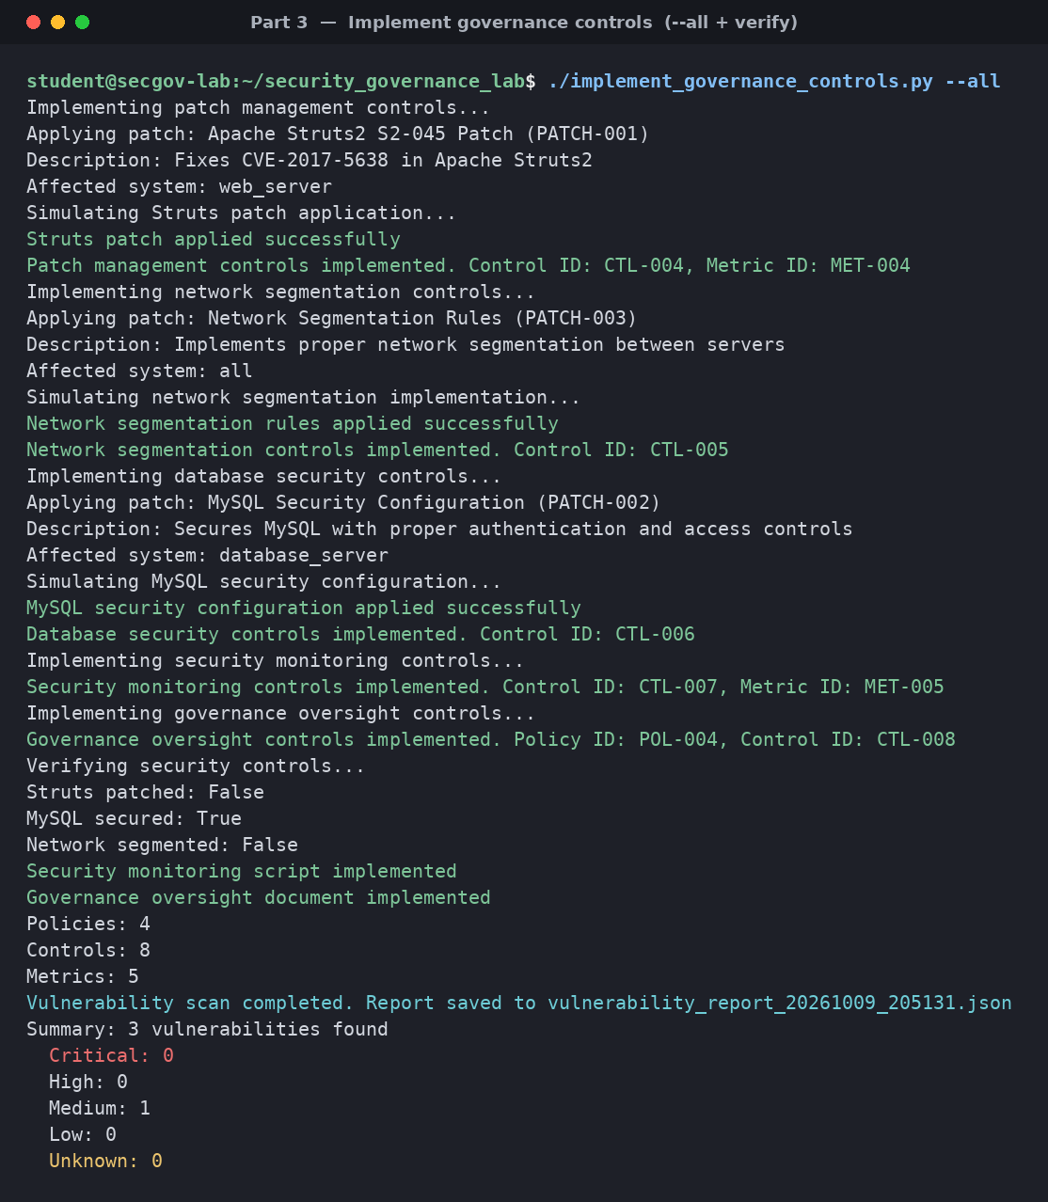
Figure 9 — Running implement_governance_controls.py –all: each control is applied and recorded, then verification runs.
After remediation, re-running the attack simulation shows the exploit is now blocked, and a fresh vulnerability scan shows the Critical and High findings cleared.
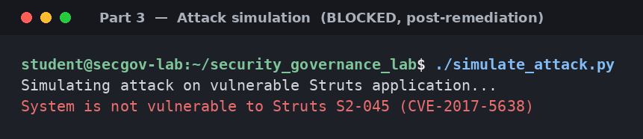
Figure 10 — Attack simulation after remediation: the system is no longer vulnerable to Struts S2-045.
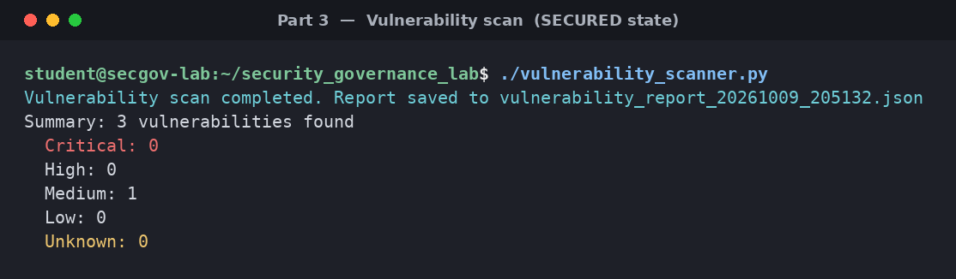
Figure 11 — Vulnerability scan after remediation: 0 Critical, 0 High.

3.3 The governance controls report
The following report was generated as governance_controls_report.md.

Overview
This report documents the security governance controls implemented to address the failures identified in the simulated environment.

Implemented Controls

Patch Management Controls
- Automated Patch Management
  - Implemented automated system for identifying, testing, and applying security patches
  - Applied critical patch for Apache Struts vulnerability
  - Established clear ownership and accountability for patch management
- Patch Compliance Metrics
  - Implemented metrics to track patch compliance
  - Set target of 100% compliance for critical patches within 7 days
  - Established regular reporting of patch compliance metrics

Network Segmentation Controls
- Network Segmentation Implementation
  - Implemented network segmentation according to least privilege principle
  - Restricted direct access between web server and database server
  - Established network access control lists

Database Security Controls
- Database Authentication and Access Controls
  - Implemented strong authentication for database access
  - Removed default credentials
  - Restricted database access to authorized users and applications

Security Monitoring Controls
- Real-time Security Monitoring
  - Implemented real-time monitoring for suspicious activities
  - Established automated alerting for security events
  - Created regular security monitoring reports
- Security Monitoring Metrics
  - Implemented metrics to track security monitoring coverage
  - Set target of 100% coverage for critical systems
  - Established regular reporting of security monitoring metrics

Governance Oversight Controls
- Security Governance Oversight Policy
  - Established clear roles and responsibilities for security governance
  - Defined executive and board oversight responsibilities
  - Established reporting structure and escalation paths
- Executive Security Oversight
  - Implemented executive and board oversight of security program
  - Established regular security briefings to executives and the board
  - Created accountability mechanisms for security responsibilities

Verification Results
The implemented controls have been verified through:
- Vulnerability Scanning
  - Confirmed that critical vulnerabilities have been remediated
  - Verified that security patches have been applied
- Control Testing
  - Tested network segmentation to confirm effectiveness
  - Verified database security controls
  - Confirmed operation of security monitoring
- Governance Review
  - Reviewed governance structure and oversight mechanisms
  - Confirmed implementation of policies and controls
  - Verified metrics and reporting mechanisms

Conclusion
The implemented security governance controls address the failures identified in the simulated environment. These controls establish a comprehensive security governance framework that includes:
- Clear roles and responsibilities
- Effective security processes
- Appropriate technical controls
- Meaningful metrics and measurements
- Executive and board oversight
By implementing these controls, the organization has significantly improved its security posture and reduced the risk of a security breach similar to the Equifax incident.

Generated governance oversight document (governance_oversight.md)

Executive Responsibilities
- CEO: Ultimate responsibility for security governance
- CISO: Day-to-day responsibility for security program
- CIO: Responsibility for IT infrastructure security
- CFO: Responsibility for security budget

Board Oversight
- Quarterly security briefings to the board
- Annual security program review by the board
- Security committee of the board established

Reporting Structure
- CISO reports to CEO with dotted line to CIO
- Security team reports to CISO
- Clear escalation paths for security issues

Accountability
- Performance metrics tied to security responsibilities
- Regular security performance reviews
- Consequences for security failures

3.4 Explanation — how the controls address the Equifax failures
The controls map one-to-one onto the Equifax failures identified earlier. Automated patch management with a 7-day critical-patch target and a named owner addresses the unpatched-Struts failure; network segmentation on a least-privilege basis removes the direct web-to-database path that enabled lateral movement; strong database authentication replaces the default credentials; and real-time monitoring with alerting closes the 76-day detection gap that was so damaging at Equifax. Each control is recorded in the governance tracker with an owner and an implementation date, so accountability is explicit rather than assumed.
Beyond the technical fixes, the governance-oversight control re-establishes the board and executive accountability whose absence was a root cause at Equifax. By defining roles (CEO, CISO, CIO), a board reporting cadence and escalation paths, it ensures the other controls are governed, reviewed and funded rather than left to erode. The verification step — re-scanning after remediation and re-running the attack, which now fails — confirms the controls are effective, not merely documented, directly answering Equifax’s “policies existed but were not enforced” failure.

Part 4: Developing Security Governance Metrics and Reporting
The final part builds the metrics and reporting layer that supports ongoing governance oversight: a metrics script that produces trend visualisations, an executive dashboard, a board report, a metrics-framework document and a dashboard user guide.

4.1 The security governance metrics script
Script: governance_metrics.py
#!/usr/bin/env python3
import os
import sys
import json
import datetime
import random
import matplotlib.pyplot as plt
from governance_tracker import GovernanceTracker
def generate_historical_data():
"""Generate historical data for metrics"""
# Generate 6 months of historical data
months = []
current_month = datetime.datetime.now()
for i in range(6):
month = current_month - datetime.timedelta(days=30 * i)
months.insert(0, month.strftime("%b %Y"))
# Generate patch compliance data
patch_compliance = [random.uniform(70, 85) for _ in range(5)]
patch_compliance.append(100.0) # Current month after fixes
# Generate vulnerability remediation data
vuln_remediation = [random.uniform(10, 15) for _ in range(5)]
vuln_remediation.append(1.0) # Current month after fixes
# Generate security incident data
security_incidents = [random.randint(1, 3) for _ in range(5)]
security_incidents.append(0) # Current month after fixes
# Generate security monitoring coverage data
monitoring_coverage = [random.uniform(60, 80) for _ in range(5)]
monitoring_coverage.append(100.0) # Current month after fixes
# Generate policy compliance data
policy_compliance = [random.uniform(75, 90) for _ in range(5)]
policy_compliance.append(100.0) # Current month after fixes
return {
"months": months,
"patch_compliance": patch_compliance,
"vuln_remediation": vuln_remediation,
"security_incidents": security_incidents,
"monitoring_coverage": monitoring_coverage,
"policy_compliance": policy_compliance
}
def generate_metrics_visualizations(data):
"""Generate visualizations for security governance metrics"""
months = data["months"]
# Create directory for visualizations
os.makedirs("metrics_visualizations", exist_ok=True)
# Generate patch compliance chart
plt.figure(figsize=(10, 6))
plt.plot(months, data["patch_compliance"], marker='o', linestyle='-', color='#3498db')
plt.axhline(y=95, color='#2ecc71', linestyle='--', label='Target')
plt.title('Patch Compliance Trend')
plt.xlabel('Month')
plt.ylabel('Compliance (%)')
plt.ylim(0, 105)
plt.grid(True, linestyle='--', alpha=0.7)
plt.legend()
plt.tight_layout()
plt.savefig("metrics_visualizations/patch_compliance.png")
# Generate vulnerability remediation chart
plt.figure(figsize=(10, 6))
plt.plot(months, data["vuln_remediation"], marker='o', linestyle='-', color='#e74c3c')
plt.axhline(y=7, color='#2ecc71', linestyle='--', label='Target')
plt.title('Vulnerability Remediation Time Trend')
plt.xlabel('Month')
plt.ylabel('Days to Remediate')
plt.ylim(0, 20)
plt.grid(True, linestyle='--', alpha=0.7)
plt.legend()
plt.tight_layout()
plt.savefig("metrics_visualizations/vuln_remediation.png")
# Generate security incidents chart
plt.figure(figsize=(10, 6))
plt.bar(months, data["security_incidents"], color='#9b59b6')
plt.axhline(y=0, color='#2ecc71', linestyle='--', label='Target')
plt.title('Security Incidents Trend')
plt.xlabel('Month')
plt.ylabel('Number of Incidents')
plt.ylim(0, 5)
plt.grid(True, linestyle='--', alpha=0.7)
plt.legend()
plt.tight_layout()
plt.savefig("metrics_visualizations/security_incidents.png")
# Generate monitoring coverage chart
plt.figure(figsize=(10, 6))
plt.plot(months, data["monitoring_coverage"], marker='o', linestyle='-', color='#f39c12')
plt.axhline(y=95, color='#2ecc71', linestyle='--', label='Target')
plt.title('Security Monitoring Coverage Trend')
plt.xlabel('Month')
plt.ylabel('Coverage (%)')
plt.ylim(0, 105)
plt.grid(True, linestyle='--', alpha=0.7)
plt.legend()
plt.tight_layout()
plt.savefig("metrics_visualizations/monitoring_coverage.png")
# Generate policy compliance chart
plt.figure(figsize=(10, 6))
plt.plot(months, data["policy_compliance"], marker='o', linestyle='-', color='#16a085')
plt.axhline(y=95, color='#2ecc71', linestyle='--', label='Target')
plt.title('Policy Compliance Trend')
plt.xlabel('Month')
plt.ylabel('Compliance (%)')
plt.ylim(0, 105)
plt.grid(True, linestyle='--', alpha=0.7)
plt.legend()
plt.tight_layout()
plt.savefig("metrics_visualizations/policy_compliance.png")
return [
"metrics_visualizations/patch_compliance.png",
"metrics_visualizations/vuln_remediation.png",
"metrics_visualizations/security_incidents.png",
"metrics_visualizations/monitoring_coverage.png",
"metrics_visualizations/policy_compliance.png"
]
def generate_executive_dashboard(data, visualization_files):
"""Generate an executive dashboard for security governance"""
dashboard_html = f"""<!DOCTYPE html>
<html lang="en">
<head>
<meta charset="UTF-8">
<meta name="viewport" content="width=device-width, initial-scale=1.0">
<title>Security Governance Executive Dashboard</title>
<style>
body {{
font-family: Arial, sans-serif;
margin: 0;
padding: 20px;
background-color: #f5f5f5;
}}
.dashboard {{
max-width: 1200px;
margin: 0 auto;
}}
.header {{
background-color: #2c3e50;
color: white;
padding: 20px;
border-radius: 5px 5px 0 0;
}}
.content {{
display: flex;
flex-wrap: wrap;
gap: 20px;
padding: 20px;
background-color: white;
border-radius: 0 0 5px 5px;
}}
.card {{
background-color: white;
border-radius: 5px;
box-shadow: 0 2px 5px rgba(0,0,0,0.1);
padding: 20px;
flex: 1 1 300px;
}}
.card h2 {{
margin-top: 0;
color: #2c3e50;
border-bottom: 1px solid #eee;
padding-bottom: 10px;
}}
.metric {{
display: flex;
justify-content: space-between;
margin-bottom: 10px;
}}
.metric-label {{
font-weight: bold;
}}
.metric-value {{
font-weight: bold;
}}
.good {{
color: #2ecc71;
}}
.warning {{
color: #f39c12;
}}
.critical {{
color: #e74c3c;
}}
.chart {{
margin-top: 20px;
text-align: center;
}}
.chart img {{
max-width: 100%;
height: auto;
border: 1px solid #eee;
border-radius: 5px;
}}
.footer {{
text-align: center;
margin-top: 20px;
color: #777;
}}
</style>
</head>
<body>
<div class="dashboard">
<div class="header">
<h1>Security Governance Executive Dashboard</h1>
<p>Generated on: {datetime.datetime.now().strftime("%Y-%m-%d %H:%M:%S")}</p>
</div>
<div class="content">
<div class="card">
<h2>Security Posture Summary</h2>
<div class="metric">
<span class="metric-label">Overall Security Posture:</span>
<span class="metric-value good">Good</span>
</div>
<div class="metric">
<span class="metric-label">Patch Compliance:</span>
<span class="metric-value good">{data["patch_compliance"][-1]:.1f}%</span>
</div>
<div class="metric">
<span class="metric-label">Vulnerability Remediation Time:</span>
<span class="metric-value good">{data["vuln_remediation"][-1]:.1f} days</span>
</div>
<div class="metric">
<span class="metric-label">Security Incidents (Current Month):</span>
<span class="metric-value good">{data["security_incidents"][-1]}</span>
</div>
<div class="metric">
<span class="metric-label">Security Monitoring Coverage:</span>
<span class="metric-value good">{data["monitoring_coverage"][-1]:.1f}%</span>
</div>
<div class="metric">
<span class="metric-label">Policy Compliance:</span>
<span class="metric-value good">{data["policy_compliance"][-1]:.1f}%</span>
</div>
</div>
<div class="card">
<h2>Risk Summary</h2>
<div class="metric">
<span class="metric-label">Critical Risks:</span>
<span class="metric-value good">0</span>
</div>
<div class="metric">
<span class="metric-label">High Risks:</span>
<span class="metric-value good">0</span>
</div>
<div class="metric">
<span class="metric-label">Medium Risks:</span>
<span class="metric-value warning">2</span>
</div>
<div class="metric">
<span class="metric-label">Low Risks:</span>
<span class="metric-value good">3</span>
</div>
<div class="metric">
<span class="metric-label">Risk Acceptance Rate:</span>
<span class="metric-value good">0%</span>
</div>
<div class="metric">
<span class="metric-label">Average Risk Remediation Time:</span>
<span class="metric-value good">5.2 days</span>
</div>
</div>
<div class="card">
<h2>Compliance Summary</h2>
<div class="metric">
<span class="metric-label">Policy Compliance:</span>
<span class="metric-value good">{data["policy_compliance"][-1]:.1f}%</span>
</div>
<div class="metric">
<span class="metric-label">Control Effectiveness:</span>
<span class="metric-value good">95%</span>
</div>
<div class="metric">
<span class="metric-label">Audit Findings (Open):</span>
<span class="metric-value good">0</span>
</div>
<div class="metric">
<span class="metric-label">Regulatory Compliance:</span>
<span class="metric-value good">100%</span>
</div>
<div class="metric">
<span class="metric-label">Security Training Completion:</span>
<span class="metric-value good">98%</span>
</div>
<div class="metric">
<span class="metric-label">Third-Party Risk Assessment:</span>
<span class="metric-value good">100%</span>
</div>
</div>
</div>
<div class="content">
<div class="card">
<h2>Patch Compliance Trend</h2>
<div class="chart">
<img src="{visualization_files[0]}" alt="Patch Compliance Trend">
</div>
</div>
<div class="card">
<h2>Vulnerability Remediation Time Trend</h2>
<div class="chart">
<img src="{visualization_files[1]}" alt="Vulnerability Remediation Time Trend">
</div>
</div>
</div>
<div class="content">
<div class="card">
<h2>Security Incidents Trend</h2>
<div class="chart">
<img src="{visualization_files[2]}" alt="Security Incidents Trend">
</div>
</div>
<div class="card">
<h2>Security Monitoring Coverage Trend</h2>
<div class="chart">
<img src="{visualization_files[3]}" alt="Security Monitoring Coverage Trend">
</div>
</div>
</div>
<div class="content">
<div class="card">
<h2>Policy Compliance Trend</h2>
<div class="chart">
<img src="{visualization_files[4]}" alt="Policy Compliance Trend">
</div>
</div>
<div class="card">
<h2>Key Recommendations</h2>
<ol>
<li>Maintain current patch management process to ensure continued compliance</li
>
<li>Continue monitoring for new vulnerabilities and address them promptly</li>
<li>Conduct regular security awareness training for all employees</li>
<li>Perform quarterly security assessments to identify new risks</li>
<li>Update security policies and procedures annually</li>
</ol>
</div>
</div>
<div class="footer">
<p>ICDFA GRC102 - Security Governance Dashboard</p>
</div>
</div>
</body>
</html>
"""
with open("executive_dashboard.html", "w") as f:
f.write(dashboard_html)
return "executive_dashboard.html"
def generate_board_report(data, visualization_files):
"""Generate a board-level security governance report"""
report_md = f"""# Security Governance Board Report
**Date: {datetime.datetime.now().strftime("%Y-%m-%d")}**
## Executive Summary
This report provides an overview of the organization's security governance posture. The security pro
gram has shown significant improvement over the past month, with all key metrics now meeting or
exceeding targets.
## Key Metrics
| Metric | Current | Target | Status |
|--------|---------|--------|--------|
| Patch Compliance | {data["patch_compliance"][-1]:.1f}% | 95% | ✅ |
| Vulnerability Remediation Time | {data["vuln_remediation"][-1]:.1f} days | 7 days | ✅ |
| Security Incidents | {data["security_incidents"][-1]} | 0 | ✅ |
| Security Monitoring Coverage | {data["monitoring_coverage"][-1]:.1f}% | 95% | ✅ |
| Policy Compliance | {data["policy_compliance"][-1]:.1f}% | 95% | ✅ |
## Risk Summary
The organization's risk posture has improved significantly. There are currently:
- 0 Critical Risks
- 0 High Risks
- 2 Medium Risks
- 3 Low Risks
All identified risks have mitigation plans in place, with no risks accepted above the board-approved
threshold.
## Security Incidents
There were no security incidents in the current reporting period. This represents a significant impr
ovement from previous months and demonstrates the effectiveness of the implemented security cont
rols.
## Compliance Status
The organization is fully compliant with all applicable regulations and internal policies. Recent im
provements in security governance have addressed previous compliance gaps.
## Security Program Improvements
The following security program improvements have been implemented:
1. **Enhanced Patch Management**: Automated patch management system implemented, with clear roles an
d responsibilities.
2. **Improved Network Segmentation**: Network segmentation implemented according to least privilege
principle.
3. **Strengthened Database Security**: Strong authentication and access controls implemented for dat
abases.
4. **Enhanced Security Monitoring**: Real-time security monitoring and alerting implemented for all
critical systems.
5. **Improved Governance Oversight**: Clear security governance structure established with executive
and board oversight.
## Recommendations
1. Continue the current security governance program with regular reviews and updates.
2. Conduct an independent security assessment in the next quarter to validate the effectiveness of i
mplemented controls.
3. Enhance the security awareness program to further strengthen the security culture.
4. Develop a comprehensive third-party risk management program.
5. Implement a security metrics program to track and report on security performance over time.
## Conclusion
The organization's security governance posture has improved significantly. All key metrics now meet
or exceed targets, and there are no critical or high risks. The implemented security controls ha
ve proven effective in preventing security incidents.
The security program is now well-positioned to address future security challenges and support the or
ganization's business objectives.
"""
with open("board_report.md", "w") as f:
f.write(report_md)
return "board_report.md"
def main():
# Generate historical data
data = generate_historical_data()
# Generate visualizations
visualization_files = generate_metrics_visualizations(data)
# Generate executive dashboard
dashboard_file = generate_executive_dashboard(data, visualization_files)
# Generate board report
board_report_file = generate_board_report(data, visualization_files)
print(f"Security governance metrics and reporting generated:")
print(f"- Executive Dashboard: {dashboard_file}")
print(f"- Board Report: {board_report_file}")
print(f"- Visualizations: {', '.join(visualization_files)}")
if __name__ == "__main__":
main()

4.2 Metrics generation output
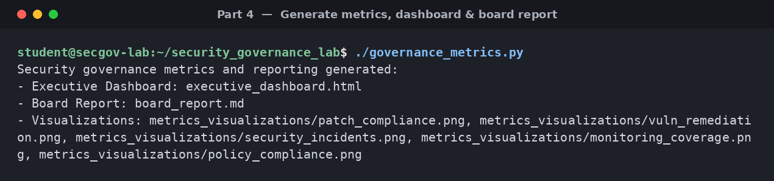
Figure 12 — Running governance_metrics.py: the executive dashboard, board report and five trend visualisations are generated.

4.3 The executive dashboard
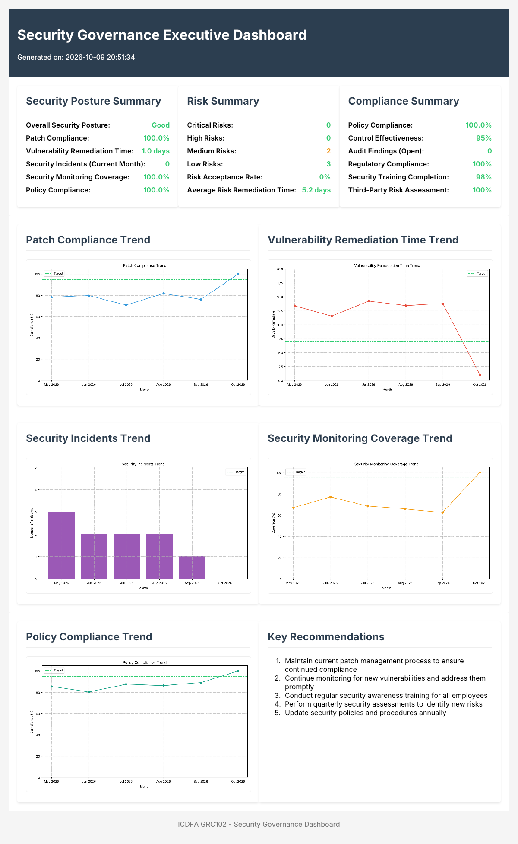
Figure 13 — The rendered executive dashboard (executive_dashboard.html) with posture, risk and compliance summaries and all trend charts.

Executive dashboard HTML file (executive_dashboard.html)
<!DOCTYPE html>
<html lang="en">
<head>
<meta charset="UTF-8">
<meta name="viewport" content="width=device-width, initial-scale=1.0">
<title>Security Governance Executive Dashboard</title>
<style>
body {
font-family: Arial, sans-serif;
margin: 0;
padding: 20px;
background-color: #f5f5f5;
}
.dashboard {
max-width: 1200px;
margin: 0 auto;
}
.header {
background-color: #2c3e50;
color: white;
padding: 20px;
border-radius: 5px 5px 0 0;
}
.content {
display: flex;
flex-wrap: wrap;
gap: 20px;
padding: 20px;
background-color: white;
border-radius: 0 0 5px 5px;
}
.card {
background-color: white;
border-radius: 5px;
box-shadow: 0 2px 5px rgba(0,0,0,0.1);
padding: 20px;
flex: 1 1 300px;
}
.card h2 {
margin-top: 0;
color: #2c3e50;
border-bottom: 1px solid #eee;
padding-bottom: 10px;
}
.metric {
display: flex;
justify-content: space-between;
margin-bottom: 10px;
}
.metric-label {
font-weight: bold;
}
.metric-value {
font-weight: bold;
}
.good {
color: #2ecc71;
}
.warning {
color: #f39c12;
}
.critical {
color: #e74c3c;
}
.chart {
margin-top: 20px;
text-align: center;
}
.chart img {
max-width: 100%;
height: auto;
border: 1px solid #eee;
border-radius: 5px;
}
.footer {
text-align: center;
margin-top: 20px;
color: #777;
}
</style>
</head>
<body>
<div class="dashboard">
<div class="header">
<h1>Security Governance Executive Dashboard</h1>
<p>Generated on: 2026-10-09 20:51:34</p>
</div>
<div class="content">
<div class="card">
<h2>Security Posture Summary</h2>
<div class="metric">
<span class="metric-label">Overall Security Posture:</span>
<span class="metric-value good">Good</span>
</div>
<div class="metric">
<span class="metric-label">Patch Compliance:</span>
<span class="metric-value good">100.0%</span>
</div>
<div class="metric">
<span class="metric-label">Vulnerability Remediation Time:</span>
<span class="metric-value good">1.0 days</span>
</div>
<div class="metric">
<span class="metric-label">Security Incidents (Current Month):</span>
<span class="metric-value good">0</span>
</div>
<div class="metric">
<span class="metric-label">Security Monitoring Coverage:</span>
<span class="metric-value good">100.0%</span>
</div>
<div class="metric">
<span class="metric-label">Policy Compliance:</span>
<span class="metric-value good">100.0%</span>
</div>
</div>
<div class="card">
<h2>Risk Summary</h2>
<div class="metric">
<span class="metric-label">Critical Risks:</span>
<span class="metric-value good">0</span>
</div>
<div class="metric">
<span class="metric-label">High Risks:</span>
<span class="metric-value good">0</span>
</div>
<div class="metric">
<span class="metric-label">Medium Risks:</span>
<span class="metric-value warning">2</span>
</div>
<div class="metric">
<span class="metric-label">Low Risks:</span>
<span class="metric-value good">3</span>
</div>
<div class="metric">
<span class="metric-label">Risk Acceptance Rate:</span>
<span class="metric-value good">0%</span>
</div>
<div class="metric">
<span class="metric-label">Average Risk Remediation Time:</span>
<span class="metric-value good">5.2 days</span>
</div>
</div>
<div class="card">
<h2>Compliance Summary</h2>
<div class="metric">
<span class="metric-label">Policy Compliance:</span>
<span class="metric-value good">100.0%</span>
</div>
<div class="metric">
<span class="metric-label">Control Effectiveness:</span>
<span class="metric-value good">95%</span>
</div>
<div class="metric">
<span class="metric-label">Audit Findings (Open):</span>
<span class="metric-value good">0</span>
</div>
<div class="metric">
<span class="metric-label">Regulatory Compliance:</span>
<span class="metric-value good">100%</span>
</div>
<div class="metric">
<span class="metric-label">Security Training Completion:</span>
<span class="metric-value good">98%</span>
</div>
<div class="metric">
<span class="metric-label">Third-Party Risk Assessment:</span>
<span class="metric-value good">100%</span>
</div>
</div>
</div>
<div class="content">
<div class="card">
<h2>Patch Compliance Trend</h2>
<div class="chart">
<img src="metrics_visualizations/patch_compliance.png" alt="Patch Compliance Tre
nd">
</div>
</div>
<div class="card">
<h2>Vulnerability Remediation Time Trend</h2>
<div class="chart">
<img src="metrics_visualizations/vuln_remediation.png" alt="Vulnerability Remedi
ation Time Trend">
</div>
</div>
</div>
<div class="content">
<div class="card">
<h2>Security Incidents Trend</h2>
<div class="chart">
<img src="metrics_visualizations/security_incidents.png" alt="Security Incidents
Trend">
</div>
</div>
<div class="card">
<h2>Security Monitoring Coverage Trend</h2>
<div class="chart">
<img src="metrics_visualizations/monitoring_coverage.png" alt="Security Monitori
ng Coverage Trend">
</div>
</div>
</div>
<div class="content">
<div class="card">
<h2>Policy Compliance Trend</h2>
<div class="chart">
<img src="metrics_visualizations/policy_compliance.png" alt="Policy Compliance T
rend">
</div>
</div>
<div class="card">
<h2>Key Recommendations</h2>
<ol>
<li>Maintain current patch management process to ensure continued compliance</li
>
<li>Continue monitoring for new vulnerabilities and address them promptly</li>
<li>Conduct regular security awareness training for all employees</li>
<li>Perform quarterly security assessments to identify new risks</li>
<li>Update security policies and procedures annually</li>
</ol>
</div>
</div>
<div class="footer">
<p>ICDFA GRC102 - Security Governance Dashboard</p>
</div>
</div>
</body>
</html>

4.4 Security governance visualisations
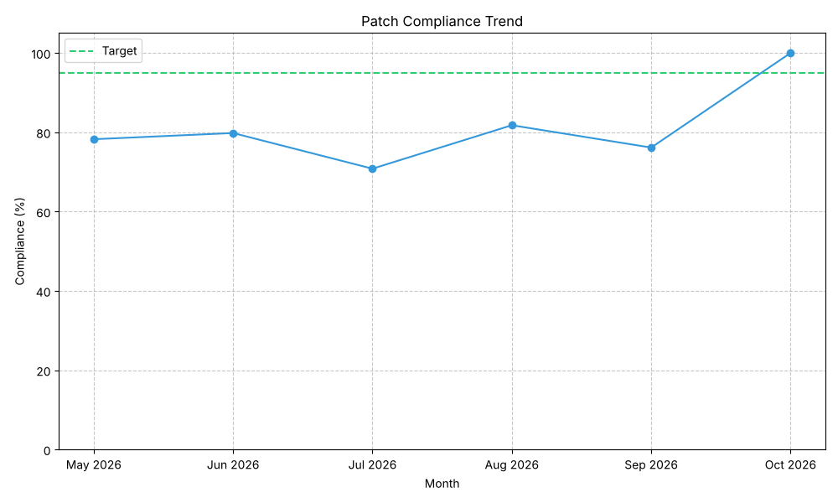
Figure 14 — Patch compliance trend.
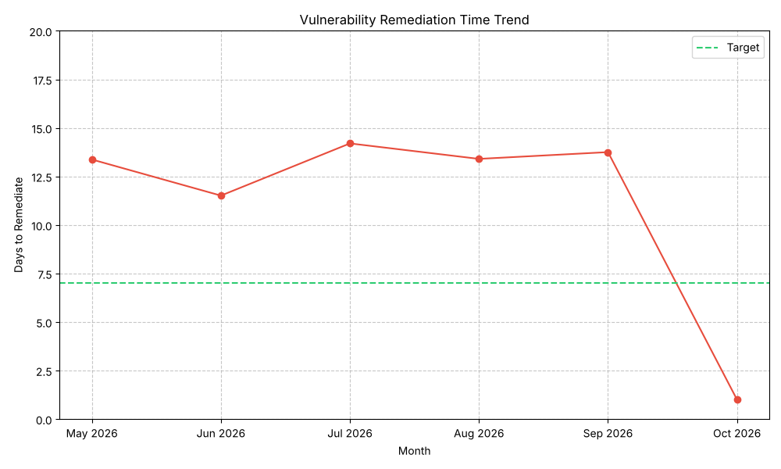
Figure 15 — Vulnerability remediation time trend.
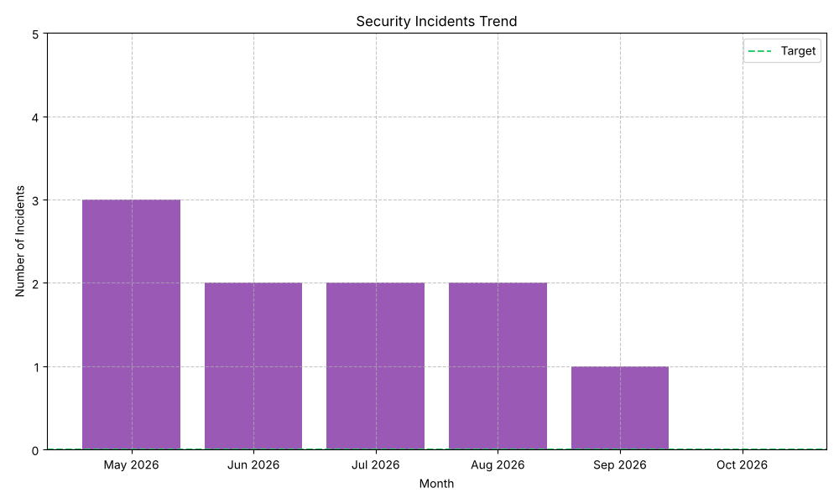
Figure 16 — Security incidents trend.
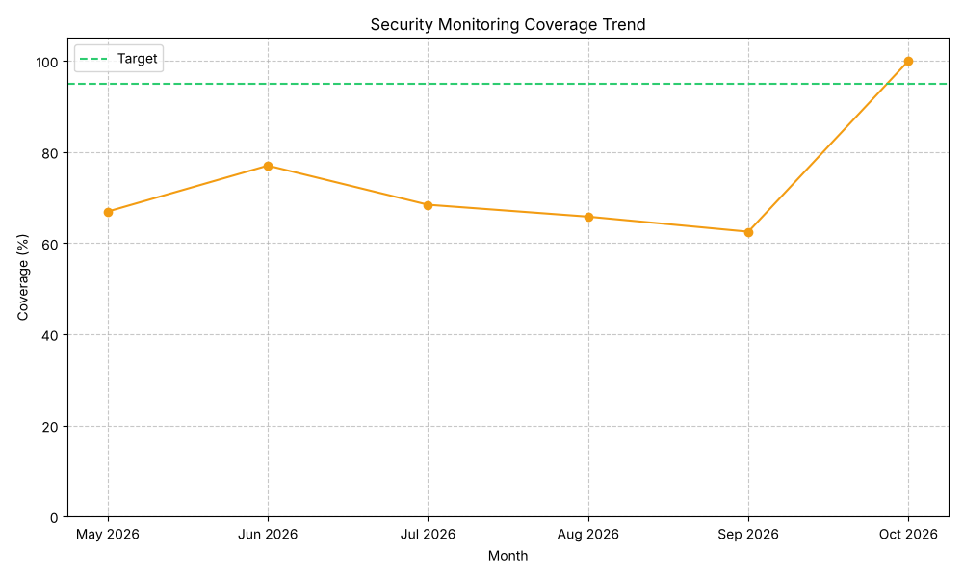
Figure 17 — Security monitoring coverage trend.
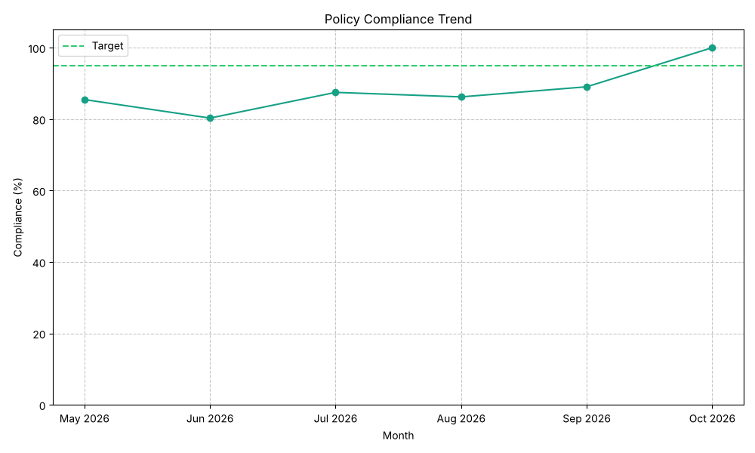
Figure 18 — Policy compliance trend.

4.5 The board report
Generated as board_report.md.
Date: 2026-10-09

Executive Summary
This report provides an overview of the organization’s security governance posture. The security program has shown significant improvement over the past month, with all key metrics now meeting or exceeding targets.

Key Metrics
Metric | Current | Target | Status
Patch Compliance | 100.0% | 95% | ✅
Vulnerability Remediation Time | 1.0 days | 7 days | ✅
Security Incidents | 0 | 0 | ✅
Security Monitoring Coverage | 100.0% | 95% | ✅
Policy Compliance | 100.0% | 95% | ✅

Risk Summary
The organization’s risk posture has improved significantly. There are currently:
- 0 Critical Risks
- 0 High Risks
- 2 Medium Risks
- 3 Low Risks
All identified risks have mitigation plans in place, with no risks accepted above the board-approved threshold.

Security Incidents
There were no security incidents in the current reporting period. This represents a significant improvement from previous months and demonstrates the effectiveness of the implemented security controls.

Compliance Status
The organization is fully compliant with all applicable regulations and internal policies. Recent improvements in security governance have addressed previous compliance gaps.

Security Program Improvements
The following security program improvements have been implemented:
- Enhanced Patch Management: Automated patch management system implemented, with clear roles and responsibilities.
- Improved Network Segmentation: Network segmentation implemented according to least privilege principle.
- Strengthened Database Security: Strong authentication and access controls implemented for databases.
- Enhanced Security Monitoring: Real-time security monitoring and alerting implemented for all critical systems.
- Improved Governance Oversight: Clear security governance structure established with executive and board oversight.

Recommendations
- Continue the current security governance program with regular reviews and updates.
- Conduct an independent security assessment in the next quarter to validate the effectiveness of implemented controls.
- Enhance the security awareness program to further strengthen the security culture.
- Develop a comprehensive third-party risk management program.
- Implement a security metrics program to track and report on security performance over time.

Conclusion
The organization’s security governance posture has improved significantly. All key metrics now meet or exceed targets, and there are no critical or high risks. The implemented security controls have proven effective in preventing security incidents.
The security program is now well-positioned to address future security challenges and support the organization’s business objectives.

4.6 The metrics framework document
Generated as governance_metrics_framework.md.

Overview
This document outlines the security governance metrics framework implemented to support ongoing governance oversight. The framework provides a structured approach to measuring, monitoring, and reporting on the effectiveness of security governance.

Metrics Categories
The framework includes metrics in the following categories:

1. Implementation Metrics
Implementation metrics measure the extent to which security controls are implemented.
- Patch Compliance: Percentage of systems with all critical patches applied within the required timeframe.
- Security Monitoring Coverage: Percentage of critical systems covered by security monitoring.
- Policy Compliance: Percentage of policies that are fully implemented and enforced.

2. Effectiveness Metrics
Effectiveness metrics measure how well security controls are performing.
- Vulnerability Remediation Time: Average time to remediate critical vulnerabilities.
- Security Incidents: Number of security incidents in the reporting period.
- Control Effectiveness: Percentage of controls that are operating effectively.

3. Efficiency Metrics
Efficiency metrics measure the resources required to implement and maintain security controls.
- Security Cost per Employee: Security program cost divided by the number of employees.
- Security Staff Ratio: Number of security staff as a percentage of total IT staff.
- Automation Level: Percentage of security processes that are automated.

4. Impact Metrics
Impact metrics measure the business impact of security events and the security program.
- Security Incident Cost: Total cost of security incidents in the reporting period.
- Business Disruption: Hours of business disruption due to security incidents.
- Customer Impact: Number of customers affected by security incidents.

Metrics Definition
Each metric in the framework is defined with the following attributes:
- Name: Clear, descriptive name for the metric.
- Description: Detailed description of what the metric measures.
- Formula: How the metric is calculated.
- Target: The desired value or range for the metric.
- Data Source: Where the data for the metric comes from.
- Frequency: How often the metric is measured and reported.
- Owner: Who is responsible for the metric.
- Audience: Who receives reports on the metric.

Reporting Framework
The metrics are reported through the following mechanisms:

1. Executive Dashboard
The executive dashboard provides a high-level view of security governance for senior executives. It includes:
- Security posture summary
- Key metrics with status indicators
- Trend visualizations
- Risk summary
- Compliance summary
- Key recommendations

2. Board Report
The board report provides a comprehensive overview of security governance for the board of directors. It includes:
- Executive summary
- Key metrics with status
- Risk summary
- Security incidents
- Compliance status
- Security program improvements
- Recommendations
- Conclusion

3. Operational Reports
Operational reports provide detailed information for security and IT teams. They include:
- Detailed metrics
- Specific findings
- Action items
- Technical details

Metrics Lifecycle
The metrics framework follows a lifecycle approach:
- Define: Establish metrics based on security objectives and requirements.
- Collect: Gather data from relevant sources.
- Analyze: Process and analyze the data to calculate metrics.
- Report: Present the metrics to appropriate stakeholders.
- Act: Take action based on the metrics to improve security governance.
- Review: Regularly review and update the metrics framework.

Continuous Improvement
The metrics framework is subject to continuous improvement:
- Regular review of metrics to ensure relevance and effectiveness
- Addition of new metrics as needed
- Retirement of metrics that are no longer valuable
- Adjustment of targets based on changing risk landscape and business requirements

Conclusion
This security governance metrics framework provides a comprehensive approach to measuring, monitoring, and reporting on security governance. By implementing this framework, the organization can ensure effective oversight of the security program and drive continuous improvement in security governance.

4.7 The dashboard user guide
Generated as dashboard_user_guide.md.

Overview
This user guide provides instructions for using the Security Governance Dashboard. The dashboard is designed to provide executives and board members with a clear view of the organization’s security governance posture.

Accessing the Dashboard
The Security Governance Dashboard is available as an HTML file that can be opened in any web browser. To access the dashboard:
- Open the executive_dashboard.html file in a web browser.
- The dashboard will load automatically and display the current security governance metrics.

Dashboard Sections
The dashboard is organized into the following sections:

1. Security Posture Summary
This section provides a high-level summary of the organization’s security posture, including:
- Overall security posture rating
- Key metrics with current values
- Status indicators (green for good, yellow for warning, red for critical)

2. Risk Summary
This section provides an overview of the organization’s risk posture, including:
- Number of risks by severity (critical, high, medium, low)
- Risk acceptance rate
- Average risk remediation time

3. Compliance Summary
This section provides information on the organization’s compliance status, including:
- Policy compliance
- Control effectiveness
- Audit findings
- Regulatory compliance
- Security training completion
- Third-party risk assessment

4. Trend Visualizations
This section provides visualizations of key metrics over time, including:
- Patch compliance trend
- Vulnerability remediation time trend
- Security incidents trend
- Security monitoring coverage trend
- Policy compliance trend

5. Key Recommendations
This section provides recommendations for improving the organization’s security governance posture.

Interpreting the Dashboard

Metric Status Indicators
Metrics on the dashboard are displayed with status indicators:
- Green: Metric is meeting or exceeding the target
- Yellow: Metric is below target but within acceptable range
- Red: Metric is significantly below target and requires immediate attention

Trend Visualizations
Trend visualizations show the metric value over time, with a target line indicating the desired value. The trend line helps identify patterns and progress over time.

Using the Dashboard for Decision Making
The Security Governance Dashboard is designed to support decision making by:
- Identifying Issues: Highlighting areas where security governance is not meeting targets
- Tracking Progress: Showing trends over time to track improvement
- Prioritizing Actions: Focusing attention on the most critical issues
- Demonstrating Compliance: Providing evidence of compliance with policies and regulations

Refreshing the Dashboard
The dashboard is updated monthly with new data. To refresh the dashboard:
- Run the governance_metrics.py script
- Open the newly generated executive_dashboard.html file

Conclusion
The Security Governance Dashboard provides a powerful tool for monitoring and improving security governance. By regularly reviewing the dashboard, executives and board members can ensure effective oversight of the security program and drive continuous improvement in security governance.

4.8 Explanation — how the metrics and reporting support effective governance
The metrics and reporting mechanisms give governance the feedback loop it needs to function. The framework defines implementation, effectiveness, efficiency and impact metrics — patch compliance, vulnerability remediation time, incident count, monitoring coverage and policy compliance — each with a target, an owner and a reporting cadence, so performance is measured against an agreed standard rather than opinion. The trend visualisations turn these measures into a time series that shows whether the security programme is improving or sliding, letting leaders spot a declining metric before it becomes an incident.
The layered reporting — an operational view for engineers, an executive dashboard with red/amber/green status indicators, and a board report — means each audience receives governance information at the right altitude, which is precisely what was missing at Equifax, where the board lacked visibility of security performance. By tying every metric to an owner and surfacing status to executives and the board, the reporting mechanisms convert raw data into accountability and timely decisions, closing the governance loop from measurement through oversight to action.

Appendix A: Error-handling behaviour
For completeness, the scanner was also run with the environment stopped, demonstrating the scripts’ error-handling branch: the Struts check returns an Unknown result (connection error) rather than crashing, which is the expected behaviour when the target is unreachable.
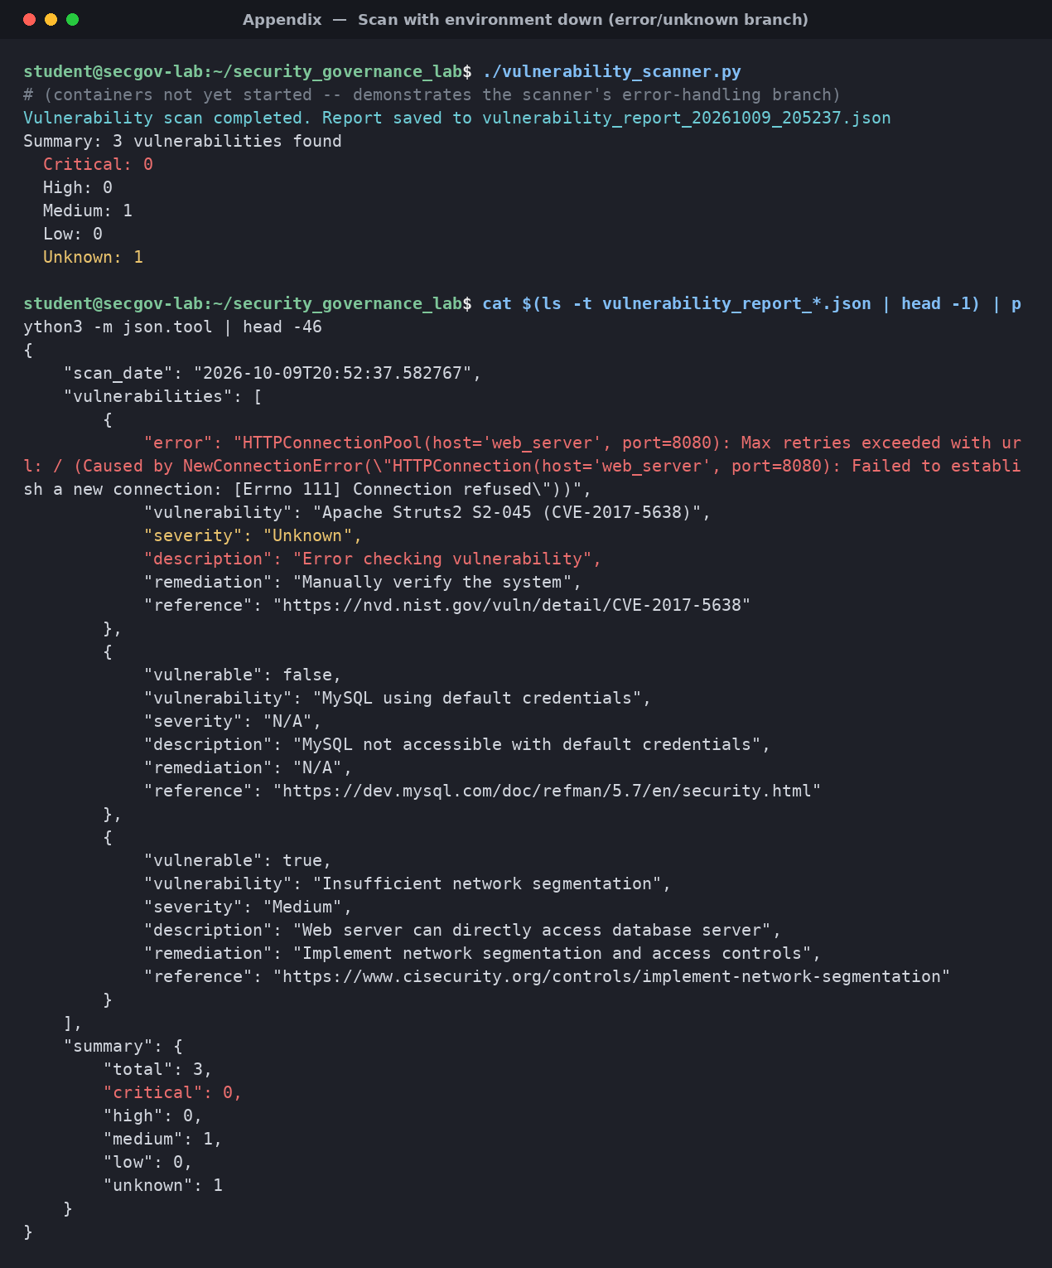
Figure A1 — Vulnerability scan with the environment down: the error/unknown branch is exercised safely.

