**eyeGalaw**

**USER MANUAL**

By

Christine Mae H. Juruena

**USER'S MANUAL**

**TABLE OF CONTENTS**

|  |  |  |  |
| --- | --- | --- | --- |
|  |  | | **Page #** |
| ***1.0*** | ***GENERAL INFORMATION .....................................................................................................*** | | ***1*** |
| **1.1** | **System Overview ....................................................................................................................** | | **2** |
| **1.2** | **Organization of the Manual ..................................................................................................** | | **2** |
| ***2.0*** | ***SYSTEM SUMMARY .................................................................................................................*** | | ***3*** |
| **2.1** | **System Configuration ............................................................................................................** | | **4** |
| **2.2** | **User Access Levels .................................................................................................................** | | **4** |
|  | |
| ***3.0*** | ***INSTALLATION AND EYEGALAW FUNCTIONALITIES...................................................................................................................*** | | ***5*** |
| **3.1** | **Installation...................................................................................................** **........ ........ ........** | | **6** |
| **3.2** | **Newly Installed Startup Page ...............................................................................................** | | **6** |
| |  |  | | --- | --- | | **3.2** | **Starting eyeGalaw ........................................................................................................ ........** | | | | **7** |
| |  |  | | --- | --- | | **3.2** | **Stopping** **eyeGalaw.................................................................................................................** | | | | **9** |
| **3.5** **eyeGalaw functionalities........................................................................................................** | | | **10** |
|  | | |  |
|  | | |  |
|  | | |  |

**1.0** **GENERAL INFORMATION**

1. **GENERAL INFORMATION**

General Information section explains in general terms the system and the purpose for which it is intended.

1. **System Overview**

eyeGalaw is a Google Chrome extension that uses eye movements to navigate webpages using an ordinary camera. Functions include scrolling up and down, back and forward page, hide and show interface, and enabling and disabling scrolling. Using this extension, the user can normally browse a webpage by clicking and scrolling and at the same time navigate using eye movements. eyeGalaw offers a new experience in web navigation, and can possibly revolutionize webpage navigation that caters for everyone, even for people with special needs.

1. **Organization of the Manual**

The user’s manual consists of five sections: General Information, System Summary, Getting Started, Using The System, and Reporting.

General Information section explains in general terms the system and the purpose for which it is intended.

System Summary section provides a general overview of the system. The summary outlines the uses of the system’s hardware and software requirements, system’s configuration, user access levels and system’s behavior in case of any contingencies.

Getting Started section explains how to get eyeGalaw and install it on the device. The section presents briefly system menu.

**2.0** **SYSTEM SUMMARY**

1. **SYSTEM SUMMARY**

System Summary section provides a general overview of the system. The summary outlines the uses of the system’s hardware and software requirements, system’s configuration, user access levels and system’s behavior in case of any contingencies.

1. **System Configuration**

eyeGalaw operates on any operating system. It is compatible with the any version of Google Chrome. Since the eyeGalaw is used in navigating active web pages, it requires connection to Internet. After installation on the device, eyeGalaw can be used immediately without any further configuration. It is only the user’s prerogative to change the default setting of the extension.

1. **User Access Levels**

Everyone can use application, as long as ‘Developer Mode’ is enabled in Google Chrome.

**3.0 INSTALLATION AND EYEGALAW FUNCTIONALITIES**

1. **INSTALLATION AND EYEGALAW FUNCTIONALITIES**

This section explains how to install eyeGalaw. This also provides a detailed description of system functionalities.

1. **Installation**

The newest installation version currently available can be downloaded from https://github.com/chjuruena/eyeGalaw/archive/v0.1.zip. For enabling the Developer Mode in Google Chrome, go to chrome://extensions/ and check the box for Developer mode in the top right (see Figure 1). Locate the ZIP file on your computer and unzip it. Then go back to the chrome://extensions/ page and drag the unzipped folder for your extension to install it. For an alternative option instead of dragging the file, Click the Load unpacked extension button and select the unzipped folder for your extension to install it.

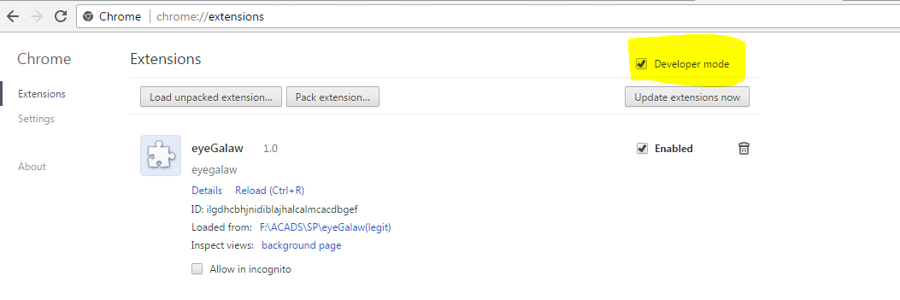

**Figure 1 Enabling Developer Mode in Google Chrome**

1. **Newly installed Start Up Page**

When newly installed, a start up page will welcome the user with a demo video (Figure 2) and some reminders when using the Chrome extension (Figure 3) .

**3.3 Starting eyeGalaw**

To start the extension. click the extension’s icon on the extension tab. This shows a pop-up. Clicking ’Start’ asks for the user’s permission to access the computer’s web camera (Figure 4). This is a part of Google Chrome’s security feature. When access is permitted, the extension then starts to initialize eyeGalaw. When the extension is started, it loads the interface with its default settings while already getting input from the webcam at real-time. Note that the interface is made adaptive according to the monitors screen size. For the interface to work, the browser needs to be maximized first before it will be enabled. The interface will be adaptive for five screen resolutions only chosen from the top screen resolutions used as of January 2016 [9]. The chosen screen resolutions consist of 1024x768 pixels or higher, namely: 1366x768, 1920x1080, 1280x1024, 1280x800, and 1024x768 pixels.

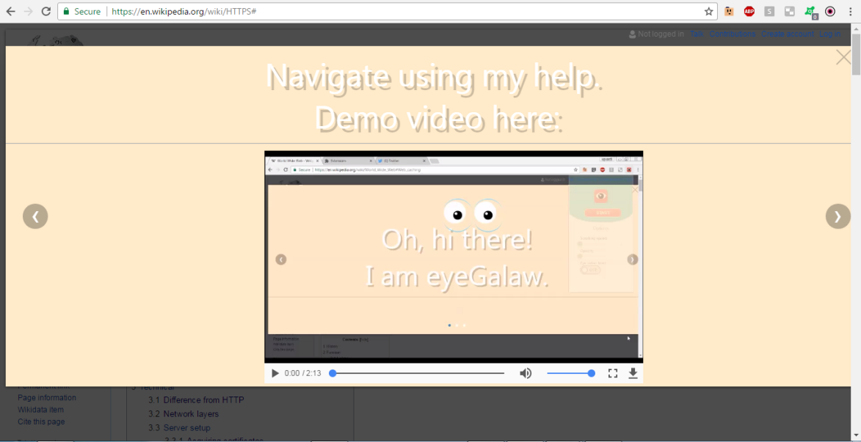

Figure 2 Demo video for eyeGalaw

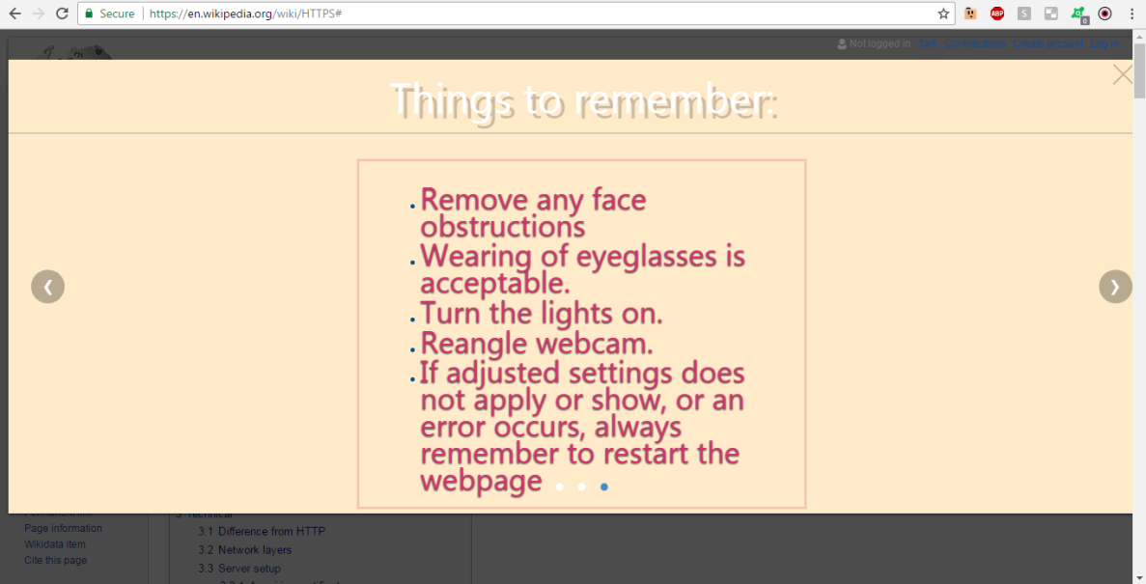

Figure 3 Reminders when using eyeGalaw

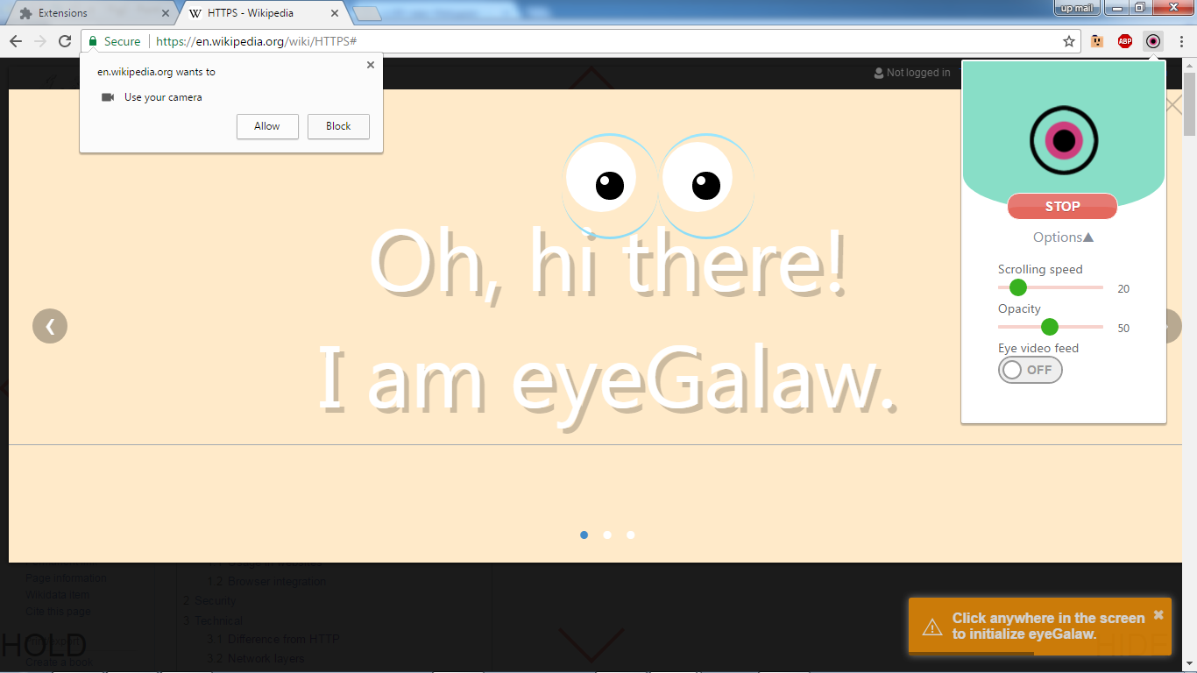

Figure 4 Permission to access the computer’s web camera

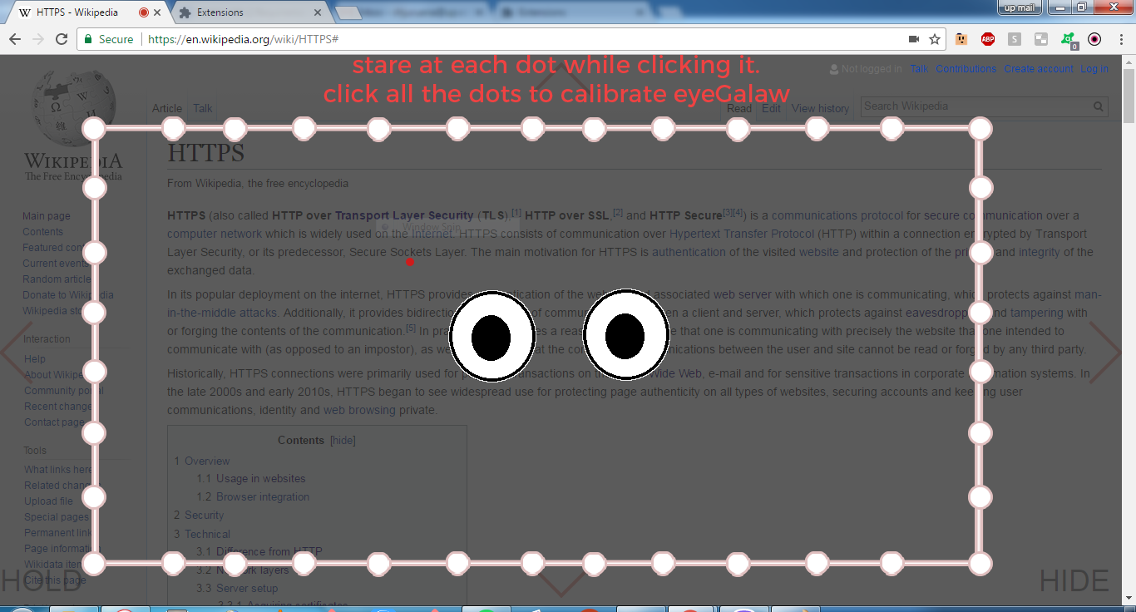

Figure 5 Loading screen whenever eyeGalaw needs click-gaze calibration

Before enabling the interface buttons, an initial calibration phase is required. A loading screen will show up asking the user to click anywhere while looking at the mouse pointer (Figure 5). This is the user’s guide for initially calibrating the click and gaze method for it to increase the accuracy of the prediction of the gaze point. The loading screen only disappears when eyeGalaw has gathered enough data to predict the user’s eye gaze showing the red dot on the screen. To stop the currently executed command (i.e., during continuous scrolling, going to the next page continuously) the user needs to gaze at other places on the screen, removing the gaze from the previously gazed buttons. This is applicable to all the buttons on the interface. Note that extension is only limited to its control functionalities (scroll up/down, next/previous page and hold) thus, clicking through links and other tasks that require interactions should not be affected.

**3.4 Stopping eyegalaw**

To stop eyeGalaw, click the ‘STOP’ button on the pop-up. This removes all the navigation buttons on the screen and its functionalities. It saves all the settings edited by the user for future use.

**3.5 eyeGalaw functionalities**

**3.5.1 Settings Tab**

It can be opened by left clicking the icon on the extensions tab on Google Chrome (Figure 6). The following settings can be adjusted: Scrolling speed, Opacity, and Enable/disable eye video feed.



Figure 6 eyeGalaw settings Tab

**3.5.2 Scroll Up and Down**

This enables the user to scroll up or down through the web pages. The scrolling speed can be adjusted in the settings. Continuously staring at the arrows will respond by scrolling at the designated direction (Figure 7). To stop the scrolling, the user needs to gaze at other places on the screen, remove the gaze from the arrows. This is also applicable to all the buttons on the interface.

Figure 7 Scroll up and down buttons

**3.5.3 Back page and Forward page**

This works similarly like the back page and forward page button in the browser (Figure 8).

Figure 8 Back and Forward page buttons

**3.5.4 Hold**

This lets the user to stay at the current part of the screen without hiding the interface. The hold button can be toggled on or off. Toggling the ’Hold’ button temporarily disables the Scroll Up and Down button, Back page and Forward page. If toggled on, the scrolling of the web page will be disabled so that the web page will stay at the particular part of the screen even if the user accidentally gazes at the scroll up or down button (Figure 9 and 10). The transparency of the interface will be increased to indicate that the interface is temporarily disabled.

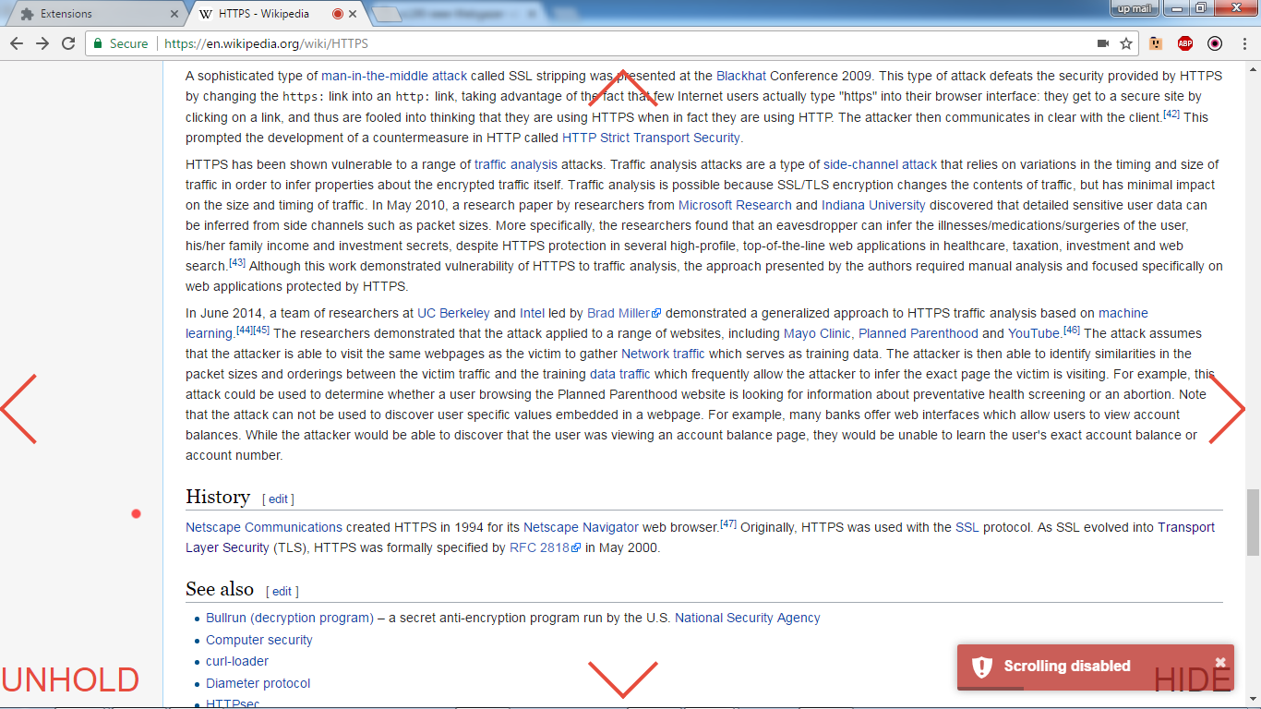

Figure 9 HOLD button enabled, disabled scrolling

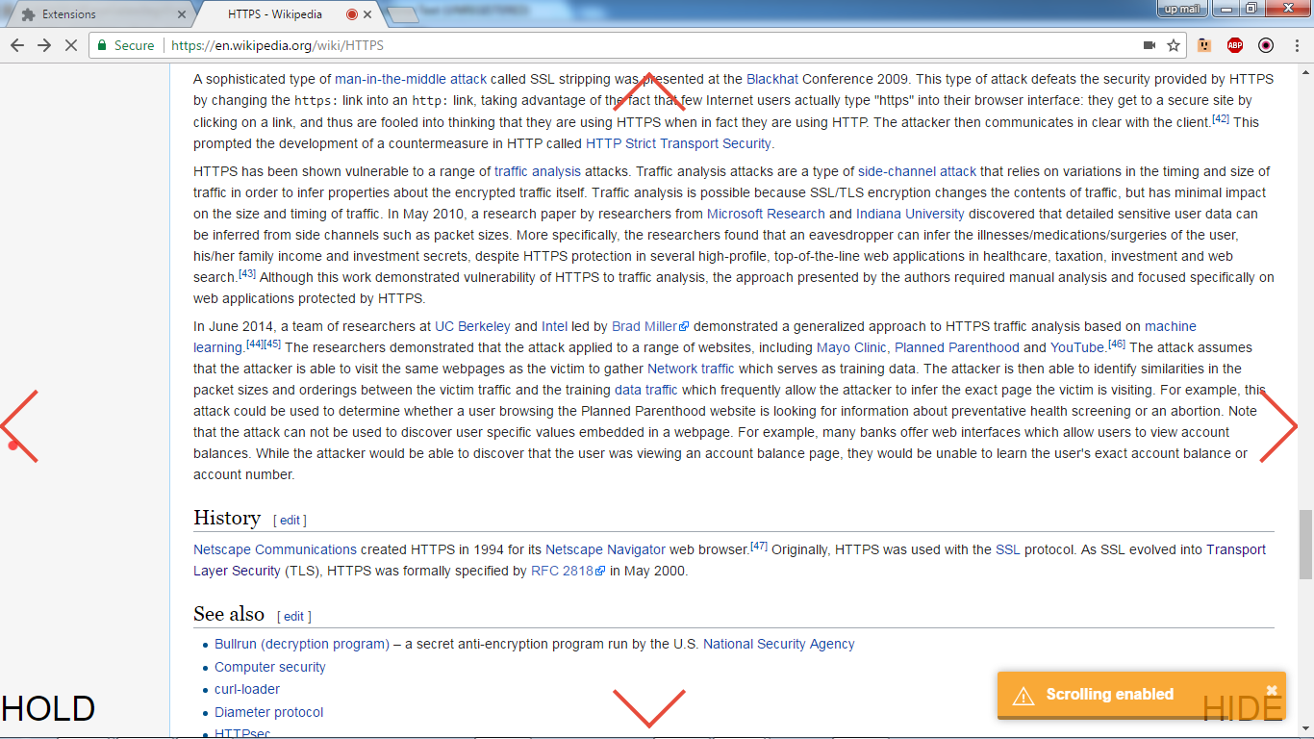

Figure 10 HOLD button disabled, enabled scrolling

**3.5.5 Toggle Hide/Show interface**

This permits the user to hide or show the interface on the browsed web page. The button is labeled ’Hide’ while the interface is shown; when hidden, it is labeled ’Show’. As a default, the interface is shown therefore the button will be labeled ’Hide’ when the extension is started (Figure 11).

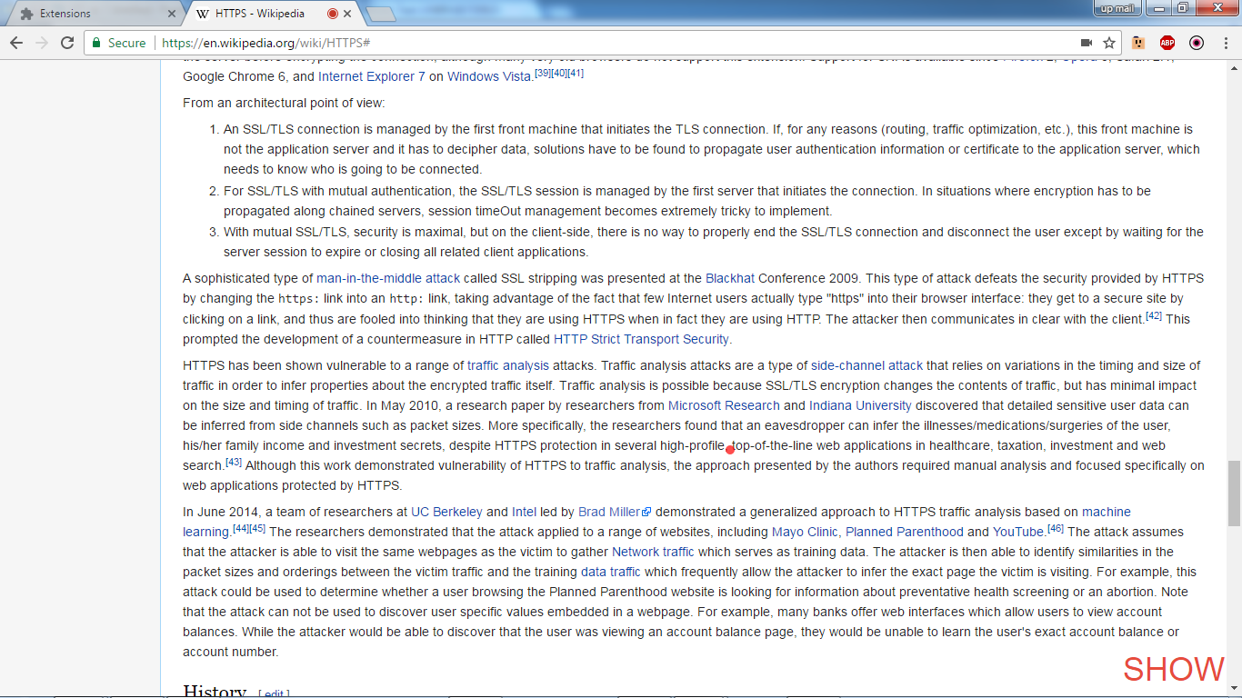

Figure 11 HIDE button enabled, hiding all the control except itself