

SCPlayerPro

Contact us:<http://www.sttplay.com>

Content

What can we do

Features

Simple start

Demo Scenes

Script References

**Thank you**

**What can we do?**

**As the application field of Unity becomes wider and wider, it is also a very friendly thing for the multimedia industry.** **However, many video files need to be demonstrated, and some plugins cannot meet the needs of customers, Therefore, we have developed an interesting plug-in specifically for this situation, namely SCPlayerPro. We hope to provide some help to friends who are engaged in the development of the multimedia industry. At the same time, we will continue to improve our own capabilities.**

**Like most media players, we deal with audio and video playback.** **The difference with other playback plug-ins is that we will be compatible with most video formats and some non-popular pixel formats.** **The current release version is suitable for windows and android platforms, supporting local files and network files.** **We will continue to maintain and update to support media types and cross-platform versatility. We will support common external devices such as cameras, virtual cameras, and microphones, of course, rtsp, rtmp, hls and other online streams are indispensable. We will also make adjustments based on user feedback, and we will strive to give users the most satisfactory answer.**

**On this basis, we packaged it, that is, the core decoding plug-in SCCore.dll. In terms of video playback, we did not use DX9 and DX11 for direct video rendering, but used Texture2D in Unity for intuitive rendering. Considering the needs of relatively special users, users may want to obtain the original data of video frames, so they must get the data of each frame to the CPU. Although this will affect certain performance, it can better meet the needs of users. These effects are negligible. In terms of audio playback, we have also encapsulated, and the same factors as video, we can also obtain the original PCM audio data. Users can easily obtain the original data after audio and video decoding for secondary use.**

Features

* **Support most audio and video files**

Support video file format: mp4, flv, mov, rmvb, wmv, avi, rm, rmvb, 3gp, 3g2, mpg, mpeg… …

Support audio file format: mp3, flac, wma, wav, aac… …

* **It is friendly to support network streaming**

The current version supports rtsp, rtmp, hls, http, https… …

* **It is friendly to support camera**

In addition to supporting traditional USB cameras, virtual cameras are also supported

* **It is friendly to the video support of different resolutions**

The image can be parsed normally if the image is large or small, and the image will not be abnormal due to memory alignment

* **pixel formats that are not supported by the plug-in are detected and automatically converted to BGRA pixel format**

The plug-in is not omnipotent. When it encounters an unsupported pixel format, it will automatically convert to the BGRA pixel format, which greatly increases the compatibility of the pixel format.

* **Support multiple pixel formats, and uniformly set the memory to be aligned to 1 byte**

Output pixel format support YUV420P, YV422P, YUV444P, YUYV422, UYVY422, NV12, NV21, RGB, BGR, RGBA, BGRA, ARGB, ABGR, GRAY. and uniformly set the memory to be aligned to 1 byte.

* **The user can manually specify the output pixel format to ensure normal use in special occasions**

Users can set according to their needs.

* **Supports hardware acceleration of multiple device types, and users can specify the device types for hardware acceleration**

Users can set according to their needs.

* **Friendly and compatible with videos containing transparent channels**

Many player plug-ins do not support, we also solved this pain point

* **Manually or enable audio and video tracks**

Users may not need all streams, we also provide to enable or disable audio and video streams

* **Render to Rawimage or mesh**

It is easy to draw on mesh or ugui

**Bnefit**

**Developers can easily obtain the original audio and video data and perform secondary processing, and can also easily and simply realize the playback of ordinary videos or special videos, you can simply control the opening, closing, and replay of the video, which is very friendly to developers who often control video state switching. We have encapsulated UnitySCPlayerPro, users do not need to care about internal processing and data exchange, users only need to simply call the interface function to achieve control over UnitySCPlayerPro. We can also process large-resolution videos efficiently. We can use hardware accelerated video decoding, and we can also change the output pixel format according to our own needs. We can friendly support the smooth playback of 8K videos.**

**Support resolution**

**480p 60 fps**

**720p 60 fps**

**1080p 60 fps**

**4K 60 fps**

**8K 30 fps**

**The above indicator is a range value, which can also be well supported in these ranges**

**Technical specifications**

**The operating environment of the plug-in is based on Unity2019.4.x, We have no special requirements for the .Net version. The plug-in uses a 3D model 360vr.fbx, this model is used to play panoramic video, we have inverted its normal and UV, if the user needs it can be used directly.**

**Simple start**

**1.Right-click on the blank of the “Hierarchy” panel, select SCPlayerPro and then select the SCPlayerPro option to create a player.**

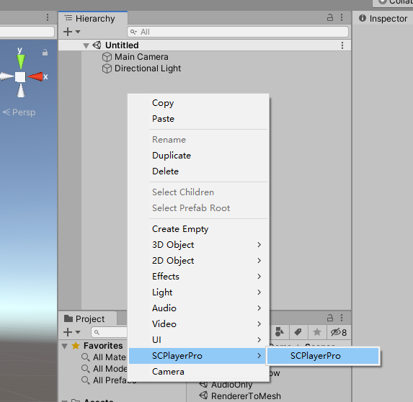

**2.** **Select the SCPlayerPro object, select the BROWSE button on the SCPlayerPro component to select a media file**

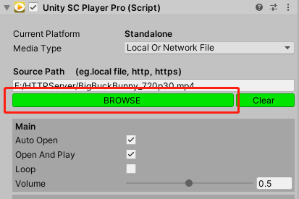

**3.** **We also need a render object, here we create a cube**

**4.Select the cube to add a SCMeshRenderer component**

**5.** **Drag the previously created SCPlayerPro to the player of SCMeshRenderer**

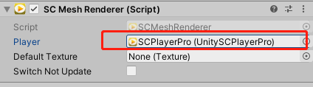

**6.OK, Let's click the play button to test**

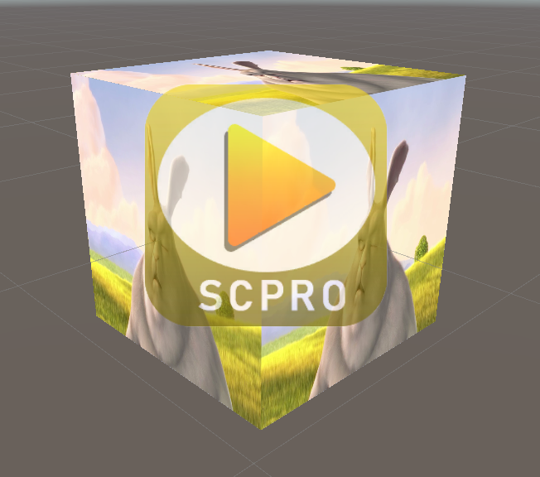

Demo scenes

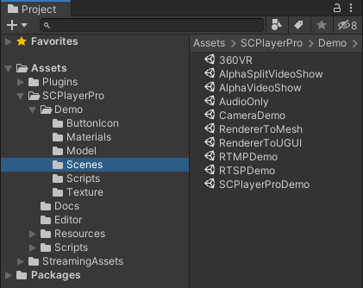

**Here are some example cases for reference**

**Here we did not upload the StreamingAssets folder, because the video file is relatively large, here is a screenshot of the catalog. Currently, video files in the StreamingAssets directory are used in many demos. Before using, you need to choose the correct file path according to your own situation.**

**Note that the SCAssets folder is a special folder, and the file path inside can be called by SCMGR.GetUrlFromSCSCAssets(), which is common on the current platform.**

**For example SCMGR.GetUrlFromSCSCAssets("AlphaLeftRight.mp4");**

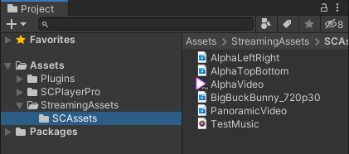

* **SCPlayerProDemo**

**A complete player, most of the functions can be reflected in this player. (Click the gear button in the upper right corner to set various parameters in the ui interface)**

* **RendererToUGUI**

**We can draw the video on the UGUI canvas through this scene, of course, the canvas is based on Rawimage**

* **RendererToMesh**

**We can draw a video on the 3D model through this scene**

* **AudioOnly**

**This scene played a wonderful piece of music**

* **AlphaVideoShow**

**This scene shows the playback of transparent videos that most players do not support**

**AlphaSplitVideoShow**

**This scene shows the playback of transparent videos，however, this type of video does not contain transparent channels, but uses RGB color values to represent transparent channel data through a certain part of the image.**



**For example, this kind of video, the left is the normal video, the right is the transparent channel data.**

* **360VR**

**Play the panoramic video and draw it on a special sphere**

**（In addition to SCPlayerProDemo, other demos can use SampleController gameObject to set the file path and whether to use the StreamingAssets folder.）**

* **RTSPDemo/RTMPDemo**

**This scene shows how to turn on a network video stream.**

* **CameraDemo**

**This scene shows how to turn on the camera.**

**（Need to be executed in run mode）**

1. Set OpenMode to Camera.

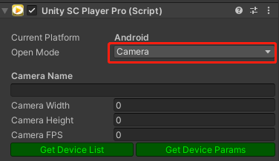

2. Clicking on GetDeviceList to get all camera names on the current device (including virtual cameras)

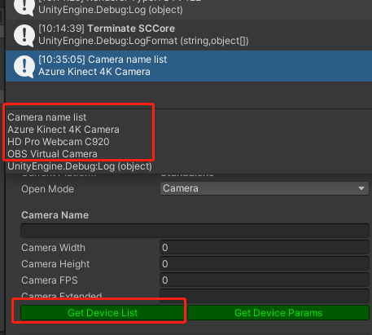

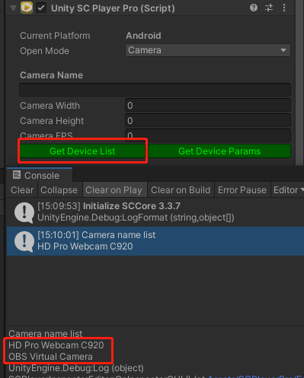

3. Here I got three camera names, and now I just need to copy the camera name into the CameraName input box to use it.



4. About the Camera Options parameter.

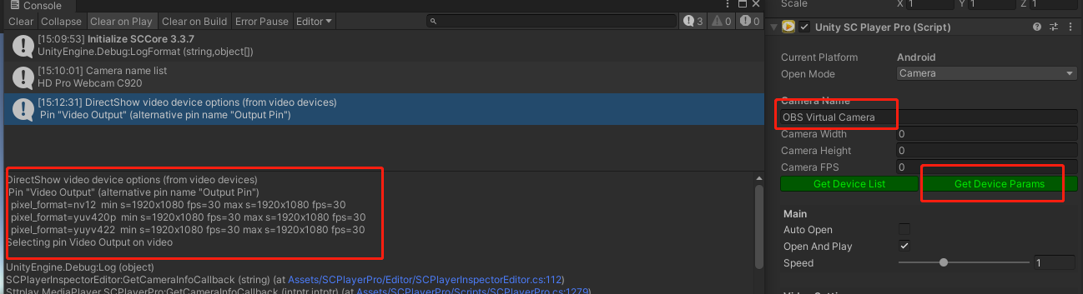After entering the camera name, you can click the GetDeviceParams button to get more parameters for the camera. This list allows the camera to output a specific format by setting the relevant parameters.

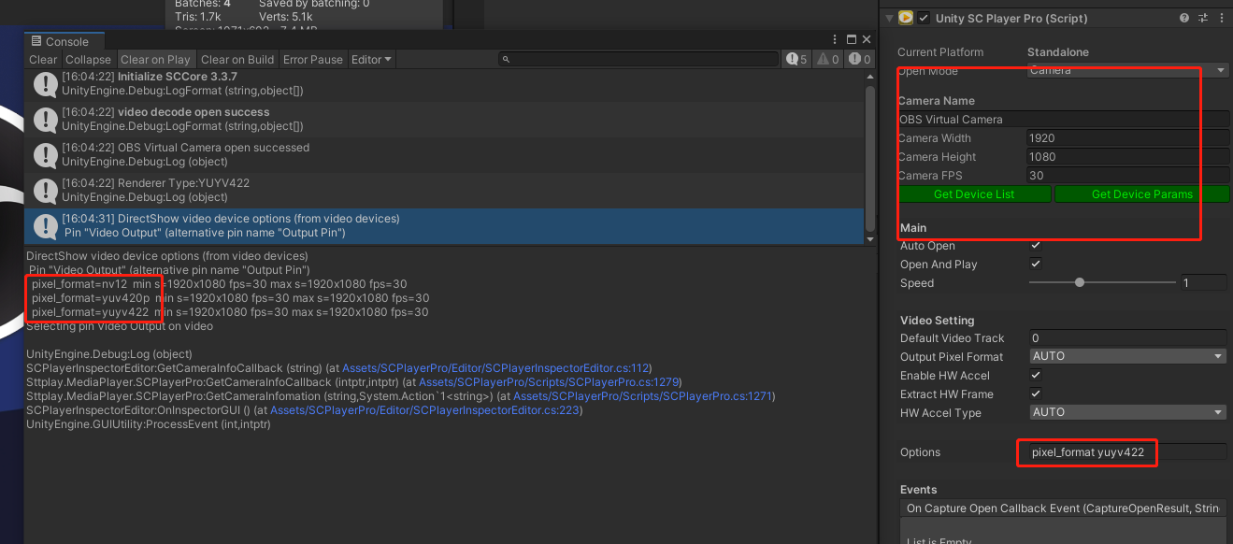

UnitySCPlayerPro options

packet_cache 10; Keep the buffer frame at around 10 frames

open_timeout 5000; Set the network stream opening timeout to 5 seconds

fflags nobuffer; Refer to the fflags parameter in ffmpeg

lowdelay; Decoder low latency mode

rtsp_transport tcp; Set the transmission protocol of rtsp stream

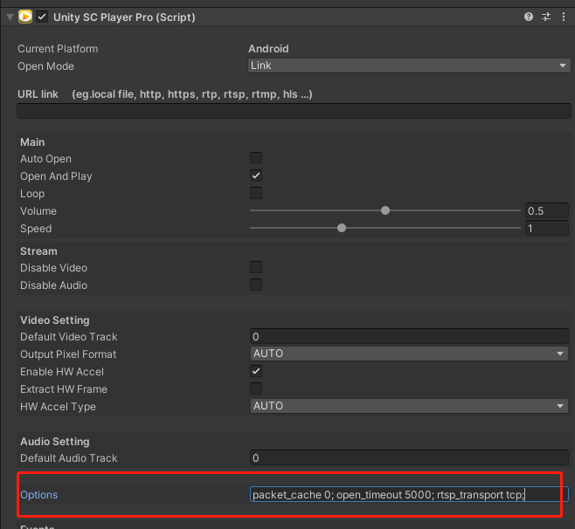

Script References

Our core program is UnitySCPlayerPro, here is the detailed instructions

UnitySCPlayerPro.cs

Important fields or attribute

**mediaType**: File type to open, If you choose LocalOrNetworkFile, then the supported files are local files, network files, For example, file: ///, http, https, but not hls stream

**Closed**: Mark whether player is closed, open failure is also considered not close

**OpenSuccessed**: Mark whether player successfully opened media

**url**: URL When the choice of mediatype is different, url has different meanings, for specific support, please refer to mediaType

**disableVideo**: Whether to disable video

**disableAudio**: Whether to disable audio

**enableHWAccel**: Whether to enable hardware acceleration , not all videos support hardware acceleration. If you enable this option, hardware acceleration will be tried first, and if it fails, the CPU will be used for decoding.

**HWAccelType**: Hardware device type when video hardware accelerates decoding, Not all of the current platforms are supported, if the current option does not support, set as the default.

**outputFmt**: Pixel format of output SCFrame

**autoOpen**: Whether to open the media when UnityPlayer starts

**openAndPlay**: Play directly after opening or stay at the first frame

**loop**: Whether the media is played in a loop, This option is valid only when the mediaType is LocalOrNetworkFile

**volume**:Media volume

**IsPaused**: Whether the marker is in a paused state

**onOpenEvent**: Called when opening

**onCloseEvent**: Called when closing

**onCaptureOpenCallbackEvent**: Called when StreamCapture demux succeeds or failed

**onFirstFrameRenderEvent**: Called after the first frame is drawn, if there is no video stream, this event will not be called

**onRendererFrameEvent**: Called after each frame of video is drawn , if there is no video stream

**onStreamFinishedEvent**: Called when the video has finished playing, whether looping or not

**CurrentTime**: Current playback timestamp, valid when the mediaType is LocalOrNetFile

**Duration**: The total duration of the media, valid when the mediaType is LocalOrNetFile

**VideoRenderer**: Video renderer

Important method

**Open**: Open the media file by changing the method, You can pass a url, if you don’t pass it, use an default url

**Close**: No matter what state SCPlayerPro is in, it will be closed

**Pause**:Pause the video

**Play**:Play the video

**Replay**: Replay from the beginning, you can also specify whether to pause

**SeekFastPercent**: Seek video according to percentage, seek to key frame

**SeekFastMilliSecond**: Seek video according to millisecond, seek to key frame

**ReleaseCore**: Release all resources of player, After the release is complete, the object can no longer be used, and the user does not need to manage

SCUGUIRenderer.cs

Important fields or attribute

**player**: Need to choose a for video drawing

**defaultTexture**: You can set a default image to RawImage

**switchNotUpdate**: The screen does not refresh when player is closed or when the video source is switched

SCMeshRenderer.cs

Important fields or attribute

**player**: Need to choose a for video drawing

**defaultTexture**: You can set a default image to RawImage

**switchNotUpdate**: The screen does not refresh when SCPlayerPro is closed or when the video source is switched.

There are not many parts that we need to manually control. This is also our major feature. It is simple and easy to use. The above script description can satisfy our playback and display of any video.

Important Notice

1.On some machines, there may be no audio output issues via AudioDriverType.Auto initialization, which is related to the settings of the computer's audio output device. Of course, you can also try to change the initialization method by changing the AudioDriverType in function InitilizeSCPlayerPro of Assets\SCPlayerPro\Scripts\SCMGR.cs, here you can choose DirectSound or Winmm.

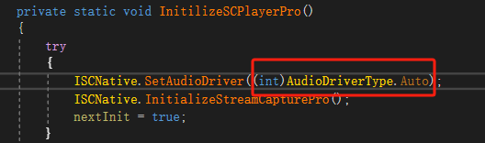

Thanks