https://www.youtube.com/watch?v=QYVRwJfcnWE

VVVV Beginner Class – Summer 2023

Start - Monday May 8th 2023 6-9 PM (CET) / In English Language / Online via Zoom
12 weekly (Mondays) modules until July 31st 2023.
This semester-long live class is designed for students and professionals alike and as a weekly add-on to your studies or work. You will be a group of learners from different countries and backgrounds, united by the goal to learn a new creative coding tool to use in your career. It doesn't matter if you are an artist, a musician, an architect, a programmer, an event technician or any other curious mind. In any case, you should have a desire for a creative process while learning a new tool.
In 12 sessions you will learn all the basics of programming in vvvv gamma. The course covers everything you need to know to start your vvvv career and entering specific intermediate or advanced vvvv topics.

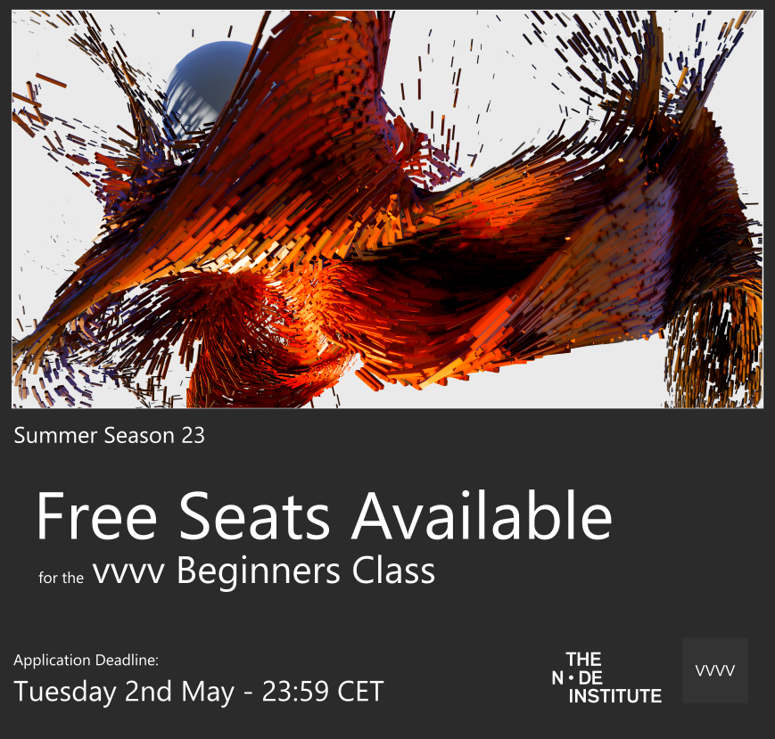
You'd like to join but cannot afford the fee? We're offering 2 free seats for this course! To apply for a free seat, answer these questions:
- Who are you?
- What's your educational background so far?
- What are you hoping to get out of this course?
Send to: edu@vvvv.org
Deadline: May 2nd - 23:59 CET
We'll notify chosen participants by May 6th
Start of the course: May 8th

About the Instructors
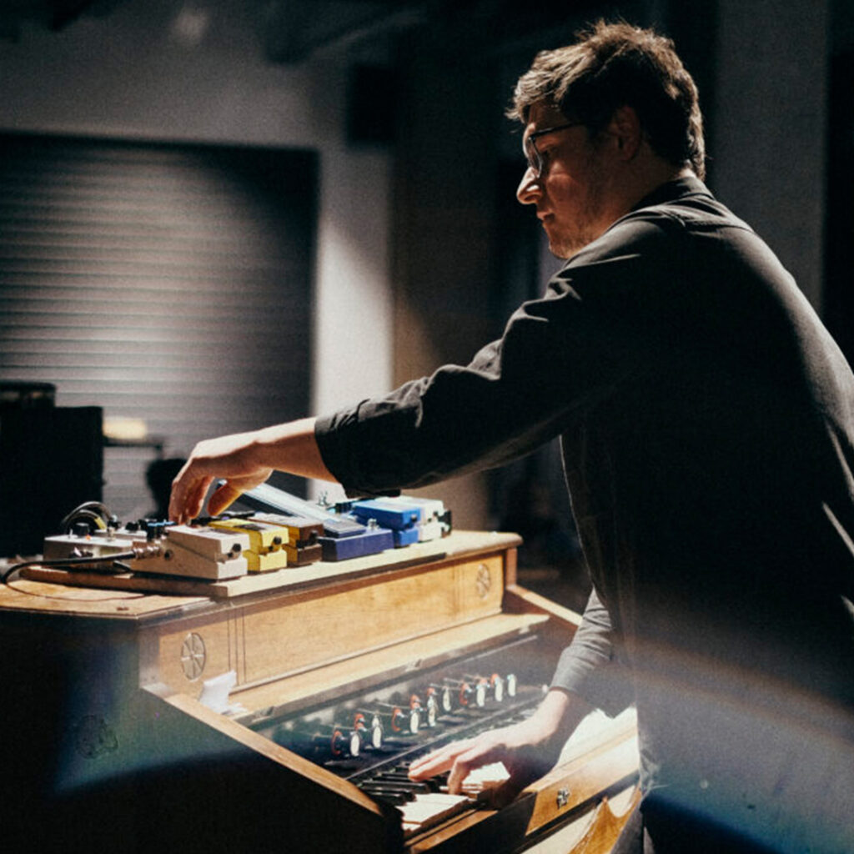
Christoph Ignaz Kirmaier aka chk is a musician, multimedia artist, educator and co-founder of the Vienna and Berlin based Studio 3e8. In the past years he has worked all across large-scale corporate multimedia installations, sound design, generative graphics, electronics, animation, music videos, user experience and robotic prototypes in several companies, bands and collectives. Christoph is teaching vvvv at the University of Applied Sciences St. Pölten in the course of the master digital design, and is currently also studying himself at the Tangible Music Lab in Linz in the master programme Postdigital Lutherie.
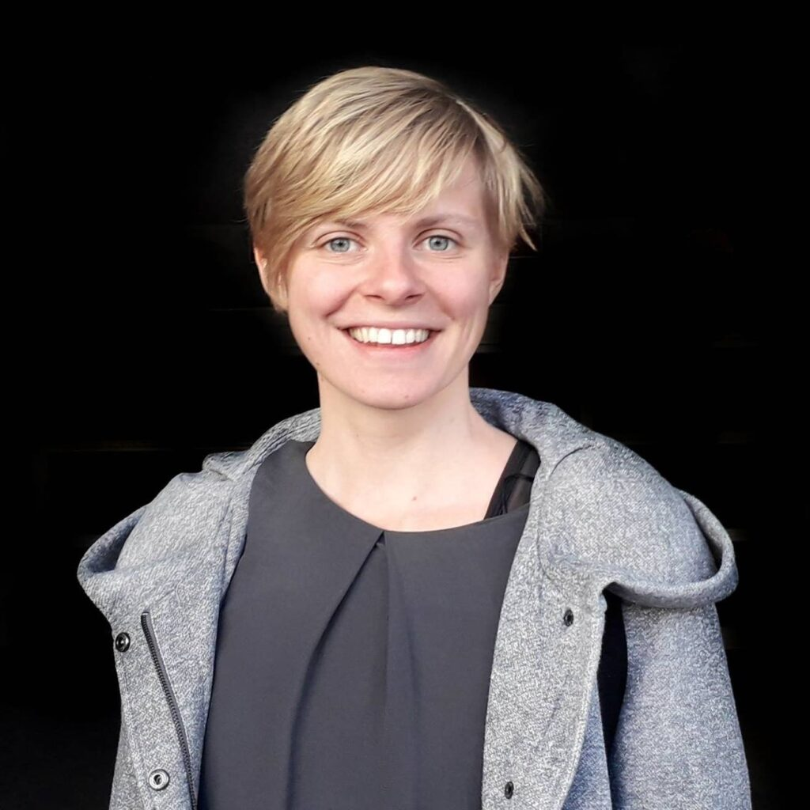
Two sessions will be taken over by Rosi Grillmair aka remony, artist and coding/"node"ing - nerd as well as long term vvvv community member. She is an excellent educator in the field of interactive media, community driven programming tools and artistic installations. Her sessions are a mix of playful lectures, hands-on tutorials and enough time for your questions and in-depth discussions.

Good to know
⇒ There is no prior knowledge of vvvv needed.
⇒ We will meet in zoom calls. The URLs will be shared within the sessions of this course.
⇒ vvvv runs on Windows only. Please connect to zoom with a Windows machine.
⇒ Make sure you have a 3 button mouse attached.
⇒ Recordings of the live sessions will be accessible only for the participants for their personal review.
⇒ The class will happen if we have 10 or more participants.

Why should I learn vvvv?
vvvv is a visual live programming environment with a focus on creative coding. You will solve any task between prototyping and and final production with ease since vvvv's visual language VL combines metaphors known from dataflow, functional and object oriented programming. For visual output you can leverage the benefits of a game engine and a visual programing language combined. There is no need to write any code, even if you extend the functionalities to your own needs.
⇒ It is free for personal and educational use without any restrictions
⇒ It is quick and easy to install, with no copy protection or need for registration
⇒ It comes with an accessible integrated Help Browser
⇒ It connects to most popular protocols and devices
⇒ It exports patches as executables so you can hand them over to your clients
To give you an idea of the areas in which vvvv is widely used, here is a list of buzz words vvvv is often associated with:
Interactive Installations, Physical Computing, Generative Design, Interaction Design, Data Visualization, Computer Vision, Rapid Prototyping, Projection Mapping, Realtime Visuals and Sound (Particles, Signed Distance Fields, Instanced Graphics etc.)
It is used by designers, artists and technologists in all kinds of media installations.
Here is what people do with it:
https://vimeo.com/371511910
Besides staying true to its nature of being a an easy to use and quick prototyping environment, vvvv gammas programming language VL comes with modern features, combining concepts of dataflow and object oriented programming and serves as a fully fledged .NET programming language and takes your project from prototype to production. For the ones interested programming specific features, here is a small list of things you can expect when patching vvvv.
⇒ Combine object oriented programming with dataflow
⇒ Define your own datatypes (Classes and Records)
⇒ Composed Datatypes (Spread of Spread,..)
⇒ Loops to iterate within one frame
⇒ Work with Generics and Delegates
⇒ Reactive programming
⇒ Async data processing (multi-threading)
⇒ Easy caching of expensive operations
⇒ Use any Input/Output like MQTT, RestAPI, TCP, OSC, Serial Ports etc.
⇒ While being a visual language, it can easily be extended via C# and the use of .NET Nugets. All of its libraries are open-source, thus can be inspected and learned from.
Its only caveat: As of now, vvvv still only runs on Windows. While we’re already working towards supporting other platforms we cannot give a specific date yet when this will be possible. Please keep an eye on the roadmap for staying up to date.

1. The Environment and Drawing Basics
Dear Participants, welcome to the vvvv beginner class in the summer season 2023. We are super curious to get to know you!

General Information

Meeting link
Please save this link, it will be used for all lessons:
https://us02web.zoom.us/j/82152483380

Objectives of the course
- Get you familiar with the visual programming environment
- Provide a clear path through all important nodes and techniques
- Introduce you to the methodology of the language VL
- Support for your project throughout the course

Timeline of every session
- 18:00 - 18:30: Project presentations
- 18:30 - 19:30: Patching
- 19:30 - 19:45: Break
- 19:45 - 20:45: Patching
- 20:45 - 21:00: Questions

Recording

Lesson Overview

Navigating the Environment
- https://youtu.be/7m1EzfxUtzo

Data Types & IOBoxes
- https://youtu.be/9iH72qdb4Xk

Nodes & Pins
- https://youtu.be/eCTEAFfb9rQ

Installing Nugets
- https://youtu.be/-U_kUQ3VDog

VL.TheBigBang
Please use the instructions of the video above to install the NuGet VL.TheBigBang, a tutorial nuget that I have created as additional learning material.
- nuget install VL.TheBigBang
All screenshots in this course are taken from this library, and I will additionally write where to find that specific screenshot in the patches.

Getting Help
- YouTube Channel: https://www.youtube.com/@vvvvTv42
- Forum: https://discourse.vvvv.org/
- The Gray Book: https://thegraybook.vvvv.org/
- The chat rooms on Element

2D Drawing Pipeline

Rendering Pipeline in Skia
Skia is the built-in 2D rendering library. The final composition is drawn with a Renderer node, which takes a layer input of all 2D content that should be visualized. When starting a new patch. you must reference the VL.Skia pack to see all of its nodes in the Node Browser.
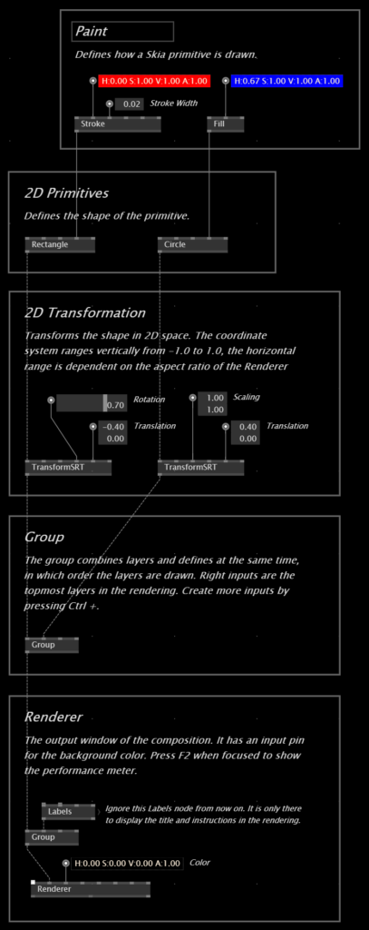

Counting a value continuosly up with an LFO
An LFO generates a continous value rising from 0.0 to 1.0 over a given time. It can also be paused and reset. On its output, we get a Bang for every new cycle and the total number of cycles it has made since reset. Therefore we can also use it as a trigger for a continuous signal or an increasing number.
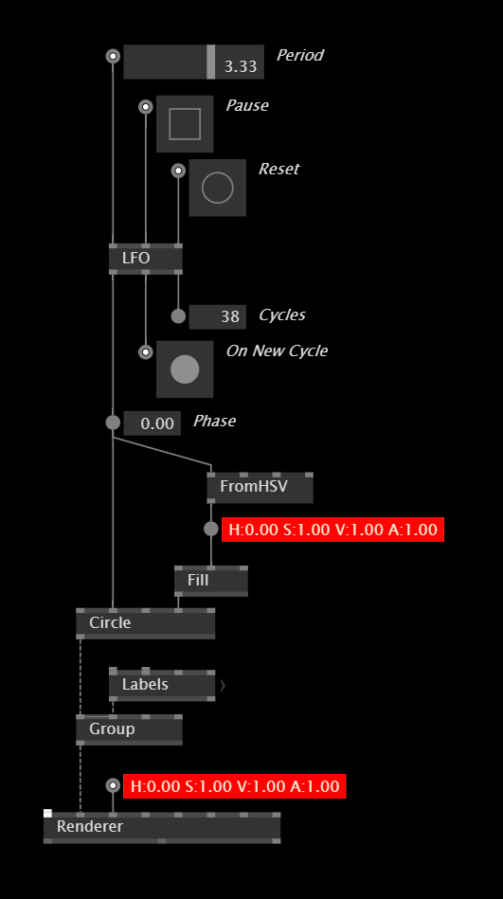

Simple Mouse Interaction
vvvv offers easy and convenient nodes to read the values from basic input devices like a mouse. Connect the Layer output of the Mouse node to the Renderer and use the information of the node to control your patches.
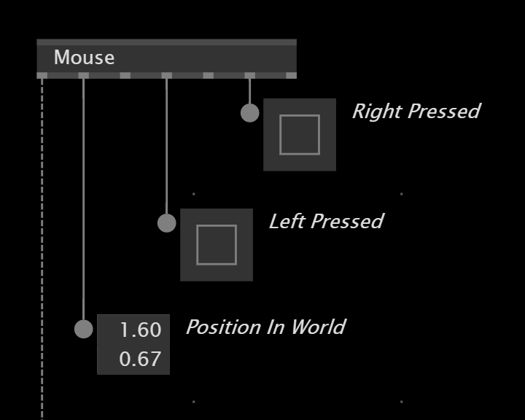

Generating and keeping random values
S+H stands for "sample and hold". It will keep the value going into the left input pin while the right input boolean is true. In this example set the Sample pin manually via an IOBox. It is often used to keep the output from a Random node. In this example an LFO is used to keep the random value every second.
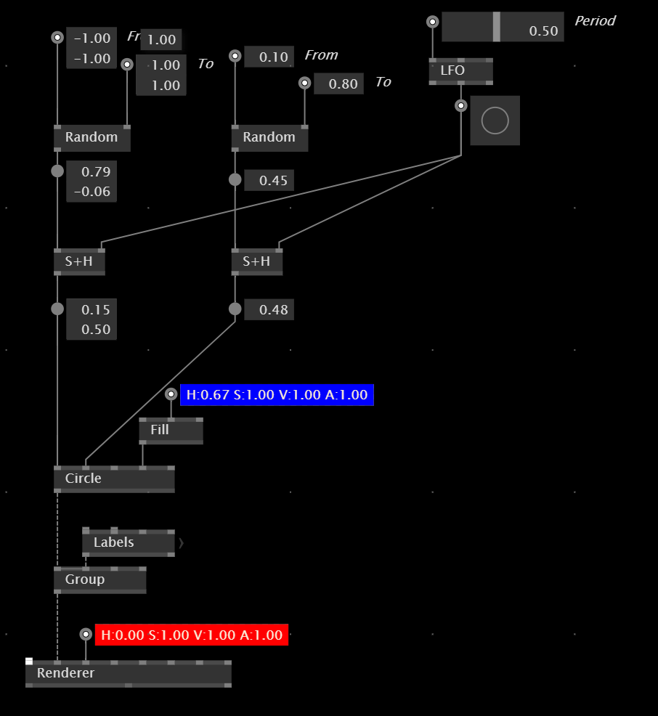

Using a TogEdge as a trigger
Especially when dealing with input devices like a mouse which we want to use as a trigger for certain processes we need to know the TogEdge node. It detects a boolean input change from 0 to 1, and vice-versa and will output an corresponding Bang for each direction.
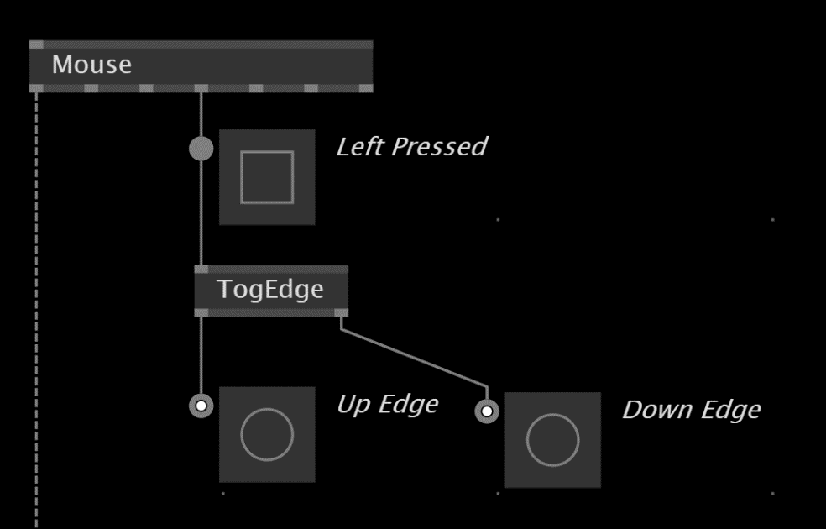

Additional Resources
- https://youtube.com/playlist?list=PL2KeRstDQVRRVnzCHEambwAI4yWmpIF-p
- https://thegraybook.vvvv.org/
- https://discourse.vvvv.org/

Lesson Material

2. 3D Rendering With Stride

Recording

Project Presentations

Lesson Overview

Creating a Node
https://youtu.be/wEziL9RTkMM

3D Rendering with VL.Stride
https://youtu.be/4rDgVe1F0gg

Rendering Pipeline
Stride is the built-in 3D render engine. It features a system of entities of primitives, shaders, lights and much more, which are collected and rendered in a SceneWindow. Before you can use the nodes from the Stride package, you need to reference it.
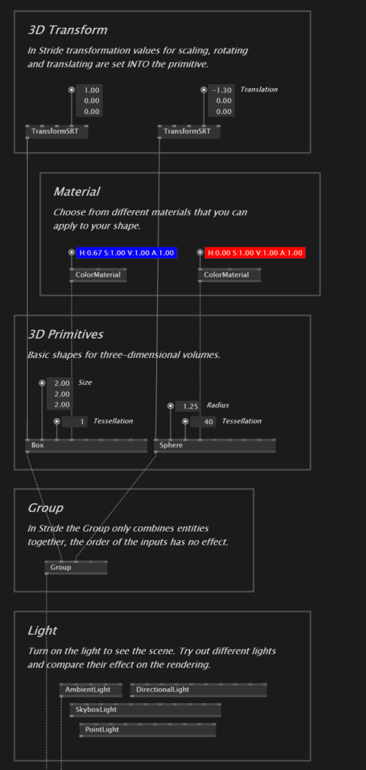
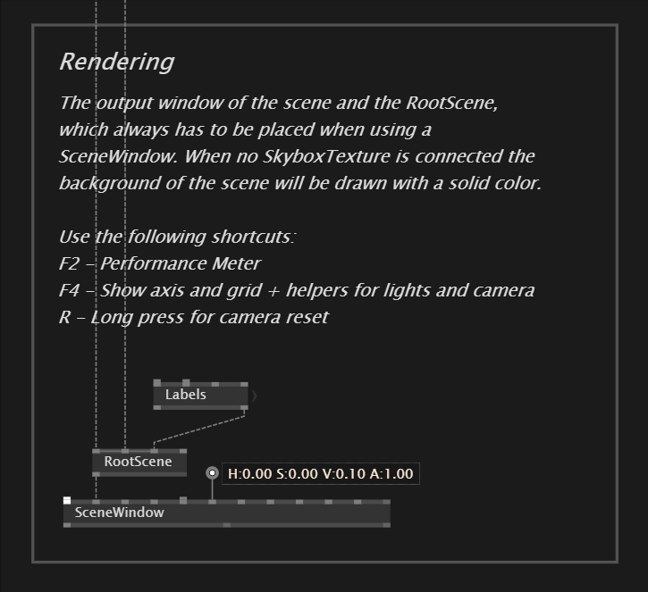

PBRMaterial
While the ColorMaterial will disable any shading and lights won't have any effect on the volume, the PBRMaterial defines how the lights will be reflected on the volume and enables shadows. Use a Blend node on a PBRMaterial to set the transparency and play with the metalness and roughness inputs to see their effect.
Realistic shadows will only be rendered when a PBRMaterial is set into the primitives. Try playing around with the positions of the primitives and the settings of the lights. It is also possible to keep the lighting of your scene but completely disable the shadow casting for individual primitives with the "Is Shadow Caster" input.
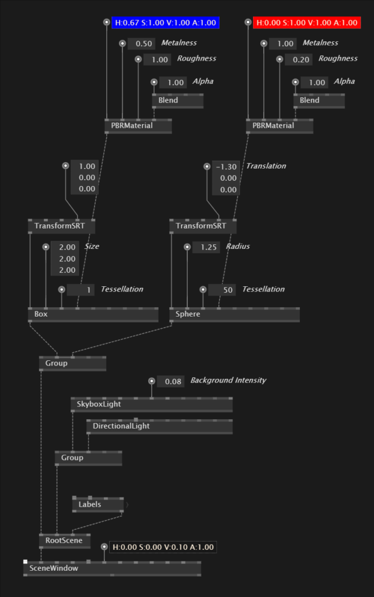

PostFX
At the end of the render pipeline several post effects can be applied to the final scene. Check out the help patch for a detailed overview.
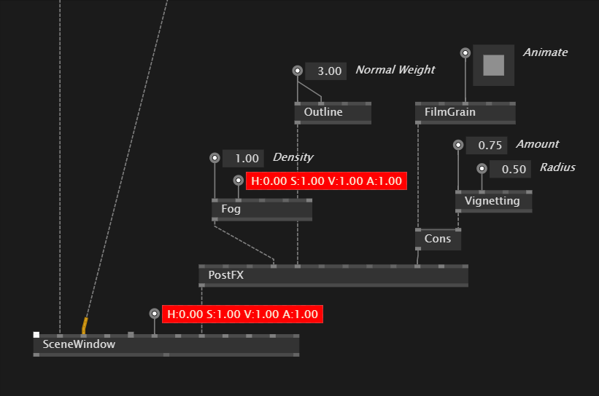

Additional Resources
- https://www.stride3d.net/
- https://youtu.be/Cs60A_pSIy0
- https://vimeo.com/467434033

Lesson Material

3. Spreads & Algorithms I

Recording

Project Presentations

Lesson Overview

About Spreads
If you have been programming before, you might have come across the concept of a list or an array - some kind of container that can contain multiple values. In VL they are referred to as collections and there are a few different ones that can be used: Spread, Dictionary, HashSet or the mother of them all, the Sequence.
Having such a variety of collections can be confusing when starting to learn VL. But as a beginner you have in fact only to care about the Spread, which is the most common implementation of a list in vvvv. A Spread is generated manually or automatically, usually iterated over with a ForEach loop and can be manipulated with spread operation nodes. One entry of a Spread is called Slice.
It is important to keep in mind that a Spread is really just a list of values, that you can handle with the same flexibility when dealing with only one value. So when dealing with Slices of a Spread, the same programming logic can be applied to them like anywhere else in vvvv.
https://youtu.be/3u3QOd4UyWM

Creating a Spread manually
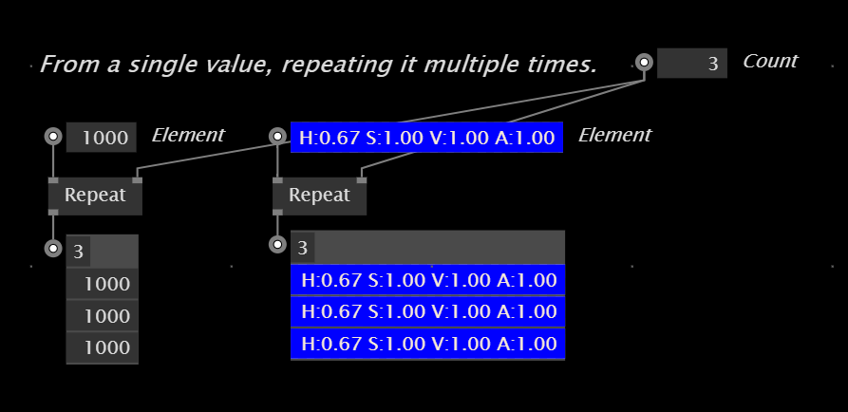
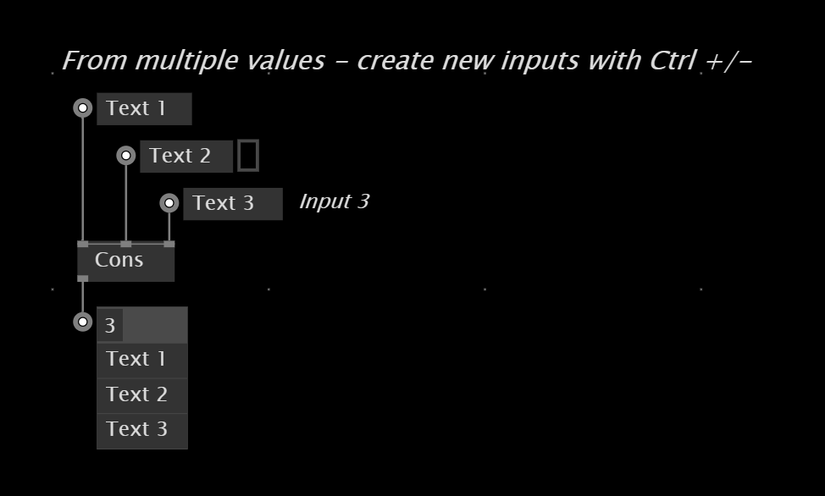

ForEach region
When talking about spreads in vvvv, it is necessary to also talk about loops, because we need them in order to do something with the data inside a spread. To iterate over the slices of a spread, we use a so-called region with the label ForEach. To iterate over all items in your spread, you need to enter the ForEach region via the splicer icon, which looks like a little cone.
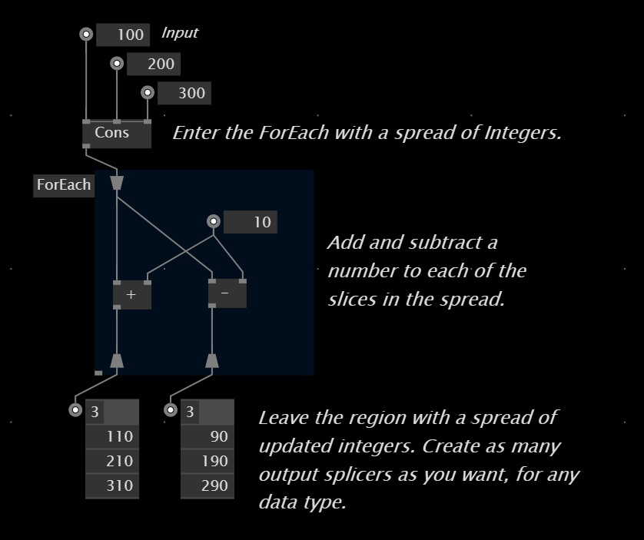

Repeat region
Additionally to the ForEach we can make use of another region called Repeat. This one simply repeats everything that is inside of the region for the specified count at the input.
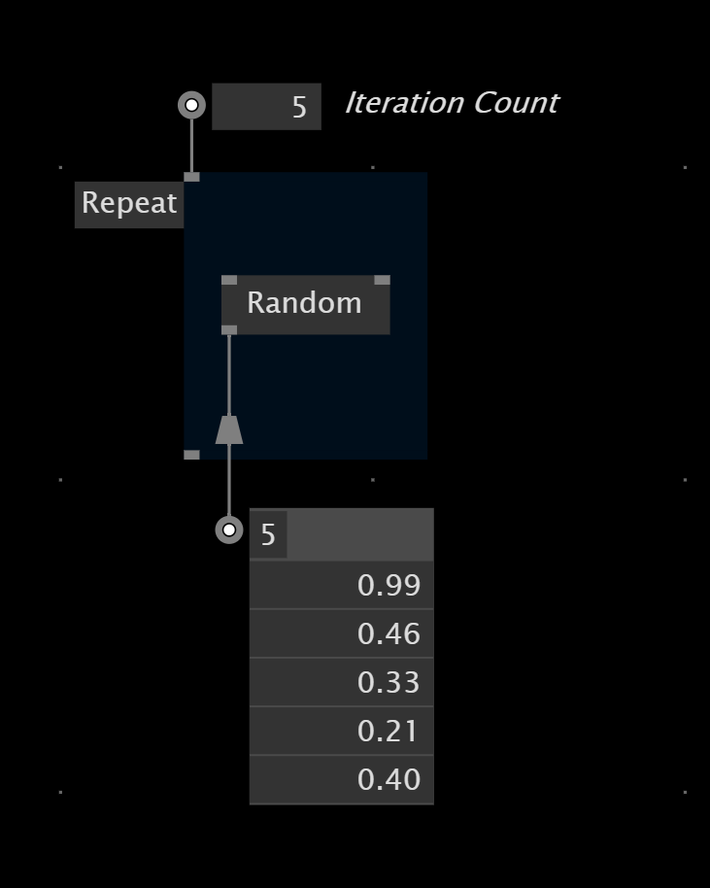

GetSlice, Set Slice & Count
Use a GetSlice to get a single value by its index.
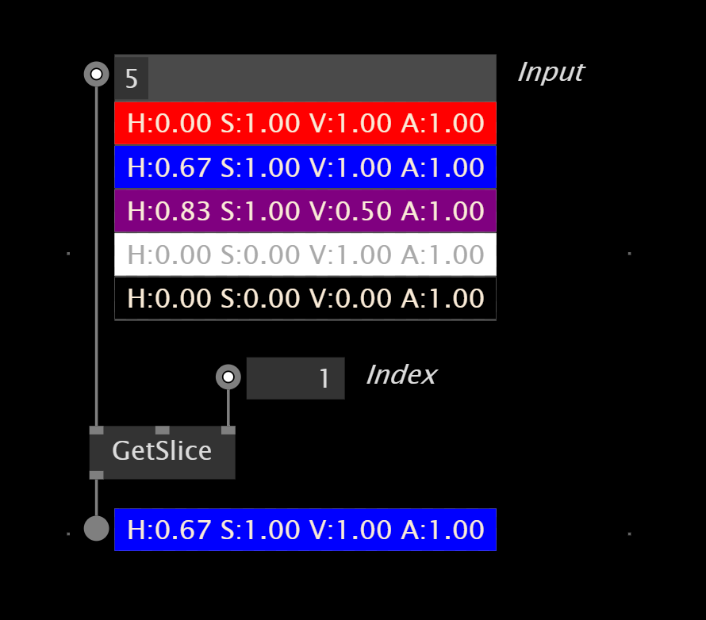

Set a slice at a specified index.
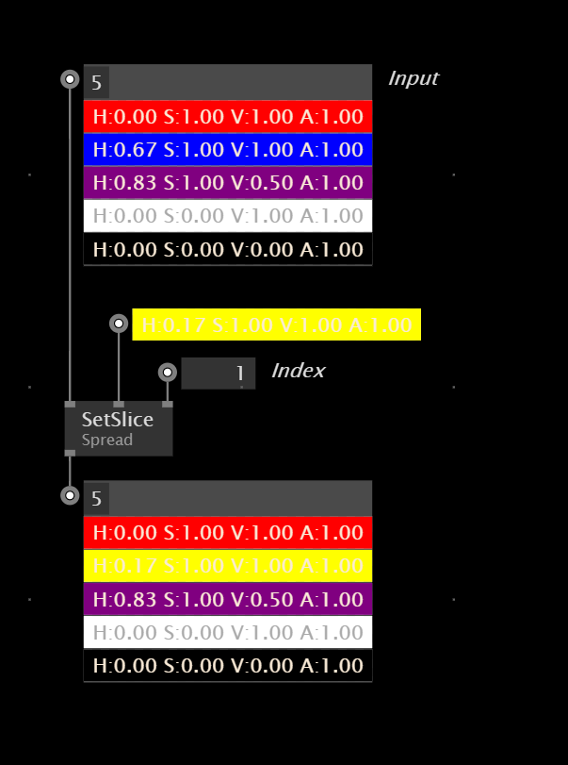

Count the slices of a spread.
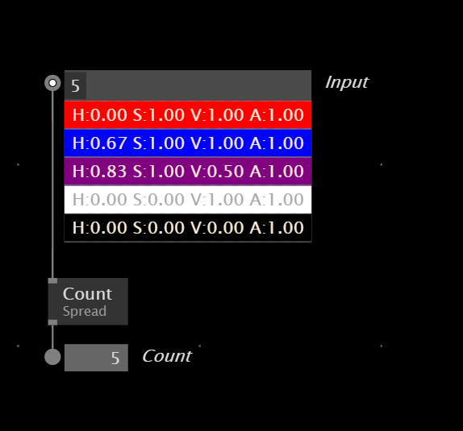

If region
The If region allows to execute parts of your patch when a condition is met. Otherwise the region will be bypassed and the input will be directly forwarded to its corresponding output.
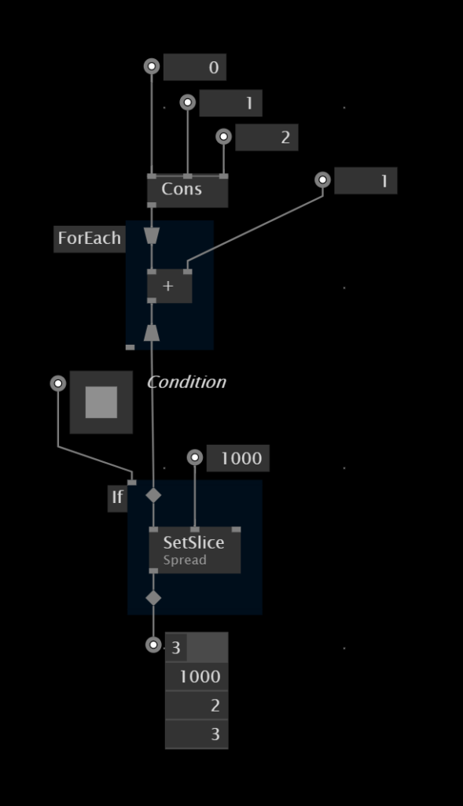

Wanderer
The Wanderer is a very flexible node that generates a smoothly transitioning Vector2 or Vector3 with lots of settings to explore.
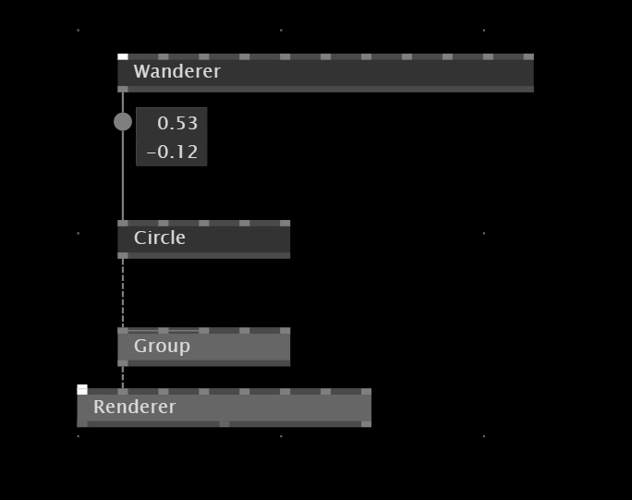

Additional Resources
- https://youtu.be/rDfQm7rOEEM

Lesson Material

4. Spreads & Algorithms II

Recording

Project Presentations

Lesson Overview

Spread Generators
So far all the spreads we have been visualizing were manually created or with an external trigger on the Queue node. But there is a bunch of automatic generators that we can make use of and generate values that are in a specific relation to each other. All of them have a count input pin.
There are spread generators for data in one, two or three dimensions. But keep in mind that this is only data and we can still choose how to draw it. So we can also use one- or two-dimensional data to draw in 3D space.

One-Dimensional Spreads
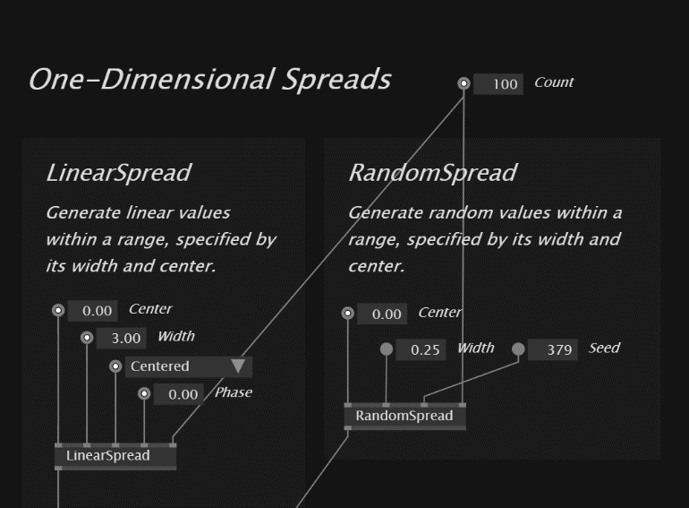

Two-Dimensional Spreads
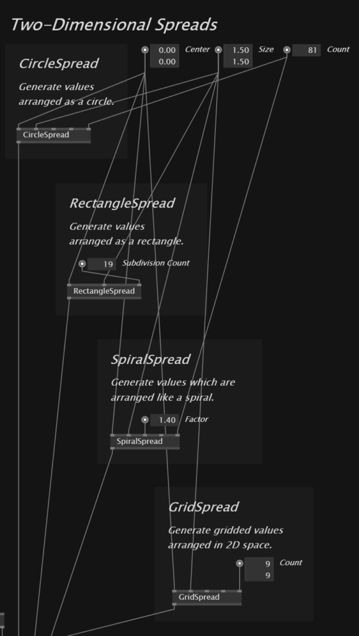

Three-Dimensional Spreads
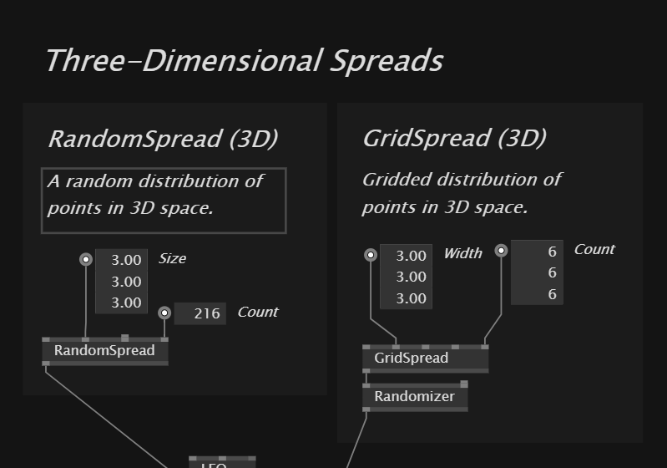

2D Spreads in 3D Space
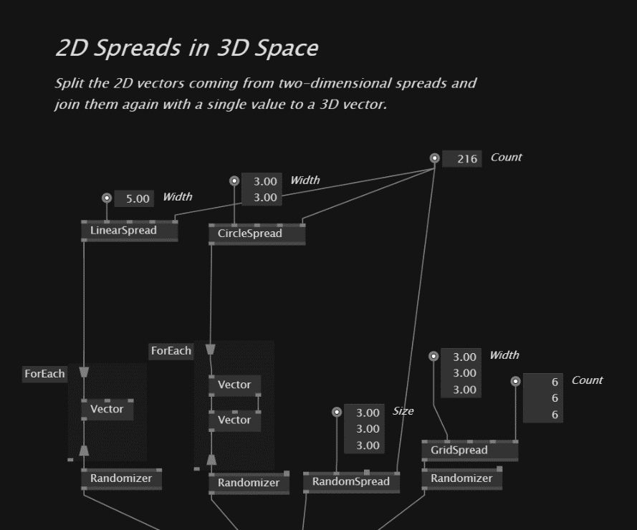

Attractor
The Attractor node re-calculates the position of a point in 2D and 3D space depending on the position of another point. By doing so, it is possible to simulate some kind of magnetic behaviour and make a single point pull or push others. It is basically driven by four parameters:
- the position of the attracting point
- the strength of the attraction
- the power of the attraction
- the radius in which the attraction is applied
Strength and power will influence each other drastically, in most cases it is fine to keep the strength in the range between 0 and 1. The power will then influence the amount of attraction towards the specified point.
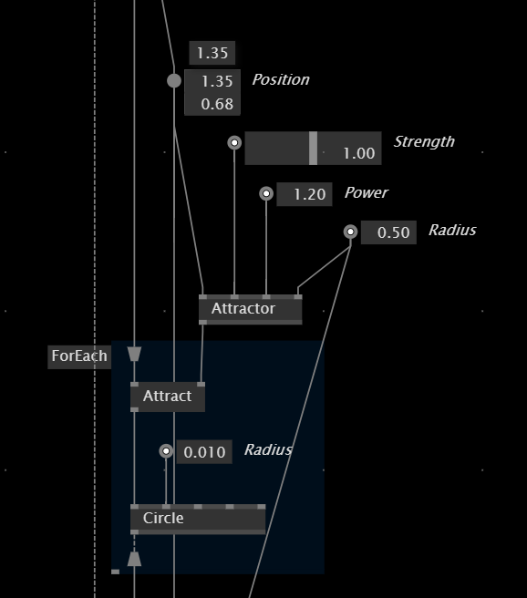

SimplexNoise
Noise is an algorithm that can be used to generate organic distributions of values. They are in a way randomly generated, but still the values are somehow connected to each other. Noise can be calculated for single values as well as 2D, 3D and even 4D values, therefore the SimplexNoise node in vvvv is adaptive and can be used for all of these data types.
Noise can be easily animated, if the value on its input or output is somehow computed with an animated value, for example a steadily counting float. We can use a Stopwatch for this purpose. Also play around with the sliders to set values for the Octaves, Frequency and Persistence inputs and see how they affect the computed values.
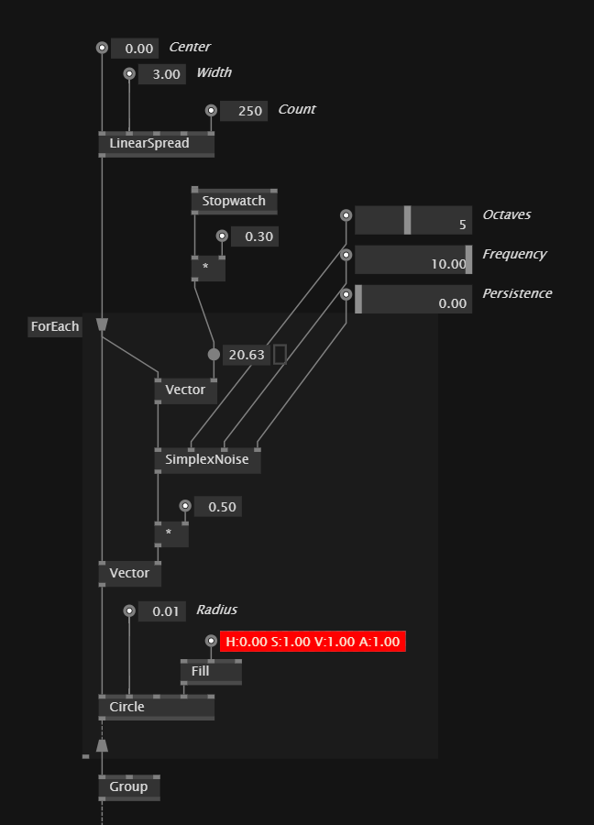

ConnectAll
We can make use of the convenience node ConnectAll, which delivers this information for a larger number of points. In fact, you can analyse the distance between as many points as your CPU allows before dropping the frame rate. On the output you can grab the information for every connection that exceeds a certain threshold you specify on the input.
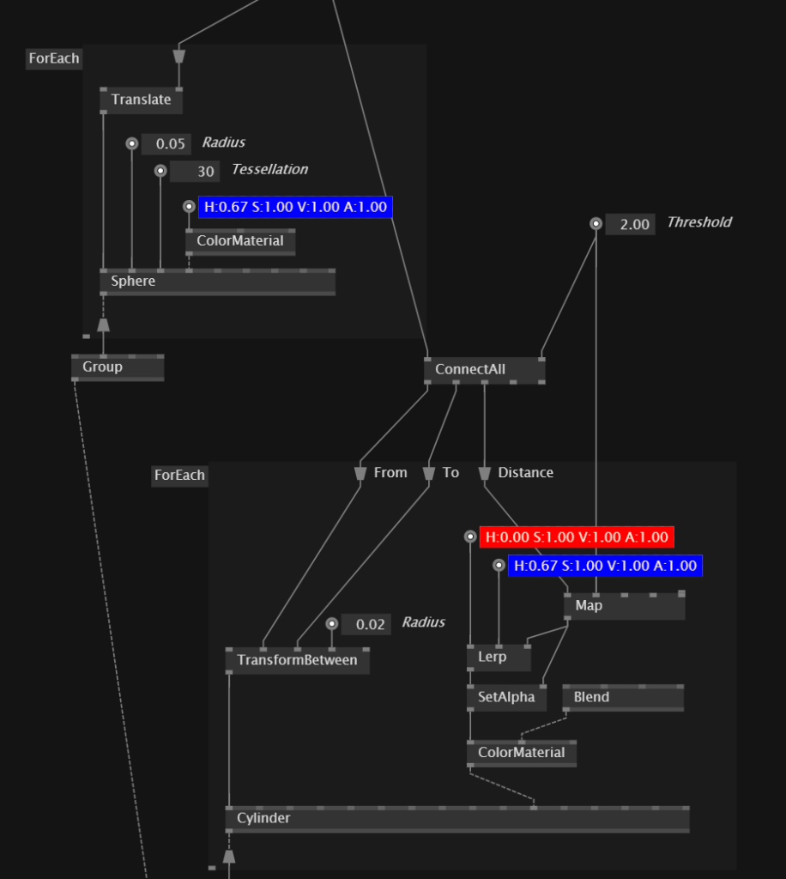

Lesson Material

5. Audio Visualization & Textures

Recording

Project Presentations

Lesson Overview

Texture Sources
Stride works with textures when dealing with 2D image data. Textures can be loaded from your drive and applied as a material to the primitives. There are also lots of other texture sources, which will be introduced in the next patches. Textures can be displayed as IOBoxes in the patch.
Video playback and webcam capabilities for Stride are offered with the MediaFoundation pack which also return a texture. For this purpose reference the pack VL.Video.MediaFoundation and use these nodes to generate either a Texture.
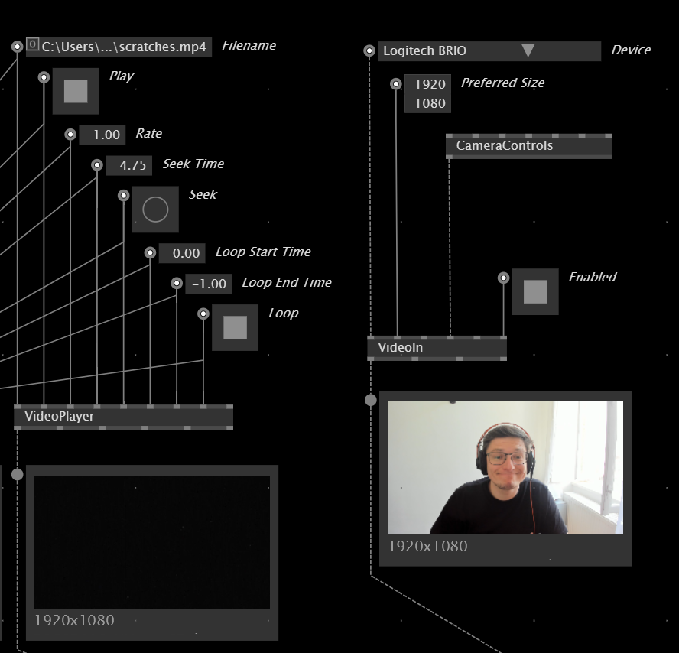

Besides the textures from a file or video feed, Stride also offers a wide range of texture sources of which some are static and some are animated. They all can be modified on their input pins in real time. Here are some example texture sources… more of them in the Node Browser in the category Stride > Textures > Source.
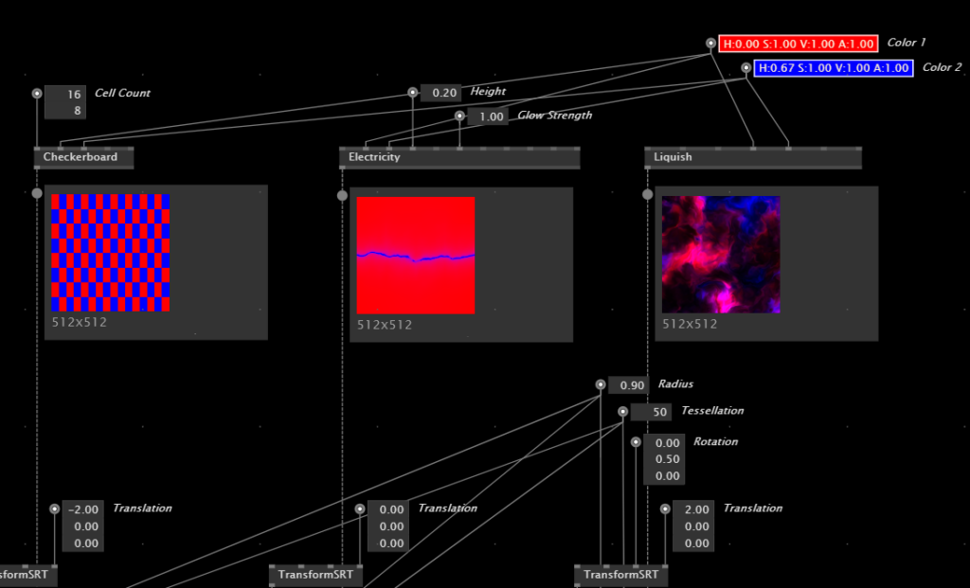

Texture Effects
Use a wide range of real time shaders that operate on textures in Stride, with lots of configuration and animation options. With the mixer nodes, multiple textures can be combined. You can find them all in the category Stride > Textures > Filters / Mixer.
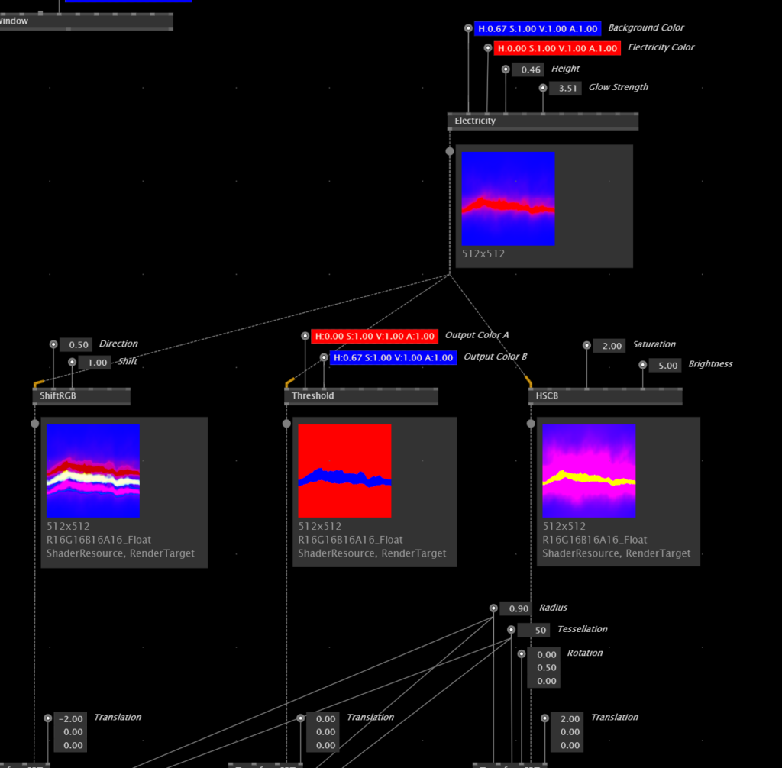
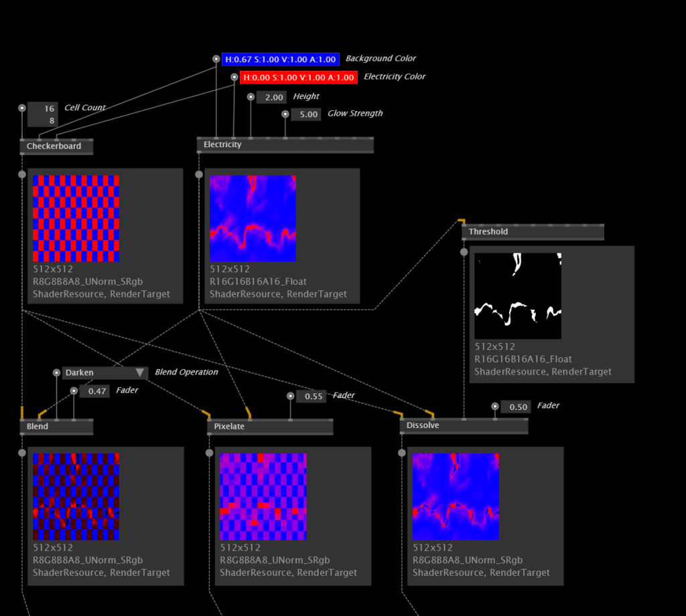

Using Feedback
As outlined in the last session, we can use a variety of texture sources, filters and mixers and apply these as effects on our textures. A very common technique in the toolkit of a generative designer is the Feedback node, which does a similar thing to a pad - it is basically creating a copy of a texture and making it accessible in the next frame. Like this we can blend the current texture and the one from one frame ago together and use this for a variety of visual effects. In its simplest case, this would be a trail of circles.
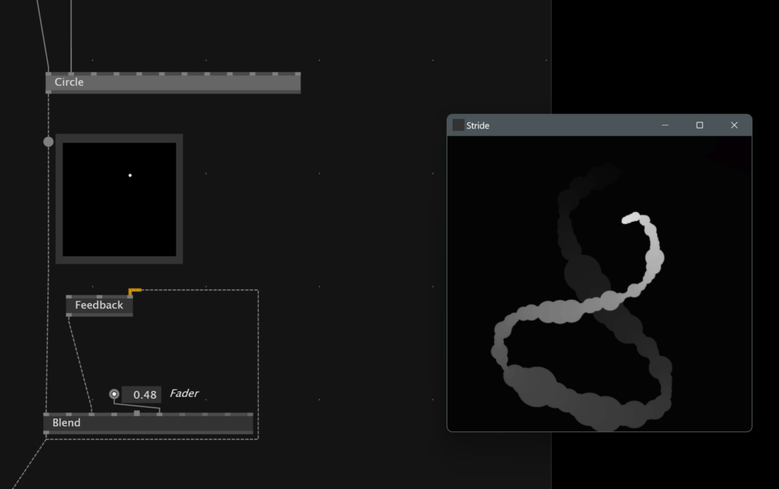
Right in between the output of the feedback and the second input of the Blend node, it is possible to insert all other Filter effects, which applies them to the feedback chain. If we for example insert a Blur node, this effect is frame by frame applied to the texture which makes the trail blur our the longer it gets.

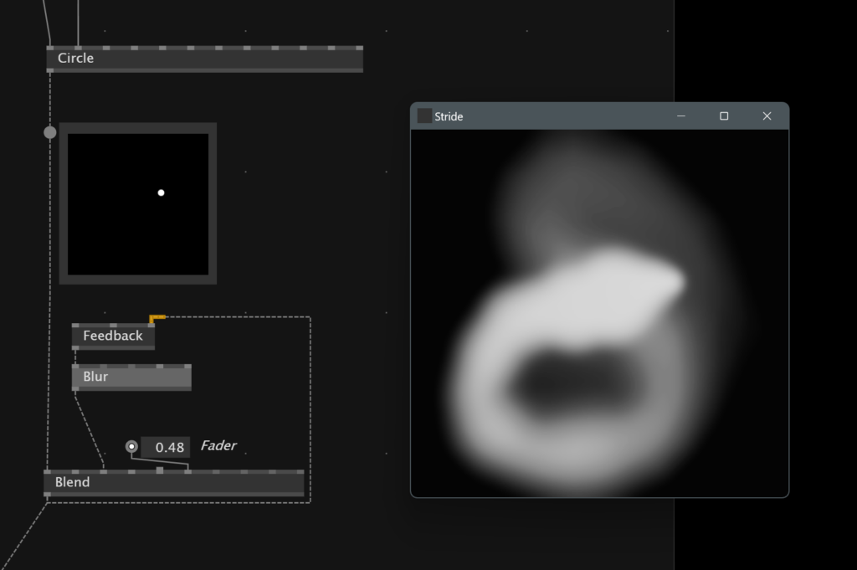

AudioPlayer & AudioIn
vvvv should pick your default system audio driver. However, if you want to switch to another driver, you can do so via the Audio Configuration extension in the quad menu. It is also possible to open it using the shortcut Alt + C.
Use an AudioPlayer node to get the audio stream from a file from disk, and the AudioIn node to get the input configured for your driver, like a microphone or internal audio routings. The tooltip will show you a little meter of your audio signal once it is connected to an audio sink.
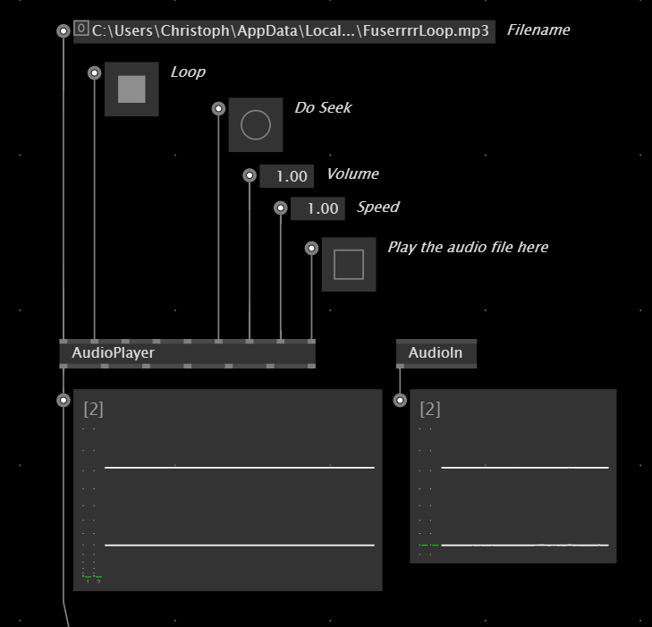

In order to analyse the audio stream you need to make sure you are only dealing with a single audio signal. Most audio sources will deliver a stereo signal, which you can convert into a mono signal using the ToMono node. Alternatively, it is also possible to use a GetSlice node, as the channels are actually delivered as a spread.
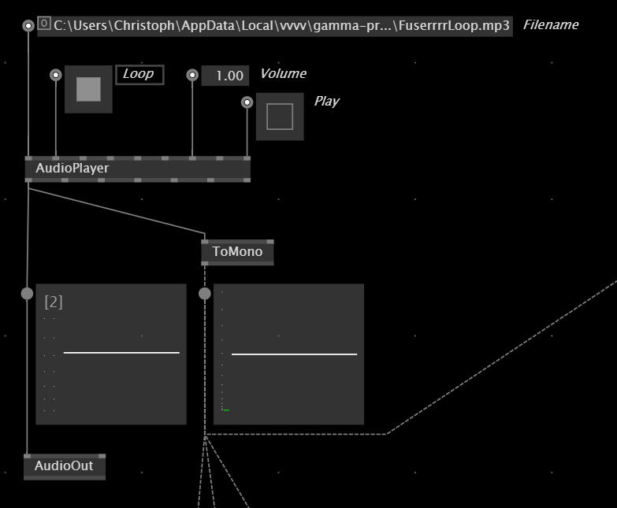

Meter
Get the current amplitude of the audio signal. We can use it as a continuously changing value for a real-time animation. Combine it with a Damper to smoothen the signal.
Also it is possible to use it as a trigger for a distinct event, in this case inverting the colors, once the meter hits a certain threshold. We can use a MonoFlop to filter out Bangs with very short distances which can occur in this situation.
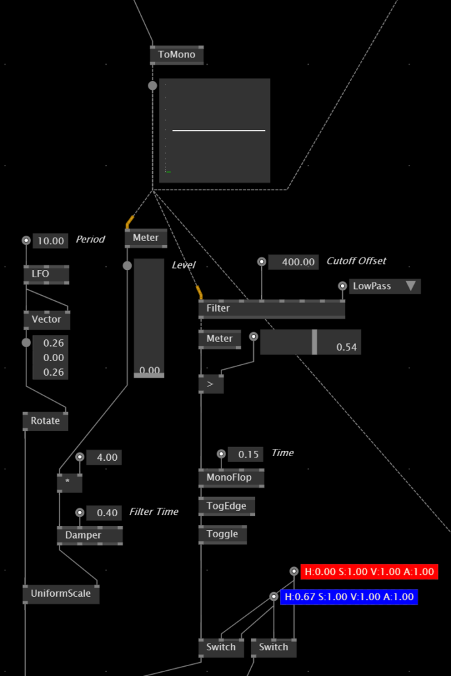

FFT
With the FFT node it is possible to analyse the spectral bands in your audio signal. It will deliver the amplitudes for all audible frequencies. In order to transform the output to a spread of Float32, it needs to be converted using a FromSequence node. Also you can pipe the output of the FFT through the experimental Lin2Log node, to create a more natural distribution of frequency amplitudes.
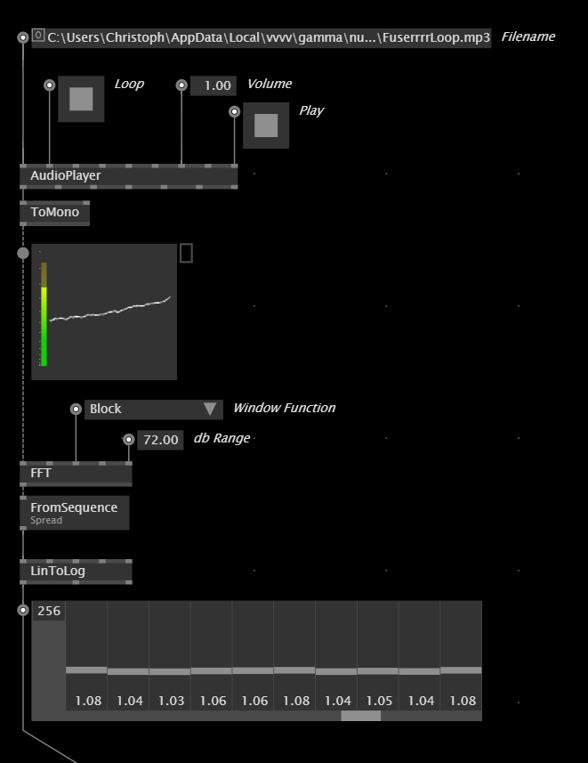

Lesson Material

6. Building User Interfaces

Recording

Project Presentations

Lesson Overview

Application vs. Definitions
Let's draw your attention to the definitions of a VL document. You can imagine this like the front and back side of your patch - the application is the patch itself and the back is where you store your custom data types, processes and operations. Go to your documents definitions by clicking on the "Definitions" entry in the document menu, to see this backside of your document, where you will also find the deifnitions of the nmodes that you have created so far.
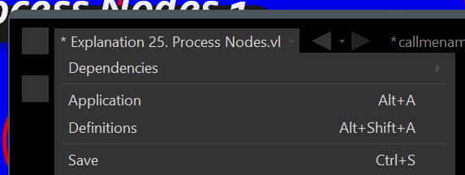

By the way - when you type something in the Node Browser and select the entry "Node" in there, it automatically creates the Process Node with the name AND the definition of the Process on the backside of your document. A nice little handy shortcut!
Another side note here, as it is often a cause for trouble - when you are making your way though the Help Browser and copy something nice over to your project, it can happen that some of the nodes are red. Besides referencing the needed libraries you should also check, if the help patch contains custom definitions that you must also copy over to your document.

Setting files as dependencies
The same way we can add VL libraries (like VL.Skia, VL.Stride, VL.Audio), we can also set another VL file as a dependency for our document. This is super handy - imagine you are working together as a team on a project and split the development tasks for the project. So every person could create a VL document, that has nothing on the application side, but only definitions on the definitions side. In the end there is finally only one document that sets a reference to the other files to give this document access to all the nodes the project members have created. With a little training this is a very helpful workflow when working together as a team.
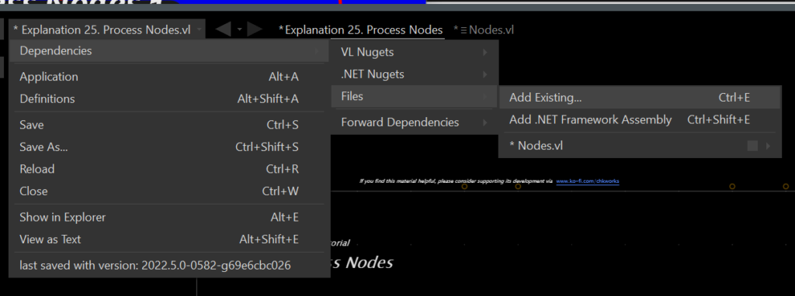

Channels
Using channels we can make use of data binding upstream from multiple locations inside vvvv. It is your frist confrontation with the concept of data being sent upstream via a dashed line and we will explore this concept more, when it comes to programming with objects created from classes. What you basically need to know now - channels can be read and set from anywhere inside your patch using methods that operate on the output of the channel node. In this example the SetValue operation will be executed then the value on the IOBox changes, therefore the last changed value will be available on the operation "Value".
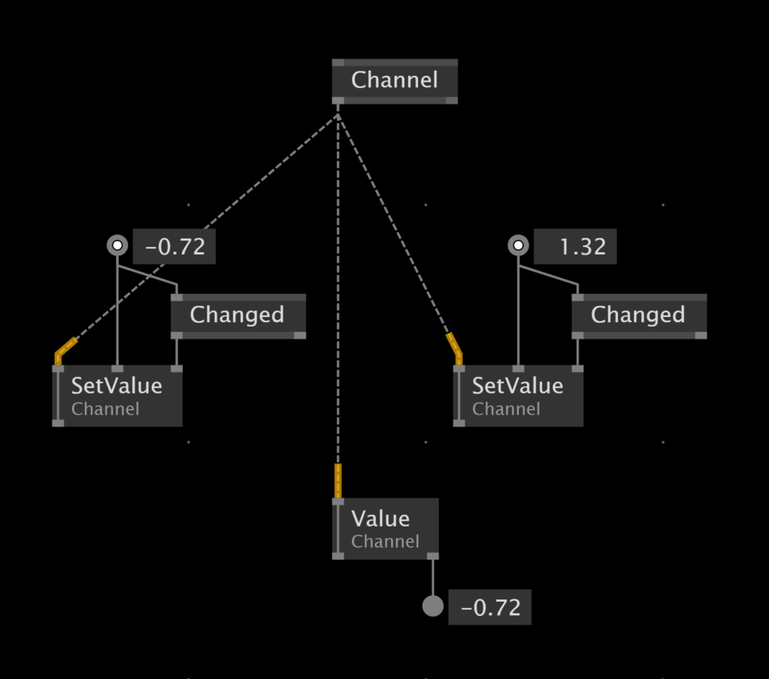

ImGui
Channels allow to implement real-time interfaces using ImGui, a new library integrated in vvvv gamma since the newst version 5. It is a huge and widely known method for building user interfaces in applications and games, that allows to really simply create powerful settings for applications in vvvv. To render anything ImGui related, we need to use the ImGui region, in which we patch the user interface. Another region called window can be used to have the interface inside a re-positionable window. Finally the interface is rendered using a SkiaRenderer which can be sent as an overlay into the 3D scene.
Also inside of the ImGUi region, we can use nodes to detect events. For example we can detect if the interface is active or hovered to send this value into a channel, which we use to disable the camera on the scene. Also we can detect if the mouse is double-clicked, to show and hide the interface.
There are lots of more examples using ImGui, so check out the help browser to explore all the other widgets and also their styling options.
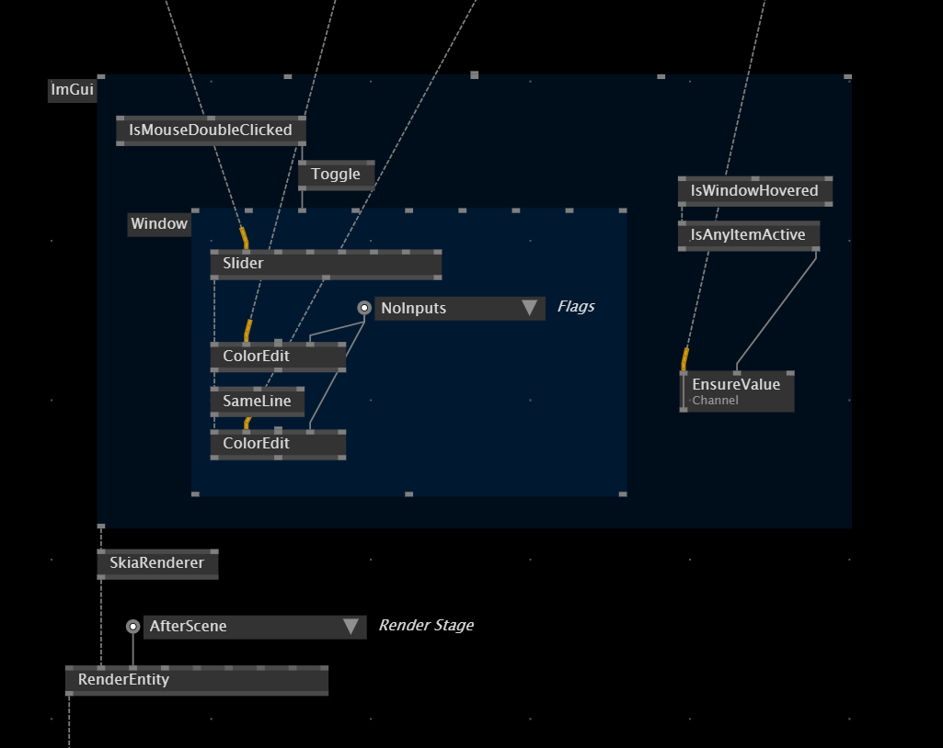

Lesson Material

6. Advanced 3D

Recording

Project Presentations

Lesson Overview

Bugfix
Bugfix is a private project of chk from a few years back, in which macro photographs of a bug were shot out of 70 angels, with 20 levels of detail in each angle. It was controlled by the position of the body in front of the projection, using a Kinect - moving sideways made the bug rotate in place, which moving towards the screen sharpened the image.
We can use the capabilities of Stride to create a virtual mockup of an installation like this. This is mainly possible by using the node ProjectorLight, which can be fed with a texture so simulate a projector throwing content on objects in space.
Bild fehlt
The photographs were added into a video file, in which every second represents one angle, and the milliseconds within one second represent the levels of detail from that angle. To make a prototype using the mouse in Stride, we basically have to take this calculation into account - moving the mouse sideways controls the seconds, which moving the mouse up and down controls the milliseconds.
Bild fehlt

VL.Fuse
Texture sources and effects are shader code in the background, which means this code is written in a special language called SDSL. If you for example, open a Liquish node, right-click on it and hit „Open“, you will see that the editor opens up, showing the SDSL code running in the background of the node.
Fuse is a library, that creates a very modular, fine-grained node set to patch shaders instead of writing these with code. It is currently in active development, and it is totally beyond the scope of this beginners course, as also the instructors are not very experienced working with it, and it also requires a decent amount of understanding how a shader works by itself. But there are lots of examples in the help browser that can get you started - in the class we basically patched the example "Render Particles With Material“, so feel free to play around with it!

By Rosi

Shader Programming with vvvv
Shaders are programs that run on your graphics card (GPU) instead of your central processing unit (CPU). They were originally used when real-time graphics contained many objects and should be calculated quickly. By now they are used to bring basically anything on display in real-time graphics.

GPU and CPU Programming
On the CPU you can not run multiple tasks truly parallel. Even if your computer is a quadcore (= 4 CPUs) the tasks need to be at least scheduled and sorted to the multiple cores.
The GPU is used for parallel processing. You can atomize your program into the smallest tasks and let them all execute one small thing at the same time.

Example Fragment shader
It's a program that calculates the colour of each pixel on your screen for one frame. When you use Full HD, so 1080x1920 pixel resolution, you have about 2 million workloads, which the GPU can process massively in parallel.
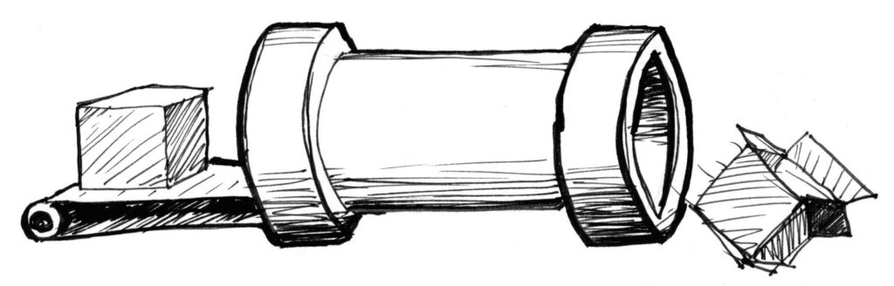
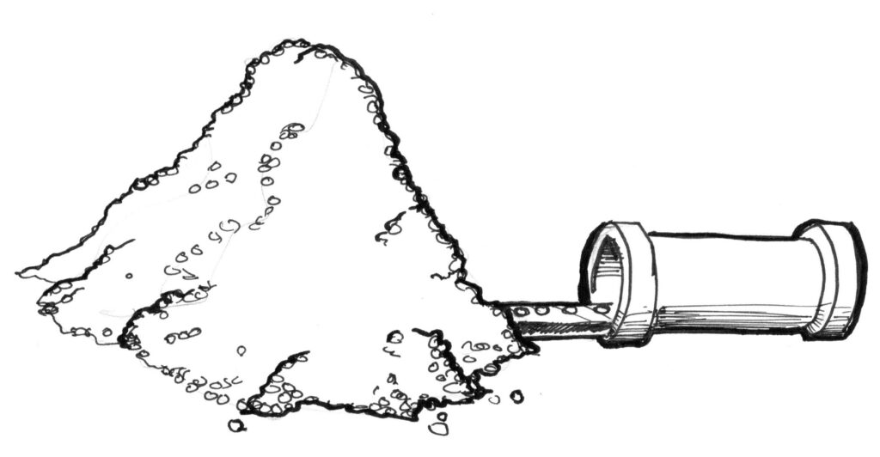
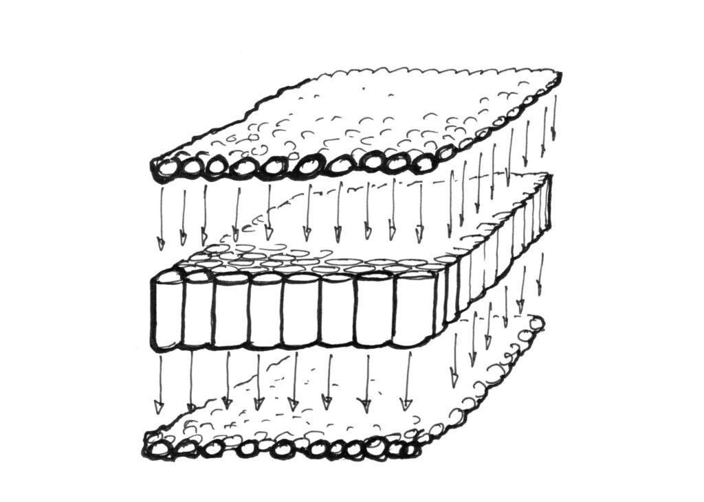
(Images by https://thebookofshaders.com/, a useful resource)
The logic of shader programs is different from the CPU programs we wrote so far.
The single entities = Buffer Ressource Elements (pixels, particles,…) don't know anything about each other. The only thing they know about themselves are the attributes you attach to them (Position, Size, Velocity, Color,…)
In a Fragment- or Pixel Shader, the fragments only know their own position. The art of writing a good shader is using math in a way that you can use this information only to write a function that evaluates colours differently for each pixel to create an image.
Check this out to see how creative you can get: https://www.shadertoy.com/
This shader artist brought writing math functions to calculating aesthetic 3D scenes to a new level: https://www.youtube.com/@InigoQuilez

Fragment, Vertex and Compute Shaders
Fragment Shader: Calculate the color of each pixel on the screen.
Vertex Shader: When calculating a 3D scene, this shader comes in an early stage of your computer's graphics pipeline. It calculates colour by vertices.

Example
The brightness of a vertex according to the angle of the light and the amount of light that reaches it.
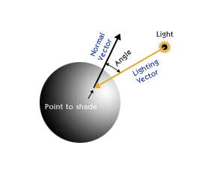
Compute Shader: This is detached from directly calculating graphics. It uses the logic of shader code to calculate millions of tasks at the same time and just uses the GPU's infrastructure. These shaders are used to accelerate AI tasks or in our case, we use them for particle systems.
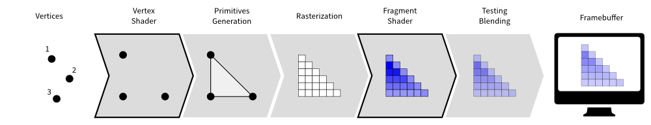

Signed Distance Field
A powerful way to make use of the fact that each element only knows about its attributes are signed distance fields or SDFs:
Think about how you would draw a white circle on a black background with a fragment shader. You decide the centre point and the radius. Your shader code then only contains a function that calculates the distance from each fragment to the centerpoint. If it is below the given radius it should be drawn white and otherwise black.
You can think of SDFs as functions that lie in 2D or 3D space. Your element „subscribes“ to the function when its attributes allow it to do so. By that, you don't have to calculate 3D scenes as meshes or groups of objects, but they just appear as whatever you want them to be according to your shader code.

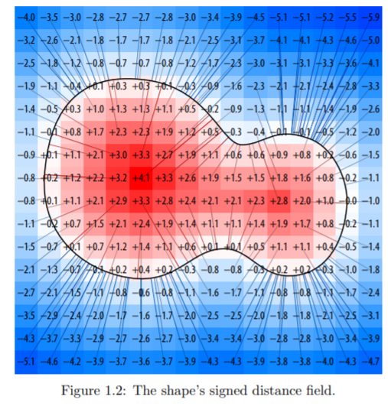

Shader Programming with Fuse
Fuse is developed by a group of people to make the most of shader functionalities (visual programming on the GPU) in vvvv: https://www.thefuselab.io/
Its focus is on procedural functions (functions executed with the logic of math being applied to many elements at the same time) and geometric shapes that come to the screen as SDFs and are rendered with Raymarching, use Compute Shaders to benefit from the efficiency and the speed of GPU coding. By preparing all that with vvvv it becomes a powerful combination of the benefits of a gaming engine and a programming language.

Particle Systems
The basic building blocks:
- Compute System
- Emission Stage
- Simulation Stage
- Rendering/Bridge to Stride
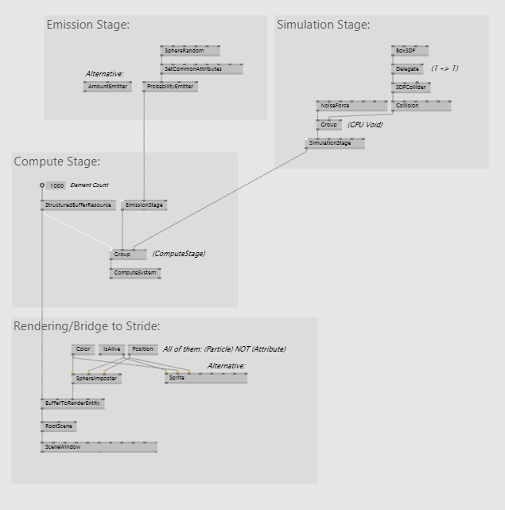

Compute System
This is where the shader code comes together, the core of all calculations. the StructuredBufferRessource specifies how many elements should be calculated in parallel (= the amount of particles).

Emission Stage
Theoretically, a particle system doesn't need an emitter - given that the same elements stay in the buffer - but then you don't have the benefits of them appearing and being discarded, changes over Lifetime of the particle and so on.
There are different emitters that reach the cap of calculatable elements specified in the element count (StructuredBufferRessource) in different ways. Most common are Amount Emitter and Probability Emitter.
SetCommonAttributes: This is the information that every element knows about itself. Basic and most important here is the Position - it's a must-have. Additionally, Attributes like Size, Velocity, Color, Lifetime and custom attributes can be set.
Notice the difference of the patching logic to how we did it before in CPU land: Each attribute holds a different value for each element but as they are all calculated in parallel you neither need a ForEach/Repeat region, nor can you access the individual values.

Simulation Stage
This is a very playful part of the particle system. A variety of forces can be applied to your elements. These forces are conditioned by the Attributes.
e.g.: the strength is dependent on the Age of the particle, the distance to a certain point (Position), the Size and so on.
Again think about the force related to each element values (SDF logic): The particles "subscribe" to the force according to functions that you write for them.
Check out the many example patches that come with the fuse package to learn more about forces and the Simulation Stage.

Rendering/Bridge to Stride
To bring the particle system to the screen, a 3D render engine is needed. Also, check out Raymarching to make the GPU functions in space visible so that they appear like meshes.
BufferToRenderEntity is the trick to get the elements from your shader processed and rendered. Sprite (Effect) or a ...-Imposter are the cheapest ways performance wise.
Here, you need to call the Attributes from the Compute System - make sure you use the right nodes like Color(Particle) and apply them.
Have fun playing around with this setup!

Lesson Material

7. Language Methodologies

Recording

Project Presentations

Lesson Overview

Transformation Chains
So far we have been transforming 2D and 3D primitives with the TransformSRT node. Notice that with this approach, the object is always rotating in place, around its own origin.
If we want to translate the origin before rotating the object, therefore rotating around another center, we can use the TransformSRT (Center) node. Also notice that this also affects the scaling - the layer will grow from the translated center point.
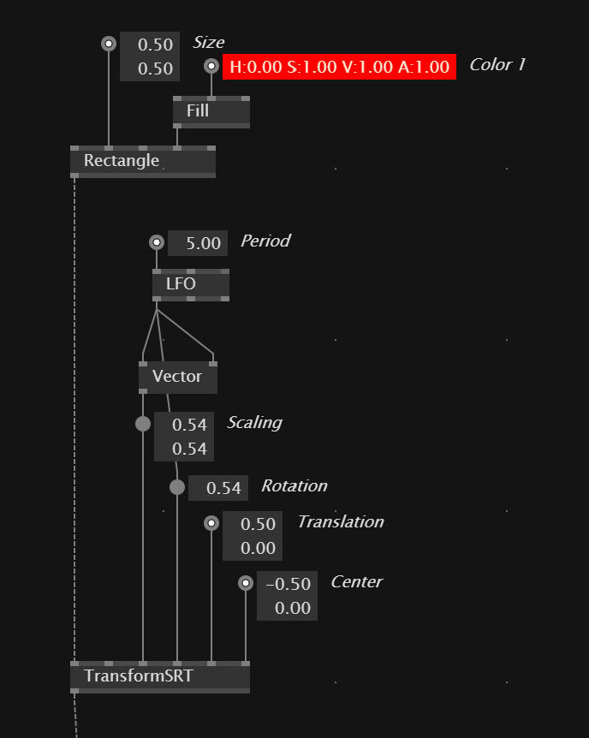

Besides the TransformSRT node it is also possible to use individual nodes for scaling, rotating and translating. It is important to take care of the order how they are connected, because rotating before translating will make the volume or layer rotate like in the example with a translated center point.
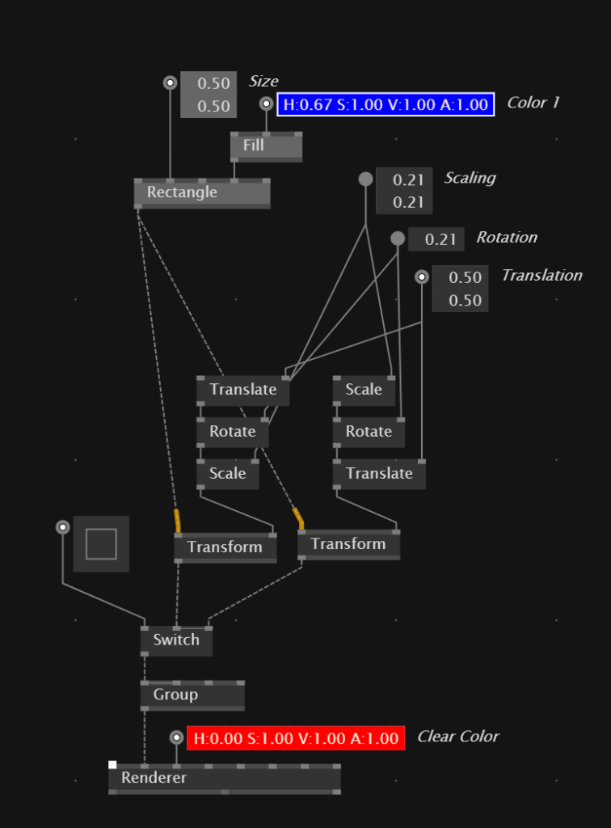

Pads
Pads can be used to store data and use or modify this data in the next iteration. Basically it functions like a variable in other programming environments. Pads can be created from the Node Browser and should have a distinct name.
Pads can used them to store any data type, and in their default state they are simply grayed out, indicating that their data type is yet undefined. Once a pad knows which data type it should be holding, it will turn dark gray. To specify the data type of a pad, either connect a link from somewhere, or specify the data type in the configuration menu (right-click > Configure).
A pad can be placed multiple times in the patch and will make the data inside available in the next frame. Using pads like this requires caution - everything that is going in and out of a pad will have a delay of 1 frame as the value is delivered back in the next frame. So keep this in mind when you are dealing with real-time input.
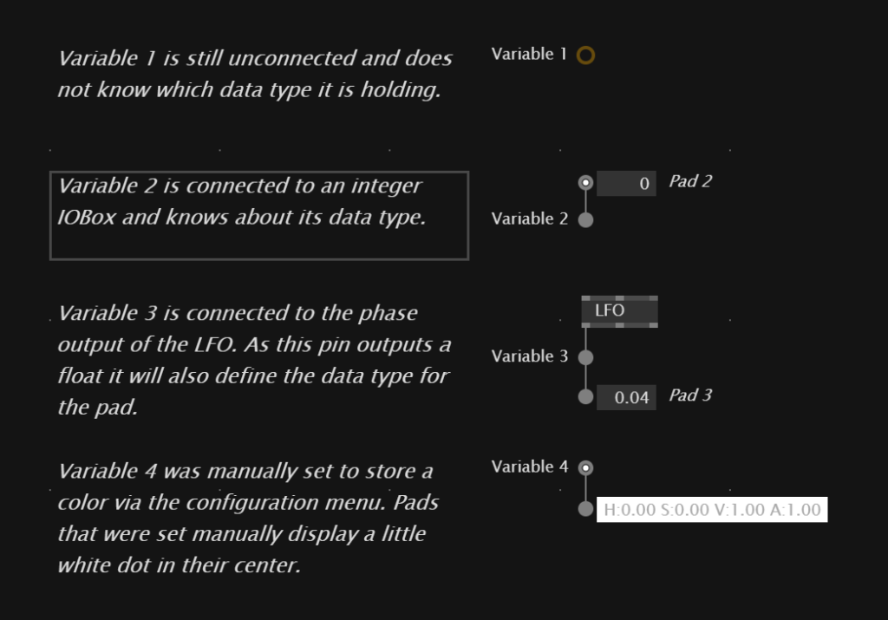

Pads are a great way to modify data from one frame to the next by combining them with If regions, as the inside of the If only triggers when the Condition input is set to true. Make sure that in the end, the modified value gets stored back into the pad.
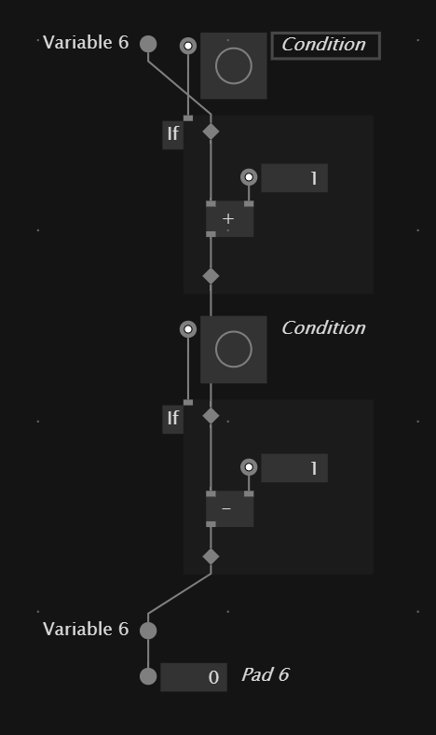

In our example we have used a pad only for the purpose of copying its content into the next frame. Doing this, we can make a distance calculation between the current position of the mouse and the one from the previous frame using the Distance node, and apply the calculated distance as the radius of a circle attached to the mouse position.
Bild fehlt

Update and Create
It is time to introduce you to the concept of operations in vvvv which is very powerful and the base for many further concepts, especially when defining your own data types. Every patch and document has the ability to execute parts of it on specific operations, of which Update and Create are the two default ones.
You can imagine the Update operation as the runtime mode of your patch which is constantly evaluating and executing your nodes. Links that are executed on Update are indicated in gray - which is the default style for all links when patching along.
Create on the other hand is an operation that runs only once when the patch is initialized. It can be used to set or compute a value one time on startup and provide this as the default value for a pad. Create operations are always styled as white links.
By right-clicking on a link and selecting the "Assign" entry, it is possible to define the operation of which the selected link should be evaluated. A link that is assigned to the Create operation will execute only one time when the patch started. This way it is possible to set default values for pads.
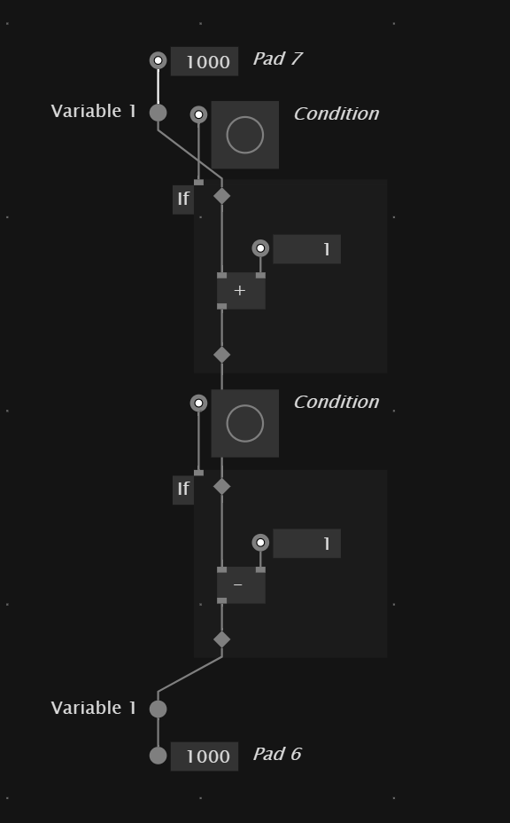
Here is also another example in which the Create operation for the pad involves more nodes that just IOBoxes. In this case, Create generates a random number between 0 and 1000, additionally adds 1000 and sets this computed value as the default for the pad.
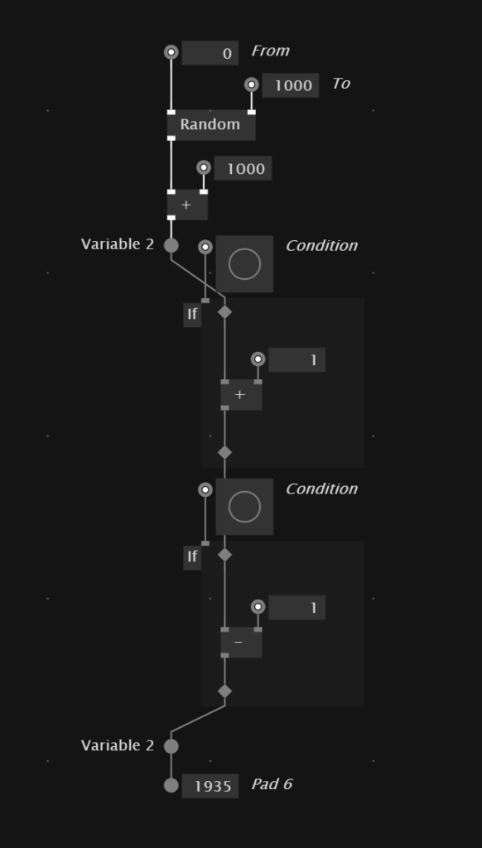

Process Nodes
Most node based environments offer methods to create subpatches which abstract certain functionality and avoid duplicated code all over the place. This is also possible in vvvv using so-called Process Nodes. In fact, every node that is in the Node Browser and that we have used so far, is a Process Node in the background and it is open to the user to create as many of these as desired.
Let's assume we patched along and the result is something like this - three red circles, each with random positions and sizes which are computed on the Create operation and saved into pads.
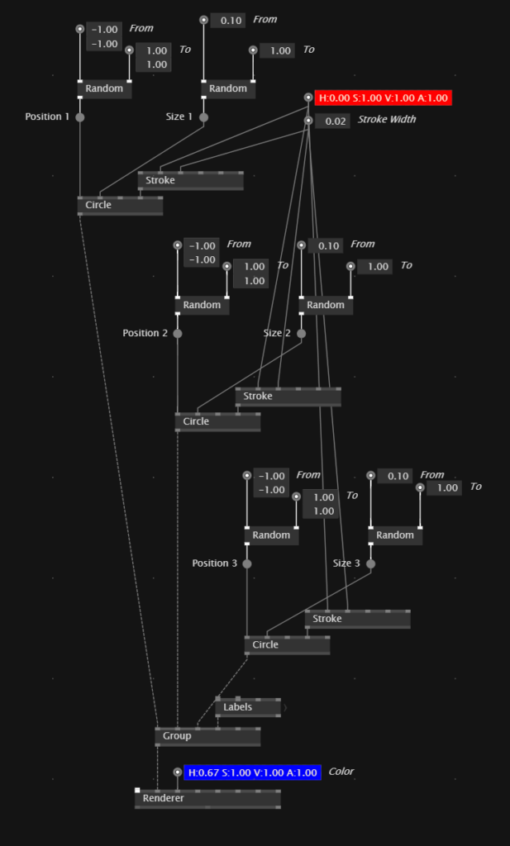

I hope that you can see the value of defining a process node here. This way we can get rid of some of these redundant nodes and bundle them into a little module. You can create a Process from the Node Browser and should give it a meaningful name, for example ColoredCircle.
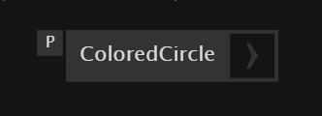

What we have just created was the so-called definition of a process. All definitions are indicated by an arrow to the right, showing that it is something which can be opened and edited. After creating the definition, the node will show up in the Node Browser and can be used just like any other node.
Note that it has two input pins which we can use to set the color and stroke width from outside, and an output pin from which the layer can be connected to the final Renderer. Also the process nodes have a random position and size when the patch is loaded or restarted, exactly like before. This is because a Process node can also contain pads and have their individual implementations of the Create and Update operations.
Please right-click and select "Open" on one of the ColoredCircles underneath or the definition to find out more about creating pads and pins inside Process nodes.
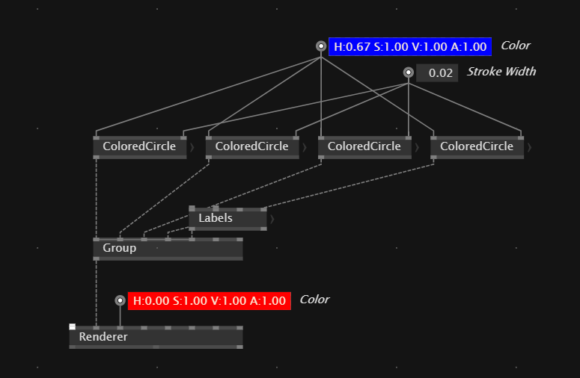

Glad that you asked - of course any custom Process node also works when used in loops!
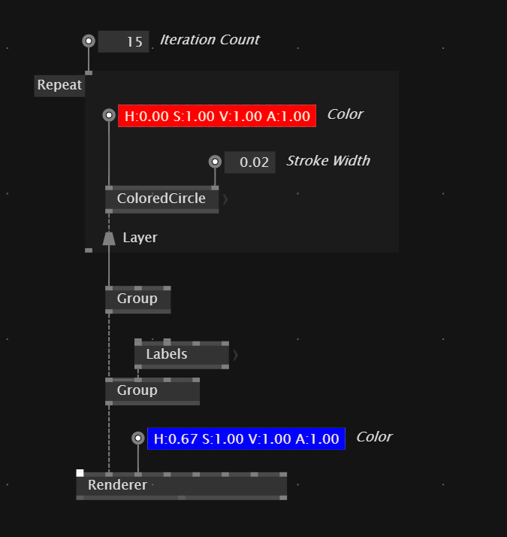

Homework
Use all techniques explored so far to create this solar system. Take a look at the details - the orbits that don't have shadows, while the planets are black on the back side, the glowing sun, the even distribution of positions. Also all planets have a random rotation speed around the sun as well as another random speed around their own axis. You should use a LinearSpread of the generation of planets / orbits, process nodes, create/update - if you want bonus points, take a look at also implementing the moon orbiting around the sun.
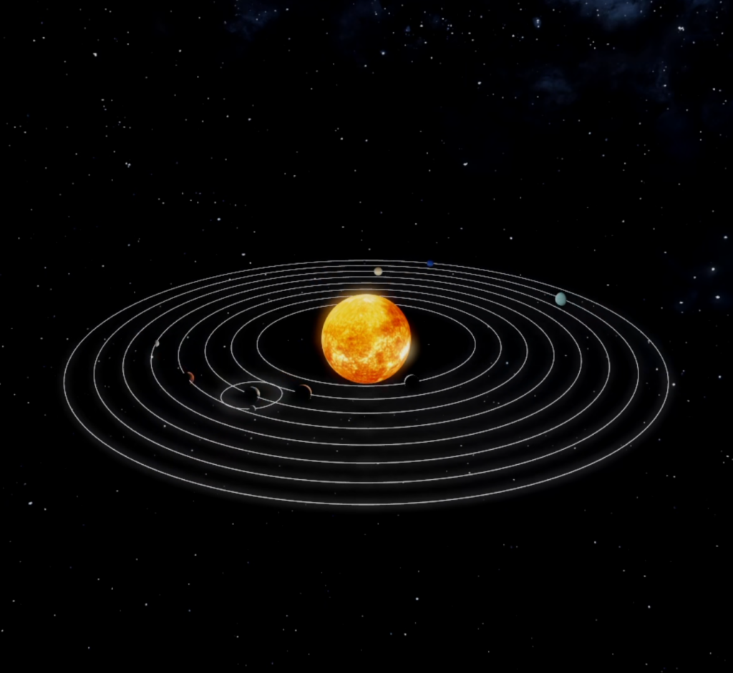

Lesson Material

8. Object-Oriented Patching I

Recording

Project Presentations

Lesson Overview

Queue
The Queue node allows us to add slices to a spread using a trigger input. Every value that is connected to its input will be inserted at the very top of the spread. When the frame count is set to -1, the spread can contain endless values. If set to a number, the slices at the bottom will fall out, when new slices come in. It can be cleared with a Bang on the Clear input.
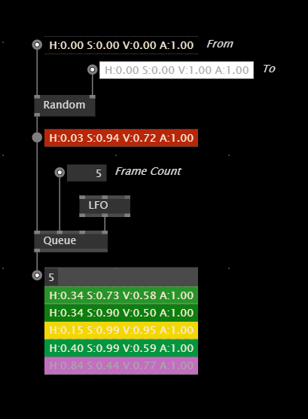

Keep Pin in Loops
You can add a keep pin to the loop regions to control which of the slices should be included in the output. This will also keep the loop from operating on this particular slice. In the following example we check if the randomly generated position is higher than 0, otherwise we throw the slice it away.
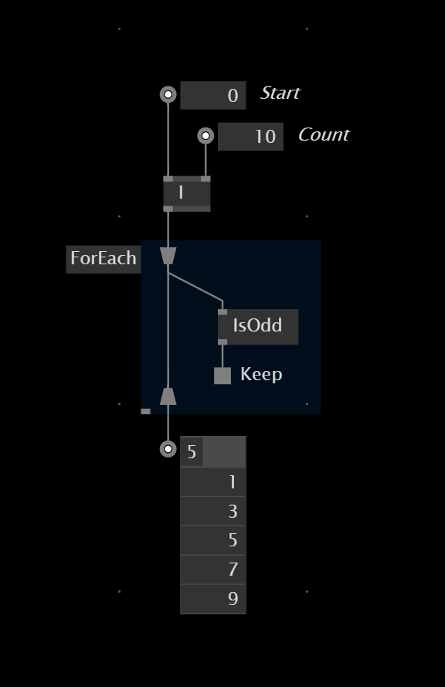

Intro to Object-Oriented Patching
So far we have only been using Process nodes to abstract functionality. In the background, every Process defintion is creating an object and it creates an instance of that object, once the Process is placed as a node in the patch.
This is nice, because using Process when can put certain functionality into little modules, re-use them by playing the nodes multiple times and therefore also clean up the patch.
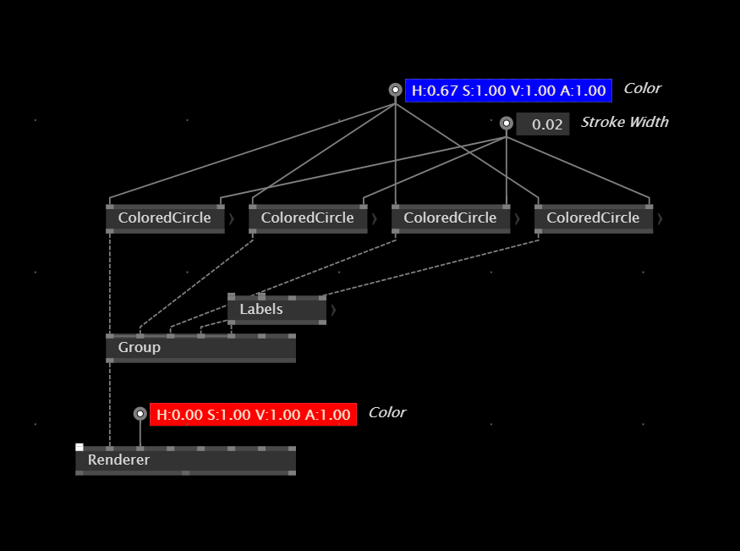

Records & Classes
Process nodes have only one disadvantage - they can not be created dynamically without interacting the patch itself, by placing the Process into it. If we want to create and kill instances of an object from the application itself, for example by interacting with the application using the mouse of the keyboard, we need to use Records and Classes. They both can be selected from the Patch Explorer which is available in the top left corner of the patch.
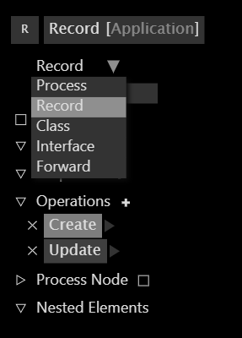

You can also create a Record or Class definition directly from the Node Browser, just like the Process.
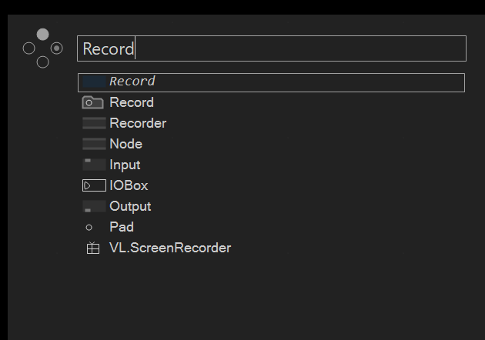
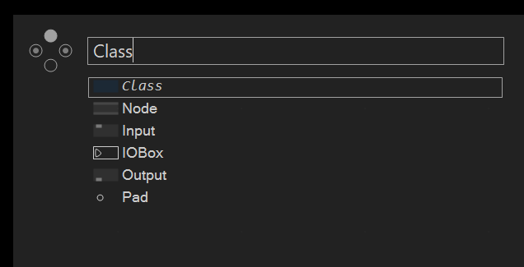

The basic difference between a Record and a Class touches a topic most common in Software Engineering about the mutable or immutable nature of an Object. It basically means that immutable objects (such as Records), have to be stored back into a pad, which a mutable object can also set its properties from downstream, just like we saw with the Channel feature in Session 6.
Both approaches come with fine differences in their features. These features might sound very abstract to you, and you will probably not care about them too early in the future, but I just want to leave them here as a reference.
You pick an immutable Record, when you:
- want to detect changes of the data inside the record (which a class is not able to do)
- want to implement undo/redo funtionality, because immutable types are able to create snapshots when they change (whereas an instance of a class will change itself and not create a copy)
You pick a mutable Class, when you:
- want to change the data in the data type from multiple locations in your patch, because you can access the methods of the type from anywhere in the application (while a record has to be stored back into a pad)
- want to optimize the performance as mutable data is faster (but for the downside of not being able to traverse back through snapshots).
Please refer to the help patch "Process vs. Records vs. Class" for more explanations on this topic.

Use Case: Bundling properties into an object
Let's come up with two use cases, in which chosing a Record over a Process is super handy and will extend your ability to express ideas in VL. The first one would be to bundle properties into a custom data type, which you would not be able to do with plain nodes or even a Process. You would always have to store all related data in seperate spreads outside of the Process and drive the ForEach with these lists. Using a Record, you can bundle the properties inside the object, and just store the whole object in a Spread.
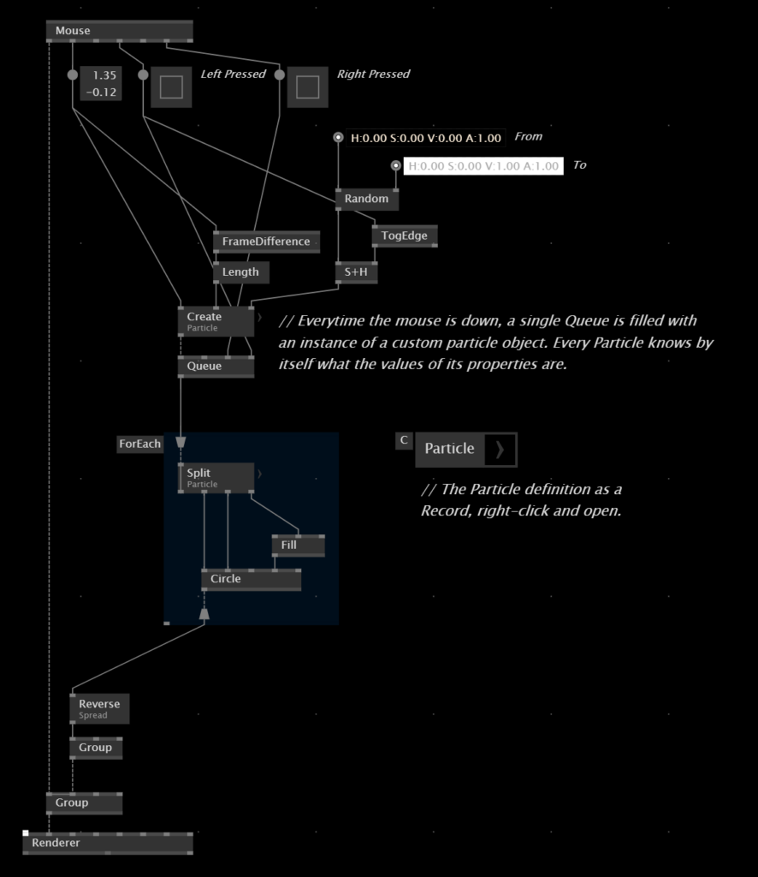

Use Case: Creating instances of objects dynamically
The other use case in which you need to use distinct operation nodes of objects is, when you want to create and destroy instances of objects during the runtime of the application. In this example, all three mouse buttons operate differently on the management of the spread - the left mouse button creates an object and adds it to the spread, the right mouse button removes it from the spread when the mouse is also inside the circle, and the middle mouse button clears the spread entirely.
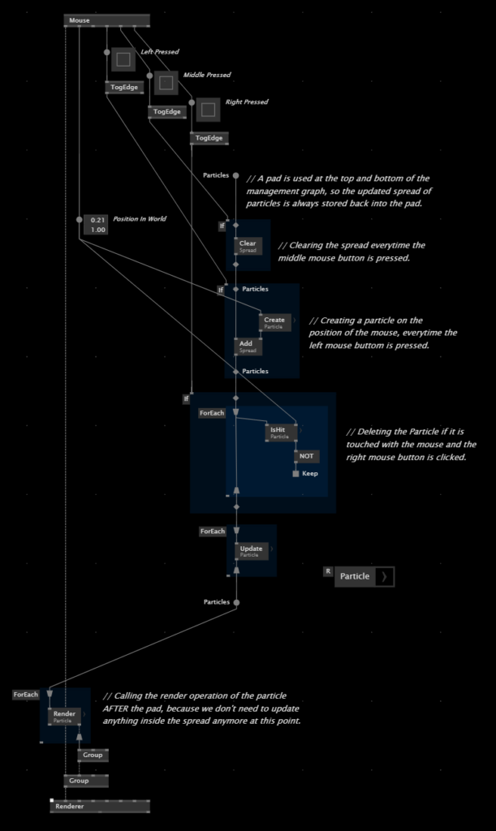

Lesson Material

9. Object-Oriented Patching II
Rosis Session

Recording

Project Presentation

Lesson Overview

Lesson Material

10. Network Protocols
Rosis Session

Recording

Project Presentation

Lesson Overview

Lesson Material

11. Data Visualization

Recording

Project Presentation

Lesson Overview

Dynamic Texture
Using the DynamicTexture2D node, it is possible to generate a texture from data. The node is adaptive and can create a texture from different kinds of data, for example color, floats and integers. But as you feed different data types into the dynamic texture, you also need to take care of the image format, which you can specify on the DynamicTexture2d.
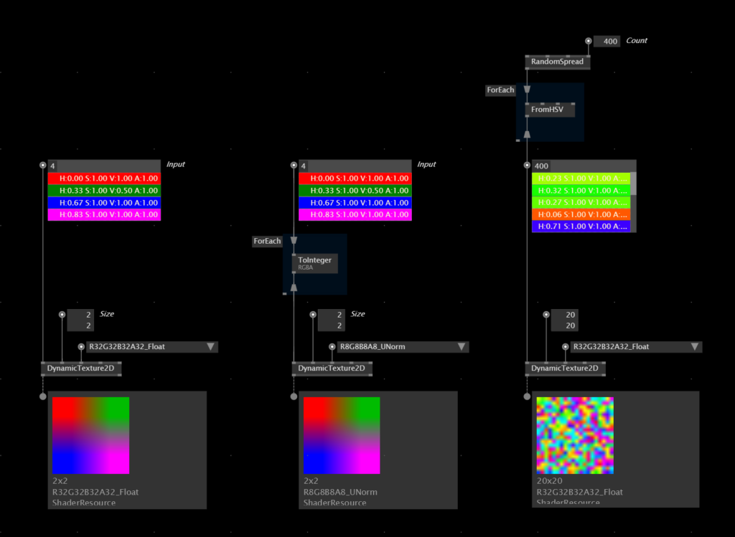

Using this technique, we generated an animated heat map from noise. The texture is finally sent through a Blur node to make it smooth. You can imagine that this data could also be generated from a stream of values or a camera feed instead of a SimplexNoise node.
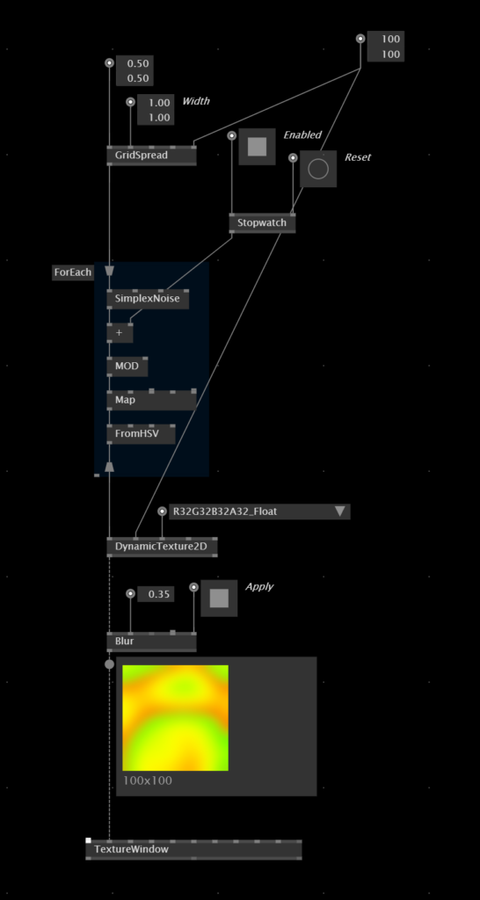

World Cities
We are starting this session with a legendary three-dimensional visualization of the worlds largest cities. The data for this rendering is stored inside a CSV, which stands for Comma Seperated Values. It can be opened and manipulated in any standard spreadsheet editor like Excel.
The first thing we need to do is bringing the data into a format that will work with the final visualization. Inside of a Cache region, which only evaluates when it is triggered on its Force-Input, we first split the whole CSV into a spread of likes, drop the first line (as it only contains the headlines of the data) and then iterate over the spread of lines. We can the use four GetSlice nodes to get to the data we are actually looking for - the name of the city, the latitude and longitude position as well as the population. Take care to properly map and parse the data into values that we can later use inside Stride, especially the latitude and longitude which we turn into a Vector2 ranging from 0 to 1.
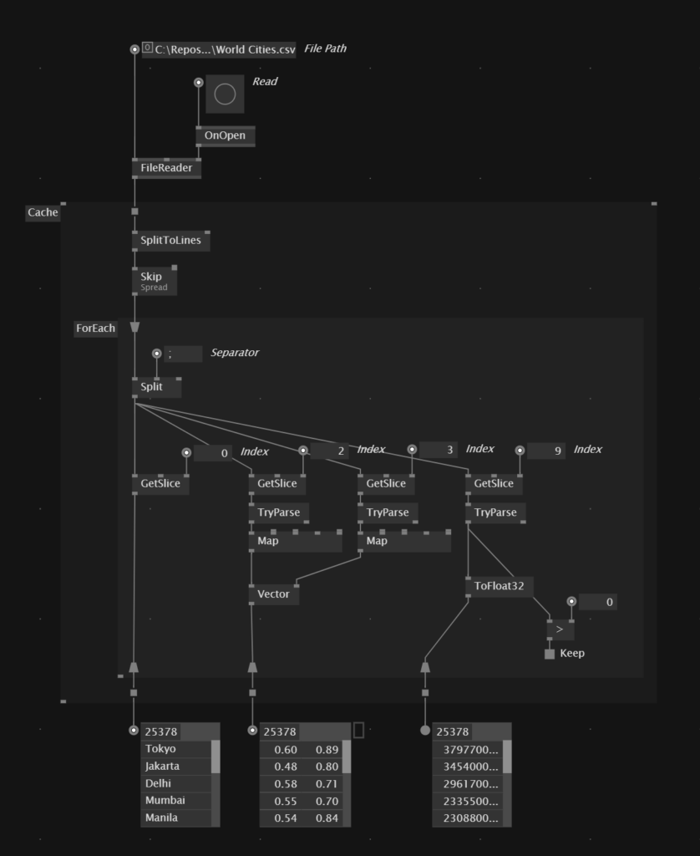
We can then create a spread of transformations to instance a multitude of cylinder entities on the graphics card. Watch out for the transformations! We are making use here of a very elaborate chain of transformations which makes the cylinders grow out of the outer bounds of an invisible sphere.
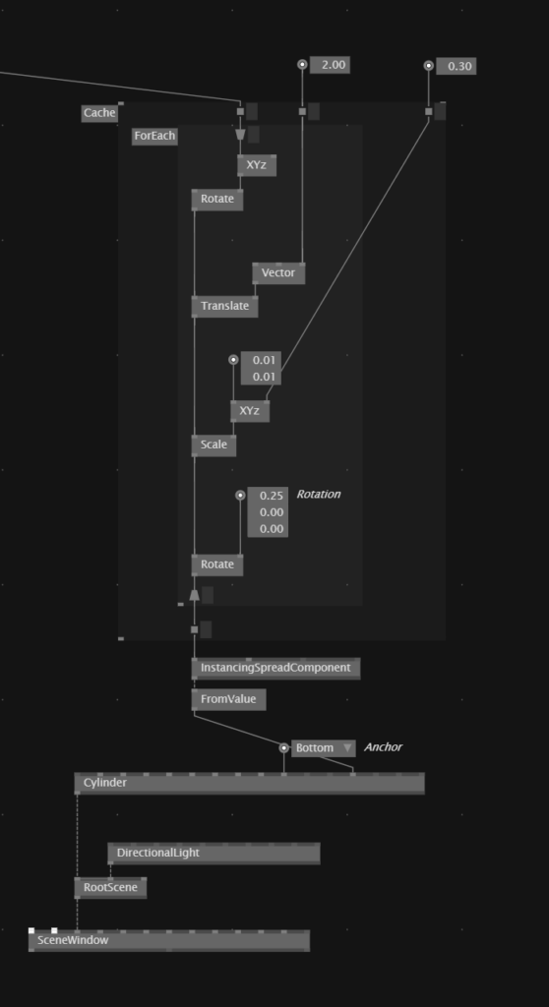
Finally we need to take the populations for the CSV into account to set the lengths of the cylinders using the scaling along one of its axis. By searching for the maximum value inside of the spread, we can use this value to scale the cylinders between 0 and the highest population.
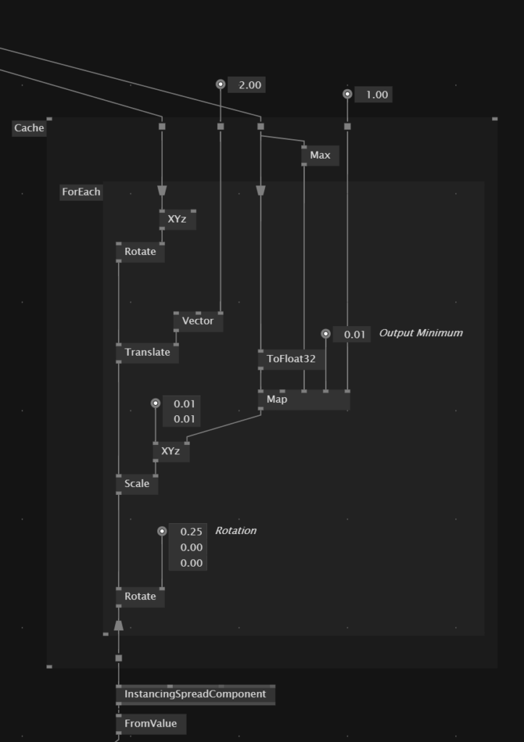
With some refactoring and PostFX, we get this really nice visualization of the worlds population.
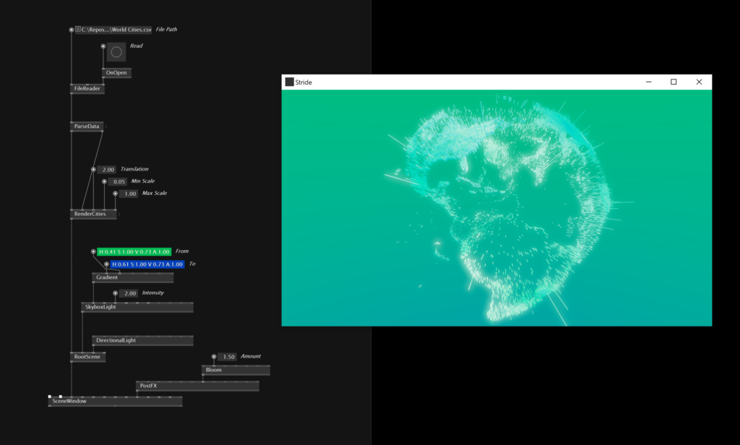

Custom Shapes with Dynamic Paths
Skia offers lots of nodes, that can be used to generate any shape from path operations. These have to be chained into each other which in the end makes up the final path. In the session we have created a path that created a slice for a pie chart using three path operators one after the other. The path is inside a process to make it possible to draw multiple of these slices in a loop.d
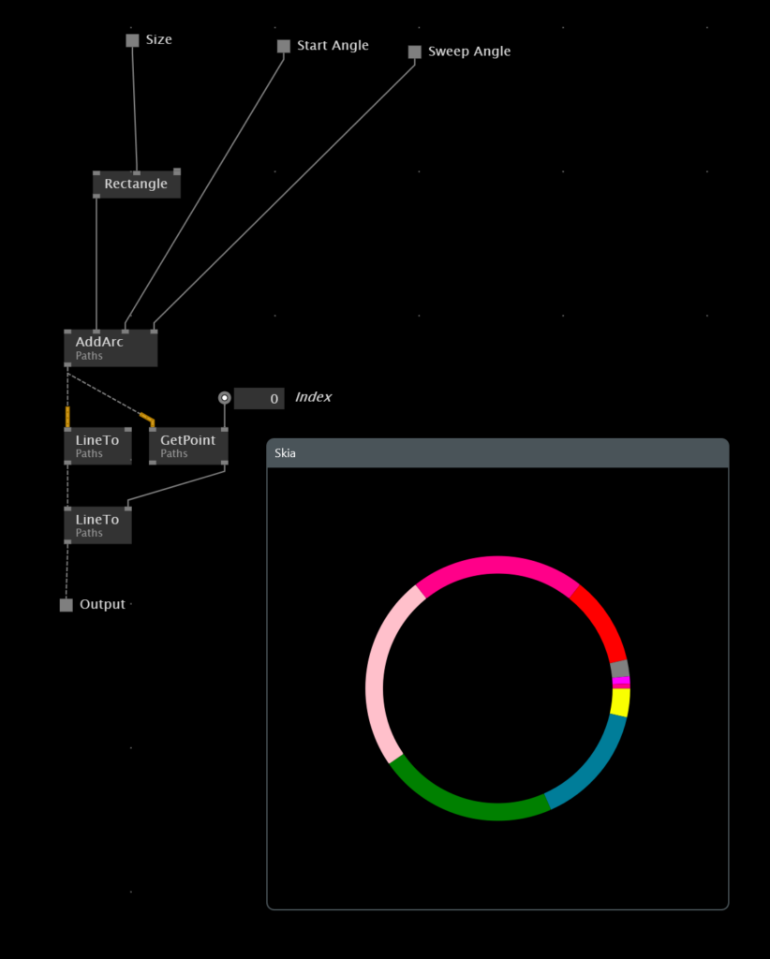

Data from CSV
Using the FileReader node you can get data inside a CSV, which can be generated from a normal spreadsheet tool like Excel. In this example we have used the yearly survey data from vvvv users in the year 2016. In the end the SplitToLines and the looped Split node will create a spread of spreads - with the outer spread representing the rows and the inner spreads representing the columns.
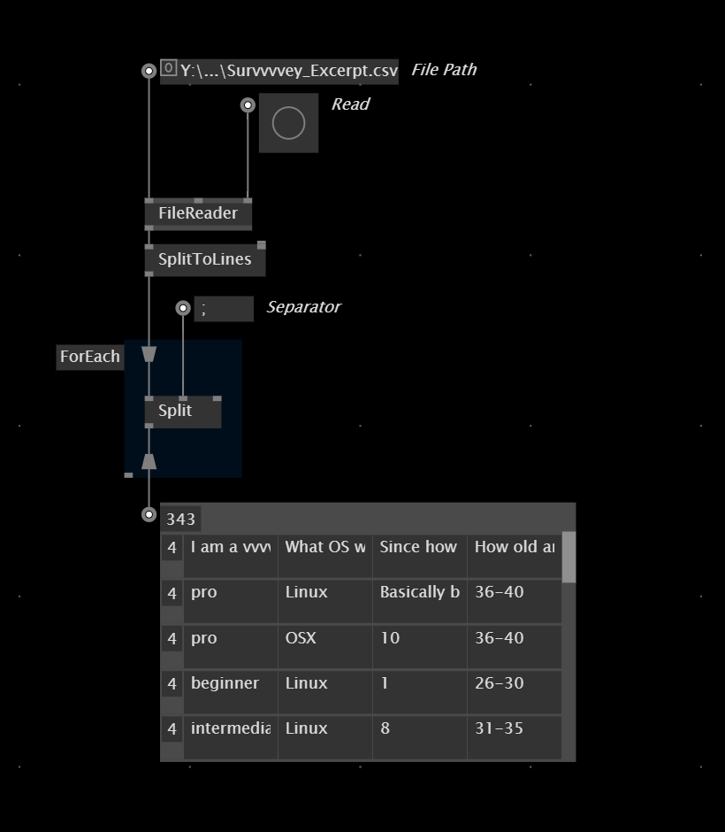

Managing Data
To manage the data returned from the spreadsheet, we can make use of serveral regions to sort, group and select data, depending on certain parameters. I understand that these regions are a bit cumbersome at this point, but the will be re-worked in the future for better usability and readability. In our example, we
- Just get a single slice of the spread inside the spread
- Group it by using the same grouping argument like the content of the slice itselt, in this case the slices with the same name will be added to groups
- Order them by the key of the group, which will order the groups alphabetically
- Finally count all slices inside the groups and return a total number, how many times the answers occur in the data set.
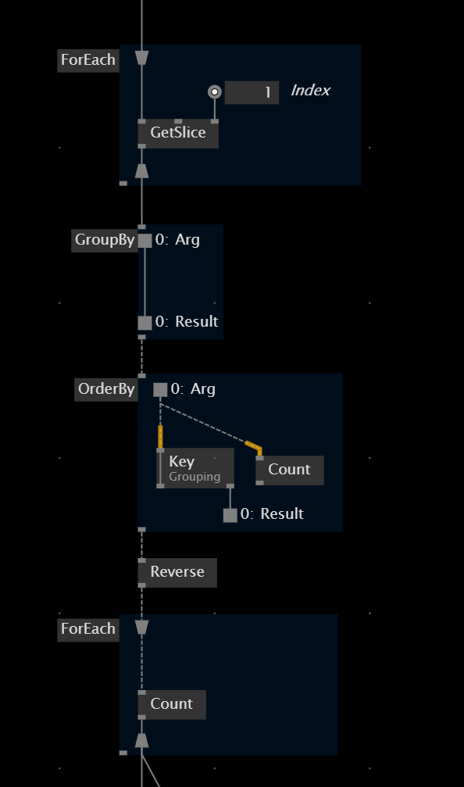
Finally this data is used to generate percentual amounts depening on the total numbers of answer, which are fed into the PieChart that we have created before as a Process Node.
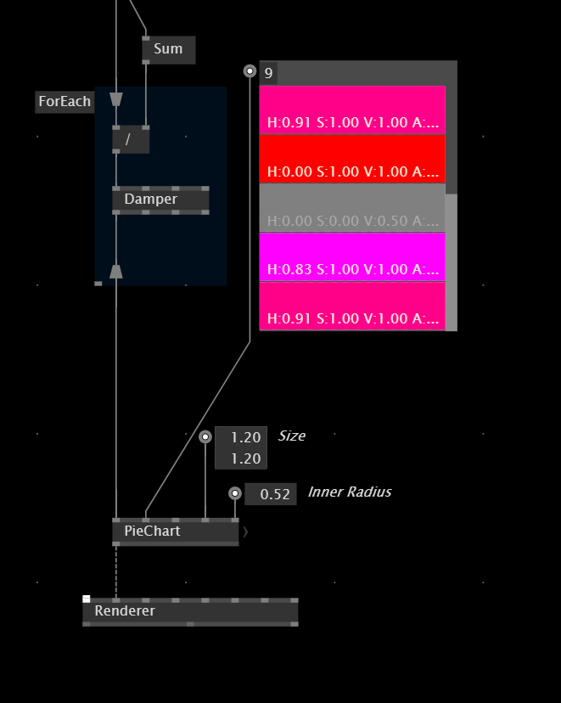

HTTP Requests
Besides generating data from files on your hard drive, you can also make use of so-called HTTP requests (Hypertext Transfer Protocol), which are in fact nothing else then accessing a website in your browser. A HTTP request always returns a response to its call, which in the case of typing in a URL for a website just returns the website as HTML code. HTTP request can therefore also return data through URLs. This is mostly referred to "calling an API" and there are lots and lots of these publicly available.
In our case we are calling the public API of Wiener Linien, the public transport and make a prototype / visualization for a concept and project by Ilina Kokaleska and Julia Kunert. Its a public display for the next departure time of a tram station in Vienna, consisting of ten huge spheres of which the front side is translucent and the other side is not. Depending on the countdown until the next departure, they rotate by 180 degrees and visualise the minutes until the next tube leaves the station.
- https://www.seelab.wien/zeitkugeln/
In vvvv you can easily send HTTP requests with the library VL.SimpleHTTP by sebescudie:
- nuget install VL.SimpleHTTP
Afterwards you can use the node Request (Async) to send an HTTP request, of which you can access the reponse on the output pin. In our case we are calling the URL that returns a JSON with all public data for a specific bus station in Vienna.
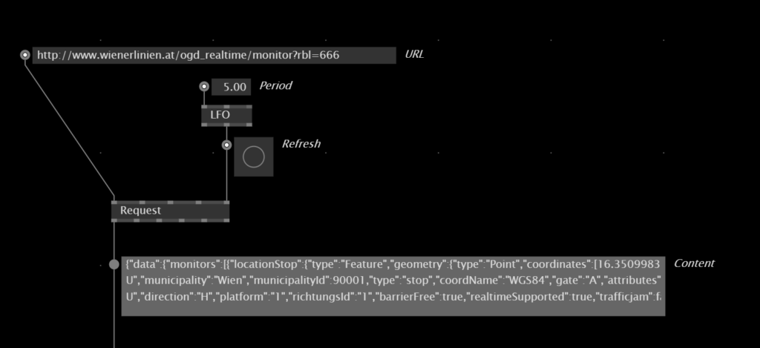

Accessing Data in XMLs
The output of HTTP request is mostly in the JSON format, which you can also see in the screenshot above. In vvvv we don't have a proper convenient node set for accessing data in JSONs, but for XML instead. Therefore we need to parse the data returned from the API to XML.
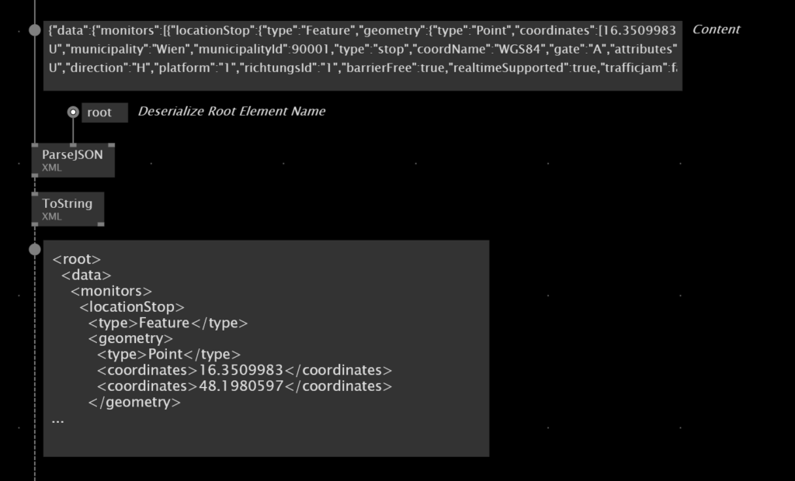

Afterwards you can make use of several nodes to access the data inside the XML. Please refer to the help patches tagges with "XML" in the help browser for more examples.

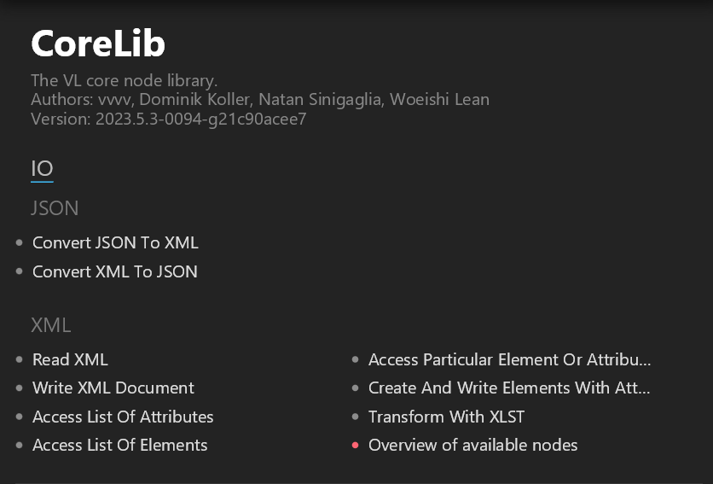

In our case we crawl through all elements inside the XML returned from the API, until we get to the single Integer that indicates the countdown until the next bus departure, and which we then use to control the rotation of the spheres in 3D space.
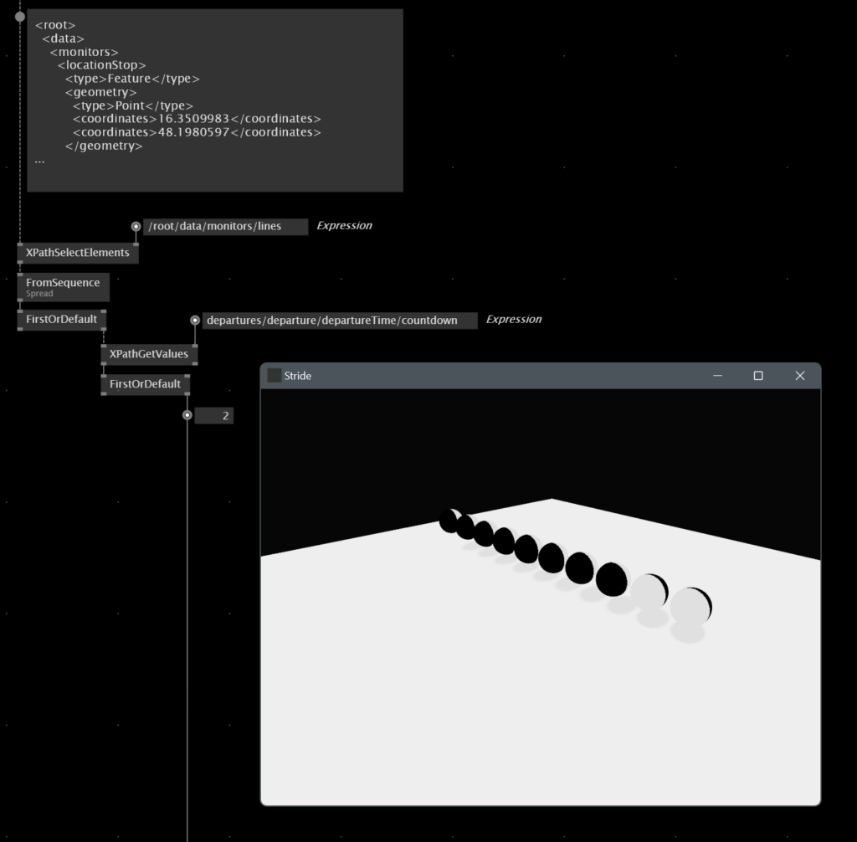
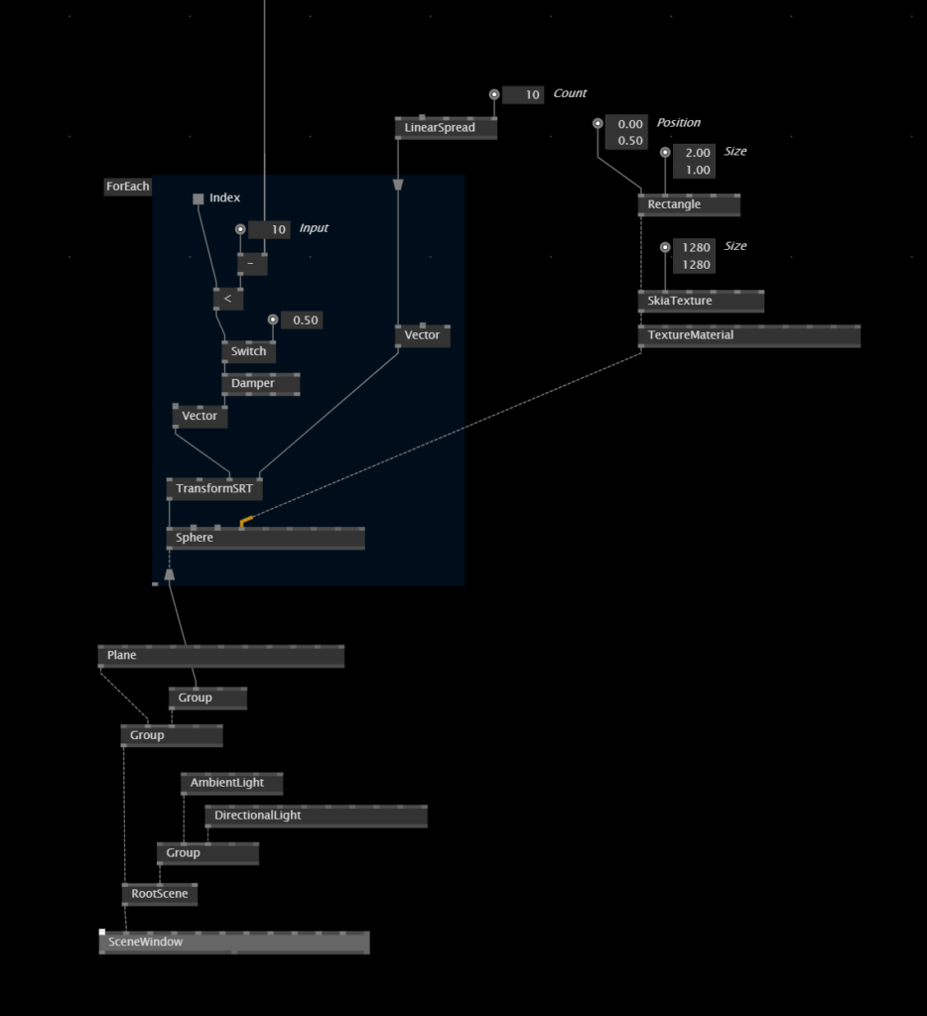

12. Machine Learning

Recording

Project Presentation

Lesson Overview

Gesture Recognition with VL.2D.DollarQ
We are closing the beginner's course with an introduction into using Machine Learning and AI algorithms inside of vvvv for creating powerful gestures to control our applications. This is not a hardcore course into data modelling and training, but looking more on the interaction design and prototyping side of things.
- nuget install VL.2D.DollarQ -pre
Lets start by training and recognizing two-dimensional gestures using the VL.2D.DollarQ nuget. This nuget allows to save two-dimensional data drawn into a Renderer as XML files to your hard drive and then train the data so it can recognized classified gestures. For instance you can draw multiple characters of the same (10 iterations of A, 10 iterations of B etc.), classify them as the character they should represent and make it recognize the gesture or character by itself.
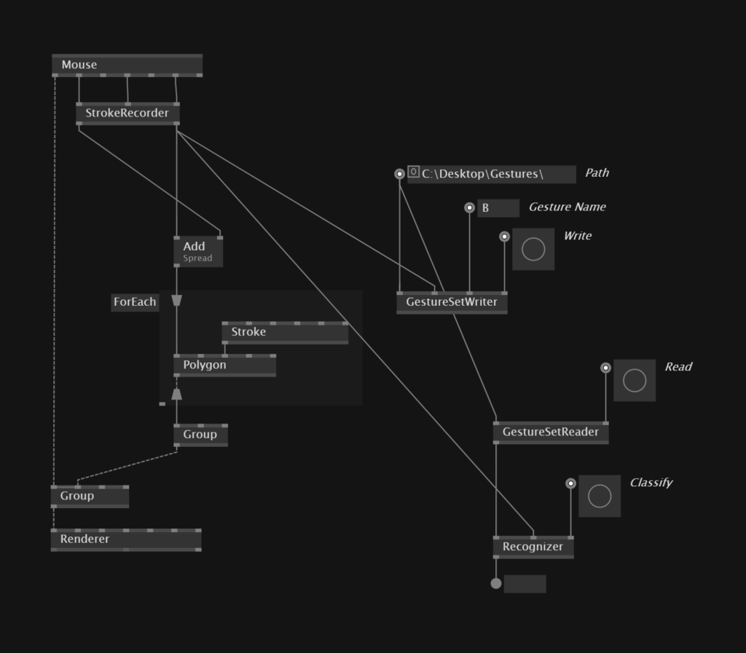

Basically we first need to set up the drawing by using the StrokeRecorder node. It ships with the nuget and is a very simple process in which you will find two Queue nodes that create a spread of spread of Vector2 positions. We are dealing here with a spread of spreads, because one stroke itself is a spread of positions, and as we are dealing with a multistroke scenario, we have to create a spread of strokes.
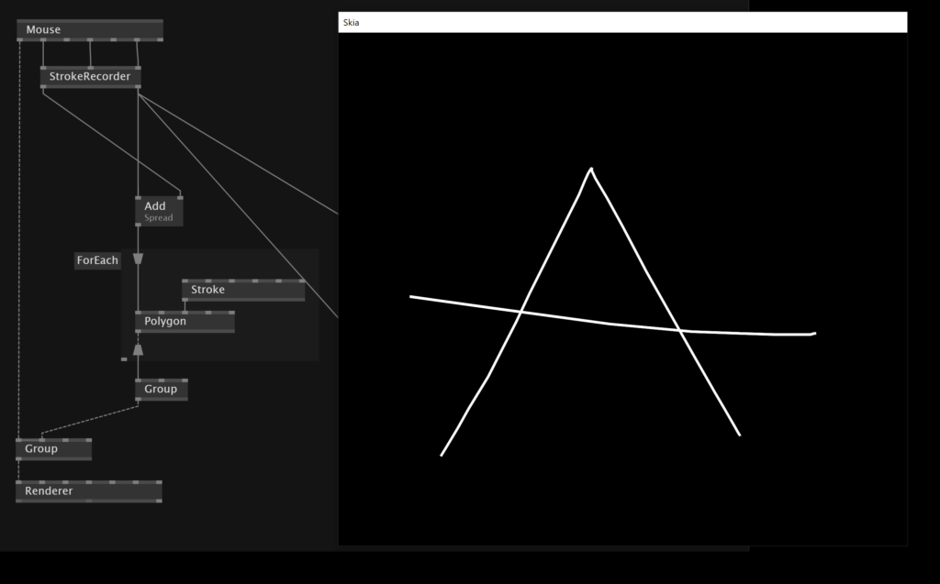

Each character (or gesture, if you want to recognize abstract drawings like shapes), can then be sent as raw data into the GestureSetWriter node and saved to disc. Remember that before triggering "Write", you need to specify a path to a folder and the name of the gesture / character you want to classify. In this case, we classify the drawing a an A, and repeat this process multiple times.
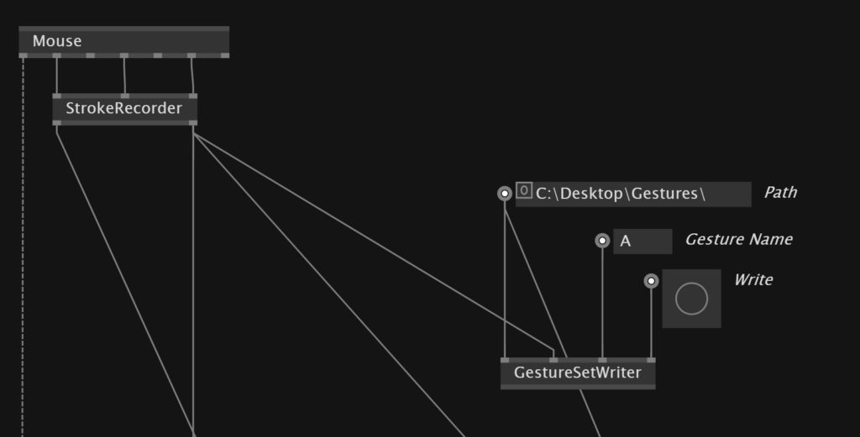

After several trainings of multiple variations of the same gesture, and maybe also one or more other gestures (like B, C, D... and so on), you can use the GestureSetReader node, to make the algorithm recognize similar shapes and gestures by itself. If you afterwards send then the data from the drawing into the Recognizer node, it will try to classify what you draw by itself, when you trigger the "Classify" bang.
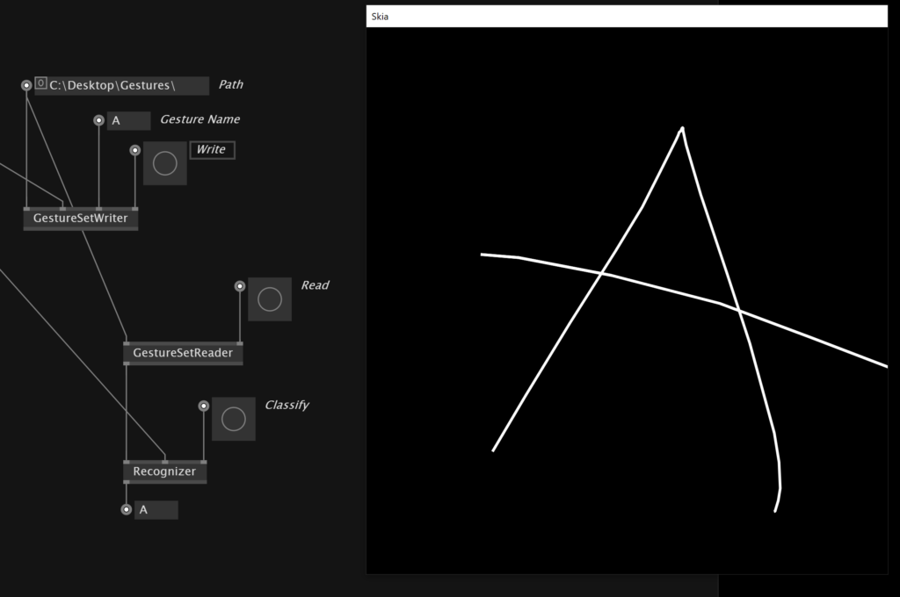

Camera Tracking with VL.MediaPipe
For the following examples we will make use a very cool nuget, that recently was released by the vvvv group. It is a VL wrapper for the powerful MediaPipe camera tracking tool by Google, that uses machine learning algorithms under the hood to analyse live camera feeds. By doing so you get extremely fast and accurate face, pose and hand tracking from any webcam. Check out the help patch "Use MediaPipe" to discover all functionalities!
- nuget install VL.MediaPipe -pre
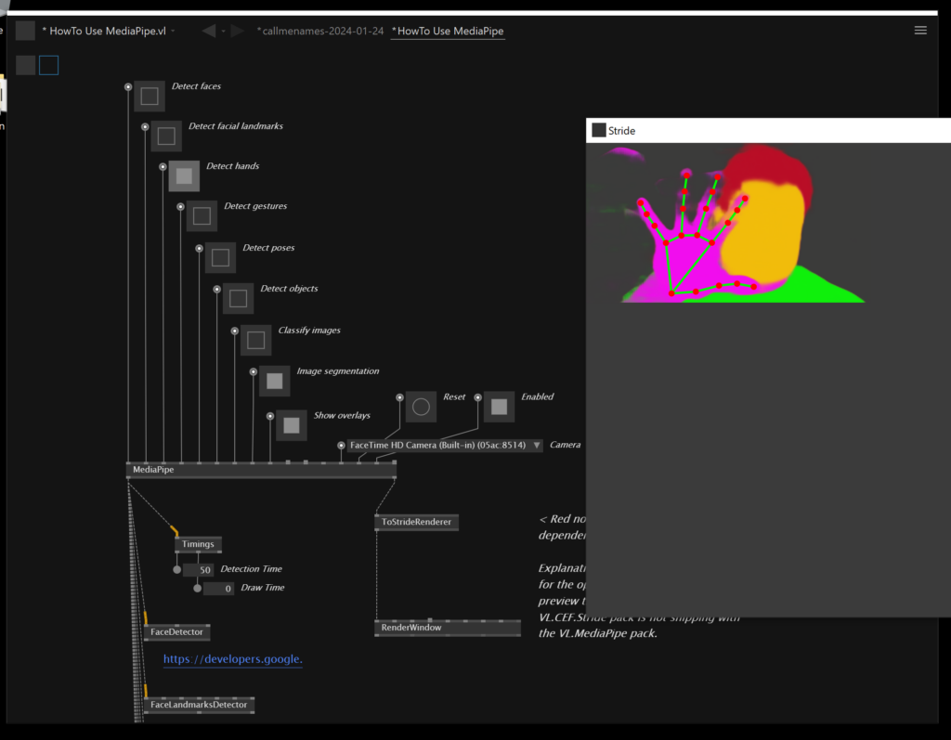

Training Models with VL.Wekinator
Finally we are going to explore a piece of software called Wekinator. It allows to create any kind of interaction from arbitrary data, by simply sending the data into it, telling the software what it should be interpreted as and train the data from your specifications. In our first example, we will use the face landmark recognition from VL.MediaPipe to detect it we are smiling or frowning and let Wekinator afterwards decide by itself if it should interpret our facial expression as one of both.
- nuget install VL.Wekinator -pre
Get the wekinator software here:
https://www.wekinator.org/
The following instructions and screenshots should serve as a guideline. Please refer to the recording when you really want to set it up from scratch, as its very difficult to describe every single step involved.

Classification Training
Let's set up first the tracking part to find out what the data actually looks like that we want to train the model with. So we are setting up the facial landmark detector mode for MediaPipe and use the Position operation of the Facelandmark Class to get its Vector3 data.
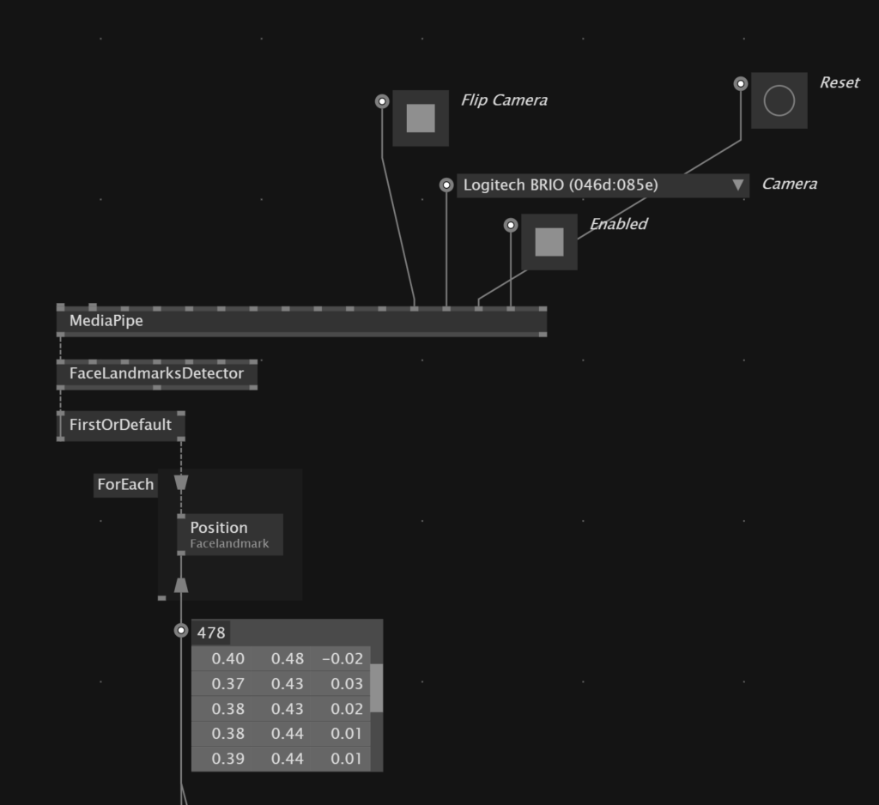

Afterwards we can use this data to render it with Stride. The little algorithm in the middle makes sure that the face is always positioned in the center of the scene and to get rid of noisy data. We basically just substract from every position the position of one specified point, which will then serve as the pivot for all positions. The position with index 8 is just randomly picked, it is the point right between the eyes. Doing so, we filter we filter out the information if the landmarks are more to the left or to the right of the scene, so the information is more accurate for the training later.
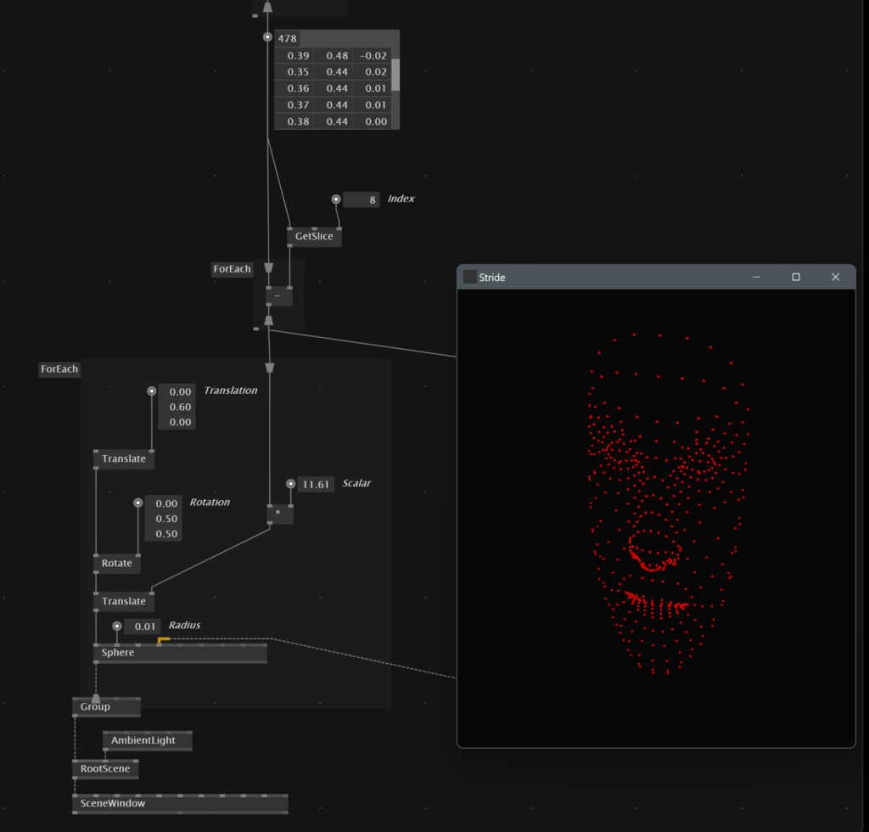

Afterwards we can set up wekinator. For dealing with Wekinator you need to know that it can only handle floats as input data, so we can not send the Vector3 positions directly into it. We have to use the node VectorsToValues, which converts a spread of vectors to a spread of floats. This makes in this case 1434 values in total.
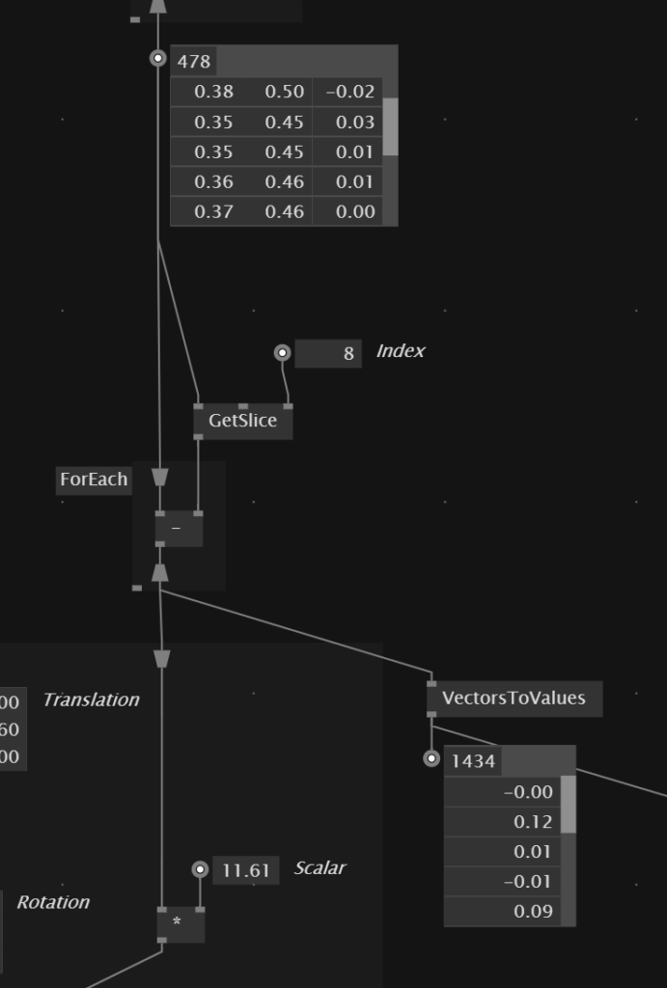

We can then setup the Wekinator software like so. The input count is the same amount of data that we got finally inside of vvvv. The we set the output to 1 with 2 classes - this basically means that we want to get 1 category of information with x different case. In our case we want to get back just 1 information of two different cases, which are either smiling or frowning.
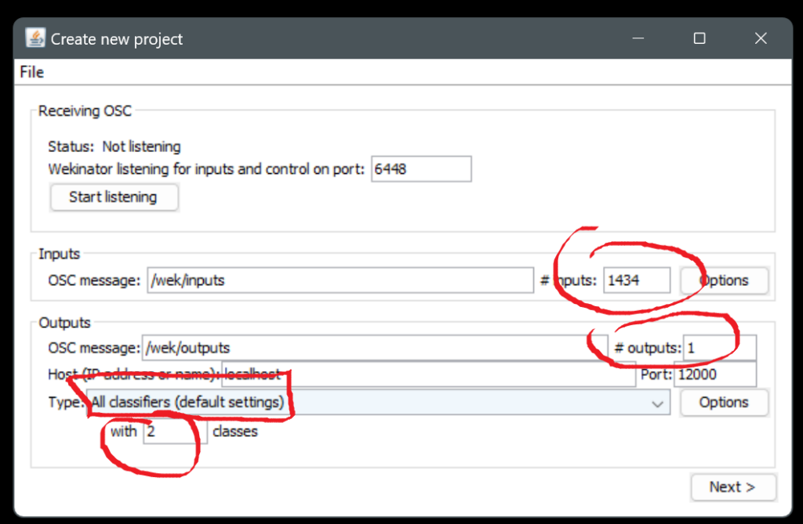

If you are then sending the data into the Wekinator node, you should see the "OSC In" inside Wekinator light up, that means the connection is established. If it is red or does not connect at all, check your settings in the previous step, especially if you have set the right input data.

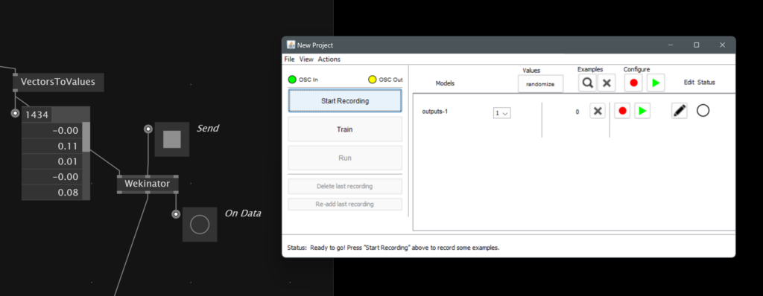

Finally you can start recording the data while classifying it as either smiling or frowning. For classifying it as one of these, you have to set the dropdown to 1 or 2, in which we tell the software that 1 means smiling and 2 means frowning. Make sure to stop the recording when switching the facial expression.
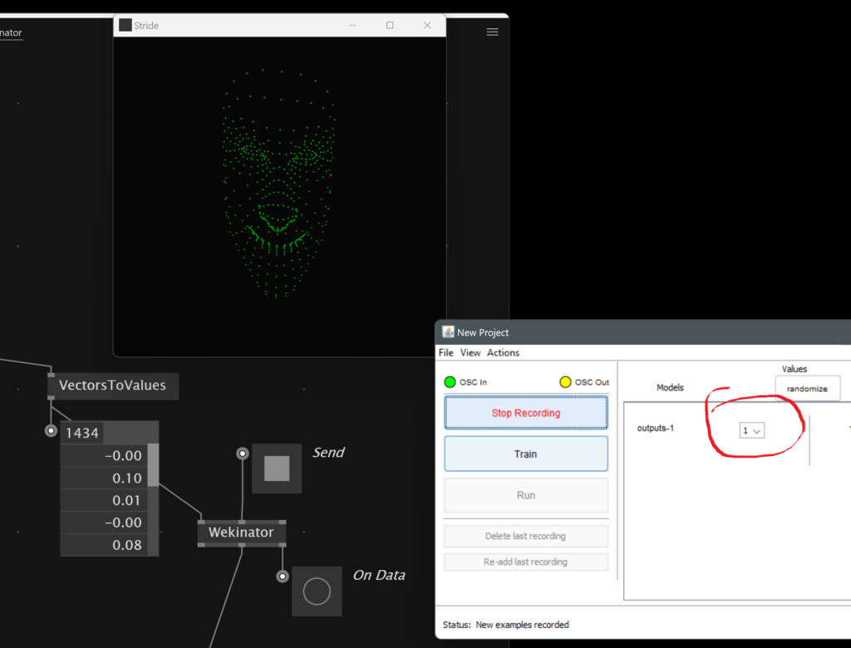
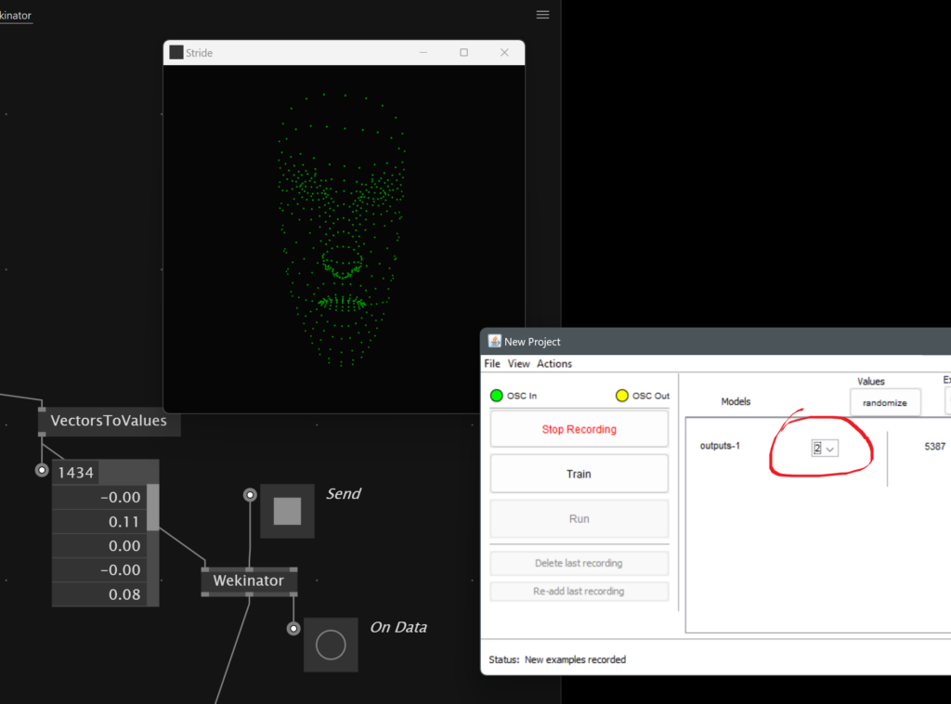

Hit then the "Train" button. It will take a few seconds for Wekinator to process your recorded data.
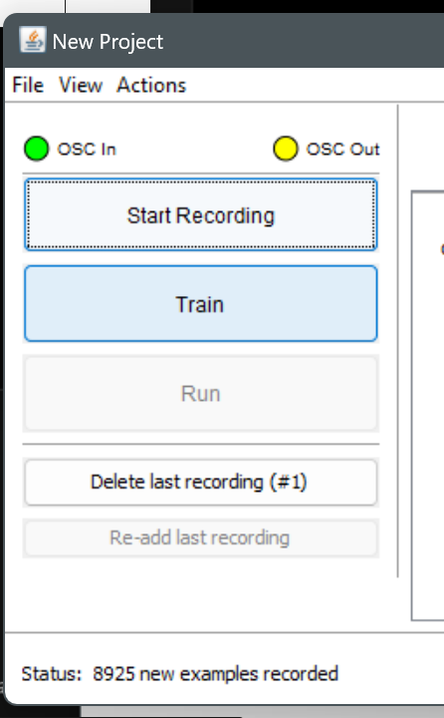

If you then hit "Run" you can grab the information from Wekinator inside of vvvv and use the information for anything in your patch. In your example we receive a 1, if Wekinator thinks you are smiling, and a 2, if it thinks you are frowning. We are simily using this information to set a different material for the spheres inside the rendering.
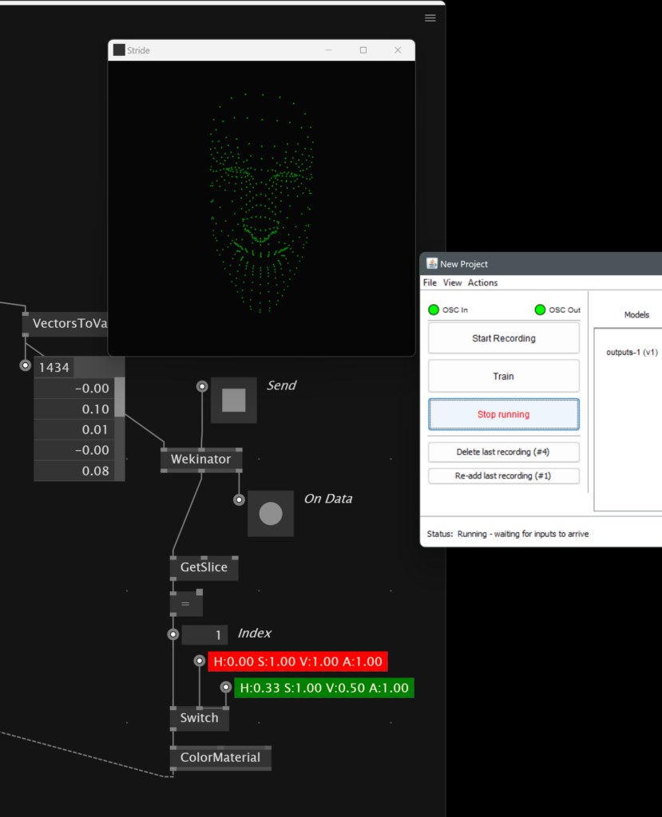
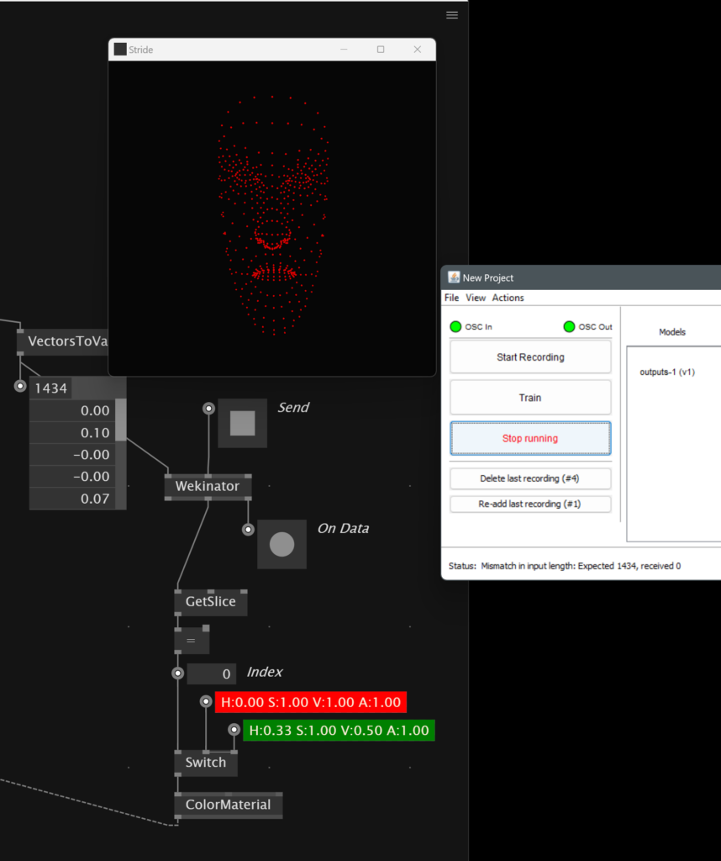

Regression Training
For the next example we are switching to the continuous mode of Wekinator with which we can linearly interpolate between two states of arbitrary data and treat these two states like a slider - if the data is state 1, the slider should have a value of 0, and if it is in state 2, the slider should have the value 1. In our example we are working with the hand tracking of MediaPipe, which gives us 21 Vector3 points, therefore a list of 63 floats.
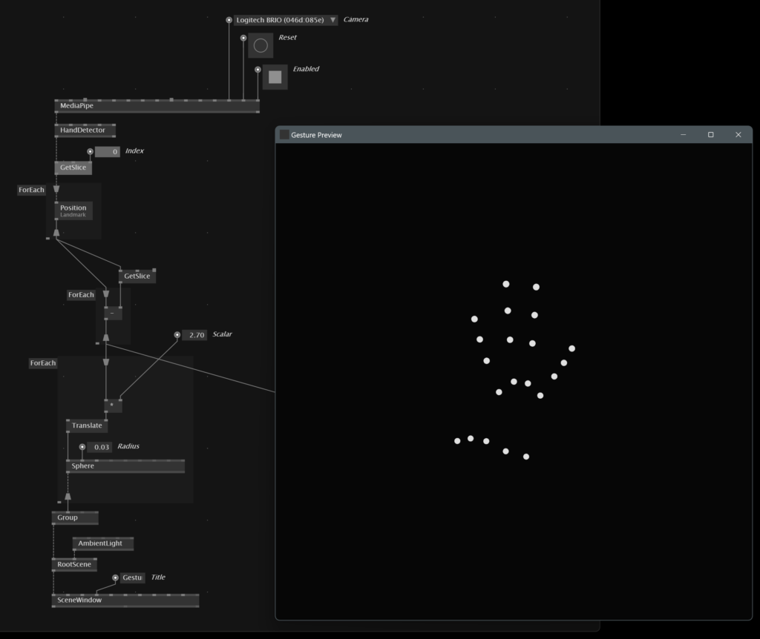

This time we are setting up the wekinator project like this - we won't deal with classes anymore, but want to provide 2 outputs, which we will map to different locations of our patch later. Take care of the input count and set the type to "All continuous".
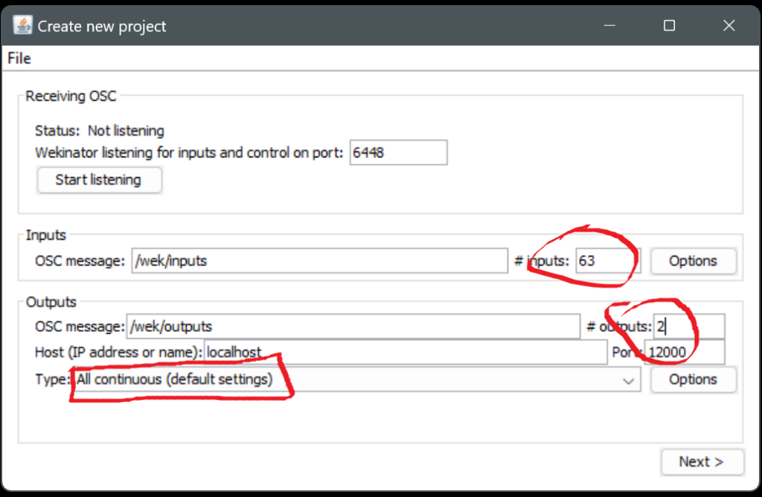

Afterwards you can send in the data from vvvv and record two different states, similarily like in the previous example. The difference is here, that you specify with the two sliders in the rows, which state your data represents. In our case we have set both sliders to 0 for a closed fist, and to 1 for an open palm. Again make sure, to stop the recording while you are changing the gesture and the data it should represent. You can then afterwards hit the train button - in this case the training process will probably take much longer, so give it a little time.
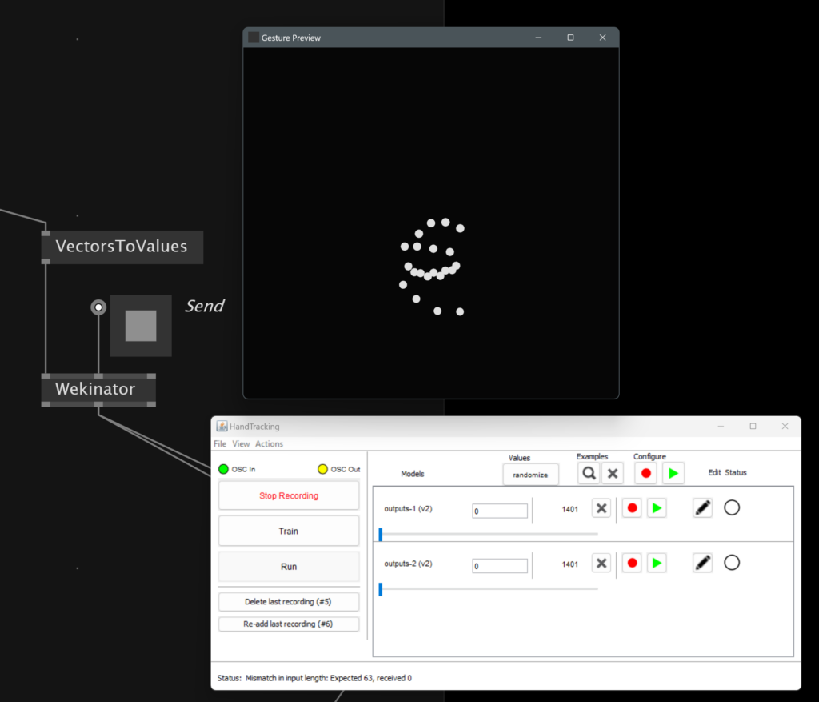
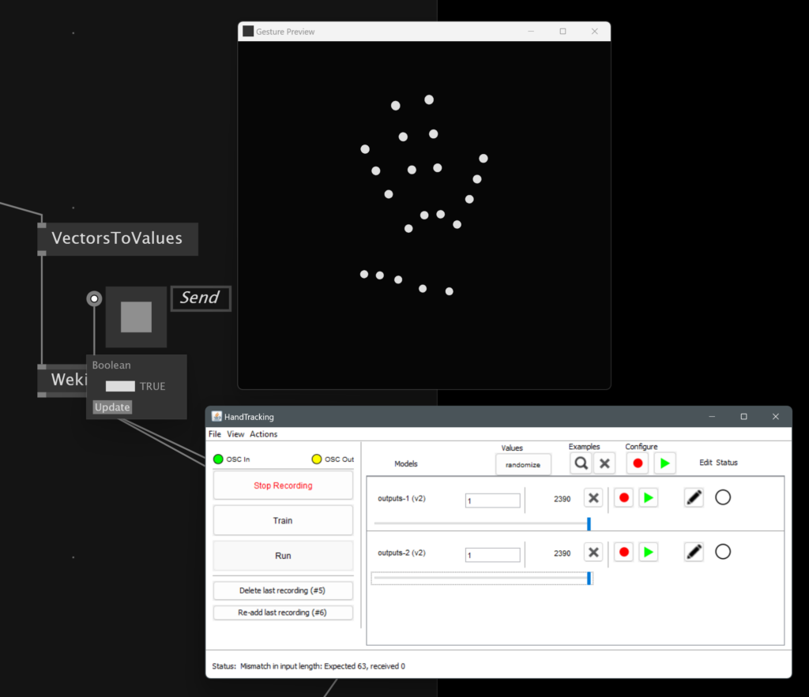

Once you hit "Run" afterwards, Wekinator will send the continuous values to vvvv as a spread, so you can simply grab them from the Wekinator output and map it to any range that you need in your project. In our case we have sent the two values into different parameters of the Fuse help patch "Basic Workflow".
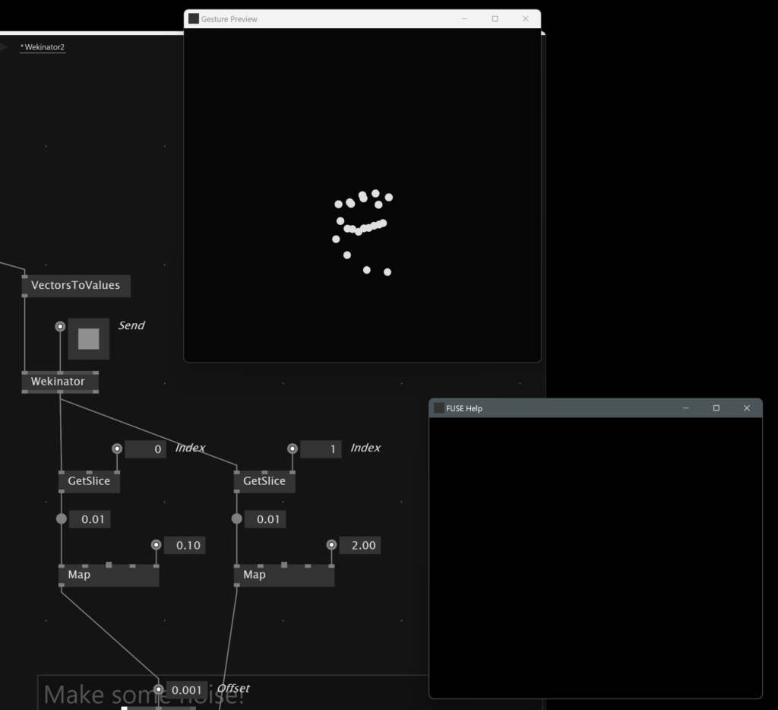
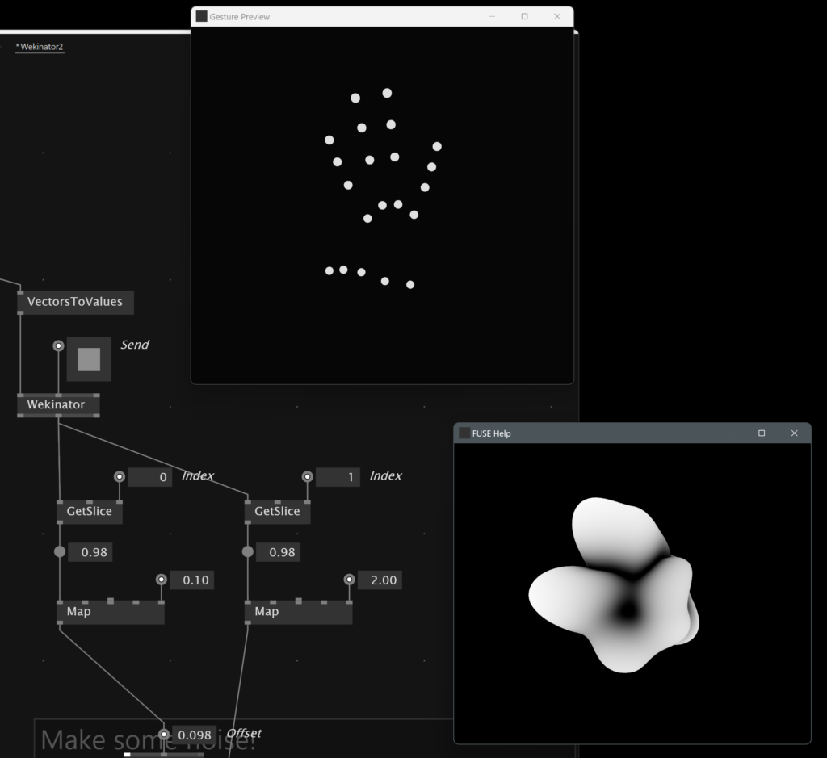
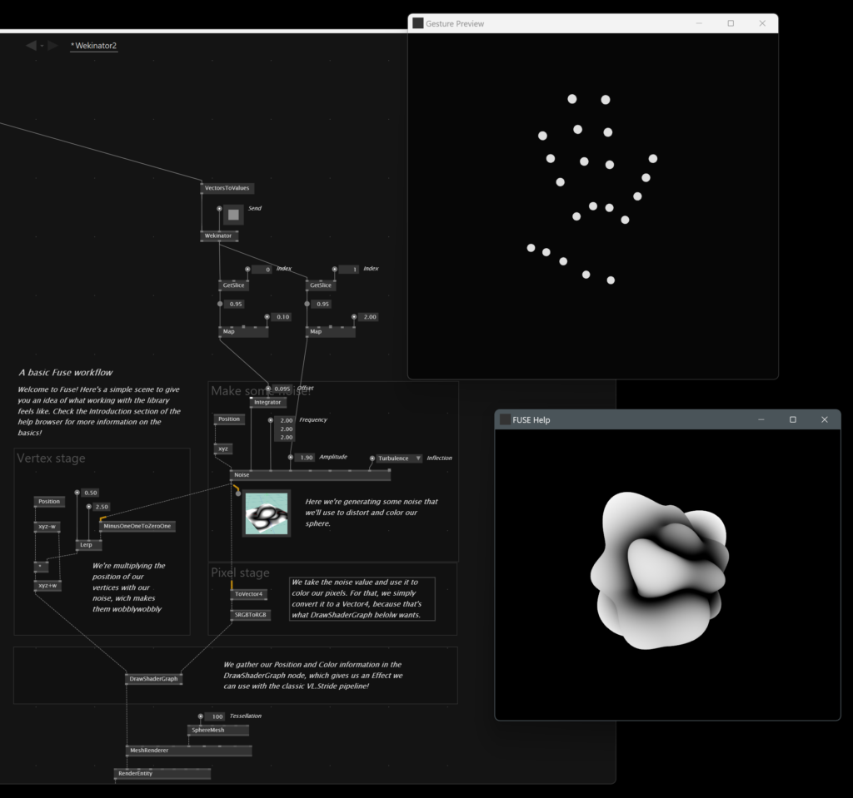

Lesson Material

13. Open Session

Recording

Project Presentation

Lesson Overview

Time to say goodbye...
We really enjoyed spending the time with you in the past three months, thank you very much for joining this class! We really hope you stick around with vvvv and in the community. As the last session we prepared a little bit of practical tricks when dealing with vvvv projects, especially when it comes to production and collaboration. Here is a little wrap-up...

The GammaLauncher
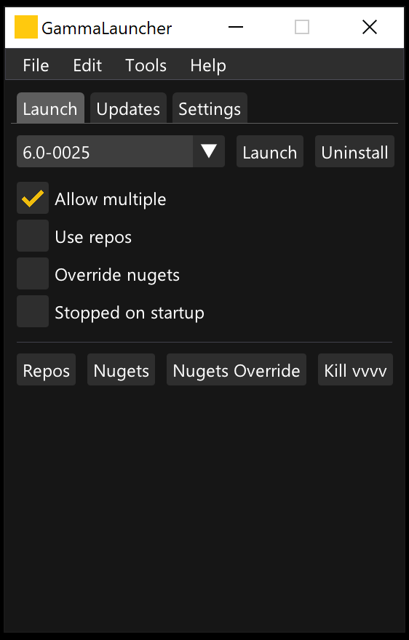
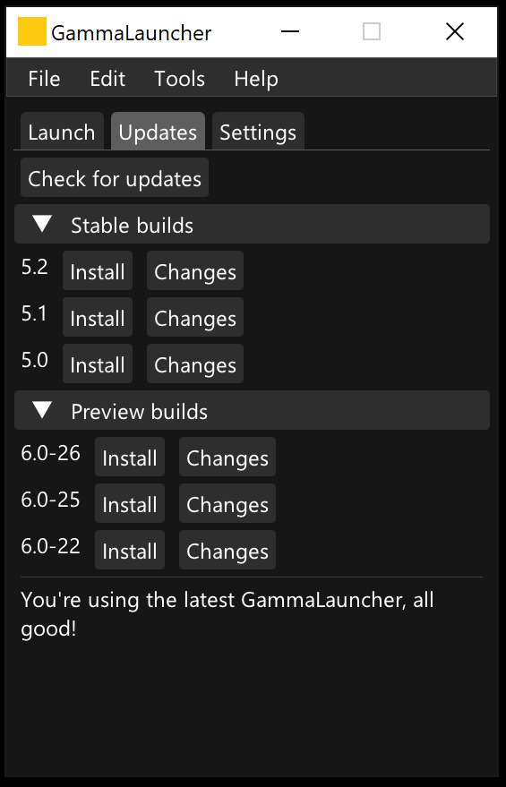
The GammaLauncher is a very handy open-source tool developed by long-time community member sebescudie. It is a starting point for downloading all recent stable and preview versions, as well as a tool to start vvvv with command line arguments. With these you can for example start vvvv in stopped runtime mode, disabe package compilation or load plugins from source, which you probably won't be dealing with unless you want to get your handy dirty developing nugets and plugins.
Download it here:
https://github.com/sebescudie/GammaLauncher
And read the docs about the meaning of the different command line arguments the GammaLauncher is launching with here:
https://thegraybook.vvvv.org/reference/hde/commandline-arguments.html#commandline-arguments

VL.AutomataUI
A plugin that will make your life patching more complex stuff in vvvv much more easy is VL.AutomataUI, a visual state machine and editor. With it you can set up a state machine in a convenient drag and drop window, and call operations on the Automata state object output to set the state from the patch logic and also get the current state. By doing so you can make your renderings dependent on the current application or installation state, trigger transitions and animations and take over control over your patch.
- nuget install VL.AutomataUI -pre
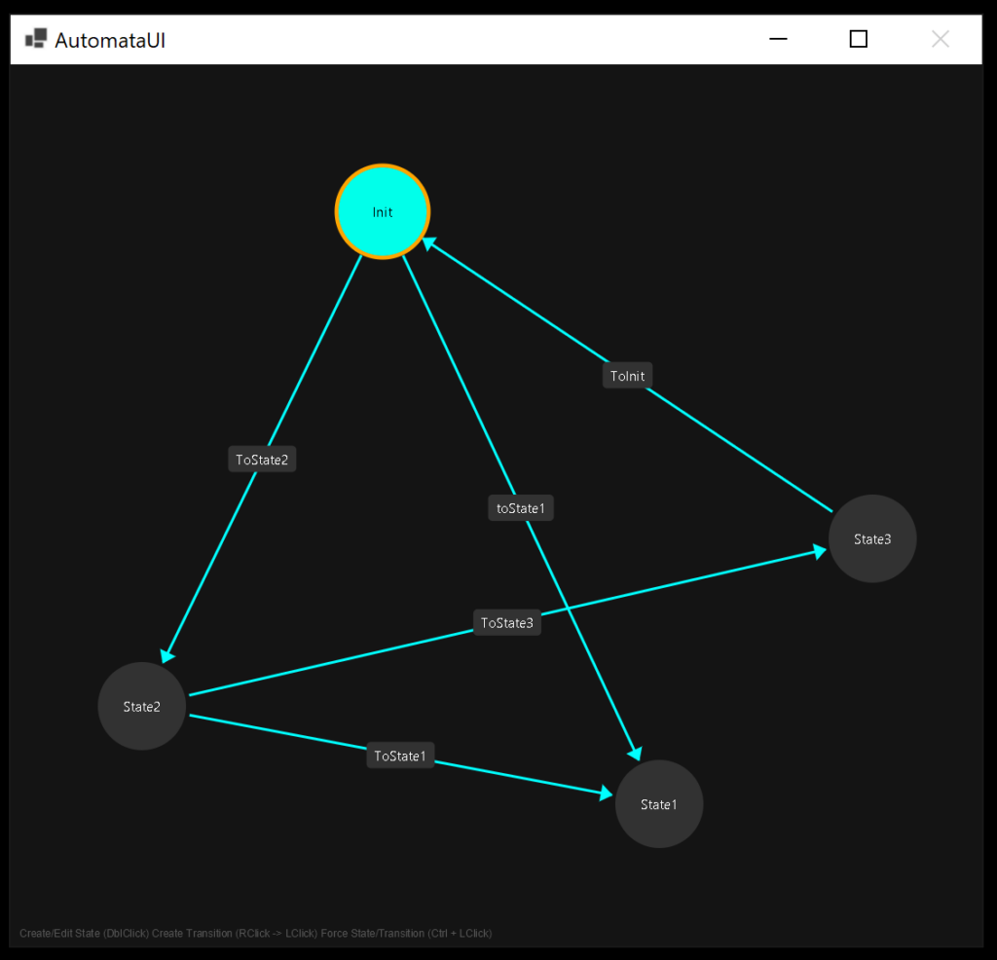

Project Structure
Finally als find in the attachments of this course an example of how I usually structure patches when they get more complex and especially when collaborateurs and other developers jump on board. Describing everything about it on this page is totally out of scope, so please refer to the recording presenting the structure.

Lesson Material

