**Home Page Change:**

**Current:**

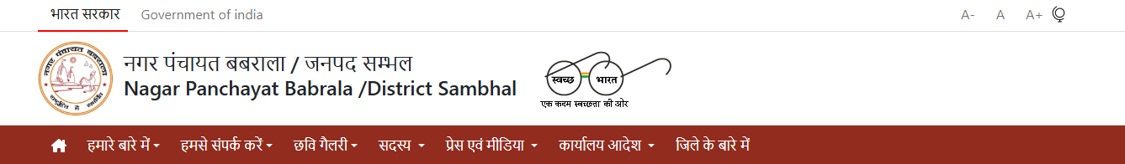

**1.Change Check:** glass image shifts right hand side

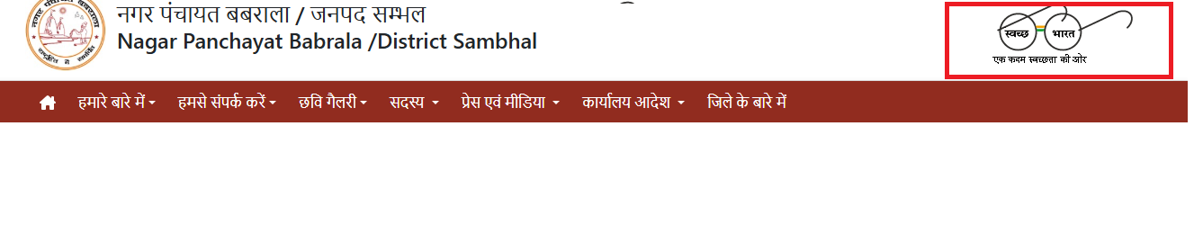

**2.Remove:** A_ A A+

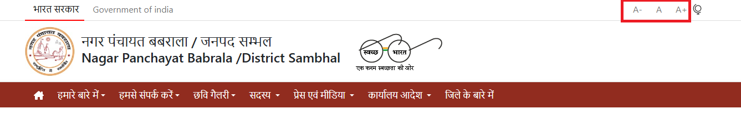

3.Need all pages same drop down with link other pages.

4.Make Home page link on HOME image

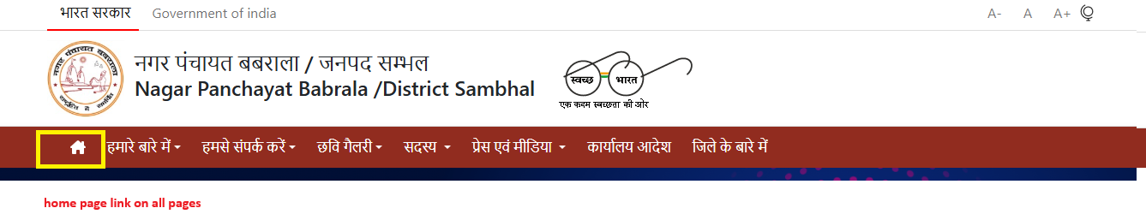

5.**Whats new** and **Press release** make tab and click alternate and high light when click

6.**Tender** make as Tab button like 

7. Stop scroll images make static 3 images and also make page for View profile and link all pages.

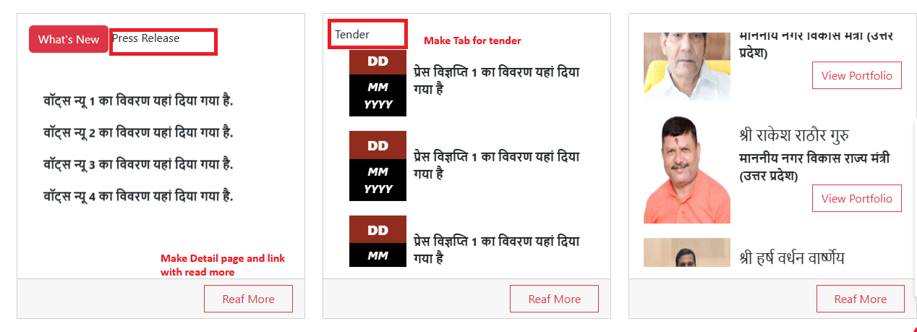

8. **HOME, profile, Contact, Document** make Tab on TAB click content change

9. 2nd screen make some space for content between 4 images   
**योजनाएं,सेवाएं,घटना,  
गतिविधि** put some dummy content (in 2 lines)

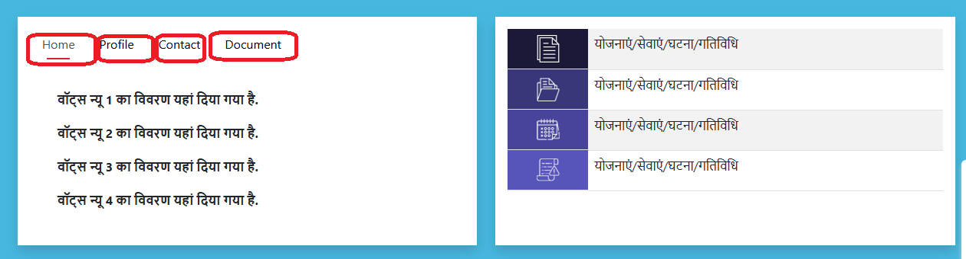

10. Make one page for below links: **बजट**



11. Image box Make link on View All Tab>>>>>>photogallery.html

12 Video box Make link on View All Tab>>>>>> Video.html

13.Make RecentTenders.html , RewardedTender.html page normal page only content

