CSE140L Summer 2018 Lab 4

1. Objective: The test bench provided in the assignment will store a typed string of 7-bit ASCII characters in a register file (data memory). You will design an encrypter, comprising a control state machine, an arithmetic/logic unit, and the data memory just mentioned. The encrypter will perform the following operations:

1.1. Prepend the message with a specified number of ASCII space characters.

1.2. Extend the message to a total length of 60 characters.

1.3. Add a parity bit to each character.

1.4. Encrypt this entire string with an 8-bit PN code which starts in a given state and has a specified ensemble of feedback taps.

1.5. Store the resulting encrypted message in a specified range of memory locations. (In Lab 5, we shall decrypt a given encrypted message.)

2. Deliverables:

2.1 A working Verilog model, built around a state machine for control/sequencing and a data path comprising a data register file / memory and arithmetic/logic circuitry.

2.2 Screenshots of waveform viewer and transcript, demonstrating that it worked properly.

2.3 Screenshots of your top-level block diagram (from Quartus), control unit block diagram, and data path diagram (also from Quartus).

2.4 Readme.txt to help graders wade through your code and documentation and to alert us regarding what worked and what didn’t.

3. Provided:

3.1 Verilog test bench

3.2 Shells for top level Verilog module, register file

4. Details of required functionality:

4.1 The testbench will store the binary equivalents of a given 7-bit ASCII character string (which you or the TAs can easily change) into addresses 0 through N, where N<50, of a 128-element 8-bit-wide register file you will design.

4.2 Your encrypter/encoder will prepend this message with a preamble comprising P bytes of ASCII space = 0x20. The testbench will provide P in memory location 61.

4.3 If the message plus preamble is shorter than 60 bytes, your encrypter will append enough ASCII space characters to pad the total length of prefix + message + suffix to 60 bytes.

4.4 Your encoder will also augment each 7-bit character with a parity bit = reduction XOR of the 7 message bits as the new MSB (bit [7]). (For example, 0x20 = 7’b010_000 or 8'b0010_0000 becomes 0xA0 = 8'b1010_0000.)

4.5 Your encoder will bitwise XOR the first 0xA0 (space with parity) against the given 8-bit LFSR starting state, which the testbench will have stored in register memory location 62. Write (store) this new byte into memory location 64.

4.6 Now bitwise XOR each subsequent byte of the prefixed and padded message with each new state of the LFSR, using the LFSR feedback bit pattern the testbench has stored in register memory location 63. Write each successive byte of the encrypted message into locations 65, 66, ... , 123.

4.7 Compare your results against those given by the testbench.

4.8 Do a Quartus build and capture RTL Viewer screenshots listed under “deliverables.”

Appendix 1. LFSR Generator Sample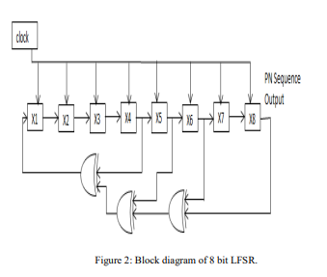
Sample LFSR

If we number the bits X0 through X7 instead of the X1 through X8 shown, we can express the feedback pattern shown as:

X7, X5, X4, X3 = binary 1011_1000 = 0xB8.

Your LFSR should be able to work with any combination of feedback taps (the testbench reserves the right to use any of the known six 4-tap or two 6-tap maximal-length patterns).

Appenix 2. ASCII Table (7-bit, non-extended)

