ETRI AI RTL Course

**CNN IP**

**Technical Design Document**

Rev. 0.1

Aug. 16. 2019

Copyright 2019. MJ, Choi All Rights Reserved

**Contents**

**1 Introduction** **4**

1.1 Purpose 4

1.2 Document Organization 4

**2 Design Overview** **5**

2.1 Approach 5

2.2 Architectural Goals and Constraints 5

2.3 About AXI IF 5

2.4 Allocate Address Map 5

**3 Architecture** **6**

3.1 Block Diagram 6

3.2 State Diagram 6

**Revision History**

|  |  |  |  |
| --- | --- | --- | --- |
| **Version** | **Date** | **Description** | **Author** |
| 0.1 | 08/16/2019 | Initial Draft | Minjae Choi |

**1 Introduction**

1.1 Purpose

The purpose of this document is to make it easier for me to understand the design process later.

Its main purpose is to –

* Makes it easier for people to see what I did ETRI AI RTL Course. (Seems like portfolio)
* Explain my design process to others by explaining the details of each phase of the design.

This document will be updated as the process progresses.

1.2 Document Organization

This document is organized into the following sections:

|  |  |
| --- | --- |
| **Introduction** | Provides information related to this document |
| **Design Overview** | Describes the approach, architectural goals and constraints, axi if, allocate address map used In design and development |
| **Architecture** | Describes the system components |

Input,

Weight,

Result Memory

+

Register Set

Filter register

Input

Internal Signal Controller

( FSM, Enable, Counter…… )

Convolution Logic

FilterReg Write Done

Start Signal = 1

Kernel = 3 or 5

Stride = 1 or 2

Padding = 0 or 1

Convolution Done

Done Signal = 1

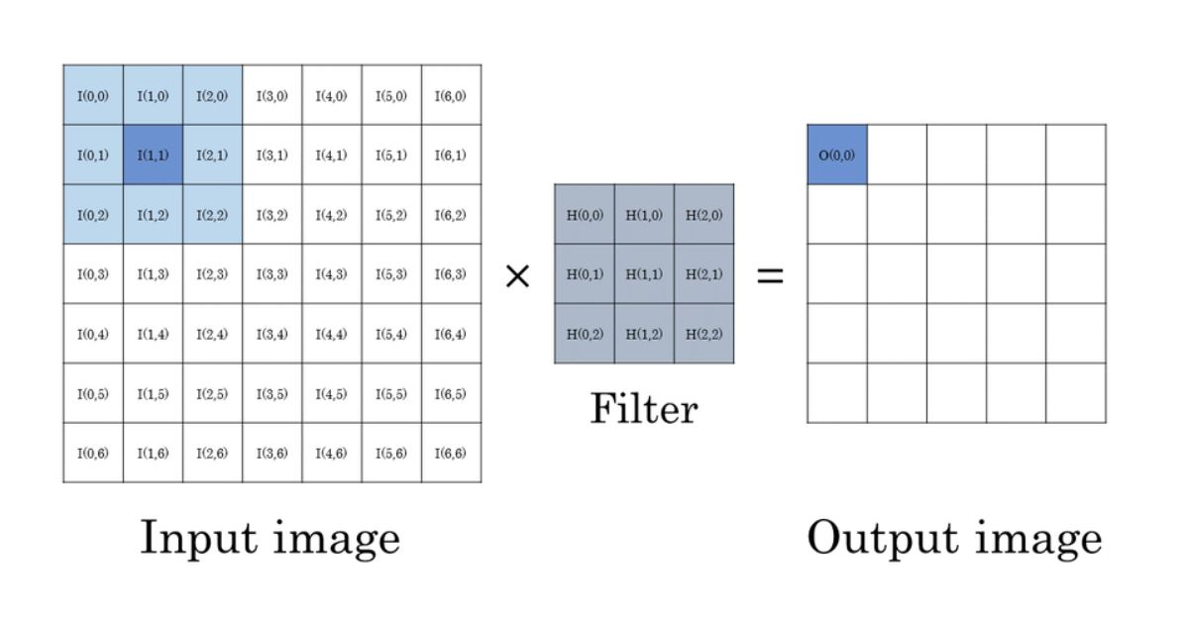

0x00000 ~ 0x00010

Reserved

0x10000 ~ 0x1FFFF

Reserved

0x20000 ~ 0x2FFFF

Input

Weight

0x30000 ~ 0x3FFFF

Reserved

Reserved

Result

Start, Done Signal

Kernel, Stride, Padding

Set up