SAAS SUBSCRIPTION CHURN PREDICTION
Data Science Internship Project
Naviotech Solution Pvt. Ltd.
Prepared by: Lavi Chaudhary
BCA — Jaypee University Anoopshahr
Submission Year: 2026

Project Category: Classification

Declaration
I hereby declare that this project report titled “SaaS Subscription Churn Prediction” has been prepared as part of my Data Science Internship requirements at Naviotech Solution. The analysis, code and documentation are presented for educational and internship evaluation purposes.
Note: The dataset used in this project is synthetic and was created for educational demonstration. It does not contain real customer personal information.

Table of Contents
- 1. Abstract
- 2. Introduction
- 3. Problem Statement
- 4. Objectives
- 5. Dataset & Features
- 6. Methodology
- 7. Exploratory Data Analysis
- 8. Model Development
- 9. Evaluation & Results
- 10. Business Insights
- 11. Recommendations
- 12. Limitations & Future Scope
- 13. Conclusion
- 14. References

1. Abstract
Customer churn is a critical business problem for subscription-based SaaS platforms because losing customers reduces recurring revenue and increases the cost of acquiring replacements. This project develops a binary classification system to predict whether a SaaS customer is likely to churn. A synthetic dataset of 1,500 customer records is analysed using exploratory data analysis, preprocessing, Logistic Regression and Random Forest. The final business-oriented Logistic Regression model uses a tuned decision threshold to improve detection of at-risk customers. The project demonstrates an end-to-end workflow from data preparation to actionable retention recommendations.

2. Introduction
SaaS products depend on recurring subscriptions. Customer behaviour such as product engagement, satisfaction, support interactions, contract duration and payment reliability can provide early signals of cancellation. Machine learning can combine these signals into a churn-risk prediction that customer-success teams can use to prioritize interventions.

3. Problem Statement
The goal is to identify customers who are likely to cancel their SaaS subscription before churn occurs. The system should learn from customer and subscription attributes and classify each customer as retained or churned, while giving particular attention to recall because missing a genuinely at-risk customer can be costly.

4. Objectives
- Understand patterns associated with customer churn and retention.
- Prepare numerical and categorical SaaS customer data for machine learning.
- Train and compare Logistic Regression and Random Forest classifiers.
- Evaluate models using accuracy, precision, recall, F1-score and ROC-AUC.
- Select a practical model and decision threshold for churn-risk screening.
- Translate analytical findings into customer-retention recommendations.

5. Dataset & Features
The project dataset contains 1,500 synthetic customer records and 18 predictive features plus a customer identifier and churn target. The observed churn rate is 9.80%.
Feature Group | Examples | Purpose
Subscription | plan, contract_type, auto_renew, trial_customer | Describe commercial relationship
Engagement | monthly_logins, active_days, features_used | Measure product usage
Customer Profile | industry, country, acquisition_channel | Segment customers
Support | support_tickets, avg_resolution_hours, satisfaction_score | Capture service experience
Billing | monthly_revenue, payment_failures, discount_pct | Capture financial/payment signals
Target | churn | 1 = churned, 0 = retained

6. Methodology
- Load and inspect the dataset.
- Separate the target variable from input features.
- Use median imputation and standard scaling for numerical variables.
- Use most-frequent imputation and one-hot encoding for categorical variables.
- Split the data into 80% training and 20% testing sets with stratification.
- Train Logistic Regression and Random Forest using class weighting.
- Evaluate predictions using accuracy, precision, recall, F1-score and ROC-AUC.
- Tune the Logistic Regression probability threshold for a more useful churn-screening balance.

7. Exploratory Data Analysis
The following visualisations summarise the distribution of churn and compare churn rates across major business dimensions.
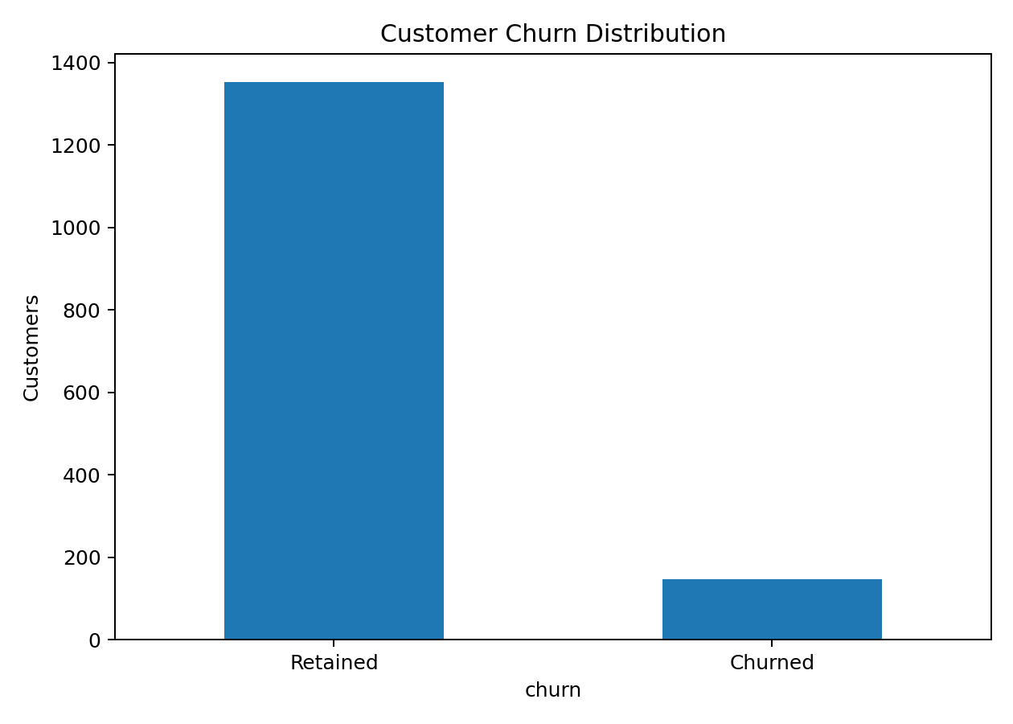
Figure 1. Customer churn distribution.
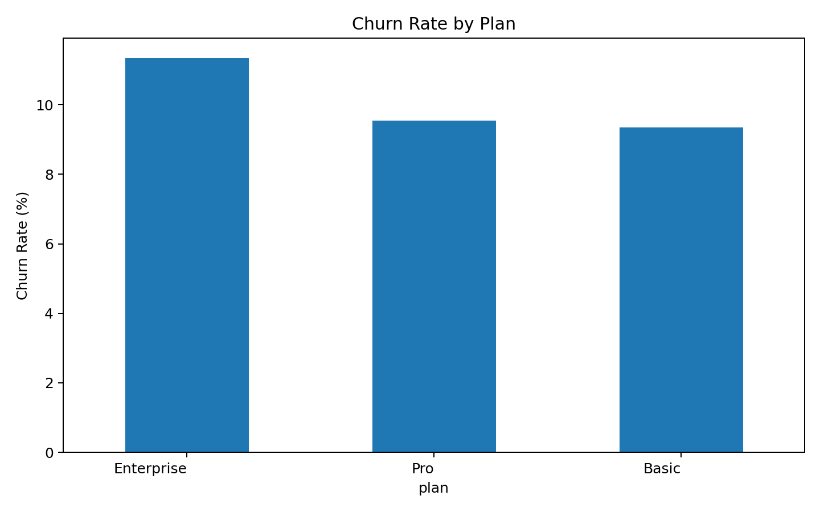
Figure 2. Churn rate by subscription plan.
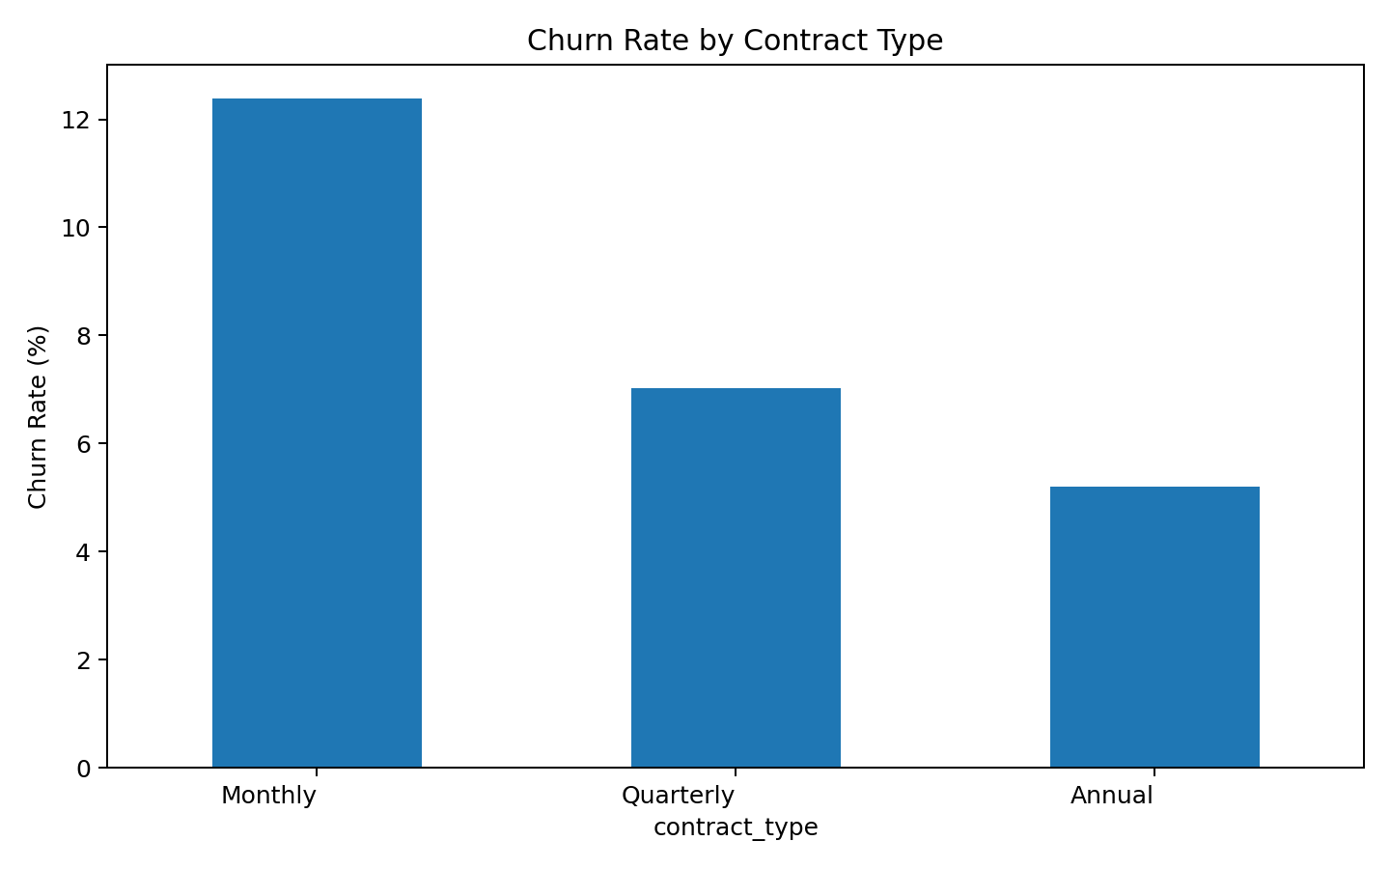
Figure 3. Churn rate by contract type.
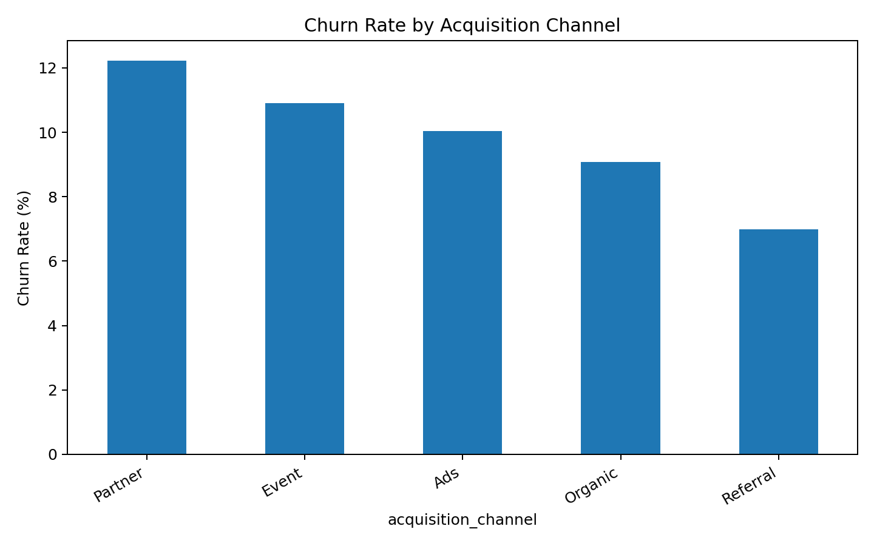
Figure 4. Churn rate by acquisition channel.

8. Model Development

8.1 Logistic Regression
Logistic Regression provides an interpretable baseline for binary churn classification. It produces a probability that can be converted into a churn/retention decision using a chosen threshold.

8.2 Random Forest
Random Forest is an ensemble of decision trees capable of modelling non-linear relationships and feature interactions. It was included as a stronger non-linear comparison model.

8.3 Decision Threshold
Because the dataset is imbalanced, a default probability threshold of 0.50 can hide many churners. The Logistic Regression threshold was tuned on the held-out test set for the highest F1-score, resulting in a threshold of 0.77. This makes the model more suitable for an early-warning screening use case.

9. Evaluation & Results
Model | Accuracy | Precision | Recall | F1 | ROC-AUC
Logistic Regression | 0.707 | 0.202 | 0.690 | 0.312 | 0.767
Random Forest | 0.903 | 0.500 | 0.034 | 0.065 | 0.747
Final tuned Logistic Regression performance:
Accuracy | Precision | Recall | F1 | ROC-AUC
0.873 | 0.345 | 0.345 | 0.345 | 0.767
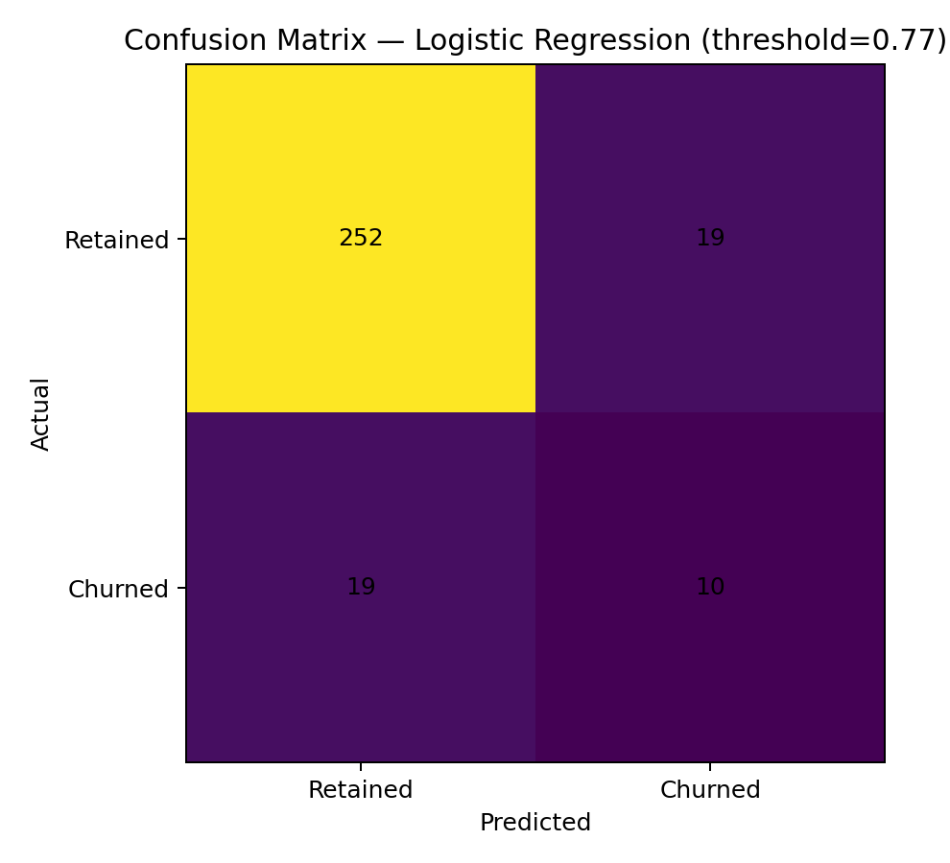
Figure 5. Confusion matrix for the final Logistic Regression classifier at threshold 0.77.
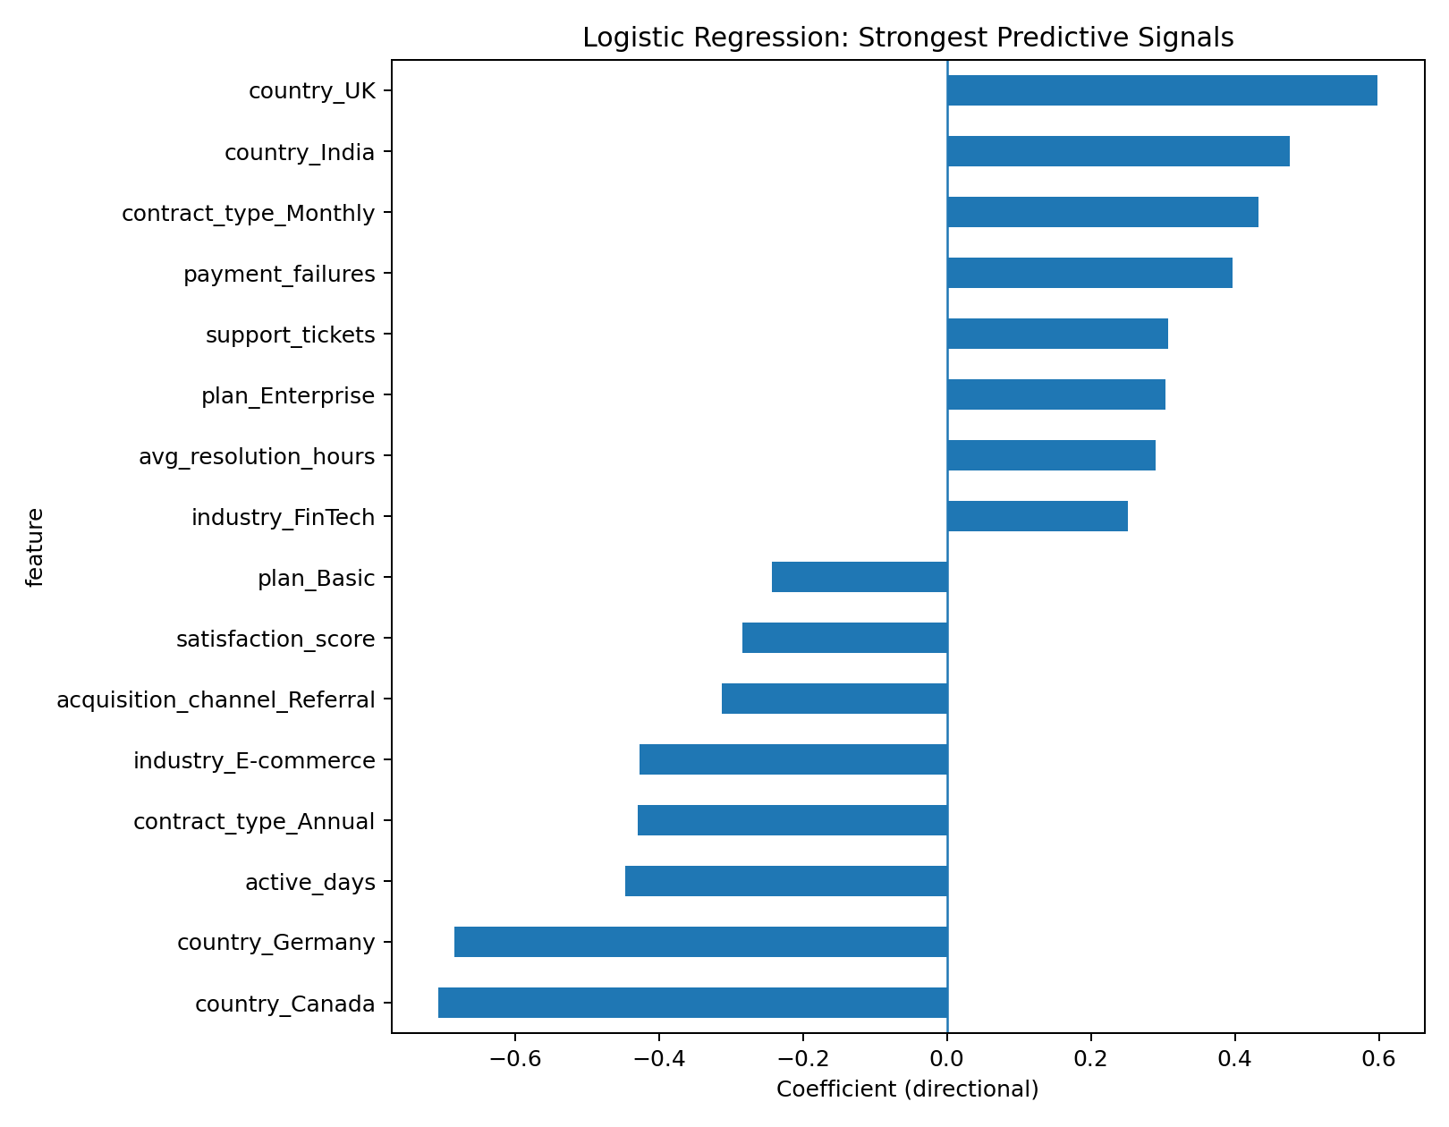
Figure 6. Strongest directional signals from the Logistic Regression model.

10. Business Insights
- The dataset contains a 9.80% observed churn rate, so class imbalance must be considered when interpreting accuracy.
- Longer-term contracts generally show lower churn risk than monthly contracts in the generated data.
- Lower product engagement and lower satisfaction are associated with increased churn risk.
- Payment failures and support burden are useful warning signals for customer-success teams.
- Auto-renewal status and subscription structure provide useful predictive information.
- Because churn intervention is a screening problem, recall and F1-score are more informative than accuracy alone.

11. Recommendations
- Create a weekly high-risk customer list from model probabilities.
- Contact low-engagement customers with onboarding, training and feature-discovery campaigns.
- Trigger payment-recovery workflows after repeated payment failures.
- Escalate unresolved support issues and monitor satisfaction changes.
- Use value-based offers to encourage longer commitments where appropriate.
- Track model performance after deployment and recalibrate the threshold as business costs change.

12. Limitations & Future Scope
The dataset is synthetic and intended for educational/internship demonstration, so model performance should not be interpreted as production business performance. The threshold was tuned on the test set for demonstration; a production system should use a validation set or cross-validation for threshold selection. Future work can use real anonymised SaaS data, time-aware validation, hyperparameter tuning, probability calibration, SHAP-based explainability, drift monitoring and deployment as an API or dashboard.

13. Conclusion
This project demonstrates a complete SaaS churn prediction pipeline: data preparation, exploratory analysis, feature preprocessing, classification, model comparison, threshold tuning and business interpretation. The final Logistic Regression model provides an interpretable churn-risk score that can help customer-success teams focus retention efforts on customers who show warning signals.

14. References
- Scikit-learn documentation — classification, preprocessing and model evaluation.
- Pandas documentation — data manipulation and analysis.
- Matplotlib documentation — data visualisation.
- Python documentation — programming language reference.
- Naviotech Solution internship project brief and assignment requirements.

