CONFIDENTIAL — FOR MANAGEMENT REVIEW

AdGuard
Stop paying for garbage leads.
Market-Entry & Payment-Activation Proposal
Prepared by: Shekhar Raju · CHLEAR (CHL Marketing Solutions Pvt. Ltd.)
October 2026 · Version 1.0 · Beta live with subscribers
THE ASK: Approve Razorpay LIVE activation so paying customers can check out on October 10.

1. Executive Summary
AdGuard is a lead-integrity SaaS for businesses advertising on Google and Meta. It connects to the customer's own ad accounts, audits every incoming lead in real time, blocks bots and junk before they reach the CRM or poison the ad platforms' learning, and proves the recovered money in rupees on a customer dashboard.
Where we are today:
- Platform built and live in production (Railway + Supabase/Postgres).
- Self-serve signup live: customer signs up, verifies email, sets password, gets workspace in under 5 minutes.
- Trial + Starter + Pro + Enterprise plans provisioned automatically; plan rules enforced in-product.
- Beta subscribers onboarded and using workspaces; welcome/verify email journey working end-to-end.
- Legal base live: Terms of Service v2.0 (audit disclaimer, liability cap, IP protection) accepted at signup.
- 20-CRM delivery catalog, Money Shield, Script Tag interceptor, admin cockpit all shipped.
What is missing:
Payments. Plan selection currently works but the payment step is bypassed for beta — a customer clicking “Choose Starter” gets the workspace without paying. Razorpay LIVE activation is the single remaining blocker between the product and its first rupee of revenue.
Launch date | The blocker | The ask
October 10, 2026 | Razorpay LIVE not yet activated | Approve Razorpay LIVE + KYC/bank activation now

2. What AdGuard Does (Product Walkthrough)
The journey: marketer connects Google/Meta via official OAuth → leads flow into AdGuard's audit pipeline → each lead is device-fingerprinted, deduplicated, geo-checked, email/phone validated and AI-scored in ~2 seconds → verified leads reach the CRM, junk leads are blocked with evidence → Money Shield auto-pauses campaigns that attract junk → weekly reports show recovered spend in ₹.
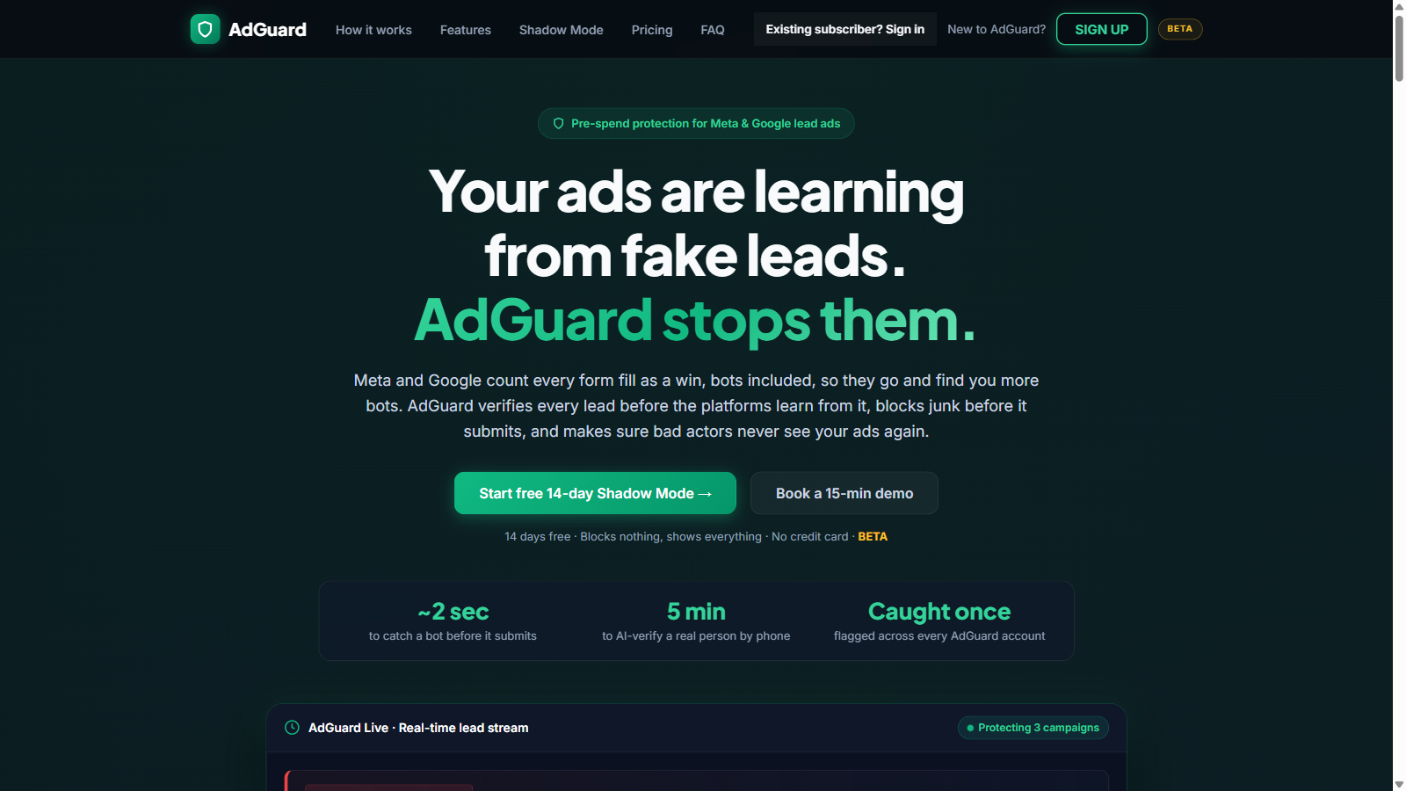
Fig 2.1 — Public landing page (ai-ad-optimiser-production-dd12.up.railway.app/adguard-landing)
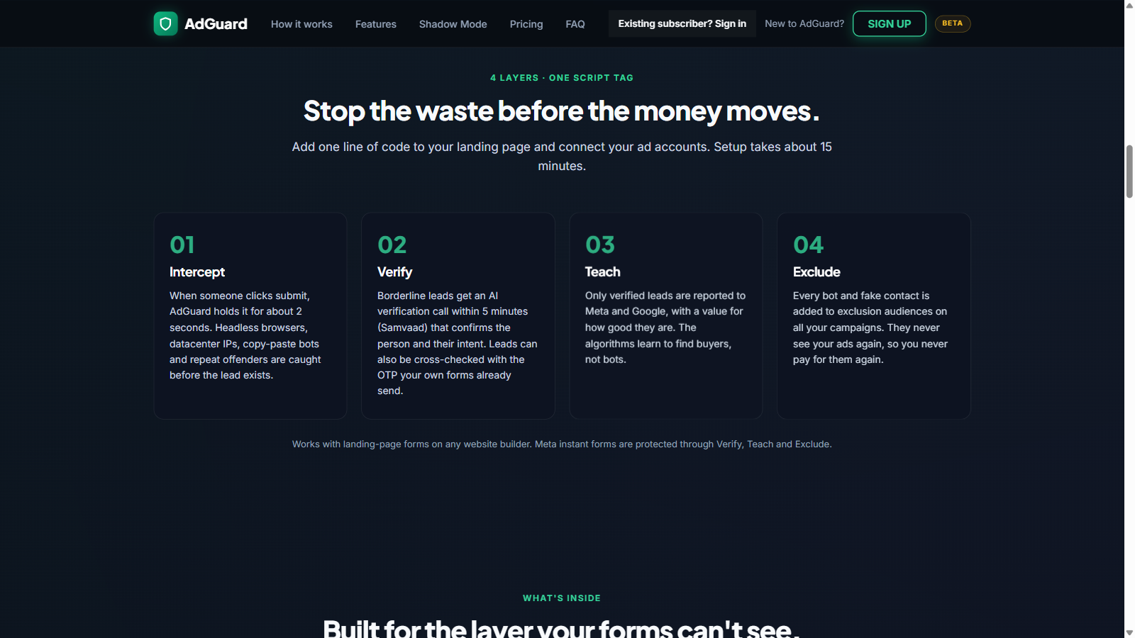
Fig 2.2 — How it works: connect → screen → shield → CRM
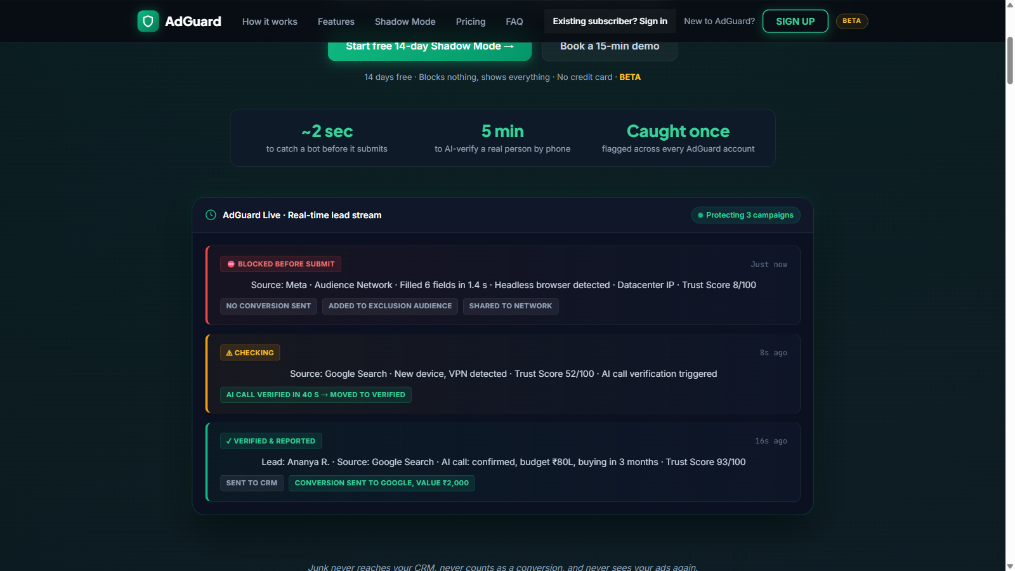
Fig 2.3 — Live lead stream demo on the landing page
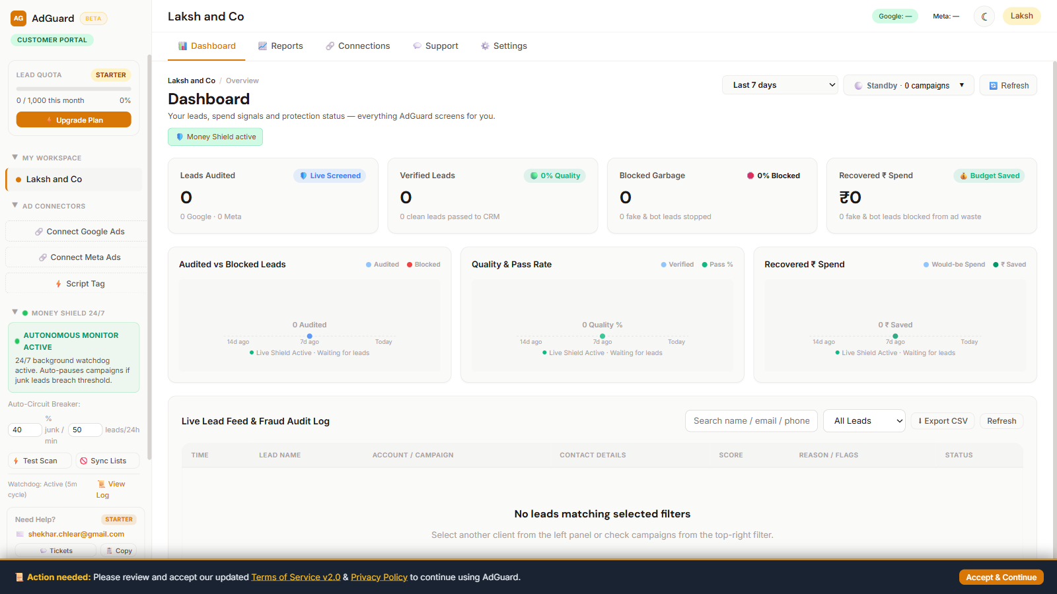
Fig 2.4 — Customer workspace: starter plan quota meter, KPIs, live feed, Money Shield
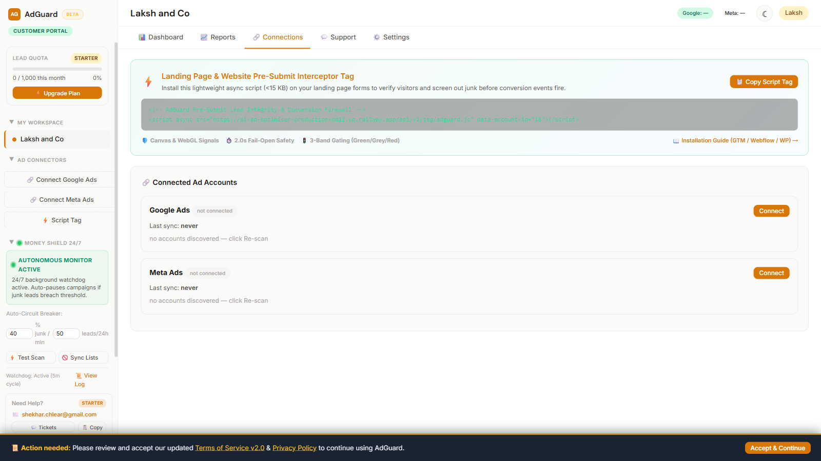
Fig 2.5 — Connections tab: OAuth connectors + campaign screening
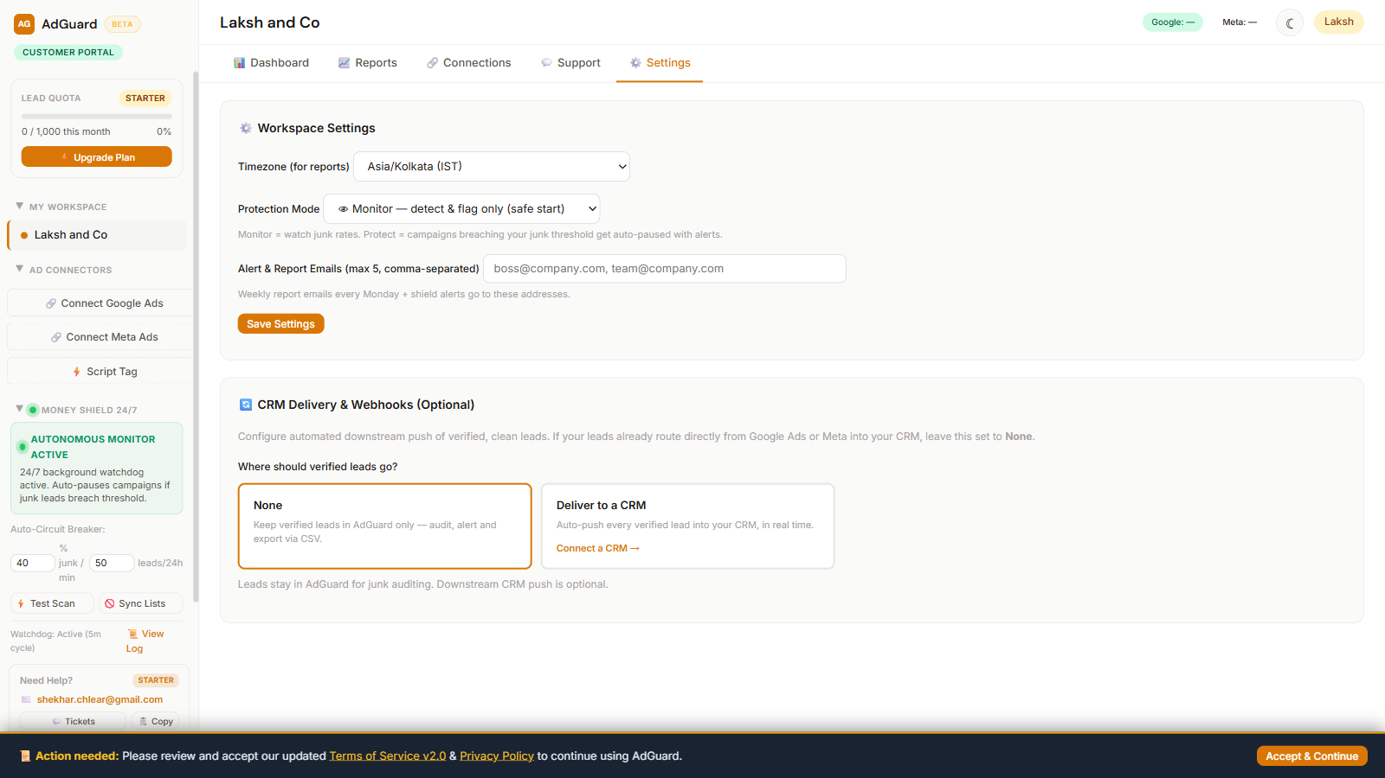
Fig 2.6 — Settings: CRM delivery choice (None / Deliver to a CRM)
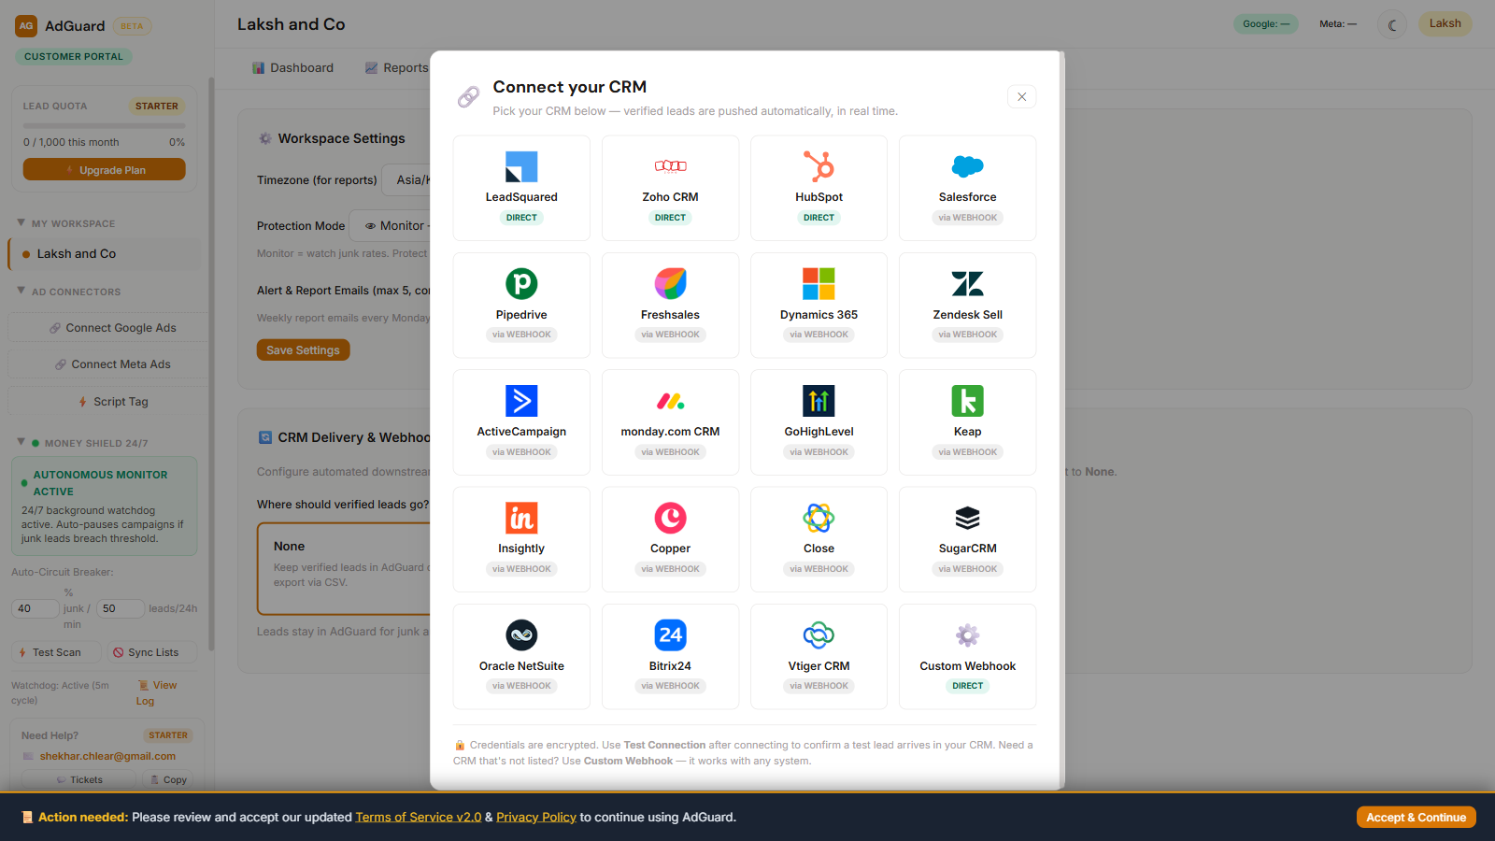
Fig 2.7 — 20-CRM picker with real logos: 4 direct integrations, 16 via universal webhook
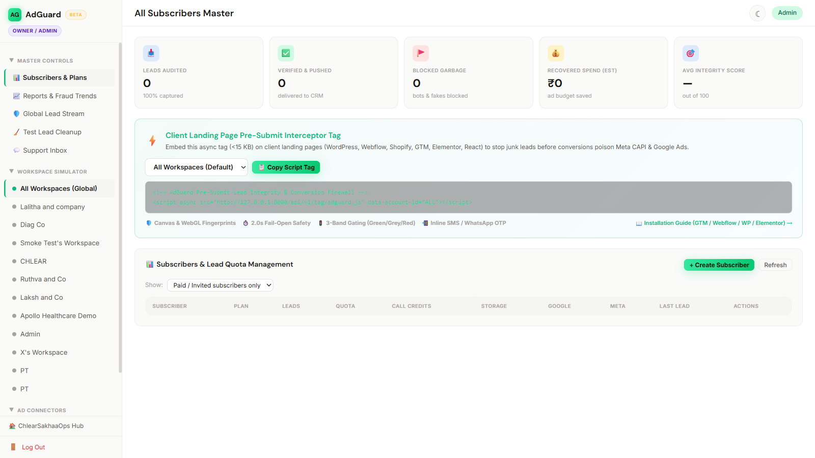
Fig 2.8 — Admin cockpit: subscriber & plan management, call credits, embed tag

2.1 Feature maturity (honest status)
Capability | Status
Lead audit pipeline (Google + Meta webhooks, AI scoring, dedupe, geo, validation) | LIVE
Self-serve signup + email journey (verify → password → welcome) | LIVE
Plans, monthly hard-stop quotas, trial 14-day expiry | LIVE
CRM delivery (20 CRMs incl. LeadSquared, Zoho, HubSpot direct) | LIVE
Money Shield monitor/protect + auto-pause governor | LIVE
Pre-Submit Interceptor script tag (fail-open, 2.0s) | LIVE
Admin cockpit (subscribers, plans, quotas, call credits, simulate) | LIVE
Prepaid call-verification credits (Pro 300 / Enterprise 500) | METERED (Samvaad debit pending)
AI call verification (Samvaad integration) | NEXT (Q4)
WhatsApp OTP step-up | PARKED (clients run OTP in own forms)
Bot Traps | PARKED (Enterprise roadmap)
Invalid-click evidence CSV writer | SCOPED (approved, in build)

3. The Problem & Market
Industry studies consistently estimate 15–30% of paid-search and paid-social leads are never real buyers — bots, competitors, form-spam, duplicates, and unqualified clicks. Indian lead-gen verticals (education, real estate, healthcare, BFSI, hyperlocal) run on form-fills, making them the most exposed. The advertiser pays the platform for every one of these, then pays a sales team to call them.
- Nobody audits lead quality at capture time — platforms optimise on volume, agencies optimise on CPL, and junk flows through the entire funnel.
- Worse: when Meta/Google “learn” from fake leads, their optimisation findsmore fake leads — the waste compounds every week.
- Existing click-fraud tools (ClickCease, Lunio, TrafficGuard) block clicks — but none of them audit the LEADS arriving via your own ad accounts, score them, and push exclusion audiences back to the platforms.
AdGuard's wedge: we sit inside the customer's own ad accounts, audit the leads, block the junk, and make the platforms buy better. One mid-size Meta lead-gen client wastes an estimated ₹20,000–50,000 per month on junk; AdGuard Starter costs ₹4,999. The product sells itself with arithmetic.

4. Plans & Pricing
Plan | Price/mo | Lead audits | AI calls | Google+Meta | Workspaces
Shadow (Free trial) | ₹0 · 14 days | 300 total, hard stop | — | 1 + 1 | 1
Starter | ₹4,999 | 1,000/month | — | 1 + 1 | 1
Pro | ₹14,999 | 5,000/month | 300 included | 1 + 1 | 1
Enterprise | ₹39,999 | Unlimited | 500 included | 2 + 2 | 10 brand workspaces

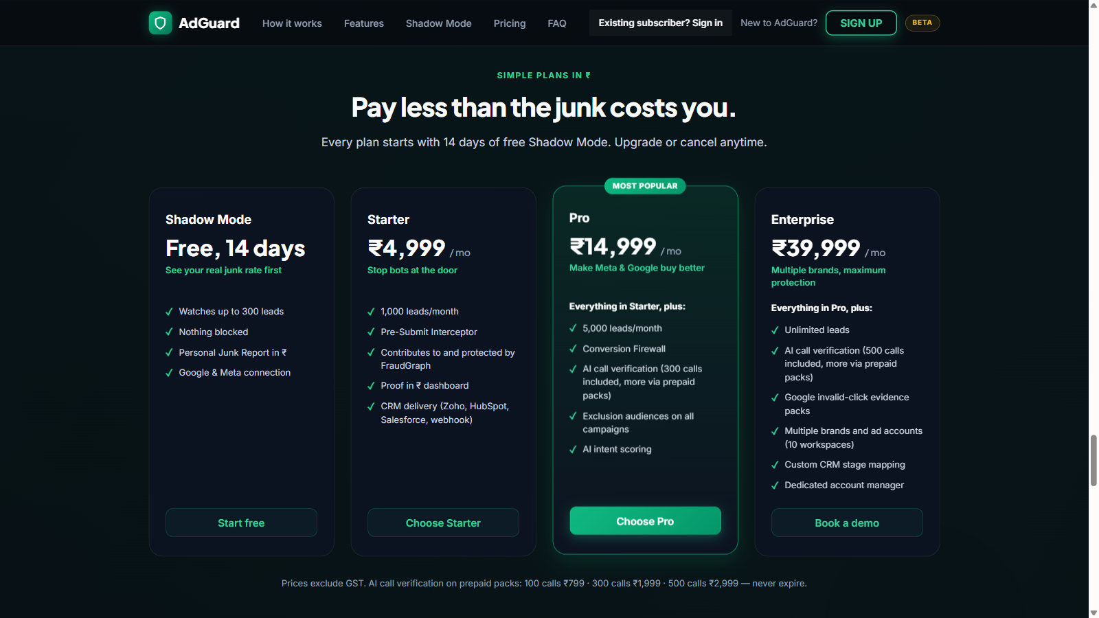
Fig 4.1 — Public pricing table as customers see it
Policy design (already enforced in-product):
- Lead quotas are hard stops with monthly reset — unused quota does not carry over (capacity provision, industry standard).
- AI call credits are a prepaid bucket that NEVER expires — ethical and defensible: credits carry across renewals; customers top up 100/₹799, 300/₹1,999, 500/₹2,999 packs.
- Trial clock starts at password activation (not signup) — no lost trial days to slow email verification.
- Connection limits (1 Google + 1 Meta) enforced at OAuth; upsell path to Enterprise is in-product.
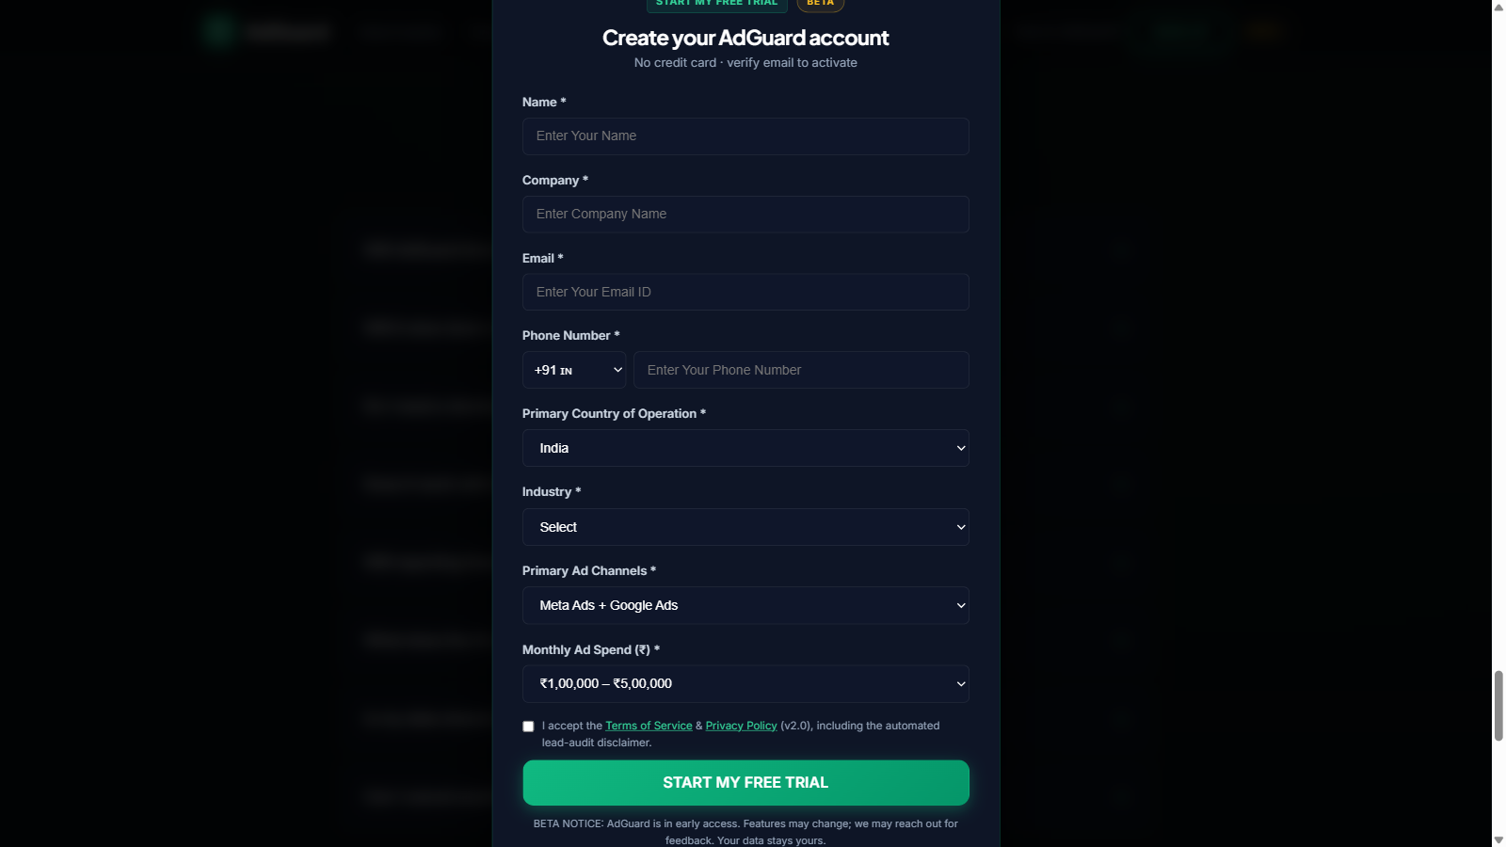
Fig 4.2 — Signup modal with mandatory ToS acceptance (legal cover built into the flow)

5. Unit Economics (Full View)
Costs are real production numbers (Railway + Supabase + gateway fees). No item is hidden.

5.1 Gross margin per subscriber
Plan | Price | Variable cost* | Gross ₹ | Gross %
Starter (1,000 leads) | ₹4,999 | ~₹300 | ~₹4,700 | ~94%
Pro (5,000 leads + 300 calls) | ₹14,999 | ~₹600 | ~₹14,400 | ~96%
Enterprise (10 ws + 500 calls) | ₹39,999 | ~₹2,500 | ~₹37,500 | ~94%

*Variable = compute, storage growth, 30 min support. Gateway adds 2% of revenue (Razorpay). AI-call cost sits inside the plans' call bundles (Samvaad ~₹2–4/call; prepaid packs retail at ₹6–8/call — 33–50% margin on top-ups).

5.2 Fixed infrastructure
Item | ₹/month
Railway (app + scheduler, 24/7) | 2,000–3,500
Supabase Postgres (free tier → Pro at growth) | 0–2,100
Domain + SSL + email | ~100
Total fixed | ≈ ₹3,000–5,000

5.3 P&L at the 60-day post-launch state
Line | ₹/month
Revenue: 10 Starter + 4 Pro + 2 Enterprise | 1,89,984
Infrastructure (scaled) | (8,000)
Gateway 2% | (3,800)
Support/dev salary | (60,000)
Operating profit | ≈₹1,18,000 → ~62% net margin

Break-even milestones | Value
Fixed infra break-even | 1 Starter subscriber
True break-even (with salary) | 6–8 subscribers (~₹65–70k MRR)
Before that | Founder-run: 1–2 subscribers = already cash-positive

6. Why Razorpay Now (The Core Ask)
Today the product has no payment path by design (beta). A customer choosing a paid plan gets the workspace, but the payment step is bypassed. This was correct for beta — beta feedback without purchase friction — but it means the funnel stops exactly where revenue starts.

6.1 What Razorpay LIVE unlocks
- Checkout: customer picks Starter/Pro/Enterprise → Razorpay (UPI, cards, netbanking, wallets) → subscription active instantly, no manual UPI transfers and no support tickets.
- Automatic provisioning: plan + quota + call credits applied the moment payment succeeds (webhook-driven).
- Prepaid call-pack purchases inside the workspace (Buy Calls → Razorpay checkout → instant credit).
- Subscriptions with auto-recharge links for quota top-ups later, recurring billing at renewal.

6.2 Gateway comparison
Gateway | Fees (Indian cards) | Settlement | Why/why not
Razorpay | ~2% + GST | T+2 days | Best developer docs, subscriptions, payment pages; industry standard
Cashfree | ~1.75–2% | T+1 | Cheaper, fewer product features (links/subscriptions weaker)
PayU | ~2% + GST | T+2 | Comparable; docs and support weaker for startups

Recommendation: Razorpay. Fees are standard, the subscription & payment-page APIs are the strongest, and the code integration is a one-day change on the pre-built branch.

6.3 Activation steps (owner actions)
Step | Owner | Time
KYC on Razorpay dashboard (PAN, GST, bank account of CHLEAR) | Management + Shekhar | Same day (docs ready)
Business verification review by Razorpay | Razorpay | 2–7 working days
Bank settlement activation | Razorpay | With activation
Flip code to LIVE keys (env var change + deploy) | Shekhar/agent | 1 hour

Activation is calendar-time, not engineering-time. Every day waiting is revenue not collected.

7. Launch Plan (October 10)
- Warm outreach: every agency/ad-ops contact across the team — personal WhatsApp, free 2-week trial.
- chlear.in's own client base: present AdGuard in existing client reviews (highest-conversion channel).
- LinkedIn launch sequence: the ₹ waste story, the fraud-graph explainer, the launch post.
- Performance-marketing communities (India): share the CHLEAR case numbers.
- Launch offer: first 10 subscribers get an early-adopter discount on annual commitment.
- 15-min demo promise: every demo request triggers an instant alert with a callback playbook — response inside 15 minutes is the differentiator.
- Subscriber enablement already shipped: gated AdGuard Academy (8 lessons) + 10-step Setup Guide — reduces support load from day one.
Weekly KPI board (from admin dashboard) | Target by Nov 30
Trial → paid conversion | > 25%
MRR | ₹1,00,000 by Jan (stated in ask)
Leads audited (cumulative) | 50,000
Junk rate found (proof of value) | > 15%
₹ recovered (customer-visible) | ₹15–20L cumulative

8. Risks & Mitigations
Risk | Mitigation (in place / planned)
Subscriber legal claim: “you didn't really audit” | ToS v2.0 §2: audit = automated algorithmic scoring via official APIs, explicitly not human verification; no detection guarantees; accuracy claims are targets, not contracts. Acceptance recorded per user with version + timestamp.
Ad platform refund decisions | ToS §2: refunds are at the platform's sole discretion; AdGuard only facilitates evidence + claim files.
Liability exposure | ToS §12: liability capped at 3 months' fees; no indirect damages.
Free-trial farming / abuse | Signup abuse guard live (phone/company pattern detection, admin flags); hard-stop quotas cap any abuse at 300 leads.
Code/IP theft (competitor clones the app) | ToS §6 prohibits reverse-engineering/derivatives (damages + injunction). Per-build invisible watermarks embedded in every page; proprietary notices in footers; repos private; legal base to act.
Email deliverability (Gmail relay ceiling) | Already observed: personal Gmail relay limits scale. Mitigation: domain mailbox (adguard domain + SPF/DKIM) queued for purchase.
Platform API changes (Google/Meta) | Official APIs only; multi-identity fallbacks built; changes absorbed by webhook adapter layer.
Support load at growth | Academy + setup guide self-serve content; weekly digest emails; ticket system with priority for paid plans.

9. Approvals Requested
# | Approval | Detail
1 | Razorpay LIVE activation | KYC under CHLEAR entity; bank account for settlement; keys handed to engineering for the 1-hour flip
2 | Pricing confirmation | ₹4,999 / ₹14,999 / ₹39,999 + call packs ₹799/₹1,999/₹2,999 (all ex-GST) as published
3 | Budget for 3 months | ₹25–40k/month (infra + support + ₹10k marketing) to reach ₹1L MRR by January
4 | Domain purchase | adguard brand domain for email deliverability + white-label (queued)

The close:
“One mid-size Meta lead-gen client wastes ₹20,000–50,000 every month on junk leads. AdGuard charges ₹4,999 to stop it — with proof in rupees the client can see. The math sells the product. The only thing between us and the market is a Razorpay activation.”

Approved by (Management) | Date | Signature

