microPIV (matPIV based)

**Menu**

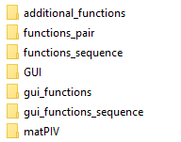

**Additional_functions:**

Aiding functions from out sourcing

**Function_pair:**

All the practible functions need for pair operation

**Gui_functions:**

The pair’s functions that are control the graphic interfacr (GUI)

**Function_sequence:**

All the practible functions need for sequence operation

**Gui_functions_sequence:**

The sequence’s functions that are control the graphic interface (GUI)

**Adding new function:**

microPIV

funcDoc

isField *