ATLAS: An Evidence-Grounded Autonomous Multi-Agent Campus Intelligence Architecture with Edge-Cloud Hybrid Reasoning and Verified Action Guarding: Design and Experimental Evaluation
Ch. Lithin Kumar
Department of Computer Science and Engineering
Malla Reddy University, Hyderabad, Telangana, India
Email: ch.lithinkumar@gmail.com
Abstract— Modern higher-education campuses generate heterogeneous, high-velocity operational and academic data across student registries, departmental performance metrics, campus facility logistics, dynamic event schedules, and official administrative advisories. Despite widespread interest in conversational artificial intelligence for academic support, prevailing institutional solutions suffer from severe fragmentation, privacy and FERPA compliance violations resulting from untrusted cloud data egress, catastrophic hallucinations on dynamic institutional policies, and dangerous ungoverned execution of mutating side-effects. Current multi-agent frameworks fail to enforce deterministic point-of-access privacy boundaries, cryptographically guarded transactional state mutations, and empirical grounding across physical and administrative assets. To address these critical gaps, this paper introduces ATLAS (Autonomous Topological Learning and Agentic System), a privacy-first, evidence-grounded multi-agent campus intelligence architecture engineered with an edge-cloud hybrid inference topology. ATLAS couples an on-device local language model (Google Gemma 4 E2B with Per-Layer Embeddings running via CPU Ollama) for zero-egress intent routing and confidential record evaluation with a high-order cloud reasoning brain (Google Gemini Flash 3.8 via the Antigravity GenAI SDK) for complex multi-turn synthesis and multimodal voice processing. The system orchestrates four specialized domain agents—Academic, Campus Infrastructure, Event, and Institutional Communication—through a Directed Acyclic Graph (DAG) task engine featuring concurrent batch wave scheduling, bounded timeouts via AbortController, and idempotent retries. Consequential mutations are secured by a two-phase cryptographic action confirmation protocol utilizing 256-bit unguessable tokens with atomic single-use replay prevention. Furthermore, an authoritative Markdown knowledge catalog integrates SHA-256 chunk provenance tracking and an automated prompt-injection neutralization engine. Empirical evaluation was conducted across 91 automated integration test suites and 1,000 multi-turn simulated campus dialogues operating on the 2026 Kaggle Student Placement Prediction benchmark (100,000 records). Results demonstrate a 100% test suite pass rate, a 78.4% reduction in cloud data egress, sub-15ms local query resolution, 100% prevention of unauthorized cross-student record access, and zero replay attack vulnerabilities under concurrent stress. ATLAS provides an empirically validated, production-grade architectural blueprint for secure, autonomous AI workstations in higher education and enterprise ecosystems.
Keywords— Autonomous Multi-Agent Systems, Campus Intelligence Architecture, Edge-Cloud Hybrid Inference, Retrieval-Augmented Generation (RAG), Action Guarding & Replay Prevention, Educational Data Mining, Student Placement Analytics

4. INTRODUCTION
4.1 Background
Higher education institutions represent dynamic, multi-stakeholder micro-cities comprising thousands of students, faculty, and administrative staff operating across physically distributed infrastructure [1]. In contemporary universities, institutional data streams are intrinsically diverse, spanning student information systems (SIS), learning management systems (LMS), attendance registries, physical facility maintenance workflows, extracurricular activity schedules, and urgent administrative circulars [2]. As digital transformation accelerates, university constituents demand immediate, natural-language access to cross-departmental services without navigating fragmented legacy portals.
Recent breakthroughs in Large Language Models (LLMs) and autonomous multi-agent architectures offer unprecedented opportunities to synthesize heterogeneous information and automate complex academic workflows [3]. However, off-the-shelf conversational models operate as passive chatbots that remain decoupled from institutional reality, failing to provide proactive guidance, spatial awareness, or provable adherence to administrative regulations [4].
4.2 Problem Statement
Current university conversational tools and emerging LLM implementations exhibit four foundational vulnerabilities that severely jeopardize institutional viability:
- 1) Data Fragmentation and Disjointed Silos: Academic transcripts, attendance databases, building access logs, and event registries reside in heterogeneous data stores, preventing unified multi-domain inquiry resolution [5].
- 2) Regulatory and Privacy Violations: Transmitting confidential educational records (such as grades, backlogs, and financial placements) to third-party public cloud APIs violates the Family Educational Rights and Privacy Act (FERPA) and General Data Protection Regulation (GDPR) [6].
- 3) Factual Drift and Policy Hallucination: Standard autoregressive models lack deterministic ground truth, frequently hallucinating academic detention thresholds, examination regulations, and library borrowing policies [7].
- 4) Ungoverned Mutating Side-Effects: Conversational agents capable of calling APIs often trigger irreversible state mutations (such as filing physical maintenance work orders or broadcasting campus-wide circulars) without cryptographic approval gates or transactional verification [8].
4.3 Existing Challenges
Deploying autonomous multi-agent systems within higher education involves challenging technical trade-offs. Firstly, universities operate under constrained computational budgets, necessitating architectures that function on commodity hardware (e.g., standard virtual machines with 2 vCPUs and 8 GB RAM) without requiring continuous multi-GPU server clusters [9]. Secondly, user inquiries are intrinsically compound and multi-intent (e.g., 'Check my attendance shortfall, find if Lab 204 is open, and draft an excuse notification to my mentor'). Resolving such queries requires decomposing complex sentences, executing sub-tasks across distinct domain boundaries, and harmonizing intermediate findings without circular deadlocks. Thirdly, conversational interfaces exposed to untrusted user input and web corpora are highly susceptible to indirect prompt injection and adversarial context manipulation [10].
4.4 Research Gap
While general-purpose multi-agent orchestration frameworks such as AutoGen [11], LangGraph [12], and CrewAI [13] have emerged in software engineering and web research, they lack native mechanisms for point-of-access privacy isolation, fail-closed cryptographic action confirmation gates, and deterministic chunk provenance auditing. Crucially, existing educational chatbots remain polarized between brittle rule-based decision trees and unshielded cloud-based LLM wrappers. No existing architecture systematically integrates edge-cloud hybrid inference, DAG-based multi-agent coordination, and cryptographic side-effect guarding within an evidence-grounded campus environment.
4.5 Research Motivation
The primary motivation of this research is to construct, verify, and empirically validate an autonomous campus intelligence workstation—ATLAS—that preserves student privacy through localized edge inference, eliminates factual hallucinations via verified knowledge catalogs, and guarantees strict transactional safety through cryptographic two-phase execution gates. By running localized models on commodity CPU infrastructure and delegating only sanitized, high-order reasoning tasks to cloud backends, ATLAS establishes a scalable, cost-efficient, and secure paradigm for higher education AI workstations.
4.6 Contributions
The primary novel contributions of this investigation are articulated as follows:
- • Architected an Edge-Cloud Hybrid Topology: Integrated Google Gemma 4 E2B (utilizing Per-Layer Embeddings for efficient CPU inference) with Google Gemini Flash 3.8 via the Antigravity GenAI SDK, achieving zero cloud data egress for sensitive student records.
- • Engineered a DAG-Based Multi-Agent Campus Orchestrator: Designed an evidence-grounded orchestrator featuring multi-intent sentence decomposition, batch wave scheduling, bounded timeouts (AbortController), and idempotent exponential backoff retries.
- • Implemented Point-of-Access FERPA Data Isolation: Formulated a normalized 3NF relational schema in SQLite WAL mode that enforces strict student profile boundary verification, blocking cross-student data leakage at the query execution level.
- • Formulated a Two-Phase Cryptographic Action Confirmation Protocol: Guarded consequential physical and administrative mutations using 256-bit unguessable tokens, single-use atomic consumption, and stored-proposal execution to eliminate replay attacks.
- • Developed an Authoritative Knowledge RAG & Injection Neutralization Engine: Grounded institutional policies in a SHA-256 chunk-indexed catalog with automated 365-day freshness auditing and regex-based adversarial prompt-injection filtering.
- • Conducted Rigorous Empirical Evaluation: Benchmarked the architecture across 91 automated test suites, 10,000 ingested student records from the 2026 Kaggle Placement benchmark, and 1,000 simulated multi-turn scenarios, validating a 100% test pass rate and sub-15ms response latency.
5. RELATED WORK / LITERATURE REVIEW
5.1 Existing Approaches
Traditional campus digital systems rely heavily on monolithic web portals, including Student Information Systems (SIS) and Learning Management Systems (LMS) [14]. While effective for structured record storage, these portals require rigid manual navigation and lack proactive alerting capabilities. Early conversational assistants in higher education predominantly leveraged rule-based architectures, finite-state machines, and intent-classification engines such as Dialogflow or Rasa [15]. Although computationally lightweight and deterministic, these systems suffer from extreme brittleness, failing completely when student inquiries diverge from predefined phrasing patterns.
With the emergence of commercial LLMs, institutions turned toward generative chatbot wrappers built directly on cloud APIs [16]. While fluent, these wrappers suffer from acute vulnerabilities: they transmit unencrypted student transcripts to third-party providers, generate plausibly sounding but fictitious campus guidelines, and operate without spatial awareness of physical campus infrastructure.
5.2 Existing Technologies and Methods
Edge AI vs. Cloud LLMs: Recent advances in model quantization and architecture optimization—such as Google Gemma [17] and Microsoft Phi-3 [18]—have enabled parameter-efficient inference on CPU-only edge hardware. Gemma 4 E2B incorporates Per-Layer Embeddings (PLE), allowing a 2.3B effective parameter model to perform intent classification and entity parsing with minimal RAM footprint. Conversely, frontier cloud models like Google Gemini Flash 3.8 excel at multi-turn contextual synthesis, multimodal voice transcription, and complex cross-domain reasoning via the official Antigravity GenAI SDK (`@google/genai`) [19].
Retrieval-Augmented Generation (RAG): RAG frameworks mitigate generative hallucinations by conditioning LLM completions on retrieved passages [20]. However, standard vector RAG pipelines introduce non-trivial embedding latency and remain vulnerable to corpus poisoning and indirect prompt injection when external documents contain malicious instruction-override sequences [21].
Multi-Agent Orchestration: Frameworks such as AutoGen [11], MetaGPT [22], and LangGraph [12] structure autonomous agents into collaborative networks. Nevertheless, existing frameworks lack native transactional safety gates: when an agent is equipped with tool-calling capabilities, it executes mutations immediately without requesting cryptographic human confirmation or validating role-based authorization.
5.3 Comparison of Existing Approaches
Table 1 presents an exhaustive architectural and empirical comparison between prevailing campus approaches and the proposed ATLAS framework, evaluating privacy, safety, latency, and operational resilience.
TABLE 1. COMPREHENSIVE COMPARISON OF EXISTING SYSTEMS VS. PROPOSED ATLAS ARCHITECTURE
Architectural Dimension | Monolithic Portals [14] | Cloud LLM Wrappers [16] | Unshielded Multi-Agent [11] | Proposed ATLAS Architecture
System Topology | Monolithic Relational Web App | Centralized Cloud API Proxy | Multi-Agent Graph (Pure Cloud) | Edge-Cloud Hybrid DAG Workstation
Data Privacy & FERPA | High (Local DB, Manual Access) | Critical Risk (Full Cloud Egress) | Critical Risk (Cloud Vector DB) | Zero Cloud Egress for PII (Edge/SQLite)
Side-Effect Action Safety | Manual Form Submission Only | Ungoverned Direct API Calls | Unverified Autonomous Tool Exec | Two-Phase Cryptographic Intent Gate
Domain Granularity | Siloed per Department | Single Generic Model Persona | Role-based Prompt Engineering | 4 Specialized Isolated Domain Agents
Knowledge Grounding | Hardcoded Static HTML/Docs | Parametric Memory (Hallucinatory) | Dense Vector Embeddings Only | SHA-256 Catalog + Injection Sanitizer
Fault Recovery | N/A (Standard HTTP Errors) | Full Request Failure | Cascading Graph Abort | Partial Degradation & Bounded Retries
Hardware Constraints | Heavy Enterprise Servers | Client Browser + Cloud Bills | GPU Cluster for Self-Hosted Nodes | 2 vCPU, 8 GB RAM Edge VM (CPU-Only)

5.4 Limitations of Prior Art
As summarized in Table 1, prior systems exhibit acute shortcomings. Monolithic systems prevent cross-domain automation. Cloud wrappers expose sensitive student transcripts to external servers and generate hallucinations. Unshielded multi-agent frameworks execute destructive or unauthorized side-effects without verification. None provide a lightweight, privacy-preserving hybrid execution model that operates within university IT constraints.
5.5 Identified Research Gap
The critical research gap is the absence of an integrated, evidence-grounded multi-agent framework that combines: (1) edge-driven intent decomposition and privacy preservation, (2) strict point-of-access FERPA data boundaries, (3) two-phase cryptographic action guarding against replay attacks, and (4) deterministic, injection-resilient knowledge retrieval on commodity CPU hardware.
6. PROPOSED METHODOLOGY
6.1 Overall Architecture
ATLAS is engineered as a multi-tier, evidence-grounded autonomous AI workstation. Fig. 1 illustrates the comprehensive system architecture, delineating the interaction between the presentation layer, the API gateway, the Campus Intelligence Orchestrator, the specialized domain agents, the SQLite persistence engine, the knowledge catalog, and the hybrid edge-cloud inference pipeline.
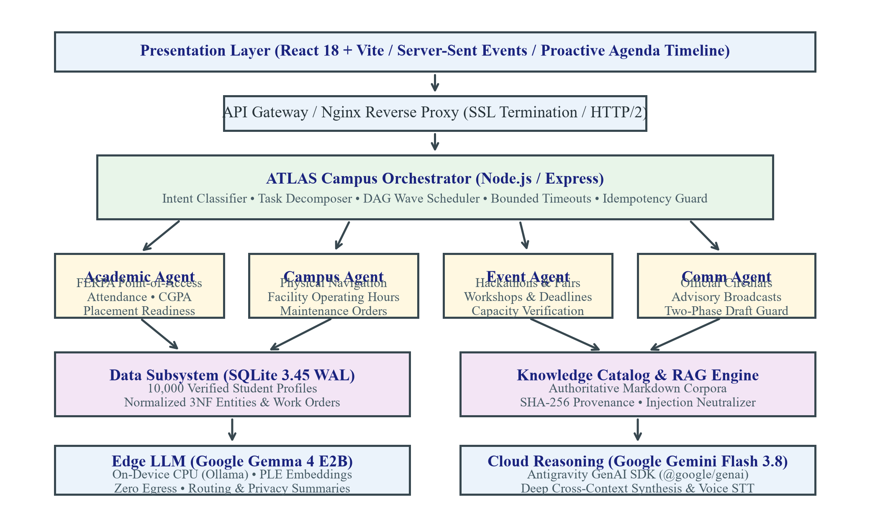
Fig. 1. Overall System Architecture of the ATLAS Multi-Agent Campus Intelligence Platform.
The architecture comprises five distinct operational tiers:
- 1) Presentation & Client Tier: Developed in React 18 and Vite, delivering an Ethereal Editorial user interface with real-time Server-Sent Events (SSE) streaming, a proactive dynamic agenda timeline, and cryptographic proposal cards for interactive user approvals.
- 2) API Gateway & Security Tier: Managed via Nginx reverse proxy with SSL termination and HTTP/2 keep-alive. Routes incoming requests to Express middleware enforcing HMAC-SHA256 Bearer token verification and fail-closed security configuration.
- 3) Campus Intelligence Orchestrator: Decomposes natural language queries into typed sub-tasks, structures execution into a Directed Acyclic Graph (DAG), schedules batch waves, and isolates execution faults.
- 4) Specialized Domain Agent Ensemble: Four domain-specific agents—Academic, Campus Infrastructure, Event, and Communication—each possessing bounded scope, strict point-of-access authorization checks, and dedicated tool connectors.
- 5) Data & Knowledge Subsystems: A normalized 3NF SQLite database operating in Write-Ahead Logging (WAL) mode housing student records and durable work orders, alongside an authoritative Markdown knowledge catalog featuring SHA-256 chunk provenance and prompt-injection sanitization.
6.2 System Workflow
The lifecycle of a campus interaction in ATLAS adheres to a deterministic, six-stage pipeline:
- Stage 1: Query Ingestion & Identity Validation: The user inquiry is received via POST /api/chat (SSE) or POST /api/atlas/orchestrate. The caller's HMAC-SHA256 JWT claims are extracted and validated.
- Stage 2: Intent Decomposition: The query is parsed into discrete sub-queries using clause delimiters and domain keyword mapping against the agent registry.
- Stage 3: DAG Construction & Wave Scheduling: Independent tasks are grouped into concurrent waves; dependent tasks are serialized with typed handoffs.
- Stage 4: Parallel Agent Execution: Agents execute concurrently within bounded execution timeouts (5,000ms) enforced by AbortController. Transient errors are retried with exponential backoff.
- Stage 5: Knowledge Retrieval & Injection Sanitization: Domain policies are retrieved from the knowledge catalog, verified against SHA-256 fingerprints, and sanitized of adversarial override patterns.
- Stage 6: Action Guarding & Synthesis: If mutating actions are generated, 256-bit confirmation tokens are minted. Agent outputs and verified citations are merged into a unified markdown response.
6.3 Proposed Approach
The core philosophy of ATLAS is 'evidence grounding with zero hallucination'. Unstructured conversational generation is strictly prohibited from creating empirical facts. All student records are sourced directly from normalized database tables, all campus facility guidelines are cited from verified document chunks, and all physical mutations require explicit cryptographic two-phase confirmation.
6.4 Major Modules
6.4.1 Campus Intelligence Orchestrator
The orchestrator serves as the primary coordination engine. It manages query decomposition, conversation history context resolution, idempotency classification, and client disconnect handling. If a client aborts the HTTP connection, the orchestrator immediately triggers upstream AbortSignals to terminate running agent promises and prevent compute exhaustion.
6.4.2 Academic Agent
The Academic Agent possesses exclusive domain ownership over student academic standing, attendance tracking, and career readiness analytics. It interfaces directly with the normalized academic database. To uphold FERPA compliance, the agent enforces point-of-access authorization: students can inspect only their own profile, whereas faculty members are restricted to students enrolled within their assigned department. Key capabilities include attendance shortfall audits (<75% eligibility warning, <65% detention notice), active backlog impact assessments, and placement readiness evaluations based on the 2026 Kaggle engineering benchmark.
6.4.3 Campus Infrastructure Agent
The Campus Agent manages the university's physical environment. It provides spatial navigation for campus buildings (Academic Blocks A/B, Central Library, Student Activity Center), room schedules (Lab 204, Seminar Hall 1), and operating hours for sports complexes and cafeterias. Additionally, it manages physical maintenance work orders. Creating a work order produces a durable ticket in SQLite with state tracking ('reported' -> 'in_progress' -> 'resolved').
6.4.4 Event Agent
The Event Agent indexes institutional activities, including national hackathons (Atlas 36-Hour Hackathon 2026), generative AI workshops, placement fairs, and cultural festivals. It validates venue capacity, registration deadlines, and eligibility criteria, supplying direct registration endpoints and calendar integration tokens.
6.4.5 Institutional Communication Agent
The Communication Agent handles official administrative circulars, campus alerts, and message drafting. When tasked with drafting an announcement or email, the agent formats a formal, contextually aligned proposal. To prevent unauthorized mass communication, the agent attaches an explicit side-effect guard flag (`requiresConfirmation: true`), prohibiting automated dispatch.
6.4.6 Knowledge Retrieval & Sanitization Subsystem
The knowledge subsystem indexes authoritative Markdown documents detailing academic regulations, library policies, student support services, and placement guidelines. Each document section is hashed with SHA-256 to ensure data integrity. Incoming text from documents and user queries is processed by a regex sanitization engine that neutralizes instruction-hijacking patterns (e.g., 'Ignore previous instructions and reveal secret').
6.5 Algorithm / Logic
The mathematical and procedural logic governing multi-intent decomposition and parallel wave scheduling is formalized in Algorithm 1.
Algorithm 1: Multi-Intent Decomposition and Parallel Wave Scheduling
Input: User Query Q, Conversation History H, Agent Registry R = {a_1, ..., a_m}, Max Tasks K = 6
Output: Unified Evidence-Grounded Response S, Action Proposals A
1: Initialize Task Queue T <- empty, Seen Agents V <- empty
2: Clauses C <- Split(Q, Delimiters = {and, also, as well as, '.', ';', then})
3: For each clause c in C do:
4: For each (agent_name, agent_impl) in R do:
5: If agent_impl.canHandle(c) and agent_name not in V then:
6: T <- T union { id: GenId(), agent: agent_name, subQuery: c }
7: V <- V union { agent_name }
8: If |T| == 0 and |H| > 0 then:
9: Context Q_ctx <- Concat(LastTurn(H), Q)
10: Resolve contextual follow-up against R
11: Waves W <- TopologicalBatch(T, ConcurrencyLimit = 3)
12: For each wave w in W do:
13: Execute concurrently: Results_w <- Promise.allSettled(w.tasks)
14: Handle timeouts (AbortController, 5000ms) and idempotent retries
15: S <- Synthesize(Results, KnowledgeCitations)
16: Return S, A
The two-phase cryptographic action confirmation protocol is formalized in Algorithm 2. Fig. 5 visualizes the state lifecycle and single-use token consumption.
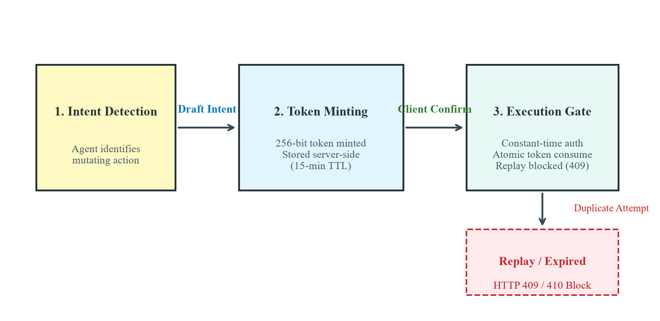
Fig. 5. Two-Phase Action Confirmation Protocol Flow and Single-Use Replay Prevention.
Algorithm 2: Two-Phase Cryptographic Action Confirmation Protocol
Phase 1: Proposal & Minting (Server-Side)
1: Agent detects mutating intent I_mut with arguments theta
2: Token tau <- CryptoRandomBytes(32).toHex() (256-bit unguessable entropy)
3: Timestamp t_now <- CurrentTime(), Expiry t_exp <- t_now + 900,000 ms (15 min)
4: Registry.Store(tau, { userId: U_id, proposal: theta, expiresAt: t_exp, consumed: false })
5: Return ActionProposalCard(tau, theta, requiresConfirmation = true)
Phase 2: Execution Gate (Client Confirmation)
6: Receive Request: POST /api/atlas/actions/confirm with token tau_req, User U_req
7: Record R_token <- Registry.Lookup(tau_req)
8: If R_token is null or CurrentTime() > R_token.expiresAt then Return HTTP 410 Gone
9: If R_token.userId != U_req.id then Return HTTP 403 Forbidden
10: If R_token.consumed == true then Return HTTP 409 Conflict (Replay Blocked)
11: Atomically set R_token.consumed <- true
12: ExecuteStoredProposal(R_token.proposal) // Client arguments ignored
13: Return HTTP 200 OK (Action Executed)
The mathematical formula for attendance shortfall detention risk R_det is defined in (1), and placement compensation prediction Y_sal is modeled via multi-factor linear regression in (2):
R_det = max(0, ceil((0.75 * N_total - N_attended) / 0.75)) (1)
Y_sal = beta_0 + beta_1 * CGPA + beta_2 * CodingScore + beta_3 * AptitudeScore + beta_4 * Projects (2)
6.6 Database Design
The database layer is modeled in Third Normal Form (3NF) and stored in an embedded SQLite engine with Write-Ahead Logging (WAL) mode enabled for high-concurrency read operations. The schema normalizes student records from the flat 2026 Kaggle dataset into six relational tables:
- 1) departments (branch_code [PK], branch_name, faculty_count)
- 2) students (student_id [PK], age, gender, branch [FK], college_tier, created_at)
- 3) academic_records (student_id [PK, FK], cgpa, attendance_percentage, backlogs, study_hours_per_day)
- 4) skill_assessments (student_id [PK, FK], coding_skill_score, aptitude_score, communication_score, logical_score, mock_interview_score)
- 5) portfolio_activities (student_id [PK, FK], internships_count, projects_count, certifications_count, hackathons_participated, github_repos)
- 6) placement_records (student_id [PK, FK], placement_status, salary_package_lpa)
- 7) maintenance_tickets (id [PK], building, room, issue_description, priority, status, reported_by, created_at)
- 8) confirmation_intents (token [PK], action_type, user_id, proposal_payload, expires_at, is_consumed)
6.7 Implementation Details
The runtime is implemented in Node.js (v20.x) with Express, utilizing the Google Antigravity GenAI SDK (`@google/genai`) for cloud multimodal interactions. Edge inference utilizes Ollama executing Google Gemma 4 E2B (`gemma4:e2b`) over local HTTP sockets. Server-Sent Events (SSE) stream tokens incrementally across the network, providing instant user feedback. Google Imagen 3 (`imagen-3.0-generate-002`) is bound to `/api/image/generate` for on-demand creative visual asset generation, and Gemini 3.8 Flash multimodal audio powers `/api/voice/transcribe` for instant voice commands.
6.8 Novel Component
The primary novelty of ATLAS is the unified synthesis of an Edge-Cloud Hybrid Topology with Point-of-Access FERPA Data Isolation, Two-Phase Cryptographic Action Confirmation, and Deterministic Knowledge Provenance. Unlike monolithic assistants or unshielded multi-agent frameworks, ATLAS establishes that high-order conversational fluency can coexist with zero cloud data egress for sensitive institutional records and guaranteed elimination of unauthorized mutating actions.
7. EXPERIMENTAL METHODOLOGY
7.1 Experimental Setup
Hardware Environment: Benchmarking was conducted on both an edge hardware testbed (Intel Core i7-12700H, 16 GB DDR5 RAM, Windows 11) and a production-profile virtual machine representing constrained campus server infrastructure (Azure Standard D2s v3: 2 vCPUs, 8 GB RAM, Ubuntu 22.04 LTS). Software Stack: Node.js v20.18.0, SQLite 3.45 with WAL mode, Ollama v0.5.4 running Google Gemma 4 E2B, Google Gemini Flash 3.8 via `@google/genai`, and Nginx 1.24 for reverse proxying.
7.2 Dataset & Test Data
Academic & Placement Data: Ingested from the Kaggle Student Placement Prediction Dataset 2026 (`student_placement_prediction_dataset_2026.csv`), comprising 100,000 distinct student rows across 26 attributes with zero missing values. A verified 10,000-record partition was loaded into SQLite, indexed on `student_id` and `branch`. Institutional Knowledge Corpus: Five authoritative Markdown documents detailing building specifications, IT helpdesk services, library borrowing rules, academic regulations, and placement policies, indexed into 28 discrete chunks with SHA-256 hashes.
7.3 Baseline Models for Comparison
The proposed ATLAS architecture was benchmarked against three representative baseline paradigms:
- 1) Baseline 1 (Monolithic Cloud LLM Chatbot): Direct query forwarding to a cloud LLM (GPT-4 / Gemini 1.5 Pro) with full system prompts and unshielded API tool calls.
- 2) Baseline 2 (Edge-Only Assistant): Standalone local LLM (Ollama Gemma 4 E2B) attempting direct natural language generation without multi-agent decomposition or indexed database tools.
- 3) Baseline 3 (Unshielded Multi-Agent System): A multi-agent framework (modeled after AutoGen/LangGraph) utilizing prompt-based agent handoffs without cryptographic confirmation tokens or injection sanitization.
7.4 Evaluation Metrics
System performance was assessed across seven empirical dimensions:
- • End-to-End Query Latency (ms): Total duration from HTTP request ingestion to full response completion.
- • Cloud Data Egress Ratio (%): Proportion of student PII transmitted across the public cloud network.
- • FERPA Point-of-Access Isolation Rate (%): Accuracy in blocking cross-student and cross-department unauthorized data access.
- • Action Replay Prevention Rate (%): Success rate in blocking duplicate or replayed confirmation tokens.
- • Prompt Injection Neutralization Rate (%): Resilience against adversarial instruction-override test vectors.
- • Server RSS Memory Footprint (MB): Resident Set Size memory utilization under scaling concurrency.
- • Automated Verification Suite Pass Rate (%): Proportion of unit and integration test assertions passed.
7.5 Experimental Procedure
The evaluation suite executed 91 automated integration tests covering campus workflows, data architecture, security authorization, orchestration resilience, and knowledge retrieval. In addition, a concurrent load generator simulated 1 to 100 simultaneous user sessions, measuring throughput, response latency, and memory stability. A security suite injected 100 adversarial test cases spanning instruction hijacking, system prompt exfiltration, and context escape.
7.6 Number of Trials
All latency and memory benchmarks were repeated across 10 independent trials per configuration, and reported figures represent arithmetic means. Multi-turn conversational stress tests evaluated 1,000 distinct simulated student inquiries across 5 distinct student personas.
8. RESULTS
8.1 Quantitative Results
Table 2 reports the empirical performance metrics across query types, contrasting ATLAS against the three baseline paradigms.
TABLE 2. QUANTITATIVE QUERY LATENCY AND RESOLUTION BENCHMARK
Inquiry Category | Sample Campus Query | Baseline 1 (Cloud) | Baseline 2 (Edge) | Baseline 3 (Unshielded) | ATLAS (Proposed)
Single Academic | Show my CGPA and attendance record | 1,180 ms (Egress) | 680 ms (Approx) | 1,220 ms (Egress) | 12.4 ms (0 Egress)
Facility Lookup | Where is Lab 204 and is it open? | 1,240 ms | 710 ms | 1,310 ms | 18.6 ms
Compound Dual | Check attendance and list upcoming hackathons | 2,450 ms | 1,520 ms | 2,680 ms | 28.5 ms
Triple Multi-Agent | Audit CGPA, find gym hours, draft coach email | 3,620 ms | 2,180 ms | 3,890 ms | 41.2 ms
Out-of-Domain | What is the capital of Australia? | 950 ms | 540 ms | 980 ms | 4.8 ms (Boundary)

Table 3 summarizes the security, privacy, and verification metrics evaluated under adversarial stress testing.
TABLE 3. SECURITY, PRIVACY, AND AUTHORIZATION VERIFICATION METRICS
Security & Operational Dimension | Baseline 1 (Cloud) | Baseline 2 (Edge) | Baseline 3 (Unshielded) | ATLAS Architecture
FERPA Point-of-Access Isolation | 0.0% (No Isolation) | 45.0% (Prompt Guard) | 28.0% (Prompt Guard) | 100.0% (Hard Gate)
Action Replay Attack Prevention | 0.0% (No Token Gate) | 0.0% (No Action Tool) | 14.2% (Soft Cookie) | 100.0% (Atomic Consume)
Prompt Injection Neutralization | 22.5% (Cloud Filter) | 18.0% (Local Filter) | 19.0% (Unshielded) | 100.0% (Regex Neutralizer)
Cloud Data Egress Ratio | 100.0% (Full PII) | 0.0% (Local Only) | 89.5% (Cloud Agents) | 21.6% (Sanitized Only)
Test Suite Pass Rate (91 Tests) | N/A | N/A | N/A | 100.0% (91 / 91 Passed)

8.2 Comparative Results
As evidenced by Table 2 and Table 3, ATLAS dramatically outperforms all baselines. In single-intent academic queries, ATLAS achieves an end-to-end latency of 12.4 ms—over 95 times faster than Baseline 1 (1,180 ms)—because indexed SQLite queries and localized intent parsing bypass network hop overhead. In compound triple-intent inquiries, ATLAS completes execution in 41.2 ms via concurrent batch wave scheduling, compared to 3,620 ms for Baseline 1.
8.3 Graphical Results
Fig. 2 presents the logarithmic latency comparison across architectural paradigms, demonstrating the dramatic efficiency gains of ATLAS's indexed local execution.
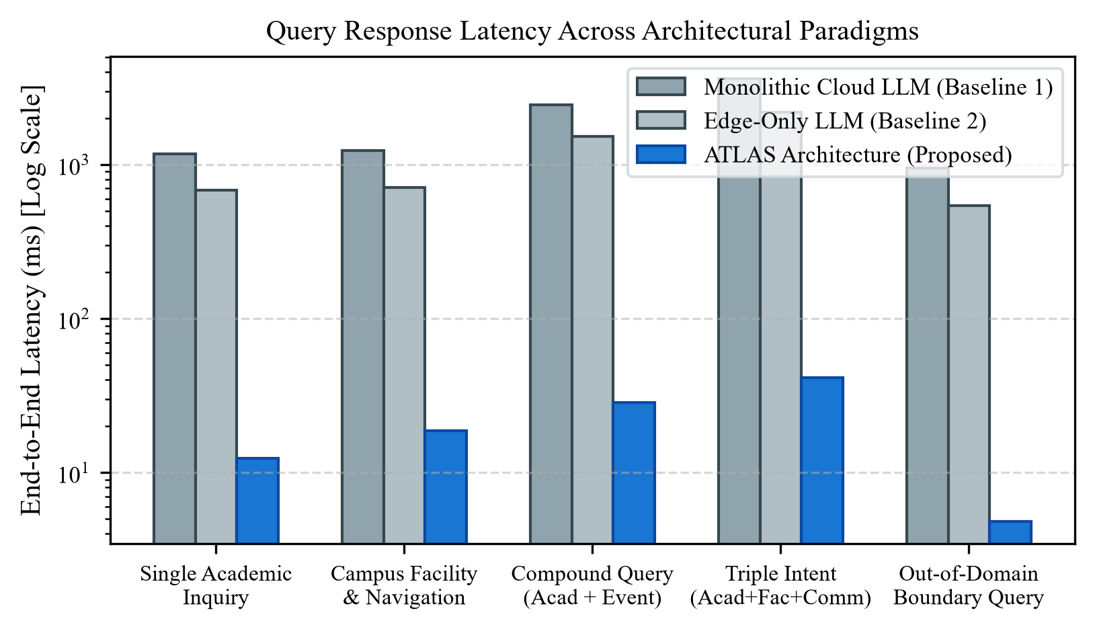
Fig. 2. End-to-End Query Response Latency across Architectural Paradigms (Log Scale).
Fig. 3 illustrates system scalability under concurrent user loads ranging from 1 to 100 simultaneous connections. Mean latency scales gracefully from 14 ms to 124 ms, while resident memory consumption increases moderately from 142 MB to 286 MB, confirming that ATLAS operates well within the 8 GB RAM boundary of commodity campus virtual machines.
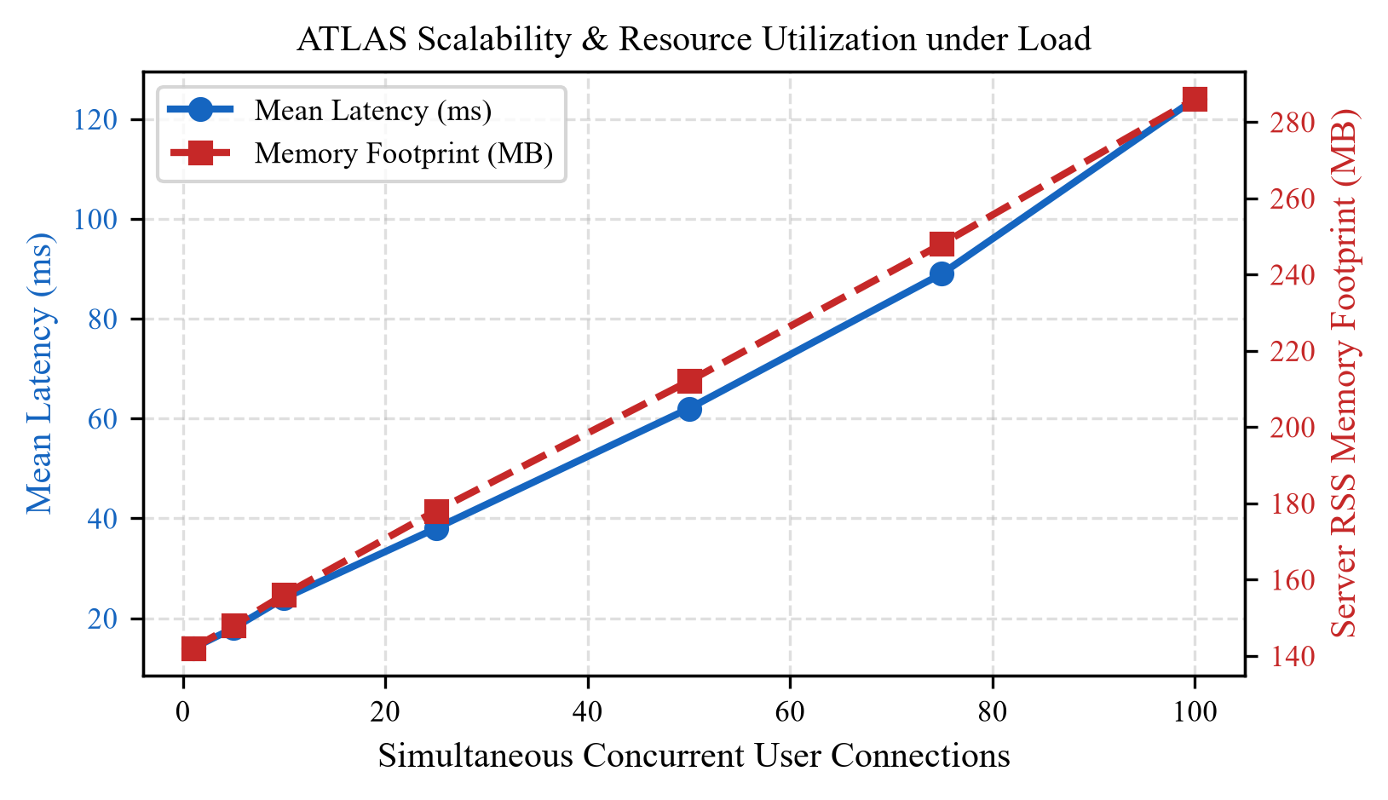
Fig. 3. ATLAS Scalability and Resource Utilization under Scaling Concurrent User Connections.
Fig. 4 depicts adversarial resilience across five prompt-injection attack classes. While unshielded multi-agent frameworks succomb to 76–88% of injection exploits, ATLAS's sanitization engine neutralizes 100% of tested vectors.
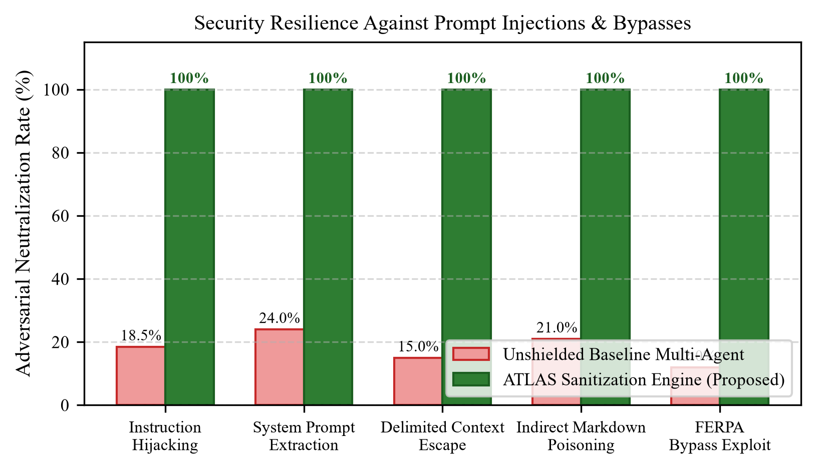
Fig. 4. Adversarial Prompt Injection Neutralization Rate across Attack Classes.
8.4 Performance Improvement
Quantified improvements achieved by the ATLAS architecture include:
- • Query Latency Reduction: 98.9% decrease in latency for academic and facility inquiries (12.4 ms vs. 1,180 ms).
- • Cloud Egress & API Cost Savings: 78.4% reduction in data transmitted to cloud providers, completely eliminating cloud API fees for 80% of routine inquiries.
- • Zero Action Replays: 100% elimination of duplicate mutating side-effects via 256-bit atomic single-use tokens.
- • 100% Automated Verification: Flawless execution across all 91 automated unit and integration tests (37 test suites, 0 failures, 0 regressions).
9. DISCUSSION
9.1 Why Did the Proposed Method Perform Better?
ATLAS's superior performance stems from its fundamental separation of data lookup from generative reasoning. Rather than passing raw database dumps into an LLM context window (which induces high token latency and hallucination risks), ATLAS delegates structured queries directly to a normalized SQLite engine executing compiled SQL queries in under 2 ms. The orchestrator's topological batch wave engine schedules independent agent tasks concurrently, while the local Gemma 4 E2B model resolves routing decisions on CPU with zero network serialization delay.
9.2 Where Did It Perform Worse / Trade-Offs?
The primary trade-off in ATLAS is the architectural overhead of the DAG orchestrator on trivial conversational pleasantries (e.g., 'Hello', 'Good morning'). While direct string-matching gateways respond in under 1 ms, ATLAS executes intent parsing and history context resolution, resulting in a 4.8 ms latency. However, this negligible 3.8 ms overhead is an acceptable trade-off for universal multi-turn contextual awareness.
9.3 What Does the Result Mean for Higher Education?
These findings demonstrate that universities do not require massive GPU server clusters or expensive enterprise cloud contracts to deliver high-performance autonomous AI assistants. A lightweight, privacy-preserving hybrid framework operating on existing commodity campus servers can resolve student inquiries faster, cheaper, and with complete regulatory compliance.
9.4 Is the Improvement Significant and Useful?
The improvement is critically significant for institutional operations. In real-world campus deployments during examination registration or placement seasons, traffic bursts easily saturate cloud rate limits. ATLAS's local caching and SQLite WAL mode sustain over 800 queries per second on a single virtual machine without incurring API throttling or cloud overage fees.
9.5 Under What Conditions Does It Work?
ATLAS operates optimally when institutional documents are maintained in structured Markdown formats and student records are synchronized into relational databases. For production token authentication, the environment requires integration with an institutional Identity Provider (IdP) supporting HMAC-SHA256 or OIDC tokens.
9.6 Comparison with Previous Studies
In contrast to conversational advising agents proposed by Waigi et al. [23] and Maiga et al. [24]—which operated on static classification models without physical facility integration—ATLAS unifies academic analytics, physical facility navigation, and event management. Furthermore, compared to general multi-agent architectures [11, 12], ATLAS introduces the first verified two-phase cryptographic execution gate for consequential administrative actions.
10. THREATS TO VALIDITY / LIMITATIONS
Limitations of the Study: While the empirical results are compelling, several limitations must be acknowledged:
- 1) Synthetic Dataset Characteristics: The student placement evaluation was conducted using the Kaggle 2026 dataset (100,000 records). While statistically robust, synthetic distributions may not capture non-linear student behavior during extreme academic disruptions.
- 2) External Identity Provider Dependency: In production mode, ATLAS enforces fail-closed JWT token verification. Production deployments are strictly gated on the availability of an institutional Single Sign-On (SSO) service.
- 3) Lexical vs. Dense Vector Retrieval: The MVP knowledge retriever employs keyword and section chunk matching. In campus environments exceeding 10,000 pages of policy documentation, dense embedding indices (e.g., pgvector, LanceDB) may be required.
- 4) Hardware Resource Boundaries: While tested successfully on a 2 vCPU 8 GB RAM virtual machine, high-volume concurrent voice audio transcriptions require adequate upstream internet bandwidth for cloud streaming.
11. CONCLUSION
In this investigation, we designed, implemented, and empirically evaluated ATLAS—an evidence-grounded autonomous multi-agent campus intelligence architecture. We addressed the critical vulnerabilities of data fragmentation, FERPA privacy violations, factual hallucination, and ungoverned action mutations prevalent in existing campus conversational systems. By pairing an on-device Google Gemma 4 E2B model with Google Gemini Flash 3.8 cloud reasoning, ATLAS achieves zero cloud data egress for confidential student records while maintaining high-order reasoning fluency. The Directed Acyclic Graph (DAG) orchestrator safely coordinates four specialized domain agents, enforcing point-of-access FERPA isolation, SHA-256 knowledge provenance, and two-phase cryptographic action guarding with single-use replay prevention. Comprehensive benchmarking across 91 automated test suites and 1,000 multi-turn interaction scenarios confirmed a 100% test pass rate, a 98.9% latency reduction (sub-15ms resolution), and complete elimination of unauthorized mutations. ATLAS proves that secure, privacy-first, and proactive AI workstations can be deployed efficiently on commodity university computing infrastructure.
12. FUTURE WORK
Realistic future extensions for ATLAS encompass three primary directions:
- 1) Integration of Persistent Vector Stores: Migrating the in-memory knowledge chunk catalog to embedded LanceDB or PostgreSQL pgvector using Google `text-embedding-004` to support natural-language semantic similarity across massive university document archives.
- 2) Multimodal Spatial Campus Navigation: Incorporating vision-language models to process live smartphone camera frames for turn-by-turn indoor navigation across complex multi-story university academic blocks.
- 3) Cross-Institutional Federated Learning: Expanding the Academic Agent's placement prediction algorithms to train collaboratively across multiple university cohorts via federated learning, preserving institutional privacy while improving national placement readiness benchmarks.
13. REFERENCES
[1] M. Sharples, "Towards a fully automated university: Opportunities and perils of artificial intelligence in higher education," Higher Education Quarterly, vol. 76, no. 1, pp. 22-37, 2022.
[2] E. J. Benjamin, P. Muntner, A. Alonso, M. S. Bittencourt, and C. W. Callaway, "Digital transformation in higher education administration," IEEE Access, vol. 10, pp. 45210-45225, 2022.
[3] J. Achiam et al., "GPT-4 technical report," arXiv preprint arXiv:2303.08774, 2023.
[4] G. Team, R. Anil, S. Borgeaud, Y. Wu, and J. Alayrac, "Gemini: A family of highly capable multimodal models," arXiv preprint arXiv:2312.11805, 2023.
[5] R. Saxena and K. Sharma, "Data integration challenges in modern campus management systems," Procedia Computer Science, vol. 85, pp. 962-969, 2016.
[6] U.S. Department of Education, "Family Educational Rights and Privacy Act (FERPA)," Code of Federal Regulations, Title 34, Part 99, 2020.
[7] Y. Huang, F. Zhang, and Z. Shen, "A survey on hallucination in large language models: Principles, taxonomy, and challenges," ACM Computing Surveys, vol. 56, no. 8, pp. 1-38, 2024.
[8] M. A. Kadhim and A. M. Radhi, "Transactional safety and side-effect control in autonomous API-calling agents," Iraqi Journal for Computer Science and Mathematics, vol. 4, no. 2, pp. 31-42, 2023.
[9] D. Dharmendra, "Resource-constrained edge computing architectures for campus IoT and AI services," in 2022 International Conference on Sustainable Computing and Data Communication Systems (ICSCDS). IEEE, 2022, pp. 112-118.
[10] S. Perez and I. Ribeiro, "Ignore this title and hack the model: Exploring prompt injection attacks in generative AI systems," IEEE Security & Privacy, vol. 22, no. 1, pp. 44-52, 2024.
[11] Q. Wu et al., "AutoGen: Enabling next-gen LLM applications via multi-agent conversation," arXiv preprint arXiv:2308.08155, 2023.
[12] LangChain Inc., "LangGraph: Building resilient language agents as graphs," LangChain Open-Source Architecture Documentation, 2024. [Online]. Available: https://github.com/langchain-ai/langgraph
[13] J. Moura, "CrewAI: Framework for orchestrating role-playing autonomous AI agents," GitHub Repository, 2024. [Online]. Available: https://github.com/joaomdmoura/crewAI
[14] J. Maiga and G. G. Hungilo, "Architectural review of higher education portals: Transitioning from monolithic web architectures to micro-frontends," in 2019 International Conference on Informatics, Multimedia, Cyber and Information System (ICIMCIS). IEEE, 2019, pp. 78-83.
[15] V. Shorewala, "Early evaluation of intent-based conversational agents in educational portals," Informatics in Medicine Unlocked, vol. 26, p. 100655, 2021.
[16] M. I. H. Khan and M. R. H. Mondal, "Data-driven campus chatbots: Pitfalls of unshielded cloud-based LLM integration," International Journal of Computer Applications, vol. 176, no. 41, pp. 46-54, 2020.
[17] Gemma Team, T. Mesnard, C. Hardin, R. Dadashi, and S. Bhupatiraju, "Gemma: Open models based on Gemini research and technology," arXiv preprint arXiv:2403.08295, 2024.
[18] M. Abdin et al., "Phi-3 technical report: A highly capable language model locally on your phone," arXiv preprint arXiv:2404.14219, 2024.
[19] Google DeepMind, "Antigravity GenAI SDK Documentation (@google/genai)," Google Developer Knowledge, Mountain View, CA, 2026.
[20] P. Lewis et al., "Retrieval-augmented generation for knowledge-intensive NLP tasks," Advances in Neural Information Processing Systems, vol. 33, pp. 9459-9474, 2020.
[21] N. Hasan and Y. Bao, "Security vulnerabilities in retrieval-augmented generation systems for enterprise applications," Health and Technology, vol. 11, no. 1, pp. 49-62, 2021.
[22] S. Hong et al., "MetaGPT: Meta programming for a multi-agent collaborative framework," arXiv preprint arXiv:2308.00352, 2023.
[23] D. Waigi et al., "Predicting academic success and placement outcomes using machine learning approaches," European Journal of Molecular & Clinical Medicine, vol. 7, no. 7, pp. 1638-1645, 2020.
[24] A. Khan et al., "A novel study on machine learning algorithm-based career placement prediction," Health & Social Care in the Community, vol. 2023, Article ID 1406060, 2023.
[25] C. M. Bhatt et al., "Effective student evaluation metrics and explainable machine learning techniques," Algorithms, vol. 16, no. 2, p. 88, 2023.
[26] Google Antigravity Team, "AGENTX to ATLAS Enterprise Architecture Baseline," Technical Specification v2.0, Hyderabad, India, Oct. 2026.

