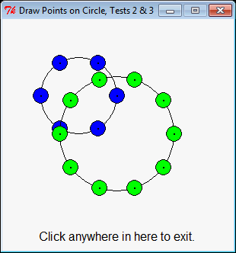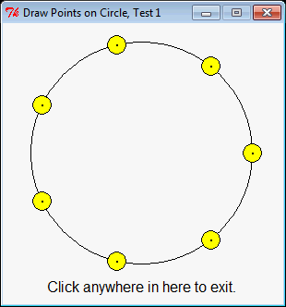Your tests can draw whatever you decide are good tests. These are just examples.

Examples of the figures that your ***draw_points_on_circle*** function should draw: 7 points (yellow dots) on one window, then 6 points (blue dots) and 10 points (green dots) on another window.

Note the tiny black dots in the center of the colored dots; those are the points on the circumference of the circle, generated by the ***generate_points_on_circle*** function that you are given and must ***use (i.e., call).***

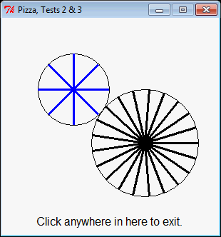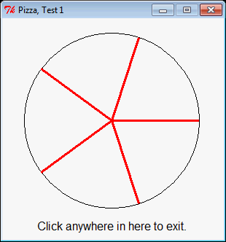**IMPORTANT:** You must ***CALL*** function ***generate_points_on_circle***, but you must **NOT copy** any of its code. This is an exercise about *using* functions that already exist, usually in a library.

Examples of the figures that your ***pizza*** function should draw: 5 slices (red lines) on one window, then 6 slices (blue lines) and 21 slices (black lines) on another window.

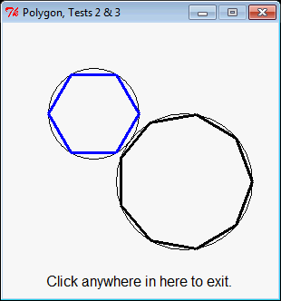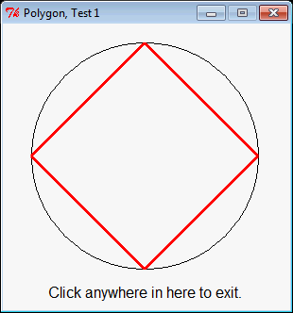

Examples of the figures that your ***polygon*** function should draw: 4 segments (red lines) on one window, then 6 segments (blue lines) and 9 segments (black lines) on another window.

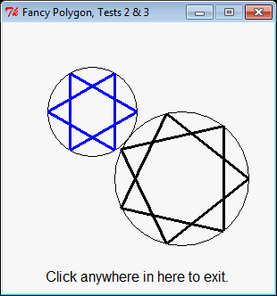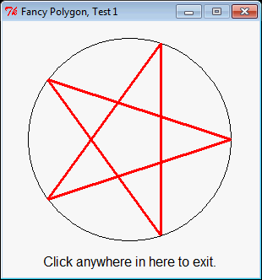

Examples of the figures that your ***fancy_polygon*** function should draw. This page features hops of length 2 (with 5, 6 and 7 segments, respectively).

The next page features longer hops:

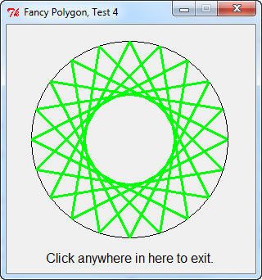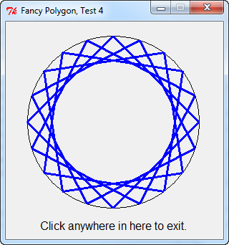

Here is ***fancy_polygon*** with 20 segments and hops of length 5, then 20 segments again with hops of length 7, and finally 30 segments with hops of length 15.

