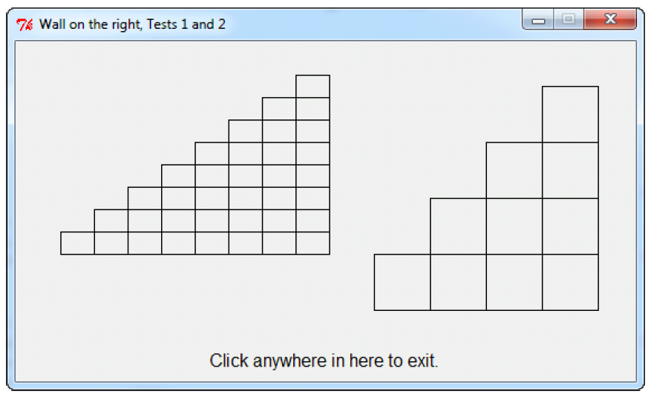

In the picture below:

* The left wall was generated by **draw_wall_on_right(rectangle1, 8, window)**
* The right wall was generated by **draw_wall_on_right(rectangle2, 4, window)**

where

* **rectangle1** is **zg.Rectangle(zg.Point(250, 30), 30, 20)**
* **rectangle2** is **zg.Rectangle(zg.Point(470, 40), 50, 50)**
* **window** is the same **550 x 300** window in each call.