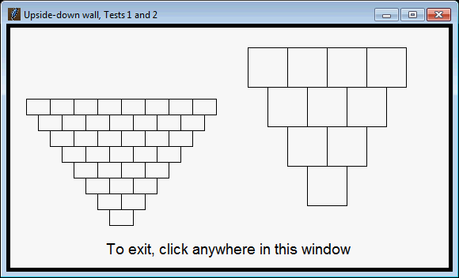

In the picture below:

* The left wall was generated by **draw_upside_down_wall(rectangle1, 8, window)**
* The right wall was generated by **draw_upside_down_wall(rectangle2, 4, window)**

where

* **rectangle1** is **rg.Rectangle(rg.Point(140, 240), 30, 20)**
* **rectangle2** is **rg.Rectangle(rg.Point(400, 200), 50, 50)**
* **window** is the same **550 x 300** window in each call.