Details

**MongoDB**

– [C.Sunter@newcastle.ac.uk](mailto:C.Sunter@newcastle.ac.uk) Jazzcat2

* b80273436 Primeval#2007
* admin adminpassword

Intro

Tool Used & Decisions

* Docker
* Web Stack - Vue.js
* Git bash
* VsCode
* - Node.js
* Mongo Db Atlas
* Mongoose
* - Post man – testing API’s
* eslint-config-airbnb
* babel
* express
* nodeman – resarts server for you
* axios
* Currpots

Implementations

* Front End
* Back End
* CI
* Server
* Version Control

Reflection & Evaluations

Setting VS Code to use git bash for the terminal

Setting up using npm init

Add dependencies to the package.JSON file so that npm install will install them

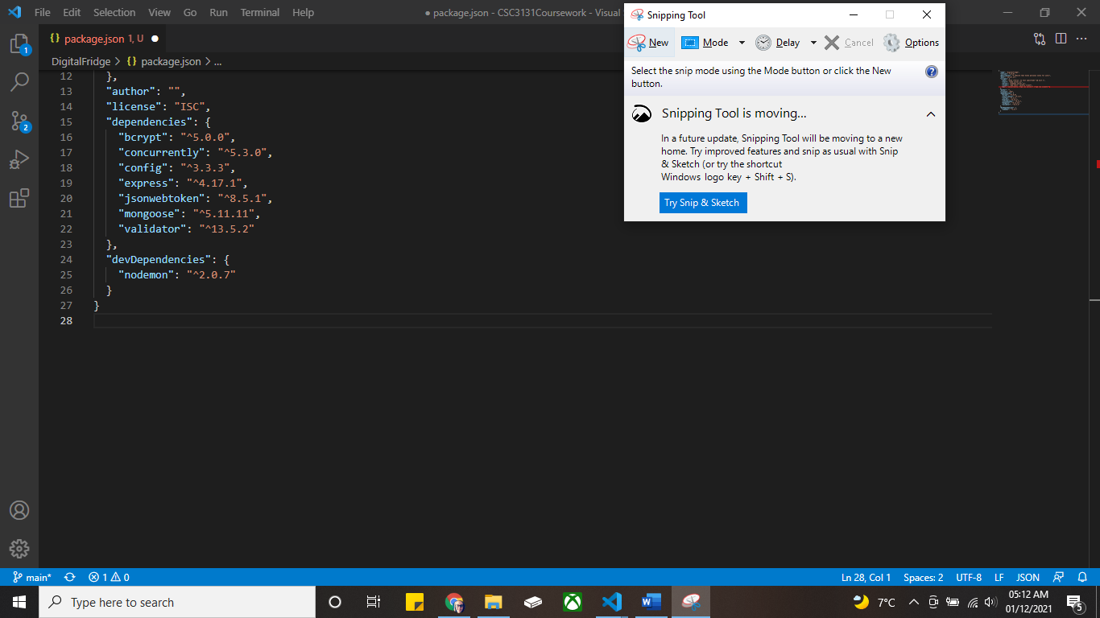

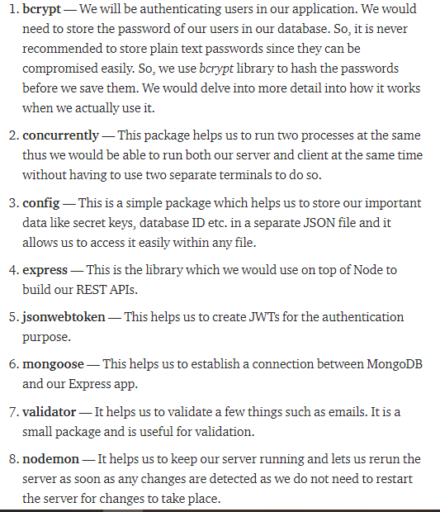

Choosing the cloud provider for mongo db

<https://www.smbnation.com/big-data-analytics/2255-5-reasons-why-azure-is-better-than-aws>

Installed node.js + Created vue project and file layout.

Created server.js file and tested using local host

Created MongoDB, whitelisted IP

and tried connecting to it. But got error so installed CURRpots to see what the ports were listening to. Didn’t see anything strange in the CURRPOTTS – realised that it was because I was listening twice within the code. Removed the second listen and all good

