September, 2019

(23/09/2019)

Macas - Teacher Perspective

Functionality: quiz preparation, quiz feedback (charts, word cloud,etc), management tools

Student Aspect:

Functionality: quiz response, quiz feedback

The meeting image

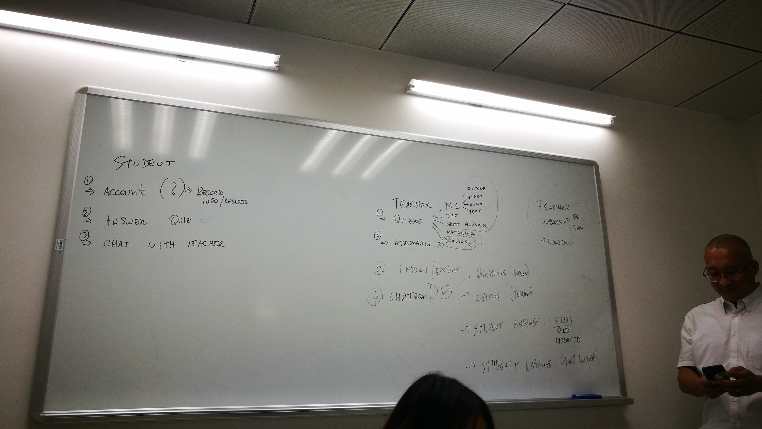

(30/09/2019)

Macas - Teacher Perspective

Database discussion - creation of tables and relationship

Student Aspect:

Database discussion - creation of tables and relationship

The meeting image

