Final Project
MSDS 6372: Chloe Barker and Jack Pehlke
2025-08-10

Data Preparation
heart_data <- read.csv("heart_2020_cleaned.csv", header = TRUE)
heart_data$HeartDisease <- factor(heart_data$HeartDisease, levels = c("No","Yes"), labels= c("No","Yes"))
heart_data$HeartDisease <- relevel(heart_data$HeartDisease, ref = "Yes") # "Yes" group the positive reference group
cat_vars <- c("Smoking", "AlcoholDrinking", "Stroke", "DiffWalking","Sex","AgeCategory", "Race", "Diabetic", "PhysicalActivity", "GenHealth","Asthma", "KidneyDisease", "SkinCancer")
num_vars <- c("BMI", "PhysicalHealth", "MentalHealth", "SleepTime","AgeCategory.num","GenHealth.num")
#Potential New Variables
genhealth_levels<- c("Poor", "Fair","Good", "Very good","Excellent")
age_levels<- c("18-24","25-29","30-34","35-39","40-44","45-49","50-54","55-59","60-64","65-69","70-74","75-79","80 or older")
heart_data <- heart_data %>%
mutate(GenHealth.num = as.numeric(factor(GenHealth, levels = genhealth_levels, ordered = TRUE)),
AgeCategory.num = as.numeric(factor(AgeCategory, levels = age_levels, ordered = TRUE)))
heart_data <- heart_data %>% mutate(across(all_of(cat_vars), as.factor))
heart_data <- heart_data %>% mutate(across(all_of(num_vars), as.numeric))
# Make new dataset
factor_cols <- sapply(heart_data,is.factor)# Identify factor columns
level_counts <- sapply(heart_data[,factor_cols, drop = FALSE], nlevels)# Count levels
ordered_factor_col_names <- names(level_counts)[order(level_counts)]# Order factor columns(by # of levels)
non_factor_col_names <- names(heart_data)[!factor_cols] # Get non-factor column names
new_col_order <- c(ordered_factor_col_names, non_factor_col_names) # Combine
data_sorted <- heart_data[,new_col_order] # Reorder the data frame columns
write.csv(data_sorted, "heart2020_data_sorted.csv",row.names = FALSE)

Data Setup
heart_data = read.csv("heart2020_data_sorted.csv",header=TRUE)
heart_data <- heart_data %>% mutate(across(all_of(cat_vars), as.factor))
heart_data <- heart_data %>% mutate(across(all_of(num_vars), as.numeric))

Overall Dataset
# Table of percent and number counts
heart = heart_data %>% group_by(HeartDisease) %>%
summarise(n = n()) %>%
mutate(percent=round(n/sum(n),4)*100)
heart
## # A tibble: 2 × 3
## HeartDisease n percent
## <chr> <int> <dbl>
## 1 No 292422 91.4
## 2 Yes 27373 8.56

Data Split
library(caret)
set.seed(4)
trainIndex <- createDataPartition(heart_data$HeartDisease, p = 0.8, list = FALSE) # to get balance of yes/no
trainHeart <- heart_data[trainIndex, ]
testHeart <- heart_data[-trainIndex, ]
write.csv(trainHeart, "trainHeart.csv",row.names = FALSE)
write.csv(testHeart, "testHeart.csv",row.names = FALSE)
trainHeart <- read.csv("trainHeart.csv")
testHeart <- read.csv("testHeart.csv")
trainHeart$HeartDisease <- factor(trainHeart$HeartDisease, levels = c("No","Yes"))
testHeart$HeartDisease <- factor(testHeart$HeartDisease, levels = c("No","Yes"))
table(trainHeart$HeartDisease)
##
## No Yes
## 233938 21899
table(testHeart$HeartDisease)
##
## No Yes
## 58484 5474

EDA: Training Dataset
# Table of percent and number counts
heartTrain = trainHeart %>% group_by(HeartDisease) %>%
summarise(n = n()) %>%
mutate(percent=round(n/sum(n),4)*100)
heartTrain
## # A tibble: 2 × 3
## HeartDisease n percent
## <fct> <int> <dbl>
## 1 No 233938 91.4
## 2 Yes 21899 8.56
# Percent of disease (yes/no)
ggplot(heartTrain,aes(x=HeartDisease,y=percent,colour=HeartDisease))+geom_bar(aes(fill=HeartDisease),show.legend=F,stat="identity")+ylab("Percentage") + scale_fill_manual(values = c("Yes" = "#CC0035", "No" = "#354CA1")) + theme_minimal(base_family = "Open Sans") + xlab("Heart Disease Status")
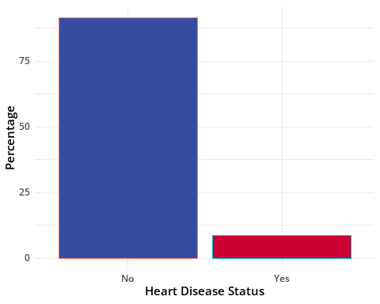
trainHeart$HeartDisease.num = as.numeric(ifelse(trainHeart$HeartDisease=="Yes",1,0))
numeric_data <- trainHeart %>% select(where(is.numeric))
numeric_data %>% filter(HeartDisease.num == "0") %>% summary()
## BMI PhysicalHealth MentalHealth SleepTime
## Min. :12.02 Min. : 0.000 Min. : 0.000 Min. : 1.000
## 1st Qu.:23.89 1st Qu.: 0.000 1st Qu.: 0.000 1st Qu.: 6.000
## Median :27.26 Median : 0.000 Median : 0.000 Median : 7.000
## Mean :28.22 Mean : 2.954 Mean : 3.822 Mean : 7.092
## 3rd Qu.:31.32 3rd Qu.: 1.000 3rd Qu.: 3.000 3rd Qu.: 8.000
## Max. :94.66 Max. :30.000 Max. :30.000 Max. :24.000
## GenHealth.num AgeCategory.num HeartDisease.num
## Min. :1.000 Min. : 1.000 Min. :0
## 1st Qu.:3.000 1st Qu.: 4.000 1st Qu.:0
## Median :4.000 Median : 8.000 Median :0
## Mean :3.673 Mean : 7.259 Mean :0
## 3rd Qu.:4.000 3rd Qu.:10.000 3rd Qu.:0
## Max. :5.000 Max. :13.000 Max. :0
numeric_data %>% filter(HeartDisease.num == "1") %>% summary()
## BMI PhysicalHealth MentalHealth SleepTime
## Min. :12.21 Min. : 0.000 Min. : 0.000 Min. : 1.000
## 1st Qu.:25.06 1st Qu.: 0.000 1st Qu.: 0.000 1st Qu.: 6.000
## Median :28.32 Median : 0.000 Median : 0.000 Median : 7.000
## Mean :29.38 Mean : 7.839 Mean : 4.665 Mean : 7.146
## 3rd Qu.:32.61 3rd Qu.:15.000 3rd Qu.: 4.000 3rd Qu.: 8.000
## Max. :83.33 Max. :30.000 Max. :30.000 Max. :24.000
## GenHealth.num AgeCategory.num HeartDisease.num
## Min. :1.000 Min. : 1.00 Min. :1
## 1st Qu.:2.000 1st Qu.: 9.00 1st Qu.:1
## Median :3.000 Median :11.00 Median :1
## Mean :2.762 Mean :10.23 Mean :1
## 3rd Qu.:4.000 3rd Qu.:12.00 3rd Qu.:1
## Max. :5.000 Max. :13.00 Max. :1

Correlation Plot and Table (Numeric Only)
colors <- colorRampPalette(c("#354CA1", "white", "#CC0035"))(200)
# Correlation Table
numeric_data %>%
cor() %>%
round(2)
## BMI PhysicalHealth MentalHealth SleepTime GenHealth.num
## BMI 1.00 0.11 0.06 -0.05 -0.23
## PhysicalHealth 0.11 1.00 0.29 -0.06 -0.48
## MentalHealth 0.06 0.29 1.00 -0.12 -0.24
## SleepTime -0.05 -0.06 -0.12 1.00 0.06
## GenHealth.num -0.23 -0.48 -0.24 0.06 1.00
## AgeCategory.num 0.00 0.11 -0.16 0.10 -0.19
## HeartDisease.num 0.05 0.17 0.03 0.01 -0.24
## AgeCategory.num HeartDisease.num
## BMI 0.00 0.05
## PhysicalHealth 0.11 0.17
## MentalHealth -0.16 0.03
## SleepTime 0.10 0.01
## GenHealth.num -0.19 -0.24
## AgeCategory.num 1.00 0.23
## HeartDisease.num 0.23 1.00
# Correlation Plot
numeric_data %>%
cor() %>%
corrplot(method = "color", type = "upper", col = colors, tl.col = "black", addCoef.col = "black",number.cex = 0.9)
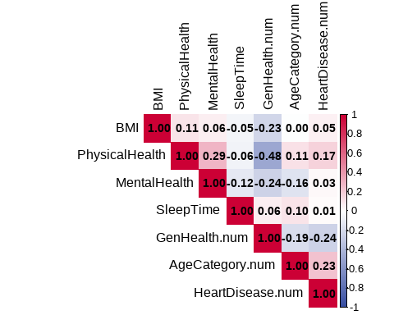

Scatterplot Matrix of Numeric Variables
numeric_data$HeartDisease = trainHeart$HeartDisease
numeric_data$HeartDisease <- factor(numeric_data$HeartDisease,levels = c("No","Yes"))
numeric_data$HeartDisease <- relevel(numeric_data$HeartDisease, ref = "Yes")
numeric_datapair = numeric_data %>% select(-HeartDisease.num)
smu_colors <- c("No" = "#354CA1", "Yes" = "#CC0035")
p <- ggpairs(numeric_datapair,mapping = aes(colour = HeartDisease),lower = list(continuous = wrap("points", alpha = 0.3, size = 0.1)))
p + scale_color_manual(values = smu_colors) + scale_fill_manual(values = smu_colors)

Box Plots of Numeric Predictors
smu2 <- c("Yes"="#CC0035","No"="#B0B7C3")
a = trainHeart %>% ggplot(aes(x=BMI, y=HeartDisease, fill = HeartDisease)) + geom_boxplot(show.legend = FALSE)+ scale_fill_manual(values = smu2) + theme_minimal(base_family = "Open Sans")
b = trainHeart %>% ggplot(aes(x=SleepTime, y=HeartDisease, fill = HeartDisease)) + geom_boxplot(show.legend = FALSE)+ scale_fill_manual(values = smu2)+theme_minimal(base_family = "Open Sans")
c = trainHeart %>% ggplot(aes(x=PhysicalHealth, y=HeartDisease, fill = HeartDisease)) + geom_boxplot(show.legend = FALSE)+ scale_fill_manual(values = smu2)+theme_minimal(base_family = "Open Sans")
d = trainHeart %>% ggplot(aes(x=MentalHealth, y=HeartDisease, fill = HeartDisease)) + geom_boxplot(show.legend = FALSE)+ scale_fill_manual(values = smu2)+ theme_minimal(base_family = "Open Sans")
e = trainHeart %>% ggplot(aes(x=AgeCategory.num, y=HeartDisease, fill = HeartDisease)) + geom_boxplot(show.legend = FALSE)+ scale_fill_manual(values = smu2)+theme_minimal(base_family = "Open Sans")
f = trainHeart %>% ggplot(aes(x=GenHealth.num, y=HeartDisease, fill = HeartDisease)) + geom_boxplot(show.legend = FALSE)+ scale_fill_manual(values = smu2)+theme_minimal(base_family = "Open Sans")
# More visual differences
(e|a)/(c|f)
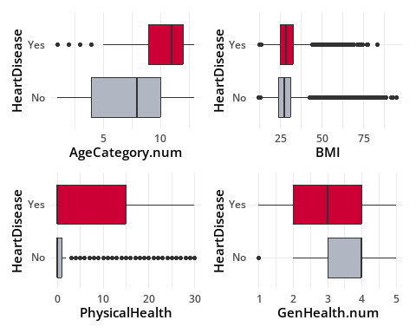
# Less visual differences
(d|b)
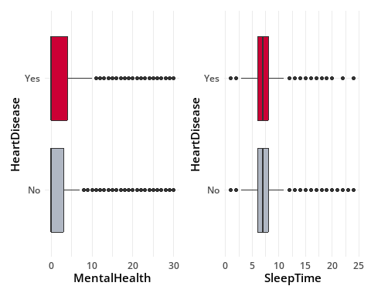

Variables with more than two levels: EDA
# g1: AgeCategory
g1<-trainHeart %>%
group_by(AgeCategory,HeartDisease) %>%
summarise(cnt=n()) %>%
mutate(perc=round(cnt/sum(cnt),4))%>%
arrange(desc(perc))
g1
## # A tibble: 26 × 4
## # Groups: AgeCategory [13]
## AgeCategory HeartDisease cnt perc
## <chr> <fct> <int> <dbl>
## 1 18-24 No 16665 0.994
## 2 25-29 No 13504 0.992
## 3 30-34 No 14858 0.988
## 4 35-39 No 16293 0.986
## 5 40-44 No 16451 0.977
## 6 45-49 No 16789 0.966
## 7 50-54 No 19074 0.945
## 8 55-59 No 22024 0.926
## 9 60-64 No 24290 0.901
## 10 65-69 No 24181 0.880
## # ℹ 16 more rows
# g2: GenHealth
g2<-trainHeart %>%
group_by(GenHealth,HeartDisease) %>%
summarise(cnt=n()) %>%
mutate(perc=round(cnt/sum(cnt),4))%>%
arrange(desc(perc))
g2
## # A tibble: 10 × 4
## # Groups: GenHealth [5]
## GenHealth HeartDisease cnt perc
## <chr> <fct> <int> <dbl>
## 1 Excellent No 52294 0.978
## 2 Very good No 86841 0.953
## 3 Good No 66793 0.898
## 4 Fair No 22052 0.795
## 5 Poor No 5958 0.658
## 6 Poor Yes 3095 0.342
## 7 Fair Yes 5702 0.205
## 8 Good Yes 7618 0.102
## 9 Very good Yes 4281 0.047
## 10 Excellent Yes 1203 0.0225
# g3: Diabetic
g3<-trainHeart %>%
group_by(Diabetic,HeartDisease) %>%
summarise(cnt=n()) %>%
mutate(perc=round(cnt/sum(cnt),4))%>%
arrange(desc(perc))
g3
## # A tibble: 8 × 4
## # Groups: Diabetic [4]
## Diabetic HeartDisease cnt perc
## <chr> <fct> <int> <dbl>
## 1 Yes (during pregnancy) No 1974 0.954
## 2 No No 201753 0.935
## 3 No, borderline diabetes No 4735 0.884
## 4 Yes No 25476 0.782
## 5 Yes Yes 7116 0.218
## 6 No, borderline diabetes Yes 623 0.116
## 7 No Yes 14064 0.0652
## 8 Yes (during pregnancy) Yes 96 0.0464
# g4: Race
g4 <- trainHeart %>%
group_by(Race, HeartDisease) %>%
summarise(cnt = n()) %>%
mutate(perc = round(cnt / sum(cnt), 4)) %>%
arrange(desc(perc))
g4
## # A tibble: 12 × 4
## # Groups: Race [6]
## Race HeartDisease cnt perc
## <chr> <fct> <int> <dbl>
## 1 Asian No 6229 0.968
## 2 Hispanic No 20836 0.947
## 3 Black No 16976 0.924
## 4 Other No 8044 0.918
## 5 White No 178135 0.908
## 6 American Indian/Alaskan Native No 3718 0.894
## 7 American Indian/Alaskan Native Yes 440 0.106
## 8 White Yes 17993 0.0917
## 9 Other Yes 715 0.0816
## 10 Black Yes 1388 0.0756
## 11 Hispanic Yes 1156 0.0526
## 12 Asian Yes 207 0.0322

Proportion plots grouped by HeartDisease
g1g <- ggplot(g1[c(14:26),], aes(x = reorder(AgeCategory, -perc), y = perc, fill = AgeCategory)) +
geom_bar(stat = "identity", show.legend = FALSE) + ylab("Proportion of Disease") +xlab("Age Category")+
theme_minimal(base_family = "Open Sans") + theme(axis.text.x = element_text(angle = 45, hjust = 1))
g2g <- ggplot(g2[c(6:10),], aes(x = reorder(GenHealth, -perc), y = perc, fill = GenHealth)) +
geom_bar(stat = "identity", show.legend = FALSE) + ylab("Proportion of Disease") + xlab("General Health") + theme_minimal(base_family = "Open Sans")
g3g <- ggplot(g3[c(5:8),], aes(x = reorder(Diabetic, -perc), y = perc, fill = Diabetic)) +
geom_bar(stat = "identity", show.legend = FALSE) + ylab("Proportion of Disease") + xlab("Diabetic") +
theme_minimal(base_family = "Open Sans") + theme(axis.text.x = element_text(angle = 45, hjust = 1))
g4g <- ggplot(g4[c(7:12),], aes(x = reorder(Race, -perc), y = perc, fill = Race)) +
geom_bar(stat = "identity", show.legend = FALSE) +ylab("Proportion of Disease") + xlab("Race") +
theme_minimal(base_family = "Open Sans") + theme(axis.text.x = element_text(angle = 45, hjust = 1))
(g1g | g2g) / (g3g | g4g)
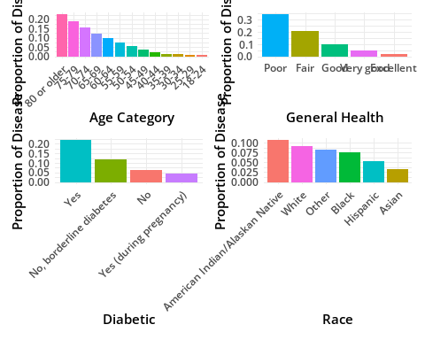

Binary Categorical Predictors EDA
# b1: Smoking
b1<-trainHeart %>%
group_by(Smoking,HeartDisease) %>%
summarise(cnt=n()) %>%
mutate(perc=round(cnt/sum(cnt),4))%>%
arrange(desc(perc))
b1
## # A tibble: 4 × 4
## # Groups: Smoking [2]
## Smoking HeartDisease cnt perc
## <chr> <fct> <int> <dbl>
## 1 No No 141246 0.939
## 2 Yes No 92692 0.879
## 3 Yes Yes 12759 0.121
## 4 No Yes 9140 0.0608
# b2:AlcoholDrinking
b2<-trainHeart %>%
group_by(AlcoholDrinking,HeartDisease) %>%
summarise(cnt=n()) %>%
mutate(perc=round(cnt/sum(cnt),4))%>%
arrange(desc(perc))
b2
## # A tibble: 4 × 4
## # Groups: AlcoholDrinking [2]
## AlcoholDrinking HeartDisease cnt perc
## <chr> <fct> <int> <dbl>
## 1 Yes No 16503 0.947
## 2 No No 217435 0.912
## 3 No Yes 20970 0.088
## 4 Yes Yes 929 0.0533
# b3: Stroke
b3 <- trainHeart %>%
group_by(Stroke, HeartDisease) %>%
summarise(cnt = n()) %>%
mutate(perc = round(cnt / sum(cnt), 4)) %>%
arrange(desc(perc))
b3
## # A tibble: 4 × 4
## # Groups: Stroke [2]
## Stroke HeartDisease cnt perc
## <chr> <fct> <int> <dbl>
## 1 No No 227788 0.925
## 2 Yes No 6150 0.636
## 3 Yes Yes 3523 0.364
## 4 No Yes 18376 0.0746
# b4: DiffWalking
b4 <- trainHeart %>%
group_by(DiffWalking, HeartDisease) %>%
summarise(cnt = n()) %>%
mutate(perc = round(cnt / sum(cnt), 4)) %>%
arrange(desc(perc))
b4
## # A tibble: 4 × 4
## # Groups: DiffWalking [2]
## DiffWalking HeartDisease cnt perc
## <chr> <fct> <int> <dbl>
## 1 No No 206433 0.937
## 2 Yes No 27505 0.774
## 3 Yes Yes 8006 0.226
## 4 No Yes 13893 0.0631
# b5: Sex
b5 <- trainHeart %>%
group_by(Sex, HeartDisease) %>%
summarise(cnt = n()) %>%
mutate(perc = round(cnt / sum(cnt), 4)) %>%
arrange(desc(perc))
b5
## # A tibble: 4 × 4
## # Groups: Sex [2]
## Sex HeartDisease cnt perc
## <chr> <fct> <int> <dbl>
## 1 Female No 125326 0.933
## 2 Male No 108612 0.894
## 3 Male Yes 12889 0.106
## 4 Female Yes 9010 0.0671
# b6: PhysicalActivity
b6 <- trainHeart %>%
group_by(PhysicalActivity, HeartDisease) %>%
summarise(cnt = n()) %>%
mutate(perc = round(cnt / sum(cnt), 4)) %>%
arrange(desc(perc))
b6
## # A tibble: 4 × 4
## # Groups: PhysicalActivity [2]
## PhysicalActivity HeartDisease cnt perc
## <chr> <fct> <int> <dbl>
## 1 Yes No 184380 0.930
## 2 No No 49558 0.862
## 3 No Yes 7935 0.138
## 4 Yes Yes 13964 0.0704
# b7: Asthma
b7 <- trainHeart %>%
group_by(Asthma, HeartDisease) %>%
summarise(cnt = n()) %>%
mutate(perc = round(cnt / sum(cnt), 4)) %>%
arrange(desc(perc))
b7
## # A tibble: 4 × 4
## # Groups: Asthma [2]
## Asthma HeartDisease cnt perc
## <chr> <fct> <int> <dbl>
## 1 No No 203558 0.919
## 2 Yes No 30380 0.886
## 3 Yes Yes 3921 0.114
## 4 No Yes 17978 0.0812
# b8: KidneyDisease
b8 <- trainHeart %>%
group_by(KidneyDisease, HeartDisease) %>%
summarise(cnt = n()) %>%
mutate(perc = round(cnt / sum(cnt), 4)) %>%
arrange(desc(perc))
b8
## # A tibble: 4 × 4
## # Groups: KidneyDisease [2]
## KidneyDisease HeartDisease cnt perc
## <chr> <fct> <int> <dbl>
## 1 No No 227313 0.922
## 2 Yes No 6625 0.705
## 3 Yes Yes 2777 0.295
## 4 No Yes 19122 0.0776
# b9: SkinCancer
b9 <- trainHeart %>%
group_by(SkinCancer, HeartDisease) %>%
summarise(cnt = n()) %>%
mutate(perc = round(cnt / sum(cnt), 4)) %>%
arrange(desc(perc))
b9
## # A tibble: 4 × 4
## # Groups: SkinCancer [2]
## SkinCancer HeartDisease cnt perc
## <chr> <fct> <int> <dbl>
## 1 No No 214127 0.923
## 2 Yes No 19811 0.833
## 3 Yes Yes 3964 0.167
## 4 No Yes 17935 0.0773

Proportion plots grouped by HeartDisease
b1b <- ggplot(b1[c(3:4),], aes(x = reorder(Smoking, -perc), y = perc, fill = Smoking)) +
geom_bar(stat = "identity", show.legend = FALSE) + scale_fill_manual(values = smu2) +
labs(x = "Smoking Status", y = "Proportion with Heart Disease") + theme_minimal(base_family = "Open Sans")
b2b <- ggplot(b2[c(3:4),], aes(x = reorder(AlcoholDrinking, -perc), y = perc, fill = AlcoholDrinking)) + geom_bar(stat = "identity", show.legend = FALSE)+ scale_fill_manual(values = smu2) + labs(x = "Alcohol Drinking", y = "Proportion with Heart Disease") + theme_minimal(base_family = "Open Sans")
b3b <- ggplot(b3[c(3:4),], aes(x = reorder(Stroke, -perc), y = perc, fill = Stroke)) + geom_bar(stat = "identity", show.legend = FALSE) + scale_fill_manual(values = smu2) + labs(x = "Stroke", y = "Proportion with Heart Disease") + theme_minimal(base_family = "Open Sans")
b4b <- ggplot(b4[c(3:4),], aes(x = reorder(DiffWalking, -perc), y = perc, fill = DiffWalking)) + geom_bar(stat = "identity", show.legend = FALSE) + scale_fill_manual(values = smu2) + labs(x = "Difficulty Walking", y = "Proportion with Heart Disease") + theme_minimal(base_family = "Open Sans")
b5b <- ggplot(b5[c(3:4),], aes(x = reorder(Sex, -perc), y = perc, fill = Sex)) + geom_bar(stat = "identity", show.legend = FALSE) + labs(x = "Sex", y = "Proportion with Heart Disease") + theme_minimal(base_family = "Open Sans")
b6b <- ggplot(b6[c(3:4),], aes(x = reorder(PhysicalActivity, -perc), y = perc, fill = PhysicalActivity)) + geom_bar(stat = "identity", show.legend = FALSE) + scale_fill_manual(values = smu2) + labs(x = "Physical Activity", y = "Proportion with Heart Disease") + theme_minimal(base_family = "Open Sans")
b7b <- ggplot(b7[c(3:4),], aes(x = reorder(Asthma, -perc), y = perc, fill = Asthma)) + geom_bar(stat = "identity", show.legend = FALSE) + scale_fill_manual(values = smu2) + labs(x = "Asthma", y = "Proportion with Heart Disease") + theme_minimal(base_family = "Open Sans")
b8b <- ggplot(b8[c(3:4),], aes(x = reorder(KidneyDisease, -perc), y = perc, fill = KidneyDisease)) + geom_bar(stat = "identity", show.legend = FALSE) + scale_fill_manual(values = smu2) + labs(x = "Kidney Disease", y = "Proportion with Heart Disease") + theme_minimal(base_family = "Open Sans")
b9b <- ggplot(b9[c(3:4),], aes(x = reorder(SkinCancer, -perc), y = perc, fill = SkinCancer)) +
geom_bar(stat = "identity", show.legend = FALSE) + scale_fill_manual(values = smu2) +
labs(x = "Skin Cancer", y = "Proportion with Heart Disease") + theme_minimal(base_family = "Open Sans")
(b1b | b7b |b9b) / (b3b | b4b| b8b)
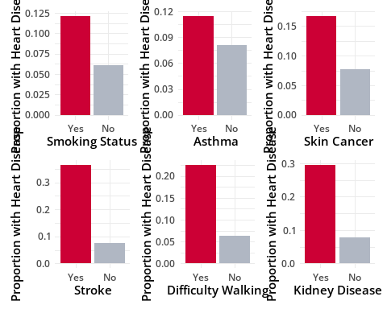
(b6b|b2b)
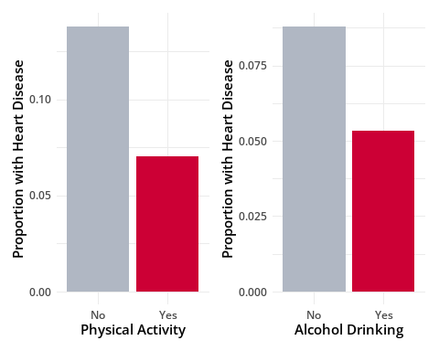
b5b
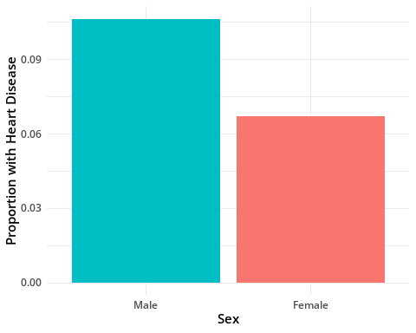

Categorical Variables: Heart Disease Proportions
cat_vars <- c("Smoking", "AlcoholDrinking", "Stroke", "DiffWalking","Sex","AgeCategory", "Race", "Diabetic", "PhysicalActivity", "GenHealth","Asthma", "KidneyDisease", "SkinCancer")
library(purrr)
cat_var_stats <- map_dfr(cat_vars, function(v) {
prop <- trainHeart %>% group_by(.data[[v]]) %>%
summarize(p_heart = mean(HeartDisease == "Yes", na.rm = TRUE)) %>%
summarize(max_diff = max(p_heart) - min(p_heart))
tibble(var = v, max_diff = prop$max_diff)
})
cat_var_stats %>% arrange(desc(max_diff)) %>%
slice_max(max_diff, n = 15) %>%
mutate(var = fct_reorder(var, max_diff)) %>%
ggplot(aes(max_diff, var)) +geom_col(fill = "#CC0035") + labs(x = "Max Difference in % Heart Disease (Yes)", y = "Variable", title = "Categorical Predictors with Strongest Variation") + theme_minimal(base_family = "Open Sans",base_size = 12)
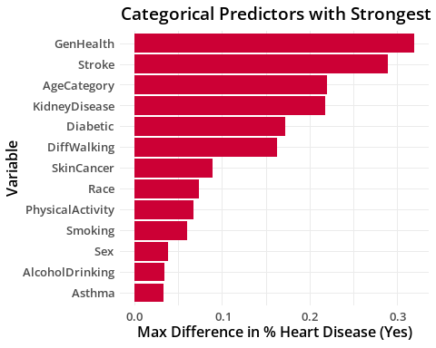

Scatterplot Matrix
head(trainHeart)
## HeartDisease Smoking AlcoholDrinking Stroke DiffWalking Sex
## 1 No Yes No No No Female
## 2 No No No Yes No Female
## 3 No Yes No No No Male
## 4 No No No No No Female
## 5 No No No No Yes Female
## 6 No No No No No Female
## PhysicalActivity Asthma KidneyDisease SkinCancer Diabetic GenHealth Race
## 1 Yes Yes No Yes Yes Very good White
## 2 Yes No No No No Very good White
## 3 Yes Yes No No Yes Fair White
## 4 No No No Yes No Good White
## 5 Yes No No No No Very good White
## 6 Yes Yes No Yes No Fair White
## AgeCategory BMI PhysicalHealth MentalHealth SleepTime GenHealth.num
## 1 55-59 16.60 3 30 5 4
## 2 80 or older 20.34 0 0 7 4
## 3 65-69 26.58 20 30 8 2
## 4 75-79 24.21 0 0 6 3
## 5 40-44 23.71 28 0 8 4
## 6 70-74 21.63 15 0 4 2
## AgeCategory.num HeartDisease.num
## 1 8 0
## 2 13 0
## 3 10 0
## 4 12 0
## 5 5 0
## 6 11 0
num.trainHeart = trainHeart[c(1,15:18)]
head(num.trainHeart)
## HeartDisease BMI PhysicalHealth MentalHealth SleepTime
## 1 No 16.60 3 30 5
## 2 No 20.34 0 0 7
## 3 No 26.58 20 30 8
## 4 No 24.21 0 0 6
## 5 No 23.71 28 0 8
## 6 No 21.63 15 0 4
num.trainHeart$HeartDisease <- factor(num.trainHeart$HeartDisease, levels = c("No","Yes"))
smu_colors <- c("No" = "#354CA1", "Yes" = "#CC0035")
p <- ggpairs(num.trainHeart,mapping = aes(color = HeartDisease, fill = HeartDisease),lower = list(continuous = wrap("points", alpha = 0.3, size = 0.1)),diag = list(continuous = wrap("densityDiag", alpha = 0.4))) + theme(axis.text.x = element_text(size = 4), axis.text.y = element_text(size = 5))
p + scale_color_manual(values = smu_colors) + scale_fill_manual(values = smu_colors)
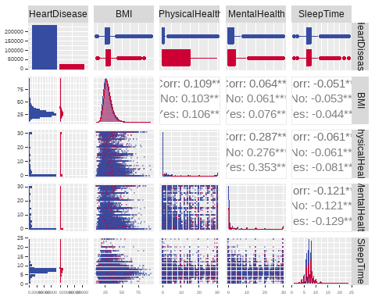

OBJECTIVE 1: Objective 1: Display the ability to perform EDA and build a logistic regression model for interpretation purposes using the training data. Perform your multiple logistic regression analysis and provide interpretation of the regression coefficients and confidence intervals for relevant predictor variables.

Logistic Regression Model
trainHeart$HeartDisease <- factor(trainHeart$HeartDisease, levels = c("No","Yes"))
logistic <- glm(HeartDisease~PhysicalHealth + BMI + AgeCategory + GenHealth + Smoking + AlcoholDrinking + Stroke + DiffWalking + Sex + Race +Diabetic + PhysicalActivity + Asthma + KidneyDisease + SkinCancer + MentalHealth + SleepTime,data=trainHeart,family="binomial")
summary(logistic)
##
## Call:
## glm(formula = HeartDisease ~ PhysicalHealth + BMI + AgeCategory +
## GenHealth + Smoking + AlcoholDrinking + Stroke + DiffWalking +
## Sex + Race + Diabetic + PhysicalActivity + Asthma + KidneyDisease +
## SkinCancer + MentalHealth + SleepTime, family = "binomial",
## data = trainHeart)
##
## Coefficients:
## Estimate Std. Error z value Pr(>|z|)
## (Intercept) -6.2881623 0.1286529 -48.877 < 2e-16 ***
## PhysicalHealth 0.0032759 0.0009625 3.404 0.000665 ***
## BMI 0.0079718 0.0012810 6.223 4.88e-10 ***
## AgeCategory25-29 0.1553017 0.1383778 1.122 0.261734
## AgeCategory30-34 0.4808528 0.1248188 3.852 0.000117 ***
## AgeCategory35-39 0.5775600 0.1197558 4.823 1.42e-06 ***
## AgeCategory40-44 0.9949860 0.1123549 8.856 < 2e-16 ***
## AgeCategory45-49 1.3355719 0.1083289 12.329 < 2e-16 ***
## AgeCategory50-54 1.7571550 0.1045690 16.804 < 2e-16 ***
## AgeCategory55-59 1.9742682 0.1029841 19.171 < 2e-16 ***
## AgeCategory60-64 2.2439788 0.1020458 21.990 < 2e-16 ***
## AgeCategory65-69 2.4895451 0.1017218 24.474 < 2e-16 ***
## AgeCategory70-74 2.7752330 0.1016643 27.298 < 2e-16 ***
## AgeCategory75-79 2.9673379 0.1022894 29.009 < 2e-16 ***
## AgeCategory80 or older 3.2306427 0.1019929 31.675 < 2e-16 ***
## GenHealthFair 1.5373408 0.0366906 41.900 < 2e-16 ***
## GenHealthGood 1.0445423 0.0330597 31.596 < 2e-16 ***
## GenHealthPoor 1.9139797 0.0456757 41.904 < 2e-16 ***
## GenHealthVery good 0.4652281 0.0339338 13.710 < 2e-16 ***
## SmokingYes 0.3395607 0.0160667 21.134 < 2e-16 ***
## AlcoholDrinkingYes -0.2080333 0.0372214 -5.589 2.28e-08 ***
## StrokeYes 1.0463656 0.0252801 41.391 < 2e-16 ***
## DiffWalkingYes 0.2005539 0.0202855 9.887 < 2e-16 ***
## SexMale 0.7092266 0.0162828 43.557 < 2e-16 ***
## RaceAsian -0.5806232 0.0944774 -6.146 7.96e-10 ***
## RaceBlack -0.3777098 0.0643032 -5.874 4.26e-09 ***
## RaceHispanic -0.2825286 0.0655127 -4.313 1.61e-05 ***
## RaceOther -0.0748928 0.0712224 -1.052 0.293013
## RaceWhite -0.1071057 0.0574076 -1.866 0.062082 .
## DiabeticNo, borderline diabetes 0.1209395 0.0471183 2.567 0.010267 *
## DiabeticYes 0.4652009 0.0187289 24.839 < 2e-16 ***
## DiabeticYes (during pregnancy) 0.2002676 0.1125688 1.779 0.075229 .
## PhysicalActivityYes 0.0145538 0.0179435 0.811 0.417313
## AsthmaYes 0.2695476 0.0215306 12.519 < 2e-16 ***
## KidneyDiseaseYes 0.5761332 0.0272599 21.135 < 2e-16 ***
## SkinCancerYes 0.1103143 0.0218634 5.046 4.52e-07 ***
## MentalHealth 0.0052765 0.0009863 5.350 8.81e-08 ***
## SleepTime -0.0201204 0.0048546 -4.145 3.40e-05 ***
## ---
## Signif. codes: 0 '***' 0.001 '**' 0.01 '*' 0.05 '.' 0.1 ' ' 1
##
## (Dispersion parameter for binomial family taken to be 1)
##
## Null deviance: 149527 on 255836 degrees of freedom
## Residual deviance: 116112 on 255799 degrees of freedom
## AIC: 116188
##
## Number of Fisher Scoring iterations: 7
AIC(logistic) # AIC: 116151
## [1] 116188.4
simple <- glm(HeartDisease~PhysicalHealth + BMI + AgeCategory + GenHealth + Smoking + AlcoholDrinking + Stroke + DiffWalking + Sex + Race +Diabetic + Asthma + KidneyDisease + SkinCancer + MentalHealth + SleepTime,data=trainHeart,family="binomial")
#summary(simple)
AIC(simple) # AIC: 115989.1
## [1] 116187.1
# Estimate for odds ratio
exp(cbind("Odds ratio" = coef(simple), confint.default(simple, level = 0.95)))
## Odds ratio 2.5 % 97.5 %
## (Intercept) 0.00188847 0.001472072 0.002422652
## PhysicalHealth 1.00323286 1.001345858 1.005123414
## BMI 1.00790935 1.005392175 1.010432829
## AgeCategory25-29 1.16827400 0.890755716 1.532254149
## AgeCategory30-34 1.61795215 1.266838260 2.066379934
## AgeCategory35-39 1.78200060 1.409199598 2.253425368
## AgeCategory40-44 2.70467587 2.170098939 3.370939192
## AgeCategory45-49 3.80145425 3.074262195 4.700657752
## AgeCategory50-54 5.79317070 4.719639271 7.110888116
## AgeCategory55-59 7.19809414 5.882458737 8.807976660
## AgeCategory60-64 9.42596025 7.717313705 11.512908516
## AgeCategory65-69 12.04992894 9.871898115 14.708497368
## AgeCategory70-74 16.03131241 13.135171301 19.566016442
## AgeCategory75-79 19.41869619 15.891296238 23.729075096
## AgeCategory80 or older 25.24731772 20.673921671 30.832420783
## GenHealthFair 4.64144943 4.320334856 4.986431262
## GenHealthGood 2.83836705 2.660490521 3.028136145
## GenHealthPoor 6.75742979 6.181042272 7.387565930
## GenHealthVery good 1.59196261 1.489530953 1.701438262
## SmokingYes 1.40345380 1.359996443 1.448299789
## AlcoholDrinkingYes 0.81206649 0.754932870 0.873524004
## StrokeYes 2.84702532 2.709401041 2.991640230
## DiffWalkingYes 1.21908572 1.172087349 1.267968634
## SexMale 2.03382108 1.970022719 2.099685516
## RaceAsian 0.55968253 0.465079434 0.673529114
## RaceBlack 0.68546398 0.604297144 0.777532835
## RaceHispanic 0.75334337 0.662574517 0.856547024
## RaceOther 0.92826407 0.807327326 1.067317016
## RaceWhite 0.89864701 0.803017567 1.005664741
## DiabeticNo, borderline diabetes 1.12885121 1.029271591 1.238064925
## DiabeticYes 1.59171552 1.534365995 1.651208582
## DiabeticYes (during pregnancy) 1.22222547 0.980238954 1.523949938
## AsthmaYes 1.30958472 1.255472995 1.366028690
## KidneyDiseaseYes 1.77867102 1.686140258 1.876279607
## SkinCancerYes 1.11734308 1.070504403 1.166231121
## MentalHealth 1.00526856 1.003327906 1.007212960
## SleepTime 0.98000511 0.970727693 0.989371199
#1 Unit increase odds ratio:
exp(0.0090482)
## [1] 1.009089
# VIF
library(car)
vif(simple)
## GVIF Df GVIF^(1/(2*Df))
## PhysicalHealth 1.798021 1 1.340903
## BMI 1.184161 1 1.088191
## AgeCategory 1.331403 12 1.011998
## GenHealth 1.944538 4 1.086681
## Smoking 1.053077 1 1.026195
## AlcoholDrinking 1.021417 1 1.010652
## Stroke 1.035732 1 1.017709
## DiffWalking 1.424655 1 1.193589
## Sex 1.076304 1 1.037451
## Race 1.098786 5 1.009465
## Diabetic 1.163092 3 1.025500
## Asthma 1.061801 1 1.030437
## KidneyDisease 1.050610 1 1.024992
## SkinCancer 1.082121 1 1.040250
## MentalHealth 1.244566 1 1.115601
## SleepTime 1.046353 1 1.022914
# effect plots
library(sjPlot)
library(sjmisc)
a1=plot_model(simple,type="pred",terms=c("BMI[all]"))
a2=plot_model(simple,type="pred",terms=c("MentalHealth[all]"))
a3=plot_model(simple,type="pred",terms=c("PhysicalHealth[all]"))
a4=plot_model(simple,type="pred",terms=c("SleepTime[all]"))
(a1|a2)/(a3|a4)
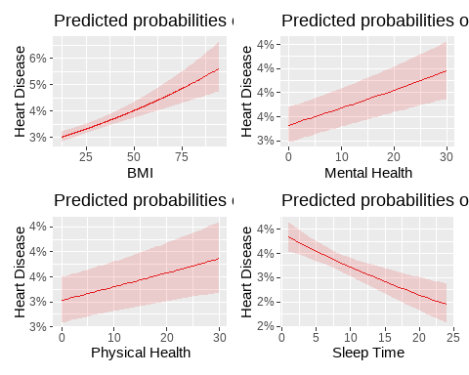

Objective 2: Build 4-5 additional classification models to compare to your model in objective 1. The goal of this objective is to build a model where prediction performance is prioritized.

Scatter Plots for Interactions
ggplot(trainHeart,aes(x=BMI,y=AgeCategory.num, color = HeartDisease))+geom_point(alpha = 0.5, size = 0.3)+ scale_color_manual(values = smu_colors)
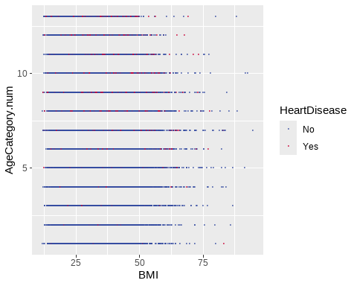
ggplot(trainHeart,aes(x=PhysicalHealth,y=MentalHealth, color = HeartDisease))+geom_point(alpha = 0.5, size = 0.3)+ scale_color_manual(values = smu_colors)
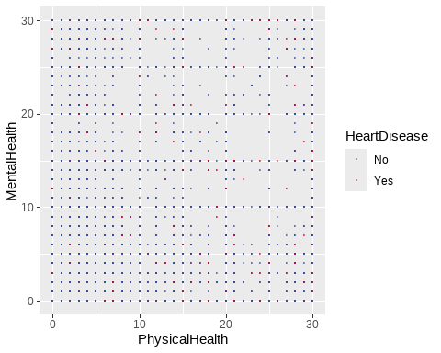
ggplot(trainHeart,aes(x=MentalHealth,y=SleepTime, color = HeartDisease))+geom_point(alpha = 0.5, size = 0.3)+ scale_color_manual(values = smu_colors)
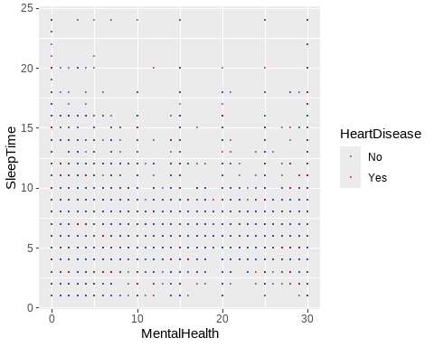
ggplot(trainHeart,aes(x=SleepTime,y=PhysicalHealth, color = HeartDisease))+geom_point(alpha = 0.5, size = 0.3)+ scale_color_manual(values = smu_colors)
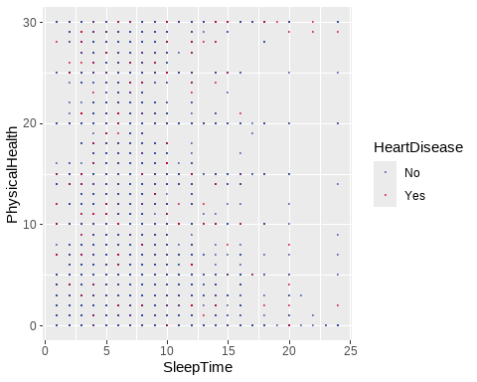

Feature Selection for Non-Additive Model
fitControl<-trainControl(method="repeatedcv",number=5,repeats=1,classProbs=TRUE, summaryFunction=mnLogLoss)
set.seed(1234)
# Feature Selection
logistic.fit1<-train(HeartDisease ~ GenHealth + AgeCategory + Sex + poly(BMI, 3) + poly(PhysicalHealth, 3) + poly(MentalHealth, 3) + poly(SleepTime, 3) + poly(BMI, 3):GenHealth + poly(PhysicalHealth, 3):GenHealth + poly(MentalHealth, 3):GenHealth + poly(SleepTime, 3):GenHealth + poly(BMI, 3):AgeCategory + poly(PhysicalHealth, 3):AgeCategory + poly(MentalHealth, 3):AgeCategory + poly(SleepTime, 3):AgeCategory + GenHealth:AgeCategory + GenHealth:Sex + AgeCategory:Sex + Stroke + KidneyDisease + Diabetic + DiffWalking + Smoking + AlcoholDrinking + Race + PhysicalActivity + Asthma + SkinCancer,data=trainHeart,
method="glmnet",
trControl=fitControl,
metric="logLoss")
coef(logistic.fit1$finalModel,logistic.fit1$finalModel$lambdaOpt)
## 302 x 1 sparse Matrix of class "dgCMatrix"
## s1
## (Intercept) -5.082381e+00
## GenHealthFair 1.365475e+00
## GenHealthGood 5.209784e-01
## GenHealthPoor 2.016405e+00
## GenHealthVery good .
## AgeCategory25-29 -2.408000e-01
## AgeCategory30-34 .
## AgeCategory35-39 -1.481856e-02
## AgeCategory40-44 .
## AgeCategory45-49 1.062255e-01
## AgeCategory50-54 6.733045e-01
## AgeCategory55-59 7.449667e-01
## AgeCategory60-64 1.140479e+00
## AgeCategory65-69 1.252103e+00
## AgeCategory70-74 1.476053e+00
## AgeCategory75-79 1.840210e+00
## AgeCategory80 or older 2.419676e+00
## SexMale 1.341756e-01
## poly(BMI, 3)1 6.976063e+01
## poly(BMI, 3)2 .
## poly(BMI, 3)3 4.348724e-01
## poly(PhysicalHealth, 3)1 6.123639e+01
## poly(PhysicalHealth, 3)2 -2.230915e+01
## poly(PhysicalHealth, 3)3 1.778967e+00
## poly(MentalHealth, 3)1 1.190629e+01
## poly(MentalHealth, 3)2 1.103054e+01
## poly(MentalHealth, 3)3 .
## poly(SleepTime, 3)1 -2.974859e+00
## poly(SleepTime, 3)2 3.134767e+01
## poly(SleepTime, 3)3 -4.135554e+00
## StrokeYes 1.027050e+00
## KidneyDiseaseYes 5.660790e-01
## DiabeticNo, borderline diabetes 9.419706e-02
## DiabeticYes 4.506710e-01
## DiabeticYes (during pregnancy) 1.118347e-01
## DiffWalkingYes 1.965493e-01
## SmokingYes 3.267143e-01
## AlcoholDrinkingYes -1.907485e-01
## RaceAsian -4.294309e-01
## RaceBlack -2.849335e-01
## RaceHispanic -1.874744e-01
## RaceOther .
## RaceWhite -5.971448e-05
## PhysicalActivityYes 7.798310e-03
## AsthmaYes 2.333381e-01
## SkinCancerYes 1.044034e-01
## GenHealthFair:poly(BMI, 3)1 -7.539566e+01
## GenHealthGood:poly(BMI, 3)1 -6.303465e+01
## GenHealthPoor:poly(BMI, 3)1 -5.519019e+01
## GenHealthVery good:poly(BMI, 3)1 -4.611984e+01
## GenHealthFair:poly(BMI, 3)2 -2.813178e+01
## GenHealthGood:poly(BMI, 3)2 2.635939e+00
## GenHealthPoor:poly(BMI, 3)2 -2.317306e+00
## GenHealthVery good:poly(BMI, 3)2 5.105812e+00
## GenHealthFair:poly(BMI, 3)3 6.342999e+00
## GenHealthGood:poly(BMI, 3)3 .
## GenHealthPoor:poly(BMI, 3)3 -5.422949e+00
## GenHealthVery good:poly(BMI, 3)3 -7.305276e+00
## GenHealthFair:poly(PhysicalHealth, 3)1 -3.978254e+01
## GenHealthGood:poly(PhysicalHealth, 3)1 -5.152734e+01
## GenHealthPoor:poly(PhysicalHealth, 3)1 -5.426217e+01
## GenHealthVery good:poly(PhysicalHealth, 3)1 .
## GenHealthFair:poly(PhysicalHealth, 3)2 .
## GenHealthGood:poly(PhysicalHealth, 3)2 -2.935700e+00
## GenHealthPoor:poly(PhysicalHealth, 3)2 1.330828e+01
## GenHealthVery good:poly(PhysicalHealth, 3)2 .
## GenHealthFair:poly(PhysicalHealth, 3)3 -4.667020e+00
## GenHealthGood:poly(PhysicalHealth, 3)3 1.064579e+01
## GenHealthPoor:poly(PhysicalHealth, 3)3 -1.082578e+01
## GenHealthVery good:poly(PhysicalHealth, 3)3 .
## GenHealthFair:poly(MentalHealth, 3)1 -2.304104e+01
## GenHealthGood:poly(MentalHealth, 3)1 .
## GenHealthPoor:poly(MentalHealth, 3)1 -2.045942e+01
## GenHealthVery good:poly(MentalHealth, 3)1 -4.549592e-02
## GenHealthFair:poly(MentalHealth, 3)2 4.423024e-01
## GenHealthGood:poly(MentalHealth, 3)2 6.376921e+00
## GenHealthPoor:poly(MentalHealth, 3)2 .
## GenHealthVery good:poly(MentalHealth, 3)2 .
## GenHealthFair:poly(MentalHealth, 3)3 .
## GenHealthGood:poly(MentalHealth, 3)3 .
## GenHealthPoor:poly(MentalHealth, 3)3 2.192813e+00
## GenHealthVery good:poly(MentalHealth, 3)3 -1.607612e+01
## GenHealthFair:poly(SleepTime, 3)1 -7.201402e+00
## GenHealthGood:poly(SleepTime, 3)1 .
## GenHealthPoor:poly(SleepTime, 3)1 -1.918736e+00
## GenHealthVery good:poly(SleepTime, 3)1 -1.139107e+01
## GenHealthFair:poly(SleepTime, 3)2 -1.155977e+01
## GenHealthGood:poly(SleepTime, 3)2 -6.149964e+00
## GenHealthPoor:poly(SleepTime, 3)2 -1.144382e+01
## GenHealthVery good:poly(SleepTime, 3)2 .
## GenHealthFair:poly(SleepTime, 3)3 2.462735e+00
## GenHealthGood:poly(SleepTime, 3)3 .
## GenHealthPoor:poly(SleepTime, 3)3 7.426681e+00
## GenHealthVery good:poly(SleepTime, 3)3 -2.180389e+00
## AgeCategory25-29:poly(BMI, 3)1 -3.881652e+01
## AgeCategory30-34:poly(BMI, 3)1 -1.149409e+01
## AgeCategory35-39:poly(BMI, 3)1 .
## AgeCategory40-44:poly(BMI, 3)1 3.393162e+01
## AgeCategory45-49:poly(BMI, 3)1 2.801001e+01
## AgeCategory50-54:poly(BMI, 3)1 .
## AgeCategory55-59:poly(BMI, 3)1 1.953293e+01
## AgeCategory60-64:poly(BMI, 3)1 2.654297e+01
## AgeCategory65-69:poly(BMI, 3)1 3.000840e+01
## AgeCategory70-74:poly(BMI, 3)1 1.813365e+01
## AgeCategory75-79:poly(BMI, 3)1 1.562326e+01
## AgeCategory80 or older:poly(BMI, 3)1 -4.051895e+00
## AgeCategory25-29:poly(BMI, 3)2 .
## AgeCategory30-34:poly(BMI, 3)2 .
## AgeCategory35-39:poly(BMI, 3)2 .
## AgeCategory40-44:poly(BMI, 3)2 .
## AgeCategory45-49:poly(BMI, 3)2 .
## AgeCategory50-54:poly(BMI, 3)2 1.438277e+01
## AgeCategory55-59:poly(BMI, 3)2 -2.343817e+01
## AgeCategory60-64:poly(BMI, 3)2 -2.292692e+01
## AgeCategory65-69:poly(BMI, 3)2 -2.966274e+01
## AgeCategory70-74:poly(BMI, 3)2 -8.062572e+00
## AgeCategory75-79:poly(BMI, 3)2 1.354845e+01
## AgeCategory80 or older:poly(BMI, 3)2 -1.551391e+01
## AgeCategory25-29:poly(BMI, 3)3 -6.845376e+01
## AgeCategory30-34:poly(BMI, 3)3 -6.312503e+00
## AgeCategory35-39:poly(BMI, 3)3 .
## AgeCategory40-44:poly(BMI, 3)3 -8.468877e+00
## AgeCategory45-49:poly(BMI, 3)3 5.759447e+00
## AgeCategory50-54:poly(BMI, 3)3 -9.403213e+00
## AgeCategory55-59:poly(BMI, 3)3 .
## AgeCategory60-64:poly(BMI, 3)3 -2.563235e+00
## AgeCategory65-69:poly(BMI, 3)3 7.015881e+00
## AgeCategory70-74:poly(BMI, 3)3 1.186066e+01
## AgeCategory75-79:poly(BMI, 3)3 4.336842e+01
## AgeCategory80 or older:poly(BMI, 3)3 1.050027e+01
## AgeCategory25-29:poly(PhysicalHealth, 3)1 2.617794e+01
## AgeCategory30-34:poly(PhysicalHealth, 3)1 6.421398e+00
## AgeCategory35-39:poly(PhysicalHealth, 3)1 1.793761e+01
## AgeCategory40-44:poly(PhysicalHealth, 3)1 6.307178e+01
## AgeCategory45-49:poly(PhysicalHealth, 3)1 3.645794e+01
## AgeCategory50-54:poly(PhysicalHealth, 3)1 2.358233e+00
## AgeCategory55-59:poly(PhysicalHealth, 3)1 1.053838e+01
## AgeCategory60-64:poly(PhysicalHealth, 3)1 -1.961290e-01
## AgeCategory65-69:poly(PhysicalHealth, 3)1 3.185611e+00
## AgeCategory70-74:poly(PhysicalHealth, 3)1 -3.224334e+01
## AgeCategory75-79:poly(PhysicalHealth, 3)1 -5.606065e+00
## AgeCategory80 or older:poly(PhysicalHealth, 3)1 .
## AgeCategory25-29:poly(PhysicalHealth, 3)2 .
## AgeCategory30-34:poly(PhysicalHealth, 3)2 -4.865232e+00
## AgeCategory35-39:poly(PhysicalHealth, 3)2 -5.496160e+00
## AgeCategory40-44:poly(PhysicalHealth, 3)2 -1.864174e+01
## AgeCategory45-49:poly(PhysicalHealth, 3)2 5.162134e+00
## AgeCategory50-54:poly(PhysicalHealth, 3)2 .
## AgeCategory55-59:poly(PhysicalHealth, 3)2 -1.247563e+01
## AgeCategory60-64:poly(PhysicalHealth, 3)2 1.268972e-01
## AgeCategory65-69:poly(PhysicalHealth, 3)2 -2.978012e+00
## AgeCategory70-74:poly(PhysicalHealth, 3)2 2.612426e+00
## AgeCategory75-79:poly(PhysicalHealth, 3)2 -1.145318e+00
## AgeCategory80 or older:poly(PhysicalHealth, 3)2 4.514250e-02
## AgeCategory25-29:poly(PhysicalHealth, 3)3 -6.802217e+00
## AgeCategory30-34:poly(PhysicalHealth, 3)3 5.010016e+00
## AgeCategory35-39:poly(PhysicalHealth, 3)3 -1.853067e+01
## AgeCategory40-44:poly(PhysicalHealth, 3)3 9.450329e-01
## AgeCategory45-49:poly(PhysicalHealth, 3)3 -8.192603e+00
## AgeCategory50-54:poly(PhysicalHealth, 3)3 .
## AgeCategory55-59:poly(PhysicalHealth, 3)3 8.295898e+00
## AgeCategory60-64:poly(PhysicalHealth, 3)3 1.735066e+01
## AgeCategory65-69:poly(PhysicalHealth, 3)3 4.975433e-01
## AgeCategory70-74:poly(PhysicalHealth, 3)3 1.150897e+01
## AgeCategory75-79:poly(PhysicalHealth, 3)3 9.207291e+00
## AgeCategory80 or older:poly(PhysicalHealth, 3)3 6.536431e+00
## AgeCategory25-29:poly(MentalHealth, 3)1 .
## AgeCategory30-34:poly(MentalHealth, 3)1 1.221309e+01
## AgeCategory35-39:poly(MentalHealth, 3)1 .
## AgeCategory40-44:poly(MentalHealth, 3)1 4.752234e+01
## AgeCategory45-49:poly(MentalHealth, 3)1 2.928571e+01
## AgeCategory50-54:poly(MentalHealth, 3)1 2.839820e+01
## AgeCategory55-59:poly(MentalHealth, 3)1 1.720801e+01
## AgeCategory60-64:poly(MentalHealth, 3)1 .
## AgeCategory65-69:poly(MentalHealth, 3)1 1.207154e+00
## AgeCategory70-74:poly(MentalHealth, 3)1 5.497186e+00
## AgeCategory75-79:poly(MentalHealth, 3)1 1.875255e+01
## AgeCategory80 or older:poly(MentalHealth, 3)1 -1.557383e+01
## AgeCategory25-29:poly(MentalHealth, 3)2 1.442164e+01
## AgeCategory30-34:poly(MentalHealth, 3)2 -4.624028e+01
## AgeCategory35-39:poly(MentalHealth, 3)2 -3.989787e+01
## AgeCategory40-44:poly(MentalHealth, 3)2 4.421333e-01
## AgeCategory45-49:poly(MentalHealth, 3)2 1.532661e-01
## AgeCategory50-54:poly(MentalHealth, 3)2 -1.958209e+01
## AgeCategory55-59:poly(MentalHealth, 3)2 -4.985132e-01
## AgeCategory60-64:poly(MentalHealth, 3)2 -2.368318e+01
## AgeCategory65-69:poly(MentalHealth, 3)2 -4.461539e+00
## AgeCategory70-74:poly(MentalHealth, 3)2 -2.199899e+00
## AgeCategory75-79:poly(MentalHealth, 3)2 5.410209e-01
## AgeCategory80 or older:poly(MentalHealth, 3)2 1.207026e+00
## AgeCategory25-29:poly(MentalHealth, 3)3 .
## AgeCategory30-34:poly(MentalHealth, 3)3 4.644122e+00
## AgeCategory35-39:poly(MentalHealth, 3)3 .
## AgeCategory40-44:poly(MentalHealth, 3)3 -9.477994e+00
## AgeCategory45-49:poly(MentalHealth, 3)3 -1.311213e+01
## AgeCategory50-54:poly(MentalHealth, 3)3 -2.374229e+00
## AgeCategory55-59:poly(MentalHealth, 3)3 -2.075420e+00
## AgeCategory60-64:poly(MentalHealth, 3)3 .
## AgeCategory65-69:poly(MentalHealth, 3)3 -2.658872e+00
## AgeCategory70-74:poly(MentalHealth, 3)3 -2.667174e+00
## AgeCategory75-79:poly(MentalHealth, 3)3 2.530578e+00
## AgeCategory80 or older:poly(MentalHealth, 3)3 -2.063662e+01
## AgeCategory25-29:poly(SleepTime, 3)1 -3.288146e+01
## AgeCategory30-34:poly(SleepTime, 3)1 .
## AgeCategory35-39:poly(SleepTime, 3)1 -1.971758e+01
## AgeCategory40-44:poly(SleepTime, 3)1 -5.665283e+01
## AgeCategory45-49:poly(SleepTime, 3)1 -1.229973e+01
## AgeCategory50-54:poly(SleepTime, 3)1 -5.385573e+00
## AgeCategory55-59:poly(SleepTime, 3)1 -5.702650e+00
## AgeCategory60-64:poly(SleepTime, 3)1 -6.992544e-01
## AgeCategory65-69:poly(SleepTime, 3)1 -6.305977e+00
## AgeCategory70-74:poly(SleepTime, 3)1 .
## AgeCategory75-79:poly(SleepTime, 3)1 -7.116107e+00
## AgeCategory80 or older:poly(SleepTime, 3)1 1.017115e+00
## AgeCategory25-29:poly(SleepTime, 3)2 1.467663e+00
## AgeCategory30-34:poly(SleepTime, 3)2 .
## AgeCategory35-39:poly(SleepTime, 3)2 2.945451e+01
## AgeCategory40-44:poly(SleepTime, 3)2 .
## AgeCategory45-49:poly(SleepTime, 3)2 -3.691595e+00
## AgeCategory50-54:poly(SleepTime, 3)2 2.994464e+00
## AgeCategory55-59:poly(SleepTime, 3)2 .
## AgeCategory60-64:poly(SleepTime, 3)2 -8.814033e+00
## AgeCategory65-69:poly(SleepTime, 3)2 -4.255532e+00
## AgeCategory70-74:poly(SleepTime, 3)2 -2.189092e+01
## AgeCategory75-79:poly(SleepTime, 3)2 -1.244383e+01
## AgeCategory80 or older:poly(SleepTime, 3)2 -2.217425e+01
## AgeCategory25-29:poly(SleepTime, 3)3 -5.999650e+01
## AgeCategory30-34:poly(SleepTime, 3)3 -3.783766e+01
## AgeCategory35-39:poly(SleepTime, 3)3 -3.406648e+01
## AgeCategory40-44:poly(SleepTime, 3)3 -1.948987e+01
## AgeCategory45-49:poly(SleepTime, 3)3 -3.918162e+01
## AgeCategory50-54:poly(SleepTime, 3)3 -4.969500e+00
## AgeCategory55-59:poly(SleepTime, 3)3 -6.563903e+00
## AgeCategory60-64:poly(SleepTime, 3)3 -1.178077e+01
## AgeCategory65-69:poly(SleepTime, 3)3 .
## AgeCategory70-74:poly(SleepTime, 3)3 5.040294e+00
## AgeCategory75-79:poly(SleepTime, 3)3 -6.590724e+00
## AgeCategory80 or older:poly(SleepTime, 3)3 1.119539e+01
## GenHealthFair:AgeCategory25-29 1.216232e-02
## GenHealthGood:AgeCategory25-29 .
## GenHealthPoor:AgeCategory25-29 -3.253621e-01
## GenHealthVery good:AgeCategory25-29 -5.264035e-02
## GenHealthFair:AgeCategory30-34 .
## GenHealthGood:AgeCategory30-34 -1.046955e-01
## GenHealthPoor:AgeCategory30-34 1.000804e-01
## GenHealthVery good:AgeCategory30-34 -1.562067e-02
## GenHealthFair:AgeCategory35-39 2.726501e-01
## GenHealthGood:AgeCategory35-39 .
## GenHealthPoor:AgeCategory35-39 .
## GenHealthVery good:AgeCategory35-39 .
## GenHealthFair:AgeCategory40-44 2.602604e-01
## GenHealthGood:AgeCategory40-44 2.700057e-01
## GenHealthPoor:AgeCategory40-44 -2.491170e-02
## GenHealthVery good:AgeCategory40-44 .
## GenHealthFair:AgeCategory45-49 3.850686e-01
## GenHealthGood:AgeCategory45-49 5.018100e-01
## GenHealthPoor:AgeCategory45-49 4.025937e-01
## GenHealthVery good:AgeCategory45-49 .
## GenHealthFair:AgeCategory50-54 3.528804e-01
## GenHealthGood:AgeCategory50-54 4.688302e-01
## GenHealthPoor:AgeCategory50-54 2.105372e-01
## GenHealthVery good:AgeCategory50-54 3.947218e-02
## GenHealthFair:AgeCategory55-59 4.044764e-01
## GenHealthGood:AgeCategory55-59 5.899475e-01
## GenHealthPoor:AgeCategory55-59 2.593376e-01
## GenHealthVery good:AgeCategory55-59 2.588464e-01
## GenHealthFair:AgeCategory60-64 1.398233e-01
## GenHealthGood:AgeCategory60-64 5.067101e-01
## GenHealthPoor:AgeCategory60-64 2.519584e-02
## GenHealthVery good:AgeCategory60-64 1.287890e-01
## GenHealthFair:AgeCategory65-69 2.241767e-01
## GenHealthGood:AgeCategory65-69 4.740614e-01
## GenHealthPoor:AgeCategory65-69 1.029397e-02
## GenHealthVery good:AgeCategory65-69 3.941552e-01
## GenHealthFair:AgeCategory70-74 3.452994e-01
## GenHealthGood:AgeCategory70-74 5.578432e-01
## GenHealthPoor:AgeCategory70-74 2.033519e-01
## GenHealthVery good:AgeCategory70-74 4.580431e-01
## GenHealthFair:AgeCategory75-79 -6.178645e-03
## GenHealthGood:AgeCategory75-79 4.184162e-01
## GenHealthPoor:AgeCategory75-79 -1.570126e-01
## GenHealthVery good:AgeCategory75-79 3.629403e-01
## GenHealthFair:AgeCategory80 or older -2.228558e-01
## GenHealthGood:AgeCategory80 or older 1.967705e-01
## GenHealthPoor:AgeCategory80 or older -5.627838e-01
## GenHealthVery good:AgeCategory80 or older 1.172062e-01
## GenHealthFair:SexMale -1.371995e-01
## GenHealthGood:SexMale -2.466067e-03
## GenHealthPoor:SexMale -1.845542e-01
## GenHealthVery good:SexMale 2.232157e-01
## AgeCategory25-29:SexMale -4.950389e-02
## AgeCategory30-34:SexMale 2.509475e-02
## AgeCategory35-39:SexMale .
## AgeCategory40-44:SexMale 2.359291e-01
## AgeCategory45-49:SexMale 5.208506e-01
## AgeCategory50-54:SexMale 4.672873e-01
## AgeCategory55-59:SexMale 4.982574e-01
## AgeCategory60-64:SexMale 5.911650e-01
## AgeCategory65-69:SexMale 6.859425e-01
## AgeCategory70-74:SexMale 6.903051e-01
## AgeCategory75-79:SexMale 6.856742e-01
## AgeCategory80 or older:SexMale 4.587236e-01
# Feature Selection After Dropping Features Above
logistic.fit2 <- train(HeartDisease ~ poly(BMI, 2) + poly(PhysicalHealth, 2) + poly(MentalHealth, 2) + poly(SleepTime, 3) + poly(BMI, 2):GenHealth + poly(PhysicalHealth, 2):GenHealth + poly(MentalHealth, 2):GenHealth + poly(SleepTime, 2):GenHealth + poly(BMI, 2):AgeCategory + poly(PhysicalHealth, 2):AgeCategory + poly(MentalHealth, 2):AgeCategory + poly(SleepTime, 3):AgeCategory + GenHealth:AgeCategory + GenHealth:Sex + AgeCategory:Sex + AgeCategory + GenHealth + Smoking + AlcoholDrinking + Stroke + DiffWalking + Sex + Race + Diabetic + PhysicalActivity + Asthma + KidneyDisease + SkinCancer,
data = trainHeart,
method = "glmnet",
trControl = fitControl,
metric = "logLoss")
logistic.fit2
## glmnet
##
## 255837 samples
## 17 predictor
## 2 classes: 'No', 'Yes'
##
## No pre-processing
## Resampling: Cross-Validated (5 fold, repeated 1 times)
## Summary of sample sizes: 204670, 204670, 204669, 204669, 204670
## Resampling results across tuning parameters:
##
## alpha lambda logLoss
## 0.10 0.000112293 0.2262822
## 0.10 0.001122930 0.2264407
## 0.10 0.011229304 0.2286249
## 0.55 0.000112293 0.2262453
## 0.55 0.001122930 0.2267719
## 0.55 0.011229304 0.2351449
## 1.00 0.000112293 0.2262426
## 1.00 0.001122930 0.2273043
## 1.00 0.011229304 0.2415035
##
## logLoss was used to select the optimal model using the smallest value.
## The final values used for the model were alpha = 1 and lambda = 0.000112293.
coef(logistic.fit2$finalModel, logistic.fit2$finalModel$lambdaOpt)
## 249 x 1 sparse Matrix of class "dgCMatrix"
## s1
## (Intercept) -5.078651e+00
## poly(BMI, 2)1 7.253900e+01
## poly(BMI, 2)2 .
## poly(PhysicalHealth, 2)1 6.118200e+01
## poly(PhysicalHealth, 2)2 -2.271905e+01
## poly(MentalHealth, 2)1 1.186894e+01
## poly(MentalHealth, 2)2 1.031408e+01
## poly(SleepTime, 3)1 -3.641896e+00
## poly(SleepTime, 3)2 1.948736e+01
## poly(SleepTime, 3)3 -6.327816e+00
## AgeCategory25-29 -1.939562e-01
## AgeCategory30-34 .
## AgeCategory35-39 -1.118358e-02
## AgeCategory40-44 .
## AgeCategory45-49 1.027848e-01
## AgeCategory50-54 6.697000e-01
## AgeCategory55-59 7.403101e-01
## AgeCategory60-64 1.133206e+00
## AgeCategory65-69 1.253731e+00
## AgeCategory70-74 1.473888e+00
## AgeCategory75-79 1.840972e+00
## AgeCategory80 or older 2.425435e+00
## GenHealthFair 1.345594e+00
## GenHealthGood 5.132796e-01
## GenHealthPoor 1.939595e+00
## GenHealthVery good .
## SmokingYes 3.261232e-01
## AlcoholDrinkingYes -1.915498e-01
## StrokeYes 1.026555e+00
## DiffWalkingYes 1.969704e-01
## SexMale 1.331510e-01
## RaceAsian -4.313939e-01
## RaceBlack -2.833738e-01
## RaceHispanic -1.873330e-01
## RaceOther .
## RaceWhite -2.971840e-05
## DiabeticNo, borderline diabetes 9.271971e-02
## DiabeticYes 4.507525e-01
## DiabeticYes (during pregnancy) 1.121420e-01
## PhysicalActivityYes 8.016324e-03
## AsthmaYes 2.343960e-01
## KidneyDiseaseYes 5.669070e-01
## SkinCancerYes 1.051088e-01
## poly(BMI, 2)1:GenHealthFair -7.784875e+01
## poly(BMI, 2)2:GenHealthFair -3.054601e+01
## poly(BMI, 2)1:GenHealthGood -6.414241e+01
## poly(BMI, 2)2:GenHealthGood 2.761301e-01
## poly(BMI, 2)1:GenHealthPoor -5.495699e+01
## poly(BMI, 2)2:GenHealthPoor -4.384504e+00
## poly(BMI, 2)1:GenHealthVery good -4.702081e+01
## poly(BMI, 2)2:GenHealthVery good 2.635735e+00
## poly(PhysicalHealth, 2)1:GenHealthFair -4.079962e+01
## poly(PhysicalHealth, 2)2:GenHealthFair .
## poly(PhysicalHealth, 2)1:GenHealthGood -5.352771e+01
## poly(PhysicalHealth, 2)2:GenHealthGood -4.604887e+00
## poly(PhysicalHealth, 2)1:GenHealthPoor -5.248148e+01
## poly(PhysicalHealth, 2)2:GenHealthPoor 9.842193e+00
## poly(PhysicalHealth, 2)1:GenHealthVery good .
## poly(PhysicalHealth, 2)2:GenHealthVery good .
## poly(MentalHealth, 2)1:GenHealthFair -2.259751e+01
## poly(MentalHealth, 2)2:GenHealthFair .
## poly(MentalHealth, 2)1:GenHealthGood .
## poly(MentalHealth, 2)2:GenHealthGood 5.511848e+00
## poly(MentalHealth, 2)1:GenHealthPoor -1.990624e+01
## poly(MentalHealth, 2)2:GenHealthPoor -6.177655e-01
## poly(MentalHealth, 2)1:GenHealthVery good -3.780370e-01
## poly(MentalHealth, 2)2:GenHealthVery good .
## GenHealthExcellent:poly(SleepTime, 2)1 .
## GenHealthFair:poly(SleepTime, 2)1 -6.681484e+00
## GenHealthGood:poly(SleepTime, 2)1 .
## GenHealthPoor:poly(SleepTime, 2)1 .
## GenHealthVery good:poly(SleepTime, 2)1 -1.042676e+01
## GenHealthExcellent:poly(SleepTime, 2)2 2.467371e+01
## GenHealthFair:poly(SleepTime, 2)2 -5.452166e-01
## GenHealthGood:poly(SleepTime, 2)2 2.312382e+00
## GenHealthPoor:poly(SleepTime, 2)2 .
## GenHealthVery good:poly(SleepTime, 2)2 7.619722e+00
## poly(BMI, 2)1:AgeCategory25-29 -3.658933e+01
## poly(BMI, 2)2:AgeCategory25-29 .
## poly(BMI, 2)1:AgeCategory30-34 -1.137029e+01
## poly(BMI, 2)2:AgeCategory30-34 .
## poly(BMI, 2)1:AgeCategory35-39 .
## poly(BMI, 2)2:AgeCategory35-39 .
## poly(BMI, 2)1:AgeCategory40-44 3.361882e+01
## poly(BMI, 2)2:AgeCategory40-44 -6.456087e-01
## poly(BMI, 2)1:AgeCategory45-49 2.464469e+01
## poly(BMI, 2)2:AgeCategory45-49 4.648304e+00
## poly(BMI, 2)1:AgeCategory50-54 .
## poly(BMI, 2)2:AgeCategory50-54 1.042270e+01
## poly(BMI, 2)1:AgeCategory55-59 1.746561e+01
## poly(BMI, 2)2:AgeCategory55-59 -2.167157e+01
## poly(BMI, 2)1:AgeCategory60-64 2.512776e+01
## poly(BMI, 2)2:AgeCategory60-64 -2.090836e+01
## poly(BMI, 2)1:AgeCategory65-69 2.644109e+01
## poly(BMI, 2)2:AgeCategory65-69 -2.975377e+01
## poly(BMI, 2)1:AgeCategory70-74 1.460175e+01
## poly(BMI, 2)2:AgeCategory70-74 -1.002306e+01
## poly(BMI, 2)1:AgeCategory75-79 4.611634e+00
## poly(BMI, 2)2:AgeCategory75-79 -7.699165e+00
## poly(BMI, 2)1:AgeCategory80 or older -4.731753e+00
## poly(BMI, 2)2:AgeCategory80 or older -1.710097e+01
## poly(PhysicalHealth, 2)1:AgeCategory25-29 2.908424e+01
## poly(PhysicalHealth, 2)2:AgeCategory25-29 .
## poly(PhysicalHealth, 2)1:AgeCategory30-34 7.945924e+00
## poly(PhysicalHealth, 2)2:AgeCategory30-34 -5.267223e+00
## poly(PhysicalHealth, 2)1:AgeCategory35-39 2.668604e+01
## poly(PhysicalHealth, 2)2:AgeCategory35-39 -1.106581e+01
## poly(PhysicalHealth, 2)1:AgeCategory40-44 6.678245e+01
## poly(PhysicalHealth, 2)2:AgeCategory40-44 -1.991180e+01
## poly(PhysicalHealth, 2)1:AgeCategory45-49 3.901888e+01
## poly(PhysicalHealth, 2)2:AgeCategory45-49 9.230968e-01
## poly(PhysicalHealth, 2)1:AgeCategory50-54 3.076684e+00
## poly(PhysicalHealth, 2)2:AgeCategory50-54 -1.796556e-01
## poly(PhysicalHealth, 2)1:AgeCategory55-59 9.933182e+00
## poly(PhysicalHealth, 2)2:AgeCategory55-59 -1.023054e+01
## poly(PhysicalHealth, 2)1:AgeCategory60-64 -9.974266e-01
## poly(PhysicalHealth, 2)2:AgeCategory60-64 4.432250e+00
## poly(PhysicalHealth, 2)1:AgeCategory65-69 4.031612e+00
## poly(PhysicalHealth, 2)2:AgeCategory65-69 -3.180032e+00
## poly(PhysicalHealth, 2)1:AgeCategory70-74 -3.195537e+01
## poly(PhysicalHealth, 2)2:AgeCategory70-74 3.837492e+00
## poly(PhysicalHealth, 2)1:AgeCategory75-79 -5.456134e+00
## poly(PhysicalHealth, 2)2:AgeCategory75-79 .
## poly(PhysicalHealth, 2)1:AgeCategory80 or older .
## poly(PhysicalHealth, 2)2:AgeCategory80 or older 9.292088e-01
## poly(MentalHealth, 2)1:AgeCategory25-29 5.085271e-01
## poly(MentalHealth, 2)2:AgeCategory25-29 1.487111e+01
## poly(MentalHealth, 2)1:AgeCategory30-34 1.309619e+01
## poly(MentalHealth, 2)2:AgeCategory30-34 -4.492247e+01
## poly(MentalHealth, 2)1:AgeCategory35-39 7.029462e-02
## poly(MentalHealth, 2)2:AgeCategory35-39 -3.748721e+01
## poly(MentalHealth, 2)1:AgeCategory40-44 4.911658e+01
## poly(MentalHealth, 2)2:AgeCategory40-44 .
## poly(MentalHealth, 2)1:AgeCategory45-49 3.002037e+01
## poly(MentalHealth, 2)2:AgeCategory45-49 .
## poly(MentalHealth, 2)1:AgeCategory50-54 2.874427e+01
## poly(MentalHealth, 2)2:AgeCategory50-54 -1.931318e+01
## poly(MentalHealth, 2)1:AgeCategory55-59 1.699767e+01
## poly(MentalHealth, 2)2:AgeCategory55-59 .
## poly(MentalHealth, 2)1:AgeCategory60-64 .
## poly(MentalHealth, 2)2:AgeCategory60-64 -2.223269e+01
## poly(MentalHealth, 2)1:AgeCategory65-69 4.939290e-01
## poly(MentalHealth, 2)2:AgeCategory65-69 -3.125638e+00
## poly(MentalHealth, 2)1:AgeCategory70-74 4.621370e+00
## poly(MentalHealth, 2)2:AgeCategory70-74 -6.200590e-01
## poly(MentalHealth, 2)1:AgeCategory75-79 1.814275e+01
## poly(MentalHealth, 2)2:AgeCategory75-79 1.922470e+00
## poly(MentalHealth, 2)1:AgeCategory80 or older -1.863637e+01
## poly(MentalHealth, 2)2:AgeCategory80 or older 3.304723e+00
## poly(SleepTime, 3)1:AgeCategory25-29 -3.280830e+01
## poly(SleepTime, 3)2:AgeCategory25-29 1.357602e+00
## poly(SleepTime, 3)3:AgeCategory25-29 -5.604882e+01
## poly(SleepTime, 3)1:AgeCategory30-34 .
## poly(SleepTime, 3)2:AgeCategory30-34 .
## poly(SleepTime, 3)3:AgeCategory30-34 -3.456705e+01
## poly(SleepTime, 3)1:AgeCategory35-39 -2.048277e+01
## poly(SleepTime, 3)2:AgeCategory35-39 2.909808e+01
## poly(SleepTime, 3)3:AgeCategory35-39 -3.224611e+01
## poly(SleepTime, 3)1:AgeCategory40-44 -5.722544e+01
## poly(SleepTime, 3)2:AgeCategory40-44 .
## poly(SleepTime, 3)3:AgeCategory40-44 -1.553359e+01
## poly(SleepTime, 3)1:AgeCategory45-49 -1.148977e+01
## poly(SleepTime, 3)2:AgeCategory45-49 -2.724382e+00
## poly(SleepTime, 3)3:AgeCategory45-49 -3.438801e+01
## poly(SleepTime, 3)1:AgeCategory50-54 -5.386214e+00
## poly(SleepTime, 3)2:AgeCategory50-54 2.672838e+00
## poly(SleepTime, 3)3:AgeCategory50-54 -1.513931e+00
## poly(SleepTime, 3)1:AgeCategory55-59 -5.809355e+00
## poly(SleepTime, 3)2:AgeCategory55-59 .
## poly(SleepTime, 3)3:AgeCategory55-59 -1.399505e+00
## poly(SleepTime, 3)1:AgeCategory60-64 -7.077813e-01
## poly(SleepTime, 3)2:AgeCategory60-64 -7.562410e+00
## poly(SleepTime, 3)3:AgeCategory60-64 -7.539824e+00
## poly(SleepTime, 3)1:AgeCategory65-69 -6.496256e+00
## poly(SleepTime, 3)2:AgeCategory65-69 -4.362169e+00
## poly(SleepTime, 3)3:AgeCategory65-69 .
## poly(SleepTime, 3)1:AgeCategory70-74 .
## poly(SleepTime, 3)2:AgeCategory70-74 -2.093449e+01
## poly(SleepTime, 3)3:AgeCategory70-74 8.463982e+00
## poly(SleepTime, 3)1:AgeCategory75-79 -7.413216e+00
## poly(SleepTime, 3)2:AgeCategory75-79 -1.208403e+01
## poly(SleepTime, 3)3:AgeCategory75-79 -4.214708e+00
## poly(SleepTime, 3)1:AgeCategory80 or older 1.127135e+00
## poly(SleepTime, 3)2:AgeCategory80 or older -2.000129e+01
## poly(SleepTime, 3)3:AgeCategory80 or older 1.585296e+01
## GenHealthFair:AgeCategory25-29 2.902427e-02
## GenHealthGood:AgeCategory25-29 .
## GenHealthPoor:AgeCategory25-29 -2.149868e-01
## GenHealthVery good:AgeCategory25-29 -7.148227e-02
## GenHealthFair:AgeCategory30-34 .
## GenHealthGood:AgeCategory30-34 -9.444820e-02
## GenHealthPoor:AgeCategory30-34 1.512698e-01
## GenHealthVery good:AgeCategory30-34 -1.920013e-02
## GenHealthFair:AgeCategory35-39 2.670775e-01
## GenHealthGood:AgeCategory35-39 .
## GenHealthPoor:AgeCategory35-39 .
## GenHealthVery good:AgeCategory35-39 .
## GenHealthFair:AgeCategory40-44 2.651192e-01
## GenHealthGood:AgeCategory40-44 2.760765e-01
## GenHealthPoor:AgeCategory40-44 .
## GenHealthVery good:AgeCategory40-44 .
## GenHealthFair:AgeCategory45-49 3.943451e-01
## GenHealthGood:AgeCategory45-49 5.064343e-01
## GenHealthPoor:AgeCategory45-49 4.593275e-01
## GenHealthVery good:AgeCategory45-49 .
## GenHealthFair:AgeCategory50-54 3.765812e-01
## GenHealthGood:AgeCategory50-54 4.810162e-01
## GenHealthPoor:AgeCategory50-54 2.846471e-01
## GenHealthVery good:AgeCategory50-54 3.687773e-02
## GenHealthFair:AgeCategory55-59 4.278975e-01
## GenHealthGood:AgeCategory55-59 6.041014e-01
## GenHealthPoor:AgeCategory55-59 3.317048e-01
## GenHealthVery good:AgeCategory55-59 2.573335e-01
## GenHealthFair:AgeCategory60-64 1.678912e-01
## GenHealthGood:AgeCategory60-64 5.261734e-01
## GenHealthPoor:AgeCategory60-64 9.991113e-02
## GenHealthVery good:AgeCategory60-64 1.309321e-01
## GenHealthFair:AgeCategory65-69 2.338629e-01
## GenHealthGood:AgeCategory65-69 4.769339e-01
## GenHealthPoor:AgeCategory65-69 6.403673e-02
## GenHealthVery good:AgeCategory65-69 3.878448e-01
## GenHealthFair:AgeCategory70-74 3.625682e-01
## GenHealthGood:AgeCategory70-74 5.660133e-01
## GenHealthPoor:AgeCategory70-74 2.630293e-01
## GenHealthVery good:AgeCategory70-74 4.547172e-01
## GenHealthFair:AgeCategory75-79 .
## GenHealthGood:AgeCategory75-79 4.200880e-01
## GenHealthPoor:AgeCategory75-79 -1.054591e-01
## GenHealthVery good:AgeCategory75-79 3.585139e-01
## GenHealthFair:AgeCategory80 or older -2.099543e-01
## GenHealthGood:AgeCategory80 or older 1.989944e-01
## GenHealthPoor:AgeCategory80 or older -5.029596e-01
## GenHealthVery good:AgeCategory80 or older 1.154595e-01
## GenHealthFair:SexMale -1.322066e-01
## GenHealthGood:SexMale -1.770511e-03
## GenHealthPoor:SexMale -1.814723e-01
## GenHealthVery good:SexMale 2.253798e-01
## AgeCategory25-29:SexMale -8.572142e-02
## AgeCategory30-34:SexMale 2.335956e-02
## AgeCategory35-39:SexMale .
## AgeCategory40-44:SexMale 2.322237e-01
## AgeCategory45-49:SexMale 5.243804e-01
## AgeCategory50-54:SexMale 4.588320e-01
## AgeCategory55-59:SexMale 4.959286e-01
## AgeCategory60-64:SexMale 5.871558e-01
## AgeCategory65-69:SexMale 6.869518e-01
## AgeCategory70-74:SexMale 6.923235e-01
## AgeCategory75-79:SexMale 6.912564e-01
## AgeCategory80 or older:SexMale 4.615603e-01

Complex Logistic Regression Model
# Additive Model for Comparison
simple <- glm(HeartDisease~PhysicalHealth + BMI + AgeCategory + GenHealth + Smoking + AlcoholDrinking + Stroke + DiffWalking + Sex + Race +Diabetic + Asthma + KidneyDisease + SkinCancer + MentalHealth + SleepTime + PhysicalActivity ,data=trainHeart,family="binomial")
# Complex 1:
complex1 <- glm(HeartDisease ~ GenHealth + AgeCategory + Sex + GenHealth:AgeCategory + GenHealth:BMI + AgeCategory:Sex + Stroke + KidneyDisease + Diabetic + DiffWalking + Smoking + AlcoholDrinking + Race + PhysicalActivity + Asthma + SkinCancer + BMI + PhysicalHealth + MentalHealth + SleepTime,data = trainHeart, family = "binomial")
# Complex 2:
complex2 <- glm(HeartDisease ~ poly(BMI, 2) + poly(PhysicalHealth, 2) + poly(MentalHealth, 2) + poly(SleepTime, 3) + poly(BMI, 2):GenHealth + poly(PhysicalHealth, 2):GenHealth + poly(MentalHealth, 2):GenHealth + poly(SleepTime, 2):GenHealth + poly(BMI, 2):AgeCategory + poly(PhysicalHealth, 2):AgeCategory + poly(MentalHealth, 2):AgeCategory + poly(SleepTime, 3):AgeCategory + GenHealth:AgeCategory + GenHealth:Sex + AgeCategory:Sex + AgeCategory + GenHealth + Smoking + AlcoholDrinking + Stroke + DiffWalking + Sex + Race + Diabetic + PhysicalActivity + Asthma + KidneyDisease + SkinCancer, data = trainHeart, family = "binomial")
AIC(simple)
## [1] 116188.4
AIC(complex1)
## [1] 115858.2
AIC(complex2)
## [1] 115676.5
# effect plots
library(sjPlot)
library(sjmisc)
a5=plot_model(complex2,type="pred",terms=c("BMI[all]"))
a6=plot_model(complex2,type="pred",terms=c("MentalHealth[all]"))
a7=plot_model(complex2,type="pred",terms=c("PhysicalHealth[all]"))
a8=plot_model(complex2,type="pred",terms=c("SleepTime[all]"))
(a5|a6)/(a7|a8)
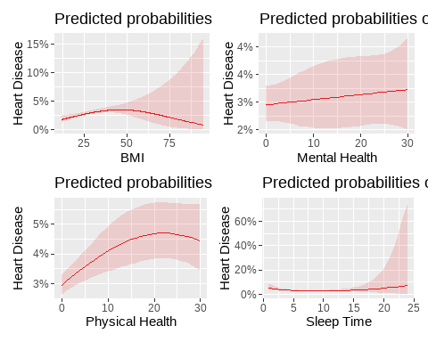

Sampling for KNN/QDA/LDA
library(pROC)
#Sample 10%
set.seed(1234)
sample_pct <- 0.10
train_sample_size <- floor(nrow(trainHeart) * sample_pct)
test_sample_size <- floor(nrow(testHeart) * sample_pct)
train_indices <- sample(seq_len(nrow(trainHeart)), size = train_sample_size)
test_indices <- sample(seq_len(nrow(testHeart)), size = test_sample_size)
trainHeart_sample <- trainHeart[train_indices, ]
testHeart_sample <- testHeart[test_indices, ]
#Identify numeric columns present in BOTH sets
numeric_cols <- intersect(
names(trainHeart_sample)[sapply(trainHeart_sample, is.numeric)],
names(testHeart_sample)[sapply(testHeart_sample, is.numeric)]
)
#Extract only shared numeric columns from both sets
train_numeric <- trainHeart_sample[, numeric_cols]
test_numeric <- testHeart_sample[, numeric_cols]
#Use preProcess to compute scaling from training data only
scale_params <- preProcess(train_numeric, method = c("center", "scale"))
#Apply scaling to both train and test
train_scaled <- predict(scale_params, train_numeric)
test_scaled <- predict(scale_params, test_numeric)
#Add back the target variable
train_scaled$HeartDisease <- factor(trainHeart_sample$HeartDisease, levels = c("No", "Yes"))
test_scaled$HeartDisease <- factor(testHeart_sample$HeartDisease, levels = c("No", "Yes"))
#Model Control
fitControl <- trainControl(method = "repeatedcv",
number = 5,
repeats = 1,
classProbs = TRUE,
summaryFunction = mnLogLoss)

KNN/LDA/QDA Models
#KNN Model
set.seed(1234)
grid <- expand.grid(k = c(3,5,7))
knn.fit <- train(HeartDisease ~ PhysicalHealth + BMI + MentalHealth + SleepTime,
data = train_scaled,
method = "knn",
trControl = fitControl,
metric = "logLoss",
tuneGrid = grid)
#LDA Model
lda.fit <- train(HeartDisease ~ PhysicalHealth + BMI + MentalHealth + SleepTime,
data = train_scaled,
method = "lda",
trControl = fitControl,
metric = "logLoss")
#QDA Model
qda.fit <- train(HeartDisease ~ PhysicalHealth + BMI + MentalHealth + SleepTime,
data = train_scaled,
method = "qda",
trControl = fitControl,
metric = "logLoss")

ROC/AUC
#ROC and AUC
actual <- test_scaled$HeartDisease
pred.knn <- predict(knn.fit, test_scaled, type = "prob")[, "Yes"]
pred.lda <- predict(lda.fit, test_scaled, type = "prob")[, "Yes"]
pred.qda <- predict(qda.fit, test_scaled, type = "prob")[, "Yes"]
roc.knn <- roc(actual, pred.knn, levels = c("No", "Yes"))
roc.lda <- roc(actual, pred.lda, levels = c("No", "Yes"))
roc.qda <- roc(actual, pred.qda, levels = c("No", "Yes"))
plot(roc.lda, col = "blue", lwd = 2, main = "ROC Curves: LDA, KNN, QDA")
plot(roc.knn, col = "red", lwd = 2, add = TRUE)
plot(roc.qda, col = "green", lwd = 2, add = TRUE)
legend("bottomright", legend = c("LDA", "KNN", "QDA"),
col = c("blue", "red", "green"), lwd = 2)
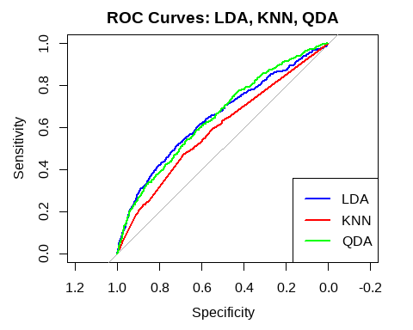
cat("AUC LDA:", auc(roc.lda), "\n")
## AUC LDA: 0.6459434
cat("AUC KNN:", auc(roc.knn), "\n")
## AUC KNN: 0.5901466
cat("AUC QDA:", auc(roc.qda), "\n")
## AUC QDA: 0.6484842
actual <- test_scaled$HeartDisease
#Visualize More Plots
# LDA
pred.lda <- predict(lda.fit, test_scaled, type = "prob")[, "Yes"]
roc.lda <- roc(actual, pred.lda, levels = c("No", "Yes"))
plot(roc.lda, col = "blue", lwd = 2, main = "ROC Curve: LDA")
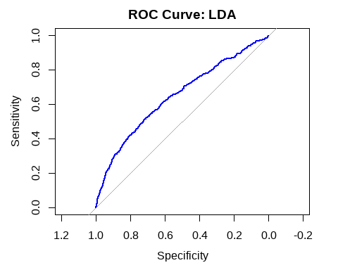
cat("AUC LDA:", auc(roc.lda), "\n")
## AUC LDA: 0.6459434
# KNN
pred.knn <- predict(knn.fit, test_scaled, type = "prob")[, "Yes"]
roc.knn <- roc(actual, pred.knn, levels = c("No", "Yes"))
plot(roc.knn, col = "red", lwd = 2, main = "ROC Curve: KNN")
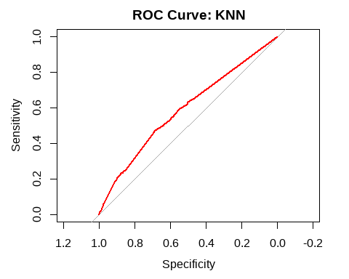
cat("AUC KNN:", auc(roc.knn), "\n")
## AUC KNN: 0.5901466
# QDA
pred.qda <- predict(qda.fit, test_scaled, type = "prob")[, "Yes"]
roc.qda <- roc(actual, pred.qda, levels = c("No", "Yes"))
plot(roc.qda, col = "green", lwd = 2, main = "ROC Curve: QDA")
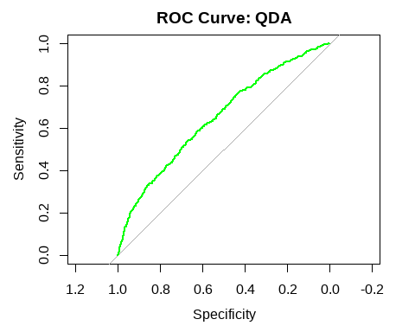
cat("AUC QDA:", auc(roc.qda), "\n")
## AUC QDA: 0.6484842

Confusion Matrices
# Confusion Matrices
threshold <- 0.1
library(caret)
# Logistic models
simple_probs <- predict(simple, trainHeart, type = "response")
simple.pred <- factor(ifelse(simple_probs > threshold, "Yes", "No"), levels = c("No", "Yes"))
complex1_probs <- predict(complex1, trainHeart, type = "response")
complex1.pred <- factor(ifelse(complex1_probs > threshold, "Yes", "No"), levels = c("No", "Yes"))
complex2_probs <- predict(complex2, trainHeart, type = "response")
complex2.pred <- factor(ifelse(complex2_probs > threshold, "Yes", "No"), levels = c("No", "Yes"))
# LDA predictions
lda_probs <- predict(lda.fit, train_scaled, type = "prob")[, "Yes"]
lda.pred <- factor(ifelse(lda_probs > threshold, "Yes", "No"), levels = c("No", "Yes"))
# QDA predictions
qda_probs <- predict(qda.fit, train_scaled, type = "prob")[, "Yes"]
qda.pred <- factor(ifelse(qda_probs > threshold, "Yes", "No"), levels = c("No", "Yes"))
# KNN predictions
knn_probs <- predict(knn.fit, train_scaled, type = "prob")[, "Yes"]
knn.pred <- factor(ifelse(knn_probs > threshold, "Yes", "No"), levels = c("No", "Yes"))
# Now create confusion matrices as before
cm.simple <- confusionMatrix(simple.pred, trainHeart$HeartDisease, positive = "Yes")
cm.complex1 <- confusionMatrix(complex1.pred, trainHeart$HeartDisease, positive = "Yes")
cm.complex2 <- confusionMatrix(complex2.pred, trainHeart$HeartDisease, positive = "Yes")
cm.lda <- confusionMatrix(lda.pred, train_scaled$HeartDisease, positive = "Yes")
cm.qda <- confusionMatrix(qda.pred, train_scaled$HeartDisease, positive = "Yes")
cm.knn <- confusionMatrix(knn.pred, train_scaled$HeartDisease, positive = "Yes")
# Print confusion matrices
cat("Confusion Matrix: Simple Logistic Regression\n")
## Confusion Matrix: Simple Logistic Regression
print(cm.simple)
## Confusion Matrix and Statistics
##
## Reference
## Prediction No Yes
## No 182405 5641
## Yes 51533 16258
##
## Accuracy : 0.7765
## 95% CI : (0.7749, 0.7781)
## No Information Rate : 0.9144
## P-Value [Acc > NIR] : 1
##
## Kappa : 0.2678
##
## Mcnemar's Test P-Value : <2e-16
##
## Sensitivity : 0.74241
## Specificity : 0.77972
## Pos Pred Value : 0.23983
## Neg Pred Value : 0.97000
## Prevalence : 0.08560
## Detection Rate : 0.06355
## Detection Prevalence : 0.26498
## Balanced Accuracy : 0.76106
##
## 'Positive' Class : Yes
##
cat("\nConfusion Matrix: Complex Logistic Regression 1\n")
##
## Confusion Matrix: Complex Logistic Regression 1
print(cm.complex1)
## Confusion Matrix and Statistics
##
## Reference
## Prediction No Yes
## No 179313 5211
## Yes 54625 16688
##
## Accuracy : 0.7661
## 95% CI : (0.7645, 0.7678)
## No Information Rate : 0.9144
## P-Value [Acc > NIR] : 1
##
## Kappa : 0.2613
##
## Mcnemar's Test P-Value : <2e-16
##
## Sensitivity : 0.76204
## Specificity : 0.76650
## Pos Pred Value : 0.23401
## Neg Pred Value : 0.97176
## Prevalence : 0.08560
## Detection Rate : 0.06523
## Detection Prevalence : 0.27874
## Balanced Accuracy : 0.76427
##
## 'Positive' Class : Yes
##
cat("\nConfusion Matrix: Complex Logistic Regression 2\n")
##
## Confusion Matrix: Complex Logistic Regression 2
print(cm.complex2)
## Confusion Matrix and Statistics
##
## Reference
## Prediction No Yes
## No 178461 5114
## Yes 55477 16785
##
## Accuracy : 0.7632
## 95% CI : (0.7615, 0.7648)
## No Information Rate : 0.9144
## P-Value [Acc > NIR] : 1
##
## Kappa : 0.2592
##
## Mcnemar's Test P-Value : <2e-16
##
## Sensitivity : 0.76647
## Specificity : 0.76286
## Pos Pred Value : 0.23228
## Neg Pred Value : 0.97214
## Prevalence : 0.08560
## Detection Rate : 0.06561
## Detection Prevalence : 0.28245
## Balanced Accuracy : 0.76466
##
## 'Positive' Class : Yes
##
cat("\nConfusion Matrix: LDA\n")
##
## Confusion Matrix: LDA
print(cm.lda)
## Confusion Matrix and Statistics
##
## Reference
## Prediction No Yes
## No 20641 1513
## Yes 2759 670
##
## Accuracy : 0.833
## 95% CI : (0.8284, 0.8376)
## No Information Rate : 0.9147
## P-Value [Acc > NIR] : 1
##
## Kappa : 0.1502
##
## Mcnemar's Test P-Value : <2e-16
##
## Sensitivity : 0.30692
## Specificity : 0.88209
## Pos Pred Value : 0.19539
## Neg Pred Value : 0.93171
## Prevalence : 0.08533
## Detection Rate : 0.02619
## Detection Prevalence : 0.13403
## Balanced Accuracy : 0.59451
##
## 'Positive' Class : Yes
##
cat("\nConfusion Matrix: QDA\n")
##
## Confusion Matrix: QDA
print(cm.qda)
## Confusion Matrix and Statistics
##
## Reference
## Prediction No Yes
## No 19966 1494
## Yes 3434 689
##
## Accuracy : 0.8074
## 95% CI : (0.8025, 0.8122)
## No Information Rate : 0.9147
## P-Value [Acc > NIR] : 1
##
## Kappa : 0.1204
##
## Mcnemar's Test P-Value : <2e-16
##
## Sensitivity : 0.31562
## Specificity : 0.85325
## Pos Pred Value : 0.16711
## Neg Pred Value : 0.93038
## Prevalence : 0.08533
## Detection Rate : 0.02693
## Detection Prevalence : 0.16116
## Balanced Accuracy : 0.58443
##
## 'Positive' Class : Yes
##
cat("\nConfusion Matrix: KNN\n")
##
## Confusion Matrix: KNN
print(cm.knn)
## Confusion Matrix and Statistics
##
## Reference
## Prediction No Yes
## No 15254 226
## Yes 8146 1957
##
## Accuracy : 0.6728
## 95% CI : (0.667, 0.6785)
## No Information Rate : 0.9147
## P-Value [Acc > NIR] : 1
##
## Kappa : 0.2073
##
## Mcnemar's Test P-Value : <2e-16
##
## Sensitivity : 0.89647
## Specificity : 0.65188
## Pos Pred Value : 0.19370
## Neg Pred Value : 0.98540
## Prevalence : 0.08533
## Detection Rate : 0.07650
## Detection Prevalence : 0.39491
## Balanced Accuracy : 0.77418
##
## 'Positive' Class : Yes
##
model_names <- c("Simple", "Complex1", "Complex2", "LDA", "QDA", "KNN")
accuracies <- c(
cm.simple$overall["Accuracy"],
cm.complex1$overall["Accuracy"],
cm.complex2$overall["Accuracy"],
cm.lda$overall["Accuracy"],
cm.qda$overall["Accuracy"],
cm.knn$overall["Accuracy"]
)
sensitivities <- c(
cm.simple$byClass["Sensitivity"],
cm.complex1$byClass["Sensitivity"],
cm.complex2$byClass["Sensitivity"],
cm.lda$byClass["Sensitivity"],
cm.qda$byClass["Sensitivity"],
cm.knn$byClass["Sensitivity"]
)
specificities <- c(
cm.simple$byClass["Specificity"],
cm.complex1$byClass["Specificity"],
cm.complex2$byClass["Specificity"],
cm.lda$byClass["Specificity"],
cm.qda$byClass["Specificity"],
cm.knn$byClass["Specificity"]
)
performance_table <- data.frame(
Model = model_names,
Accuracy = round(accuracies, 4),
Sensitivity = round(sensitivities, 4),
Specificity = round(specificities, 4)
)
print(performance_table)
## Model Accuracy Sensitivity Specificity
## 1 Simple 0.7765 0.7424 0.7797
## 2 Complex1 0.7661 0.7620 0.7665
## 3 Complex2 0.7632 0.7665 0.7629
## 4 LDA 0.8330 0.3069 0.8821
## 5 QDA 0.8074 0.3156 0.8532
## 6 KNN 0.6728 0.8965 0.6519
cat("AUC LDA:", auc(roc.lda), "\n")
## AUC LDA: 0.6459434
cat("AUC QDA:", auc(roc.qda), "\n")
## AUC QDA: 0.6484842
cat("AUC KNN:", auc(roc.knn), "\n")
## AUC KNN: 0.5901466

Logistic Simple/Complex Model Metrics
# Logistic Simple/Complex Model Metrics with 0.3 threshold
# Function to compute metrics for a given model and dataset
get_metrics <- function(model, data, positive_class = "Yes", threshold = 0.3) {
# Predict probabilities
probs <- predict(model, newdata = data, type = "response")
# Convert to predicted class using custom cutoff
preds <- ifelse(probs >= threshold, positive_class, "No")
# Convert to factors with same levels as actuals
actual <- factor(data$HeartDisease, levels = c("No", positive_class))
preds <- factor(preds, levels = c("No", positive_class))
# Confusion matrix
cm <- confusionMatrix(preds, actual, positive = positive_class)
# Extract metrics
sens <- cm$byClass["Sensitivity"]
spec <- cm$byClass["Specificity"]
ppv <- cm$byClass["Pos Pred Value"]
npv <- cm$byClass["Neg Pred Value"]
# Prevalence
prevalence <- mean(actual == positive_class)
# AUROC
roc_obj <- roc(actual, probs, levels = c("No", positive_class))
auc_val <- auc(roc_obj)
return(data.frame(
Sensitivity = sens,
Specificity = spec,
Prevalence = prevalence,
PPV = ppv,
NPV = npv,
AUROC = auc_val
))
}
# Apply to each model
metrics_simple <- get_metrics(simple, trainHeart, threshold = 0.1)
metrics_complex1 <- get_metrics(complex1, trainHeart, threshold = 0.1)
metrics_complex2 <- get_metrics(complex2, trainHeart, threshold = 0.1)
# Combine results
results <- rbind(
Simple = metrics_simple,
Complex1 = metrics_complex1,
Complex2 = metrics_complex2
)
print(results)
## Sensitivity Specificity Prevalence PPV NPV AUROC
## Simple 0.7424083 0.7797151 0.08559747 0.2398253 0.9700020 0.8409817
## Complex1 0.7620439 0.7664980 0.08559747 0.2340106 0.9717598 0.8419010
## Complex2 0.7664734 0.7628560 0.08559747 0.2322798 0.9721422 0.8434701

