Monopoly Practical test – Report
28 – 08 – 2022

Table of Contents
Monopoly Practical test – Report 1
Introduction 1
Design 1
Git 1
The App 2
Code 7
Conclusion 17

Introduction
This document demonstrates my process and how I created my Monopoly console application. With my app I feel like I have completed the brief, all of the functional requirements have been met and the finished product is a fun and visually appealing game with clean, efficient and understandable code.

Design
I started off my process with a large amount of note taking, working with the practical test document and my own vision to write down the absolute must-haves of the project and then any extra creative parts that I could add to show off my programming and creative abilities. When I knew how I wanted a certain part to function (in terms of code) I would write it down as I went along.
I decided I wanted to use the C# language in the dotnet framework for the following reasons.
Firstly, C# is one of the languages I am most familiar with and that I have spent the most time with, with it I knew that I could complete the practical with my current level of skill. C# is a fast language designed for object orientated programming, which is a requirement for this practical. Lastly, I knew that both the framework and language are versatile and are a good choice for console based applications.
After deciding how it all works I got on with some pseudocode, starting with what made most sense, then editing it down to where it’s almost like usable code.
Evidence of notes and pseudo are uploaded and available in the GitHub Monopoly project.

Git
I have used GitHub throughout the project to create backups of all relevant files.
GitHub repository:
https://github.com/chloehp/Monopoly

The App
The following screenshots show the different parts of the finished app. Screenshots include demonstrations of the game passing the listed requirements.
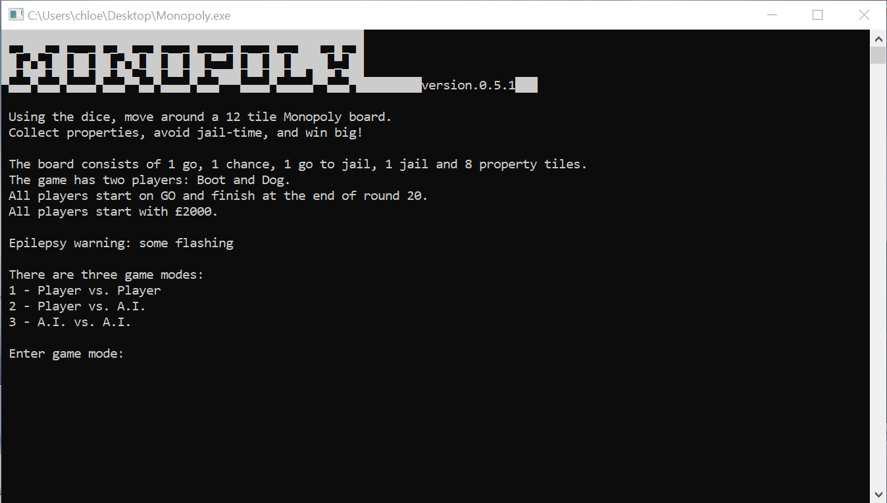
The home screen has information on how to play. To ensure I fully covered the brief, I created multiple game modes. The A.I. vs. A.I. mode has no player input. The player vs. player mode has no A.I.
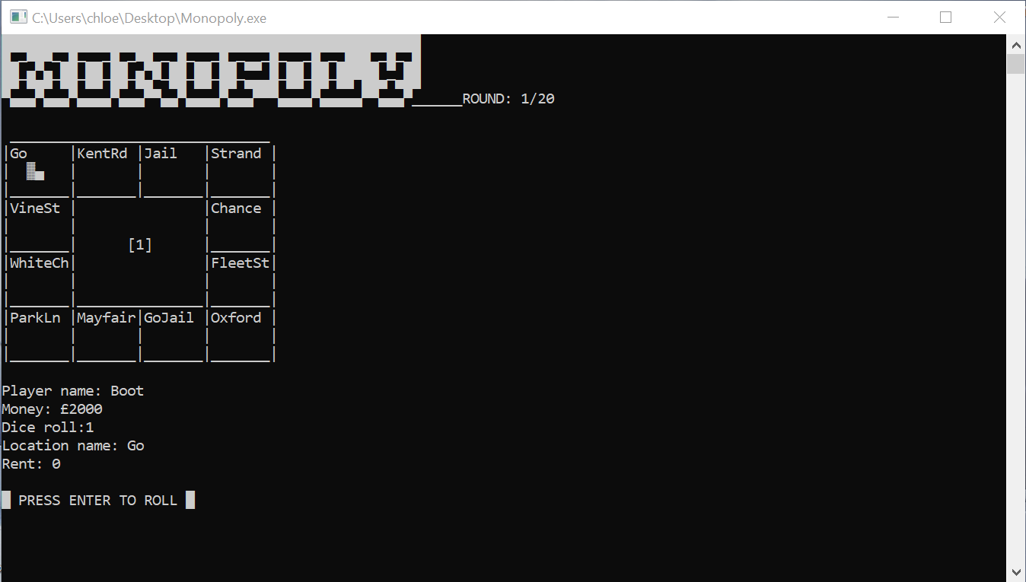
This is the screen for most of the game. It contains all the necessary information.
I made the title with this website: https://fsymbols.com/text-art/
I drew the rest myself.
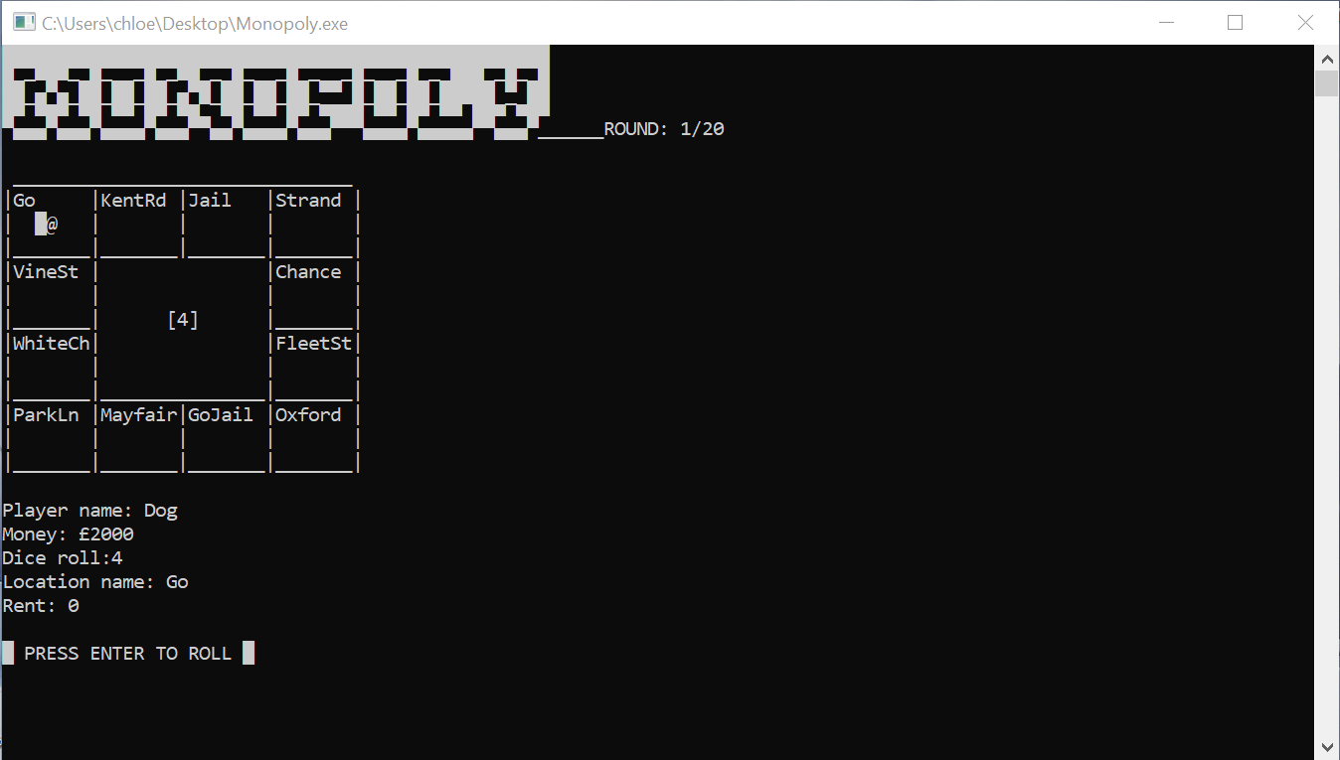
This and the following screenshot demonstrates a dice roll of 4, and the player “Dog” moving 4 tiles. There is a basic animation showing the player bump along the tiles.
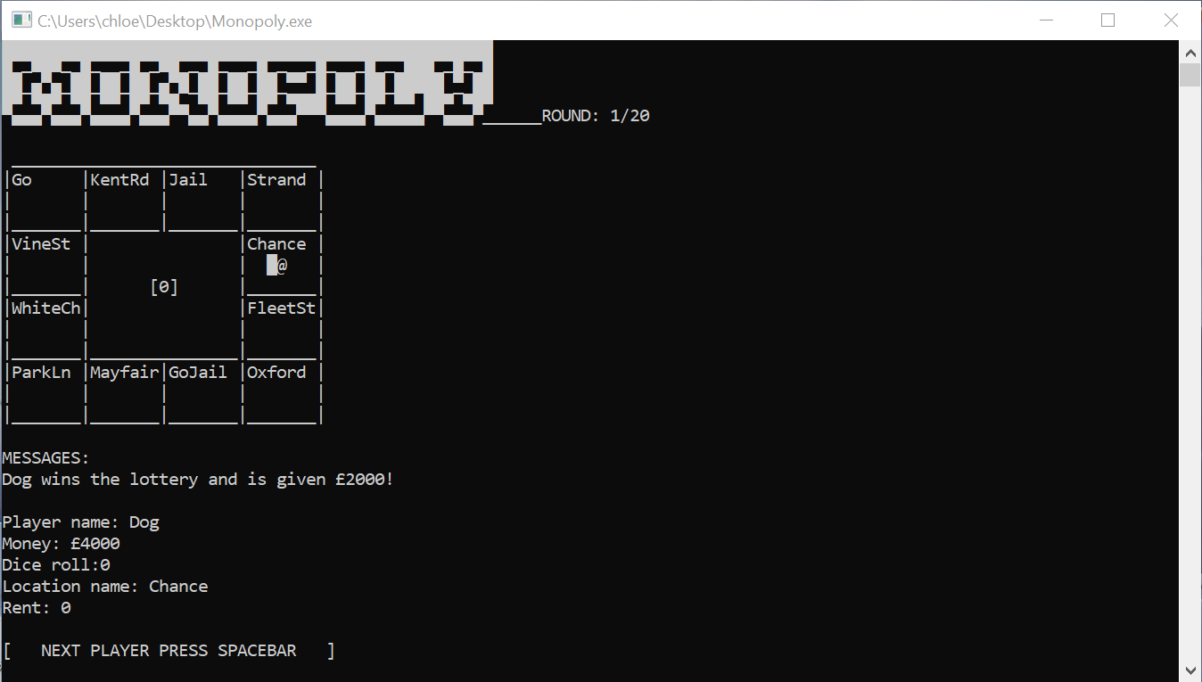
Above: Player landing on “Chance” where have 1/3 a chance either winning £2000, losing £2000, or being sent to jail. In this instance, Dog has won!
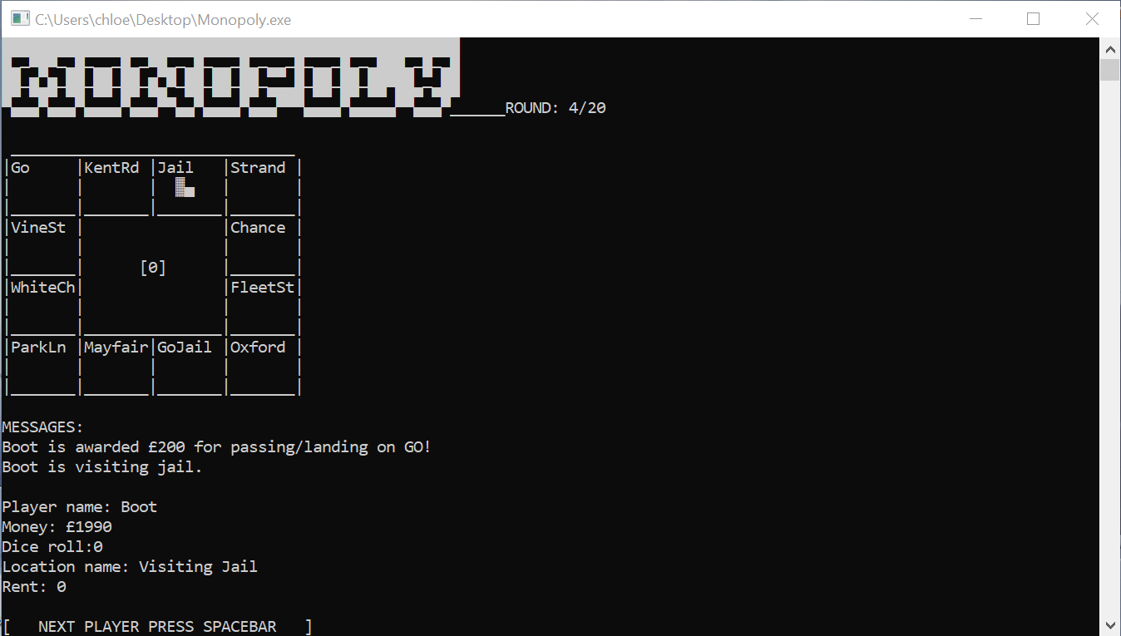
Above screenshot demonstrates player passing “Go” and “visiting jail”.
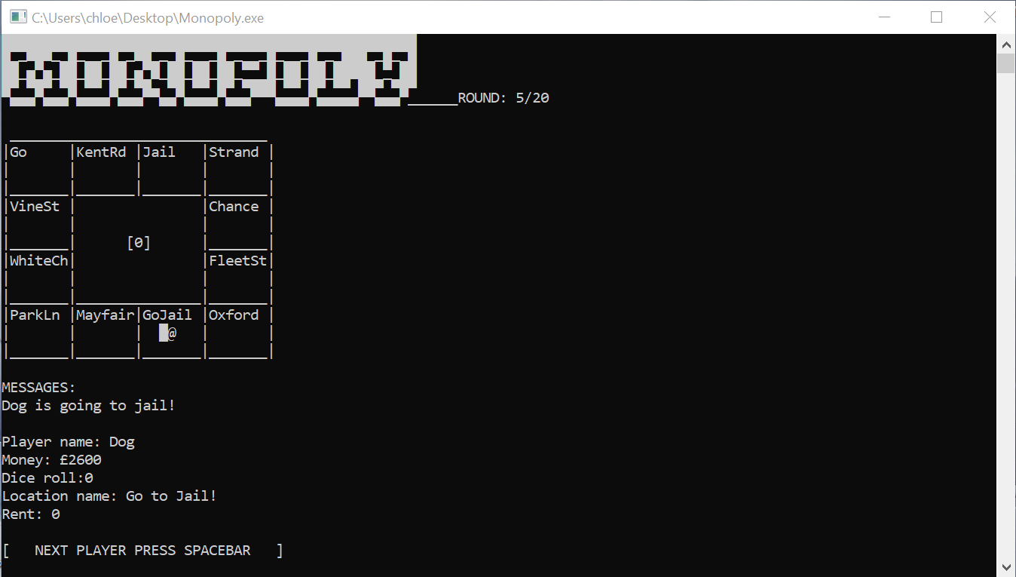
Above: The player being sent to “Jail”

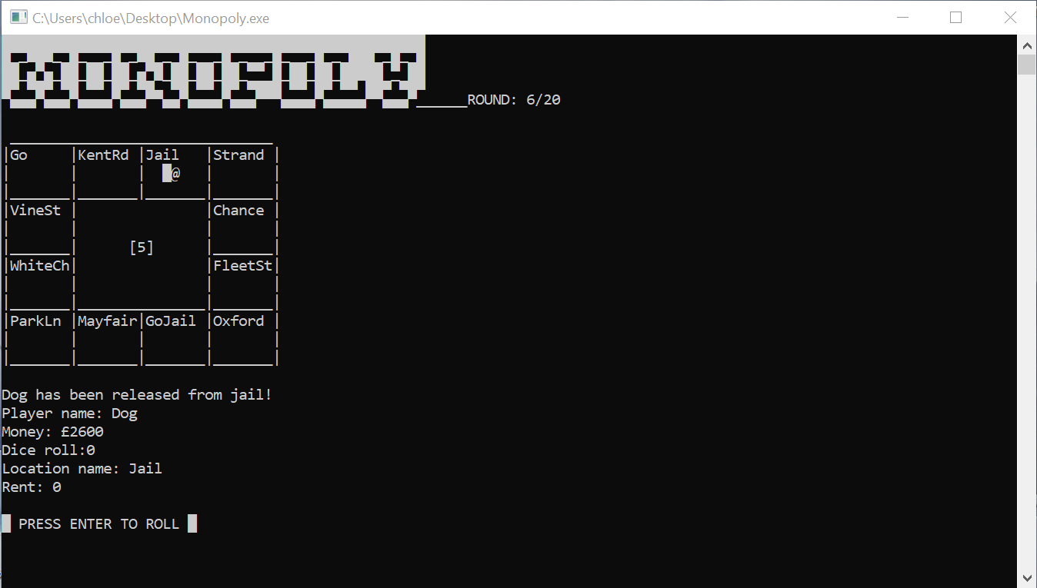
This screen shows the screen when the player is released from jail (after rolling a 3 or higher).
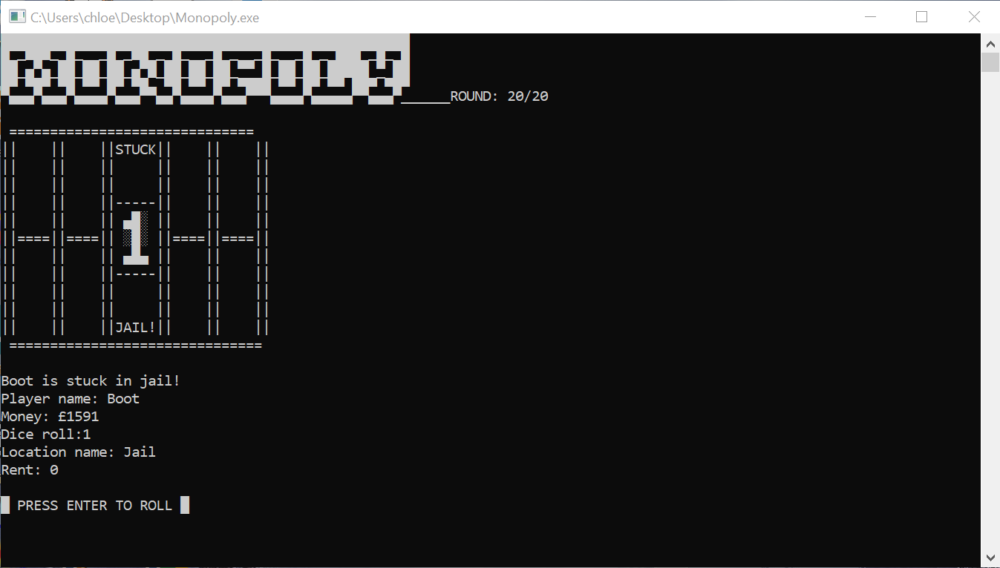
This screen shows the screen when a player has rolled a 1 after being sent to jail. They are stuck until their next turn, where they have another chance to try and roll > 3.

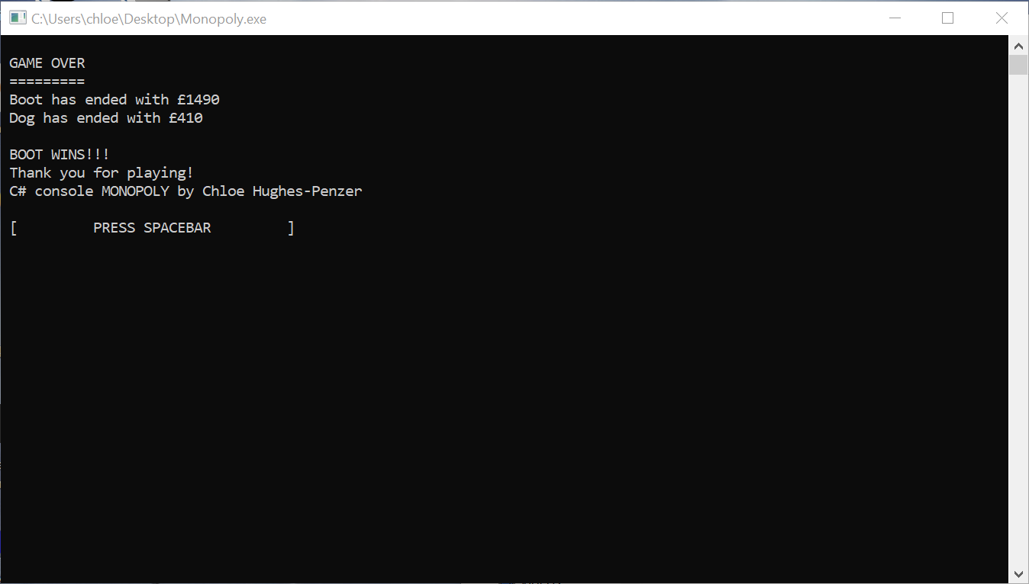
The game finishes at the end of round 20. The end screen displays the money that the two characters finish with and which character wins.

Code
The following screenshots are of all the code in my app, the source code can be downloaded and/or viewed directly from the GitHub repo.
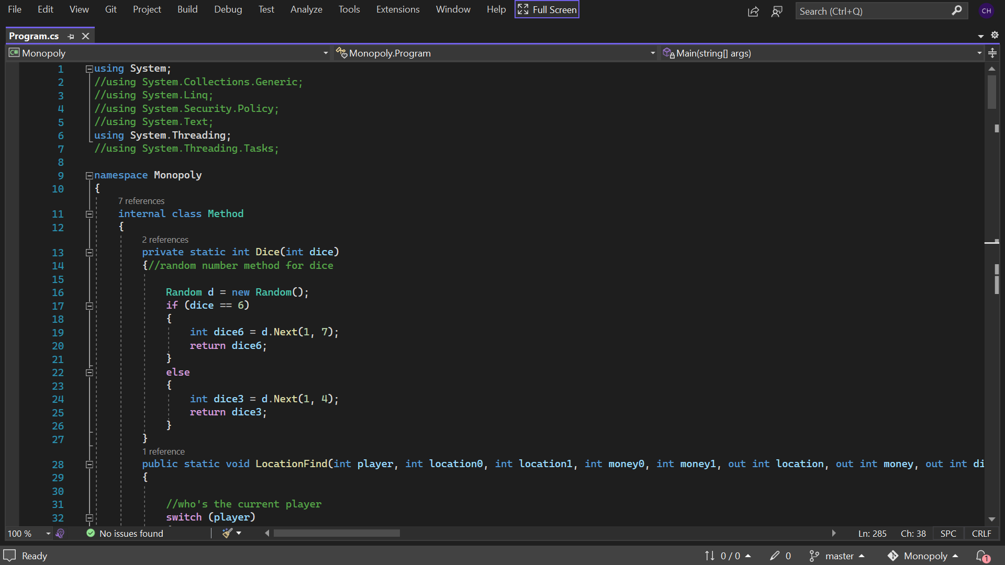
Some unused code is commented out, especially where it may be implemented later.
Above is my Dice method.
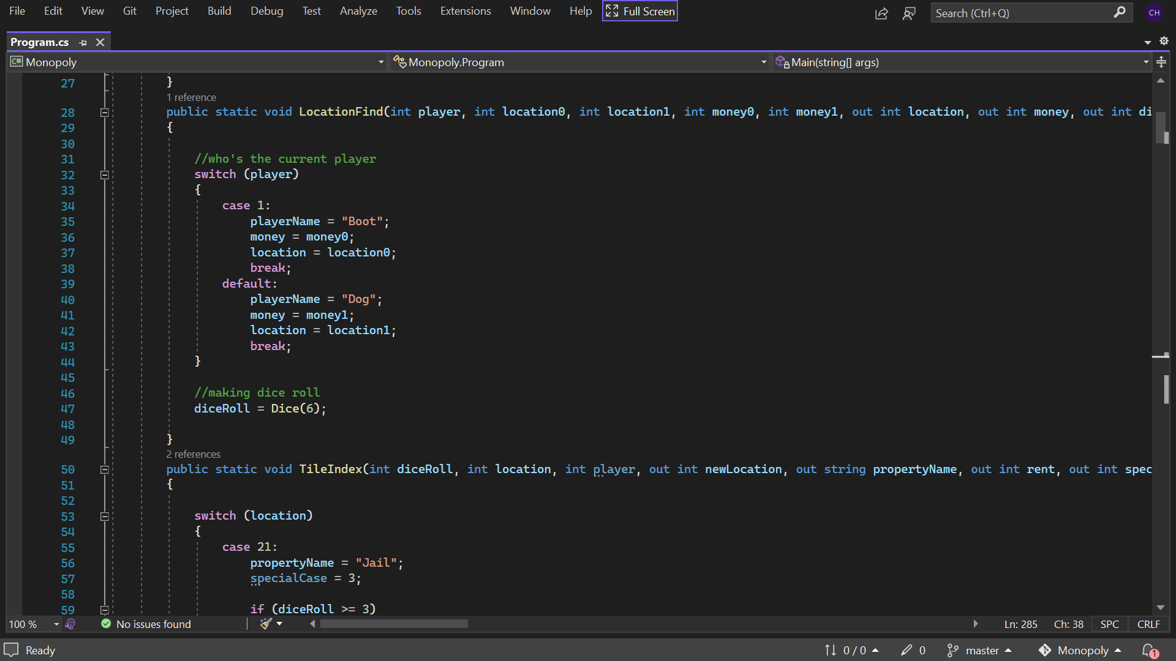
My code has been designed to be easy to edit. A programmer in the future could easily add more players by adding a few cases and objects from the Player class. Monopoly is turn based, the above method, along with for each loop in Main decide who is playing and what that means.
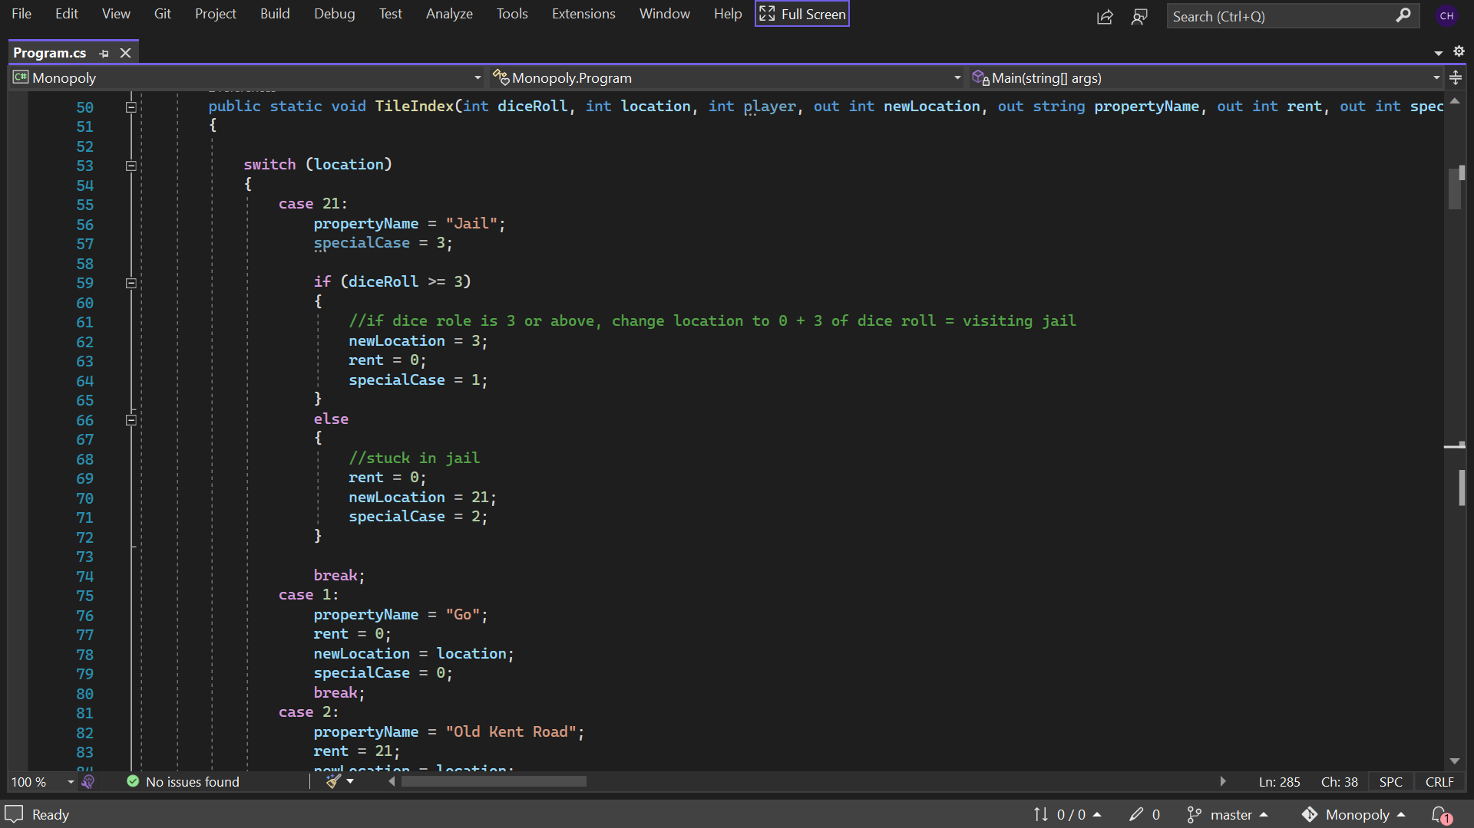
In early notes, each location was an object from a class, I found this unnecessary and instead made them switch cases.
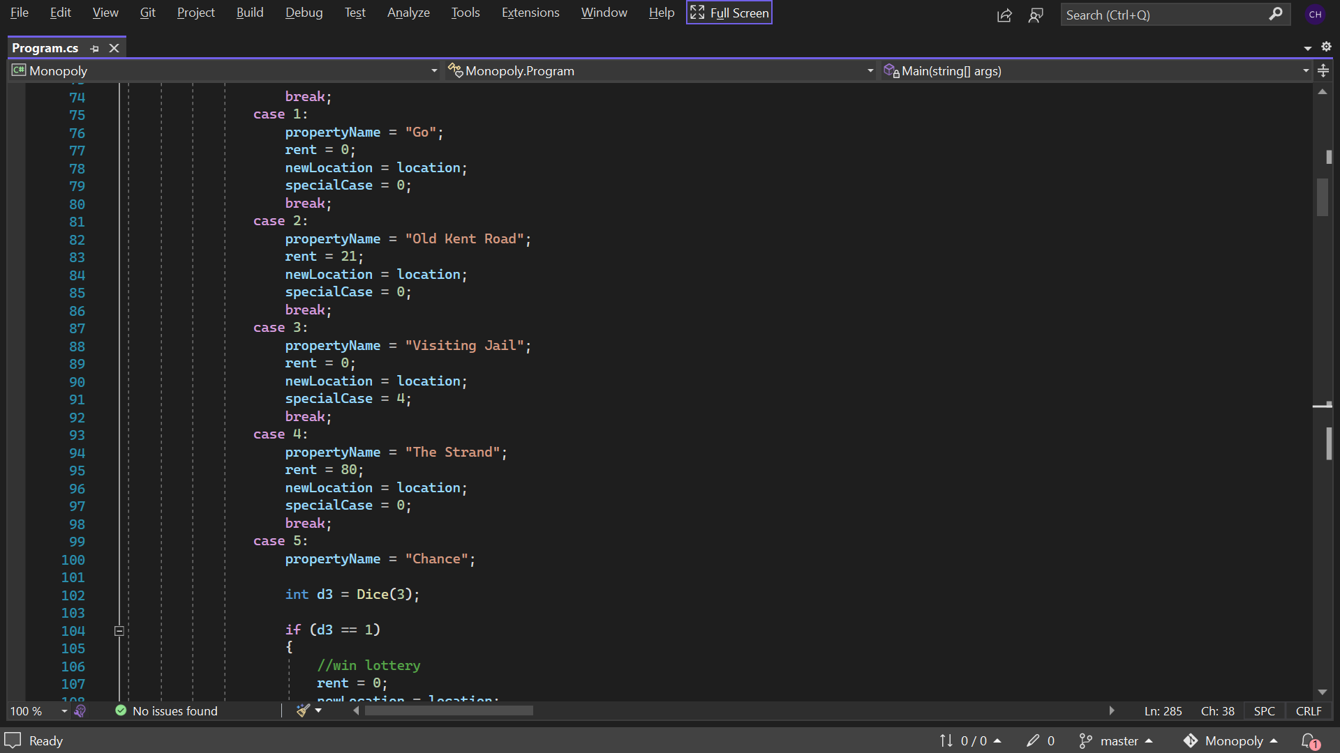
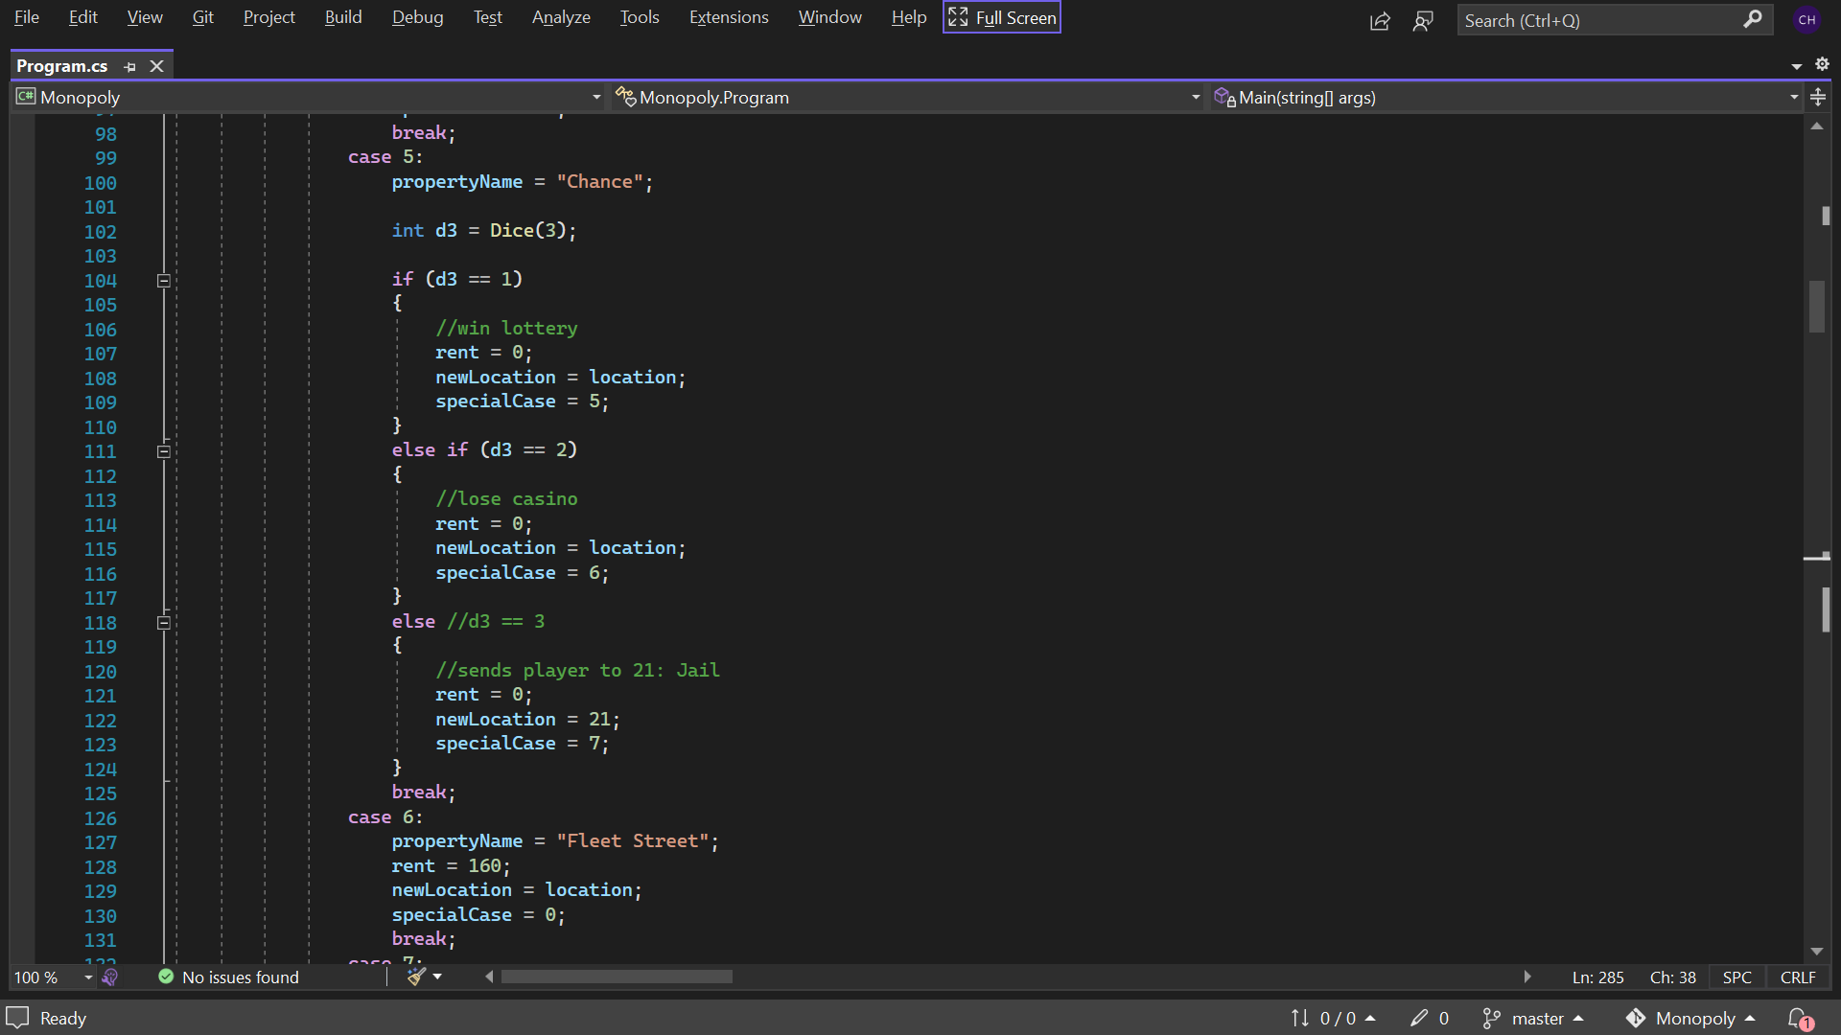
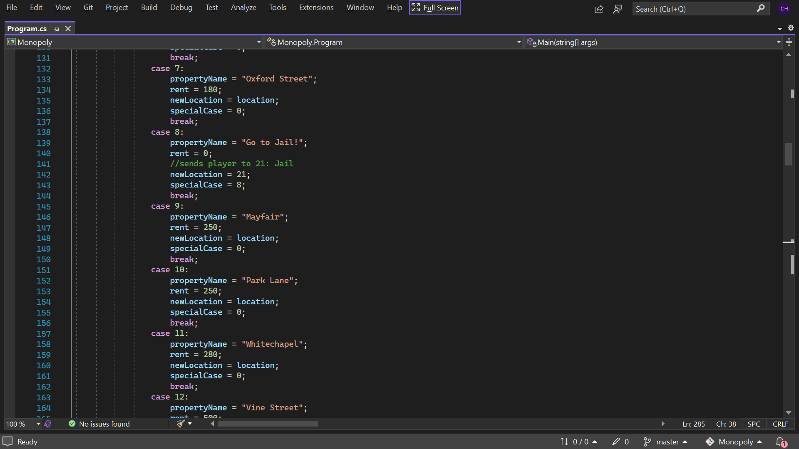
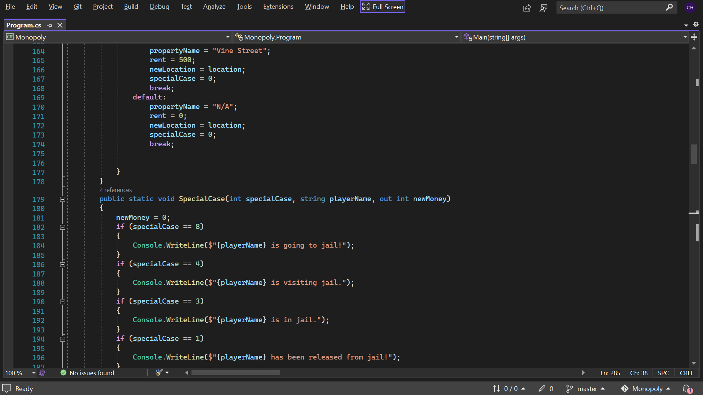
SpecialCases method tells the app what to do in special cases e.g. Chance and Jail scenarios.
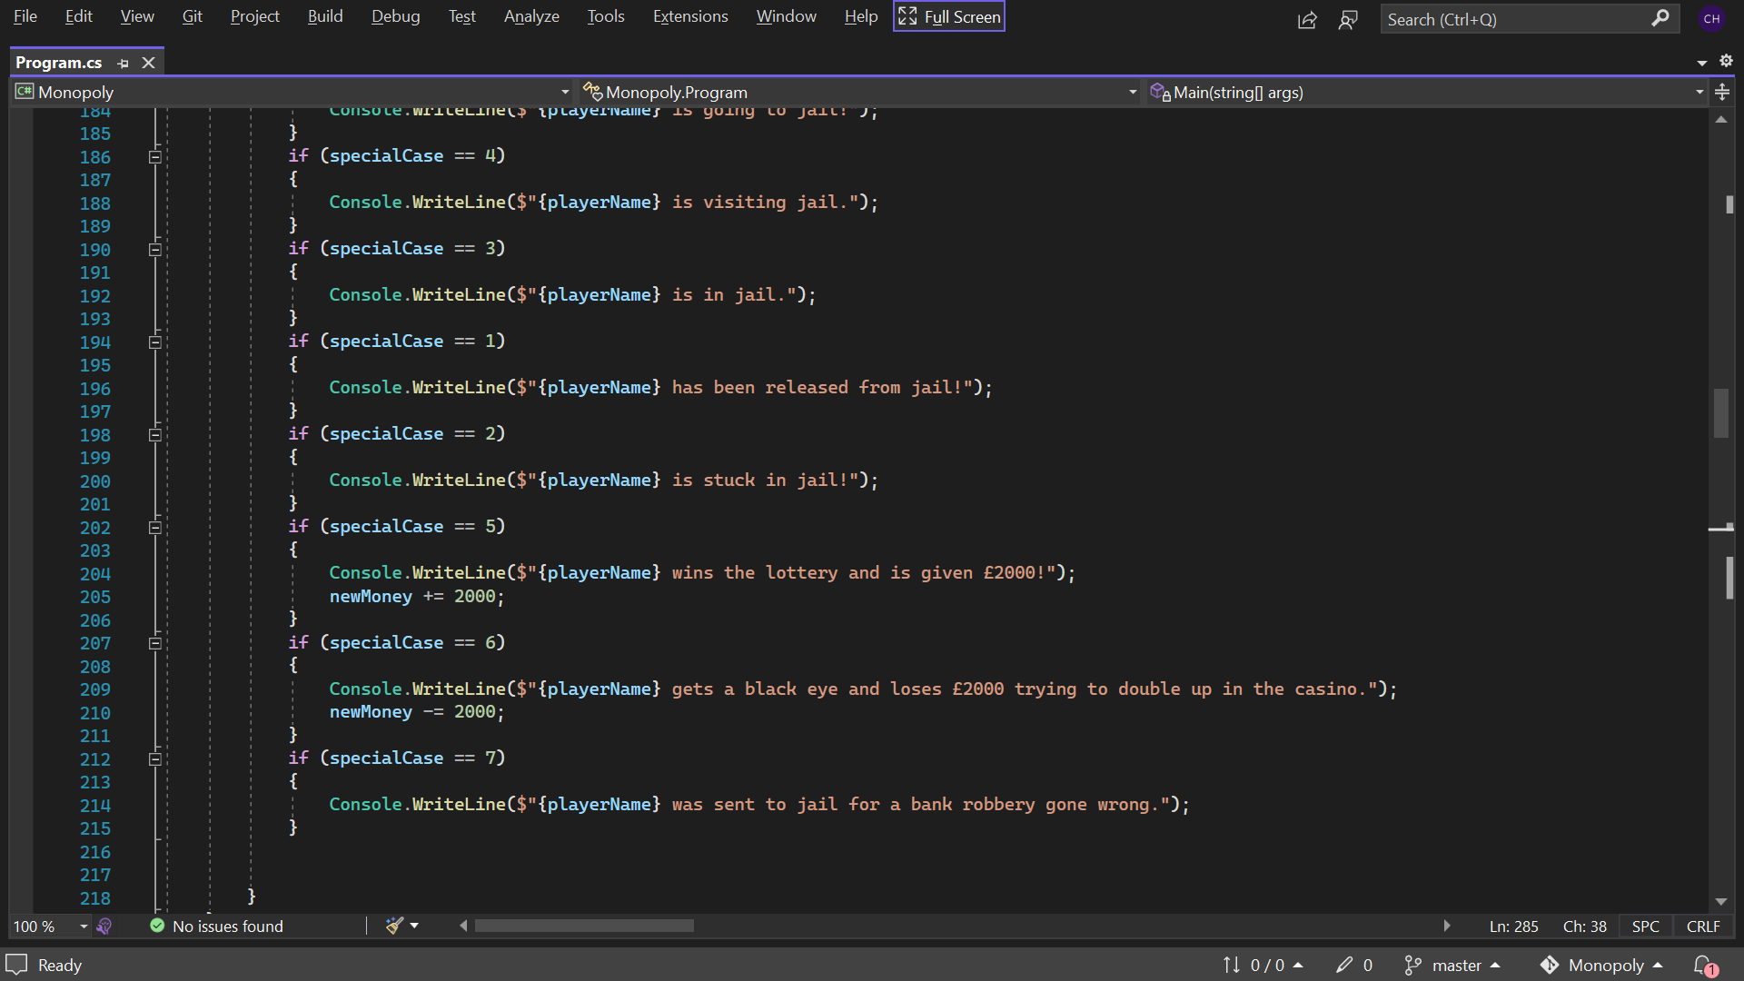
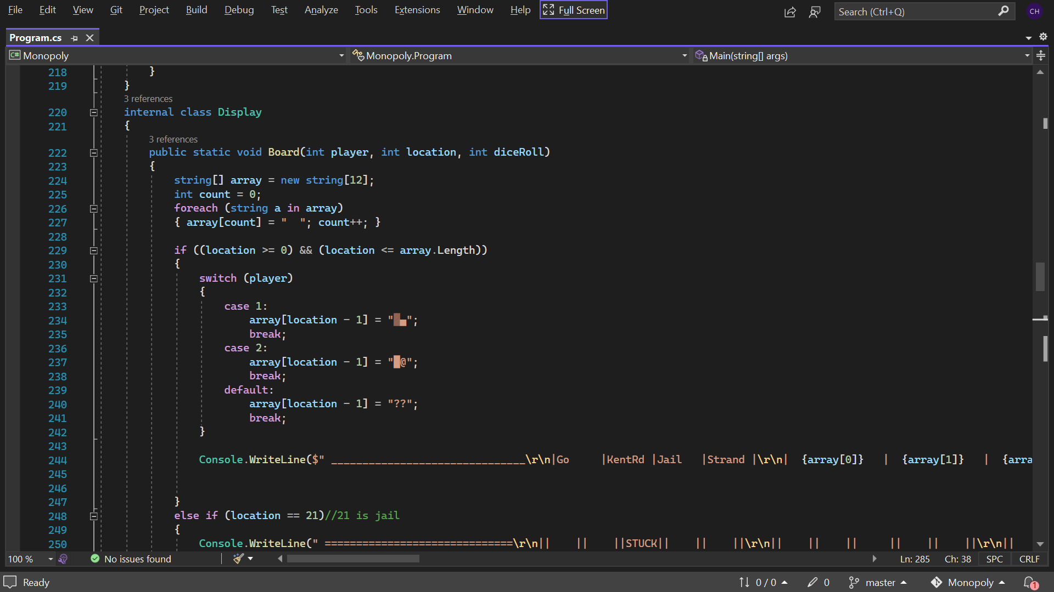
The Monopoly board was drawn in notepad. When pasted into the IDE, Visual Studio automatically codes new line and return into the string and turns it into a single line in the code so it’s easy to read from a programmers point of view.
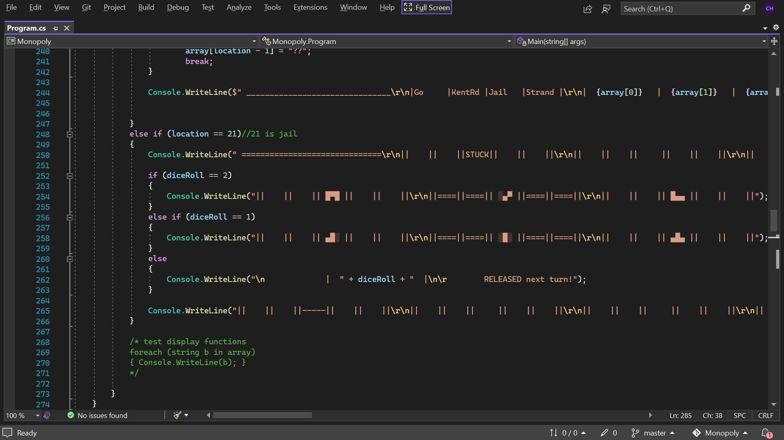
The board is printed to the console in different segments depending on the scenario.
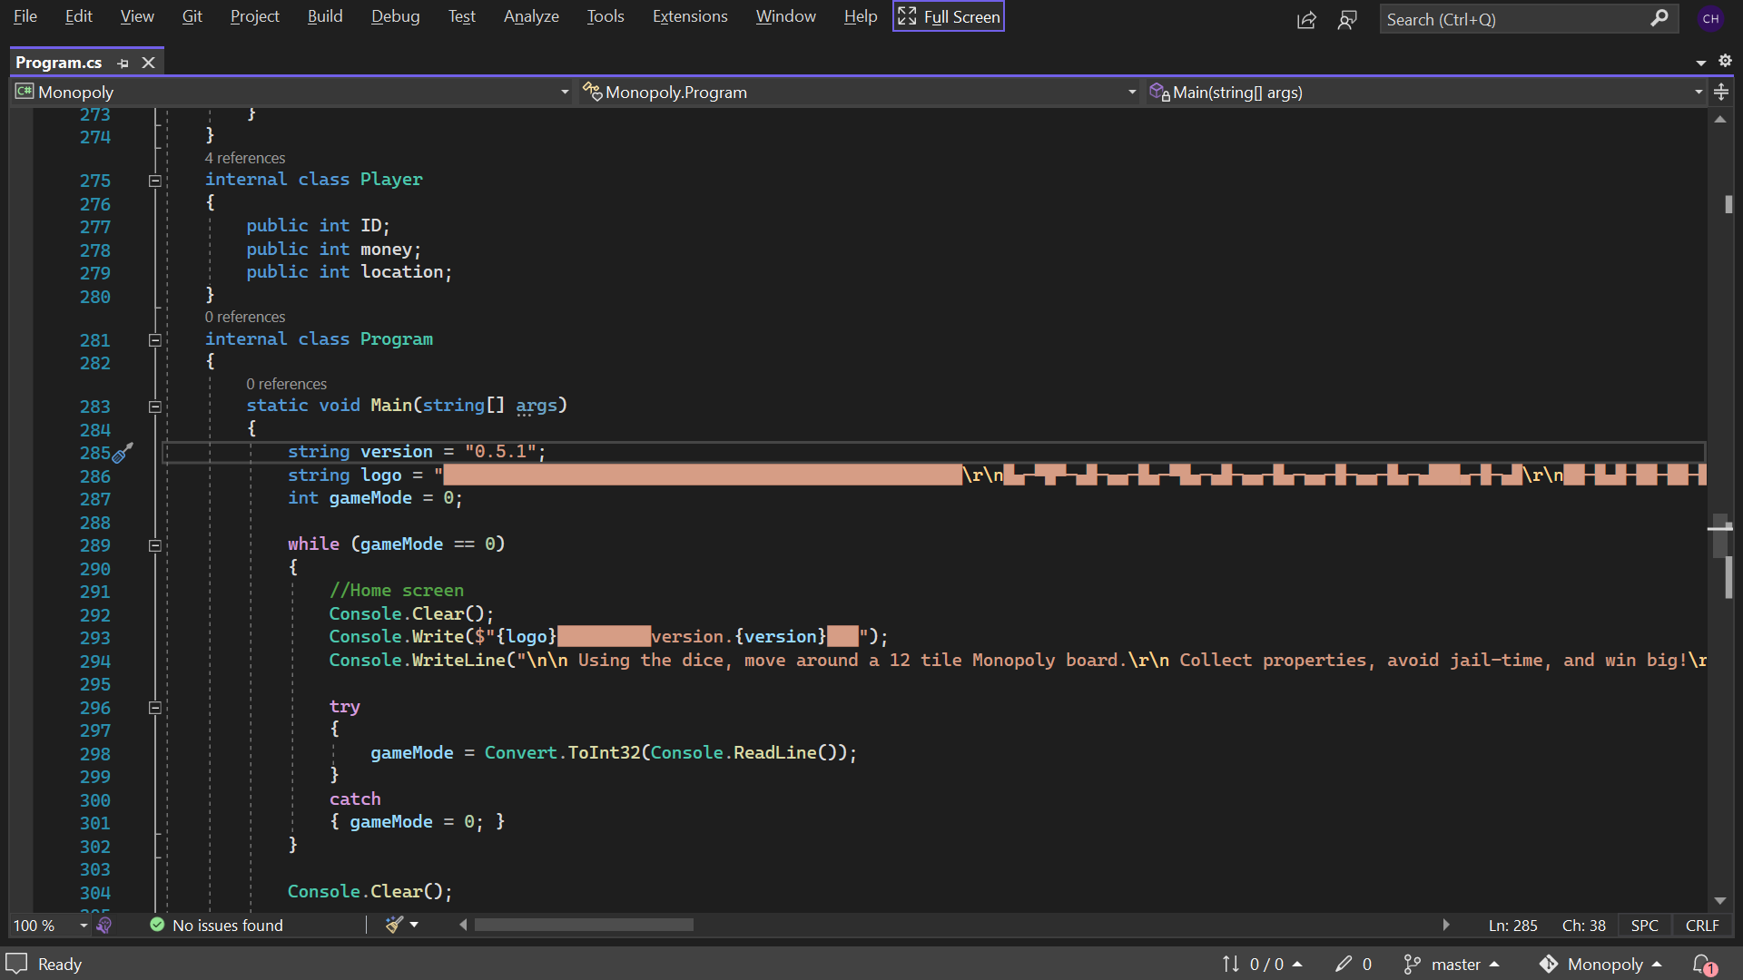
Try catch used with a loop to reset the opening screen to prevent input of anything other than an integer.
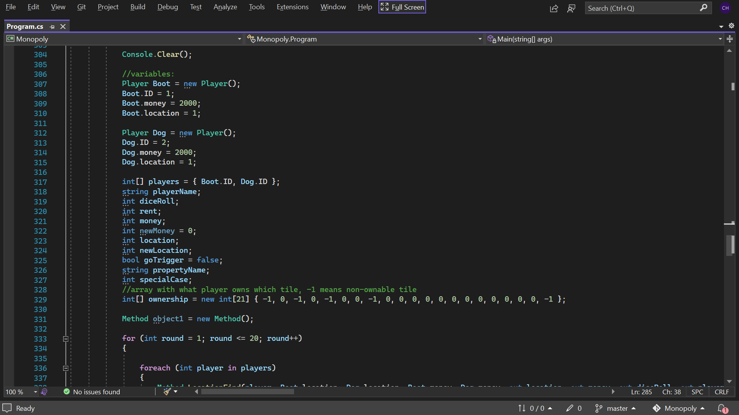
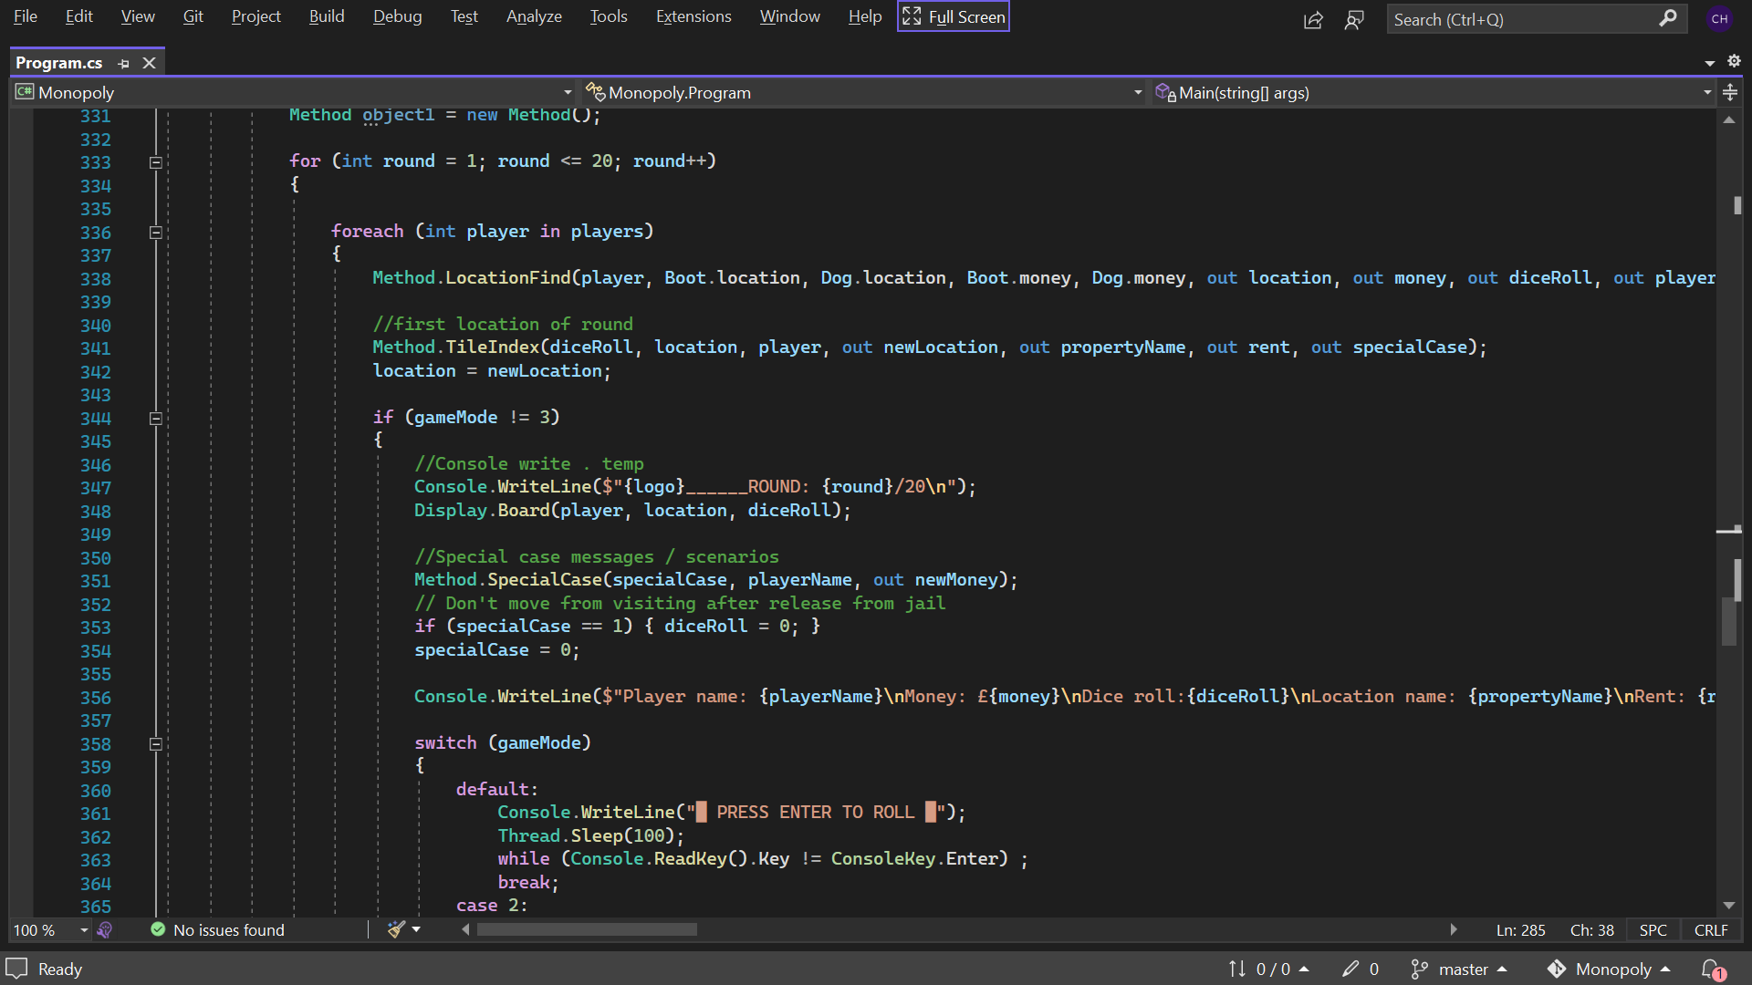
Thread sleep used to prevent visual glitches from players keyboard mashing.
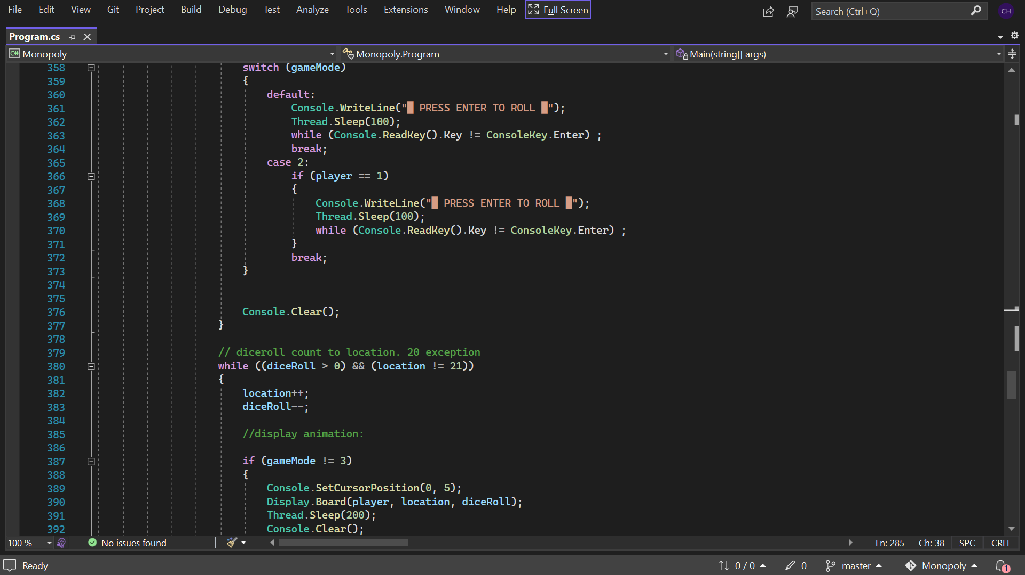
Dice counts down as location counts up. This allows for simple passing go and also the animation of the player bumping along the tiles.
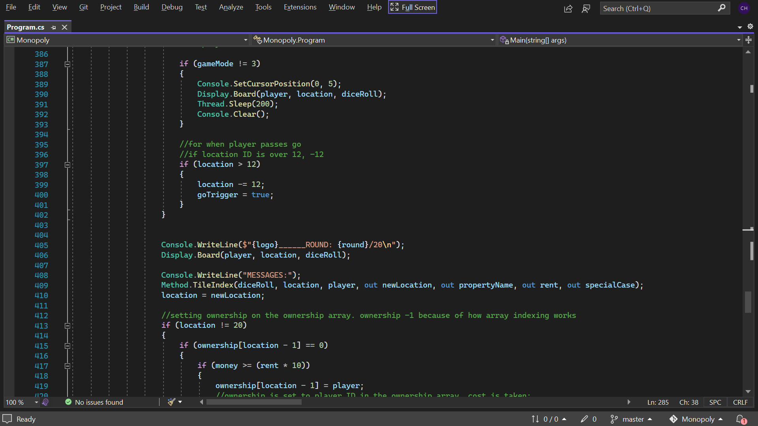
If location is over 12 take away 12. This allows the player to keep going round the board in circles. Small visual glitch (half a second blank screen) as player passes go and the computer processes this.
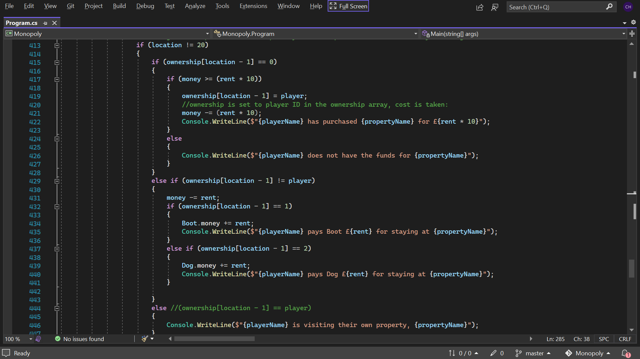
If statements for various rent/paying parts of the game. Cost of all property tiles is 10 times the rent which allows simplification of code.
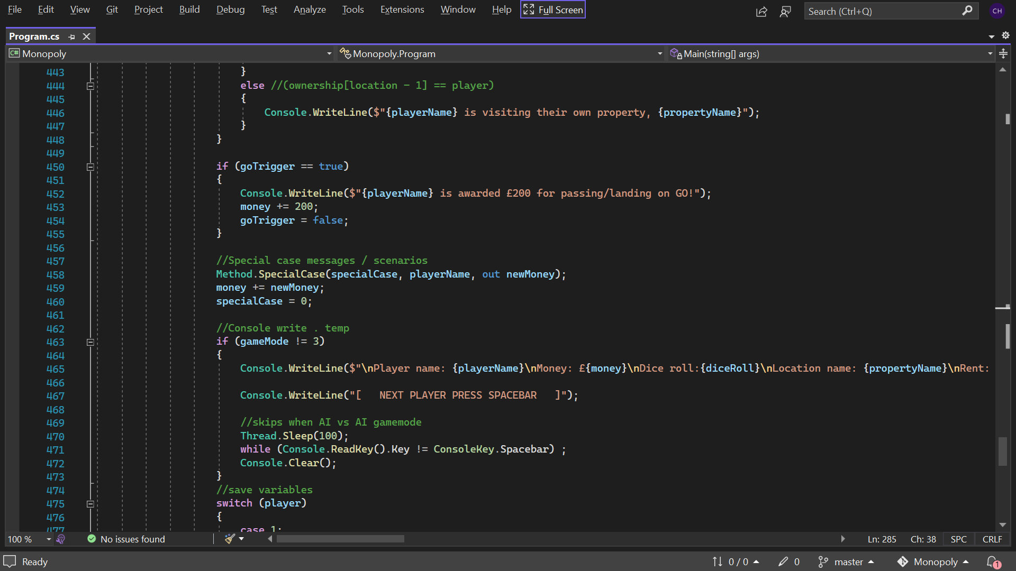
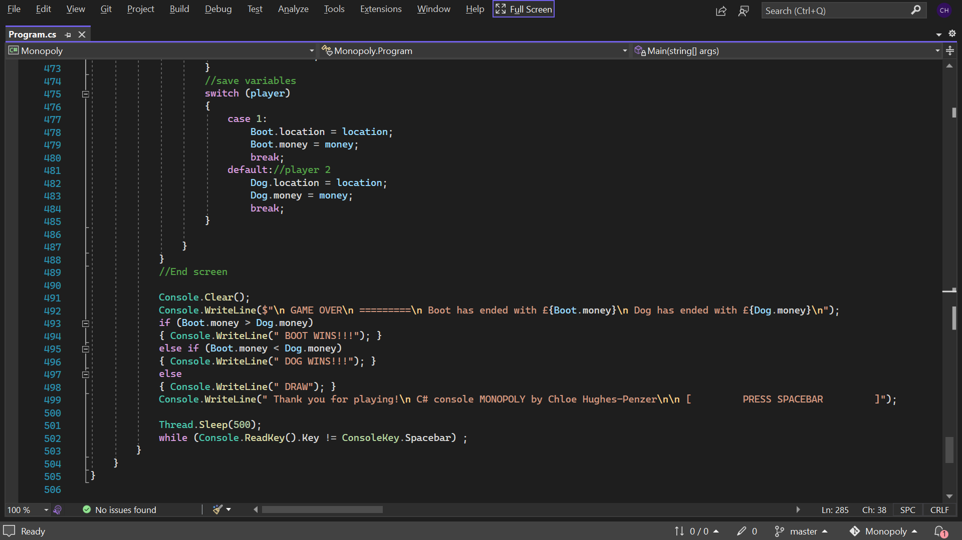
End screen and end of the code.

Conclusion

As I stated in the introduction, I believe I have created an app that fulfils every requirement listed in the brief. The code I have written demonstrates my ability in object orientated programming, I consider it be neat, well organised and efficient; I believe a sufficient amount of comments have been used to describe what is going on at all the different parts.
There are a couple changes I would make to the application if I had more time:
I use Console.Clear a lot to make a game with different screens/pages instead of one that scrolls, but not all the information needs to be refreshed all the time, so I would like only the necessary lines to be cleared; this would make the app more efficient and reduce flashing.
I would also like to reduce flashing around where the animation passes Go, I would do this with (a) new scenario(s) designed to deal with that issue.
Lastly, I originally wanted to use little emojis for the players (👢 for boot and 🐕 for dog), as well as others like dice for added look, but I found the standard windows shell that most people use by default, cmd.exe, cannot display them. Newer programs like Powershell can display the emojis, I would like for my app to be able to tell what it is being run on and alter its display accordingly.
With more time, a lot of the classes and code from my app could also be used to make the game with a graphical user interface, the benefit of O.O.P.
This has been a fun project for me, it was a good challenge in terms of problem solving, I appreciated how open ended it was so that I could make something special so that I could show off some of my creative and programming skills. I hope I have successfully demonstrated my abilities and be considered for the upcoming job opportunity.
Thank you for taking the time to review my application and enjoying my game!

