# Web-Dev report

In the last almost two months of being in this module, I have learned so much about the process of web development. For me the first few weeks were a great refresher of HTML and CSS, in which I also learned some of the basics of Git and how to create a GitHub repository with VSC. In the last couple of weeks I’ve learned the grid and flex system for CSS which has been really helpful in this assignment. I’ve completed three of the class challenges but unfortunately I was off ill for the two last lectures. I’ve kept up with the online lectures.

I believe I have accomplished everything required for this assignment.

Below is a screenshot of my wireframe design, made in Figma.

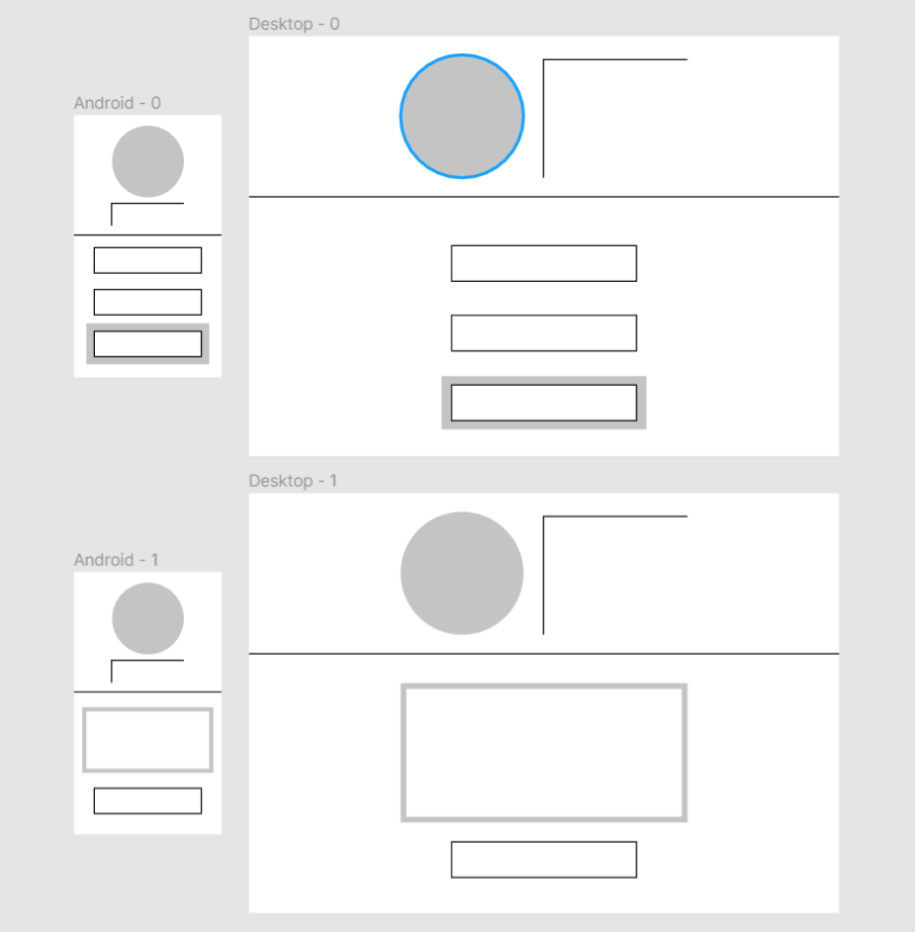

By using flex and grid display properties, my site is designed to work just as well on a desktop as on mobile, this was tested through Firefox developer tools which allowed me to view the site through multiple different screen sizes.

In mobile versions of the site, the user would scroll on the main contents to look through it whilst the header remains at the top of the page, or scroll on the header to show or hide the footer.

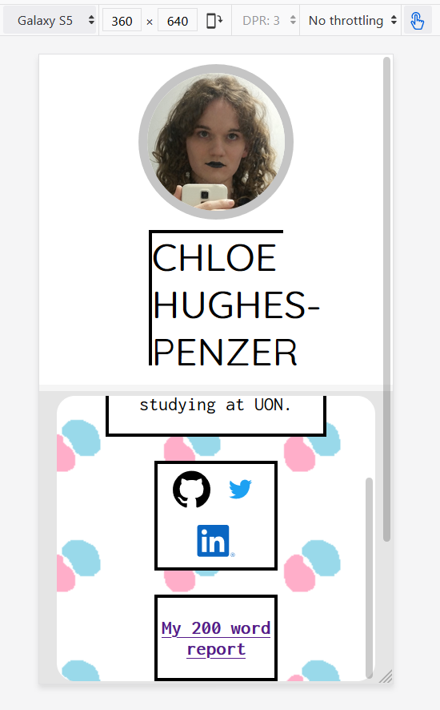

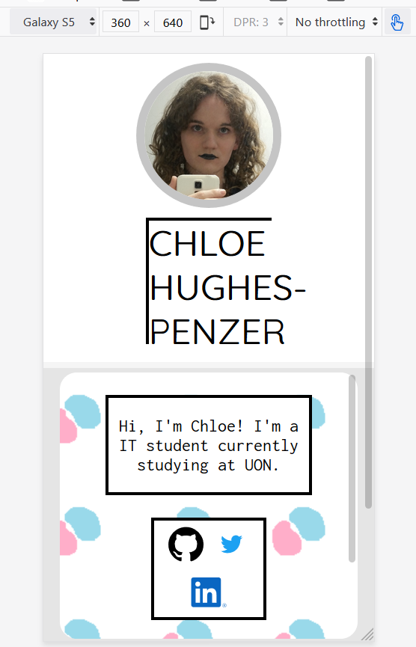

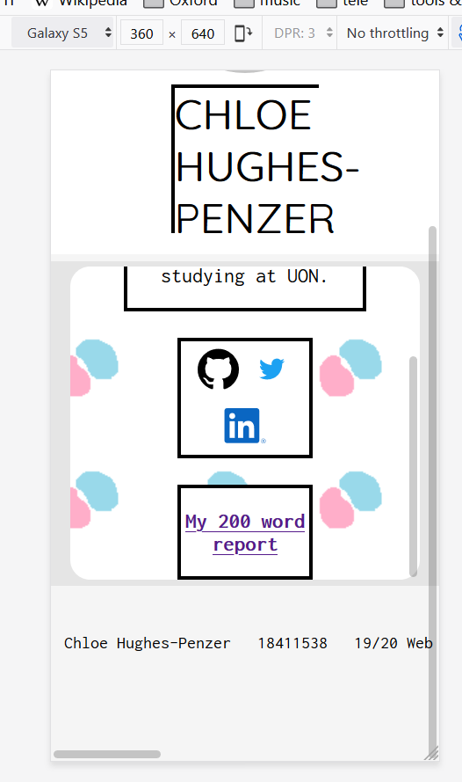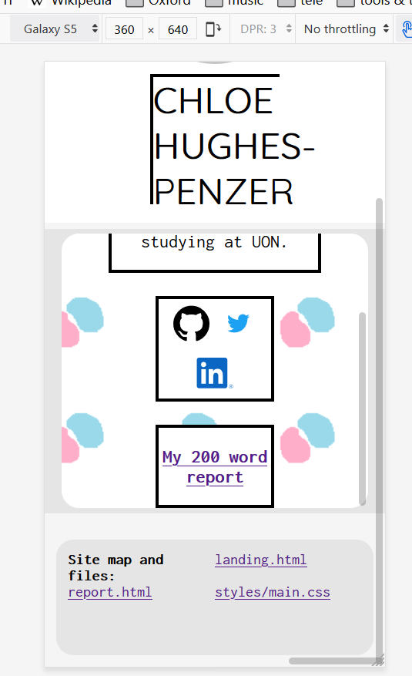

The following screenshots show how my site looks and functions on various devices.

