Assignment 1 - Linear Regression Model Fitting Using R
Huynh Nguyen
2026-09-17

1. Introduction
The purpose of this analysis is to develop and evaluate a multiple linear regression model for predicting residential SalePrice in Ames, Iowa. The model uses housing characteristics that are expected to influence market value, including overall quality, above-ground living area, basement area, garage capacity, year built, number of full bathrooms, fireplaces, neighborhood, and kitchen quality. In addition to estimating the regression model, this report evaluates model fit, residual behavior, normality of residuals, potential outliers, and multicollinearity.

2. Data Preparation
# Load housing data set
AmesHousing <- read_csv("AmesHousing.csv")
## Rows: 2930 Columns: 82
## ── Column specification ────────────────────────────────────────────────────────
## Delimiter: ","
## chr (45): PID, MS SubClass, MS Zoning, Street, Alley, Lot Shape, Land Contou...
## dbl (37): Order, Lot Frontage, Lot Area, Overall Qual, Overall Cond, Year Bu...
##
## ℹ Use `spec()` to retrieve the full column specification for this data.
## ℹ Specify the column types or set `show_col_types = FALSE` to quiet this message.
# Convert column names into valid R names (for example, 'Overall Qual' -> 'Overall.Qual').
names(AmesHousing) <- make.names(names(AmesHousing))
# Open spreadsheet view
# View(AmesHousing)
# data file has 83 columns and 2930 rows
# Basic dimensions of the original dataset
dim(AmesHousing)
## [1] 2930 82
# Check data type
str(AmesHousing)
## spc_tbl_ [2,930 × 82] (S3: spec_tbl_df/tbl_df/tbl/data.frame)
## $ Order : num [1:2930] 1 2 3 4 5 6 7 8 9 10 ...
## $ PID : chr [1:2930] "0526301100" "0526350040" "0526351010" "0526353030" ...
## $ MS.SubClass : chr [1:2930] "020" "020" "020" "020" ...
## $ MS.Zoning : chr [1:2930] "RL" "RH" "RL" "RL" ...
## $ Lot.Frontage : num [1:2930] 141 80 81 93 74 78 41 43 39 60 ...
## $ Lot.Area : num [1:2930] 31770 11622 14267 11160 13830 ...
## $ Street : chr [1:2930] "Pave" "Pave" "Pave" "Pave" ...
## $ Alley : chr [1:2930] NA NA NA NA ...
## $ Lot.Shape : chr [1:2930] "IR1" "Reg" "IR1" "Reg" ...
## $ Land.Contour : chr [1:2930] "Lvl" "Lvl" "Lvl" "Lvl" ...
## $ Utilities : chr [1:2930] "AllPub" "AllPub" "AllPub" "AllPub" ...
## $ Lot.Config : chr [1:2930] "Corner" "Inside" "Corner" "Corner" ...
## $ Land.Slope : chr [1:2930] "Gtl" "Gtl" "Gtl" "Gtl" ...
## $ Neighborhood : chr [1:2930] "NAmes" "NAmes" "NAmes" "NAmes" ...
## $ Condition.1 : chr [1:2930] "Norm" "Feedr" "Norm" "Norm" ...
## $ Condition.2 : chr [1:2930] "Norm" "Norm" "Norm" "Norm" ...
## $ Bldg.Type : chr [1:2930] "1Fam" "1Fam" "1Fam" "1Fam" ...
## $ House.Style : chr [1:2930] "1Story" "1Story" "1Story" "1Story" ...
## $ Overall.Qual : num [1:2930] 6 5 6 7 5 6 8 8 8 7 ...
## $ Overall.Cond : num [1:2930] 5 6 6 5 5 6 5 5 5 5 ...
## $ Year.Built : num [1:2930] 1960 1961 1958 1968 1997 ...
## $ Year.Remod.Add : num [1:2930] 1960 1961 1958 1968 1998 ...
## $ Roof.Style : chr [1:2930] "Hip" "Gable" "Hip" "Hip" ...
## $ Roof.Matl : chr [1:2930] "CompShg" "CompShg" "CompShg" "CompShg" ...
## $ Exterior.1st : chr [1:2930] "BrkFace" "VinylSd" "Wd Sdng" "BrkFace" ...
## $ Exterior.2nd : chr [1:2930] "Plywood" "VinylSd" "Wd Sdng" "BrkFace" ...
## $ Mas.Vnr.Type : chr [1:2930] "Stone" "None" "BrkFace" "None" ...
## $ Mas.Vnr.Area : num [1:2930] 112 0 108 0 0 20 0 0 0 0 ...
## $ Exter.Qual : chr [1:2930] "TA" "TA" "TA" "Gd" ...
## $ Exter.Cond : chr [1:2930] "TA" "TA" "TA" "TA" ...
## $ Foundation : chr [1:2930] "CBlock" "CBlock" "CBlock" "CBlock" ...
## $ Bsmt.Qual : chr [1:2930] "TA" "TA" "TA" "TA" ...
## $ Bsmt.Cond : chr [1:2930] "Gd" "TA" "TA" "TA" ...
## $ Bsmt.Exposure : chr [1:2930] "Gd" "No" "No" "No" ...
## $ BsmtFin.Type.1 : chr [1:2930] "BLQ" "Rec" "ALQ" "ALQ" ...
## $ BsmtFin.SF.1 : num [1:2930] 639 468 923 1065 791 ...
## $ BsmtFin.Type.2 : chr [1:2930] "Unf" "LwQ" "Unf" "Unf" ...
## $ BsmtFin.SF.2 : num [1:2930] 0 144 0 0 0 0 0 0 0 0 ...
## $ Bsmt.Unf.SF : num [1:2930] 441 270 406 1045 137 ...
## $ Total.Bsmt.SF : num [1:2930] 1080 882 1329 2110 928 ...
## $ Heating : chr [1:2930] "GasA" "GasA" "GasA" "GasA" ...
## $ Heating.QC : chr [1:2930] "Fa" "TA" "TA" "Ex" ...
## $ Central.Air : chr [1:2930] "Y" "Y" "Y" "Y" ...
## $ Electrical : chr [1:2930] "SBrkr" "SBrkr" "SBrkr" "SBrkr" ...
## $ X1st.Flr.SF : num [1:2930] 1656 896 1329 2110 928 ...
## $ X2nd.Flr.SF : num [1:2930] 0 0 0 0 701 678 0 0 0 776 ...
## $ Low.Qual.Fin.SF: num [1:2930] 0 0 0 0 0 0 0 0 0 0 ...
## $ Gr.Liv.Area : num [1:2930] 1656 896 1329 2110 1629 ...
## $ Bsmt.Full.Bath : num [1:2930] 1 0 0 1 0 0 1 0 1 0 ...
## $ Bsmt.Half.Bath : num [1:2930] 0 0 0 0 0 0 0 0 0 0 ...
## $ Full.Bath : num [1:2930] 1 1 1 2 2 2 2 2 2 2 ...
## $ Half.Bath : num [1:2930] 0 0 1 1 1 1 0 0 0 1 ...
## $ Bedroom.AbvGr : num [1:2930] 3 2 3 3 3 3 2 2 2 3 ...
## $ Kitchen.AbvGr : num [1:2930] 1 1 1 1 1 1 1 1 1 1 ...
## $ Kitchen.Qual : chr [1:2930] "TA" "TA" "Gd" "Ex" ...
## $ TotRms.AbvGrd : num [1:2930] 7 5 6 8 6 7 6 5 5 7 ...
## $ Functional : chr [1:2930] "Typ" "Typ" "Typ" "Typ" ...
## $ Fireplaces : num [1:2930] 2 0 0 2 1 1 0 0 1 1 ...
## $ Fireplace.Qu : chr [1:2930] "Gd" NA NA "TA" ...
## $ Garage.Type : chr [1:2930] "Attchd" "Attchd" "Attchd" "Attchd" ...
## $ Garage.Yr.Blt : num [1:2930] 1960 1961 1958 1968 1997 ...
## $ Garage.Finish : chr [1:2930] "Fin" "Unf" "Unf" "Fin" ...
## $ Garage.Cars : num [1:2930] 2 1 1 2 2 2 2 2 2 2 ...
## $ Garage.Area : num [1:2930] 528 730 312 522 482 470 582 506 608 442 ...
## $ Garage.Qual : chr [1:2930] "TA" "TA" "TA" "TA" ...
## $ Garage.Cond : chr [1:2930] "TA" "TA" "TA" "TA" ...
## $ Paved.Drive : chr [1:2930] "P" "Y" "Y" "Y" ...
## $ Wood.Deck.SF : num [1:2930] 210 140 393 0 212 360 0 0 237 140 ...
## $ Open.Porch.SF : num [1:2930] 62 0 36 0 34 36 0 82 152 60 ...
## $ Enclosed.Porch : num [1:2930] 0 0 0 0 0 0 170 0 0 0 ...
## $ X3Ssn.Porch : num [1:2930] 0 0 0 0 0 0 0 0 0 0 ...
## $ Screen.Porch : num [1:2930] 0 120 0 0 0 0 0 144 0 0 ...
## $ Pool.Area : num [1:2930] 0 0 0 0 0 0 0 0 0 0 ...
## $ Pool.QC : chr [1:2930] NA NA NA NA ...
## $ Fence : chr [1:2930] NA "MnPrv" NA NA ...
## $ Misc.Feature : chr [1:2930] NA NA "Gar2" NA ...
## $ Misc.Val : num [1:2930] 0 0 12500 0 0 0 0 0 0 0 ...
## $ Mo.Sold : num [1:2930] 5 6 6 4 3 6 4 1 3 6 ...
## $ Yr.Sold : num [1:2930] 2010 2010 2010 2010 2010 2010 2010 2010 2010 2010 ...
## $ Sale.Type : chr [1:2930] "WD" "WD" "WD" "WD" ...
## $ Sale.Condition : chr [1:2930] "Normal" "Normal" "Normal" "Normal" ...
## $ SalePrice : num [1:2930] 215000 105000 172000 244000 189900 ...
## - attr(*, "spec")=
## .. cols(
## .. Order = col_double(),
## .. PID = col_character(),
## .. `MS SubClass` = col_character(),
## .. `MS Zoning` = col_character(),
## .. `Lot Frontage` = col_double(),
## .. `Lot Area` = col_double(),
## .. Street = col_character(),
## .. Alley = col_character(),
## .. `Lot Shape` = col_character(),
## .. `Land Contour` = col_character(),
## .. Utilities = col_character(),
## .. `Lot Config` = col_character(),
## .. `Land Slope` = col_character(),
## .. Neighborhood = col_character(),
## .. `Condition 1` = col_character(),
## .. `Condition 2` = col_character(),
## .. `Bldg Type` = col_character(),
## .. `House Style` = col_character(),
## .. `Overall Qual` = col_double(),
## .. `Overall Cond` = col_double(),
## .. `Year Built` = col_double(),
## .. `Year Remod/Add` = col_double(),
## .. `Roof Style` = col_character(),
## .. `Roof Matl` = col_character(),
## .. `Exterior 1st` = col_character(),
## .. `Exterior 2nd` = col_character(),
## .. `Mas Vnr Type` = col_character(),
## .. `Mas Vnr Area` = col_double(),
## .. `Exter Qual` = col_character(),
## .. `Exter Cond` = col_character(),
## .. Foundation = col_character(),
## .. `Bsmt Qual` = col_character(),
## .. `Bsmt Cond` = col_character(),
## .. `Bsmt Exposure` = col_character(),
## .. `BsmtFin Type 1` = col_character(),
## .. `BsmtFin SF 1` = col_double(),
## .. `BsmtFin Type 2` = col_character(),
## .. `BsmtFin SF 2` = col_double(),
## .. `Bsmt Unf SF` = col_double(),
## .. `Total Bsmt SF` = col_double(),
## .. Heating = col_character(),
## .. `Heating QC` = col_character(),
## .. `Central Air` = col_character(),
## .. Electrical = col_character(),
## .. `1st Flr SF` = col_double(),
## .. `2nd Flr SF` = col_double(),
## .. `Low Qual Fin SF` = col_double(),
## .. `Gr Liv Area` = col_double(),
## .. `Bsmt Full Bath` = col_double(),
## .. `Bsmt Half Bath` = col_double(),
## .. `Full Bath` = col_double(),
## .. `Half Bath` = col_double(),
## .. `Bedroom AbvGr` = col_double(),
## .. `Kitchen AbvGr` = col_double(),
## .. `Kitchen Qual` = col_character(),
## .. `TotRms AbvGrd` = col_double(),
## .. Functional = col_character(),
## .. Fireplaces = col_double(),
## .. `Fireplace Qu` = col_character(),
## .. `Garage Type` = col_character(),
## .. `Garage Yr Blt` = col_double(),
## .. `Garage Finish` = col_character(),
## .. `Garage Cars` = col_double(),
## .. `Garage Area` = col_double(),
## .. `Garage Qual` = col_character(),
## .. `Garage Cond` = col_character(),
## .. `Paved Drive` = col_character(),
## .. `Wood Deck SF` = col_double(),
## .. `Open Porch SF` = col_double(),
## .. `Enclosed Porch` = col_double(),
## .. `3Ssn Porch` = col_double(),
## .. `Screen Porch` = col_double(),
## .. `Pool Area` = col_double(),
## .. `Pool QC` = col_character(),
## .. Fence = col_character(),
## .. `Misc Feature` = col_character(),
## .. `Misc Val` = col_double(),
## .. `Mo Sold` = col_double(),
## .. `Yr Sold` = col_double(),
## .. `Sale Type` = col_character(),
## .. `Sale Condition` = col_character(),
## .. SalePrice = col_double()
## .. )
## - attr(*, "problems")=<externalptr>
# Choose variables
variables <- c(
"SalePrice",
"Overall.Qual",
"Gr.Liv.Area",
"Total.Bsmt.SF",
"Garage.Cars",
"Year.Built",
"Full.Bath",
"Fireplaces",
"Neighborhood",
"Kitchen.Qual"
)
# Create data frame and pick variables related
data_model <- AmesHousing[,variables]
# Check columns that missing values
missing_value <- colSums(is.na(data_model))
missing_value
## SalePrice Overall.Qual Gr.Liv.Area Total.Bsmt.SF Garage.Cars
## 0 0 0 1 1
## Year.Built Full.Bath Fireplaces Neighborhood Kitchen.Qual
## 0 0 0 0 0
n_before <- nrow(data_model)
data_model <- na.omit(data_model)
n_after <- nrow(data_model)
# Encode qualitative variables as factors
data_model$Neighborhood <- as.factor(data_model$Neighborhood)
data_model$Kitchen.Qual <- as.factor(data_model$Kitchen.Qual)
cat("Observations before removing incomplete cases:", n_before, "\n")
## Observations before removing incomplete cases: 2930
cat("Observations used in the regression model:", n_after, "\n")
## Observations used in the regression model: 2928
cat("Observations removed due to missing values:", n_before - n_after, "\n")
## Observations removed due to missing values: 2
The original Ames Housing dataset contains 2930 observations and 82 variables. After selecting the variables needed for the analysis and removing observations with missing values, the final dataset contains 2928 observations.
A total of 2 observations were removed because they contained missing values in at least one of the selected variables. Neighborhood and Kitchen.Qual were converted to factors because they are categorical variables. Therefore represents their categories using indicator (dummy) variables in the regression model.

3. Correlation Analysis
# correlation analysis
numeric_vars <- data_model %>%
select(
SalePrice,
Overall.Qual,
Gr.Liv.Area,
Total.Bsmt.SF,
Garage.Cars,
Year.Built,
Full.Bath,
Fireplaces
)
cor_matrix <- cor(numeric_vars)
round(cor_matrix, 2)
## SalePrice Overall.Qual Gr.Liv.Area Total.Bsmt.SF Garage.Cars
## SalePrice 1.00 0.80 0.71 0.63 0.65
## Overall.Qual 0.80 1.00 0.57 0.55 0.60
## Gr.Liv.Area 0.71 0.57 1.00 0.44 0.49
## Total.Bsmt.SF 0.63 0.55 0.44 1.00 0.44
## Garage.Cars 0.65 0.60 0.49 0.44 1.00
## Year.Built 0.56 0.60 0.24 0.41 0.54
## Full.Bath 0.55 0.52 0.63 0.33 0.48
## Fireplaces 0.47 0.39 0.46 0.33 0.32
## Year.Built Full.Bath Fireplaces
## SalePrice 0.56 0.55 0.47
## Overall.Qual 0.60 0.52 0.39
## Gr.Liv.Area 0.24 0.63 0.46
## Total.Bsmt.SF 0.41 0.33 0.33
## Garage.Cars 0.54 0.48 0.32
## Year.Built 1.00 0.47 0.17
## Full.Bath 0.47 1.00 0.23
## Fireplaces 0.17 0.23 1.00
# correlation matrix
cor_plot <- corrplot(cor_matrix, method = "number", type = "upper")
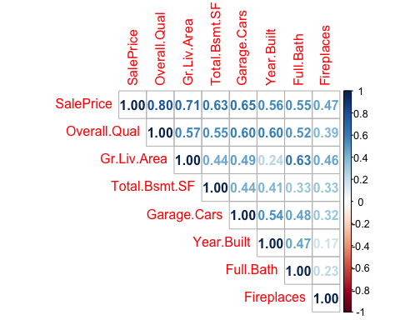
Correlation matrix for SalePrice and selected quantitative predictors
sale_correlations <- cor_matrix[-1, "SalePrice"]
strongest_cor_name <- names(which.max(abs(sale_correlations)))
strongest_cor_value <- sale_correlations[strongest_cor_name]
weakest_cor_name <- names(which.min(abs(sale_correlations)))
weakest_cor_value <- sale_correlations[weakest_cor_name]
cor_plot
## $corr
## SalePrice Overall.Qual Gr.Liv.Area Total.Bsmt.SF Garage.Cars
## SalePrice 1.0000000 0.7991402 0.7067791 0.6322603 0.6477298
## Overall.Qual 0.7991402 1.0000000 0.5705760 0.5472523 0.5993633
## Gr.Liv.Area 0.7067791 0.5705760 1.0000000 0.4448187 0.4886214
## Total.Bsmt.SF 0.6322603 0.5472523 0.4448187 1.0000000 0.4376077
## Garage.Cars 0.6477298 0.5993633 0.4886214 0.4376077 1.0000000
## Year.Built 0.5583357 0.5967964 0.2419494 0.4074787 0.5373124
## Full.Bath 0.5455776 0.5223496 0.6301070 0.3251348 0.4779974
## Fireplaces 0.4743187 0.3925955 0.4550286 0.3330070 0.3209903
## Year.Built Full.Bath Fireplaces
## SalePrice 0.5583357 0.5455776 0.4743187
## Overall.Qual 0.5967964 0.5223496 0.3925955
## Gr.Liv.Area 0.2419494 0.6301070 0.4550286
## Total.Bsmt.SF 0.4074787 0.3251348 0.3330070
## Garage.Cars 0.5373124 0.4779974 0.3209903
## Year.Built 1.0000000 0.4699359 0.1700463
## Full.Bath 0.4699359 1.0000000 0.2298495
## Fireplaces 0.1700463 0.2298495 1.0000000
##
## $corrPos
## xName yName x y corr
## 1 SalePrice SalePrice 1 8 1.0000000
## 2 Overall.Qual SalePrice 2 8 0.7991402
## 3 Overall.Qual Overall.Qual 2 7 1.0000000
## 4 Gr.Liv.Area SalePrice 3 8 0.7067791
## 5 Gr.Liv.Area Overall.Qual 3 7 0.5705760
## 6 Gr.Liv.Area Gr.Liv.Area 3 6 1.0000000
## 7 Total.Bsmt.SF SalePrice 4 8 0.6322603
## 8 Total.Bsmt.SF Overall.Qual 4 7 0.5472523
## 9 Total.Bsmt.SF Gr.Liv.Area 4 6 0.4448187
## 10 Total.Bsmt.SF Total.Bsmt.SF 4 5 1.0000000
## 11 Garage.Cars SalePrice 5 8 0.6477298
## 12 Garage.Cars Overall.Qual 5 7 0.5993633
## 13 Garage.Cars Gr.Liv.Area 5 6 0.4886214
## 14 Garage.Cars Total.Bsmt.SF 5 5 0.4376077
## 15 Garage.Cars Garage.Cars 5 4 1.0000000
## 16 Year.Built SalePrice 6 8 0.5583357
## 17 Year.Built Overall.Qual 6 7 0.5967964
## 18 Year.Built Gr.Liv.Area 6 6 0.2419494
## 19 Year.Built Total.Bsmt.SF 6 5 0.4074787
## 20 Year.Built Garage.Cars 6 4 0.5373124
## 21 Year.Built Year.Built 6 3 1.0000000
## 22 Full.Bath SalePrice 7 8 0.5455776
## 23 Full.Bath Overall.Qual 7 7 0.5223496
## 24 Full.Bath Gr.Liv.Area 7 6 0.6301070
## 25 Full.Bath Total.Bsmt.SF 7 5 0.3251348
## 26 Full.Bath Garage.Cars 7 4 0.4779974
## 27 Full.Bath Year.Built 7 3 0.4699359
## 28 Full.Bath Full.Bath 7 2 1.0000000
## 29 Fireplaces SalePrice 8 8 0.4743187
## 30 Fireplaces Overall.Qual 8 7 0.3925955
## 31 Fireplaces Gr.Liv.Area 8 6 0.4550286
## 32 Fireplaces Total.Bsmt.SF 8 5 0.3330070
## 33 Fireplaces Garage.Cars 8 4 0.3209903
## 34 Fireplaces Year.Built 8 3 0.1700463
## 35 Fireplaces Full.Bath 8 2 0.2298495
## 36 Fireplaces Fireplaces 8 1 1.0000000
##
## $arg
## $arg$type
## [1] "upper"
sale_correlations
## Overall.Qual Gr.Liv.Area Total.Bsmt.SF Garage.Cars Year.Built
## 0.7991402 0.7067791 0.6322603 0.6477298 0.5583357
## Full.Bath Fireplaces
## 0.5455776 0.4743187
strongest_cor_name
## [1] "Overall.Qual"
strongest_cor_value
## Overall.Qual
## 0.7991402
weakest_cor_name
## [1] "Fireplaces"
weakest_cor_value
## Fireplaces
## 0.4743187
Correlation measures the strength and direction of the linear relationship between two quantitative variables. Values range from -1 to +1.
Among the selected quantitative predictors, Overall.Qual has the strongest relationship with SalePrice, with a correlation of 0.799.
The weakest relationship is between Fireplaces and SalePrice, with a correlation of 0.474.
A positive correlation means that as the predictor increases, SalePrice tends to increase. A correlation closer to 1 represents a stronger positive linear relationship.

4. Multiple Linear Regression
#regression
regression_model <- lm(
SalePrice ~
Overall.Qual +
Gr.Liv.Area +
Total.Bsmt.SF +
Garage.Cars +
Year.Built +
Full.Bath +
Fireplaces +
Neighborhood +
Kitchen.Qual,
data = data_model
)
model_summary <- summary(regression_model)
model_summary
##
## Call:
## lm(formula = SalePrice ~ Overall.Qual + Gr.Liv.Area + Total.Bsmt.SF +
## Garage.Cars + Year.Built + Full.Bath + Fireplaces + Neighborhood +
## Kitchen.Qual, data = data_model)
##
## Residuals:
## Min 1Q Median 3Q Max
## -427879 -13689 -23 12868 244903
##
## Coefficients:
## Estimate Std. Error t value Pr(>|t|)
## (Intercept) -4.875e+05 8.889e+04 -5.484 4.51e-08 ***
## Overall.Qual 1.246e+04 7.702e+02 16.179 < 2e-16 ***
## Gr.Liv.Area 4.264e+01 1.937e+00 22.014 < 2e-16 ***
## Total.Bsmt.SF 2.165e+01 1.764e+00 12.272 < 2e-16 ***
## Garage.Cars 1.062e+04 1.086e+03 9.784 < 2e-16 ***
## Year.Built 2.612e+02 4.478e+01 5.834 6.03e-09 ***
## Full.Bath -1.508e+03 1.608e+03 -0.938 0.348298
## Fireplaces 9.484e+03 1.103e+03 8.596 < 2e-16 ***
## NeighborhoodBlueste -7.416e+03 1.171e+04 -0.633 0.526605
## NeighborhoodBrDale -9.649e+03 8.590e+03 -1.123 0.261398
## NeighborhoodBrkSide 1.418e+04 7.405e+03 1.914 0.055692 .
## NeighborhoodClearCr 3.100e+04 7.883e+03 3.932 8.61e-05 ***
## NeighborhoodCollgCr 2.003e+04 6.303e+03 3.178 0.001497 **
## NeighborhoodCrawfor 3.624e+04 7.184e+03 5.044 4.83e-07 ***
## NeighborhoodEdwards 6.726e+03 6.819e+03 0.986 0.324091
## NeighborhoodGilbert 1.186e+04 6.528e+03 1.817 0.069263 .
## NeighborhoodGreens 6.519e+03 1.276e+04 0.511 0.609486
## NeighborhoodGrnHill 1.197e+05 2.309e+04 5.184 2.32e-07 ***
## NeighborhoodIDOTRR 6.756e+03 7.612e+03 0.888 0.374849
## NeighborhoodLandmrk -2.107e+03 3.207e+04 -0.066 0.947613
## NeighborhoodMeadowV 7.414e+02 8.296e+03 0.089 0.928790
## NeighborhoodMitchel 1.633e+04 6.831e+03 2.391 0.016872 *
## NeighborhoodNAmes 1.223e+04 6.541e+03 1.870 0.061539 .
## NeighborhoodNoRidge 6.887e+04 7.233e+03 9.523 < 2e-16 ***
## NeighborhoodNPkVill -5.591e+03 9.020e+03 -0.620 0.535464
## NeighborhoodNridgHt 5.247e+04 6.590e+03 7.962 2.41e-15 ***
## NeighborhoodNWAmes 9.219e+03 6.731e+03 1.370 0.170897
## NeighborhoodOldTown 3.834e+03 7.222e+03 0.531 0.595557
## NeighborhoodSawyer 1.455e+04 6.851e+03 2.124 0.033750 *
## NeighborhoodSawyerW 1.066e+04 6.677e+03 1.596 0.110497
## NeighborhoodSomerst 2.491e+04 6.425e+03 3.877 0.000108 ***
## NeighborhoodStoneBr 6.791e+04 7.527e+03 9.023 < 2e-16 ***
## NeighborhoodSWISU 4.082e+03 8.200e+03 0.498 0.618681
## NeighborhoodTimber 3.298e+04 7.047e+03 4.680 2.99e-06 ***
## NeighborhoodVeenker 3.004e+04 8.862e+03 3.390 0.000709 ***
## Kitchen.QualFa -5.502e+04 5.087e+03 -10.817 < 2e-16 ***
## Kitchen.QualGd -4.876e+04 2.794e+03 -17.452 < 2e-16 ***
## Kitchen.QualPo -7.528e+04 3.208e+04 -2.346 0.019022 *
## Kitchen.QualTA -5.691e+04 3.157e+03 -18.026 < 2e-16 ***
## ---
## Signif. codes: 0 '***' 0.001 '**' 0.01 '*' 0.05 '.' 0.1 ' ' 1
##
## Residual standard error: 31450 on 2889 degrees of freedom
## Multiple R-squared: 0.847, Adjusted R-squared: 0.845
## F-statistic: 420.9 on 38 and 2889 DF, p-value: < 2.2e-16
r_squared <- model_summary$r.squared
adj_r_squared <- model_summary$adj.r.squared
f_stat <- model_summary$fstatistic
f_value <- unname(f_stat[1])
f_df1 <- unname(f_stat[2])
f_df2 <- unname(f_stat[3])
f_pvalue <- pf(
f_value,
f_df1,
f_df2,
lower.tail = FALSE
)
cat("R-squared:", round(r_squared, 4), "\n")
## R-squared: 0.847
cat("Adjusted R-squared:", round(adj_r_squared, 4), "\n")
## Adjusted R-squared: 0.845
cat("F-statistic:", round(f_value, 3), "\n")
## F-statistic: 420.918
cat("F-test p-value:", f_pvalue, "\n")
## F-test p-value: 0
The model has an R-squared of 0.847. Therefore, approximately 84.7% of the variation in SalePrice is explained by the predictors included in the regression model.
The Adjusted R-squared is 0.845. Adjusted R-squared accounts for the number of predictors in the model. A value close to R-squared suggests that the model is not gaining much explanatory power simply by adding unnecessary predictors.
The overall F-statistic is 420.92, with a p-value of <0.001.
The F-test is statistically significant, meaning that the predictors collectively explain a significant amount of variation in SalePrice.

5. Residual Analysis
Residual plots are used to examine whether the regression errors appear randomly distributed around zero and whether there are signs of nonlinearity, unequal variance, or unusual observations. The assignment asks for residual plots based on coefficient magnitude and t-statistics. Because categorical predictors create multiple dummy coefficients that cannot be represented by one continuous x-axis, this comparison is performed among the selected quantitative predictors.
# Save residuals
model_residuals <- residuals(regression_model)
# Quantitative predictors used in the regression
numeric_predictors <- c(
"Overall.Qual",
"Gr.Liv.Area",
"Total.Bsmt.SF",
"Garage.Cars",
"Year.Built",
"Full.Bath",
"Fireplaces"
)
# Coefficient table without intercept
coef_table <- summary(regression_model)$coefficients
# Keep only quantitative predictors
numeric_coef <- coef_table[
rownames(coef_table) %in% numeric_predictors,
,
drop = FALSE
]
# Statistically significant coefficients
significant_coef <- numeric_coef[
numeric_coef[, "Pr(>|t|)"] < 0.05,
,
drop = FALSE
]
# Highest coefficient magnitude among significant predictors
highest_coef_var <- rownames(significant_coef)[
which.max(abs(significant_coef[, "Estimate"]))
]
# Highest absolute t-statistic among significant predictors
highest_t_var <- rownames(significant_coef)[
which.max(abs(significant_coef[, "t value"]))
]
# Lowest coefficient magnitude
lowest_coef_var <- rownames(numeric_coef)[
which.min(abs(numeric_coef[, "Estimate"]))
]
# Lowest absolute t-statistic
lowest_t_var <- rownames(numeric_coef)[
which.min(abs(numeric_coef[, "t value"]))
]
selection_table <- data.frame(
Criterion = c(
"Highest significant coefficient magnitude",
"Highest significant t-statistic",
"Lowest coefficient magnitude",
"Lowest t-statistic"
),
Predictor = c(
highest_coef_var,
highest_t_var,
lowest_coef_var,
lowest_t_var
)
)
knitr::kable(
selection_table,
caption = "Predictors Selected for Residual Analysis")
Predictors Selected for Residual Analysis
Criterion | Predictor
Highest significant coefficient magnitude | Overall.Qual
Highest significant t-statistic | Gr.Liv.Area
Lowest coefficient magnitude | Total.Bsmt.SF
Lowest t-statistic | Full.Bath
plot_residuals <- function(variable, title_text) {
plot(
data_model[[variable]],
model_residuals,
xlab = variable,
ylab = "Residuals",
main = title_text
)
abline(h = 0, lty = 2, lwd = 2)
}
a <- plot_residuals(
highest_coef_var,
paste("Residuals vs", highest_coef_var,
"- Highest Coefficient Magnitude")
)
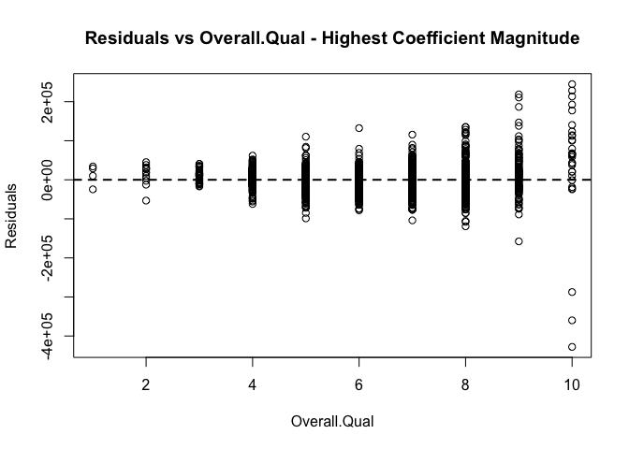
b <- plot_residuals(
highest_t_var,
paste("Residuals vs", highest_t_var,
"- Highest t-statistic")
)
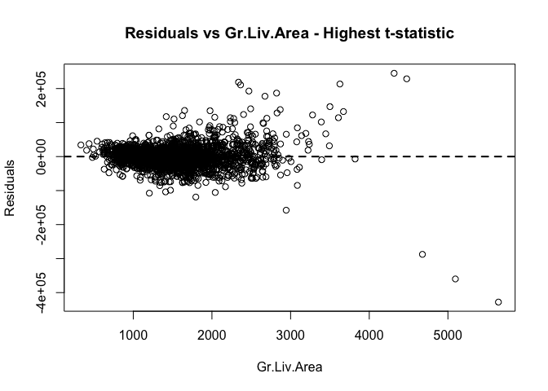
c <- plot_residuals(
lowest_coef_var,
paste("Residuals vs", lowest_coef_var,
"- Lowest Coefficient Magnitude")
)
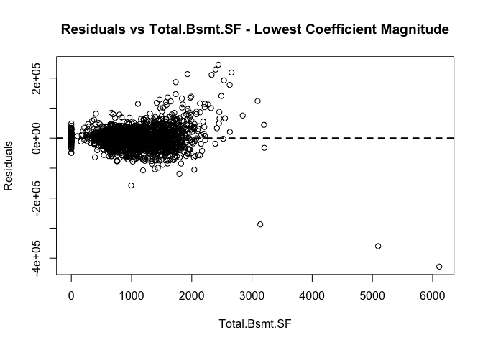
d <- plot_residuals(
lowest_t_var,
paste("Residuals vs", lowest_t_var,
"- Lowest t-statistic")
)
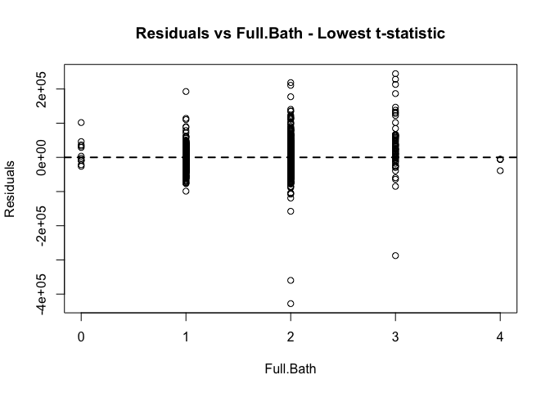
a
## NULL
b
## NULL
c
## NULL
d
## NULL

Regression Coefficient Review
A regression coefficient estimates how much SalePrice changes when one predictor increases by one unit while the other predictors are held constant.
For example:
- Overall.Qual: coefficient = 1.246156^{4}. A one-point increase in overall house quality is associated with an estimated $12,462 increase in SalePrice, holding the other variables constant.
- Gr.Liv.Area: coefficient = 42.64. One additional square foot of above-ground living space is associated with approximately $42.64 higher SalePrice, holding other variables constant.
- Garage.Cars: coefficient = 1.062103^{4}. Increasing garage capacity by one car is associated with approximately $10,621 higher predicted SalePrice.

Statistical Significance
Statistical significance is evaluated using the p-value. At the 5% significance level, a predictor is considered statistically significant when p < 0.05.
Overall.Qual has a p-value of <0.001, so it is statistically significant.
Gr.Liv.Area has a p-value of <0.001, so it is statistically significant.
A statistically significant predictor provides evidence of an association with SalePrice after controlling for the other predictors in the regression model.

Residual Analysis Review
Residuals are the differences between the actual SalePrice and the SalePrice predicted by the regression model.
The statistically significant quantitative predictor with the largest coefficient magnitude is Overall.Qual.
The statistically significant quantitative predictor with the largest absolute t-statistic is Gr.Liv.Area.
The predictor with the smallest coefficient magnitude is Total.Bsmt.SF, while the predictor with the smallest absolute t-statistic is Full.Bath.
A satisfactory residual plot should show observations scattered randomly around zero with approximately constant spread. Curvature may indicate a nonlinear relationship, while a funnel-shaped pattern may indicate heteroscedasticity.

6. Q-Q Plot and Outlier Analysis
# Calculate studentized residuals
student_residual <- rstudent(regression_model)
# Generate Q-Q plot and label top 5 unusual observations
qq_outliers <- car::qqPlot(
student_residual,
id = list(n = 5),
main = "Q-Q Plot of Studentized Residuals"
)
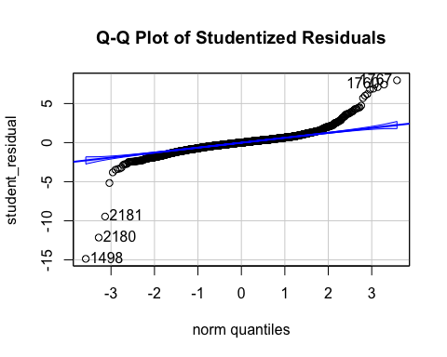
qq_outliers
## [1] 1498 2180 2181 1767 1760
The Q-Q plot evaluates whether the regression residuals are approximately normally distributed.
If most points follow the reference line, the normality assumption is reasonably satisfied. Points that move substantially away from the line, especially in the upper or lower tails, indicate possible departures from normality.
The five observations labeled on the graph have the largest deviations and are treated as potential outliers. Their studentized residuals are reported in the table above.

7. Multicollinearity
# if VIF < 5 -> generally no multi-collinearity
vif_result <- vif(regression_model)
vif_result
## GVIF Df GVIF^(1/(2*Df))
## Overall.Qual 3.493723 1 1.869150
## Gr.Liv.Area 2.836449 1 1.684176
## Total.Bsmt.SF 1.787964 1 1.337148
## Garage.Cars 2.016728 1 1.420115
## Year.Built 5.425120 1 2.329189
## Full.Bath 2.339460 1 1.529529
## Fireplaces 1.512059 1 1.229658
## Neighborhood 16.615294 27 1.053421
## Kitchen.Qual 2.936216 4 1.144125
Variance Inflation Factors (VIF) were used to evaluate multicollinearity among the explanatory variables. For predictors with one degree of freedom, VIF values below approximately 5 generally indicate that multicollinearity is not a serious concern. Higher values indicate stronger relationships among explanatory variables. Because Neighborhood and Kitchen.Qual contain multiple categories, the car package may report generalized variance inflation factors (GVIF).

8. Conclusion
This analysis developed a multiple linear regression model to explain house SalePrice in Ames, Iowa using housing quality, living area, basement size, garage capacity, year built, bathrooms, fireplaces, neighborhood, and kitchen quality.
The fitted model explains approximately 84.7% of the observed variation in SalePrice, with an adjusted R-squared of 0.845.
The overall regression F-test is statistically significant, indicating that the selected predictors jointly contribute to explaining SalePrice.
Model adequacy was further evaluated using residual plots, the Q-Q plot, studentized residuals, and multicollinearity diagnostics. These results should be considered together when assessing the usefulness and limitations of the fitted regression model.

