## Criterion B: Design

## Design Overview:

**Web Page Hierarchy:**

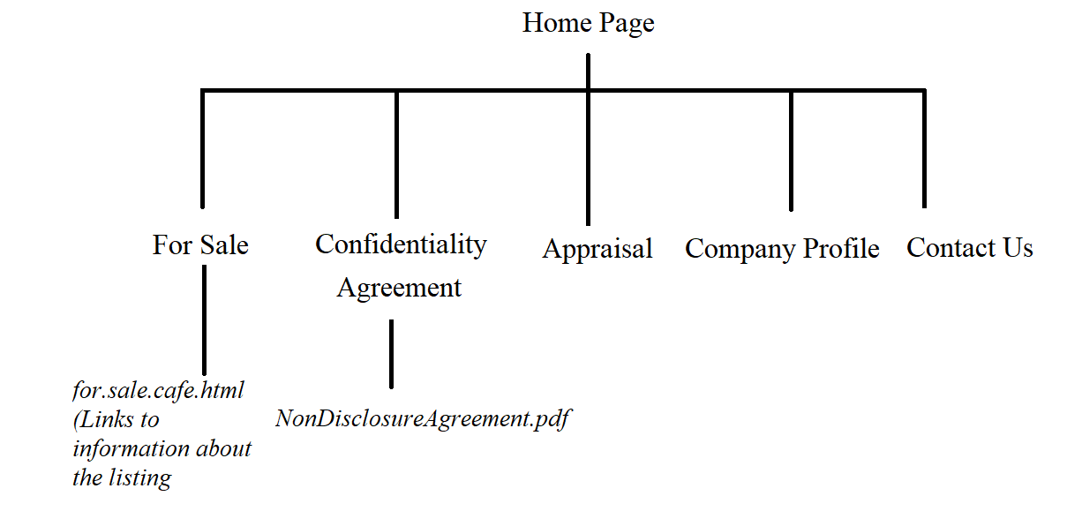

**File Structure**

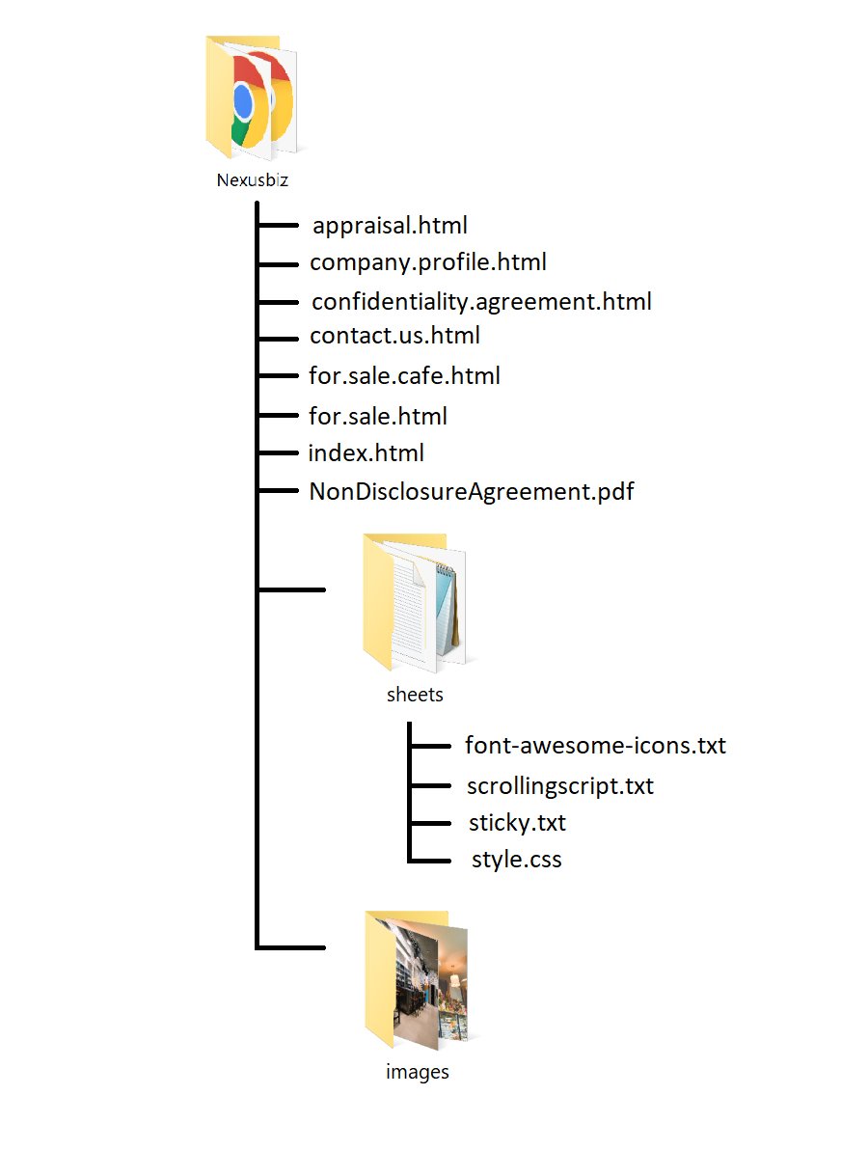

The following are a series of storyboards which outlined the design of the potential structure of each webpage to be created, drawn before the creation of the subsequent webpage.

**Home page**

**Initial designs:**

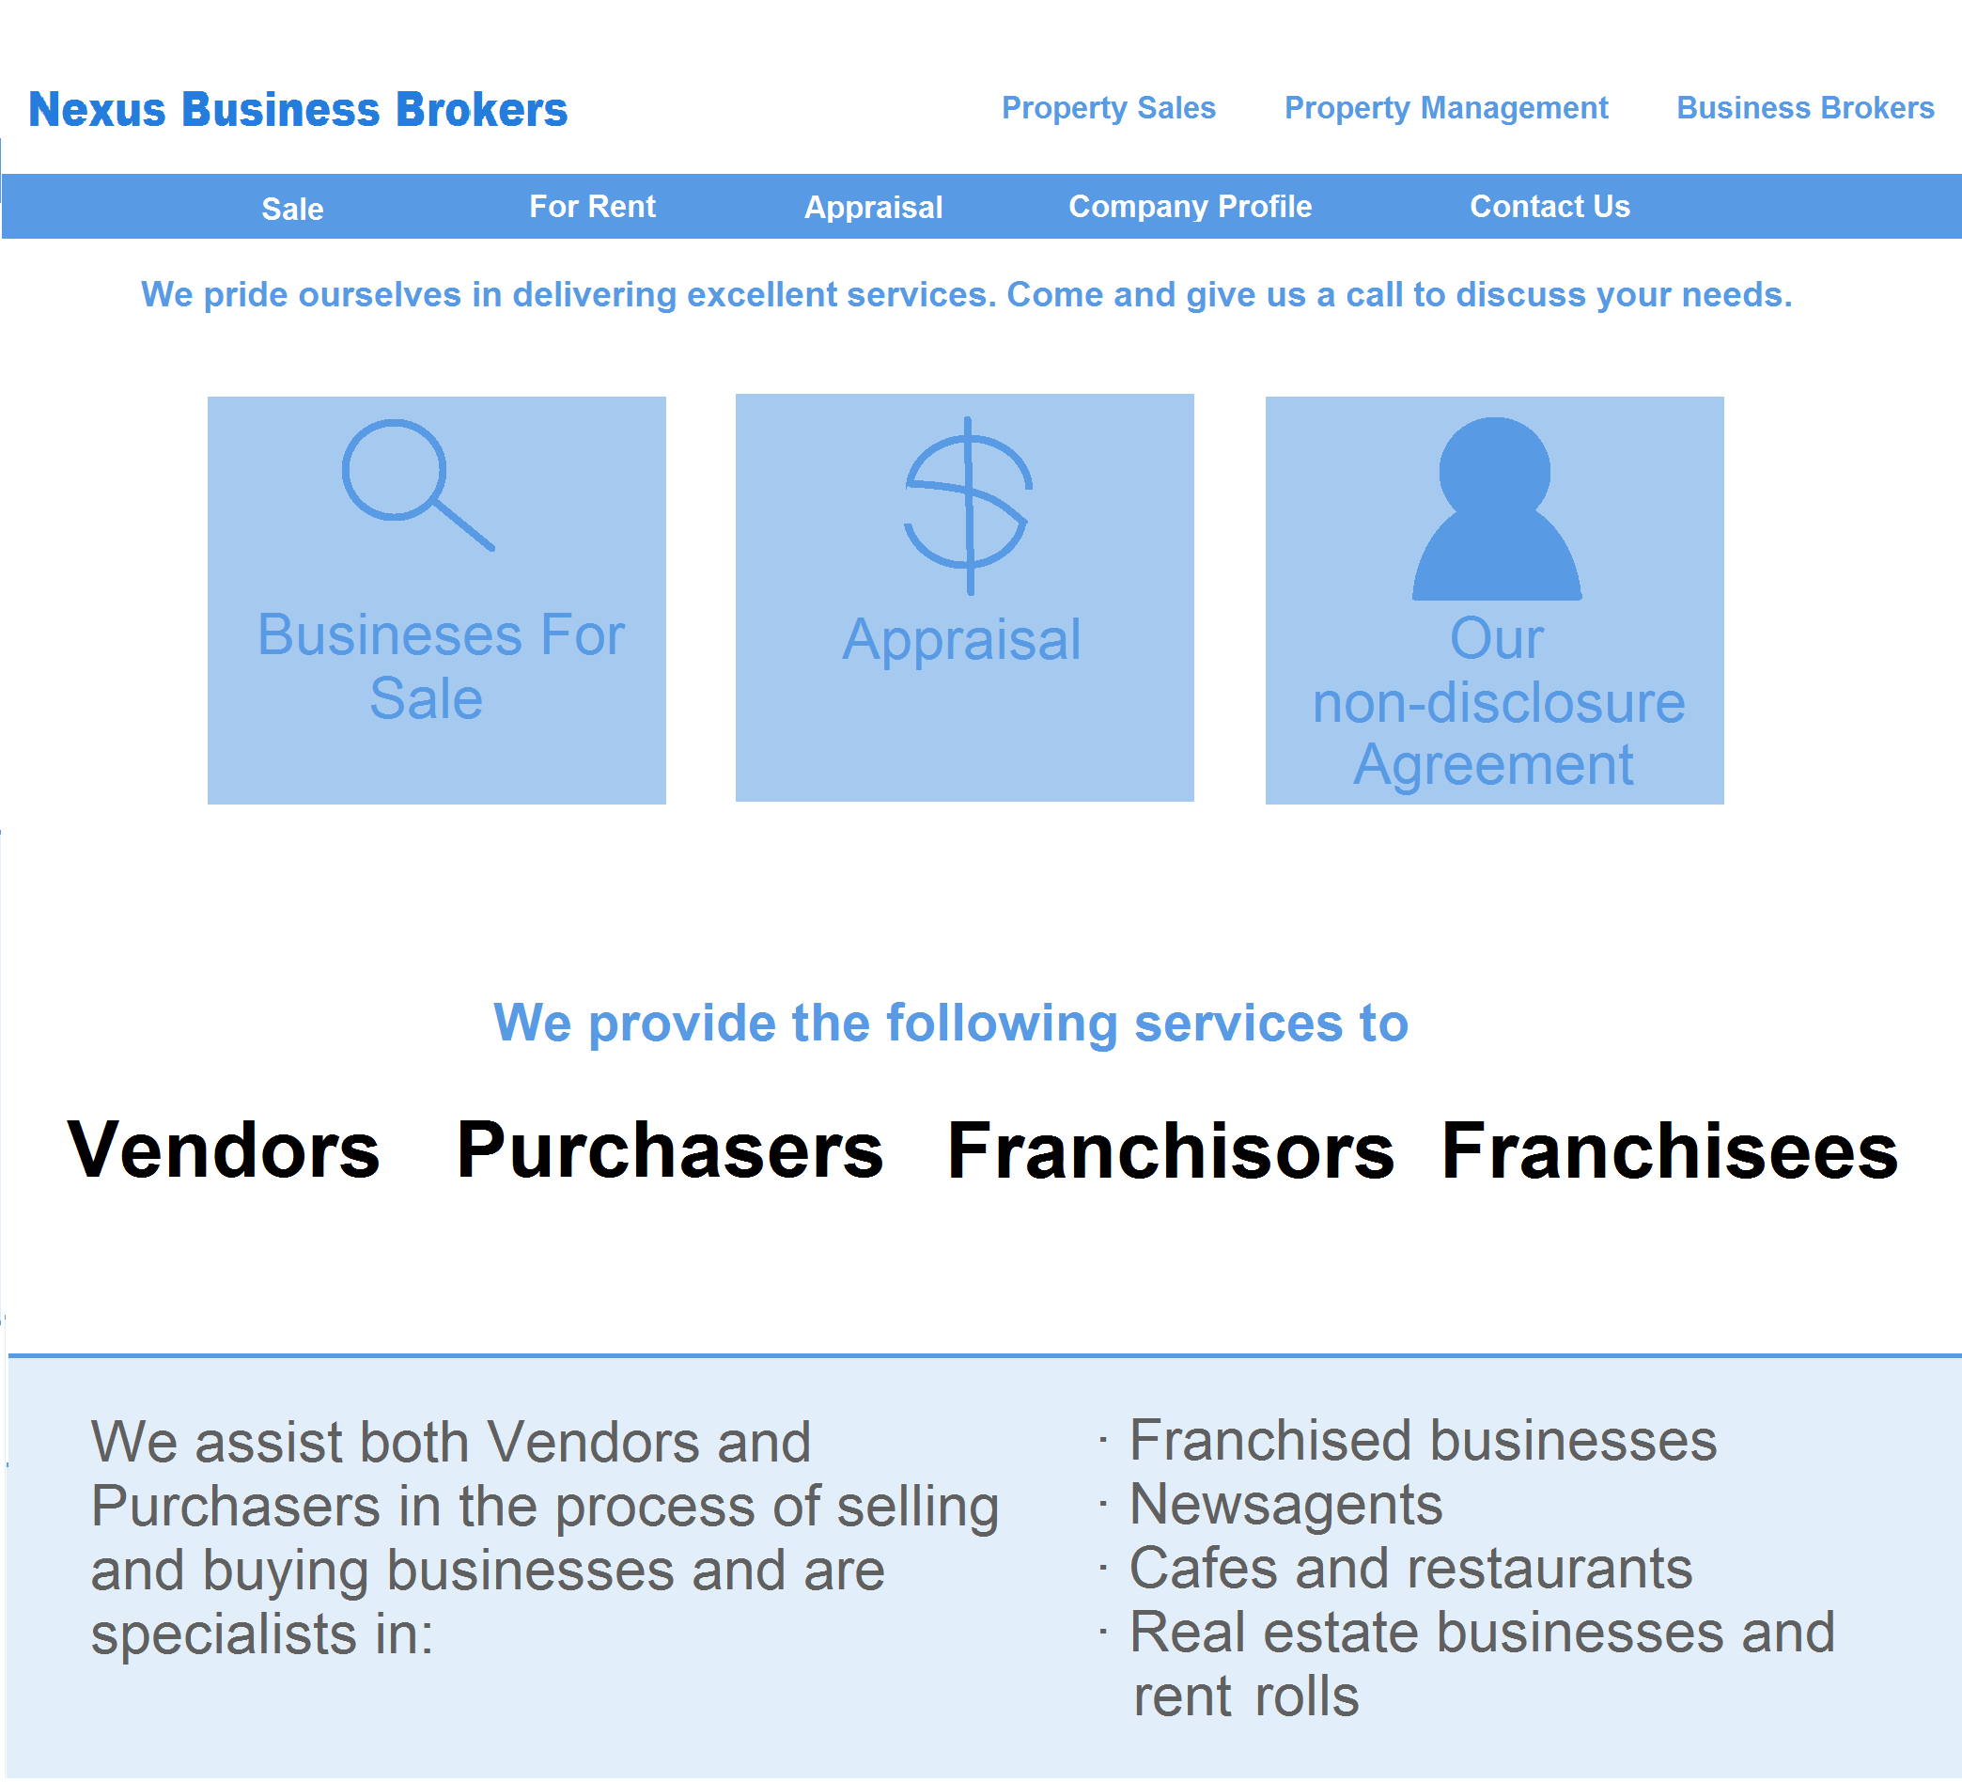

**After Iteration:**



**For Sale Page:**

**After iteration:**

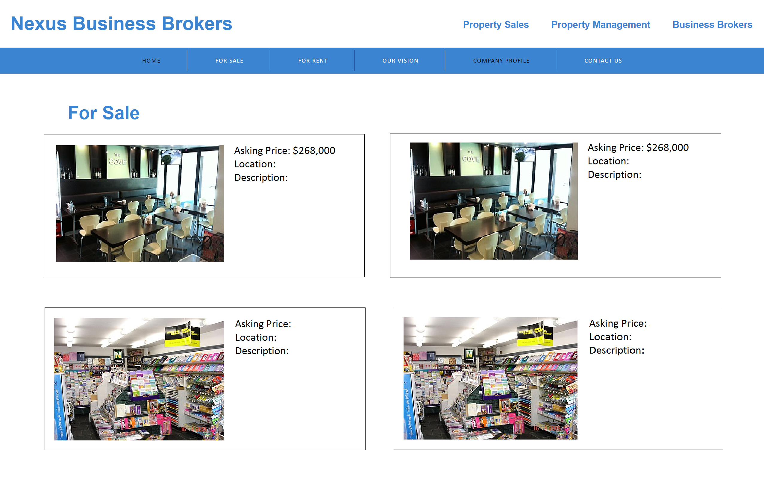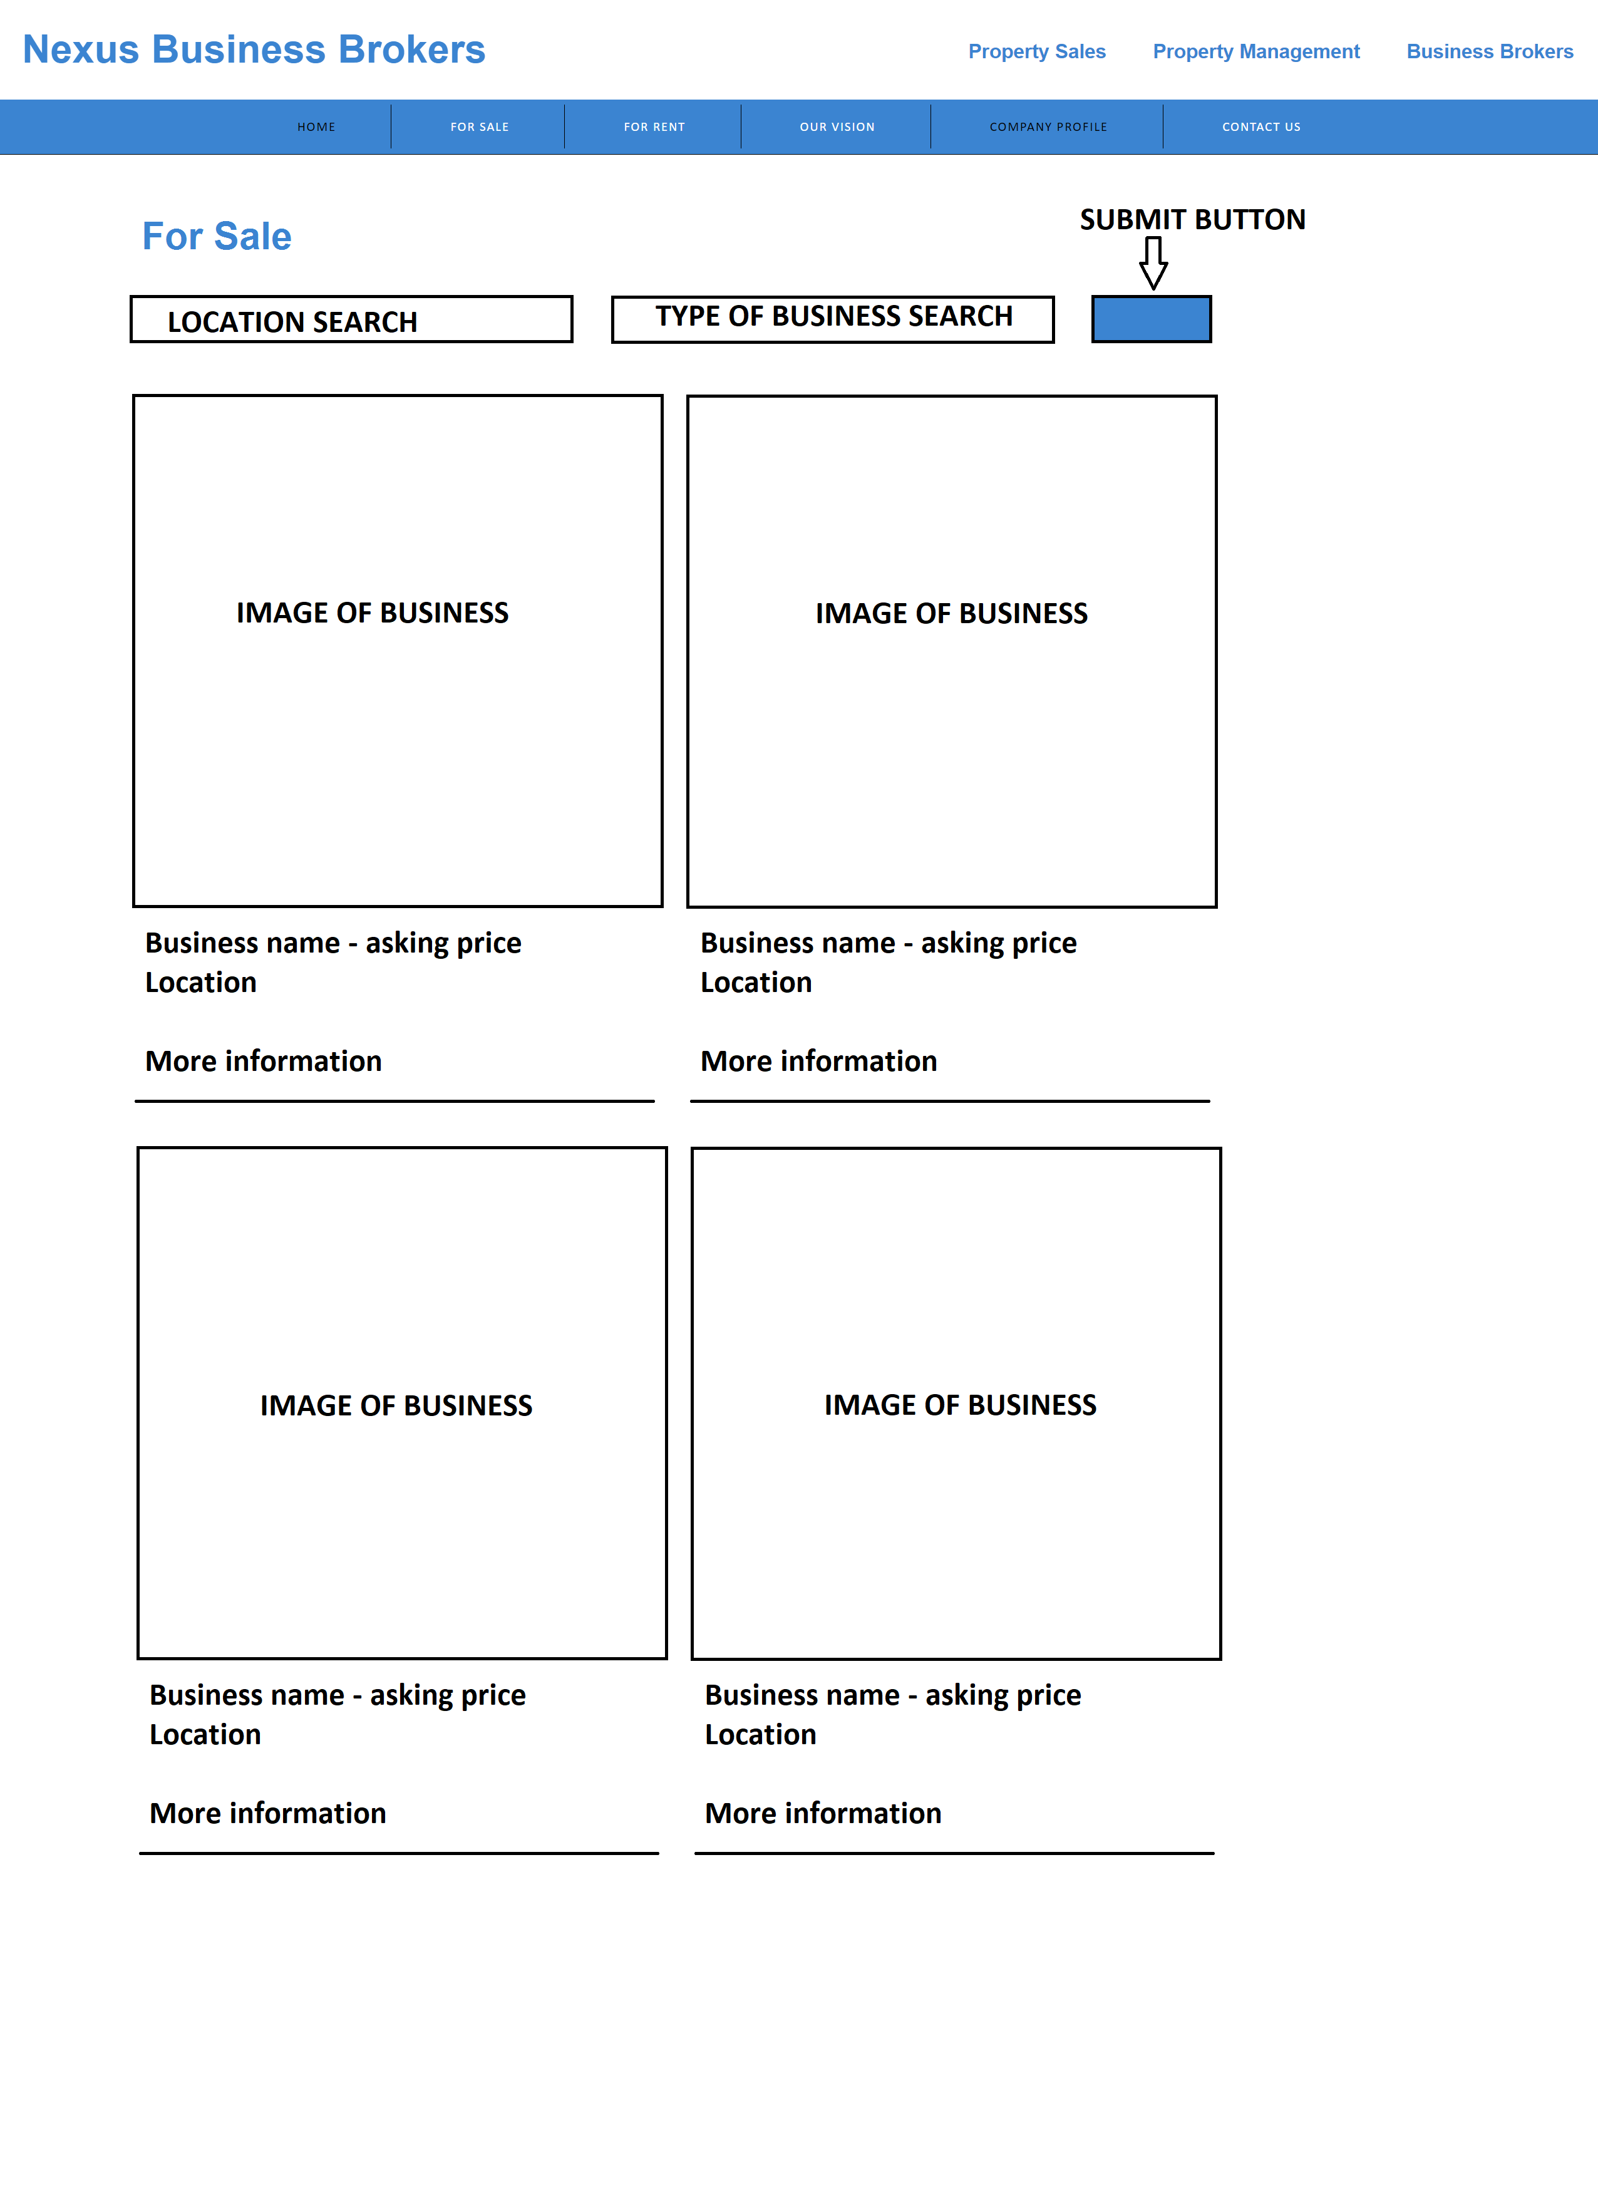

**Listing profile**

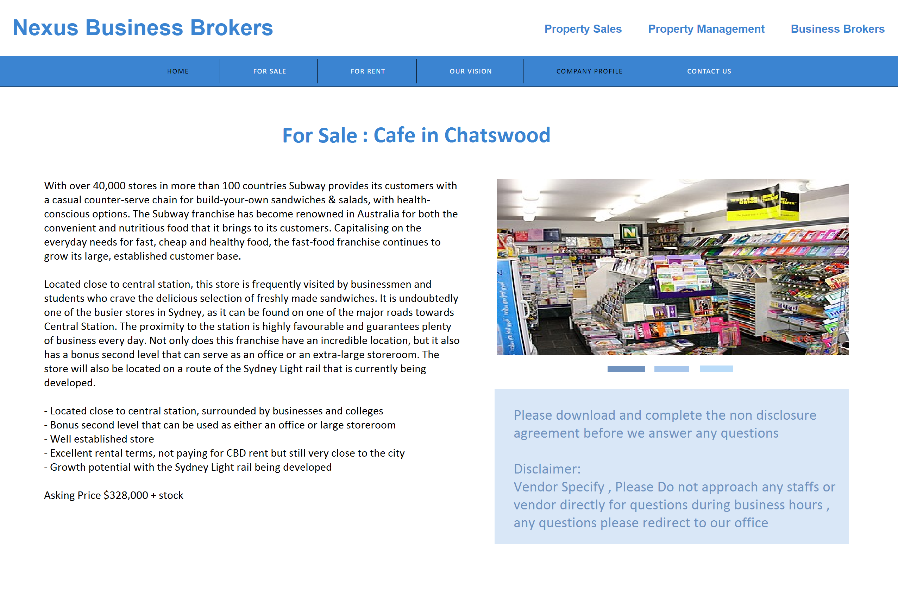

**After iteration:**

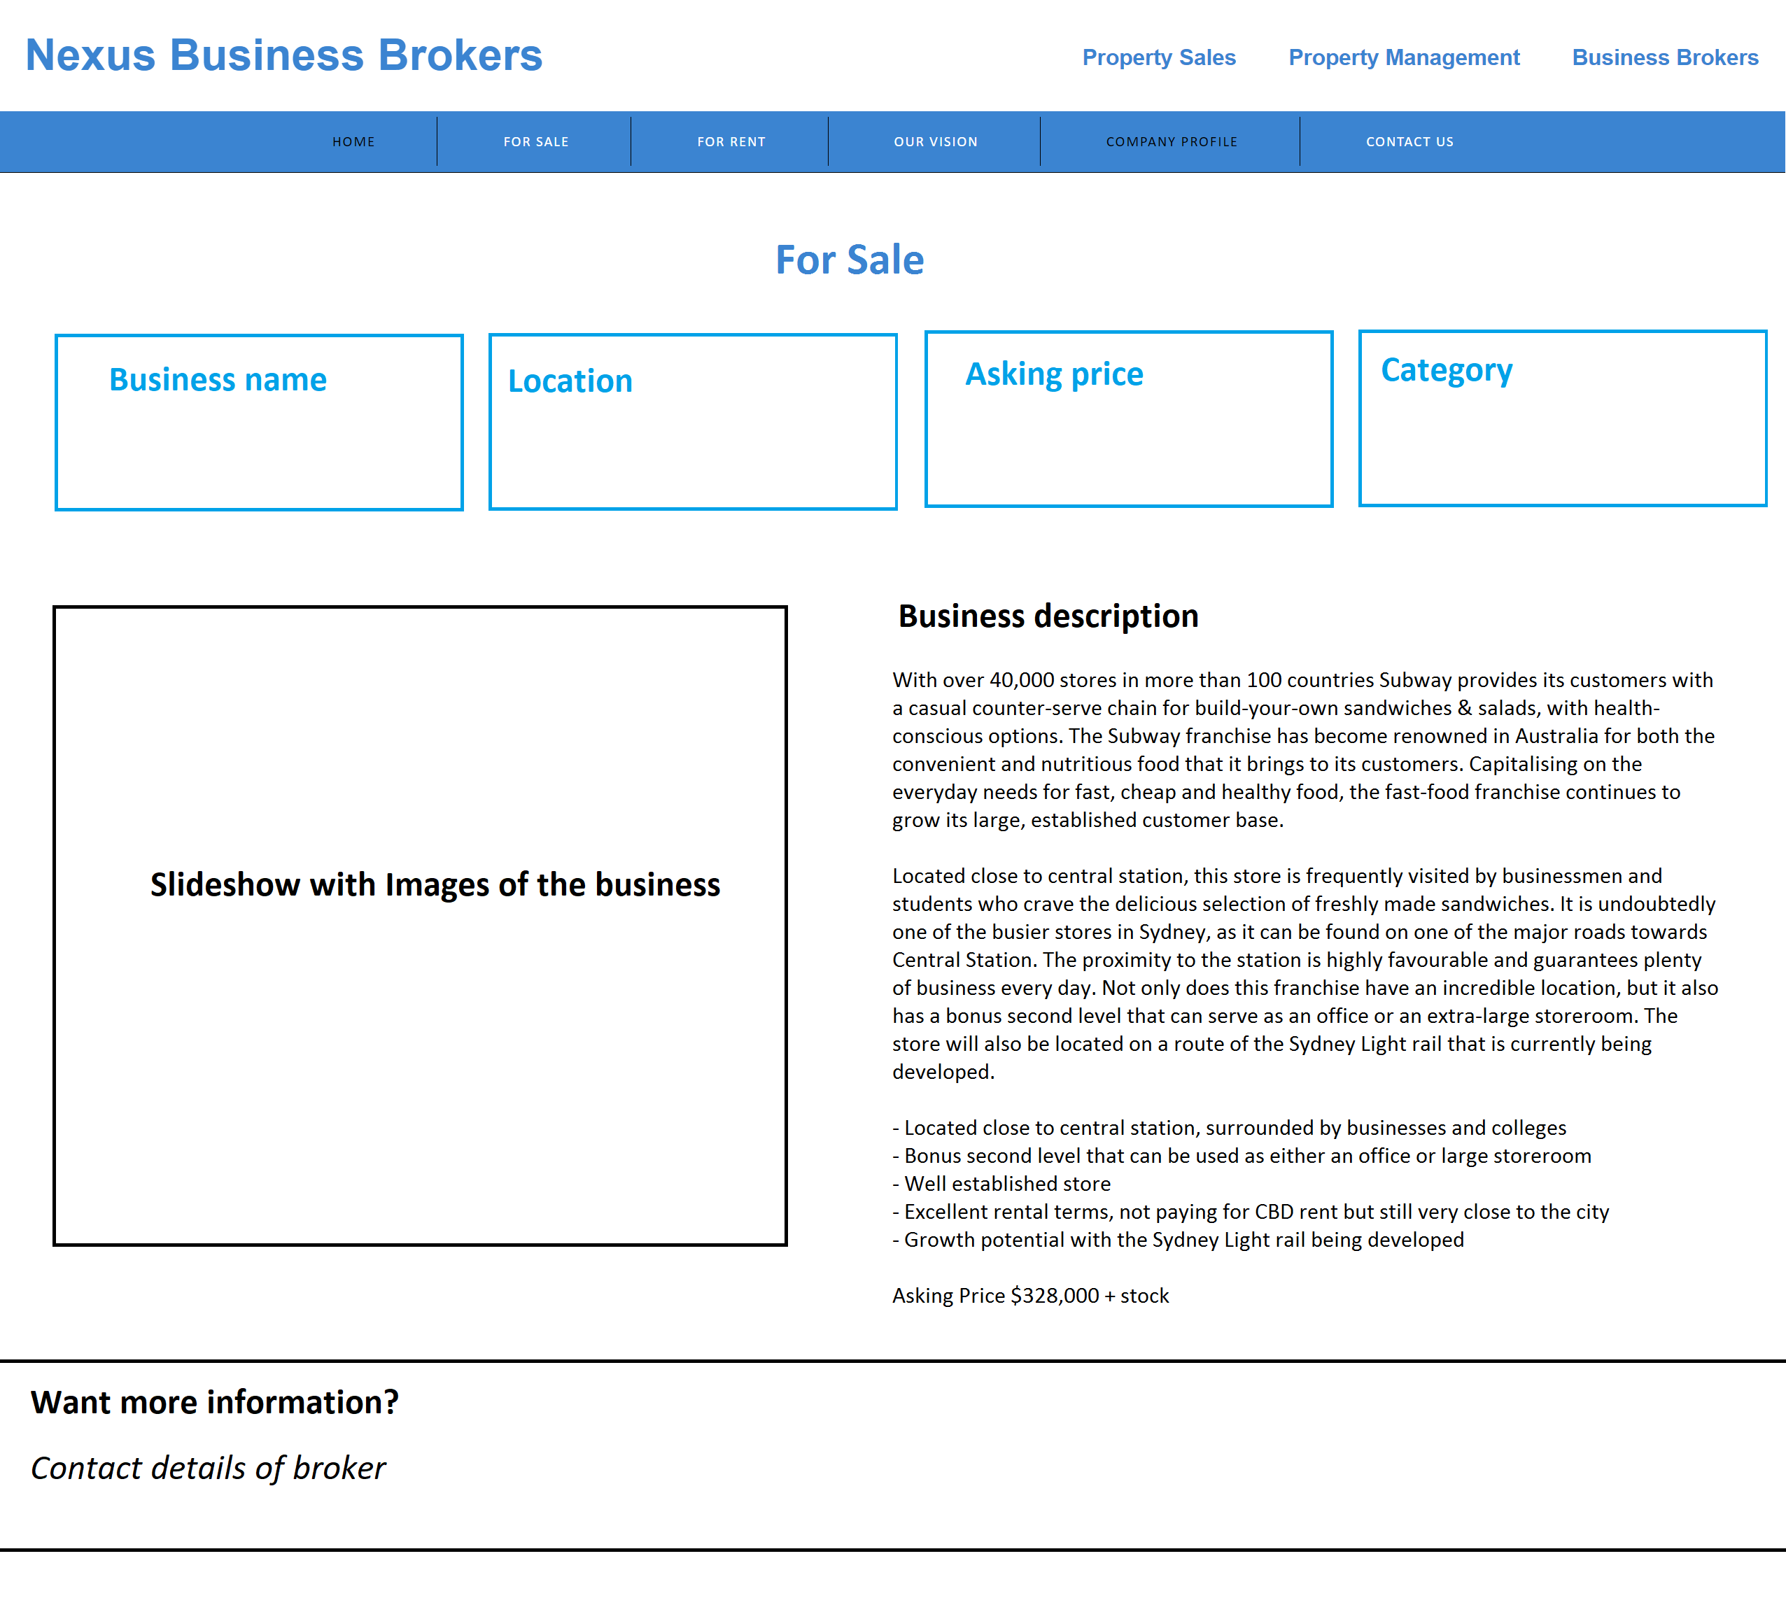

**Company Profile**

**Confidentiality Agreement**

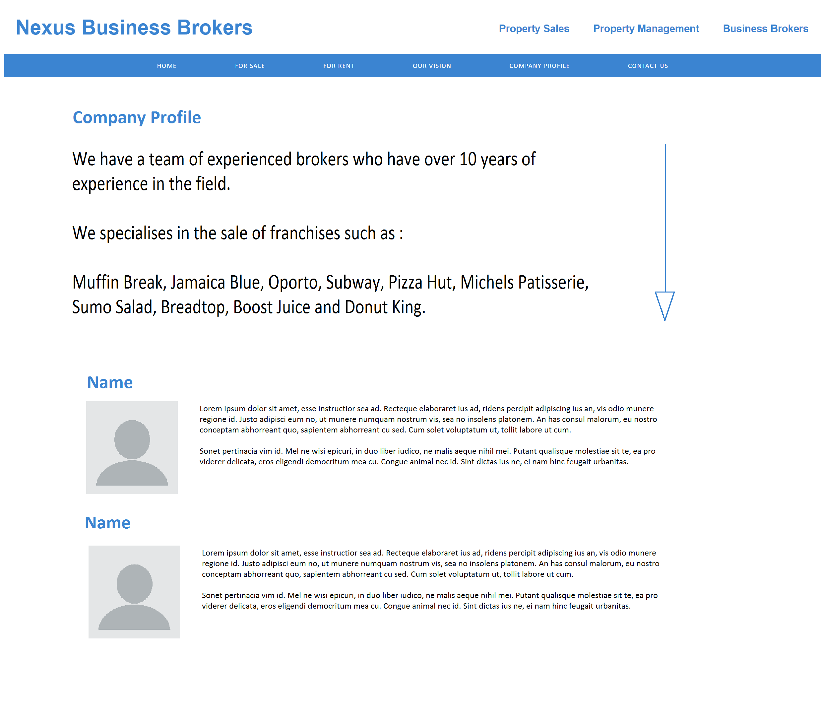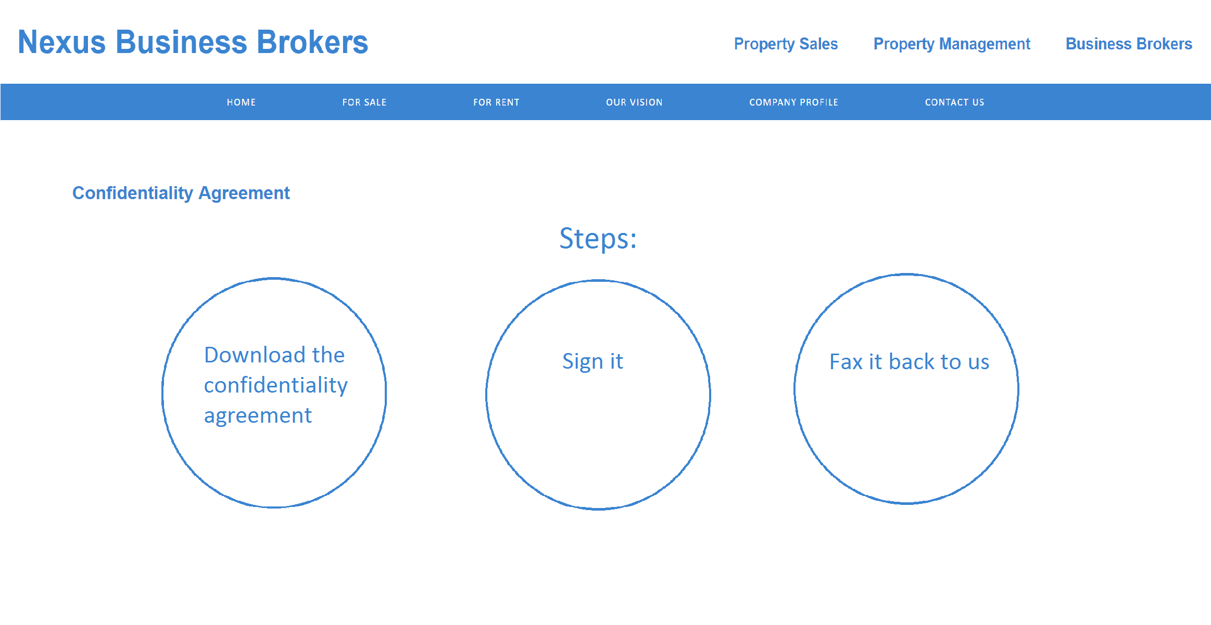

**Appraisal Form:**

**Contact Us Page**

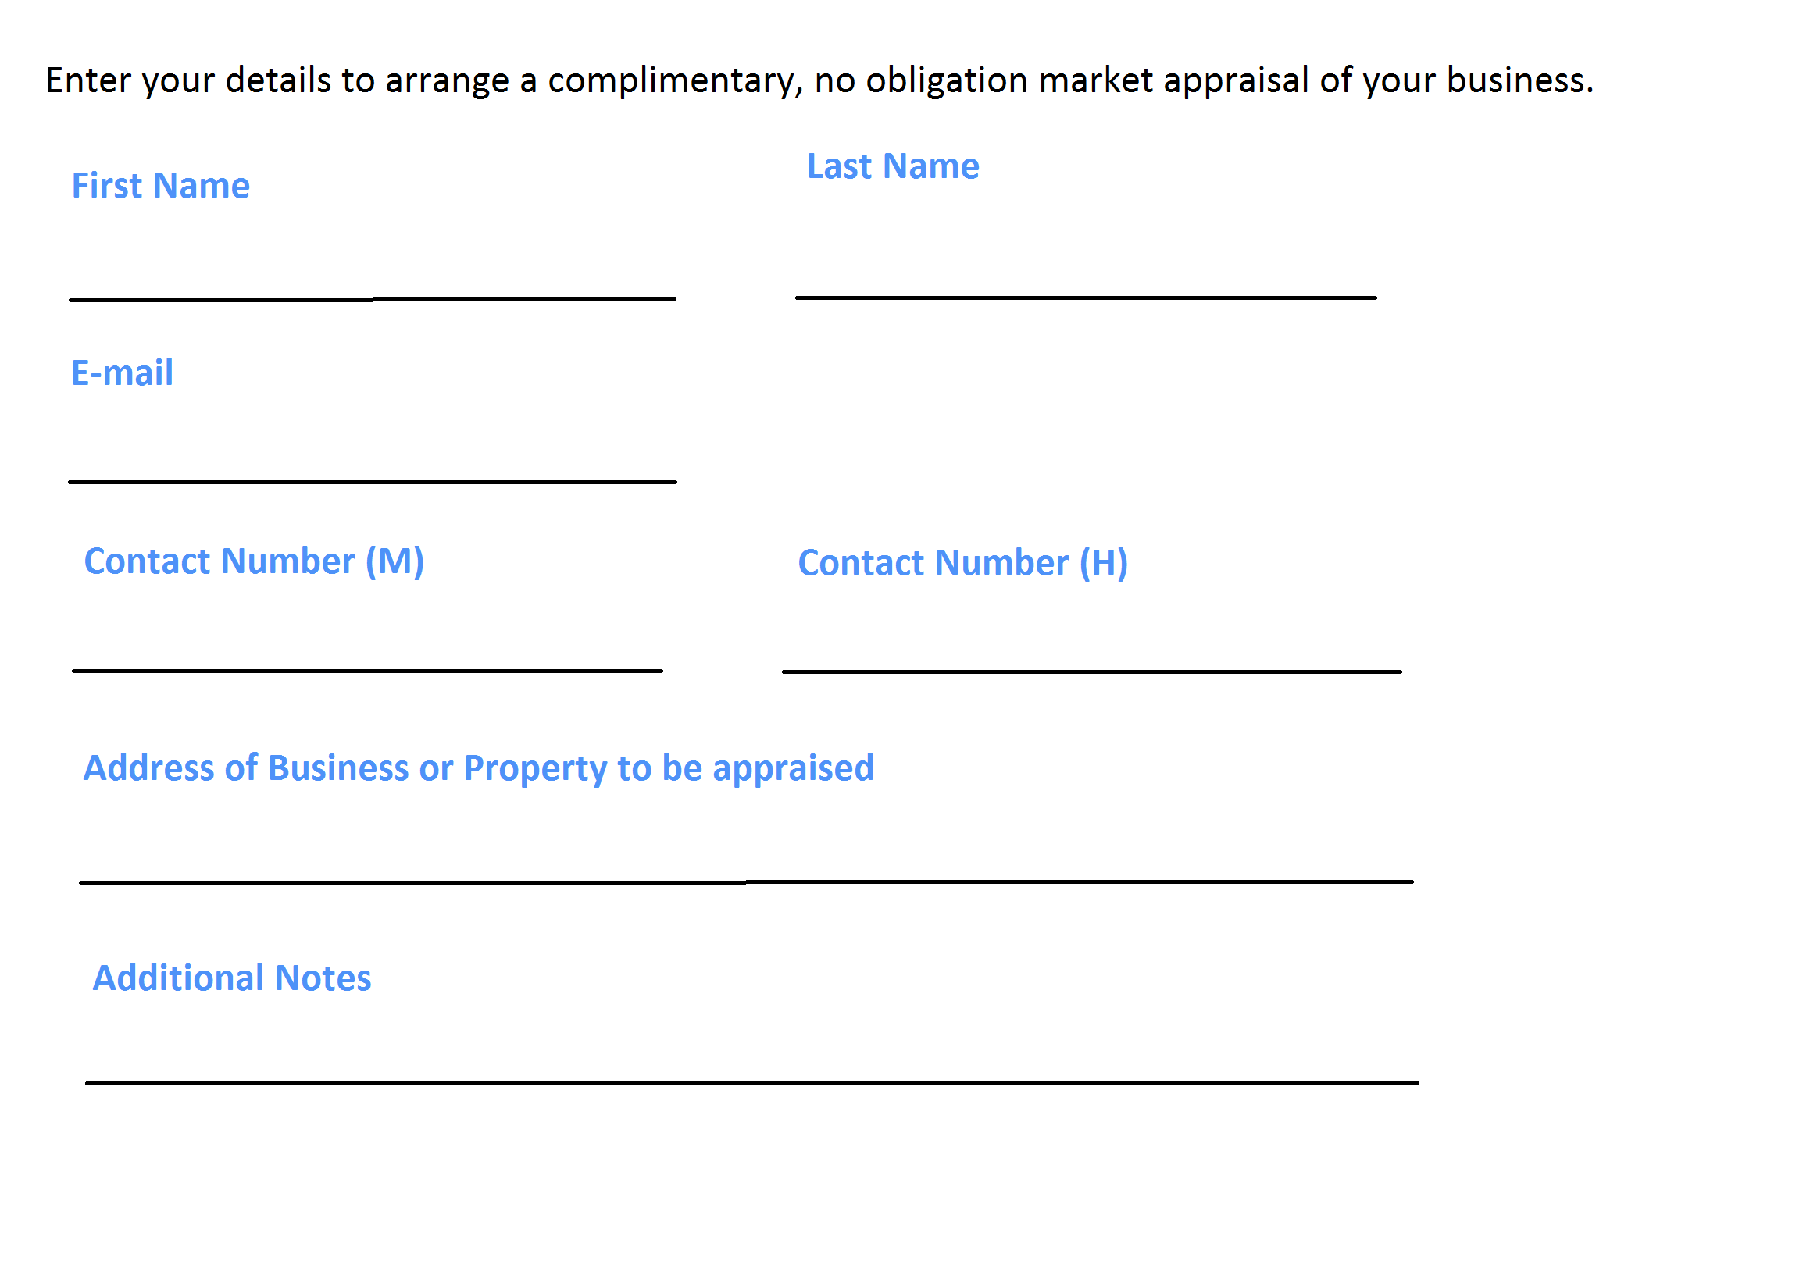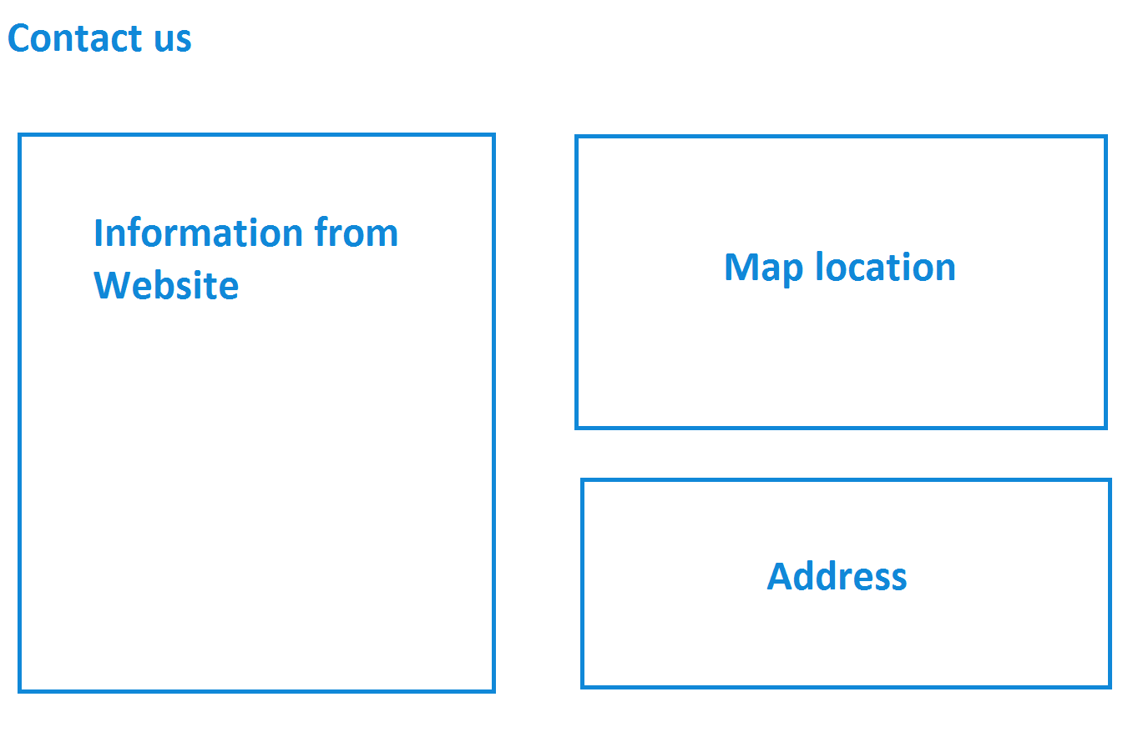

# Testing Plan

|  |  |  |  |
| --- | --- | --- | --- |
| Action to Test | Files Tested | Method of Testing | Result of Test |
| Navigation bar sticks to the top of the webpage after being scrolled past. | All pages | Implemented the JavaScript code and opened the file in Google Chrome | Success |
| Non-Disclosure Agreement can be downloaded | confidentiality.agreement.html | Clicked on the link that linked to the PDF file | Success |
| Text can be input into the appraisal form | appraisal.html | Attempt to type text in all input areas | Success |
| Submit Button results in a popup being executed and that it smooth scrolls to the top of the page | appraisal.html | Press the submit button at the bottom of the page | Success |
| Map to the office is displayed correctly | contact.us.html | Open the file in Google Chrome | Success |
| Slider at the bottom of the homepage provides the correct commission amount and displays the correct value input. | Index.html | Open the website on Google Chrome and test the slider. Test for different values on the slider and use a calculator to determine whether it calculates the correct commission. | Success |
| Each page has the correct links | All pages | Navigate through all links and ensure that they are correct. | Success |
| Pages look aesthetic on different screen sizes | All pages | * Navigate the website using a large desktop screen, resizing the webpage when browsing. * Zoom in and out of the webpage | Success |

58 words