## Criterion C: Development

Techniques used

* HTML
* CSS
* JavaScript
* JQuery

HTML5

HTML5 is a mark-up language used for structuring and presenting content on the World Wide Web. I chose to use HTML5 because it is widely supported by many browsers and is simple and easy to use. HTML5 allowed me to structure pages on my website and display links that users can navigate through. (Criteria 3)

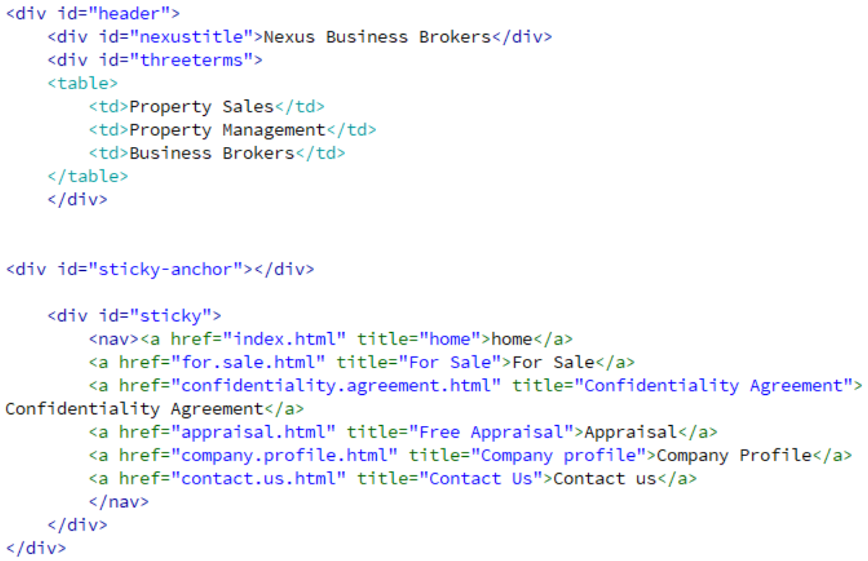

Cascading Style Sheets

CSS is a style sheet language that is used to describe the presentation of a document written in HTML5. CSS was used in showing how elements in my webpage were to be displayed, and was necessary to satisfy my requirements (Criteria 1 and 6) in making the website aesthetically pleasing and professional whilst being coded to suit a variety of screen sizes. In achieving this aim, CSS played a very important role as it allowed me to style elements of the website and customize features such as inputs, buttons and links on the webpage.

For example, the @media rule was used to make the text disappear if the screen size was small. As well as this, the use of % widths in most elements of the webpage such as the navigation bar, meant that the webpage can be resized and retain its aesthetic value.

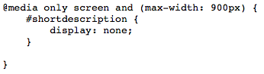

*Below, the following screenshots of the website compare how the home page would be displayed on screens of a different size.*

JavaScript



JavaScript is a scripting language used to add client-side behaviour to HTML pages and allows for dynamic interaction. Using JavaScript allowed me to include animations and effects such as a sticky navigation bar, a popup and a slideshow, that brought my website to a greater level of design complexity. Such functions would have also been very difficult to implement without its use.

To make my navigation bar stick, JavaScript was used to relocate the #sticky to the top of the page after scrolling down so that it always stays at the top of the page.

*Below is JavaScript code from the file sticky.txt that was applied to each webpage*

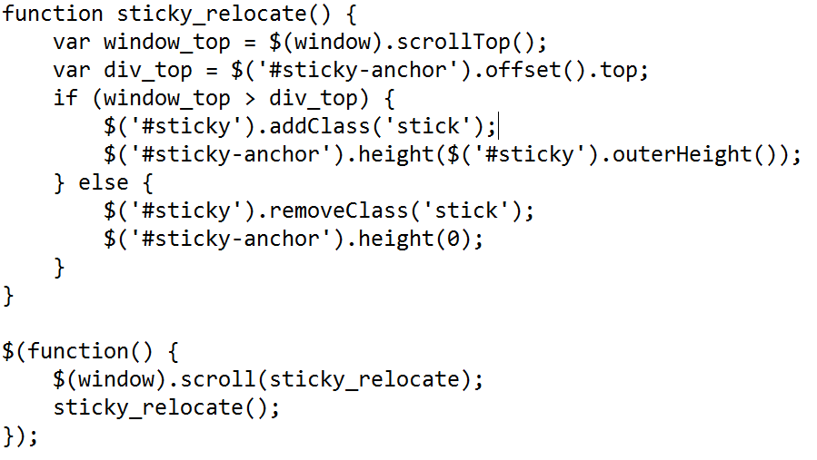

JavaScript was also used in creating my ‘appraisal.html’ page.

The following piece of JavaScript:

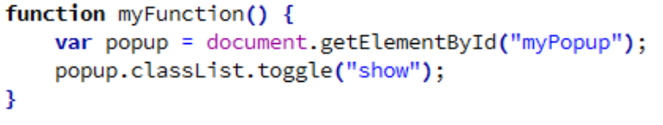

Interacted with HTML:

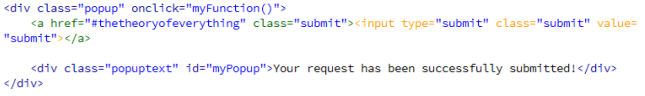

This meant that when the submit button at the bottom of the page was clicked, this would trigger a function that caused a popup to show.

JQuery

JQuery is a JavaScript library which simplifies the client-side scripting of HTML. It increases the productivity of the developer and allows them to achieve functionality with a smaller amount of code. In my project, I incorporated a widget provided by jQuery UI.

Using jQuery/JavaScript, I also demonstrated algorithmic thinking in creating a slider to show how the owner prices the commission they receive for helping to sell a business.

Through jQuery and JavaScript, I created a slider which calculated the price of commission using if statements that changed the value of the commission based off the value of the user’s input. The amount of commission, held in the variable ‘Comm’ was then rounded to 2 decimal places and set as the value of an input bar.

*The following is a screenshot of my code for the slider featured in index.html*

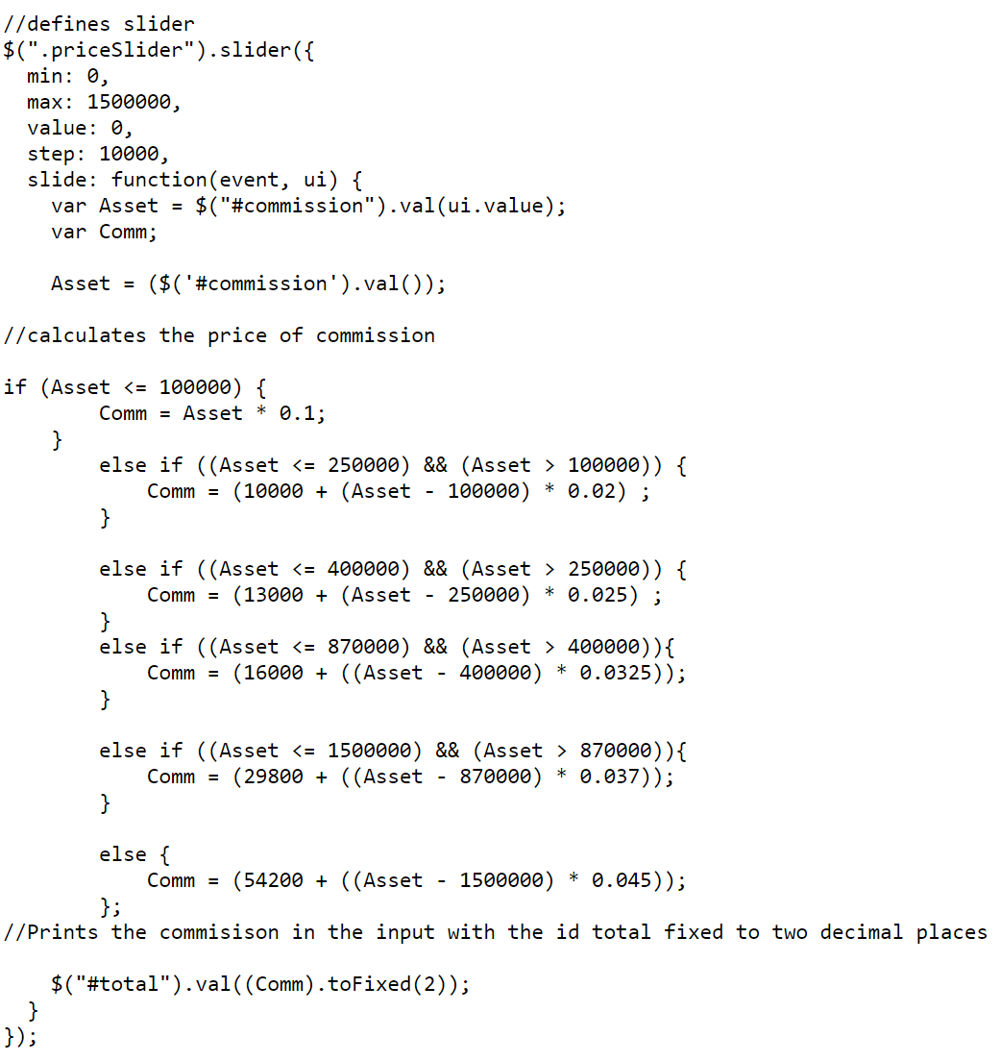

*This is a screenshot of the html used to display the slider on the webpage*

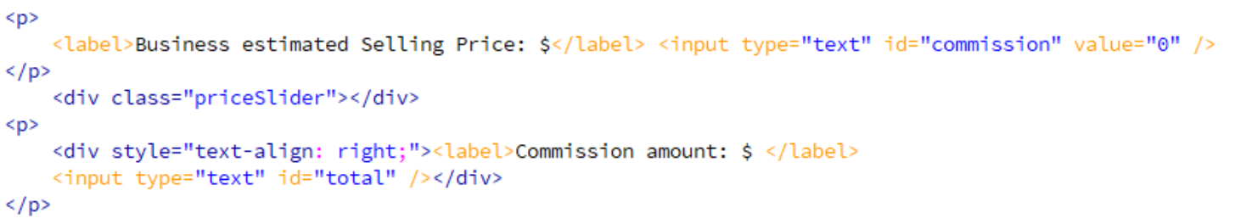

# Tools used

Font Awesome Icons[1]

“A tool that provides scalable vector icons” that can be customised using CSS. This was included in various pages of my website such as ‘for.sale.cafe.html’ and ‘for.sale.html’ and was very easy to use.

Hover.css by Ian Lunn[2]

“A collection of CSS3 powered hover effects that can be applied to links, buttons…and so on”, was referenced and manipulated in the creation of my submit button on the appraisal page and for sale page and was edited to achieve an interesting effect upon hovering the button using CSS.

Sticky div at top after scrolling[3]

This code was referenced to create my navigation bar which stuck to the top of the page after scrolling. I used the code for my website but heavily edited the element using CSS for my website.

JQuery UI[4]

“JQuery UI is a curated set of user interface interactions, effects, widgets and themes build on top of the jQuery JavaScript Library.” In my project, I used a slider widget to create dynamic interaction in my website where an estimated pricing amount could be calculated when the estimated selling price of a business to be sold was entered in the slider.

Google Fonts[5]

Google fonts is a “directory of open source designer web fonts” developed by Google, supported by a variety of web browsers. Google fonts is also highly accessible through its use of technology such as cross-site caching and the use of the WOFF 2.0 compression when available, making the web faster for all users “particularly in areas where bandwidth and connectivity are an issue”. Fonts can easily be applied to web pages through a stylesheet link which I added to my style.css file through the following line of CSS:



I then applied the fonts that I chose to various classes and id’s in my website which helped my website look very professional. For example:

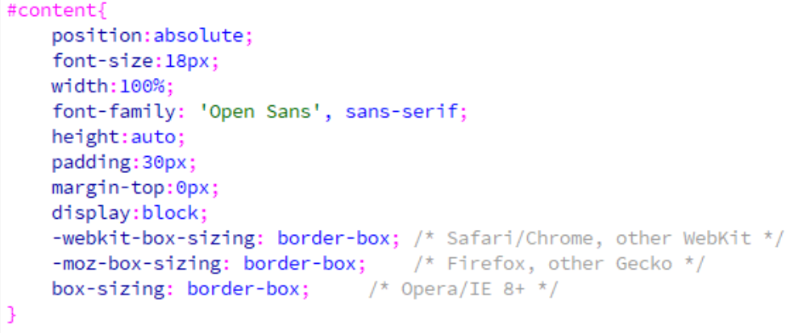

*The following screenshot demonstrates my use of different fonts in the creation of my website. As shown on company.profile.css*



871 words

1. Gandy, D. (2017). *Font Awesome, the iconic font and CSS toolkit*. [online] Fontawesome.io. Available at: http://fontawesome.io/ [Accessed 17 Aug. 2017].
2. Lunn, I. (2017). *Hover.css - A collection of CSS3 powered hover effects*. [online] Hover.css. Available at: http://ianlunn.github.io/Hover/ [Accessed 17 Aug. 2017].
3. Lin, Y. (2017). *Stick div at top after scrolling*. [online] Blog.yjl.im. Available at: http://blog.yjl.im/2010/01/stick-div-at-top-after-scrolling.html [Accessed 17 Aug. 2017].
4. jQuery UI Team (2017). *Slider | jQuery UI*. [online] Jqueryui.com. Available at: http://jqueryui.com/slider/ [Accessed 22 Aug. 2017].
5. ## Google (2017). *Google Fonts*. [online] Google Fonts. Available at: https://fonts.google.com/about [Accessed 5 Sep. 2017].

  