**Chloe Traynor B00122523 Website**

My GitHub is <https://github.com/chloetray/Electric-Picnic>

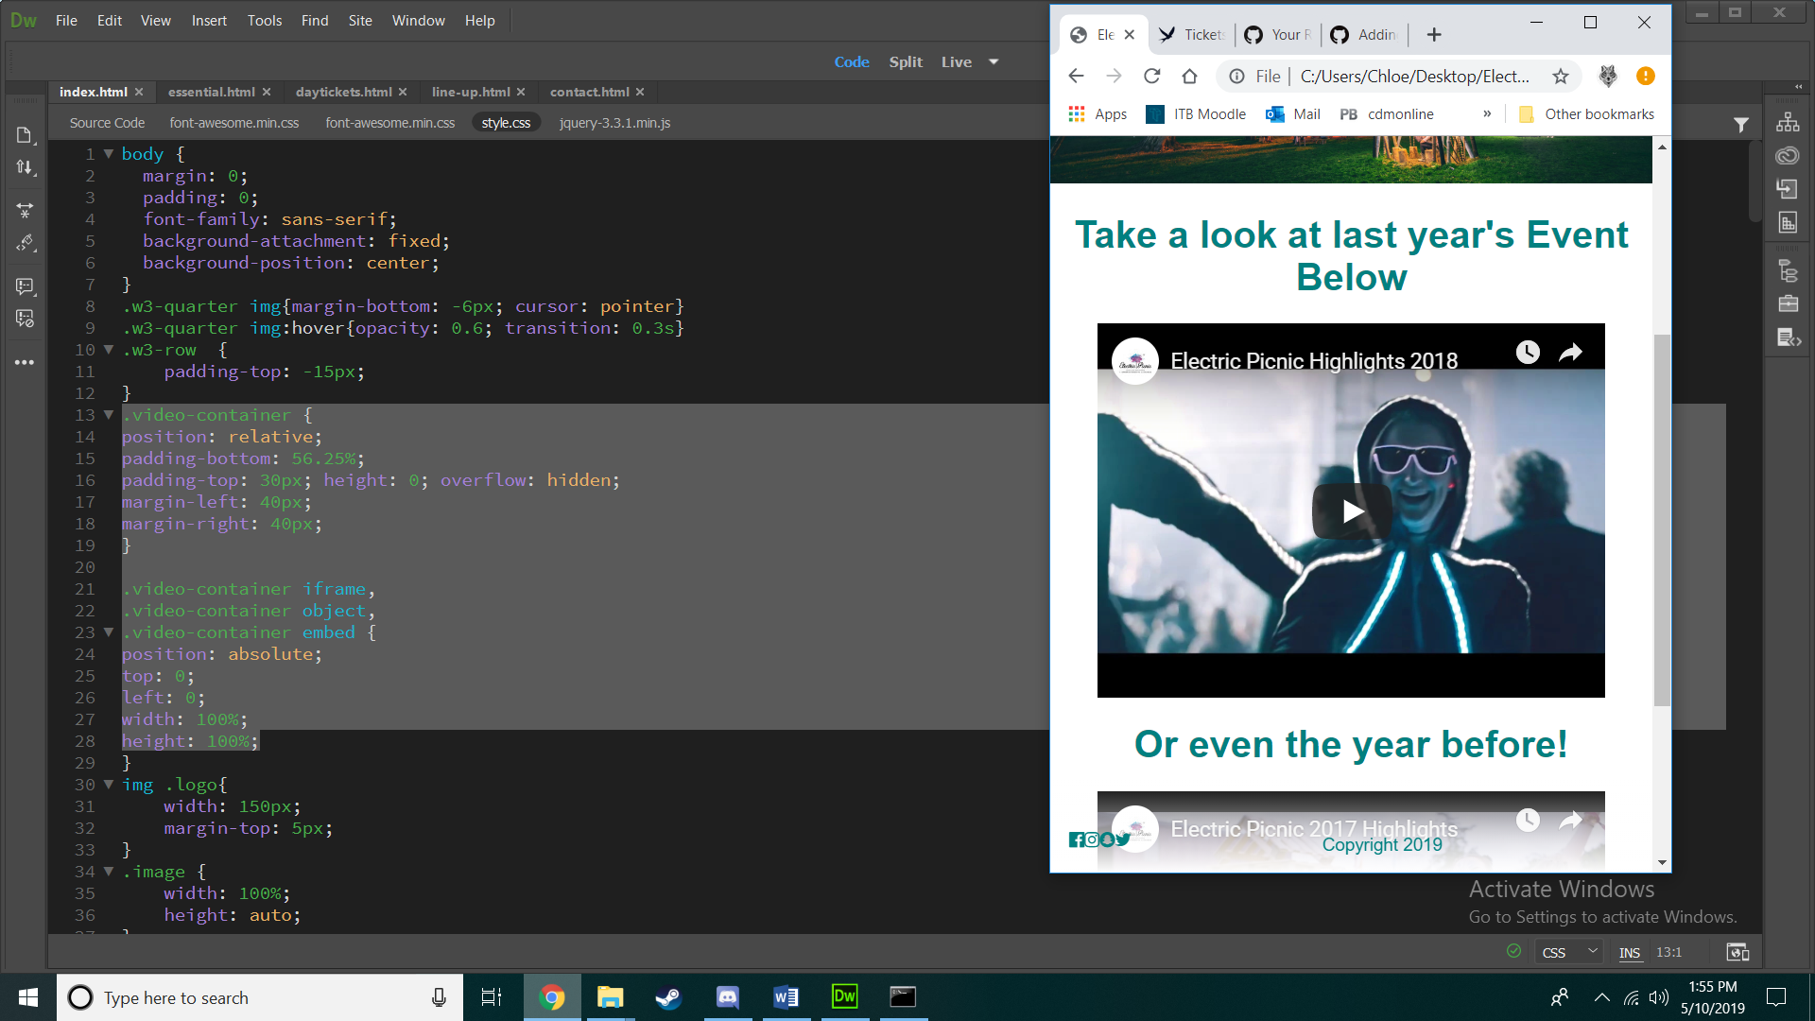

I was able to make the videos responsive by wrapping them in a div .video-container. I then used css as you can see from the highlighted code above.

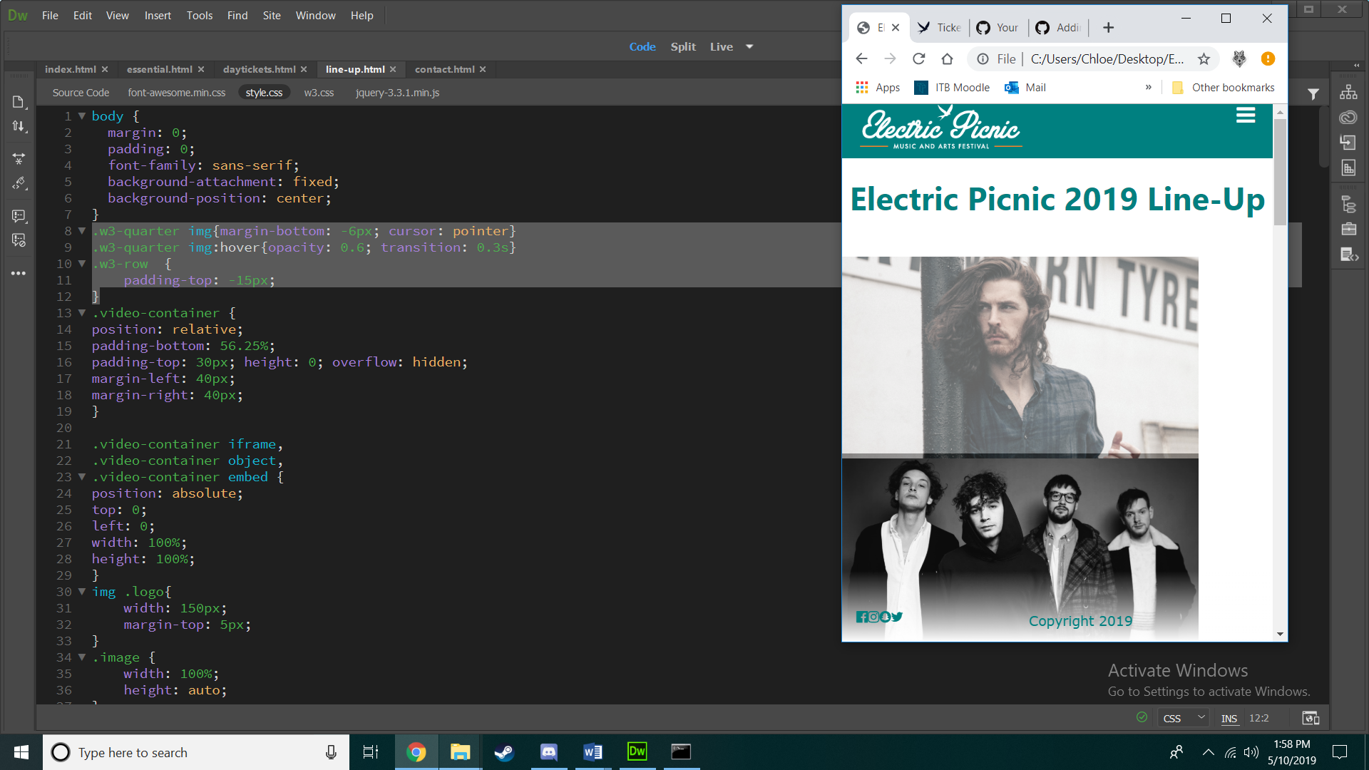

I added the effect of when hovering over an image the opacity goes down, and added a transition so it has a smooth change.

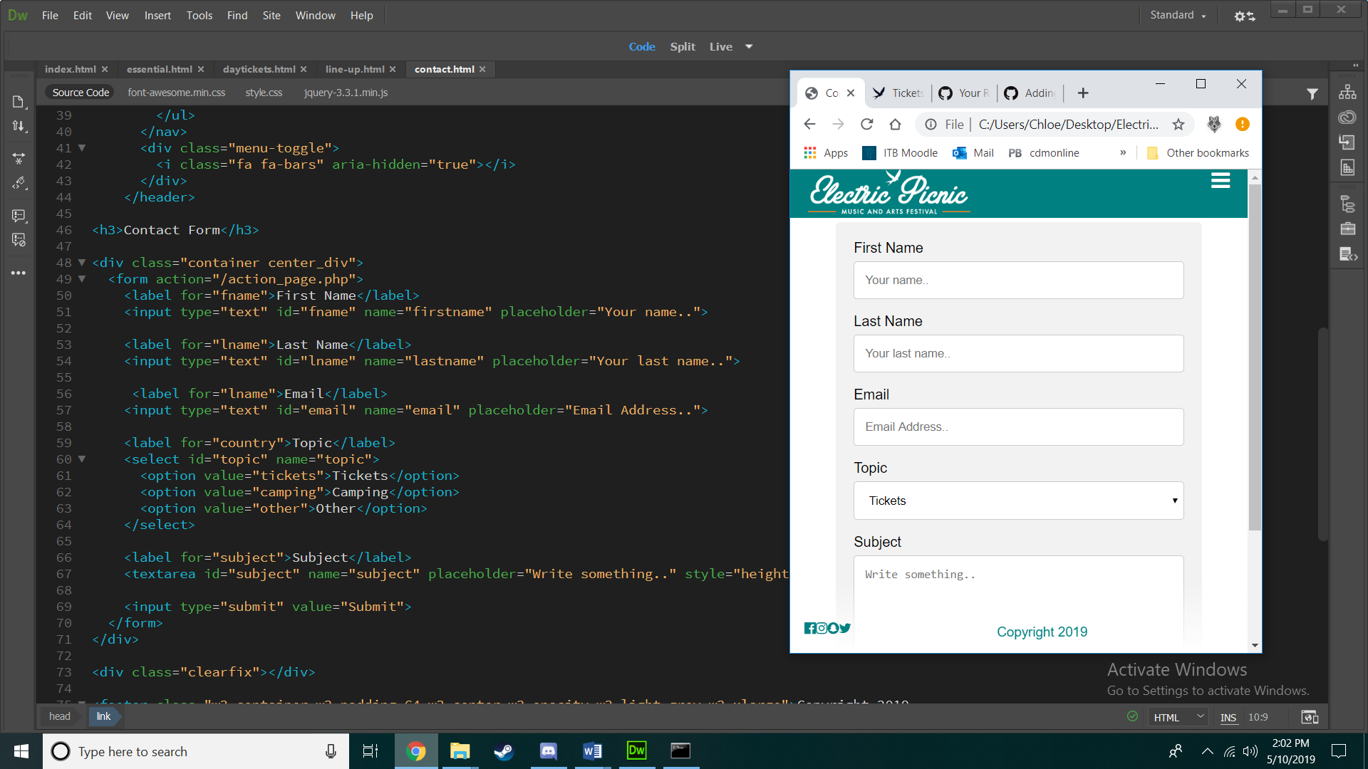

I put a div class around the form so I could add a margin each side to make it centered.

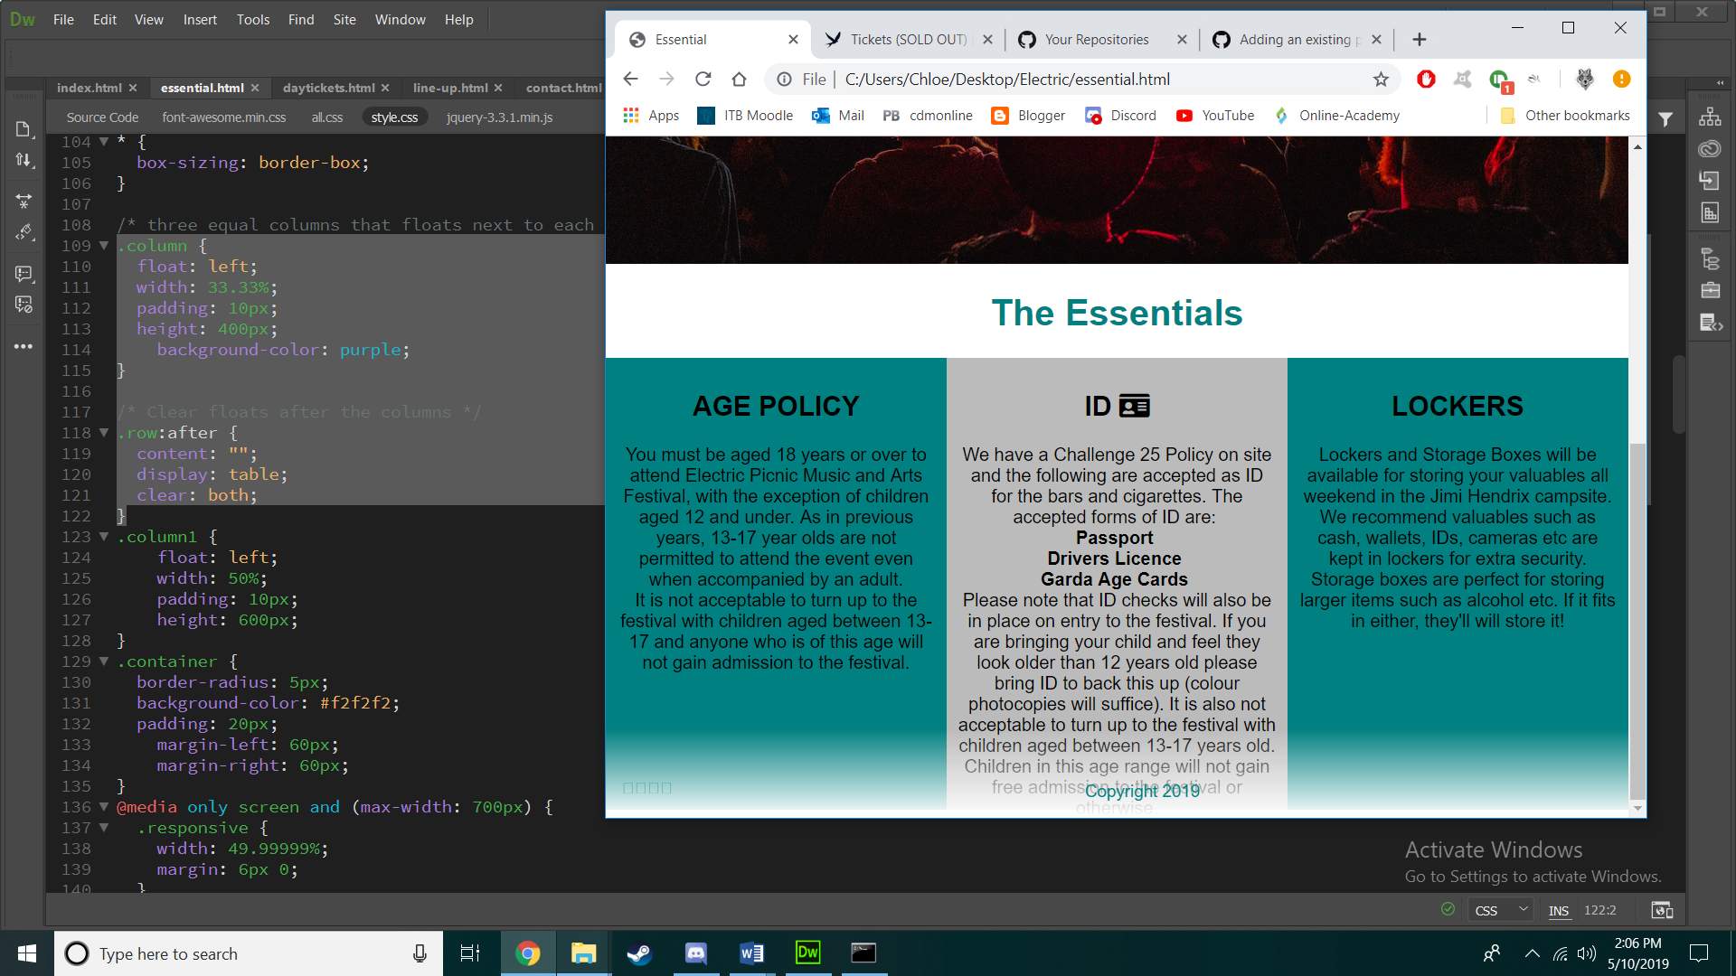

I made containers to add information to, and to make it nicer to look at. I did the colors to match the colors of the website. I made each h1 a teal color using the css. I Used font-family in my css to make the font Helvetica.

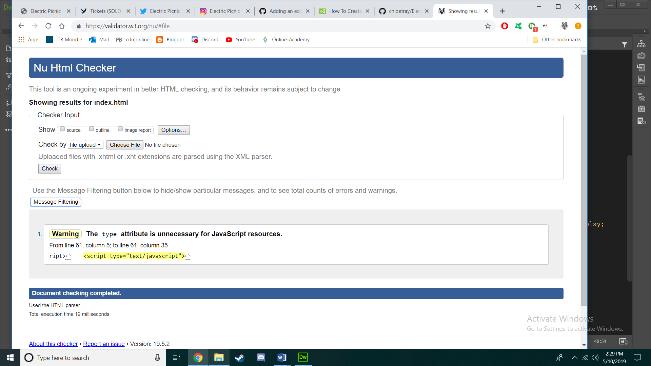

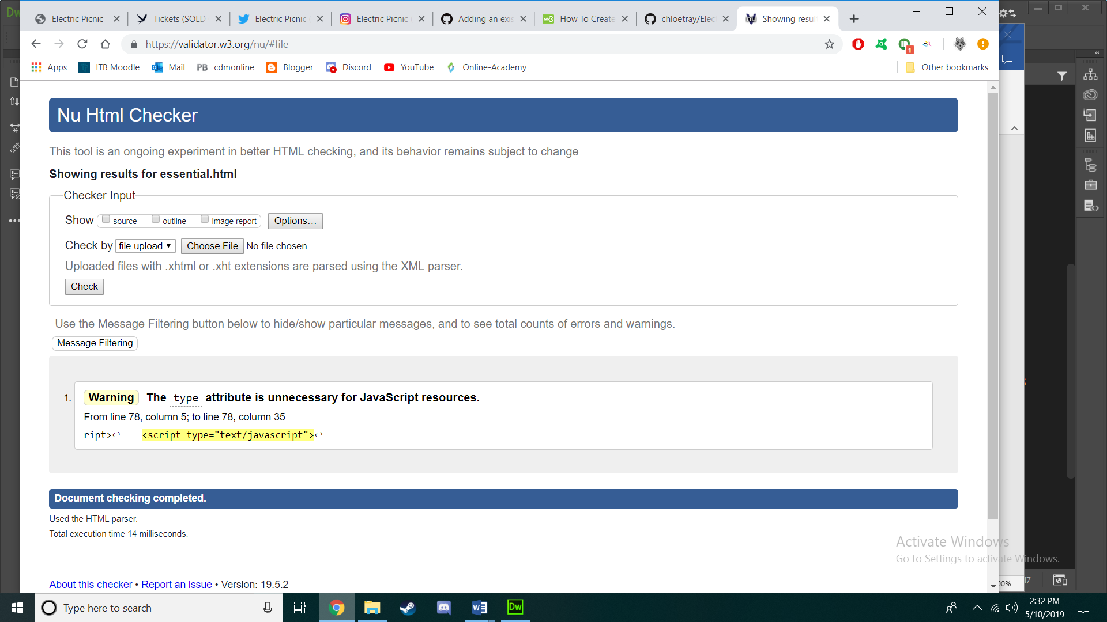

I validated my html using validator.w3.org