WIP Name: Pilus

General aesthetics: Pixelart – as typical for RPGs, Sort of biomechanical(?) inspired by games like disco Elysium and fear and hunger. Definitely have character portraits like disco Elysium has, and use the crosscode dialogue system.

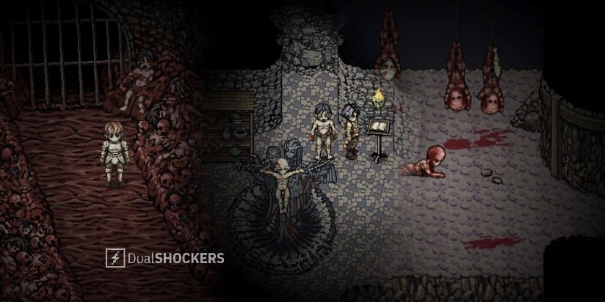Fear and hunger gameplay – I want a similar aesthetic for the overworld.

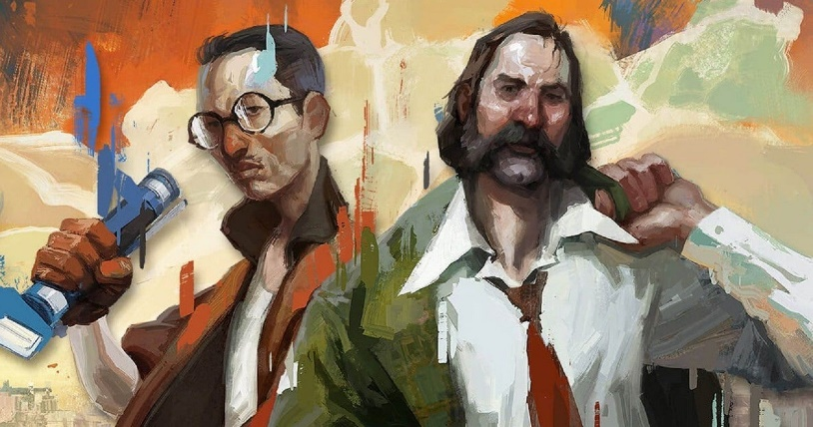Disco Elysium portraits.

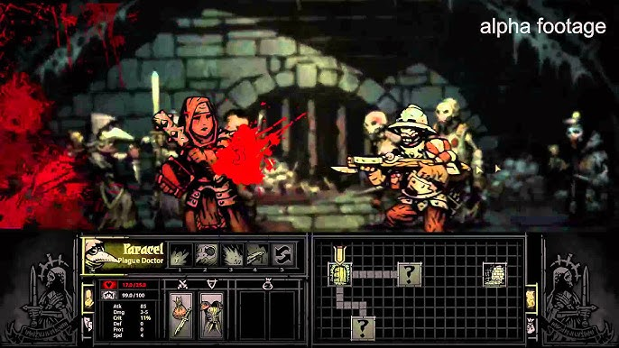A potential vibe to go for with the combat UI.

Hopefully the game ends out a little more lighthearted than these lmao, I want the aesthetic to be kind of dark, but have moments that show the humanity of the characters, as the darkness is supposed to reflect the world itself.

Meta Themes:

Basically, use peoples’ preconceptions about typical RPG tropes and ideas to trick people into making particular decisions.

* RPGs usually have multiple endings, including a “good” and “bad” ending, so have some decisions that seem to tend towards one of those. E.g. something that seems like it would gain a new party member etc.
* “Experimental doctor” arc, usually this gives the player various buffs, but on completion the player will get a small permanent debuff.
* Boss fights will happen in the overworld, and you have to figure out how to get them into an actualy combat system.

Due to some of these permanently effecting the story/gameplay in an “objectively bad” way, there will be autosaving after each of these to a singular save slot.

Saving mechanics: Start the game with a warning saying the game autosaves at important times but will not always autosave. Before important bosses or after important moments the game will save. There will be 1 save slot, which will just be accessed with “save” and “continue” buttons. Probably going to just write everything to a text file in the game directory.

Potentially have “lookout points” for saving, where it will cut toa different perspective, and allow saving, this takes a lot of art tho.

Combat mechanics: Most of the regular encounters will be typical RPG combat, inspired by fear and hunger as in most enemies will relatively complicated and won’t be a pushover. The only benefit for fighting an enemy will be getting its DNA, so the player should fight each enemy only once, to keep combat interesting. Boss encounters will have the same mechanics for the person attacking (roughly), but I want to add that one idea I had of moving around and dodging the enemy’s attacks in the overworld to reach the buttons – this will be reserved for important moments for effect.

Combat ui general idea:

Obv not actual sprites yet :/.

Start by making a scrolling menu class with box size, and data. Make it work with an arbitrary amount of player characters and enemy characters.

Have a list of players and list of enemies and loop through each until combat ends.

Some abilities can only be used once each combat

How to add a new player ability:

* Add function in the player class
* In combatcontroller, add it to the target selector
* Put it in playerdata when obtainable

Backend things :

* Combat system extras – status effects, attack bonuses, effect / buff / debuff indicators
* Single MC combat.
* Combat (bosses)
* Combat fleeing, based on enemy toughness basically.
* Combat defending
* Once combat abilities
* Shop
* Title screen / saving
* Settings
* sound

Design things:

* Enemy design
* Ability design
* Intended builds
* Bosses
* The game…
* puzzles

I haven’t thought of names yet D:

Story Premise / backstory:

Humans have recently discovered a method of transferring genes and parts between each other, but over time this process has become too easy to do, and almost everyone has some sort of change from their original selves. In the beginning, the doctor who invented the technique tested it on his wife, who eventually died from her body being overloaded from replacing almost every part of it. After further research, the doctor found out that the body has limits to how much changes it can handle, small changes having less effect to larger changes such as replacing limbs. A few years later, the doctor created synthetic genes in a laboratory, not coming from a person and not requiring a donor, giving people genes is now looking like a promising technique for healthcare. This is not how it continued. Soon the gene transfer techniques become quicker, easier and less intrusive, making them more widespread in public. This created a “black market” of genes, small groups of people would dig graves and even murder to gain access to desirable genes. Now, a few decades later, this has escalated so much as to create the undercity, a run-down part of the city run by gene trafficking overlords. Opposed to the undercity, the rich live lavishly taking their pick in the best genes from around the city and are the only people who can afford the still expensive.

With it being widespread a lot of people have it and a lot of people are against it too, this creates a bit of contention between the two groups.

Story overview:

Introduction: Starts with a news broadcast stating that the doctor is dead at the old age of 73 due to unknown causes. The broadcast states that he was one of the most influential figures in modern healthcare and society as a whole and gives a brief overview of his life [yayy organic way to introduce backstory]. The broadcast then cuts to a speech from the minister of health, starts sounding all generic. The tv switches off. Your sibling (the minister of health) says something like “not my best work” and there’s a little conversation between you and your sibling to introduce you both as characters. Your then get asked to deliver a letter, saying it’s very important it gets delivered properly.

You then walk down the streets and get a little look at the world, something doesn’t quite seem right, some of the people don’t seem quite right. At the post office you are greeted by a very serious man who take your letter into the back, realizing the gravity of the delivery (or is he always like that), once he leaves 2 large men enter the room and mutter over there, they approach you and knock you to the ground, one says “this isn’t the one”, the other “They definitely fit the description.”. The last thing you know is they pick you up and you pass out.

You wake up in an unknown dark place to the post office guy poking at you asking if you’re ok. You, being confused ask what happened, apparently the two men just dumped you two here, without an eye. You then panic and realize your eye is gone. The man asks you to help you out, and you agree.

You then continue off int the streets of the undercity with the man showing you around the small area he lived in, he says this is where he grew up, but you don’t even recognize this area, you discuss how you got here and that you want to leave. He agrees to help you leave and try to find your eye. The man suggests it could’ve been the current overlord who took your eye, and you start trying to find information about him.

This part is now you find the gondola and this is the real realization that your in the other city. To return you need a gondola pass from the other side, or be a citizen of this place, which mail boy is but he stays with you to help you return. So you decide to visit the town hall to try solve it.

At this point you realize you are across the other side of the giant crater that the city sits on.

After a little digging you find the location of his hideout and take a visit, the receptionist dismisses you for not having an appointment and you can’t get to see him

This area theirs is two guards, NEVER BOTH ON SCREEN AT ONCE (there’s a twist later that they’re the same person) a happy guard who you meet first and he says hes glad you didn’t run into his sister first bc shes mean or smth.

You need to find two keys, the comedy guard’s key requires you to guess his birthday, after 3 guesses he gets impatient and gives you really obvious hints – when you scroll over a correct day month or year he makes a really obvious face, and acts really surprised when you guess it.

The tragedy guard’s key requires a bribe, she is very vague about the bribe to begin with, but when you ask what she wants, she tells you to come with her, she then brings you into a dark backroom, which she locks. You ask again, she says she’ll be taking one of your fingers. “don’t worry I won’t take an essential one”, you try to escape by running away around all the boxes and random items in the room, but the door is locked, and you bang against it.

Just before she reaches you hear mail boi outside asking what’s taking so long, and he hears the banging on the door and forces it open and you escape. Back where you first met the tragedy guard, the comedy guard comes out and says he calmed her down and you may pass. He also introduces himself as Busk and leaves back into that same room.

without “proving yourself”, by fetching an item from the abandoned town nearby.

Now do the ice area with puzzles and whatnot.

Now talk to the real overlord, he isn’t one for conversation, and attacks you saying something all dramatic like “you’ve proven your prowess against nature, but people haven’t worried about that for decades, people are the real enemy” and attacks you. Then begins a scripted boss fight for you to lose, he just keeps increasing his status over time and decreasing yours until you lose. You then pass out and are moved deeper into his compound saying your weak.

Once you wake up the guards escort you to a dormitory with many other people. From discussing with then you find that the overlord will always accept a challenge, and feels he has to prove himself. So, challenging him and beating him in something simple could prove effective at wearing him down. After working at chopping trees, listening to the guards, it seems like they don’t enjoy working under the overlord, so you manage to convince them to let you back as an audience to the overlord.

The next day you challenge the overlord to a fight and boast that he cant hit you in close combat, then you get into regular combat for a turn and you can attack him (or something like that). Another non-scripted boss fight happens, where you keep getting opportunities to boast that his next attack will not hit you, for each successful boast, his def drops dramatically, and you get an extra opportunity to attack him. When you defeat him, he lets you pass, after divulging that it was not his men who stole your eye, and it could’ve been the prince - the only other person above him in the city.

On return to your house, you and the kid find that your sibling is missing… and you remember back to the guys who attacked you earlier. The journey into the royal palace begins.

At the entrance you realize you can’t get in, and the mail boy suggests entering through the chemical plant. You two then sneak in through the ventilation ducts in the chemical plant. This place has some mechanical puzzles, and some physics puzzles. In the middle of the area a scripted encounter with guards who escape happens. The area continues until walking across a high catwalk above a vat of acid, when the head guard comes along, and a boss fight occurs. The headguard is strong and can’t be damaged initially. But reaching the end of the catwalk reveals a button that drops the catwalk and the head guard into the acid, he then climbs up and can be fought normally. When you beat him, you gain access to the royal palace.

The royal place is strange, all the populated areas have no encounter, but the non-populated areas have many. The populated areas have puzzles involving moving people around to clear a path. In this area, there is a guard post, where you overhear that your eye is in the treasury. The second area is the prince’s living area, this is a stealthy area, having to stay out of the prince’s LOS and reach the treasury room. Upon looking for your eye he prince enters the room holding your eye, rolls it along the floor towards you and before you can put it in, a boss fight begins. Upon reaching half health he gets bored and leaves, stating “well, I guess you’ll never find them then, I’ll be in the throne room.” In reference to your kidnapped sibling.

You now must find the prince in the throne room where the real boss fight begins. The prince has a few phases where he keeps switching out genes and changing attacks. During his final phase, he breaks the floor, and you fall back into the main area of the palace, where you finally beat him and take his key. With this you can access where your sibling is held.

(WIP – I think this this is bad)

The next day, the prince announces being attacked in his own home and orders your arrest. When police arrive at your house, the overlord brings you back to his compound and commends you for taking the prince down a notch, and tells you to leave town, which ends the game.

When you arrive you find out that you were too late, and your sibling already gave them what they wanted to know as well as the intercepted letter so the whole point of coming to stop them didn’t work.

Then the game heavily implies that you could’ve done something different earlier – then you (player) are prompted to return to before entering the chemical plant and hinted on what you need to do to continue (TBD – likely some item fetching stuff with the books or red seals or smth – this hint is for a quicker way to enter the palace)

Try 2 of stopping the information getting out skips the entire chemical plant, and meets you with the emperor immediately in the palace, he then takes you to where your sibling is being held and all three of you go to his “special dungeonv” (I swear it’s not sus).

After some puzzles to escape the dungeon you confront the emperor again for a harder final boss, which ends in you getting hurt (scripted) and your sibling gives up the information to save you.

You then return home and keep thinking about what you could’ve done and the option to return and try again comes up but then your sibling enters and you discuss how they needed that information at some point and not to dwell on the past so much.

(tee hee fake out)

END

Some notes: lil mail boi keeps talking about how bad it is for the gene tec in general how its being used for eugenics and stuff. But the idea of it being good builds up over the course of the game, beginning with the prison guards talking about people who could get cured of all these diseases bc of it. This builds up all throughout the game – hopefully at the time of the first final boss the player doesn’t quite know what to think about it but doesn’t question the MC/Game and does everything again. And by the 2nd fake reset the player doesn’t really want to.

IDEA: SECRET BOSS

A long questline leads to a secret boss at the end of the game.

Potential Leads: find the library card to get a book to give to someone, the mayor’s seal found in their office with the desk key.

Once you’ve found 5 library books the librarian gives you access to the “secret library for true book lovers”. For after the 5th book the librarian doesn’t let you give it in saying smth like “Please keep it, you earned it.”

This secret library is in the city you begin in, so when there at the midpoint of the game if you visit you can meet the book dealer, he trades items for books and books for items. Here you may show him the library card - which is his!!!! He is very happy about this since he can now return to the regular library and has twice the choice of books. He gives you a “royal researcher’s recommendation”, which when sealed with the red seal can be used in the special dungeon in after the reset to access the royal archives. The secret boss is the royal archives themselves. Defeating it gives you the bookworm gene – gives attack for each book you’ve found.

The idea is to have 7 books accessible before returning to the original city – 1 near to the library, 1 other before leaving to regia aqua, 2 in regia aqua, 2 in the prison and 1 near the exit AFTER the boss fight to encourage players to go to the library first. 1 more can be found at your house after returning.

The 3 extra books can be redeemed with the book dealer for some healing and buff items – as only 5 books are needed for the actual quest.

Dialogue System:

Use a similar structure to the previous system

* Msg class with – Name, text (string), body, face (sprite), speaker (gameobject)
* Text is a delegate
* Queue of msg when press z go to next msg if there is one
* Flag to say when in dialogue, when msg added this is set, when none left its reset.
* When speaking, the speaker gets slightly larger.
* When displaying next msg, make new textbox, which first decides its direction and height, and then moves all other boxes up.
* When leaving dialogue (trying to go to next text without having any in the queue), destroy all the textboxes

INVENTORY:

The status portrait will change based on the genes being used, showing any visual changes to the player character.

Inventory is just inventory menu. Genes is an equipment menu,

**Heat puzzle**

Buttons that either increase or decrease the heat, this puts a visual effect on the screen.

When cold water freezes which makes it walkable and has certain effects on items placed on it.

When hot, water turns to steam which isn’t walkable, but effects items placed on it.

Box on the water – can be pushed 1 square from the edge in water, slides to the end on ice, and make the steam walkable.

If there are 2 boxes in a row, it acts how you would expect on ice, but in water it flings the 2nd box to the other side.

Puzzles:

Tutorial of how to push the boxes.

Easy puzzles to get the player used to changing the modes to get the boxes places.

Medium difficulty puzzle where you are locked in ice mode.

Another medium difficulty puzzle

The first two basic heat puzzles where you have to relocate the block

Exiting requires you don’t have the giant rock.

To the left is an potentially an outlook for saving – if not – it can just have some dialogue between the characters.

To the right is a fisherman’s hut, which you can talk to him to play a fishing minigame, and he has books in his house too, which give more info on why there is random ice and stuff.

A book titled “Thermal reservoirs and the lack thereof” this book seems to be authored by the fisherman, but he doesn’t remember it. It starts off with a log “I have found a naturally occurring oil with similar properties to refrigerant, perhaps it could be useful.” Time skip “When this oil falls down the waterfall, it solidifies under the pressure, and floats back to the top through underground rivers, it then remelts, freezing the water at the top of the river – a natural refrigerator.”

A book titled “Fish almanac”, a passage from the book “once every ten to fifteen years the local sturgeon population dips significantly, the reason for this is still unknown”, another passage reads “Some residents report sightings of a ‘kraken’ in these waters, which is strange, since most of the water isn’t more than a couple meters deep.”

A book titled “Geological reports part 17” from around 30 years ago. “The lake supports more life under its bed than in the waters – having a bed made of soft mud, many creatures burrow and live in the slurry, including a few species of fish. It is suspected this mud extends for up to a hundred meters down.”

Fishing minigame

Like the Stardew valley fishing minigame, but instead of holding up to go up and letting go to go down, you must alternate all the arrow keys to reel in and out, there are only 3 types of fish – trout, eel, and sturgeon with difficulty in that order. You must catch each fish before catching the next one. Once caught all three fish, the fisherman will congratulate you and show you his special fishing area, where you can fish for fun, this doesn’t really do anything except get you food to heal with. In the special fishing area, there is the Giant Rock, which you can get and continue the puzzles.

The second ice puzzle room will have a lot more evidence of this village, like ruins of buildings and pieces of wood and things like that.

To reach the real ruins the player must both solve the ice puzzle, and find the rusty key in one of the ruined houses.

In the next room, there are a few more abandoned houses containing random items, one house contains a key required to continue, and another house has a combat encounter with a giant rat, which gives the “rat tail” gene, which make the player slightly faster in the overworld.

After solving the puzzle in the area, you can make your way forward up some stairs into into a larger house, which after some inspection is the old town hall of the village, there are some random items and combat encounters in the house.

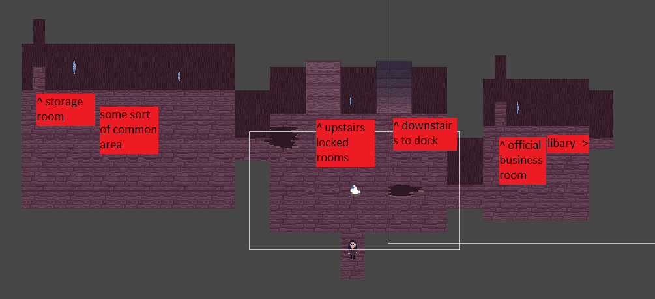

Common area: This area contains tables and chairs set up in rows and a bar/kitchen (this the saloon in stardew), a couple of the tables have papers on them detail some random official documents stating an evacuation of the town and a declaration of martial law.

Storage room: This area is filled with boxes and crates containing canned food from at least 20 years ago, mostly still edible so you take some. The room is filled with dust, and you start sneezing. The room has a few rows and hidden behind a shelf out of view is the antihistamine gene, giving immunity to all DOT effects in combat (and the sneezing).

Room to the right: There isn’t much in here, just one desk with a sealed letter on it, if opened it’s a letter to the mayor of the town from the mainland, giving approval to evacuate the town, it seems it arrived too late, as it was never opened.

Official business room: In it there is one large desk with a set of stamps of papers on it, as well as space to line up. On the desk you can take the stamps, and the papers don’t seem to have a singular purpose, boat licenses, fishing licenses, building permits, normal bureaucratic stuff.

Library: There are hundreds of shelves containing books, but almost all of them are water damaged, or just crumble when you try to pick them up, after a while of looking around and inspecting books, there are two salvageable ones, a book about the local marine life – “A diverse ecosystem of wildlife exists under our feet, with biodiversity the like we haven’t seen before. Even though there exist many predators to prey on the smaller herbivorous fish, there is an abundance of freshwater trout, which flock to the shallower waters to breed, safe from the predators. Local fish school movements suggest the existence of an apex predator in the waters, the existence of is yet to be confirmed.” The second book details the construction process of the town – this book doesn’t contain any particularly useful information to the character, but perhaps someone else could use this land survey and drilling information. Both books can be taken and donated back to the mainland library. Here you can also find a library card (ONESHOT REFERNCE!?!?) this allows you to take books from the mainland library, maybe used for a quest later.

Upstairs: This leads to a small corridor with two rooms, the mayors office, and a meeting room. To access the mayor’s office, the desk key is needed, and the fish key is needed to access the meeting room.

Mayor’s office: In this room is a desk and set of drawers. You can take the mayor’s seal from their desk as well as read a bunch of documents detailing the evacuation of the town.

Meeting room: This room has a combat encounter with the business skeleton, which when defeated drops the calcium gene, reducing damage taken.

Basement: This contains a couple code-based puzzles which need to be solved in order to continue to the dock area.

The first code puzzle shows a bunch of colored stars which need to be replaced with numbers, each color corresponds to a number which is shown by the book of that color in the library.

The second code requires beating the skeleton upstairs in the meeting room which will reveal the code on defeat.

First code = 9481

Second code = 1849

Docks: A set of wooden docks with ship parts scattered around, you have to collect 5 parts to repair the boat and travel to the island of the sea monster boss.

**MAINLAND LIBRARY**

A book titled “The rise and fall of regia aqua” published fifteen years ago, it starts “Regia aqua was a small fishing village stationed in the middle of lake [insert name], it sat upon man-made islands, floating due to large deposits of a natural oil, which is significantly less dense than water. It was the main source of food for this side of the divide for many years, until twenty years ago overfishing upset the ecosystem, driving the predators to tear the village apart, leaving little remaining.”

* This is only findable after returning from regia aqua

An old book titled “The great divide”. It starts “For hundreds of years, people have living in this area, and the area’s natural geography has always been an issue for the occupants, dubbed ‘the great divide’ by the original settlers, this ravine has been the cause of great conflict over the years.” – quite a few pages are missing – “In the modern day, the town has split into two across the ravine, causing quite a class divide, however a promising new technology – gene editing – seeks to remedy this.”

A book titled “The history of local coins” – its so boring I don’t even want to open it.

SAMPLE BOSS:

If close he will charge up and dash towards the player twice.

If far away he will charge up and dash until hitting a wall causing an explosion of projectiles OR cause projectile to come up from the ground tiles. If he would hit close to the heat button, he will use the projectile attack, if he will end up close to the player he will use the dash, otherwise its random.

If within a normal distance from the player cycles between these at random

* Runs half way around the player shooting projectiles then enters dash twice mode ;
* Goes to above or below the player (whichever is closer) and shoots a spread of shots ;
* Goes to the sides of the player further away and shoots fast single shots then enters big dash mode, unless would end up close to the heat button. ;
* Dashes once through the player to the sniper point on the other side, can only use when similar y to the player ;
* Every so often he phases out and does a bullet hell section ;

SEA MONSTER BOSS:

You never see the main body of the monster (TBC) but it attacks you with tentacles from the water. The water also has geysers which can hit both you and the boss.

The fight starts with only 1 tentacle attacking you, and after a couple attacks it will charge up and get hit by a geyser turn red and fall on the ground so you can attack it.

Once defeated, the real fight starts, the boss starts attacking you with 3 tentacles and each one defeated spawns 2 more until all 7 remaining are defeated.

When only 2 remain they do special attacks in overworld and you fight those both at once.

Tentacle overworld attacks:

* Short attack, does a short slash at the player with a range of half the length of the platform.
* Splash, if the player is close to the edge it can splash down doing aoe.
* Slam, it charges up and slams down, here it can be hit by geysers, and it can be stunned to go into combat with it.

Geyser attack:

* Charges, and explodes damaging any nearby down tentacles spreading some water projectiles around.

Tentacle combat:

* Has a small amount of health, such that the player kills it in 3ish turns
* Slash hit both of you for small damage
* Slam hits one for a lot of damage
* Splash hits both for a lot of damage rarely
* If theres more than 3 tentacles alive then they start dong other thigns

Final phase:

* Hits a geyser and a lot of water projectiles
* A safe spot flashes close to the player and it sweeps round the rest of the arena
* Quicker slams.
* Double slash, slashes from both sides

Final phase combat:

* Has a lot more health.
* Debuffs the players attack by being slippery
* Increasing def by coiling
* Slams one person for damage
* It hits many times randomly with water.
* Slash damaging both.