WIP Name: Pilus

General aesthetics: Pixelart – as typical for RPGs, Sort of biomechanical(?) inspired by games like disco Elysium and fear and hunger. Definitely have character portraits like disco Elysium has, and use the crosscode dialogue system.

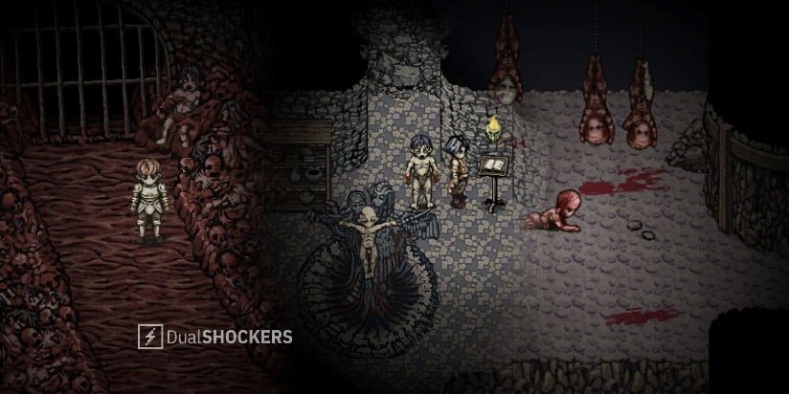Fear and hunger gameplay – I want a similar aesthetic for the overworld.

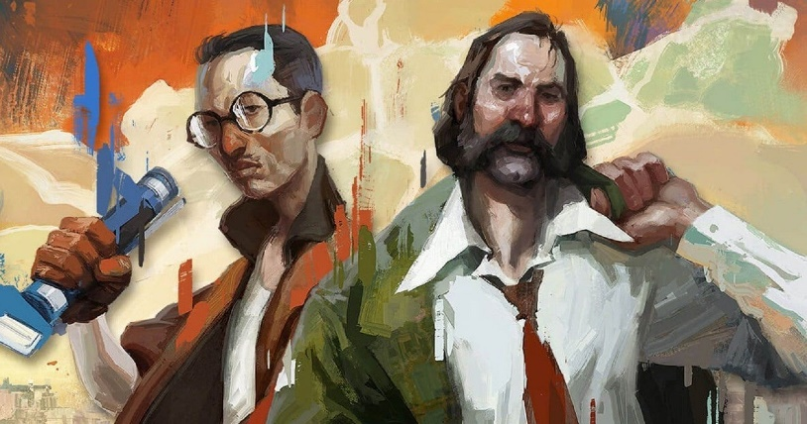Disco Elysium portraits.

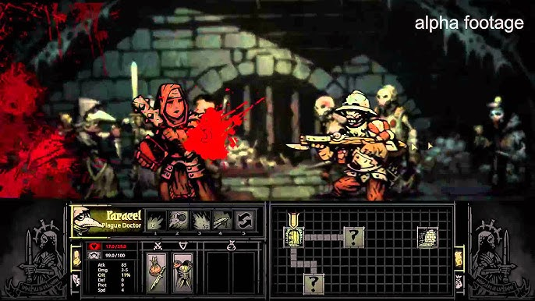A potential vibe to go for with the combat UI.

Hopefully the game ends out a little more lighthearted than these lmao, I want the aesthetic to be kind of dark, but have moments that show the humanity of the characters, as the darkness is supposed to reflect the world itself.

Meta Themes:

Basically, use peoples’ preconceptions about typical RPG tropes and ideas to trick people into making particular decisions.

* RPGs usually have multiple endings, including a “good” and “bad” ending, so have some decisions that seem to tend towards one of those. E.g. something that seems like it would gain a new party member etc.
* “Experimental doctor” arc, usually this gives the player various buffs, but on completion the player will get a small permanent debuff.

Due to some of these permanently effecting the story/gameplay in an “objectively bad” way, there will be autosaving after each of these to a singular save slot.

Saving mechanics: Start the game with a warning saying the game autosaves at important times but will not always autosave. Before important bosses or after important moments the game will save. There will be 1 save slot, which will just be accessed with “save” and “continue” buttons. Probably going to just write everything to a text file in the game directory.

Combat mechanics: Most of the regular encounters will be typical RPG combat, inspired by fear and hunger as in most enemies will relatively complicated and won’t be a pushover. The only benefit for fighting an enemy will be getting its DNA, so the player should fight each enemy only once, to keep combat interesting. Boss encounters will have the same mechanics for the person attacking (roughly), but I want to add that one idea I had of moving around and dodging the enemy’s attacks in the overworld to reach the buttons – this will be reserved for important moments for effect.

Combat ui general idea:

Obv not actual sprites yet :/.