**Temasek Polytechnic**

**School of Informatics and IT**

**Diploma in Information Technology (IT)**

Project Plan

**Project Particulars**

|  |  |
| --- | --- |
| **Tutor** | Mdm Ho Li Ching |
| **Class** | P02 |
| **Project Title** | Delonix Regia Hotel Management System |

**Project Team’s Particulars**

|  |  |
| --- | --- |
| **Matric Number** | **Student Name** |
| 1403575B | **Chloven Tan Zi Xuan** |
| 1403539H | **Chua Cheng Yu** |
| 1400555G | **Lin Jiamin** |
| 1401557B | **Ngoh Man Ling** |

**Table of Contents**

1. Introduction
   1. Objectives and scope of the project
   2. Assumptions and constraints
   3. Definitions and acronyms
2. Roles and responsibilities
3. Estimates and project schedule
   1. Work breakdown structure
   2. Project schedule
   3. Budget summary
4. Risk management plan

**Project Plan**

**1 Introduction**

**1.1 Objectives and scope of the project**

The objective of the project is to help both Mr. and Mrs. Wang in bringing business to their hotel as they are currently not doing well even though their hotel is located at a reasonably good district.

The deliverables of the project is to create a system that will be able to help the clients’ issue.

Our group decided to help them with the issue by creating an phone application which will be able to book a room and a meeting room, have a customer management system and also a Restaurant Reservation System. we belive that this system benefits both the customers & staffs. The booking system will be able to attract more customers to the hotel as it is very convienient and efficient for them to use. As for the customer managment section is more of a system for the managment side to check the different reports to improve customer statifaction so that the business can prosper even more.

**1.2 Assumptions and constraints**

We assume that the delivery date of the project will be on time even though there will be some constaint like time management that will affect the project but we are determined to finish the project on time as we have planned and scheduled some of our project time and meetups.

For the hardware and software availibilty, we might have to dicuss again so that all of us are on the same page using similar tools so that at the end of project we will be able to complile together.

We assume that the project plan will be smooth throughtout. However, there are some difficulties like the resource given from the client may be too little and we could not really understand what Mr & Mrs wang really wants for their system. Also, its a bit hard for us to split the work for the project plan and TOR, hence, we helped each other to add on whichever component is lacking.

In conclusion, we really learn how to work as a team to complete this project together.

**1.3 Definitions and acronyms**

TOR - Terms of Reference

SDLC - Software Development Life Cycle

STS - Software Test Specification

UAT - User Acceptance Test

Buget - The budget hardware and software that is required for the project including manpower cost.

Deliverables - Any measurable, verifiable outcome or result that must be produced to complete a project or part of a project.

**2 Roles and responsibilities**

* Ngoh Man Ling: Restaurant Reservation System
* Lin Jia Min: Customer Management System
* Chua Cheng Yu: Meeting Room Reservervation System
* Chloven: Room Reservation System

**3 Estimates and project schedule**

**3.1 Work breakdown structure**

|  |  |  |  |  |  |
| --- | --- | --- | --- | --- | --- |
| Task Name | Duration | Start | Finish | Predecessors | Resource Names |
| **Inception Phase Iter 1** | 7.25 days | Thu 28/4/16 | Mon 9/5/16 |  | Man Ling,Jia Min,Cheng Yu,Chloven |
| Complete Terms of Reference | 1 day | Thu 28/4/16 | Fri 29/4/16 |  | Cheng Yu,Chloven,Jia Min[50%],Man Ling[50%] |
| Complete Project Plan | 2 days | Sun 1/5/16 | Tue 3/5/16 |  | Jia Min,Man Ling,Cheng Yu[50%],Chloven[50%] |
| Create Initial use case & domain model | 2 days | Tue 3/5/16 | Thu 5/5/16 |  | Cheng Yu,Chloven,Jia Min,Man Ling |
| Lifecycle Objectives Milestone | 2 days | Thu 5/5/16 | Mon 9/5/16 |  | Cheng Yu,Chloven,Jia Min,Man Ling |
| **Elaboration Phase Iter 1** | 16.75 days | Tue 10/5/16 | Thu 2/6/16 | 1 | Cheng Yu,Chloven,Jia Min,Man Ling |
| Complete SRS | 4 days | Tue 10/5/16 | Sat 14/5/16 |  | Cheng Yu,Chloven,Jia Min,Man Ling |
| Design Software Architecture | 3 days | Sat 14/5/16 | Wed 18/5/16 | 7SS | Jia Min,Man Ling |
| Prototype and yse software architecture | 2 days | Wed 18/5/16 | Fri 20/5/16 | 8FF | Jia Min,Man Ling |
| Conduct logical database design | 2 days | Tue 24/5/16 | Thu 26/5/16 | 8SS | Cheng Yu,Chloven |
| Prototype user interface | 2 days | Thu 26/5/16 | Sat 28/5/16 | 9SS | Cheng Yu,Chloven |
| Lifecycle Architecture Milestone | 4 days | Sat 28/5/16 | Thu 2/6/16 |  |  |
| **Construction Phase Iter 1** | 8.25 days | Thu 2/6/16 | Mon 13/6/16 | 6 | Cheng Yu,Chloven,Jia Min,Man Ling |
| Software Test Specification | 2 days | Thu 2/6/16 | Sat 4/6/16 |  | Cheng Yu,Chloven |
| Customer Management System testing | 3 days | Sat 4/6/16 | Wed 8/6/16 |  | Jia Min |
| Room System testing | 3 days | Wed 8/6/16 | Sat 11/6/16 | 14SS | Chloven |
| Release 1 | 1 day | Sat 11/6/16 | Mon 13/6/16 |  |  |
| **Construction Phase Iter 2** | 7 days | Tue 14/6/16 | Thu 23/6/16 | 13 | Cheng Yu,Chloven,Jia Min,Man Ling |
| Meeting room system testing | 3 days | Tue 14/6/16 | Fri 17/6/16 |  | Cheng Yu |
| Restaurant system testing | 3 days | Fri 17/6/16 | Wed 22/6/16 | 19 | Man Ling |
| Release 2 | 1 day | Wed 22/6/16 | Thu 23/6/16 |  |  |
| **Construction Phase Iter 3** | 5.5 days | Fri 24/6/16 | Mon 4/7/16 | 18 | Cheng Yu,Chloven,Man Ling,Jia Min |
| The four sub-system | 4 days | Fri 24/6/16 | Thu 30/6/16 |  | Cheng Yu,Chloven |
| Beta Release | 2 days | Thu 30/6/16 | Mon 4/7/16 |  |  |
| **Transition Phase Iter 1** | 10.38 days | Mon 4/7/16 | Wed 20/7/16 | 22 | Cheng Yu,Chloven,Jia Min,Man Ling |
| Acquisition and installation of Hardware and Software | 3 days | Mon 4/7/16 | Thu 7/7/16 |  | Cheng Yu,Chloven |
| Conversion | 3 days | Thu 7/7/16 | Tue 12/7/16 | 26SS | Cheng Yu,Chloven |
| User Training | 2 days | Tue 12/7/16 | Thu 14/7/16 |  | Jia Min,Man Ling |
| Documentation | 3 days | Thu 14/7/16 | Tue 19/7/16 |  | Jia Min,Man Ling |
| Final Release | 1 day | Tue 19/7/16 | Wed 20/7/16 |  |  |

**3.2 Project Schedule**

*[Use Microsoft Project 2003 to draw a detailed schedule, showing target dates for complet*

*ion of iterations and phases, release points, demos and other milestones. It should also show the dependencies between activities, the estimated time required to reach each milestone and the allocation of people to activities]*

The graph below shows the project schedule for our team. We included non-working day as well which is saturday and sunday. Some of the saturday are change to working day due to time constraint.

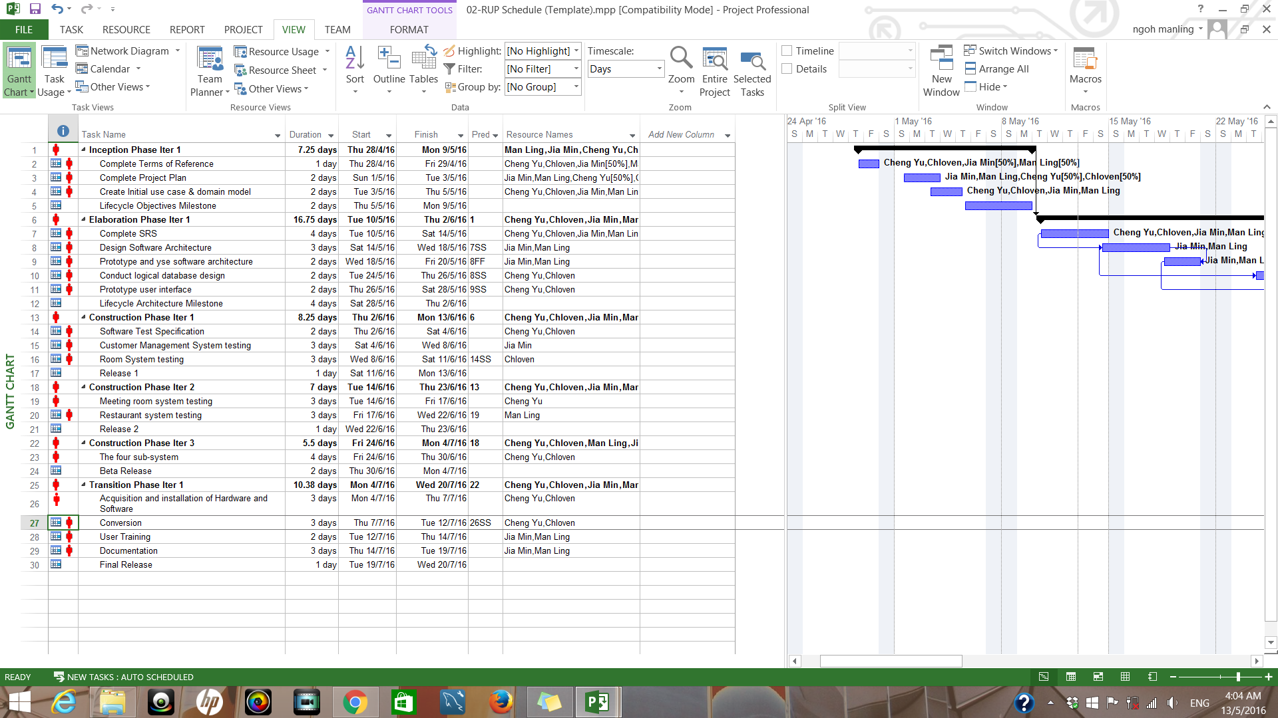

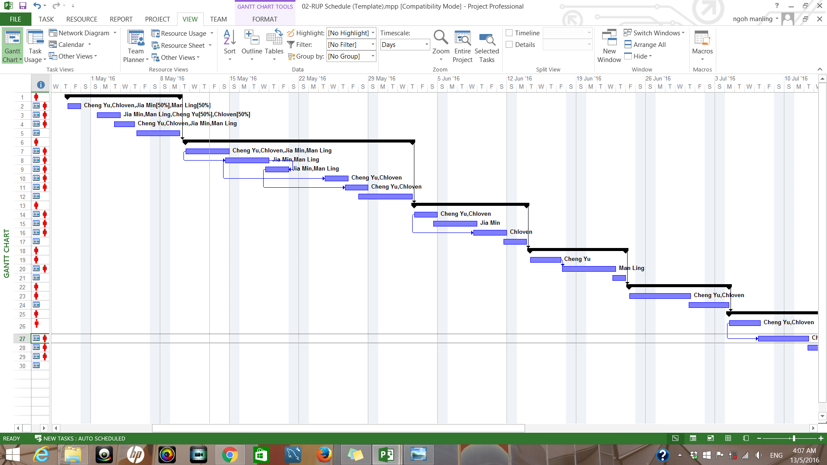

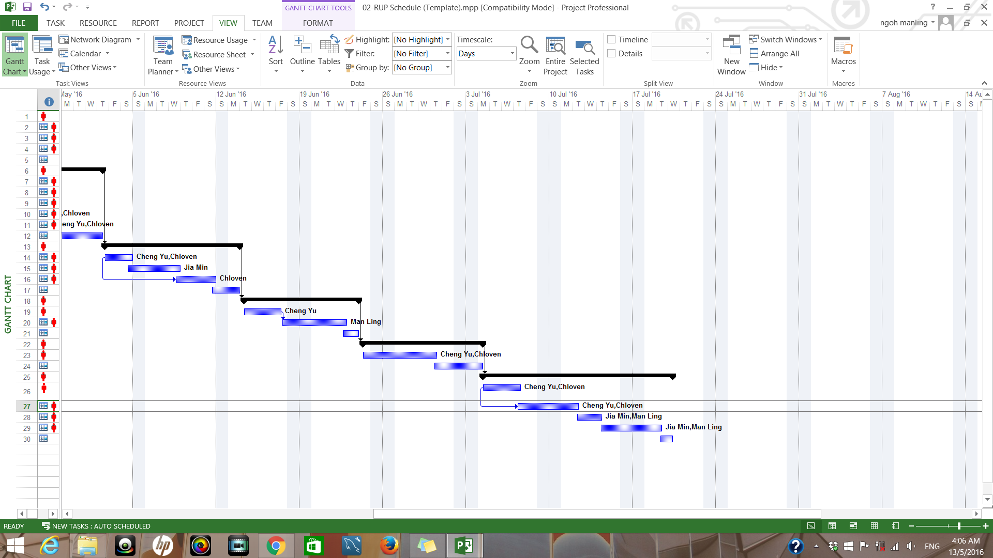

**3.3 Budget** **Summary**

|  |  |
| --- | --- |
|  | Budget |
| Salary | $28 000 |
| Software cost |  |
| Microsoft visual studio | - |
| Microsoft project | - |
| Rational functional tester | $5000 |

There will be four of us working on this project and will be completing it in two months. The salary for each of us are $3500 for each month.

**4 Risk Management Plan**

We will be focusing on four projects risks that might happen which are time risks, technology risk, operational risk and financial risk.

Time risk are one of the risk we might face. For instance, we change too much of our system, in the end some of the components is being changed to not meet the original requirment and more time is wasted in fixing all the problems faced. We might not be able to meet the deadlines for each task also which will result in the delay of implementing the system. The later the system are implemented, the more losses Mr and Mrs Wang will have to incurred as their business are not doing well.

What we can do is that we can research first if what the client wants is feasible and discuss with them to find the best possible way before getting down to work first. Furthermore, we can spit into smaller components to evaluate so that we can reduce the chances of not meeting the client requirements. Moreover, we should also strictly follow the deadline for each task.

We may face hardware or software failure when trying to build the system which will result in losing our data.Natural disasters such as fire will also damage the hardware and software of the system. In the worst case scenario, we will have to build up the system again if we did not back up the files. Other than that, viruses might also infect our system which will disrupt computer operation.If that happens, the whole hotel system will be down and their business will have to be suspended temporarily. To add on, hackers might also hack into our system, stealing customer’s confidential information such as bank account number. They might also inject malicious code in our website or system to cause it to malfunction.

To prevent theses technology risk from happening, we can consider signing up for Norton Secured seal. They will be able to help to scan for malware in your system and also did vulnerability testing. They also provide improved SSL tools for certificate checking to prevent viruses from entering the system. Other than that, we also need to back up our data and program to prevent the worst case scenario. We suggest you to use Tivoli Storage Manager where it let you back up files on a scheduled basis.

Financial risk happens when we did not have enough funding. To build up a functional and robust system, we might need certain resources such as the software that needs to be paid and software engineer.If the engineer want their salary to be higher and it over exceeded our budget, we will have to decrease other parts of the project cost just for the engineer which might have a drop of quality in the other part of the project. We might not be able to purchase some of the software also if we did not have enough funding.

The risk reduction strategy would be that to find another software engineer that would accept the salary cost within our budget. Another way is to do a detailed research of the price of the hardware and software needed.With the budget all plan out, we will be able to have enough funding to complete this project.

Operational risks occur during execution of the business function. These risks can be cause by human, system or external events. For example, if our system are not well- coded, they are likely to malfuction or causes error. It will also gives hacker a chance to attack our system. Users satisfaction and sales will then decrease.

We will need to plan out the code that we will be using beforehand first.Operational risk management software are available to prevent operational risk from happening.This will be needed when the system are already been deployed. One of the software are MetricStream ORM App. They help buisiness identify risk and make important decisions with the graph report of their data and losses.