Temasek Polytechnic

School of Informatics and IT

Diploma in Information Technology (IT)

Software Requirement Specifications (SRS)

Project Particulars

|  |  |
| --- | --- |
| Tutor | Mdm Ho Li Ching |
| Class | P02 |
| Project Title | Delonix Regia Hotel Management System |

Project Team’s Particulars

|  |  |
| --- | --- |
| Matric Number | Student Name |
| 1403575B | Chloven Tan Zi Xuan |
| 1403539H | Chua Cheng Yu |
| 1401557B | Ngoh Man Ling |
| 1400555G | Lin Jia Min |

Revision History

|  |  |  |  |
| --- | --- | --- | --- |
| Date | Version | Description | Author |
| <dd/mm/yy> | <x.x> | <details> | <name> |
|  |  |  |  |
|  |  |  |  |
|  |  |  |  |

Table of Contents

1. DISTRIBUTION OF WORKLOAD

2. OVERVIEW OF REQUIREMENTS

2.1 System Functions

2.2 User Characteristics

2.3 General Constraints

2.4 Functional Requirements

2.5 Data Requirements

2.6 User Interface Requirements

2.7 Interface with Other Systems

2.8 Assumptions

3 OPERATIONAL AND QUALITY REQUIREMENTS

3.1 Operating Environment

3.2 Development Constraints

3.3 Performance

3.4 Availability

3.5 Security and Access Control Requirements

4 SPECIAL REQUIREMENTS

5 REFERENCES

# DISTRIBUTION OF WORKLOAD

[Determine which members of the team will be responsible for which areas in the requirement gathering process. Individual’s responsibilities should be clearly spelt out.]

|  |  |
| --- | --- |
| Requirement Gathering | Members |
| Overview of requirements | All |
| System Function | All |
| User characteristics | All |
| General constraints | All |
| Functional requirements | All |
| Data requirements | All |
| User interface requirements | All |
| Intreface with other systems | All |
| Assumption | All |
| Operational and Quality requirements | All |
| Operating environment | All |
| Development constraints | All |
| Performance | All |
| Availability | All |
| Security and access control requirements | All |
| Special requirements | All |

# 

checkout,payments& room status, housekeeping

|  |  |
| --- | --- |
| System | Members |
| Room availability and booking system  -Log in  -Check in | Chloven Tan |
| Housekeeping system | Ngoh Man Ling |
| Reporting system  -Room occupancy  -All guest in one room report  -All guest in all room report | Chua Cheng Yu |
| Reporting system  -Room status report  -Housekeeping report  Room availability and booking system  -Check out  -Payment | Lin Jia Min |

# OVERVIEW OF REQUIREMENTS

## System Functions

We will be implementing three system which are room booking and availbility system, reporting system, housekeeping system and the checkout system.

Housekeeping system will basically keep track of all the hotel employees profile and the information are categorise in departments. This will help us to manage the hotel employees personal information. Another function in this sub-system are the duty schedule of the employees. The duty chart will show who is on duty in different department. This allows the company to efficiently schedule the work for employees. User are also able to view the duty schedule in daily, weekly or monthly mode.

For the room booking and availability system, the system will be able to capture customer and room details like name, address, number of guest, phone number, payment information, and the system will also capture desired check in and check out time. Basically, this system will help the receptionist and administrator to access the customer details and room booking details and they will also be able to edit it at will. Customer will also be able to book the hotel room online by themselve with this system.

The Reporting system which will be able to generate 5 types of different report. The first type of report business will be able to view the ‘Room status’, which business can check whether the room is Vacant, occupied or scheduled for cleaning. The second type of report business will be able to view all the guest in all room. Where business will be able to check the total amount of people in hotel in any of the days. The third type of report, business will be able to track the list of guest in one room. Where the system will separate the types, and report the number of adult & children in each room. The fourth type of report is the room occupancy statistic report, where business can choose to view either or all the daily, weekly, monthly and yearly reports of the hotel. Where only management & above will have access over it. Last but not least, the housekeeping report, where management & above will be able to view the staff duties allocation by daily, weekly, monthly and yearly reports.

## User Characteristics

The users that will be using the housekeeping sub-system are the management users and the administrator. The management users will need to use this system to schedule work for the employees, plan the number of hours their work. Management user can also give them leave when necessary. The administrator will also be using this system for managing the employees account. They can create new employees profile, edit profile and delete it when not in need anymore.

The users that will be using the room availability and booking systems are the receptionist, the management users and the administrators. The role of the receptionist on the room availability and booking system is to help customers check in and check out the room by accessing the system and looking at the name, room type and etc. Additionally, receptionist are to generate the payment invoice for the guest users when they checkout, like the number of days they stayed, the items stolen and etc. and also to create or edit the information of the guest if there is any updates. As for adminitrator, he will be able to have full access to the system like creating, editing and viewing. The management users will need to use the room booking and availibilty system to view the guest and rooms to do some checking in case of any emergancies.

The users that will be using the reporting system are management users, administrators. The management users will be viewing all the reports listed above to do checking and editing some reports in it like listing the number of guest in the room and all the room. The administrator will be scheduling and list the duties of all the staff in the hotel and to view the room occupancy.

## General Constraints

For housekeeping system to function efficiently, the room booking and availbility system must be functional as well. We will need to know which room are occupied, vacant and needs cleaning through the room booking and availbility system. This will be important for the scheduling of housekeeping duties for the employees. Besides that, through the room booking and availbility system, we will also be able to know the special request requested by the guests such as to add more towels. This will enable us to provide good and efficient service to the guest. Hence, without the room booking and availbility system, the housekeeping system will not be able to work well also.

For the room booking and availibility system, it is not dependant on other systems such as the reporting system and the housekeeping system as the room booking and availibility system will not be affected by the other 2 systems. However, it does affect the other 2 systems so the room booking and availibility will need be be able to function for the other 2 systems to be functional as well. There are no other constraints on this system.

For the reporting system to function well, we need all the systems listed like the housekeeping and the room and availability system to function well. The reporting system need all the report statistic of all the system in it so that the management users can analyze the reports of the housekeeping system and room and availability system. Management users that analyze the report can try to improve on all the systems in it by seeing all those statistics. For example the management users see the report for all the guest in all the rooms in monthly basis can see if there is an increase number of guests that booked the hotel over the month. By this way, they can know what or how to improve on bringing more customers to stay in the hotel. Also, to see the housekeeping reports by seeing the staff schedule and their duties can try to manage their time well in schedule which make the staff to do their work easier. Therefore, without all the systems, the reporting system could not work well at all.

## Functional Requirements

[Function requirements state what the system should do e.g. the system shall allow library items to be search by Keywords, Author, Title, and Call Number.]

The housekeeping system allows user to add new employees. Employees information must be entered. Editing and deleting of employees profile are also allowed. They are also able to view employees in different department as it is being categorised. User are also able to create duty schedule by entering the employee’s name, assigned date, assigned duty, start and end time. Editing and deleting of schedule are also allowed.

The Room booking and availability system allows customers to choose the room type, book a room, type in personal details like name, address, email, and payment details like credit card. Details of guest staying like number of adults and number of children guest staying. The system will also be able to accept check in and check out details like the desired time and date of the check in and check out. the system will also be able to get additional remarks like king or queen size bed and smoking or non smoking rooms. The system will also be able to have a log in system for different users of the system. The receptionist will be able to edit and add new customers and booking of the room and the administrator and the management users will be able to do the same and also be able to create accounts for staffs.

The reporting system should allow the management and the administrator to view the room status of every room, seeing the statistics of all the guest in all the room on a daily basis and checking the number of guests in a room and also checking the room occupancy statistics of a daily, monthly and yearly basis. The administrator and the management can also add in staff members in the hotel and also giving them duties and schedule for their work on a daily basis. Changing of time in the schedule and removing staff too. After the management had preview all the reports, it will have to be send to the printer to print it out.

## Data Requirements

[Data that is stored within the system e.g. Info about books in library, member’s details]

Housekeeping System

* Employee’s details
* Employee’s schedule

Room booking and availability system

* Customer’s details
* Room details
* User accounts
* Check-in and check-out details

Reporting System

* Room status
* Number of guests in a room
* Number of guests in the hotel
* Number of rooms occupied in a daily basis
* Staff schedule
* Staff duties

## User Interface Requirements(Basic flow of system)

[Describe any user interface diagram or draft screen shot drawn out during the requirements gathering process. You may also describe the navigation mechanism if necessary. ]

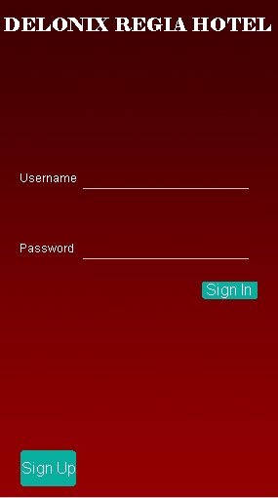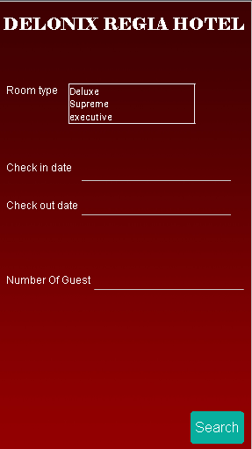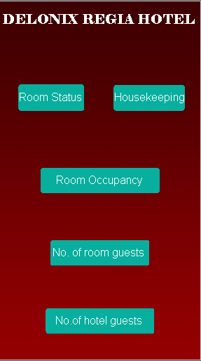

Log in Room booking Reporting

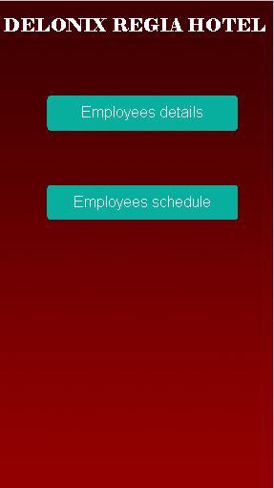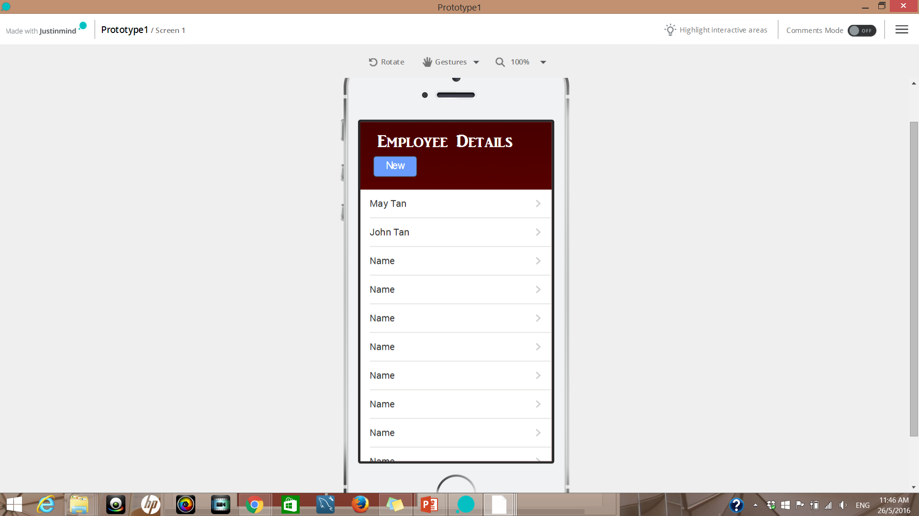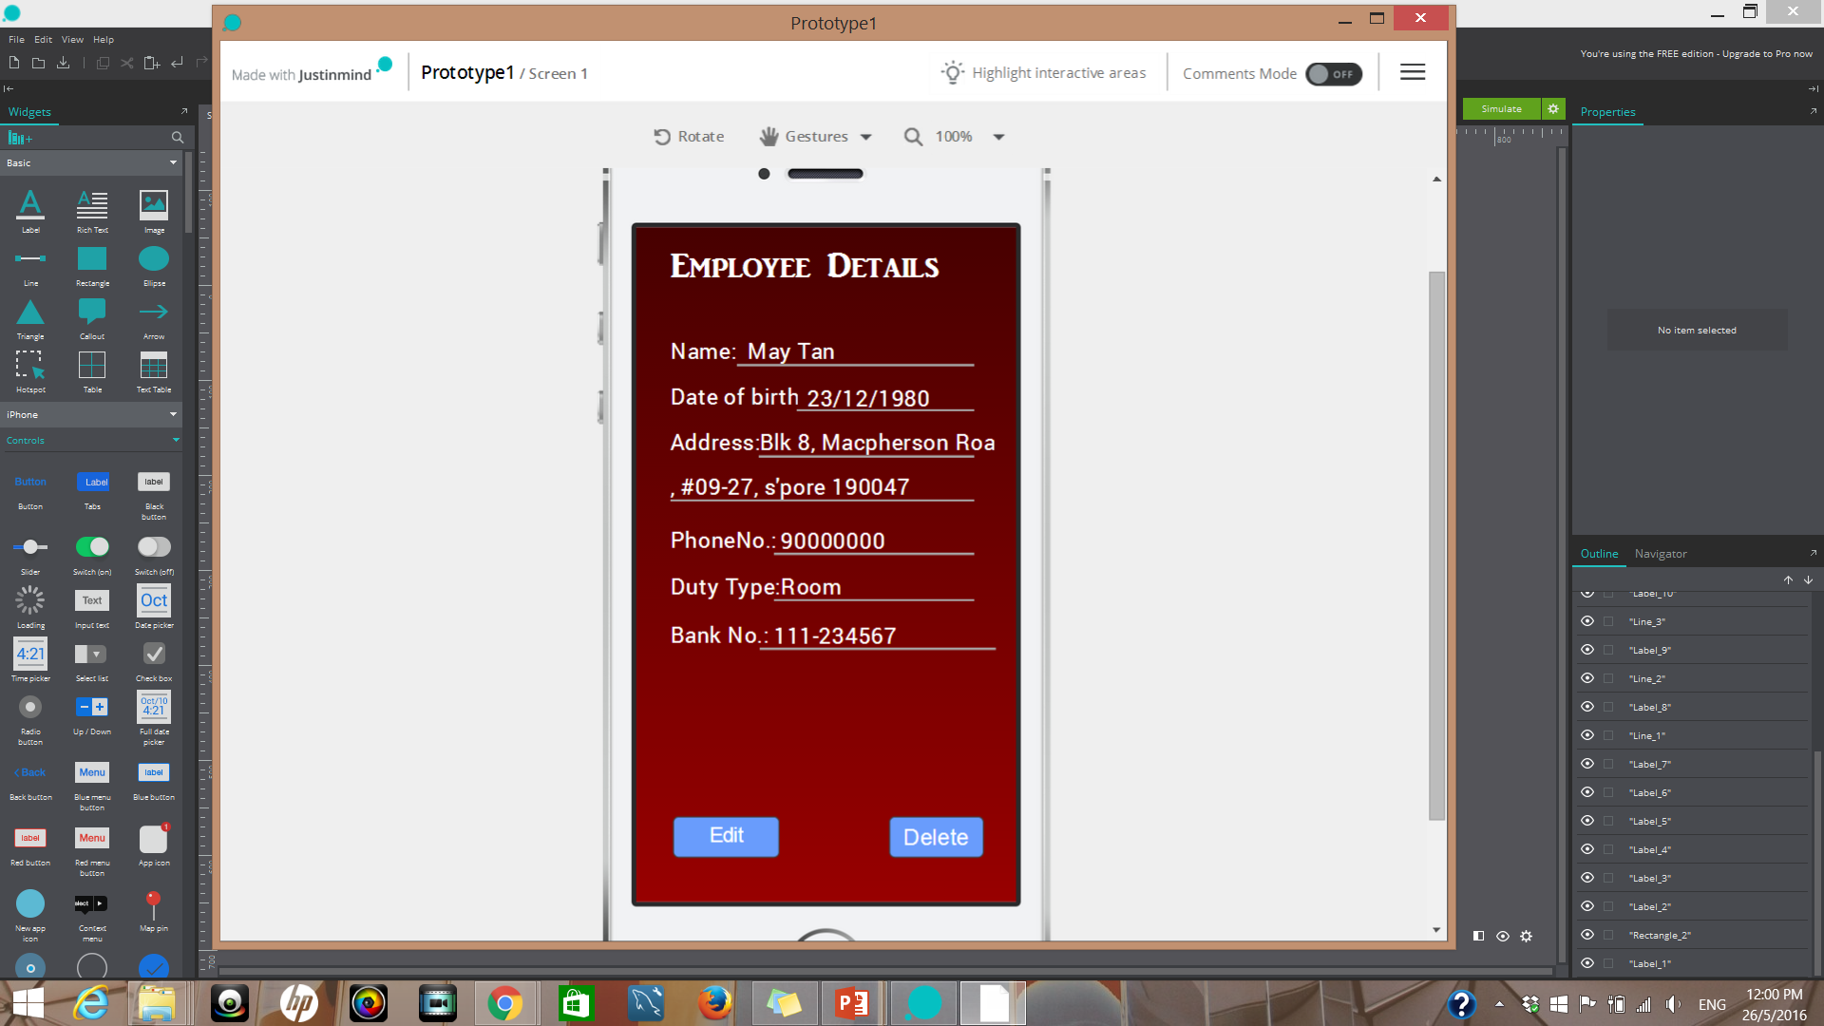

House Keeping Fig. A Fig.B

The above two diagram shows the employees’ profile. The administrator are able to edit and delete the user’s profile.

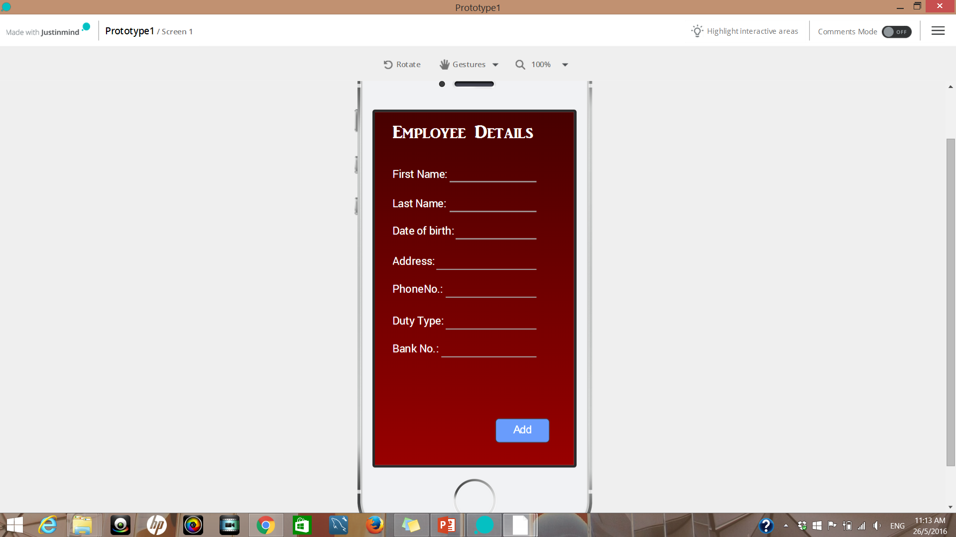

Fig.C

The administrator are also able to add new employee by clicking on the new button in figure A. After entering all the required fields, employee’s information will be saved by clicking on the Add button.

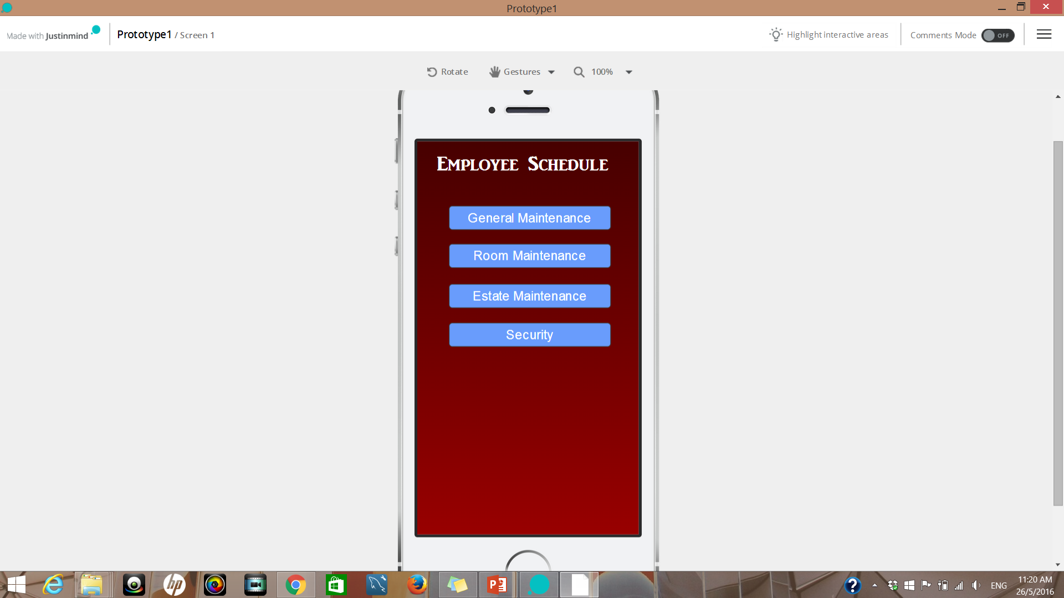 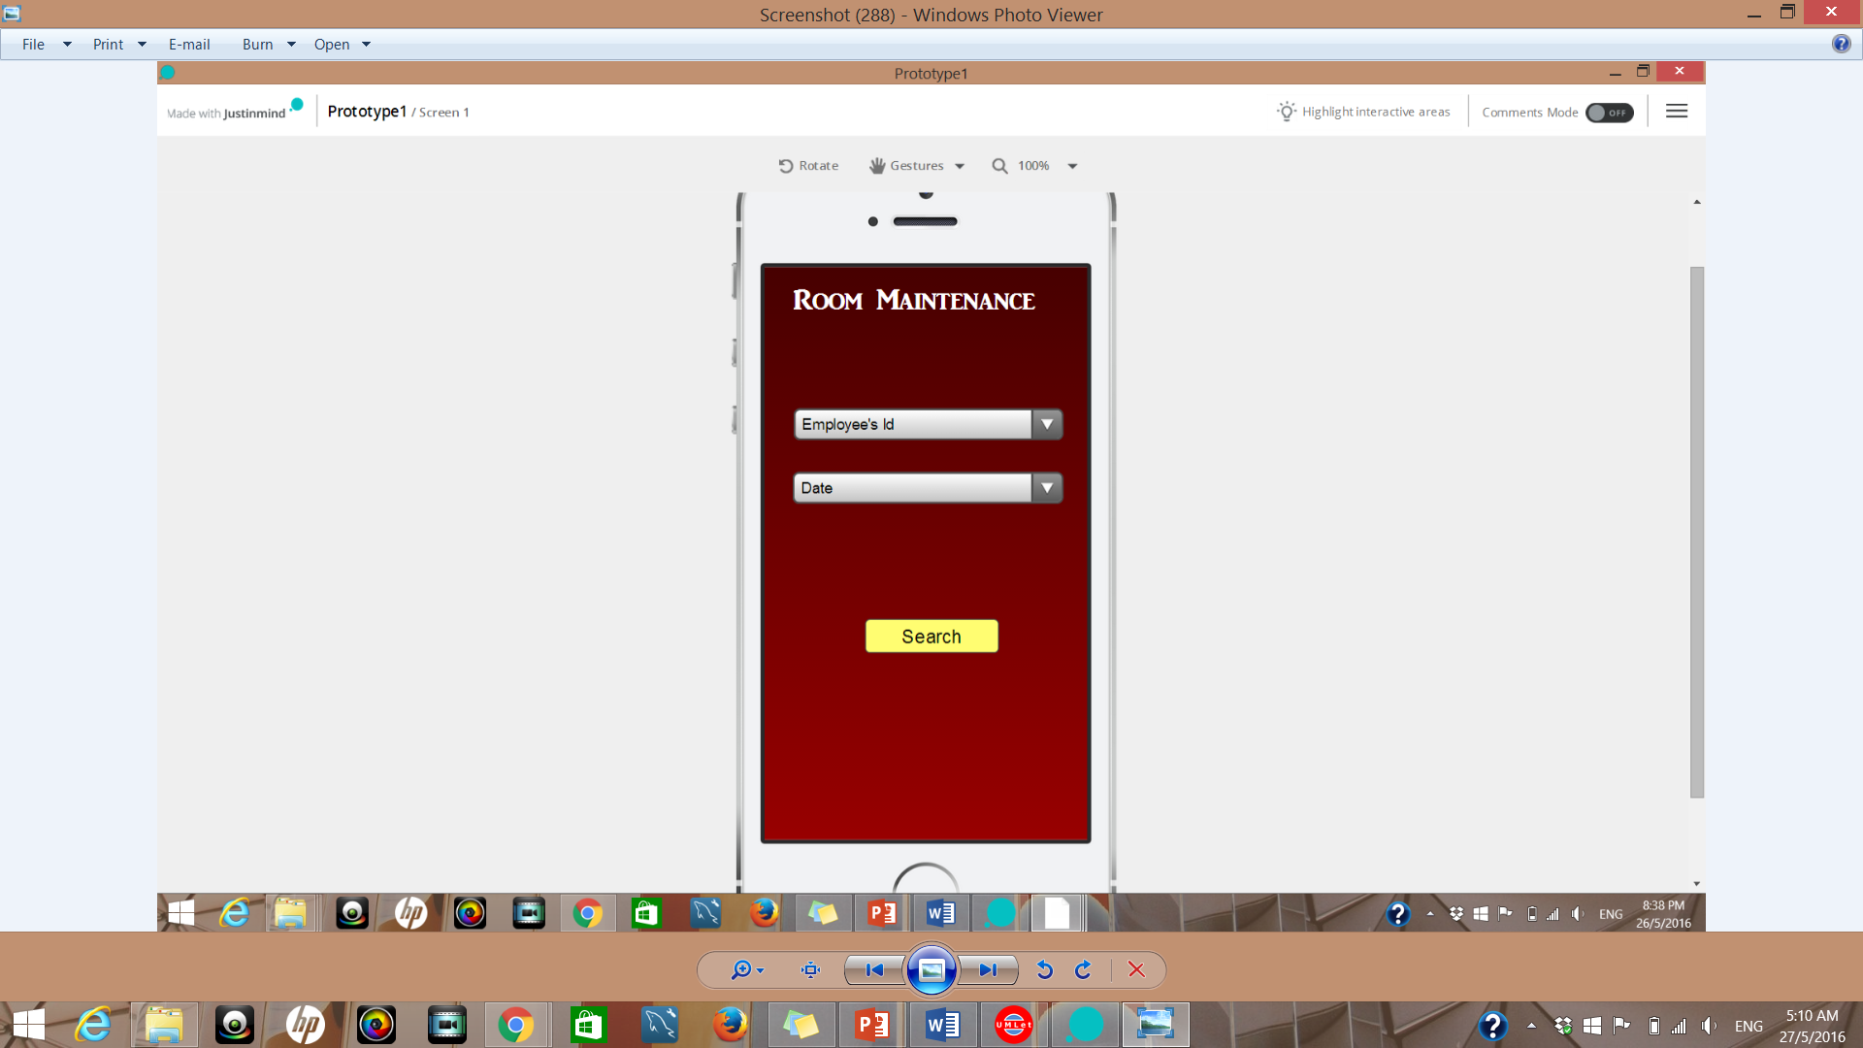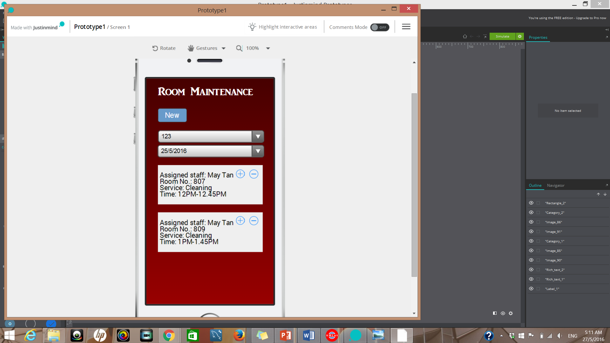

The above diagram shows the checking of employee’s schedule flow. First, after clicking employee schedule on the housekeeping menu. It will shows the four different type of housekeeping duties. For example, if the user click on room maintenance, the user will then need to select the employee’s Id and the date to filter the results. The following employee work schedule will then be displayed. User can then create new work schedule for the employee when neccessary.

## Interface with Other Systems

[Describe any requirements to interface with other system, either new or existing. List any specification for interfacing and the required data format for communication between the systems. Include any security considerations for such data transfer. ]

For the interface with other system, it will need the housekeeping system and the room booking and availability system and the reporting system to interact with each other. The reqiurements to interface with other system is that they need to use the same database and also the programming language. If all the systems use the different one, the systems might not be able to interact with each other. The administrator and the management users will have to login to the specific accounts so as to access their systems. The data format required would be string, integer and characters. If different data format is used, it will not be able to communicate with each other. Using the same database for data transfer would be in consider and also generating links to shared documents can put sensitive data at risk.

## Assumptions

[Record any assumption made or implied regarding the requirements you have gathered for the system.]

There is one of the assumption where if we implement the system on an android application. Customers will have to download the application to do their booking on the hotel. This means that the owner or the boss will have to get the staff working in the hotel an android phone or tablet to do the necessary confirmation with the customers.

# OPERATIONAL AND QUALITY REQUIREMENTS

## Operating Environment

The operating environment the system will be deployed in android. Android is a mobile operating system. The receptionist will be able to use tablets as their booking system instead of use computers and receptionist will be able to show and confirm customers for booking at the screen.

## Development Constraints

There are three types of constraints when developing a system. The three constraints are schedule, platform and programming languages. For schedule, the time to develop the system needs to take quite awhile. This will pull the project schedule even longer to finish it. This will take our time on doing other projects for our members too.

For the platform, It must work on Windows, or Linux etc. Building the software that does not satisfy the platform constraint means we might have failed to design a software system that satisfies the client concerns.

For the programming, a specific programming language will be required for various reasons. For example, the client may be a Java or Microsoft shop. We might simply prefer a certain language over another, or have a specific way using a particular programming language. Nearly always, once you have picked a language we will be stuck with that choice for the remainder of the project.

## Performance

[List the acceptable system response time for each function during time of operations; on the average and during peak hours.]

There is a different response time for each function during the time of operation. For 0.1 second is about the limit for having the user feel that the system is reacting almost instantly, meaning that no special feedback is necessary except to display the result. This function can be for displaying the schedule and the duties of the staff in the hotel and also displaying the room status in the hotel. Also it happens during the non peak hour from about 2am-3am where the guest either check in or out.

For 1.0 second is about the limit for the user's flow of thought to stay uninterrupted, even though the user will notice the delay. No special feedback is necessary during delays of more than 0.1 but less than 1.0 second, but the user does lose the feeling of operating directly on the data. This happens when the management have to see the number of guests in all the rooms in the hotel which it takes awhile to display all as the system need to gather all the number of guests in a room and the number of rooms in the hotel. It also follow the real time display for all the guests in the hotel as they might checking in at any point of time.

For 10 seconds is about the limit for keeping the user's attention focused on the dialogue. They should be given feedback indicating when the computer expects to be done. Feedback during the delay is especially important if the response time is likely to be highly variable, since users will then not know what to expect. This will happen after the users login using their account and filled their own details and the room details that they wanted to stay in is submitted into the system and it will take a while to process the information in it where the feedback will display to tell the guest that it might take a while to process it. This will took about 10 seconds as the system will take the data of the guest and put it in the database and to make the booking through the system.

## Availability

The system should be able to run 24 hours a day including weekdays, weekends and public holidays. as we need to accept customer any time in the day. The system will also have a maintenance and data backup for 2 - 4 hours every week from 2am to 4am or 2am to 6am as most guest will check in and check out in the afternoon from 11am to 12pm. It is 2 - 4 hours give sufficient time for the team to fix or upgrade any part of the system.

## Security and Access Control Requirements

The receptionist will have full access of the room booking and availability system and will be able to edit, delete and create guest rooms and guest. The management users and the administrator will be able to access all 3 system. The administrator will be able to create and edit accounts for staffs. The log will be required for the log in page as we need to know who log in and what time they log in, log for the booking of the rooms in the system, and also the editing and deleting of the guest and rooms. security requirements will be data encryption to prevent hackers from getting any data from the system.

# SPECIAL REQUIREMENTS

[Any other requirements that are not included in the above headings, like data archival, etc.]

# REFERENCES

[List any books or web site that you have used when preparing this requirement specification.]