**Temasek Polytechnic**

**School of Informatics and IT**

**Diploma in Information Technology (IT)**

Software Design Specifications (DS)

**Project Particulars**

|  |  |
| --- | --- |
| **Tutor** | Mdm Ho Li Ching |
| **Class** | P02 |
| **Project Title** | Delonix Regia Hotel Management System |

**Project Team’s Particulars**

|  |  |
| --- | --- |
| **Matric Number** | **Student Name** |
| 1403575B | **Chloven Tan** |
| 1403539H | **Chua Cheng Yu** |
| 1400555G | **Lin Jia Min** |
| 1401557B | **Ngoh Man Ling** |

**Revision History**

|  |  |  |  |
| --- | --- | --- | --- |
| **Date** | **Version** | **Description** | **Author** |
| <dd/mm/yy> | <x.x> | <details> | <name> |
|  |  |  |  |
|  |  |  |  |
|  |  |  |  |

**Table of Contents**

**1.** **DISTRIBUTION OF WORKLOAD**

**2.** **ARCHITECTURE DESIGN**

**3.** **USER INTERFACE (UI) DESIGN**

**4.** **PROGRAM DESIGN**

**5.** **DATABASE DESIGN**

# **DISTRIBUTION OF WORKLOAD**

*[Determine which members of the team will be responsible for which areas of design. Individual’s responsibilities should be clearly spelt out.]*

|  |  |
| --- | --- |
| **Design** | **Members** |
| Architecture Design | All |
| User Interface Design | All |
| Program Design | All |
| Database Design | All |

# 

# **ARCHITECTURE DESIGN**

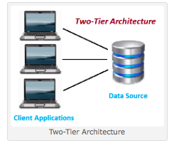

Advantages:

It will run faster compared to the Three-Tier Architecture as there is no intermidiate between client & server. Also, it is easy to maintain as modicfications are easy to be made. In addition, Communication is made faster with datebase as server and database is incorporate with each other.

Disadvantages:

It cannot make mutiple request, as it will degrade the performance. This will create a chaos and make a confusion in real time, as system not quick enough to keep-up-to date information. Moreover, the Two-Tier Architecture is also not cost effective, as if business grows and get more complex. With its increasing amount of data & systems, not only the programming logic had to be changed to suit business, but also much cost is thrown into processing business data with the additinal upgrade of technology like softwares. It is an ongoing and long-term investment in technology.

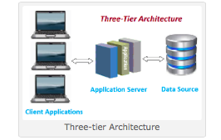

*Advantage:*

*In the Three-tier Architecture, the performance is high & good, as the presentation tier can cache request, lead to minimized in the network utillization. This will greatly reduce the load on the application and data tiers. To add on, since business doesnt have direct acces to datebase, business logic is more secure. Also, as each tier is independent,*

*Disadvantage:*

*In conclution. we reccomend Mr Wang to use the Three-tier Architecture*

# 

# References:

<http://www.softwaretestingclass.com/what-is-difference-between-two-tier-and-three-tier-architecture/>

<http://www.n-tier.com/articles/cslimits.html>

<http://des-megan.blogspot.sg/2008/11/advantages-and-disadvantages-of-3-tier.html>

# **USER INTERFACE (UI) DESIGN(should state the reason for putting** buttons , colours HCI**)**

*[Document the user interface design decisions and considerations. This should not be a mere capture of all UI forms but a reflection of UI design considerations. Is web or windows or other forms of UI used? Why did you choose that particular UI? How does the UI design impact usability and why adopt certain UI controls than others?]*

**Chloven**

The first will be the login page and the first page will be a simple page with only 2 for usability and having a simple interface. different Users will be able to access thier individual fuctions and roles thorugh signing in their own account. I chose the white font as it is bright and easy to see. The second page is when a customer book the room. The page 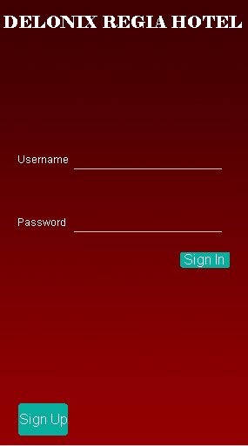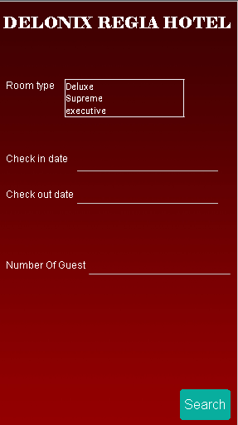

**Cheng Yu**

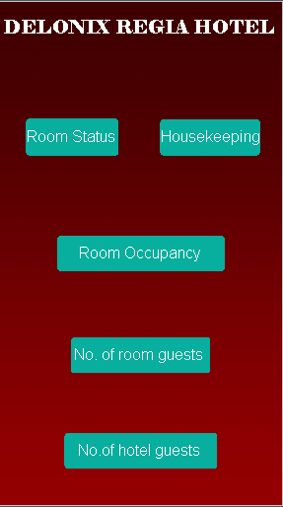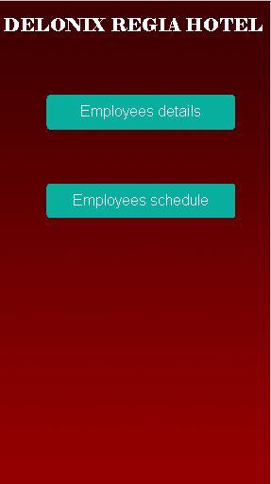

The first and second page is the page for reporting. The page has just five buttons so that it is very clear and easy to understand and use.

For the reporting system user interface, there will be five buttons to represent five different reports. The room status button when press will ask the user which level will the user wanted to see and will show the user that level of the room status. For the housekeeping, it will show the duties and the schedule of the staff working in the hotel. The room occupancy will show the user the statistics of the room occupied in terms of daily, weekly, monthly, yearly basis. When press the number of room guest, it will ask the user to type the room number and the system will show the user how many adults and children in the room. For the number of hotel guest, it will show the user how many guests had check in from that particular date that the user have chose.

**Man Ling**

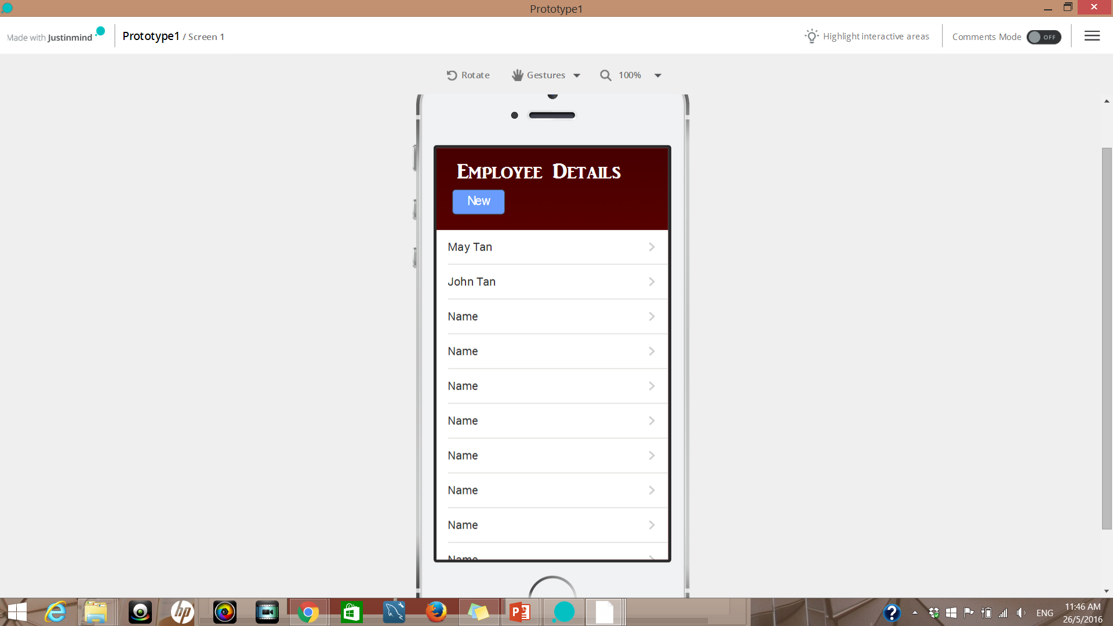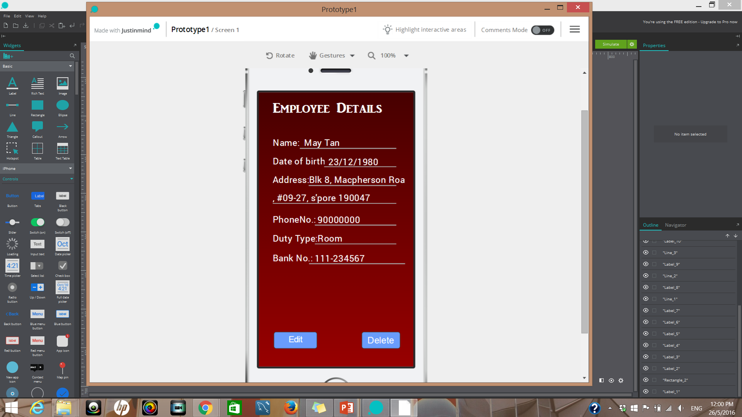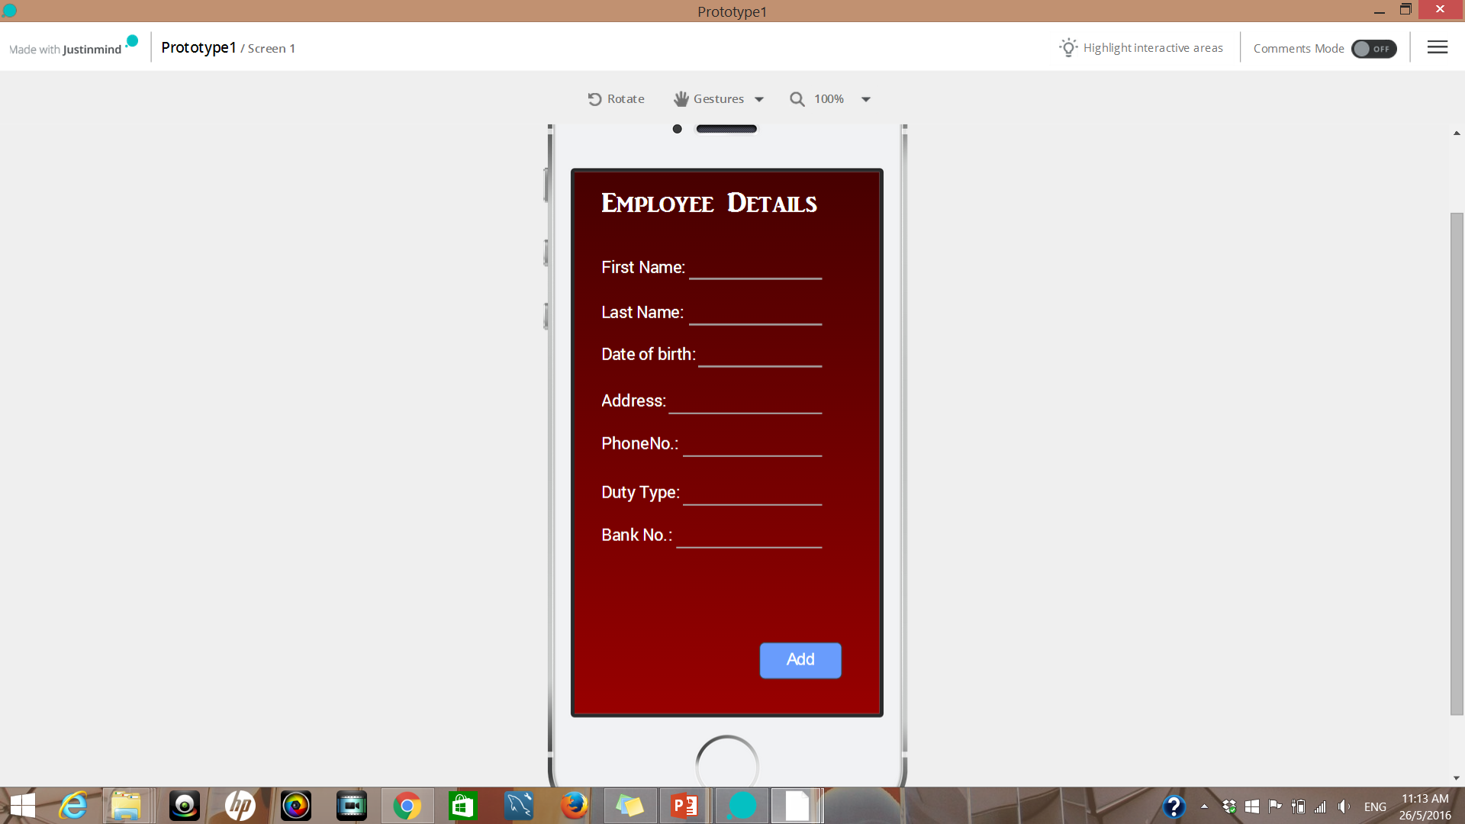

I am using a list bar which will list their name only for the employees profile. This will help to allows user to have an overview of the employees profile. If they want to view more details of an employee, they can click on the employee’s name. Details of the employee will then be displayed. Hence, listbar can help to reduce the space by reducing the displayed information for each bar. I am also using buttons for creating new accounts, edit, delete and add.

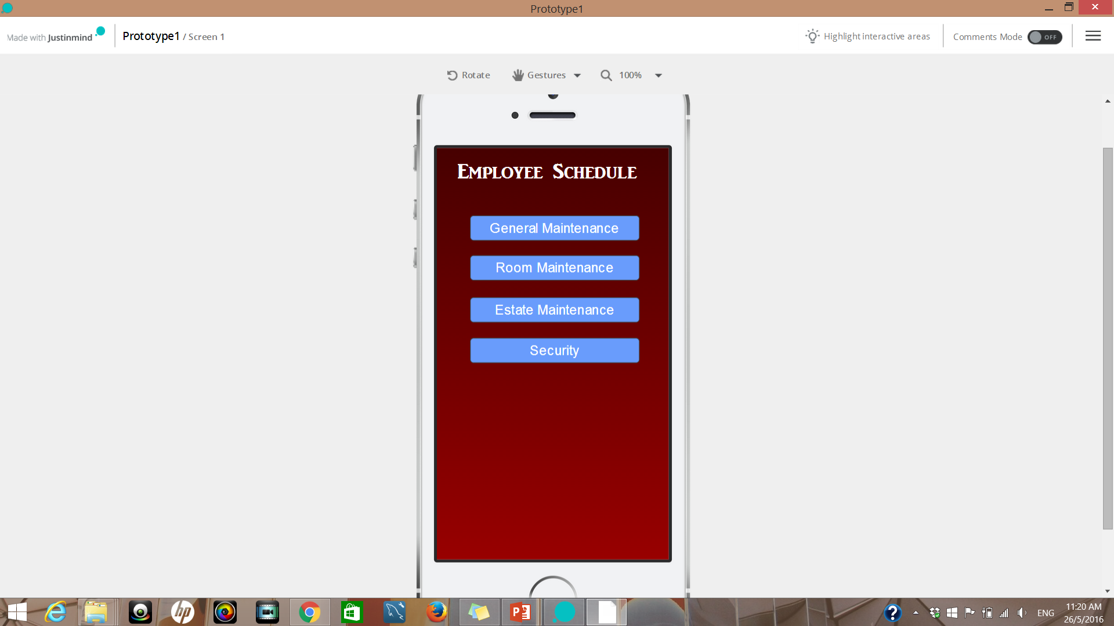 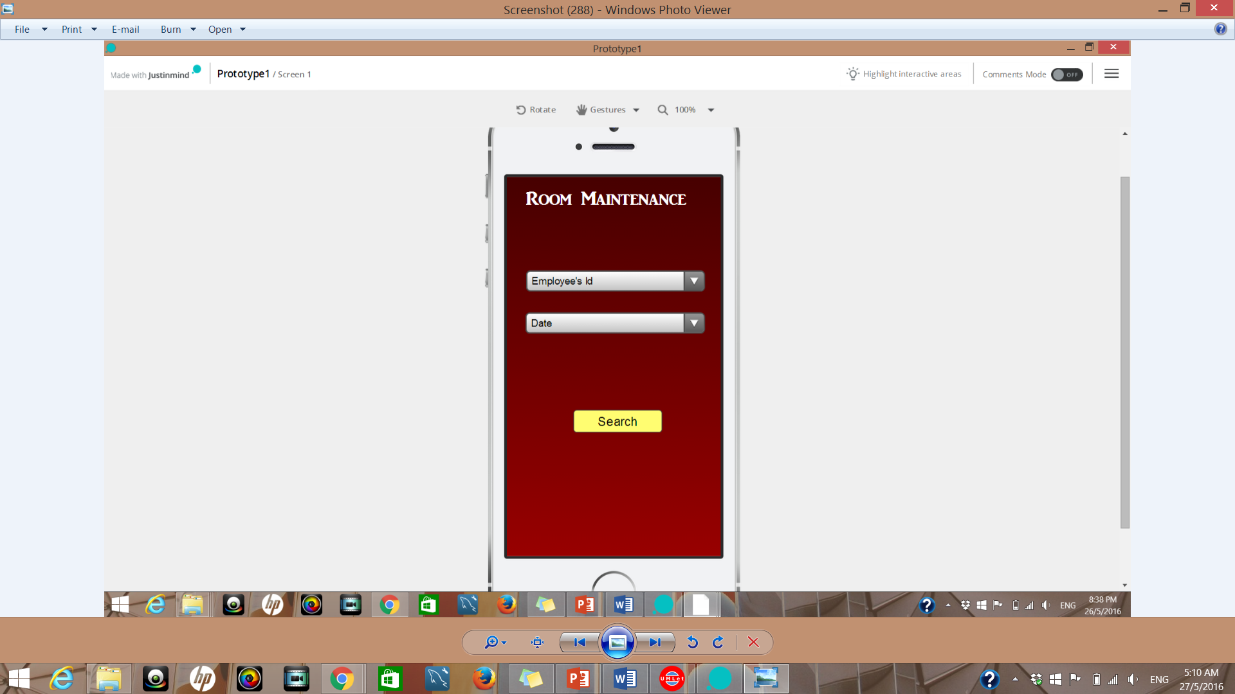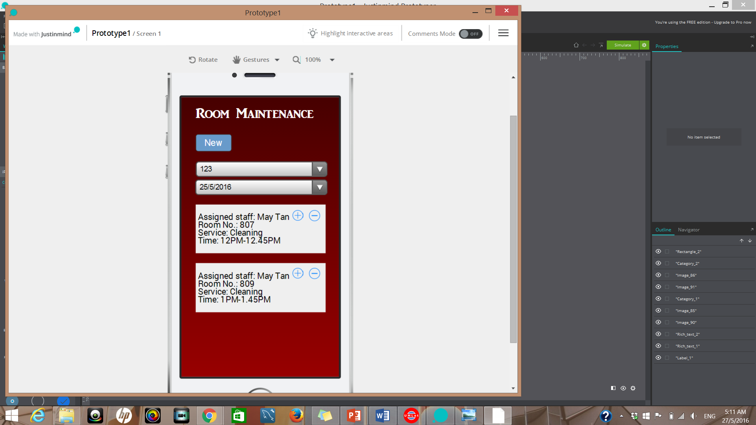

I am using a yellow search button in the second diagram. This will allows user to notice the button so as to help them to easily navigate. A filtering box are also use to filter the employee’s Id and date. There can be lots of employee so by having a filtering box can save them the hassle of remembering the staff Id. Other than that, i had also use a plus and minus icon in diagram 3. The plus is to indicate edit and minus to indicate delete. Having too much buttons in a page can be confusing for the users so i use icons instead.

**Jiamin**

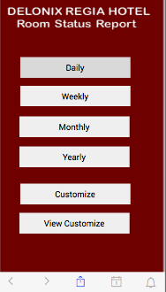 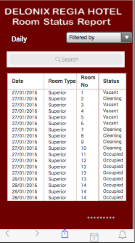

For the my part I am doing the Status & houseKeeping report. The first four prototype shows the Room Status Report sytstem and how its works. Basically, users can choose which type of report they want to view or even customize their own. For example, user choose the daily report & they will show all the details by day. There is a search function there so that user can narrow down search even after data its filtered. For example, the room no, as manager may want to check specific room for status. The Fitered columm by the side is limited and can help user sorted by room type or status, but cannot search by date & room no. Thus, by having both helps to improve the efficiency of the system.

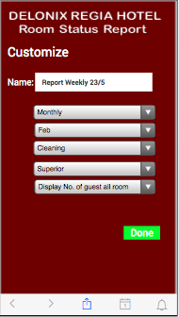 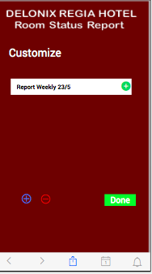

This two prototype shows user how their report is being customize, which in the example you can see clearly the first option is by daily, weekly, Monthly or yearly. Second, will be depending on what users select at the first option. Which in this case, the different month. Next will be the selection of room status. Moving on, users also can select the type of room they want to see, user can select either ‘All’, or the specific room. Lastly, user can choose the additional options which allow user to see the amount of guest in the system by total, each room, both or none. After that report will be created and saved in the database, which user can edit, view, add and delete in the future. As for the housekeeping report, the format and the flow is the same, just that the data is changed.

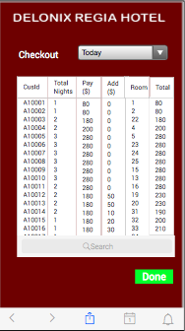

Now I have come to the additional part of the system, which is when Guest checked out from the hotel. Admin will be able to check the records of customer checking out, today, yesterday and tomorrow. The search by room number so that easier for staff to identify the correct customer. After the correct record is found, staff can click on the record and press the ‘Done’ button to procced with payment.

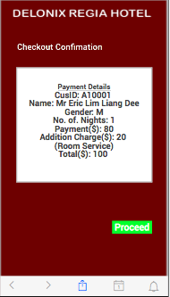 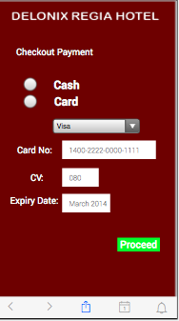

The system will then show a more detailed summary of payment before staff can confirm checkout for customer. Which will be direted to the payment page to select payment mode.

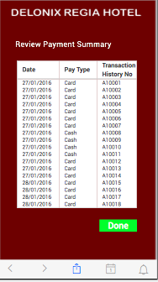

Lastly, Admin will be able to retrieve data and review the transaction history that is made.

# **PROGRAM DESIGN**

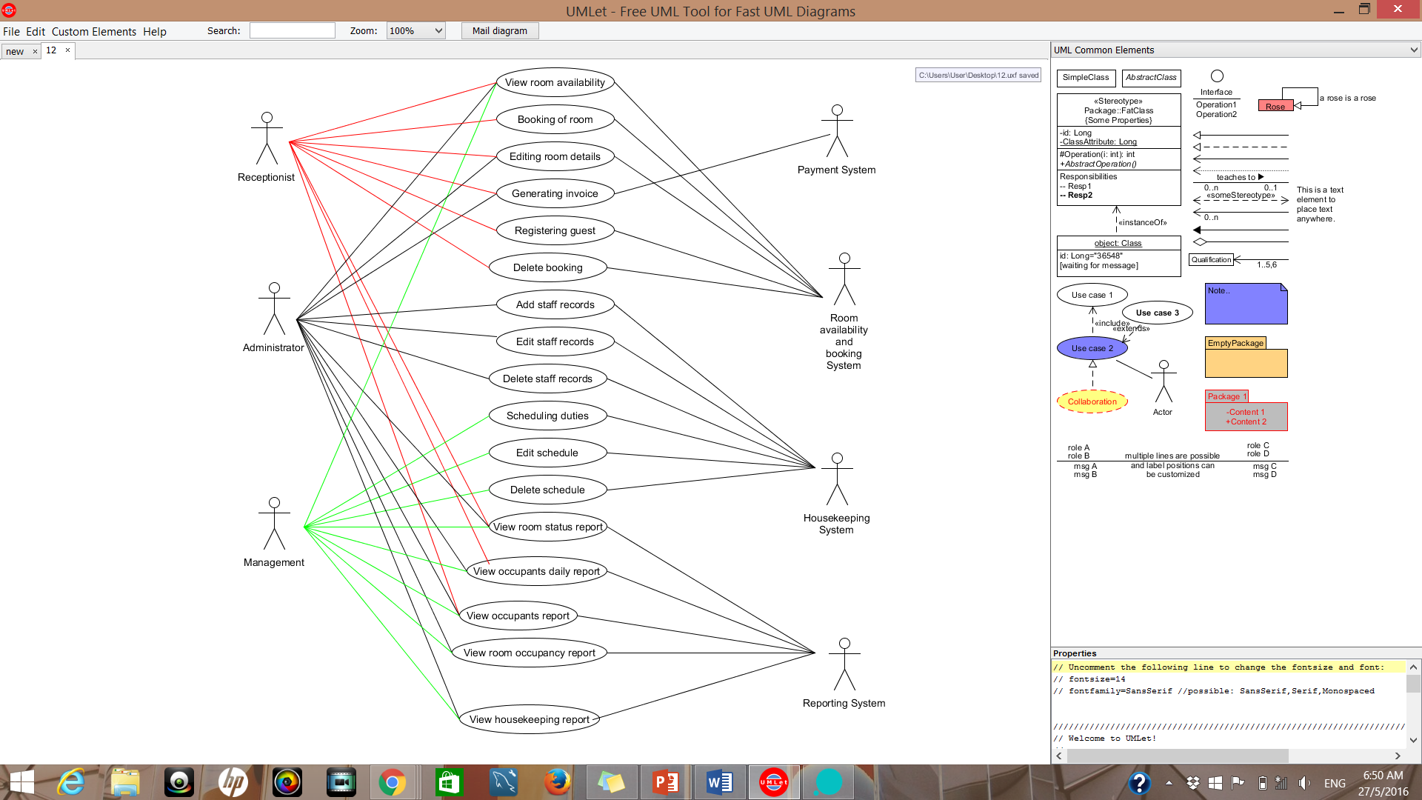

# 

The diagram above shows the use case for the three user. They will be using the three system which are room availability system, housekeeping system and reporting system.

**Booking VOPC**

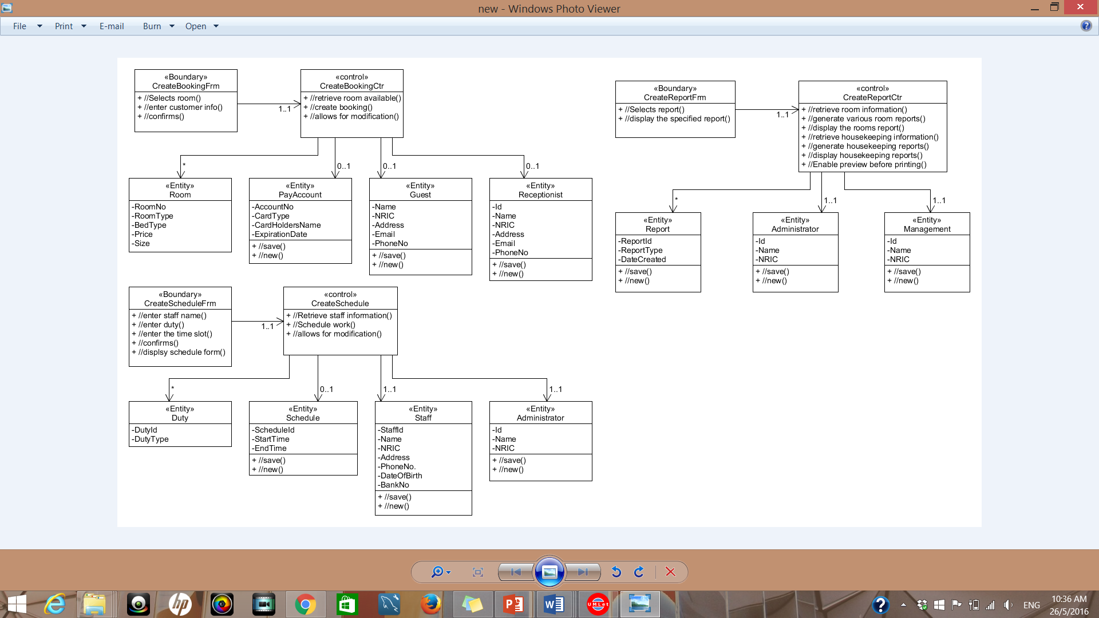

The receptionist will nned to book the room for the guest so they will need to view the room available first. The controller will generate the room details. Then they will proceed on with registering the guest into the room.

**Scheduling VOPC**



The administator will be in charge of user management. Work schedules may be done by the supervisor where they will schedule the duties to staff.

**Reporting VOPC**



The reports will be view by the administator and the management team for enhancement of sales. A person will be in charge of creating the various types of reports.The reports will need room information, user information and housekeeping information.

# **DATABASE DESIGN**

This is the database for the all the table which the primary datatype is ‘CHAR’ to make the primary key more unique.

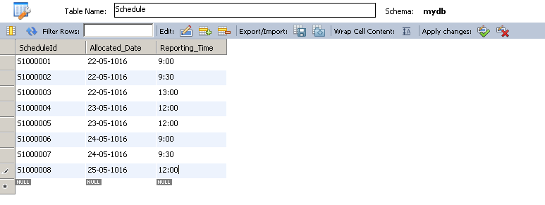

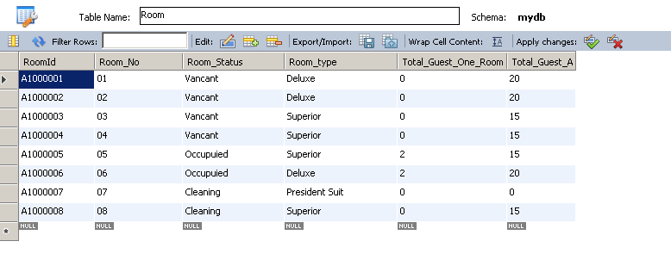

All the attributes here are required by Mr. Wang, which he can view all the details of the room status report.

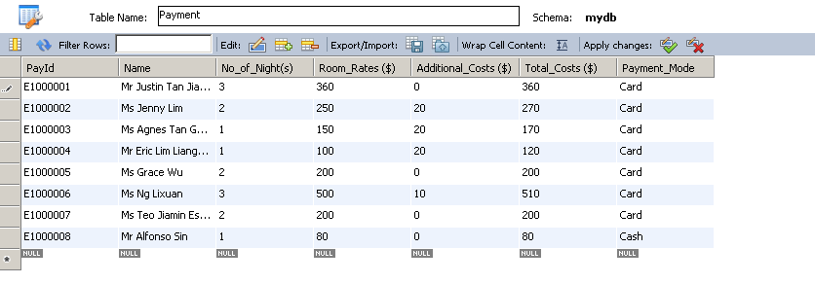

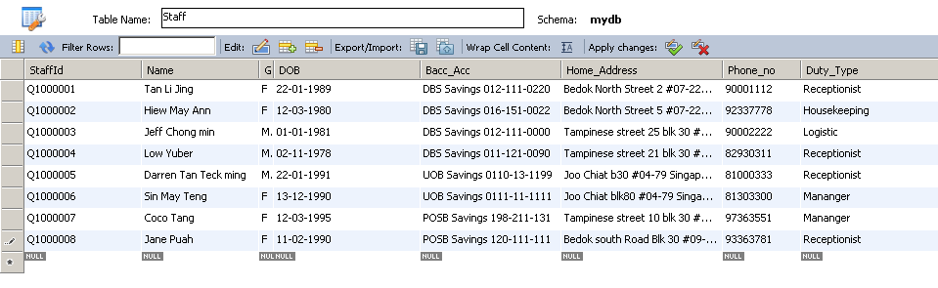

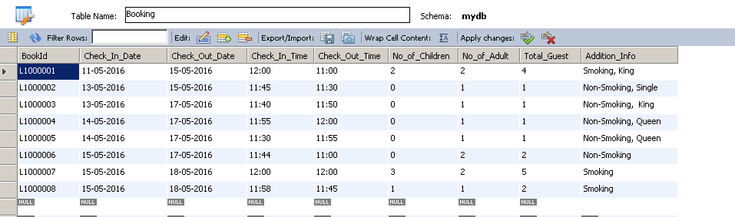

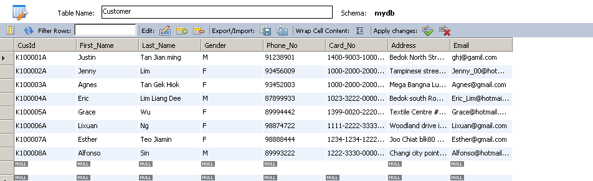

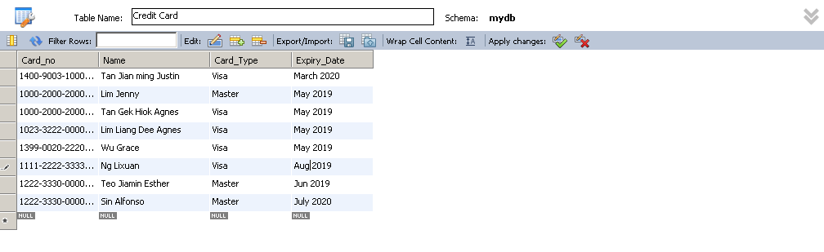

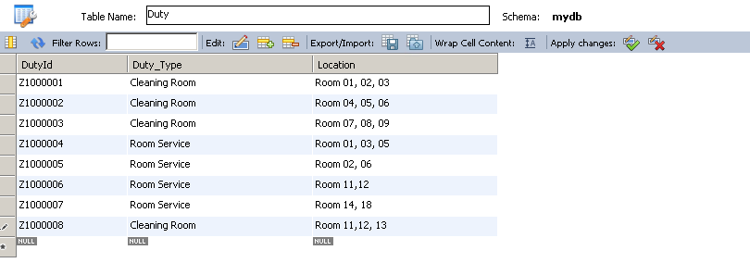

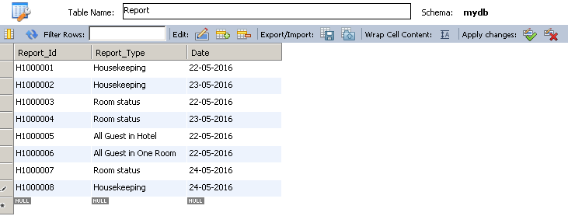

Customer(CustID, First name, Last Name, gender, Phone No, Email, Address, Card_no)

Credit card(Card no, Name, Card_Type,Expiry date)

Booking(BookId, Total guest, NoOfChildren, NoOfAdult, Check In time, Check Out time, CheckInDate, CheckOutDate, Additional info, RoomId,CustID)

Room(RoomId, RoomStatus, RoomType, TotalGuestOneRoom,Price, BedType, request_remarks)

Payment( PayId, no of nights, Room rates, Addition cost, Total cost, Payment mode,CheckInDate, CheckOutDate, BookID,CustID)

Staff(StaffId, Name, Gender, DOB, BankAcc, HomeAddress, PhoneNo, DutyTypes)

Schedule(ScheduleId, Allocated date, Reporting Time, staff_id, Duty_id)

Duty(duty_id, dutyType, Location)

Report(ReportId, Report_Type, Date, ScheduleId, BookId, RoomId)

